Rhodri Williams

[Draw your reader in with an engaging abstract. It is typically a short summary of the document. When you’re ready to add your content, just click here and start typing.]
[Document title]
[Document subtitle]

Contents
1. List of illustrations/Tables/Abbreviations Page 2
1.1. List of Equations .
1.2. List of Figures .
1.3. List of Tables .
1.4. List of Abbreviations .
2. Introduction Page 3
3. Critical Review of Current Maintenance Practices Page 4-7
3.1. Company Background .
3.2. Asset - Cut Off .
3.3. Current Maintenance Approach .
4. Evaluation of the Current Approach Page 8-9
4.1. Proposed Improvements .
4.2. Alternative Approaches .
4.2.1. Condition-based Monitoring .
4.2.2. Centralized Maintenance .
4.2.3. Outsourcing Maintenance .
5. Cost and Resource Considerations Page 10-11
5.1. Improving the Existing Strategy .
5.2. Condition-based Monitoring .
5.3. Centralized Maintenance .
5.4. Outsourcing Maintenance .
5.5. Managing Change .
5.6. Improvements .
6. Conclusions/Recommendations. Page 12
7. Referencing Page 13-14
8. Appendix Page 15-16
1. List of Figures/Tables/Abbreviations/Equations

1.1. List of Equations
Equation 1 – Mean Time Between Failure

1.2. List of Figures
Figure 1 – Cut-Off Machine
Figure 2 – Bi-Monthly Checklist
Figure 3 – Recorded Faults
Figure 4 – Asset Maintenance Log

1.3. List of Tables
Table 1 – Cost/benefit Analysis

1.4. List of Abbreviations
OEM – Original Equipment Manufacturer
PM – Preventative Maintenance
WCL – Wall Colmonoy Limited
MTBF – Mean Time Between Failure
MTTR – Mean Time to Repair
TPM - Total Productive Maintenance

2. Introduction
This report focuses on assessing Wall Colmonoy's current maintenance strategies for monitoring the cut-off machine within the castings business unit, a vital asset essential for component throughput. The aim is to highlight potential limitations of these approaches and propose recommendations for changes and enhancements. Given the cut-off machine's significance in the business unit's operations, it's imperative to thoroughly evaluate its maintenance practices. This assessment will examine the rationale behind the current approach and explore opportunities for improvement. Additionally, the report will analyse the financial and resource implications of implementing these enhancements for the company. The report will conclude with recommendations aimed at optimizing equipment performance, spanning short, medium, and long-term.

3. Critical Review of Current Maintenance Practices
3.1. Company Background
Wall Colmonoy, with a history of over 50 years, stands out as a market leader in supplying hard-surfacing and wear-resistant alloys to diverse industries such as Automotive, Oil & Gas, and Food. Situated in South Wales, the company specializes in manufacturing Nickel and Cobalt-based alloys in various forms, ranging from high-specification powders to precision machined components. Within its operations, the components business unit employs a range of manufacturing methods including Investment, Sand, and Centrifugal processes. Given the diversity of manufacturing processes, efficient organization and monitoring of plant equipment are crucial. To address this, the company has implemented a centralized system where each piece of equipment is assigned a unique asset number. This centralized approach facilitates monitoring and maintenance history tracking, enabling the identification of potential failure trends (Colmonoy, 2024).
3.2. Asset - Cut-Off
The Cut-Off unit, seen in Figure 1 is integral to the operations of the casting business, particularly in post-processing components produced through the Investment casting process. To begin, the necessary components are secured within a hydraulic jig, which is then attached to a plate resting on an air bed. This setup enables easy movement and positioning of the jig according to the size and shape of the components. The air bed can operate either via vacuum, securing the jig in place, or air pressure, enabling movement around the bed.
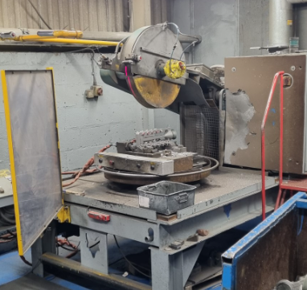
Once positioned, a laser aligns with the cutting area, and the interlocked Perspex door is closed for safety. This ensures that the unit cannot be operated unless the guard is securely closed, thus mitigating potential hazards. The operator then activates a dead man switch on an elevated lever, another safety feature of the unit. This action triggers the pneumatic retraction of the guard around the cutting blade, exposing it for operation, and initiates the rotation of the blade in preparation for cutting.
The operator lowers the lever to engage the cutting operation. Once the components are cut from the runner system, releasing the switches stops the blade's rotation and closes the guard. The lever is then raised to allow for the removal of the finished parts before repeating the process.

3.3. Current Maintenance Approach
Wall Colmonoy adopts a preventative maintenance approach for its cut off unit, as recommended by the original equipment manufacturer (OEM). This approach minimizes the impact on production capacity and reduces downtime, while also prolonging the lifespan of the asset (Velmurugan & Dhingra, 2015). Preventative maintenance strategies are advantageous in manufacturing industries, where the reliability and availability of assets are crucial for product throughput. However, it's important to balance the frequency of preventative activities to avoid excessive costs and resource wastage (Vilarinho, et al., 2017).
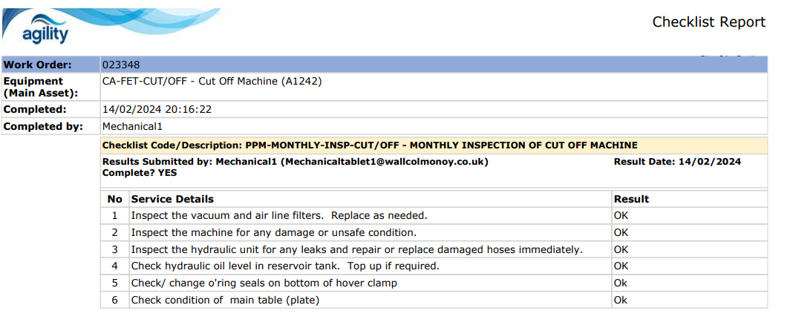
Reducing downtime on the cut off unit is vital as it's the sole unit within the company, meaning any downtime would directly affect overall production capabilities. Currently, designated maintenance personnel conduct bi-monthly checks which are show in Figure 2. Checks 5 and 6 were added in August 2023 suggesting that our maintenance team have highlighted potential risks from historical data and are trying to mitigate them in the future. This whilst seeming to be a step in the right direction still does not encompass all the maintenance activities stipulated by the OEM recommendations.

Information gathered from the fault analysis on Wall Colmonoy’ Agility system indicates that there have been 208 documented for the unit, with only 44 having reasons recorded for the jobs. The 44 recorded jobs are detailed below in Figure 3. 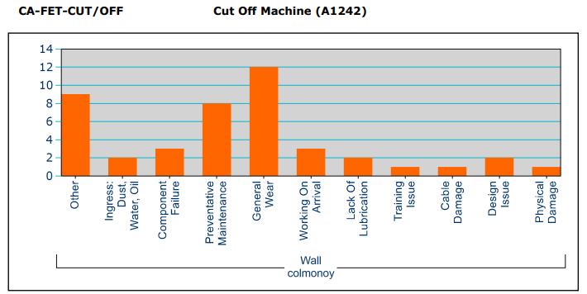

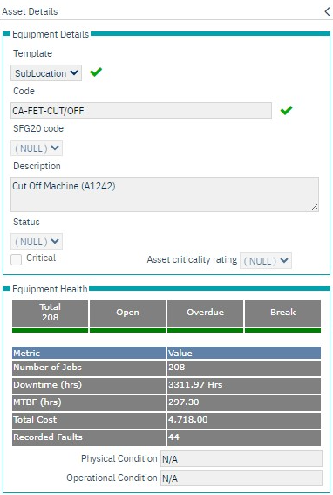
Data analysis is fundamental for achieving success in any company; however, the accuracy of the captured data is crucial for making informed decisions (Loshin, D, 2011). inadequacies within the collected data regarding the breakdowns experienced will inevitably affect the overall efficiency of the selected maintenance strategy for the cut off unit, hindering the full potential of the preventative maintenance approach.
As stated by (Hurt & Schrock, 2016), failure to fully implement preventative maintenance and neglecting the OEM-prescribed maintenance activities will have repercussions on the economic lifespan of the asset.
Wall Colmonoy’ Agility maintenance portal facilitates the management of production downtime, labour, and inventory costs, while providing visibility into asset and personnel performance. Additionally, the log indicates the amount of downtime experienced by this particular asset, which in this case is 3312 hours, seen in Figure 4.
The Mean Time Between Failures (MTBF) is calculated using Equation 1, enabling the maintenance team to anticipate the next breakdown of the asset. This facilitates more effective planning of the maintenance schedule, ultimately resulting in fewer breakdowns. The MTBF for this asset is 12.4 days.

$$MTBF= \int_{0}^{∞}{R\left(t\right)dt}$$
$$MTBF= \int_{0}^{∞}{e^{-λt}}dt$$
$$MTBF= \frac{1}{λ}$$
$$λ=\frac{Number of operation hours}{Number of failures}$$
$$λ=\frac{\sum{(start of downtime-start of uptime)}}{Number of failures}$$
Equation 1 - MTBF (Martz, 2003)

The Agility software also records the meantime to repair (MTTR), and currently sits at 0.48hr, as shown in Appendix C. Mathematically the MTTR is similar to the MTBF although it has an opposite significance in that we wish, meaning the lower the better (Thorn, 2024). Also recorded within the software is the average time to attend, and average time to repair, which are 686 minutes and 28 minutes, respectively. Whilst recording these metrics is extremely valuable to the maintenance team, any data discrepancies that exist will have a negative effect.
Data accuracy is paramount for informed decision-making, and inconsistencies in fault analysis data impede the optimization of preventative maintenance efforts (Able et al., 2016). Neglecting OEM-prescribed maintenance activities and inadequate data capture practices have resulted in increased downtime and the need for corrective maintenance, highlighting the importance of robust data management.
Wall Colmonoy's utilization of the Agility maintenance portal provides valuable insights into asset performance and facilitates effective downtime management. Metrics such as Mean Time Between Failures (MTBF) and meantime to repair (MTTR) aid in maintenance planning and resource allocation. However, any lack of data recording must be addressed to ensure the reliability of these metrics.

4. Evaluation of the Current Approach

4.1. Proposed Improvements
The current maintenance practices fall under a PPM schedule along with reactive maintenance which is something WCL has always undertaken. Thus, to prolong the life of keys assets within the manufacturing sector, there are numerous improvements that can be made to aid in the reduction of downtime due to breakdowns.
Firstly, a review of the maintenance checklists should be conducted. The additional checks added in August 2023 are a positive step, however but they do not encompass all maintenance activities prescribed by the OEM. To improve, Wall Colmonoy should develop a comprehensive maintenance plan that includes all recommended activities outlined by the OEM recommendations, and at a monthly frequency, ensuring thorough coverage of maintenance tasks.
Secondly, the accuracy of data captured during fault analysis is crucial for informed decision-making. Wall Colmonoy should implement measures to enhance data capture accuracy, such as ensuring all maintenance activities and breakdowns are properly documented and reasons for faults are recorded consistently. This will provide a clearer understanding of the unit's performance and aid in identifying areas for improvement.
Thirdly, to further enhance the maintenance approach for Wall Colmonoy's cut off unit, the implementation of Total Productive Maintenance (TPM) principles can be instrumental. TPM aims to maximize equipment effectiveness by involving all employees in the maintenance process and fostering a culture of proactive equipment care. Daily checks in accordance with the OEM recommendations, ensuring that all team members understand their roles and responsibilities in maintaining equipment reliability and are equipped with the necessary skills to perform their tasks effectively.

4.2. Alternative Approaches
Alternatively, rather than adjusting the preventative maintenance approach, other maintenance techniques such as centralized maintenance, condition-based monitoring, and outsourcing maintenance could be considered for these assets.
4.2.1 Condition-based Monitoring:
Advancements in technology offer the opportunity to implement electrical feedback for restructuring maintenance activities. This feedback enables monitoring of specific sections of the assets, analysing runtime and monitoring critical parameters such as pneumatic or hydraulic pressure. Sensors can be set to alarm maintenance or operations when these parameters reach critical levels, allowing for timely intervention (Gössinger et al., 2017). This approach, known as condition-based monitoring, ensures that maintenance activities are performed only when critical parts reach an alarm level, making scheduled maintenance checks more targeted and efficient. (Wang et al., 2022)
4.2.2. Centralized Maintenance
Centralized maintenance would provide greater access to the asset's components. However, the process of removing the assets from the area and transporting them to the maintenance workshop would be costly and time-consuming due to their size. This would necessitate a shutdown shift and the use of large machinery for removal and installation (Simeu-Abazi et al., 2012).
4.2.3. Outsourcing Maintenance
Outsourcing maintenance could be considered if the internal maintenance team lacks resources. Outsourced services may offer higher standards and adherence to safety regulations, ensuring efficient completion within the specified timeframe. However, scheduling may be a challenge due to limited availability, necessitating careful planning and regular reviews of upcoming maintenance jobs. Control of contractors is crucial to ensure onsite safety and budget management, requiring vigilant oversight and periodic reviews to prevent cost escalation (Ludwig, 2018).
5. Cost and Resource Considerations

5.1. Improving the Existing Strategy
Raising the frequency of Planned Preventive Maintenance (PPM) from bi-monthly to monthly, in line with OEM recommendations, would result in a doubling of current labour costs. However, given that failures are occurring approximately every 12 days based on the MTBF data, there is a high likelihood of breakdowns before the next scheduled checks. Therefore, increasing the PPM frequency is likely to mitigate some of the unplanned breakdowns that could adversely affect the asset's economic lifespan, and the unplanned costs that will follow.
The integration of daily TPM checks in line with OEM recommendations for the assets would require operational personnel taking on additional responsibilities within their roles. These tasks could be incorporated into a pre-shift routine to ensure the efficient conducting of these checks. This could involve the entire operations team collectively carrying out the checks to aid the process, or alternatively, a designated team leader could oversee and ensure the completion of these checks.
These improvements, along with increasing data capture regarding breakdowns will be cost efficient and easy improvement to make on the current process, however the increased frequency of the PPM checks would place more reliance on the limited resources available to the maintenance team.
5.2. Condition-based Monitoring
The initial investment in conditional monitoring may come with a substantial upfront cost, but the long-term benefits are significant (Wang & Wang, 2013). In an engineering market plagued by economic challenges, component costs are steadily increasing, accompanied by extended lead times. Many of WCL's assets still rely heavily on manual control, necessitating an electrical infrastructure upgrade costing tens of thousands of pounds per asset to enable the implementation of condition-based monitoring. However, this upgrade not only facilitates condition-based monitoring but also opens avenues for other enhancements, reducing human error and enhancing data capture processes. Such monitoring has the potential to contribute to energy efficiency by ensuring optimal asset operation, offering substantial savings given the current elevated energy prices. (Dong et al., 2020)
5.3. Centralized Maintenance
Introducing centralized maintenance strategies necessitates the appointment of a maintenance leader to streamline resource management, minimizing confusion and communication gaps to ease task completion (Prometheus Group, 2023). This leader must possess comprehensive knowledge of all site assets to promptly address breakdowns as they occur. Given WCL's diverse engineering sectors with varied manufacturing processes, it's likely that an experienced maintenance operator could undergo management training to assume this role. However, such training could entail costs into the thousands for the individual, alongside the need for an additional staff member to fill the vacated position.
5.4. Outsourcing Maintenance
Outsourcing maintenance offers potential cost savings, though it can be initially expensive. Engineer visit costs can be up to £100/hour depending on factors like the day and distance travelled. Rising living costs and in-house wages may render this approach costly for the organization. Opting for contractors solely during breakdowns while reducing the in-house maintenance team size could be beneficial. However, this may compromise reactivity, with contractors taking up to 72 hours to start work compared to in-house teams reacting within hours. Contractors typically deliver higher-quality work, potentially extending asset service life. Utilizing local contractors minimizes expenses related to their site visits. Nonetheless, relying heavily on external contractors can lead to backlog issues, impacting asset throughput. Backlogged work may necessitate overtime to recover production time, with WCL's overtime rates at time and a half for Saturday shifts and double time for Sundays, capped at six hours per day. Labour costs alone could amount to thousands of pounds, not including additional energy expenses. (Legát et al., 2017)
5.5. Managing Change
Implementing organizational changes can introduce complications, disrupting established routines and unsettling people. Resistance to change is common, particularly among older employees with extensive experience are familiar responsibilities and roles. Increased job responsibilities resulting from changes may prompt operators to seek financial compensation. Additionally, adapting to unfamiliar assets may be necessary for some individuals. Outsourcing maintenance can demotivate internal maintenance teams, potentially lowering morale and causing individuals to question their value to the organization. Introducing automation requires adequate training and adjustment time for maintenance teams, potentially compound concerns about job security when coupled with outsourcing maintenance.
5.6. Improvements
The previously discussed strategies all have advantages and disadvantages, however the aims of a suitable maintenance strategy is to improve and maintain the assets reliability and efficiency, along with reducing problem solving time for maintenance operators. If the planned maintenance was in-line with the OEM recommendations, with the advised checks being carried out monthly, then the cost of the PM would double. If these updated checks only resulted in 10% less breakdowns, based on the last 4 years of data, then it would actually cost more in labour, however a 10% reduction would likely extend the assets longevity and lower the chance of a critical fault. If the improved PM schedule resulted in a 30% decrease in breakdowns, then not only would the life of the asset likely increase, but also the cost of the labour would subsequently decrease, as seen in Table 1.

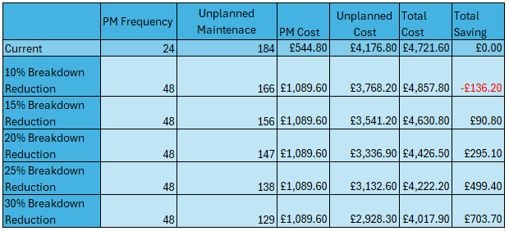
6. Conclusions/Recommendations

The evaluation of Wall Colmonoy’s current maintenance approach reveals both strengths and areas for improvement. The existing strategy incorporates a blend of planned preventive maintenance (PPM) and reactive maintenance, yet it falls short of fully adhering to original equipment manufacturer (OEM) recommendations and lacks robust data capture mechanisms for informed decision-making. Moreover, considering alternative approaches such as condition-based monitoring, centralized maintenance, and outsourcing maintenance presents viable options with their own set of advantages and challenges.
Short-term recommendations include a comprehensive review of maintenance checklists to align with OEM recommendations, ensuring thorough coverage of maintenance tasks. Additionally, measures should be implemented to improve data capture accuracy during fault analysis, facilitating better-informed decision-making. This change can be implemented in the short term, but I likely to only benefit in the medium term as it will take time to collect a meaningful dataset.
In the medium term, the implementation of Total Productive Maintenance (TPM) principles can be instrumental in fostering a culture of proactive equipment care. This involves daily checks as per OEM recommendations, empowering all team members with the necessary skills and responsibilities to maintain equipment reliability effectively.
Long-term strategies involve exploring alternative maintenance techniques discussed in this report, particularly condition-based monitoring. Implementing a condition-based monitoring approach would be the optimal choice for supporting WCL's transition into Industry 4.0. However, such a move would necessitate a substantial investment in upgrading the electrical infrastructure, costing tens of thousands of pounds. Nonetheless, embracing this upgrade would position WCL favourably for future advancements and technological integration.
9. Referencing.
Able, C.M. et al. (2016) ‘A model for preemptive maintenance of medical linear accelerators—predictive maintenance’, Radiation Oncology, 11(1). doi:10.1186/s13014-016-0602-1.
Colmonoy, W. (2024) Precisely engineered components, Wall Colmonoy. Available at: https://www.wallcolmonoy.com/products-capabilities/precision-components/ (Accessed: 01 March 2024).
Dong, T., T. Haftka, R. and H. Kim, N. (2020) ‘Advantages of condition-based maintenance over scheduled maintenance using Structural Health Monitoring System’, Reliability and Maintenance - An Overview of Cases [Preprint]. doi:10.5772/intechopen.83614.
Gössinger, R., Helmke, H. and Kaluzny, M. (2017) ‘Condition-based release of maintenance jobs in a decentralised production-maintenance system – an analysis of alternative stochastic approaches’, International Journal of Production Economics, 193, pp. 528–537. doi:10.1016/j.ijpe.2017.08.009.
Hurt, M. and Schrock, S.D. (2016) ‘Preventative maintenance’, Highway Bridge Maintenance Planning and Scheduling, pp. 155–180. doi:10.1016/b978-0-12-802069-2.00004-0.
Legát, V., Aleš, Z. and Hladík, T. (2017) ‘Maintenance audit: The tool for maintenance management quality of manufacturing equipment’, Manufacturing Technology, 17(1), pp. 53–62. doi:10.21062/ujep/x.2017/a/1213-2489/mt/17/1/53.
Loshin, D. (2011) The practitioner’s Guide to Data Quality Improvement [Preprint]. doi:10.1016/c2009-0-17212-4.
Ludwig, T. (2018a) ‘Outsourcing maintenance’, Ethical Issues in Aviation, pp. 65–70. doi:10.4324/9780429436789-8.
Martz, H.F. (2003) ‘Reliability theory’, Encyclopedia of Physical Science and Technology, pp. 143–159. doi:10.1016/b0-12-227410-5/00659-1.
Prometheus Group (2023) Centralized vs. Decentralized Maintenance Scheduling, PG white. Available at: https://www.prometheusgroup.com/resources/posts/centralized-or-decentralized-maintenance-scheduling-which-one-is-right-for-you (Accessed: 21 March 2024).
Simeu-Abazi, Z., Mascolo, M.D. and Gascard, E. (2012) ‘Performance evaluation of Centralized Maintenance Workshop by using Queuing Networks’, IFAC Proceedings Volumes, 45(31), pp. 175–180. doi:10.3182/20121122-2-es-4026.00012.
Thorn, A. (2024) ‘Maintenance’, UWTSD. Plant & Asset Engineering ACMA 6007, Swansea: IQ1, 8 March
Velmurugan, R.S. and Dhingra, T. (2015) ‘Maintenance strategy selection and its impact in maintenance function’, International Journal of Operations &amp; Production Management, 35(12), pp. 1622–1661. doi:10.1108/ijopm-01-2014-0028.
Vilarinho, S., Lopes, I. and Oliveira, J.A. (2017) ‘Preventive maintenance decisions through maintenance optimization models: A case study’, Procedia Manufacturing, 11, pp. 1170–1177. doi:10.1016/j.promfg.2017.07.241.
Wang, Y. and Wang, P. (2013) ‘Cost benefit analysis of condition monitoring systems for Optimal Maintenance Decision making’, 54th AIAA/ASME/ASCE/AHS/ASC Structures, Structural Dynamics, and Materials Conference [Preprint]. doi:10.2514/6.2013-1942.
Wang, Z., Liu, C. and Yan, F. (2022) ‘Condition monitoring of wind turbine based on incremental learning and multivariate state estimation technique’, Renewable Energy, 184, pp. 343–360. doi:10.1016/j.renene.2021.11.071.

8. Appendix
8.1. Appendix A – OEM Preventive Maintenance Checklist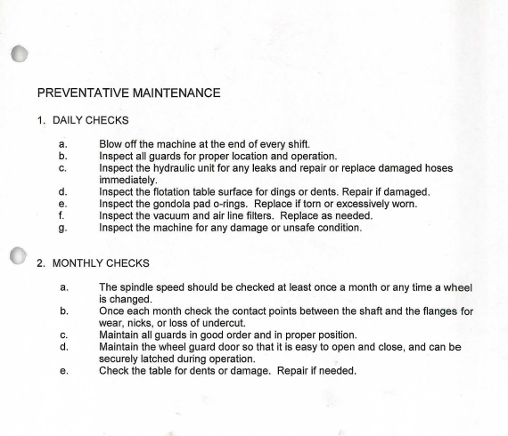

8.2. Appendix B – Asset Information from Agility

8.3. Appendix C – Mean Time to Repair (MTTR)


