
Programme: | MSc Public Health and Social Care in Practice
Module: | Practice-Based Research
Module code: | LCHS7008
Assignment Title: | Component 2 Written Research Proposal
Lecturer: | Muhammed Khan
Name: | Mst. Shahrin Sultana
ID: | 2503591

Table of Contents
Prevalence of the Problem in Health and Social Care 3
Introduction and Literature Based Background 4
Theoretical Frameworks and Social Construction 4
Physical Health and Obstetric Challenges 5
Mental Health and Psychosocial Vulnerability 5
Synthesis of Lived Experiences and Health Outcomes 6
Rationale of the Research 7
Research Question 8
Research Aim and Objectives 8
Research Methodology 8
4.1 Research Design 8
4.2 Recruitment, Sampling & Study Participants 9
4.3 Data Collection Method(s)/Procedure 11
4.4 Proposed Data Analysis Technique (Thematic Analysis) 11
4.5 Ethical Considerations 12
4.6 Implication of Research 12
4.7 Plan of Work and Time Schedule (Gantt Chart) 13
References 14

Title: “Pregnancy in Teenager (Aged 13-17) in the UK: Lived Experiences, Health Outcomes, and Social Determinants”

Prevalence of the Problem in Health and Social Care
The teen pregnancy picture in the United Kingdom is now characterized by a dramatic and disturbing change in long-run patterns. The official figures have registered the first rise in the rates of conception among women under 18 in England and Wales in fourteen years (Ajok Odoch et al., 2025). Although this rise is made against a backdrop of decades of effective reduction, it indicates that the long-standing established systemic protections and societal approaches to health might be proving less effective in the current socio-economic imperatives (Health, 2025).
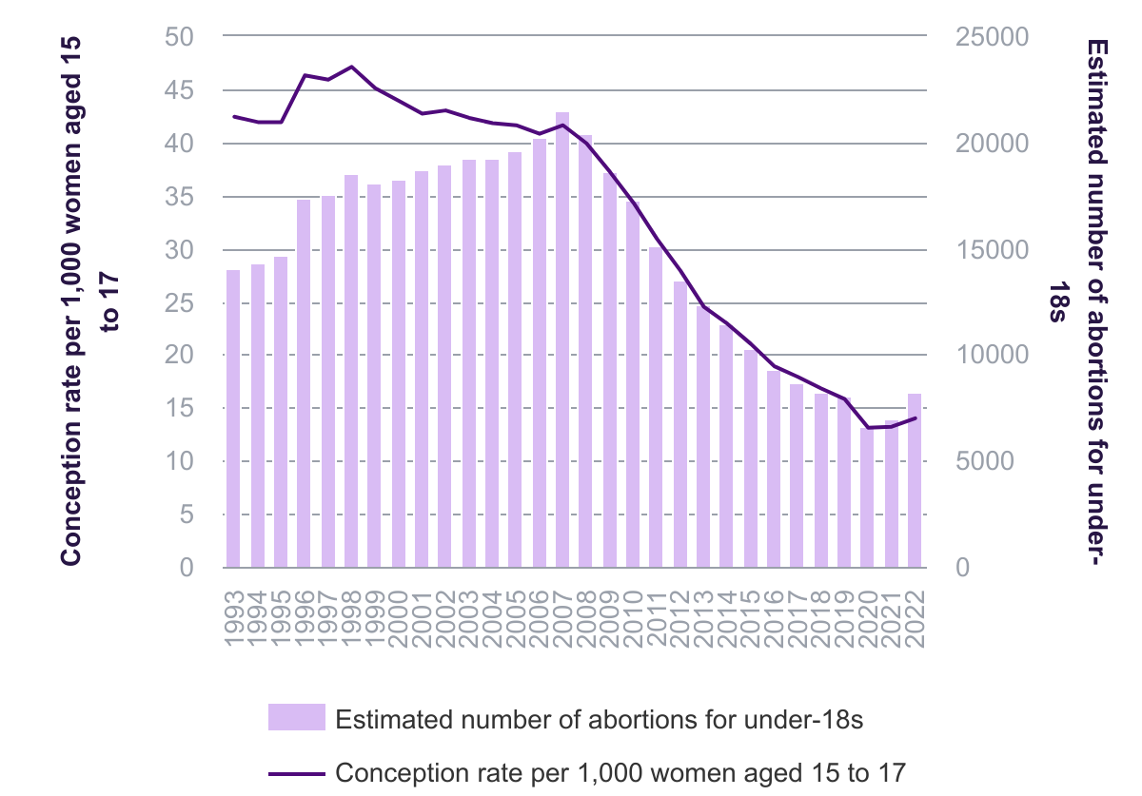
Figure 1: How has the under-18 conception rate changed over time? (Nuffield Trust, 2023)
The conception rate among individuals under 18 has significantly declined since 2007. From 2007 to 2022, the conception rate among individuals under 18 in England and Wales declined by 66%, from 42 per 1,000 women to 14 per 1,000 women, culminating in 14,233 under-18 conceptions in 2022 (Toynbee, 2025). The quantity of abortions saw a rapid decline, decreasing from 21,494 in 2007 to 8,255 in 2022, representing a 67% drop (Akram et al., 2024). The latest year, however, had a slight rise in both the rate of under-18 pregnancies and the number of abortions (Nuffield Trust, 2023).
The clinical implications of these statistics are far reaching. Infants born to mothers who are under 20 in England and Wales have much worse results in a range of indicators. Babies born to older mothers have an infant mortality rate of about 60 to 75 percent lower than that of babies born of this group (Cumming and Symon, 2025). These health inequalities are leading to the intergenerational poverty and poor health cycle that is now hard to break as health and social care services are grappling to solve this problem (Chakole et al., 2022).

Introduction and Literature Based Background
The issue of teenage pregnancy in the United Kingdom needs to be examined with respect to the complex interaction between personal choice, biological susceptibility and structural determinants of health (Baxter et al., 2021). In the UK context, teen pregnancy and early parenthood were traditionally considered through the prism of a social issue that needs to be addressed with the help of strong governmental intervention (Aluga and Okolie, 2021). This approach was best exemplified by the Teenage Pregnancy Strategy (TPS) that was initiated in 1999 and was intended to reduce the under-18 conception rate by half in a decade.
The Local Government Association has cautioned that increased conception rates in 2022 are indicative of wider systemic strains, such as the legacies of the COVID-19 pandemic, which caused the breakdown of sexual health clinics and heightened school absences (de la Calle et al., 2021).

Theoretical Frameworks and Social Construction
Academic discourse on adolescent parenthood has moved from risk-based to include young mothers' lived experiences and subjective interpretations. While quantitative indicators often connect early motherhood to low education, employment, and mental health, qualitative research provide a more nuanced view (Fabiyi et al., 2025). This social constructionist and symbolic interactionist approach propose that parenthood might provide young women who feel marginalised by standard educational and professional pathways a valued social position and purpose (Grant et al., 2024).
The many influences on a pregnant teen's life are often explained using Bronfenbrenner's ecological systems theory.
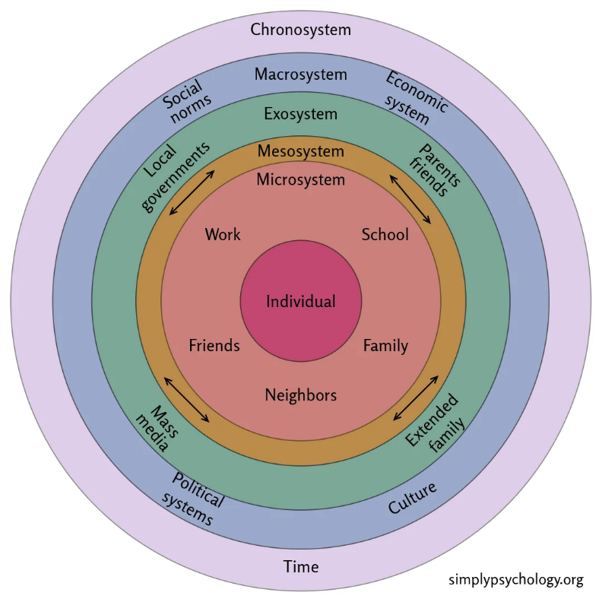
Figure 2: Bronfenbrenner's Ecological Systems Theory (Guy-Evans, 2025)
This paradigm addresses the microsystem (family, friends), mesosystem (home-school interactions), and macrosystem (social norms and policies). Teens experience judgement from family, classmates, and health and social care professionals, according to recent study (Harden et al., 2009).

Physical Health and Obstetric Challenges
Medically speaking, the age range between 13-17 is a distinct group of patients. There is a high likelihood of obstetric complications related to physiological immaturity, particularly within the years that follow menarche (Hinz et al., 2024). Adolescent mothers are under high risks of maternal anaemia, pre-eclampsia, eclampsia, and pyelonephritis (Hives et al., 2024).
The Stoke-on-Trent retrospective case note review (2020-2022) identified that the outcome of postpartum haemorrhage and low birth weights in teenage pregnancies were higher than the national level, especially in socially deprived regions (Komal Abdul Rahim et al., 2024). This is an implication that the biological risks of teenage pregnancy are inseparably tied to the social circumstances under which the teenager is placed, forming a compounding liability of clinical and environmental susceptibility (Lesinskienė, Andruškevič and Butvilaitė, 2025).

Mental Health and Psychosocial Vulnerability
Mental health of the young mothers is an area of high concern and recent statistics indicate that 31% of the young women between the ages of 17 to 24 years have a mental health issue as opposed to a much lower percentage of the young men in the same group (Ntshayintshayi et al., 2022). The stresses of maternal transition, necessitating substantial cognitive and emotional preparedness, increase these susceptibilities in the case of pregnant teenagers (Ribeiro De Checchi et al., 2024).
Postnatal depression is more common in the teenage group compared to older mothers and maternal suicide is the leading cause of death in the first year of childbirth. Recent studies also cite the effects of Adverse Childhood Experiences (ACEs) as a key factor, and people who have experienced four or more ACEs are six times more likely to experience an unintended teenage pregnancy (Stinne Glasdam et al., 2025). This connection indicates that the model of trauma-informed care is fundamental to addressing this group of people, and numerous young mothers say that their mental health requirements are not considered by the current services.

Synthesis of Lived Experiences and Health Outcomes
Some of the contemporary study provides a vivid and often somber picture of the "lived experience" of teenage pregnancy in the UK.
The Pervasive Role of Stigma
The characteristics of most interactions of the young mothers with society revolve around stigma. It has been found that most teens feel that their members of the family and even peers judge or shun them, and this may consider the pregnancy as a sign of being promiscuous or a social taboo (Sambrook Smith et al., 2019). Many teenagers also have a behaviour of concealment to prevent judgment by concealing their pregnancy until the second trimester or later. This lateness in disclosure translates to missing the window of early antenatal care, such as nutritional supplements such as folic acid and screening of high-risk conditions such as pre-eclampsia (Stinne Glasdam et al., 2025).
Educational and Economic Realities
The correlation between teenage pregnancy and education is two-way and complicated. Although being an early parent may interfere with schooling and result in drop-out, a dislike of school and poor academic ambitions are usually underlying factors that predispose an adolescent to early conception (Szlendak, Mierzejewska and Nowicki, 2025).
Homelessness and Housing Instability
A more critical determinant that has been identified in post-2020 studies is the interaction between pregnancy and housing. In the United Kingdom, temporary accommodation (TA) families were at unprecedented levels in 2023. To a pregnant teenager, living in TA implies exposure to such environmental risks as damp, mold, and vermin, which may have direct impact on fetal development and on respiratory health of the mother (van Veelen et al., 2025).

Rationale of the Research
The justification behind this study is that there is an immediate need to respond to the recent turnaround in the decline in teenage pregnancy rates in the UK. Following over ten years of consistent decrease, the increase in under-18 conceptions in 2022 points to the fact that the existing framework of upstream prevention is not working with a new generation of vulnerable adolescents (Yousefi et al., 2025). The young people who are currently getting pregnant are more disadvantaged and vulnerable than ever before, in part because of the trickle-down impacts of austerity and the social aftermaths of the COVID-19 pandemic (Ajok Odoch et al., 2025). The risk of a lost generation of young parents is critical unless the gaps in health and social care services are detected and addressed with the help of evidence-based research.
There is a great gap in the literature on the post-pandemic experienced lives of pregnant teens aged 13-17. The majority of current studies concentrate on the statistical prevalence of pregnancy or the biomedical consequences to the child, without considering the overall view of the mental and social health of the mother (Akram et al., 2024; Aluga and Okolie, 2021). Namely, little qualitative data exists on the intersection between housing instability that has been identified by the record numbers of families in temporary housing and the pregnancy experience of an adolescent. Living temporarily during pregnancy can cause many young women to feel physically vulnerable and out of contact with their support networks, but these are hardly the primary priorities of current policy frameworks (Aluga and Okolie, 2021; Cumming and Symon, 2025).
Moreover, the UK stepped-care model of mental health focuses on helping women during the perinatal time, yet disparities in access are still pronounced, especially among individuals with minoritized ethnicity or care-experienced background (de la Calle et al., 2021). Care leavers and looked-after children have a much higher likelihood of early pregnancy and, in many cases, are deprived of good parenting role models to make their transition successful. Through qualitative data synthesis over the past five years, this study will offer a holistic view of the existing barriers to care, the effectiveness of overt stigma in influencing help-seeking behaviour, and the effect of social support on resilience. The study is not only necessary to clinical practice but also to enlighten a contemporary, cross-departmental national strategy that should reflect the current realities of the youth in Britain.

Research Question
What are the lived experiences, health outcomes, and social determinants affecting pregnant Teenager aged 13-17 years in the UK?

Research Aim and Objectives
The aim of this research is to explore the lived experiences, physical and mental health outcomes, and social determinants influencing pregnancy among women aged 13-17 years in the UK.
Research Objectives
- To examine the physical and mental health outcomes associated with pregnancy in Teenager aged 13-17 years.
- To investigate the social determinants (e.g., socio-economic status, education, family support) influencing Teenager’s experiences.
- To identify gaps in health and social care services and provide recommendations to improve support and outcomes.

Research Methodology
The proposed research will be a qualitative systematic literature review (SLR) that will synthesize and interpret the results of primary qualitative research that has been carried out in the UK. The methodology is selected particularly because it offers a textual summary and synthesis of the research that is already available and it gives an insight into the complex social phenomena and the reason why some health and social patterns happen.

4.1 Research Design
The research will utilize systematic literature review as a qualitative evidence based on the steps of an aggregation review and interpretative review. This is not only a summary of the results of various studies but also translation and synthesis of the results to come up with new conceptual knowledge and theories (Ellwood et al., 2025). The review will strongly follow the guidelines of Preferred Reporting Items of Systematic Reviews (PRISMA 2020). This methodology provides high methodological rigor with a detailed protocol, clear inclusion/exclusion criteria and a four-phase flow diagram to record the process of study selection.
PRISMA 2020 Phase | Specific Actions in this Study
Identification | Searching electronic databases and grey literature for relevant titles.
Screening | Reviewing titles and abstracts against pre-defined criteria; removing duplicates.
Eligibility | Retrieving and evaluating full-text articles for final suitability.
Inclusion | Synthesizing the final set of 10-12 articles using thematic analysis.

4.2 Recruitment, Sampling & Study Participants
As this is a systematic literature review, recruitment does not involve direct interaction with human subjects but rather the systematic selection of primary qualitative research studies (Kushnir, 2025). The goal is to include approximately 10 to 12 high-quality articles that focus on the target population.
Inclusion Criteria:
Criteria | Description
Sample/Population | Pregnant teenagers or young mothers who conceived between ages 13–17 years
Phenomenon of Interest | Lived experiences of pregnancy, interactions with health and social care services, and the influence of social determinants
Setting | Studies conducted within the United Kingdom to ensure relevance to local health and policy context
Design/Research Type | Qualitative methods such as semi-structured interviews, focus groups, ethnography, and phenomenological studies
Timeframe | Publications from 2020 onwards to reflect the post-pandemic and post-austerity context

Exclusion Criteria:
- Quantitative studies, clinical trials, or meta-analyses focused solely on statistical outcomes.
- Studies involving only adult mothers (18+) without retrospective data from their teenage years.
- Non-English language papers or those conducted outside the UK context.
The sampling strategy is "purposive" in nature, aiming to select "information-rich cases" that provide the deepest insights into the research question.

4.3 Data Collection Method(s)/Procedure
Data collection will involve a systematic search across several multidisciplinary electronic databases.
Database | Area of Specialization
MEDLINE/PubMed | Key source for biomedical research and health-related outcomes
CINAHL | Focuses on nursing, midwifery, and allied health fields
PsycINFO | Covers mental health and psychological research perspectives
Web of Science | Includes cross-disciplinary social science research and citation analysis
Grey Literature | Provides access to doctoral studies and government reports

Key Search Terms will be used including:
The Boolean operators will be used to combine the terms in the search procedure. The provisional search query is: (teenage pregnancy OR adolescent motherhood OR young parents) AND (UK OR United Kingdom OR Britain) AND (lived experience OR perspectives OR views) AND (social determinants OR health outcomes).
The primary researcher will screen titles and abstracts in accordance with the PRISMA 2020 flowchart, and then screen full-text articles at the second level. Quality of the final included studies will be assessed with the help of Critical Appraisal Skills Programme (CASP) Qualitative Checklist (Page et al., 2021).

4.4 Proposed Data Analysis Technique (Thematic Analysis)
Reflexive Thematic Analysis (RTA), Braun and Clarke's (2021/2022) modern framework, will form the research's analytical core. RTA is flexible and rejects "coding reliability" and "objective truth" in favour of the researcher's active interpretation of data (Tong et al., 2014).
The analysis will follow a recursive six-phase process:
Data familiarisation: This first step entails reading and taking notes on initial impressions and "critical moments" in the chosen study transcripts (Pearson et al., 2025).
Generate Initial Codes: Dataset-wide identification of noteworthy characteristics. Latent coding will reveal social structures and power dynamics, but semantic coding will capture surface meanings.
Create Initial Themes: Beyond individual codes, the researcher will find common meaning. Themes will be "central organising concepts" rather than subject summaries.
A Review of Themes: Testing possible themes against the source data and the complete dataset for coherence and representation (Renjith et al., 2021).
Theme Definition and Naming: Creating precise, short titles and definitions for each subject that convey its core and relevance to the research question.
Making the Report: Combining concepts into an analytical narrative using source study excerpts.

4.5 Ethical Considerations
Ethical standards will be upheld during the review process by ensuring accurate and impartial reporting of results, appropriately acknowledging intellectual property, and maintaining transparency about funding sources and potential conflicts of interest. Reflexivity will be used to identify and alleviate any biases of reviewers during the selection and interpretation of studies. The review will conform to known ethical principles for secondary research and adhere to recognised reporting standards, including PRISMA recommendations.

4.6 Implication of Research
The research implications are also multi-dimensional and relate to the policy, clinical practice, and future research.
Clinical Practice: The research will be able to give practitioners the evidence necessary to build more non-judgmental, age-appropriate antenatal care pathways by revealing gaps in the age-appropriate services and the midwifery blind spots.
Policy Development: It is possible to use the synthesis to inform the development of a new sexual and reproductive health strategy in England, which has not been revised in more than two decades (van Veelen et al., 2025). It points to the necessity to integrate youth policy in health, education, and social care.
Health Equity: The research will help justify the investment in the most underprivileged local authorities and seaside resorts whose rates are stagnantly high, thus narrowing the regional gap.

4.7 Plan of Work and Time Schedule (Gantt Chart)
The research project is structured over a 16-week period, ensuring sufficient time for each stage of the systematic review process.
Task | Week 1-2 | 2-6 | 6-8 | 8-12 | 12-14 | 14-16
Protocol Development/Registration | ●
Literature Search & Database Setup | ● | ●
Title/Abstract Screening |  | ●
Full Text Screening |  | ● | ●
Data Extraction |  |  | ● | ●
Quality Assessment |  |  | ● | ●
Data Synthesis (Narrative/Analysis) |  |  |  | ● | ●
Draft Writing |  |  |  |  | ● | ●
Review & Revision |  |  |  |  | ● | ●
Final Submission |  |  |  |  |  | ●

References
Ajok Odoch, F., Damulira, C., P Frank, K., O Robert, W. and Adelline, T. (2025). Exploring the lived experiences of pregnant and breastfeeding teenage mothers in the conflict and post conflict Acholi sub Region, Uganda. African Health Sciences, [online] 25(4), pp.104–113. doi: https://doi.org/10.4314/ahs.v25i4.12.
Akram, Maleki, M., Abbas Mardani and Abbasi, S. (2024). Developing the concept of maternal in teenage mothers: a hybrid model. Frontiers in psychology, 14. doi: https://doi.org/10.3389/fpsyg.2023.1246882.
Aluga, D. and Okolie, E.A. (2021). Socioeconomic Determinants of Teenage Pregnancy and Early Motherhood in the United Kingdom: a Perspective. Health Promotion Perspectives, 11(4), pp.426–429. doi: https://doi.org/10.34172/hpp.2021.52.
Baxter, A.J., Dundas, R., Popham, F. and Craig, P. (2021). How Effective Was England’s Teenage Pregnancy strategy? a Comparative Analysis of high-income Countries. Social Science & Medicine, 270(1), p.113685. doi: https://doi.org/10.1016/j.socscimed.2021.113685.
Chakole, S., Akre, D.S., Sharma, D.K., Wasnik, P. and Wanjari, M.B. (2022). Unwanted Teenage Pregnancy and Its Complications: A Narrative Review. Cureus, [online] 14(12). doi: https://doi.org/10.7759/cureus.32662.
Cumming, S. and Symon, A. (2025). Pregnant and Homeless in the UK: A Qualitative Analysis of Maternal Experiences in Temporary Accommodation. Birth. doi: https://doi.org/10.1111/birt.12919.
de la Calle, M., Bartha, J.L., Lopez, C.M., Turiel, M., Martinez, N., Arribas, S.M. and Ramiro-Cortijo, D. (2021). Younger Age in Adolescent Pregnancies Is Associated with Higher Risk of Adverse Outcomes. International Journal of Environmental Research and Public Health, [online] 18(16), p.8514. doi: https://doi.org/10.3390/ijerph18168514.
Ellwood, J., Sampath, K.K., Rund, I., Loïc Treffel and Draper-Rodi, J. (2025). Guidance strategies for infantile asymmetry prevention: a systematic review. BMC Pediatrics, 25(1). doi: https://doi.org/10.1186/s12887-025-05670-0.
Fabiyi, F., Darwin, Z., Sah, R.K. and Firth, A. (2025). The perinatal mental health experiences of black immigrant mothers in the UK: A qualitative systematic review and thematic synthesis. PLOS One, 20(12), p.e0331547. doi: https://doi.org/10.1371/journal.pone.0331547.

Grant, C., Bicknell-Morel, T., Taylor, B.L., Powell, C., Blackburn, R.M., Lacey, R. and Woodman, J. (2024). Perinatal healthcare for women at risk of children’s social care involvement: a qualitative survey of professionals in England. BMJ Open, [online] 14(3), p.e082914. doi: https://doi.org/10.1136/bmjopen-2023-082914.
Guy-Evans, O. (2025). Bronfenbrenner’s Ecological Systems Theory. [online] Simply Psychology. Available at: https://www.simplypsychology.org/Bronfenbrenner.html.
Harden, A., Brunton, G., Fletcher, A. and Oakley, A. (2009). Teenage pregnancy and social disadvantage: systematic review integrating controlled trials and qualitative studies. BMJ, [online] 339(nov12 1), pp.b4254–b4254. doi: https://doi.org/10.1136/bmj.b4254.
Health, P. (2025). Conceptions in England and Wales. [online] Ons.gov.uk. Available at: https://www.ons.gov.uk/peoplepopulationandcommunity/birthsdeathsandmarriages/conceptionandfertilityrates/bulletins/conceptionstatistics/2022.
Hinz, A., Solomon, B., Redsell, M., Wenham, K., Connor, L.O. and Mulgrew, K.E. (2024). A hopeful future: a qualitative investigation of positive psychological functioning in young mothers. Journal of Reproductive and Infant Psychology, pp.1–21. doi: https://doi.org/10.1080/02646838.2024.2401831.
Hives, L., Bray, E.P., Nowland, R. and Thomson, G. (2024). Social media influencers in the space of pregnancy and parenting: a scoping review protocol. BMJ Open, [online] 14(10), pp.e087200–e087200. doi: https://doi.org/10.1136/bmjopen-2024-087200.
Komal Abdul Rahim, Egglestone, N.J., Tsagareli, I.G., Usmani, W., Salima Meherali and Lassi, Z.S. (2024). Mental health outcomes beyond the post-partum period among adolescent mothers: a systematic review and meta-analysis. Health Psychology and Behavioral Medicine, 12(1). doi: https://doi.org/10.1080/21642850.2024.2305741.
Kushnir, I. (2025). Thematic Analysis in the Area of education: a Practical Guide. Cogent Education, [online] 12(1). doi: https://doi.org/10.1080/2331186x.2025.2471645.
Lesinskienė, S., Andruškevič, J. and Butvilaitė, A. (2025). Adolescent Pregnancies and Perinatal Mental Health—Needs and Complex Support Options: A Literature Review. Journal of Clinical Medicine, [online] 14(7), p.2334. doi: https://doi.org/10.3390/jcm14072334.
Ntshayintshayi, P.N., Sehularo, L.A., Mokgaola, I.O. and Sepeng, N.V. (2022). Exploring the psychosocial challenges faced by pregnant teenagers in Ditsobotla subdistrict. Health SA Gesondheid, 27(1880). doi: https://doi.org/10.4102/hsag.v27i0.1880.

Nuffield Trust (2023). Teenage pregnancy. [online] The Nuffield Trust. Available at: https://www.nuffieldtrust.org.uk/resource/teenage-pregnancy.
Page, M.J., McKenzie, J.E., Bossuyt, P.M., Boutron, I., Hoffmann, T.C., Mulrow, C.D., Shamseer, L., Tetzlaff, J.M., Akl, E.A., Brennan, S.E., Chou, R., Glanville, J., Grimshaw, J.M., Hróbjartsson, A., Lalu, M.M., Li, T., Loder, E.W., Mayo-Wilson, E., McDonald, S. and McGuinness, L.A. (2021). The PRISMA 2020 statement: an Updated Guideline for Reporting Systematic Reviews. Systematic Reviews, [online] 10(1). doi: https://doi.org/10.1186/s13643-021-01626-4.
Pearson, H., Myall, M., Darlington, A.-S. and Gibson, F. (2025). The approach and application of analysing inductive and deductive datasets: a worked example using reflexive thematic analysis. Qualitative Research in Psychology, pp.1–45. doi: https://doi.org/10.1080/14780887.2025.2499265.
Renjith, V., Yesodharan, R., Noronha, J., Ladd, E. and George, A. (2021). Qualitative Methods in Health Care Research. International Journal of Preventive Medicine, [online] 12(1), p.20. doi: https://doi.org/10.4103/ijpvm.IJPVM_321_19.
Ribeiro De Checchi, M.H., Fabiana Tenani, C., Sumiya, A., Matteussi Lino, C. and Checchi Garcia, V.D. (2024). Social determinants of health and teenage pregnancy: an integrative review. MOJ Public Health, [online] 13(2), pp.111–115. doi: https://doi.org/10.15406/mojph.2024.13.00447.
Sambrook Smith, M., Lawrence, V., Sadler, E. and Easter, A. (2019). Barriers to Accessing Mental Health Services for Women with Perinatal Mental illness: Systematic Review and meta-synthesis of Qualitative Studies in the UK. BMJ Open, 9(1). doi: https://doi.org/10.1136/bmjopen-2018-024803.
Stinne Glasdam, Xu, H., Ruth-Ellen Slåtsveen, Stilwell, C., Wind, G., Andersen, J. and Turcotte, P.-L. (2025). Older caregivers’ responsibilities and strategies for their cohabiting partners living at home—a qualitative systematic literature review. Frontiers in Public Health, 13, pp.1658095–1658095. doi: https://doi.org/10.3389/fpubh.2025.1658095.
Szlendak, B., Mierzejewska, H. and Nowicki, P. (2025). Underage women’s experiences of pregnancy and childbirth and the attitudes of health professionals – a qualitative study. Kwartalnik Naukowy Fides et Ratio, 64(4), pp.9–20. doi: https://doi.org/10.34766/scqvwt51.

Tong, A., Palmer, S., Craig, J.C. and Strippoli, G.F.M. (2014). A guide to reading and using systematic reviews of qualitative research. Nephrology Dialysis Transplantation, [online] 31(6), pp.897–903. doi: https://doi.org/10.1093/ndt/gfu354.
Toynbee, P. (2025). Teenage pregnancy rates are a barometer of Britain’s progress. The tale they now tell is not reassuring. [online] the Guardian. Available at: https://www.theguardian.com/commentisfree/2025/jul/16/britain-legacy-austerity-teenage-pregnancy.
van Veelen, M., Franklin, L., McCann, A. and O’Mahony, F. (2025). A Retrospective Review of Gynaecological and Social Outcomes for Teenage Pregnancies from 2020 to 2022 in Stoke-on-Trent. Journal of Clinical Medicine, [online] 14(16), p.5745. doi: https://doi.org/10.3390/jcm14165745.
Yousefi, S., Simin Montazeri, Nahid Javadifar and Ghanbari, S. (2025). Psychosocial support during pregnancy: perceptions and expectations among pregnant teenagers in Ahvaz, Iran-a qualitative content analysis. PubMed, 22(1), pp.134–134. doi: https://doi.org/10.1186/s12978-025-02081-3.

