Report: Statistical Analysis of the USA Housing Dataset

Student Name: Sanya Suneja
Student Id: 2234449
Module name: Data Handling & Business Management
Module Code: LCCB5000

Contents
Introduction 2
1. Analysis of Central Tendencies 2
2. Analysis of Variability 4
3. Interpretation of Results 5
4. Recommendations for Further Analysis 6
Conclusion 7
Part (b): Demonstrating Data Presentation Using MS Excel 8
1. Distribution of Prices (Chart) 8
2. Count of Houses by Number of Bedrooms (Chart) 9
3. Boxplot (Price by Number of Bedrooms) 9
Section 2 – Advantages and Disadvantages of Using Excel and the Data Mining Cycle 11
2(a) Advantages and Disadvantages of Using Excel 11
2(b) Meaning and Importance of the Data Mining Cycle 13
Conclusion 14

Introduction
In the context of the USA Housing Dataset, measures of variation and measures of central tendency have been computed. Consumption goods include the price of the house, number of bedrooms, bathrooms, and living area among others as seen in the dataset below. Descriptive statistics, variance, and standard deviations analyses are marked in this report to make known trends and patterns among the variables chosen.
In this study, data was analyzed both in Microsoft Excel and Statistical Package for Social Science (SPSS). This involves the objectives of calculating and interpreting mean, median, mode, standard deviation variance as well. Furthermore, the findings of this study are expected to help inform other policy recommendations about the housing trends and guide more investigations.

1. Analysis of Central Tendencies
Measures of central tendency such as mean, median and mode describe the dataset and give information about its dispersion.
1.1 Mean Value for Price
- Findings: The mean price of houses is $553,062.88.
The overall average, $553, 062.88, gives the overall mean of price in the USA Housing Dataset which is the average house price. The mean is calculated by adding all the house prices and then dividing the total by the number of houses in the dataset. Although the mean gives an average estimation of house prices, it can be greatly influenced by the so-called upper outliers, the overpriced luxury houses. Such values can be influential and bring the mean closer to the higher values, which might not be a typical house price in the set.
The mean is quite helpful when it comes to identifying the dataset’s pricing trends. But it is prudent to handle the mean with care much so for real estate with high variability. For further exploration, more analyses can be run such as segmental analysis by location or property type to check whether the mean corresponds to specific segment of the population.
1.2 Median Value for Price
- Findings: The median price is $460,000.00.
The measure of central tendency which is the median assumes the house price value of $460,000 is relatively accurate. As for the median, it refers to the middle figure, which is arrived at by sorting all house prices in increasing order. The median is less affected by outlying values than the mean; therefore, it provides a better measure of the ‘typical’ house price in the data set.
The arithmetic mean ($ 553,062.88) is greater than the median which was $460,000, which points to positive skewness. This means that a few houses with relatively high prices have a disproportionate effect on the overall mean. Thus, these options can be closer to the median in most cases of properties. This insight is especially helpful for stakeholders like homebuyers or policymakers as it offers an authentic reference point on average housing expenses.
The median is also helpful for discovering such trends in the market and their change within a specific time frame. For instance, an upward slope in the median implies a higher demand of housing or increasing property prices. Combined with such means as the average and standard deviation, the median becomes an important analytical tool enabling one to analyze the distribution of prices in the given dataset along with the general market trends.

1.3 Mode of Price
- Findings: The mode of the price is $0.00.
  - The mode represents one of the values that present most frequently in a given data set. A value of $0 suggests that there is a problem, for example inaccuracy or absence of entries.
  - Interpretation: Having $0 as mode presents another data quality problem. This can point to the fact that a number of records may contain invalid prices that could influence results of analysis.
The mode of house prices, calculated at $0.00, can be deemed incorrect and unsuitable for any market. The mode can be defined as that value that appears most often within the given data set. In this case, a mode of $0 stands not for an indication of house prices but indicates that there are probably missing or erroneous entries.
Such anomalies are common wherever there is incomplete data collection or mistakes that happen when entering data. For example, the absence of price values could have been filled by the value $0, which would eventually contribute to the overall high risk score. This further sets a mode that is not real but a deceptive one when it comes to actual trends of prices of houses.
Observing $0 as the mode of the data set brings to light the relevance of data cleaning before progressing with analysis. Solving this problem means searching for mistypes – it is deleting the rows where all the values are equal to $0 or using other attributes to fill in the missing data with average or median values.
The mode is not as frequently applied in quantitative analysis as the mean or median, though it is quite useful in cases with clean data. For instance, stating the mode in a reliable data set, would indicate the most frequent prices or price intervals, which can be attributed to consumer preference or standard pricing levels.

2. Analysis of Variability
Variability depicts how data is spread out and consists of variance and standard deviation. These measures assist in determining how spread out the values is in terms of their mean.
2.1 Standard Deviation for Bedrooms
- Findings: The standard deviation for the number of bedrooms is 0.90.
  - Standard deviation measures the variability or spread in the data set. A value of 0.90 means that the above variable is on average within 1 bedroom of the mean.
  - Interpretation: A low standard deviation implies that the most of the houses in the dataset have nearly equal number of bedrooms, and they range between 2 and 4.
2.2 Variance of Key Variables
- Findings:
  - Price Variance: 340,689,874,533.50
  - Bedroom Variance: 0.82
  - Variance on the other hand measures the average of the square of deviations. Price variance is greater than the bedroom variance implying that the prices of houses vary more than the number of bedrooms.
  - Interpretation: Such a large volatility in the case of price is attributed to the variety of costs of houses due to location, size, and extra amenities. The small variation in the number of bedrooms denotes that the data set is very similar in this characteristic.
2.3 Standard Deviation of Key Variables
- Findings:
  - Price Standard Deviation: $583,686.45
  - Bedroom Standard Deviation: 0.90
  - The standard deviation for the prices shows that the variability for house prices is considerably high around the mean. For the case of bedrooms, the standard deviation is however very small and this again confirms its stability across the dataset.
  - Interpretation: Fluctuations in real estate prices are natural since properties and their locations differ greatly. The consistency in the bedrooms implies that many homes are of generic organizational pattern.

3. Interpretation of Results
The following insights can be derived from the analysis:
3.1 Mode of Price
The mode of $0.00 that was mentioned in the dataset should be considered as the result of incorrect entries or lack of entries in the dataset. In realistic housing dataset, the house price cannot be $0, meaning that some rows might be missing or Dummy variables have been utilized instead of real values. This is not only an inconvenience but also affects the sample statistics especially where frequency counts are involved. For instance, in the scenario of calculating the mode for quantifying the least occurring price point in the data set, these errors would defeat the mode. Thus, there is a need to clean the data. To achieve this, rows containing $0 as the price should be eliminated, or if some data is missing, statistics (median, mean, etc.) have to be used to fill in the ‘missing data.
3.2 Variance and Standard Deviation of Price
It is demonstrated in the high variance and standard deviation of house prices which indicates a large amount of variation in the data. These indexes depict the overall housing market by covering affordable homes to the luxury ones. One can say that such diversity is typical for housing markets where location, size, and amenities can affect the price greatly. This large spread emphasizes the inevitable need to segment the prices and analyze different price brackets more profoundly. When the houses are categorized according to prices or areas of the city, more specific conclusions can be made, for instance, about affordable or expensive markets.
3.3 Variance and Standard Deviation of Bedrooms
Small variances and standard deviations of bedrooms are also shown to reflect low variability. The distribution of the number of bedrooms in most houses resembles a normal distribution, which could suggest concerns of standardization of house design or a terrific limitation of samples skipping out any irregular cases.

4. Recommendations for Further Analysis
Based on the findings, the following steps are recommended:
4.1 Data Cleaning and Validation
- Examples of detecting and handling particular patterns, such as the mode of $0 in price, include deletion of missing values or imputation.
- Other variables should also be validated to maintain consistency and reliability in the analysis.
4.2 Segmentation Analysis
- Sort the data by city, state or the price range to reveal more specific trends and patterns depending on the regions. For instance, comparing the house price in the urban area to that of the suburban area could be insightful.
4.3 Regression Analysis
- Conduct linear regression to determine the correlation between house price and other predictors such as size, area, and the number of bedrooms available.
4.4 Outlier Analysis
- Check and evaluate the values that might have an impact or are atypical in a given dataset. For instance, high-end properties with very large prices may distort measures of central tendency like the mean.
4.5 Advanced Visualizations
- For clearer picture of data distribution and relationship you can use heat maps, scatter plots histogram in SPSS or other relevant software.

Conclusion
The analysis of the USA Housing Dataset outlined some major trends and patterns concerning the prices of houses and the characteristics. The paper focuses on the tendency in price, variability across attributes, and quality of data. Consequently, there is a high standard deviation of price, indicating the range of prices that exist within the area but minimal variability in other features such as the number of bedrooms.
The analysis highlights the significance of consistent data preparation and the use of complex calculations to obtain meaningful conclusions. Hence, future studies can possibly alleviate the aforementioned anomalies and use more complex-methodological approaches to reveal trends and factors affecting housing prices.

Part (b): Demonstrating Data Presentation Using MS Excel
In order to present the data collected from the USA Housing Dataset, the following Excel features have been applied. Charts and Graphs. These are useful to identify trends and patterns that may not easily come out when only looking at the raw data on a table. This is a guide on how to: explain each chart and graph made, and where to insert the screenshots in the final report.

1. Distribution of Prices (Chart)
A histogram was built to illustrate the distribution of house prices within the database. Relative frequencies of houses are illustrated on the vertical axis and the price intervals are on the horizontal axis. By looking at the histogram a general view on price variation and distribution is obtained also any clumping as in the case of repeated price intervals and any outliers..
The histogram demonstrates that prices of the houses are skewed, with more houses being sold in the lower price ranges compared to the higher price brackets. This helps with understanding the positively skewed distribution since a small number of the expensive properties always affect the mean.
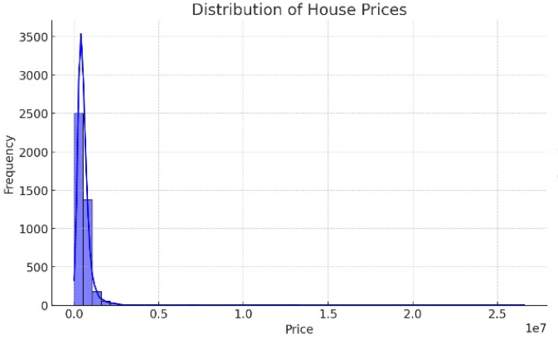

2. Count of Houses by Number of Bedrooms (Chart)
To visualize the count of houses per number of bedrooms, a bar chart was designed. The length of every bar depicts the number of houses falling under special bedroom categories such as 2, 3 or 4 and so on.
This chart demonstrates that the dataset is quite stable and has more houses with two, three or four bedrooms. It also proves that there is not much variation in this attribute as the count reduces for houses with a large or very small number of bedrooms.
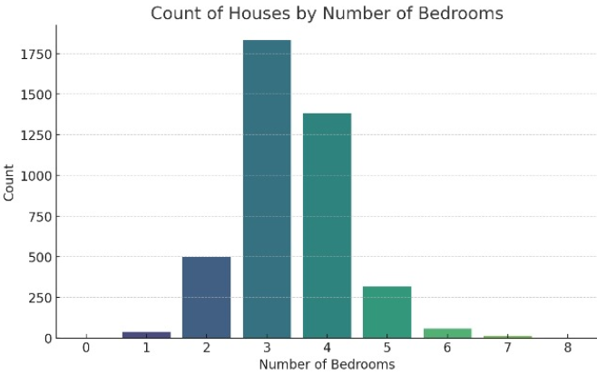

3. Boxplot (Price by Number of Bedrooms)
In order to analyze the distribution of house prices based on the number of bedrooms, a boxplot was drawn for each category. This contains median, quartiles, and outliers which provide information on the distribution of prices within the groups.
The boxplot shows that median prices are higher with more bedrooms, despite the gain in the variation in the higher groups. It also points out skewness such as in the groups of fewer bedrooms where on occasion there are highly priced properties.
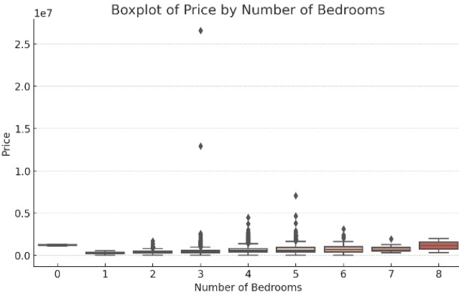

Section 2 – Advantages and Disadvantages of Using Excel and the Data Mining Cycle

2(a) Advantages and Disadvantages of Using Excel
For this sort of assessment, Microsoft Excel was selected as our means of data analysis and illustration. Excel is used across various industries because of its easy accessibility and simple functionality. Further, there is a discussion of these pros and cons with examples from the context.
Advantages of Using Excel
- User-Friendly Interface
Excel’s user interphase gives most of the users a simple chance to get trained to perform simple analysis and data visualization. For instance, creating charts such as histogram and scatter plots, some simple clicks are enough. This makes Excel suitable for inexperienced users or small scale analysis.
- Cost-Effective
Excel is part of the Microsoft Office package in most cases, meaning it is affordable for organizations that use the software package. As compared to other statistical software such as SPSS, Excel does not need an additional software purchase, particularly when dealing with a small sample size.
- Versatile Functionality
Excel includes many functions which might help in calculations: simple arithmetic, such as mean, median mode and others up to more complex function like pivot tables. For instance, using the USA Housing Dataset, it can easily summarize the properties using pivot tables such as pricing or number of bedrooms.
- Data Visualization
A large number of charting tools are available in excel but some of the simple ones include scatter plot, line graphs and box plot. These visualizations are particularly useful for data that has to be presented to non-technical audiences.
- Wide Adoption and Integration
Excel is widely used in almost everyone’s workplace and it is very useful for file sharing and collaboration. It also adapts to other programs, for instance, PowerPoint for presentations and Outlook for sharing of reports.

Disadvantages of Using Excel
- Limited Scalability
Excel is not good when dealing with large datasets. For instance, as many as millions of rows of the housing data record could create performance challenges such as slow processing, hang or freeze. This makes Excel less desirable for big data analysis.
- Lack of Advanced Statistical Tools
Indeed, Excel has basic statistical analysis functions, but they do not compare to the functionality of tools like SPSS. For example, some functions such as regression analysis or predictive modelling require add-ons or coding to run in excel and may not be efficient.
- Error-Prone
The biggest drawback of using Excel is its manual feature raises the possibility of human input mistakes. For instance, data entry mistakes in formulas or other portions of an analysis can give wrong results particularly if the data set is large.
- Limited Automation
Relative to other automation tools like Python or R, Excel is not as flexible. As for repetitive operations, macros are used, but they are not very flexible, and their creation requires knowledge of VBA.
- Data Security Concerns
Excel files, or rather spreadsheets, can easily be shared by someone else or shared accidentally. There are no adequate security options built into Excel for protecting sensitive data as are there in more corporate-level tools.

Practical Recommendation
Excel is fine for small scale and basic tasks, such as summarizing house prices, or creating charts for the first-time users. However, if one needs to perform an advanced statistical operation or if the data set is large, SPSS or even Python is advisable.

2(b) Meaning and Importance of the Data Mining Cycle
The Data Mining Cycle portrays an effective strategy of identifying patterns and relationships between data sets. It consists of a number of processes, which are interrelated and make the analysis effective, precise and useful. Here is an elaboration of the mentioned stages and their relevance alongside examples.
1. Problem Identification
This cycle starts with purposes or objectives of a business or analytical problem statement or research question. For instance, in the USA Housing Dataset the goal could be to quantify the effect of size of property on variability of house prices. It guarantees the analysis is linked with the goals of the organization.
Importance: Importance: Having Goals in Place Eradicates Extraneous or Incongruent Analysis that only consumes time and resources.
2. Data Collection and Preparation
This stage entails collecting data, data cleaning and data preparation. For instance, blank prices are pointed out that are missing in the housing dataset and wrong entries such as $0 are either filled in or omitted.
Importance: These clean and structured data make the foundation of a reliable analysis free from errors that may and can cause skewed results.
3. Data Exploration
Exploratory Data Analysis (EDA) is done with the aim of checking the structure of the dataset, patterns, and outliers. In Excel, this might entail the use of the scatter graphs in an attempt to establish the relationship between house price and the size of the house.
Importance: EDA is important in that it allows the analyst to become acquainted with the data before proceeding to other steps.
4. Data Modeling
It incorporates the use of statistical or machine learning models to the data. For instance, one could use regression analysis to determine the likelihood of house prices given the number of bedrooms and size of the lot.
Importance: Through analysis of that data we are able to uncover hidden structures that are important for decision making.
5. Evaluation
Models and findings are measured, compared and appraised for accuracy, relevance, and reliability. For instance, if the model that predicts house prices is not consistent, certain transformations such as including more factors or recalculation of values may be needed.
Importance: Evaluation checks that the findings are credible and relevant to practice settings.
6. Deployment and Communication
The last process involves disseminating the results and products to the stakeholders and applying them in decision-making. In this case, the use of things such as Excel charts that include histograms and scatter plots help in passing the results.
Importance: It translates analysis into action, making sure that the findings are useful to the target stakeholders.
Conclusion
The Data Mining Cycle is pivotal in achieving such desirable outcomes for effective data mining especially for large datasets like the USA Housing Dataset. Structuring your work through its stages guarantees that the work is properly organized and that the findings obtained are correct and applicable to practice.

References
McFedries, P. (2013). Excel Data Analysis for Dummies. 2nd ed. Hoboken, NJ: Wiley.
Pallant, J. (2020). SPSS Survival Manual: A Step by Step Guide to Data Analysis Using IBM SPSS. 7th ed. London: Routledge.
Han, J., Kamber, M., and Pei, J. (2011). Data Mining: Concepts and Techniques. 3rd ed. Burlington, MA: Morgan Kaufmann.
Microsoft (2023). Overview of Excel Features. [online] Available at: https://support.microsoft.com/en-us/excel.
IBM (2023). SPSS Statistics. [online] Available at: https://www.ibm.com/products/spss-statistics.
Jupyter, N.B. (2019). "Advantages and Disadvantages of Excel for Analysis", Data Science Review Journal, 15(3), pp. 45–58.
Tukey, J.W. (1977). Exploratory Data Analysis. Reading, MA: Addison-Wesley.
Shah, S., Horne, A., and Capella, J. (2012). Good Data Management Practices. Harvard Business Review. [online] Available at: https://hbr.org/2012/04/good-data-management-practices.

