


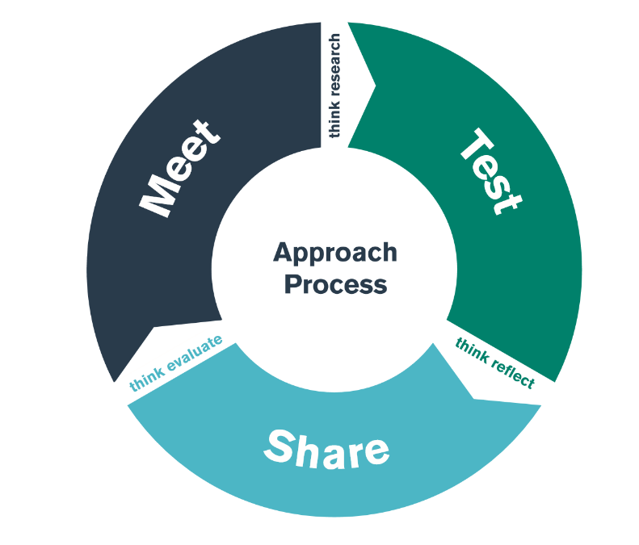

Pontio 1 BA2 &TAR /BA2 & PGCE Bridge 1
Asesu ar Gyfer Dysgu (AagD)
Assessment for Learning (AfL)

Cofnod Tystiolaeth Ymholi Darpar Athrawon

Student-Teacher Enquiry Evidence Record (STEER)

Diwrnod CWRDD / MEET day – 20.11.24
Diwrnodau PROFI / TEST days 21.11.24 – 3.12.24
Diwrnod RHANNU / SHARE day – 4.12.24

Student-Teacher Enquiry Evidence Record

11th -25th November 2020

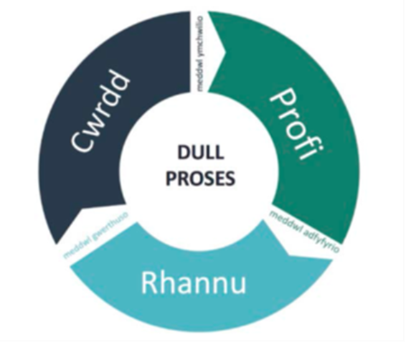

Beth yw pwrpas y gweithgaredd pontio hwn?

Cyfnod CWRDD (Ysgol Arweiniol Rhwydwaith)

Bydd y diwrnod CWRDD yn eich galluogi i nodi ac adfyfyrio’n feirniadol ar strategaethau Asesu ar gyfer Dysgu penodol y byddwch yn eu treialu yn ystod y cyfnod PROFI:

- Egluro, rhannu a deall bwriadau dysgu a meini prawf llwyddo
- Achosi trafodaethau effeithiol, tasgau a gweithgareddau sy’n ennyn tystiolaeth o ddysgu
- Rhoi adborth sy’n symud dysgu ymlaen
- Ysgogi disgyblion fel adnoddau dysgu i’w gilydd
- Ysgogi disgyblion fel perchnogion eu dysgu eu hun

Gwnewch nodiadau ar yr enghreifftiau o’r strategaethau Asesu ar gyfer Dysgu y cewch eich cyflwyno iddynt. Bydd y blychau’n mynd yn fwy yn ôl yr angen.

What is the purpose of this bridging activity?

MEET phase (Network Lead school)

The MEET day will enable you to identify and critically reflect upon specific Assessment for Learning strategies that you will trial during the TEST phase:

- Clarifying, sharing and understanding learning intentions and success criteria
- Engineering effective discussions, tasks and activities that elicit evidence of learning
- Providing feedback that moves learning forward
- Activating pupils as learning resources for one another
- Activating pupils as owners of their own learning

Make notes on the examples of the Assessment for Learning strategies you are introduced to. Boxes to expand as necessary.

- Egluro, rhannu a deall bwriadau dysgu a meini prawf llwyddo/ Clarifying, sharing and understanding learning intentions and success criteria

- Achosi trafodaethau effeithiol, tasgau a gweithgareddau sy’n ennyn tystiolaeth o ddysgu/ Engineering effective discussions, tasks and activities that elicit evidence of learning
(Ansawdd y cwestiynu / Ansawdd y siarad /Quality of questioning / Quality of talk)​.

- Rhoi adborth sy’n symud dysgu ymlaen/ Providing feedback that moves learning forward (Ansawdd yr adborth/Quality of feedback)

- Ysgogi disgyblion fel adnoddau dysgu i’w gilydd/Activating pupils as learning resources for one another (Asesu cyfoedion/ Peer assessment)

- Ysgogi disgyblion fel perchnogion eu dysgu eu hun/ Activating pupils as owners of their own learning (Asesu hunanasesu/Self assessment).

Cyfnod PROFI (Ysgol Rwydwaith PAP)

Yn ystod y cyfnod PROFI bydd disgwyl i chi dreialu, adfyfyrio a datblygu eich defnydd o strategaethau Asesu ar gyfer Dysgu dynodedig mewn ystod o gyd-destunau. Dylech anelu at dreialu o leiaf un strategaeth ar gyfer pob elfen o Asesu ar gyfer Dysgu.

TEST phase (PTE Network School)

During the TEST phase you will be expected to trial, reflect and develop your use of identified AfL strategies in a range of contexts. You should aim to trial at least one strategy for each element of Assessment for Learning.

Cyfnod RHANNU (YSGOL ARWEINIOL RHWYDWAITH)

Yn y cyfnod RHANNU bydd disgwyl i chi adrodd ar ddau o’r strategaethau Asesu ar gyfer Dysgu y gwnaethoch eu treialu yn ystod y cyfnod PROFI. Bydd hyn yn darparu tystiolaeth ar gyfer safonau addysgu cysylltiedig o fewn eich PDP.

Bydd angen i chi baratoi cyflwyniad adborth 5-10 munud i rannu eich canfyddiadau a dangos eich ymgysylltu beirniadol â’r cyfnod PROFI yn ysgol eich lleoliad. Os ydych yn defnyddio cyflwyniad PowerPoint, peidiwch â defnyddio mwy na 4 sleid. Rhaid i chi strwythuro eich canfyddiadau gan ddefnyddio’r 3 chwestiwn ar dempled profiad fel y sylfaen ar gyfer eich cyflwyniad.
- Beth wnaethoch chi a pham?
- Beth ydych chi wedi’i ddysgu?
- Cyflwynwch eich canfyddiadau a’ch adfyfyrdodau eich hun am ddim mwy na 10 munud.
- Byddwch yn feirniadol wrth feddwl am eich profiad chi a phrofiad pobl eraill o ran Asesu ar gyfer Dysgu
- Cymharwch y theori ag arfer (cysylltwch yr hyn rydych wedi’i brofi â llenyddiaeth rydych wedi ymgysylltu â hi).
- Ystyriwch ddatblygiad eich dealltwriaeth o Asesu ar gyfer Dysgu ers y Diwrnod Cwrdd.
Bydd yr Arweinydd Rhwydwaith a’r Tiwtor Cwricwlwm ill dau yn gweithredu yn rôl y trafodwr – byddant yn herio tybiaethau.
- Beth Nesaf?
A oes unrhyw beth rydych yn bwriadu ei wneud o ganlyniad i’r profiad hwn? Efallai y byddech eisiau ystyried rhai o’r cwestiynau canlynol:
  - A oes unrhyw gamau penodol y byddwch yn eu cymryd?
  - Beth fyddech chi’n ei wneud mewn amgylchiadau tebyg yn y dyfodol?
  - A oes unrhyw beth yr ydych yn bwriadu ei newid?
  - A oes gennych unrhyw gynlluniau ar gyfer dysgu pellach neu gyfleoedd datblygu?

Pan fydd eich cymheiriaid yn rhannu eu canfyddiadau a’u hadfyfyrdodau byddwch chi’n cael fformat i wneud nodiadau a gofyn cwestiynau.

SHARE phase (NETWORK LEAD SCHOOL)

In the SHARE phase you will be expected to report on two of the AfL strategies which you trialled during the TEST phase. This will provide evidence for related teaching standards within your PLP.

You will need to prepare a 5-10 minute feedback presentation to share your findings and illustrate your critical engagement from the TEST phase in your placement school. If using a PowerPoint presentation, do not use more than 4 slides. You must structure your findings using the 3 questions of an experience template as the foundations of your presentation.
- What did you do and why?
- What have you learned?
- Present your own findings and reflections for no more than 10 minutes.
- Be critical in your thinking with regards to your experience and the experience of others with AfL
- Compare the theory with practice (link what you have tested with literature you have engaged with).
- Consider the development of your understanding of AfL since the Meet Day.
The Network Lead and Curriculum Tutor will both act in the role of the discussant – they will challenge assumptions.
- What Next?
Is there anything you intend to do as a result of this experience? You might want to consider some of the following questions:
  - Are there any specific actions that you will take?
  - What would you do in similar circumstances in the future?
  - Is there anything you intend to change?
  - Do you have plans for any further learning or development opportunities?

When your peers are sharing their findings and reflections you will be given a format to make notes and ask questions.

Ar ôl y diwrnod Rhannu – gosod targed(au) personol
After the Share day – setting of personal target(s)

O ganlyniad i’r hyn rydych wedi’i ddysgu/adfyfyrio arno yn ystod diwrnodau cwrdd, profi a rhannu y pontio hwn, gosodwch darged i chi’ch hun i wella eich arfer.

As a result of what you have learnt/reflected upon during the meet, test and share days of this bridge, please set yourself a target to improve your own practice.

TARGED  Pa faes ydych chi eisiau ei ddatblygu o fewn eich arfer eich hun? | TARGET  What area do you want to develop in your own practice?
GRADDFA AMSER  Erbyn pryd ydych chi eisiau cyflawni hyn? | TIMESCALE  When do you want to achieve this by?
ADNODDAU  Beth sydd ei angen arnoch i’ch helpu i gyflawni hyn? Pwy ddylech chi siarad â nhw / eu harsylwi? Beth mae angen i chi ymchwilio iddo? | RESOURCES  What do you need to help you achieve this? Who do you need to talk to/observe? What do you need to research
MEINI PRAWF LLWYDDIANT / CANLYNIAD  Sut fyddwch chi’n barnu a yw wedi bod yn llwyddiannus ai peidio? Pa effaith ydych chi’n gobeithio ei weld mewn dysgu ac addysgu? | SUCCESS CRITERIA/ OUTCOME  How will you judge whether it has been successful or not? What impact do you hope to see in teaching and learning?
MONITRO/GWERTHUSO  Sut byddwch chi’n gwirio eich bod wedi cyflawni eich targed yn llwyddiannus? | MONITORING/EVALUATION  How will you check that you have successfully achieved your target?

Ar ôl y Diwrnod Rhannu – cwblhau Templed Profiad Personol i’w ychwanegu at eich PDP
After the Share Day – completion of a Personal Experience Template to be added to your PLP

PDP A CHYSYLLTIADAU Â’R SAFONAU PROFFESIYNOL

Bydd eich profiad pontio’n cefnogi datblygiad eich Safonau Addysgu Proffesiynol. Gweler isod am rai cwestiynau adfyfyriol ategol

PLP AND LINKS TO PROFESSIONAL STANDARDS

Your bridging experience will support your development of the Professional Teaching Standards. See below for some supporting reflection questions

ADDYSGEG  Yn ystod eich cyfnod profi, pa agweddau ar addysgeg rydych chi’n teimlo eich bod wedi’u datblygu (Mireinio, Hyrwyddo, Dylanwadu ar Ddysgwyr). Byddwch yn benodol gyda’r union fanylion yn eich Templed Profiad Proffesiynol. Awgrym: -mae asesu yn un agwedd ar addysgeg a ddylai fod wedi’i ddatblygu. | PEDAGOGY  During your test period which aspects of pedagogy do you feel you developed (Refining, Advancing, Influencing learners). Be specific with the finer detail in your Professional Experience Template. Hint: -assessment is one aspect of pedagogy which should have been developed.
CYDWEITHREDU  A oedd cyfleoedd i weithio’n gynhyrchiol gyda’r holl bartneriaid wrth ddysgu er mwyn ymestyn effeithiolrwydd proffesiynol? | COLLABORATION  Were there opportunities to work productively with all partners in learning in order to extend professional effectiveness?
ARLOESI  A wnaethoch chi ddefnyddio agwedd arloesol sy’n cael ei hamlygu trwy ddatblygu technegau a dulliau yn rheoledig ac yn bwyllog i wella canlyniadau addysgeg. | INNOVATION  Did you employ an innovative outlook which is exemplified through the controlled and measured development of techniques and approaches to improve pedagogic outcomes?
DYSGU PROFFESIYNOL  A oedd cyfleoedd i ymestyn gwybodaeth, sgiliau a dealltwriaeth a gallu dangos sut mae adfyfyrio a bod yn agored i her a chymorth yn llywio dysgu proffesiynol i ddatblygu addysgeg yn gynyddol. | PROFESSIONAL LEARNING  Were there opportunities to extend knowledge, skills and understanding and can show how reflection and openness to challenge and support informs professional learning to progressively develop pedagogy.
ARWEINYDDIAETH  A oedd cyfleoedd i gefnogi ymdrechion pobl eraill ar draws yr ysgol a thu hwnt i gyflawni’r uchelgeisiau addysgol ar gyfer Cymru? | LEADERSHIP  Were there opportunities to support the efforts of others across the school and beyond to fulfil the educational ambitions for Wales?

PONTIO – RHESTR WIRIO

 | Beth i’w wneud? | Pryd? | Nodiadau | Wedi’i wneud
1 | Profwch strategaethau AagD yn nosbarth(iadau) eich lleoliad. | Rhwng 21.11.24 – 3.12.24 | Yn ysgol eich lleoliad trafodwch fewnbwn y diwrnod CWRDD gyda’ch mentor dosbarth fel ei fod yn ymwybodol o’r disgwyliadau PROFI.
2 | Paratowch gyflwyniad ar 2 strategaeth AagD a dreialwyd gyda’r Arweinydd Rhwydwaith, tiwtor Cwricwlwm a chymheiriaid ar y diwrnod RHANNU. | 4.12.24 | Sicrhewch nad oes unrhyw feirniadaeth neu farn ar y ddarpariaeth yn ysgol eich lleoliad mewn unrhyw agwedd ar eich gwaith.  Cadwch yr holl ddisgyblion, staff a rhanddeiliaid eraill yn ddienw drwy gydol y cyflwyniad.
3 | Cwblhewch eich targed personol yn y llyfryn STEER. | 5.12.24 | Rhannwch gyda’ch mentor dosbarth yn ysgol eich lleoliad i sicrhau bod ffocws y Pontio yn gysylltiedig â thargedau yn eich “Dyddlyfr Dysgu”.
4 | Cwblhewch Dempled Profiad Proffesiynol | 5.12.24 | Cysylltwch ef ag addysgeg ond mae’n bosibl y bydd gennych dystiolaeth ar gyfer safonau eraill

BRIDGING – CHECKLIST

 | What to do? | When? | Notes | Done
1 | Test AfL strategies in your placement clas(es). | Between 21.11.24 – 3.12.24 | Discuss with your class mentor in your placement school the Meet day input so that they are aware of the TEST expectations.
2 | Prepare a presentation on 2 trialled AfL strategies to share with the Network Lead, Curriculum tutor and peers on the SHARE day. | 4.12.24 | Ensure that there is no criticism or judgements on your placement school’s provision in any aspect of your work.  Keep all pupils, staff and other stakeholders anonymous throughout.​
3 | Complete you personal target in the STEER booklet. | 5.12.24 | Share with your class mentor in your placement school to ensure that the focus of the Bridging is linked to targets in your “Learning Journal”.
4 | Complete a Professional Experience Template | 5.12.24 | Link to pedagogy but you may have evidence for other standards.

