DS3 Final
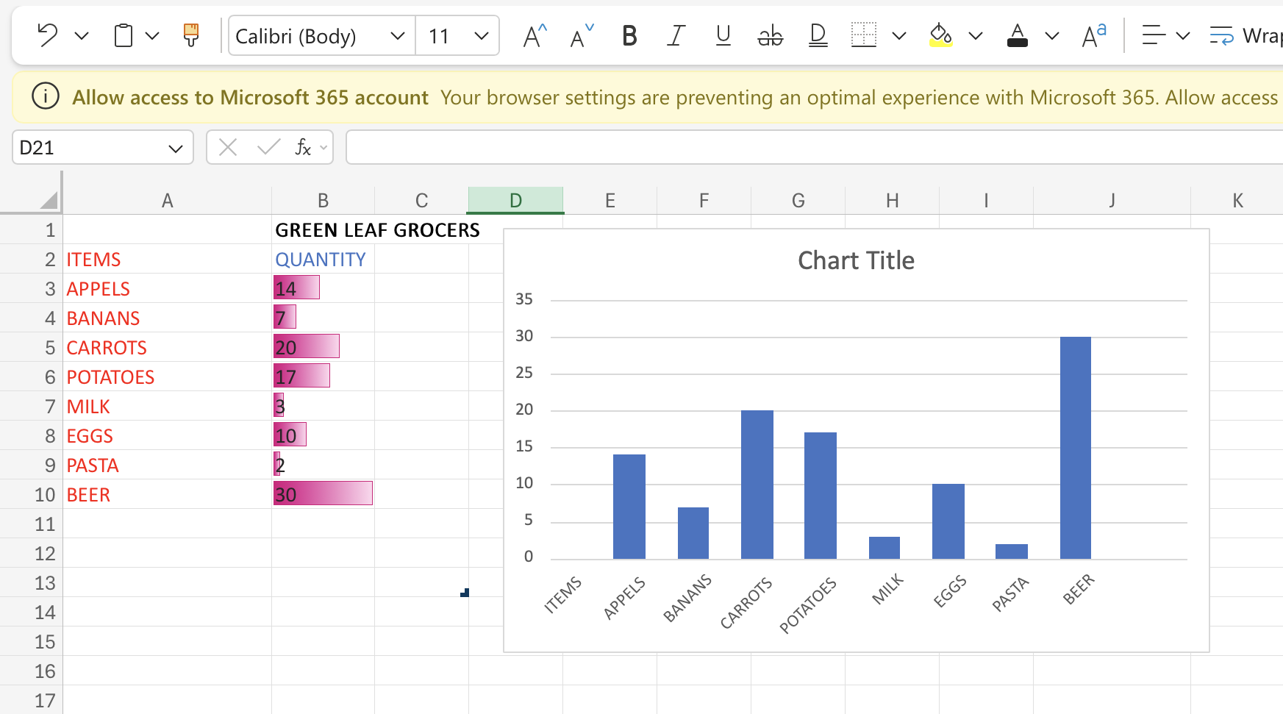
Above figure shows the excel that I have used
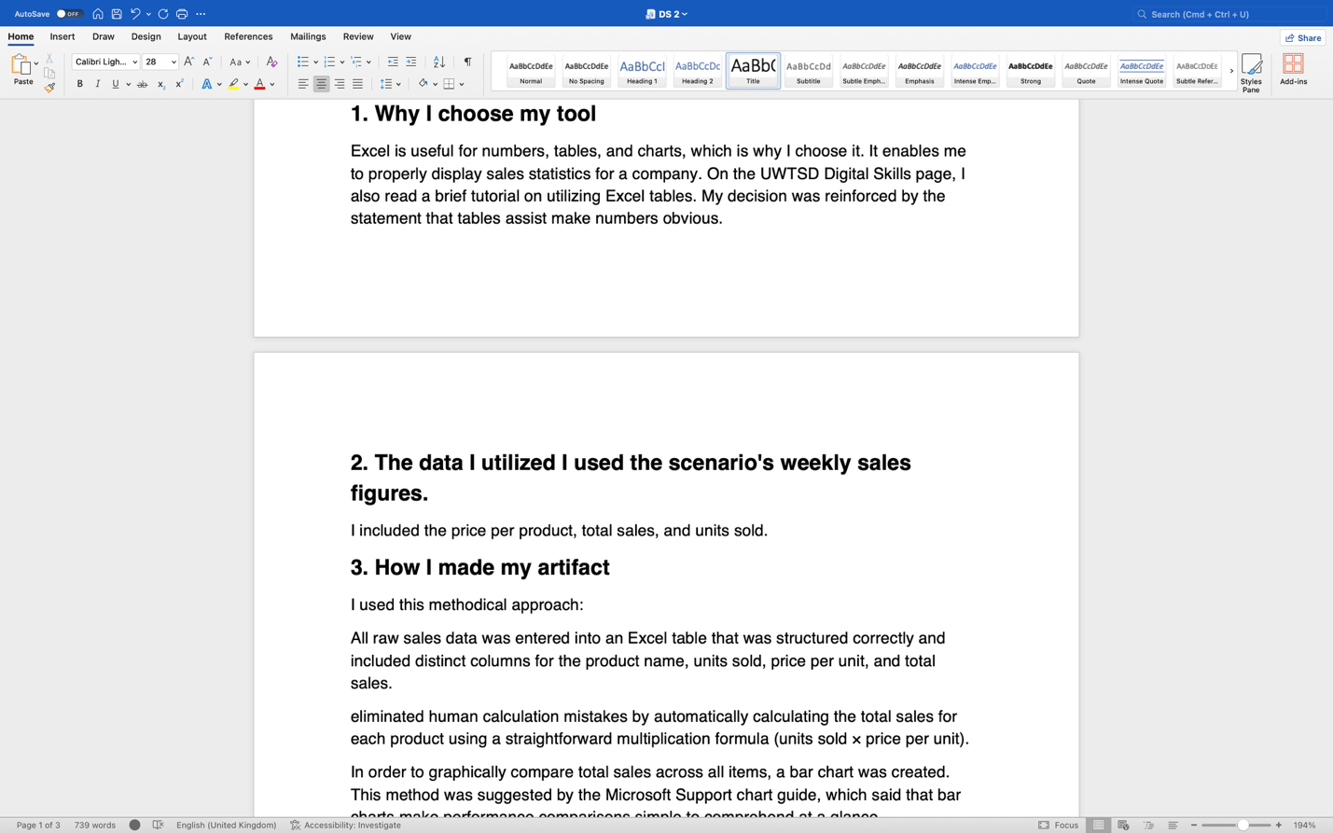
I used Microsoft world for my homework
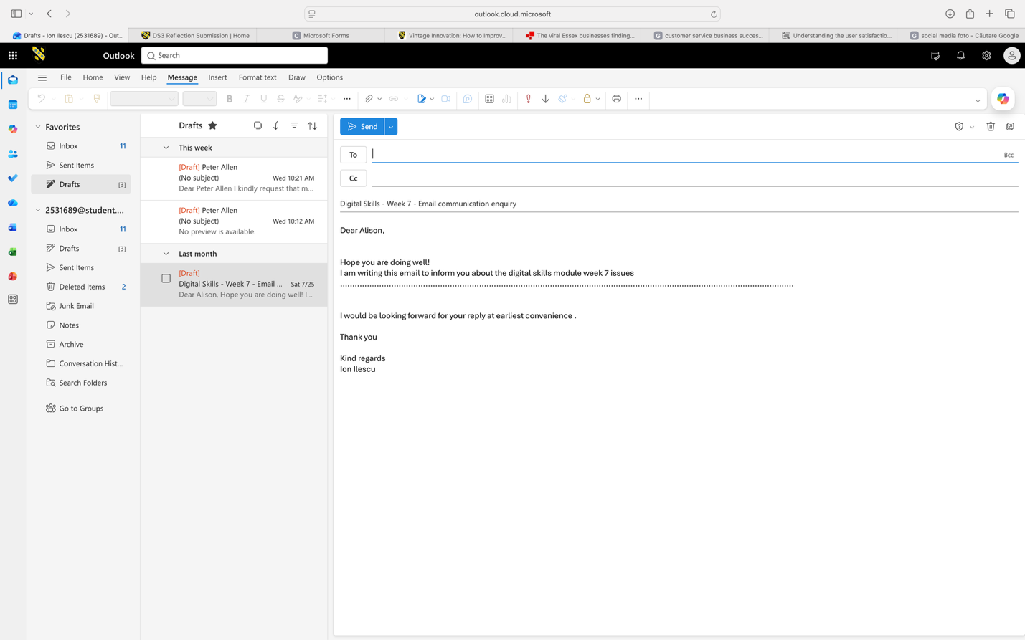
I used Outlook mail to learn how to write the correct email to the teacher

