REPORT TEMPLATE
Module: Introduction to Web and Database Concepts (ACCA4023)
Assignment: HTML & CSS Web Development
Student Name: __Giulia Marchio________________________
Student ID: __2436462________________________
Submission Date: __________________________

1. Introduction (Abstract)
This assignment focuses on the development of a website using HTML and CSS. The main aim is to explain how web pages are planned, designed, created, validated. HTML is used to build the structure of the website, while CSS is used to control the design, layout, colours, fronts and overall appearance. The assignment also explains the requirements of the website, the implementation process, how the final website meets usability, accessibility and SEO expectations.
The website has been created to show a clear understanding of basic web development concepts. It includes different pages, navigation links, images, text content and styling. During the development process, HTML and CSS validation tools are used to check for errors and improve the quality of the code. The final part of the assignment evaluates the website by looking at how easy it is to use, how accessible it is for different users, and how well it follows good web design practice.

Additional Introduction
Living a healthy lifestyle has become increasingly important because it can improve both physical and mental wellbeing. Many people want to make healthier choices, but they may not know where to begin or may find information online confusing. For this reason, the Healthy Lifestyle Guide website was created to present useful health advice in a simple and organised way that is easy for everyone to understand.
The website was developed using HTML and CSS, which are two of the most important technologies used in web development. HTML (HyperText Markup Language) provides the structure of a website by organising content such as headings, paragraphs, images and links. CSS (Cascading Style Sheets) is used to improve the appearance of the website by controlling colours, fonts, spacing and page layout. By combining these technologies, it is possible to create websites that are both functional and visually attractive.
During this project, careful planning was carried out before the website was developed. Different pages were organised to provide information about healthy eating, exercise, daily habits and sustainability. Each page follows a consistent design to make the website easy to navigate and to provide users with a positive browsing experience. Images and headings were included to make the content more engaging while keeping the layout clear and uncluttered.
Another important aim of this project was to develop a website that works well on different devices. Responsive web design allows users to access the website on desktop computers, tablets and mobile phones without affecting the quality of the content or layout. Testing and validation were also completed to identify and correct any errors in the HTML and CSS code before the website was finalised.
Overall, this project demonstrates the basic principles of web development and shows how HTML and CSS can be used to create a simple, informative and responsive website. It also highlights the importance of good design, usability and accessibility in creating websites that meet the needs of a wide range of users while effectively sharing information about healthy living.

2. Requirements
The website created for this project is called Healthy Lifestyle Guide. Its purpose is to provide simple and useful information about healthy eating, regular exercise, daily healthy habits and sustainability. The website is designed for people who want to improve their health throughout easy-to-understand advice.
The website was developed using HTML and CSS and includes multiple pages with a consistent layout and navigation menu. It is designed to be responsive so that it works on different screen sizes, including computers, tablets, and mobile phones. Images, headings and readable text were used to make the content more engaging and user friendly. Accessibility and basic SEO were also considered by using clear headings, meaningful page titles and well-organized content.
Before developing the website, it was important to identify the main requirements that would help meet the project objectives. The website needed to provide clear and reliable information while remaining simple for users to navigate. Each page was planned to focus on a different aspect of healthy living so that visitors could easily access the information they were looking for without feeling overwhelmed.
Another important requirement was to maintain a consistent design across the website. This included using the same colour scheme, font styles and navigation menu on every page to create a professional and organized appearance. Images were carefully selected to support the content and make the pages more visually appealing without distracting users from the information.
The website also needed to load quickly and display correctly on different web browsers and screen sizes. To achieve this, HTML and CSS were used to create a responsive layout that adapts to desktops, tablets and mobile devices. Finally, the website was designed with the user in mind by ensuring that the content was easy to read, the navigation was straightforward, and the overall design encouraged visitors to learn more about maintaining a healthy lifestyle.

3. Implementation
The website was created using HTML and CSS to produce a simple, responsive and easy to use Healthy Lifestyle Guide. A consistent layout, colours and navigation menu were used across all pages to give the website a professional appearance.
- Home Page: introduces the website and welcomes users with healthy lifestyle images.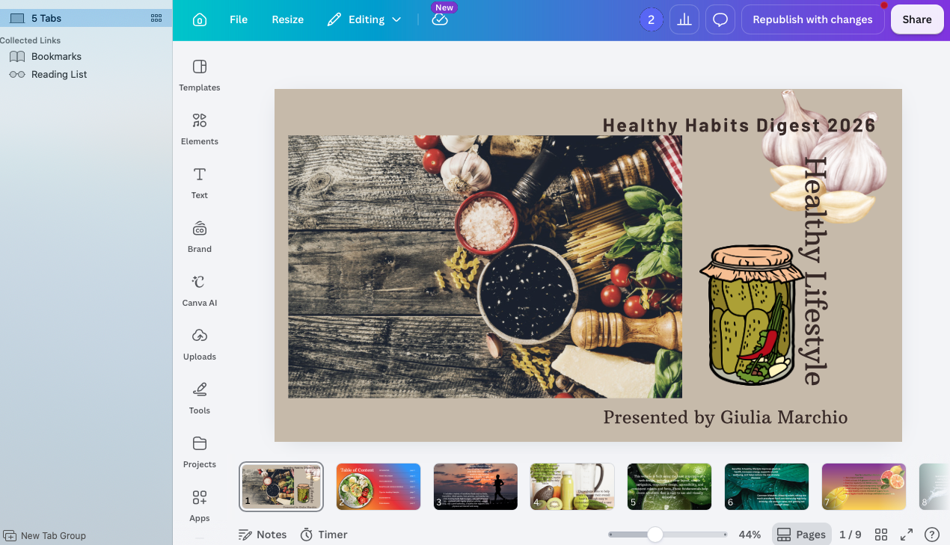

- Introduction: Explains what healthy lifestyle is and why it is important.

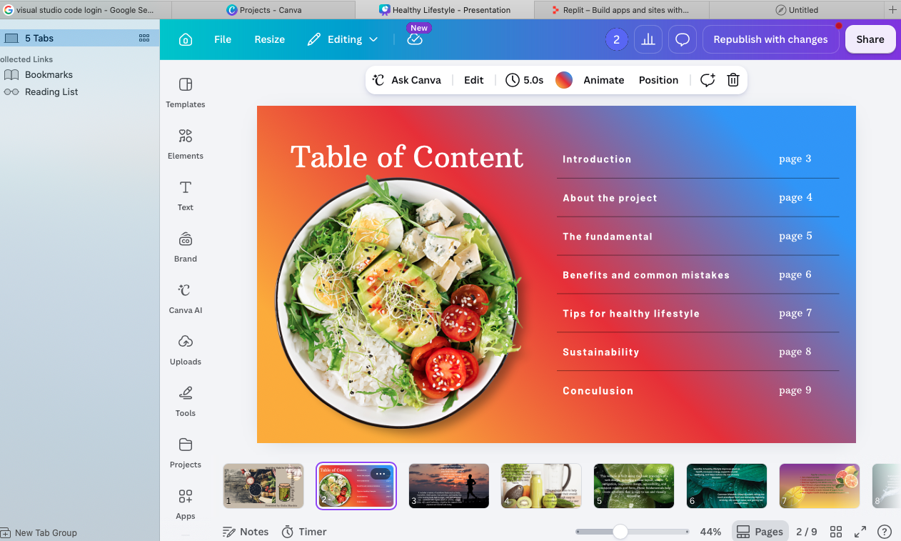

- About: Describes the purpose of the website and its target audience.
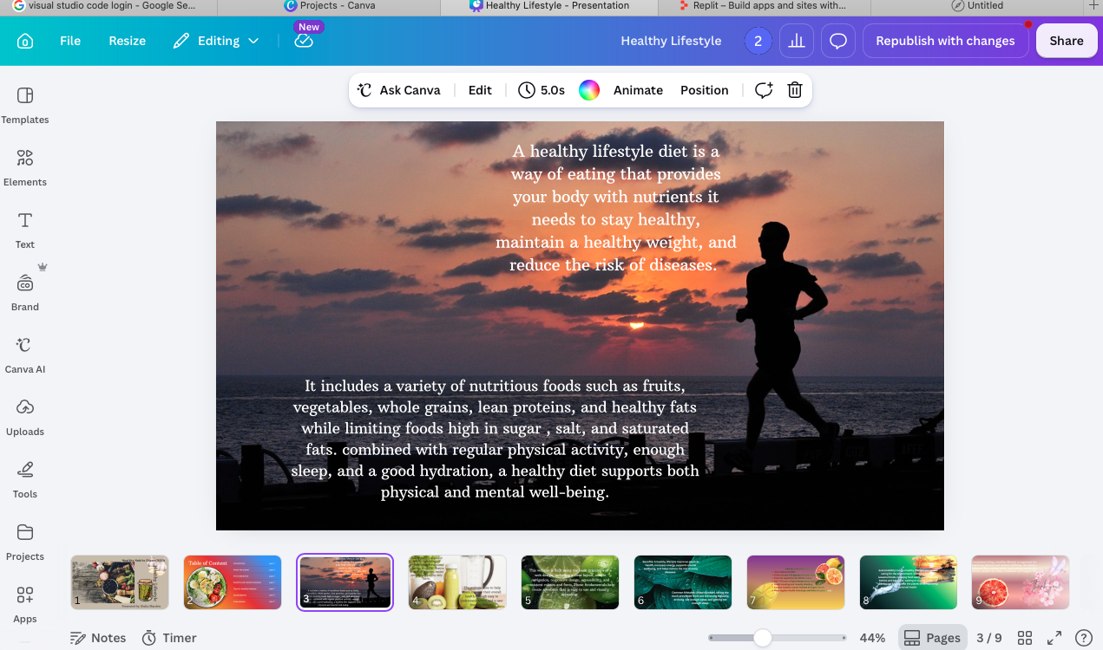
- Fundamentals: Provides information about healthy lifestyle basics.

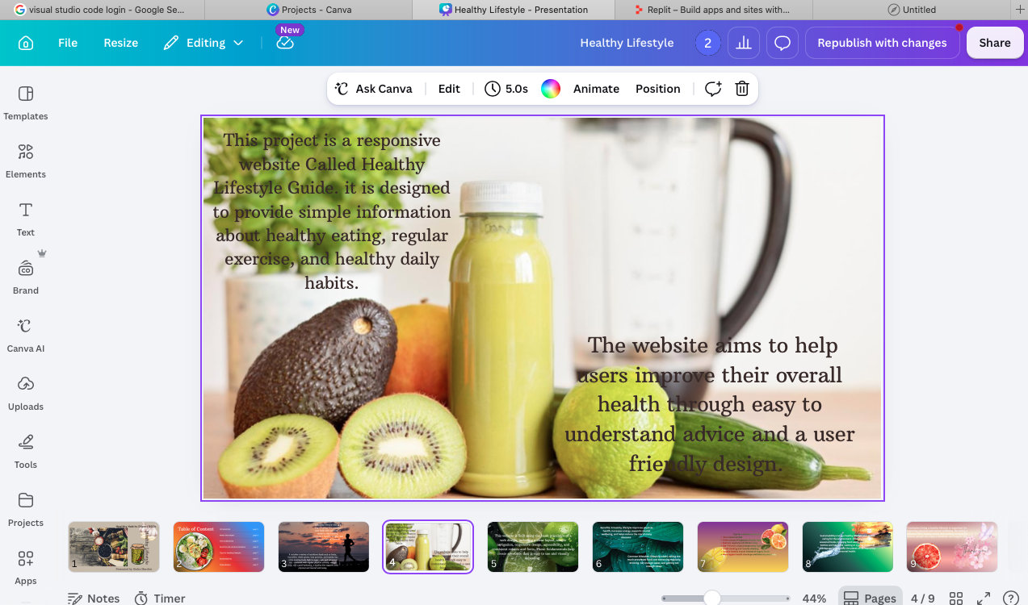

- Benefits and Mistakes: Explains the advantages of healthy living and common mistakes to avoid.
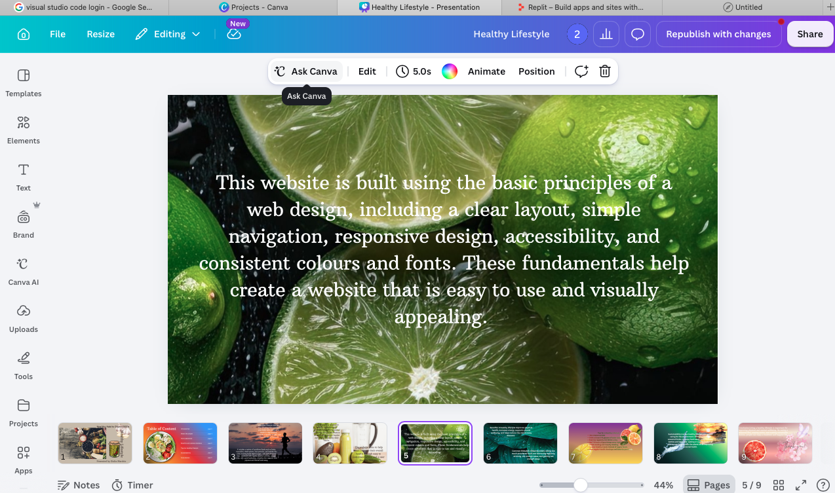

- Healthy Tips: Gives practical tips on diet, exercise and daily habits.

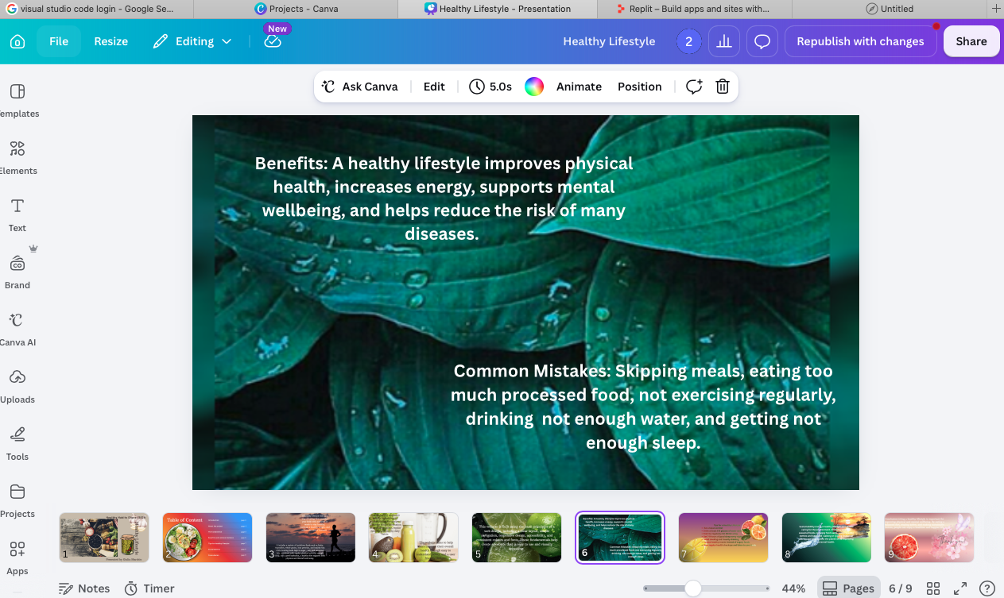
- Sustainability: Explains how healthy choices can also help environment.

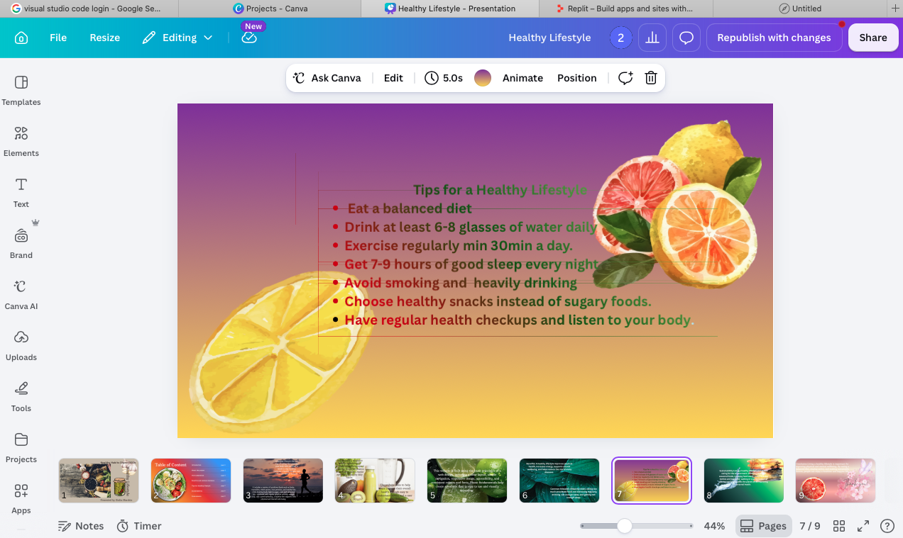

- Conclusion: Summaries the main points and encourages healthy habits.
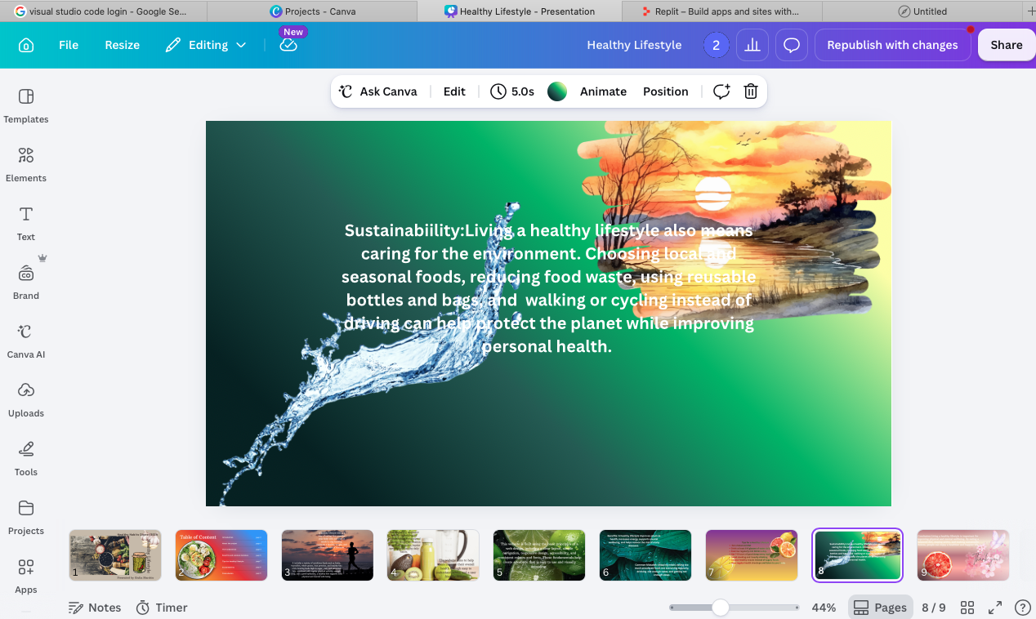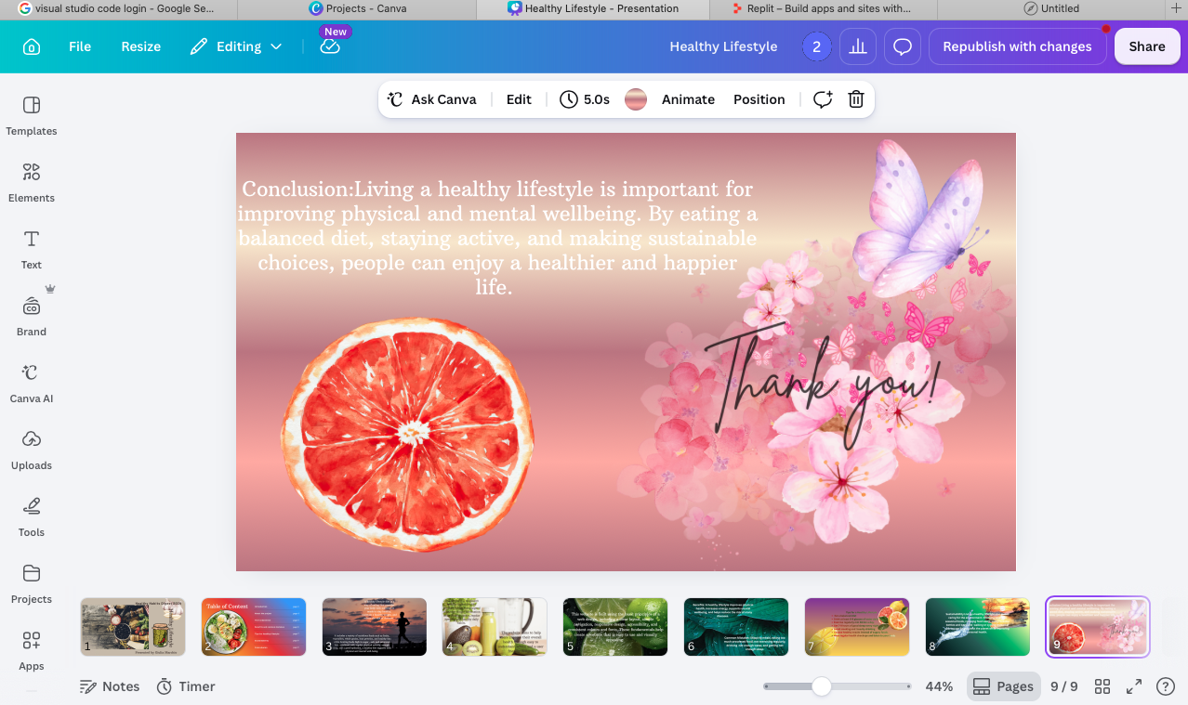
• Provide validation results (HTML & CSS). 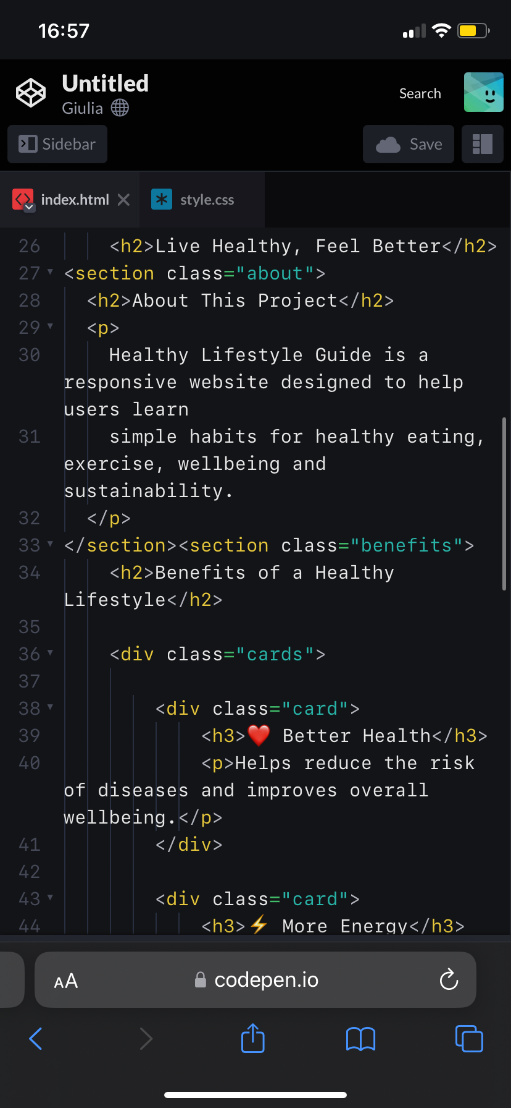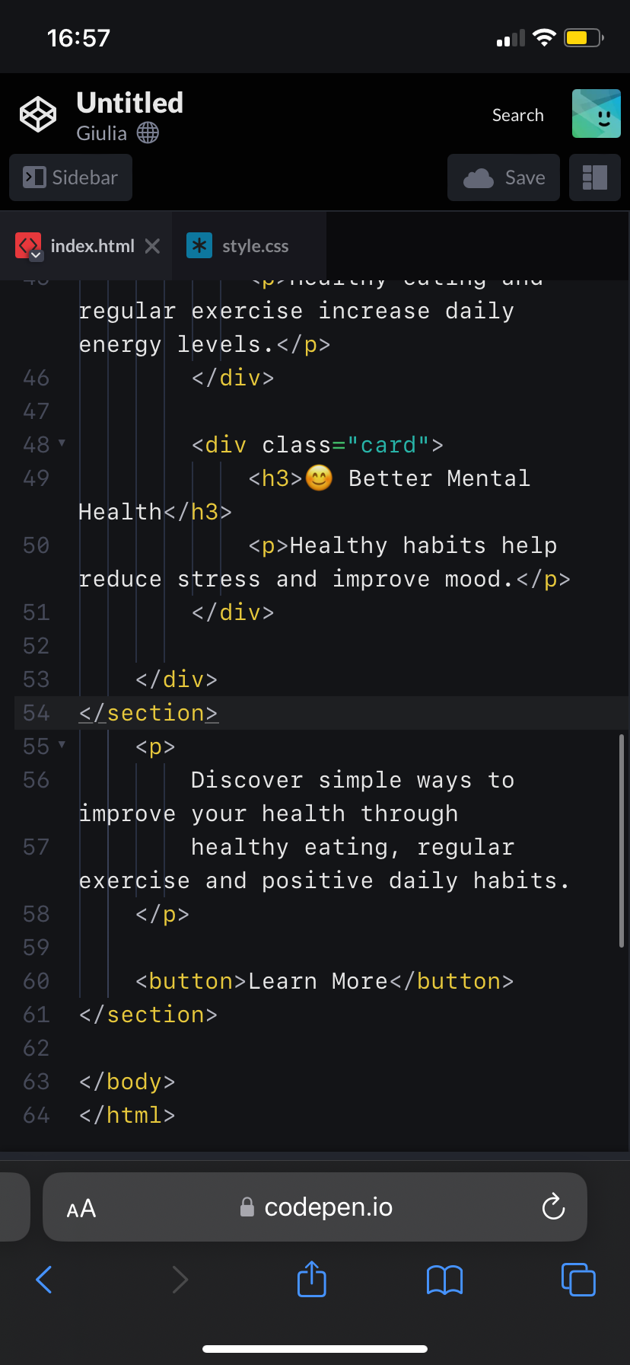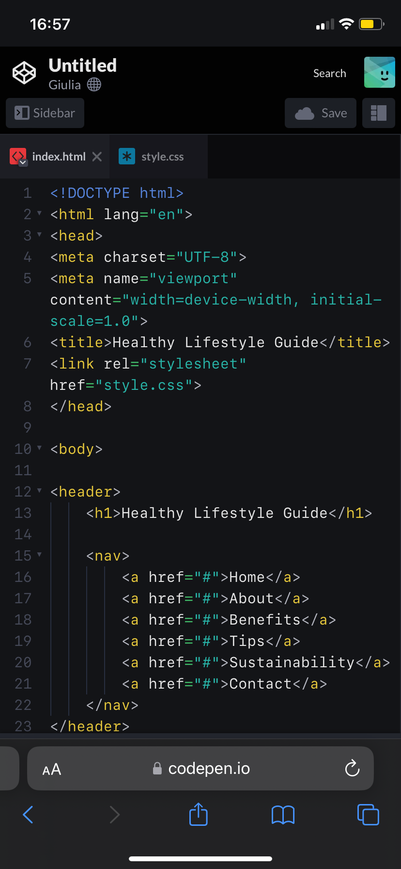

• Explain errors and fixes.
During the development of the website, a few HTML and CSS errors were found during testing. These included missing closing tags, incorrect file paths for images and small CSS formating issues. After checking the code, the errors were corrected by closing all HTML tags properly, fixing the image links and improving the CSS layout. Once these changes were made, the website displayed correctly and worked as expected on different devices.

4. Evaluation
The overall design of the Healthy Lifestyle Guide website was created with the user experience as the main priority. A simple layout and consistent page structure make it easy for visitors to understand the content without confusion. The navigation menu appears on each page, allowing users to move between sections quickly and efficiently. This improves usability because visitors do not need to spend time searching for information.
The use of images throughout the website helps to support the written content and makes the pages more engaging. The combination of text and images creates a balanced design that keeps users interested while maintaining a professional appearance. White space has also been used to separate different sections, making the website easier to read.
Although the website meets the main project requirements, there are still opportunities for future improvements. For example, interactive features such as a contact form, a health calculator or a search function could improve user engagement. Additional accessibility features, such as more descriptive alternative text for images and enhanced keyboard navigation, could also be added to make the website more inclusive. Overall, the website provides useful information in a clear and organized way while demonstrating the effective use of HTML and CSS to create a responsive and user-friendly website.
a) Research:
- Usability means how easy a website is to use. A good website should have clear navigation, readable text and a simple layout so users can quickly find the information they need. According to Nielsen (2020), a simple and consistent design improves the user experience and makes websites easier to use.
- Accessibility means making a website usable for everyone, including people with disabilities. The WCAG 2.1 guidelines recommend using clear headings, readable fonts, good colour contrast and alternative text for images. These features help more people access website content.
- SEO improves a website's visibility on search engines. Good SEO includes descriptive page titles, headings and relevant keywords. These techniques help search engines understand the website and make it easier for users to find online.
b) Website Evaluation:

Usability & Utility
The Healthy Lifestyle Guide website is easy to use because it has a clear layout, simple navigation and consistent colours. The information is organised into sections, making it easy for users to find what they need.

SEO Techniques Used
The website uses clear page titles, headings and keywords related to healthy living. Images and content are organised to improve search engine visibility.

Accessibility (WCAG 2.1)
The website follows basic accessibility principles by using readable fonts, clear headings, suitable colour contrast and a responsive design that works on different screen sizes.

c) Website Comparison: Compared with other healthy lifestyle websites, this website provides simple and easy-to-understand information without unnecessary content. It is mobile-friendly, easy to navigate and follows basic usability, accessibility and SEO principles. Overall, the website successfully achieves its aim of encouraging healthy lifestyle choices through a clear, attractive and user-friendly design.
References
- Nielsen, J. (2020). 10 Usability Heuristics for User Interface Design. Nielsen Norman Group.
- W3C. (2018). Web Content Accessibility Guidelines (WCAG) 2.1.

Conclusion
Overall, the website meets its purpose by providing useful health information in a simple, accessible and user-friendly way.

5. Conclusion
This project provided the opportunity to design and develop a responsive website using HTML and CSS while applying the principles of web development. The website, Healthy Lifestyle Guide, was created to provide users with simple and practical information about healthy eating, regular exercise, daily habits and sustainability. Throughout the project, I gained a better understanding of how websites are planned, designed and developed to meet the needs of different users.
One of the main objectives of this project was to create a website that was easy to use, visually appealing and responsive across different devices. By using HTML to build the structure and CSS to style the pages, I was able to produce a website with a consistent layout, clear navigation and attractive design. The use of images, headings and organised content helped make the information easier to understand and more engaging for users.
During the development process, I also learned the importance of testing and validating the website. Checking the HTML and CSS helped identify small errors that were corrected to improve the quality and performance of the website. This demonstrated that testing is an important part of web development because it ensures that websites work correctly and provide a better experience for users.
Another important lesson from this project was understanding the value of usability, accessibility and search engine optimisation (SEO). These features help make a website easier to navigate, accessible to a wider range of users and easier to find through search engines. Applying these principles improved both the quality and effectiveness of the final website.
Overall, I believe the Healthy Lifestyle Guide successfully achieved its purpose by presenting useful health information in a clear, simple and attractive way. Although there are areas that could be improved in the future, such as adding interactive features, contact forms or more health-related content, the website meets the main project requirements and demonstrates my understanding of HTML, CSS and web development concepts. This assignment has strengthened my practical skills and increased my confidence in creating responsive websites that are both functional and user-friendly.

6. References (IEEE Format)
[1] T. Berners-Lee, “World Wide Web Consortium (W3C),” W3C. Available: https://www.w3.org
[2] World Wide Web Consortium (W3C), Web Content Accessibility Guidelines (WCAG) 2.1, 2018. Available: https://www.w3.org/TR/WCAG21/
[3] J. Nielsen, “10 Usability Heuristics for User Interface Design,” Nielsen Norman Group, 2020. Available: https://www.nngroup.com/articles/ten-usability-heuristics/
[4] Mozilla Developer Network, “HTML: HyperText Markup Language,” MDN Web Docs. Available: https://developer.mozilla.org/en-US/docs/Web/HTML
[5] Mozilla Developer Network, “CSS: Cascading Style Sheets,” MDN Web Docs. Available: https://developer.mozilla.org/en-US/docs/Web/CSS
[6] Google Search Central, “SEO Starter Guide,” Google. Available: https://developers.google.com/search/docs/fundamentals/seo-starter-guide
[7] I. Sommerville, Software Engineering, 10th ed. Harlow, UK: Pearson, 2016.

7. Appendices
The appendices include the full HTML and CSS code listings used to create the Healthy Lifestyle Guide website.
Appendix A: HTML Code
- index.html
- introduction.html
- about.html
- tips.html
- sustainability.html
- conclusion.html
Appendix B: CSS Code
Insert the full CSS stylesheet here:
- style.css

Appendices
This section contains the full code used to develop the Healthy Lifestyle Guide website. The HTML code was used to structure the web pages, including headings, paragraphs, images and navigation links. The CSS code was used to style the website, including colours, fonts, layout, spacing and responsive design.

