
Skills for the Workplace
Module Assignment Submission
Student Name: | Jemma Rees
Student Number: | 2008032
Module No: | BMSK5001
Module Title: | Developing Workplace Critical Thinking

Statement of Confirmation of Authenticity
By the act of making this submission, the student declares that this is the work of the student named above. The work has not, in whole or in part, been knowingly presented elsewhere for assessment, or where assessment has been built on a previous assessment, this has been identified. Where materials have been used from other sources it has been properly acknowledged. If this statement is untrue, the student acknowledges that an assessment offence has been committed.
Attention is drawn to the plagiarism and unfair practice policies of both the University and of ILM.
Permission for ILM to use this script
ILM uses learners' submissions – on an anonymous basis – for assessment standardisation. By submitting, both the centre and the learner agree that ILM may use this script on condition that identifying information is removed. However, if you are unwilling to allow ILM use this script, please refuse by ticking the box: □

Table of Contents
Introduction 3
Values, Attitudes and Beliefs 3
Values 4
Attitudes 6
Beliefs 8
Summary 9
The office for National Statistics 9
Comparing personal values, attitudes, and beliefs and impact to workplace behaviour 11
Conclusion 14
References 16
Bibliography 22
Appendix 1 26
Appendix 2 27
Appendix 3 28
Appendix 4 29
Appendix 5 30

Introduction
This assignment will critically assess the impact of personal beliefs, attitudes and values within the workplace and how these affect individual behaviours. The material within this assignment shall be supported by empirical research.
Firstly the assignment will define values, attitudes and beliefs in an organisational and personal capacity. Secondly, it will introduce the Office for National Statistics (ONS) and its values, attitudes and beliefs. Before finally describing how personal values, attitudes and beliefs are mirrored within the workplace and how these impact workplace behaviour.

Values, Attitudes and Beliefs

Values, attitudes and beliefs are deep-seated within us. They are created and influenced by our life experiences, education, family, and friends. Some will remain unchanged throughout our lives, and some may change or evolve over time. The following section will define the aforementioned dispositions within a professional and personal capacity.
There are various leadership theories presented to assist in managing employees; below are the eight most common with brief explanations:
- Democratic Leadership – Openness and equal involvement enables all employees to feel empowered in decision making
- Autocratic Leadership – Employees are not 'considered nor consulted` in decisions, even where they are directly impacted
- Laissez-Faire Leadership – Authority is given to employees allowing them to be in control of their own work pace and approach
- Strategic Leadership – All employees are supported, and needs are met as much as possible. The 'manager' takes on all executive responsibilities
- Transformational Leadership – Constant goal setting and encouragement to learn and develop to grow the organisation
- Transactional Leadership – Reward based on effort
- Coach-style Leadership – Gentle encouragement for growth and development of employees and guidance to aid team cohesion
- Bureaucratic Leadership – Inclusive but restrictive in growth based on policy and previous experience
(Becker, 2021)
These eight types of leadership can be found within the theorists mentioned throughout this assignment. However, regardless of the preferred theory, all management and leadership theorists have a common goal. To achieve high performance and ensure the organisations they operate are profitable. The approach to achieving success varies broadly, as evidenced in the list above.
However, the employer and employee's underlying values, attitudes, and beliefs will guide the leadership approach and dictate the ultimate success or failure.

Values

Organisational values should be at the very foundation of business; values motivate employees, they create unity and a feeling of purpose. These are usually found in a company's mission or vision statement; they aid in communication and should underpin business decisions. Amongst many others, popular organisational values include honesty, integrity, diversity and courage (Heinilä, 2020).
This definition is comparable to Schein's 'organisational culture triangle' (TWOWP, 2019), in which he suggests there are three layers to an organisation's culture. Schein (2010) explains that these layers are divided by observability. They are; Artefacts, Espoused values and Underlying beliefs. Of these three, Schein explains espoused values create a positive image of the company and provide security to their employees in that the organisation will operate in a way that upholds their values.
Interestingly, values can change in response to the environment; for instance, when an employee enjoys their work and considers it a stable position, they may not hold their job security as a value. However, should there be a change in the job market that removes employment availability, this could impact a person's values. Initiating a re-evaluation of their position and security within the workplace, the demand from others who may be more qualified or more enthusiastic to complete the same job may elicit previously disregarded thoughts and create a new set of values. (Hauff and Kirchner, 2014)
The success of the economy can be directly linked to job satisfaction. Research suggests that, on average, men are less satisfied at work than females; this could be attributed to expectations. There is a direct correlation between a need to be the primary earner for the household and job satisfaction, and it is suggested that this value has held true since males were expected to go to war and were only concerned with one job. Conversely, females were expected to have several positions, caring for children, managing the home and work, possibly indicating why they are not as concerned with this 'status' and find job satisfaction elsewhere (Lange, 2009).
Additionally, research suggests that the effectiveness of a woman's leadership is judged based on a cultural bias (Jogulu and Wood, 2008). These underlying biases continue to create barriers for women in leadership.
Values represent the worth attributed to tangible or non-tangible items. I value the freedom to travel and the security of my home. Therefore, I value my car and my home. I also value trust, honesty, loyalty, kindness. These values can be challenging to quantify and identify when and where they developed; although I know that having observed how others interact and understanding how negative interactions can harm a person, I wanted to ensure I would not become like them.
There is a long-standing discussion about where values are created, nature or nurture. Possibly it is a bit of both. There are a variety of studies discussing this point, and specific environments and genetics can influence a person's behaviour (McLeod, 2018). However, it is generally accepted that there are inherited biases and that humans are influenced by their environment. Although, I believe that we still have choices regardless of these predetermined factors.
In stark contrast to the above, Hayek (1989) has condemned management theories for claiming to be a scientific study; values cannot be measured unbiasedly as they are changeable, specific to each person’s experiences, and influenced by situations.
Gergen (1973) supports this theory by deducing that as a person gains knowledge of a management theory, values change and evolve due to the absorption of new knowledge. Therefore, it is impossible to conduct a suitably impartial study into the success of management theories. Scientific theories cannot change the nature of the item being observed; the item will behave as it always has regardless of whoever is observing. Gergen suggests that social science is “self-fulfilling” due to the changeable nature of human beings. When presented with a new theory, knowledge is gained, and new values are created. Humans are self-aware and therefore learn and adapt, resulting in immeasurable variables resulting in a defunct experiment.

Attitudes

Attitudes are created when evaluating a situation, idea, or material item. Evaluations can form negative or positive attitudes, influenced by either an unconscious or conscious belief. Beliefs are strengthened or weakened throughout a person's life based on experience. Such as, if a person has been ridiculed for wearing glasses, they may form a negative attitude towards glasses. A conscious belief creates an explicit attitude and will inform the decision-making process. An implicit attitude is an unconscious preference. However, this can still impact decisions. (SparkNotes LLC, 2022)
Fallah (2017) suggests that if positive attitudes are encouraged in the workplace, an organisation will be more productive and more profitable. A possible explanation could be that if employees are happy and experience a less stressful environment, they can communicate with ease and confidence, leading to a cohesive team working environment, resulting in productivity. If employees are satisfied with their work, they are likely to require less time away for poor health and be more productive, again leading to a more profitable business.
This can be evidenced by Maslow's Team Building Theory (Maslow et al., 1998). Maslow explains that in fulfilling each stage of one's needs, motivation to achieve each subsequent need increases. This ultimately leads to self-actualisation; however, this is not a static state but a continuous process.
In contrast, Mayo's Hawthorne Experiment (Mayo, 1977) concerned itself with altering the employees' environment to elicit productivity. The experiments aimed to reinforce the principle that employees will become happier and more productive if their needs are met. However, the experiment only considered the employee's external needs, which, although they were improved upon, proved to be ultimately detrimental since the employees were unaware it was an experiment. Although the initial findings were positive and productivity increased, the final results suggest this led to resentment and a negative attitude towards the organisation; productivity subsequently declined.
Attitudes are likely to develop in direct response to an environment or situation; there may be a particular colleague with an unresponsive and critical disposition, which will alter the mood of those around them. However, the opposite is also true; a colleague with a lively and joyful character is likely infectious. (McQuerry, 2019)
My attitude is strongly influenced by management styles, such as when employed in an autocratic X type of management, whereby the manager believes that an employee must be controlled, micromanaged, and threatened to perform (McGregor, 2015). I find it difficult to operate as I feel I am not trusted; this threatens my values and beliefs, making it challenging to maintain a positive attitude and directly impacts my motivation.
I strive to complete all tasks to the best of my ability as I take pride in my work, and when I feel supported and trusted in the workplace, I will work harder because I want to and not because I feel threatened.
McGregor's Y theory is preferred as not only do I strive to achieve a comprehensive understanding of what I am required to do and how to carry it out, but to be fulfilled in the workplace, I need to understand why I am doing it; this leads to greater satisfaction and allows me to take pride in my work, understanding the why is immensely important to me.

Beliefs

Beliefs are something that people hold as true, and these may be backed by a scientific explanation and therefore perceived as trustworthy. Alternatively, a belief may be an opinion that has not been proven or disproven but is a belief that has formed over time, established by life experiences or influenced, for example, by family and friends. (Gurteen, 2022).
Goleman (2019) attributes organisational success to emotional intelligence, especially at a senior leadership level. Emotional intelligence is essential in a belief system; a leader will require technical skills to accomplish their role and good people skills. A leader can sense the correct approach to communicate effectively with their employees by being emotionally intelligent. While a person's beliefs are likely to be very individual, if a leader can understand an employee's beliefs, they can influence the situation to garner a positive outcome.
In learning to become emotionally intelligent and self-aware, it is possible to alter speech patterns and mirror an employee's beliefs in a way that does not compromise one's own beliefs. A leader gains trust and creates a bond between them and the employee, creating a positive attitude. The employee is likely to believe that the leader understands them and holds the same beliefs; the majority of this is a subconscious realisation. When mirroring an employee, it is suggested that it provides an unspoken reassurance that they are experiencing a positive interaction; in turn, the leader is perceived as 'more likeable' (Sanchez-Burks et al., 2006).
Conversely, Taylor's (1919) theory of scientific management assumes that money is the primary motivator to employees; Taylor believes that employees only have two requirements, "physical and economic needs" (TechnoFunc, 2020). Based on this belief, Taylor postulates that to maximise corporate profits, there should be a prescribed and scientific approach to all tasks and that employees should be taught the correct way to carry out these tasks. The reward for successful completion would be an above-average payment to the employee, and failure to complete would result in a below-average payment.
However, as this theory focuses on management from a scientific and engineering perspective, it lacks depth and omits a crucial managerial perspective. In addition, the employee's basic emotional and social needs are wholly disregarded. (TechnoFunc, 2020). Moreover, Taylor's theory was relevant in his epoch, but the theory is now outdated, promoting excessive working and burnout. (Wright and Nelson, 1981)
Similarly to values, my beliefs were established some time ago; however, my beliefs are not as steadfast as my values and are likely to change or adapt more frequently. Beliefs are influenced by knowledge; in learning and evolving in the workplace, I am confident to challenge my beliefs and reconsider them when provided with enough evidence.

Summary
In a diagram created by Allen (2020), It can be seen that values, attitudes and beliefs are the drivers for and what underpin our behaviours (Appendix 1).
When an organisation takes time to understand its employees' diversity and support these differences, the business is likely to become more effective. It is in these differences that creativity and ideas are born. In addition, an employee who feels 'seen' is more responsive and feels valued, leading to greater engagement.
Perhaps management theories' success depends on an individual's values, attitudes, and beliefs. By recognising this, a great leader can employ situational leadership and tailor their approach to the needs of the employees and manage in a way that is accepted, building trusting relationships. (Gbscorporate, 2015)

The office for National Statistics

The Office for National Statistics (ONS) is a public sector organisation and sits within the civil service; they analyse data to produce meaningful statistics for the United Kingdom. Their values, attitudes and beliefs can be found on their careers website and are as follows.
Civil servants are united by shared values and a strong sense of community. The taxpayer pays for the Civil Service so civil servants must meet the high standards the public expects.
Integrity: we put the obligations of public service above personal interests
Honesty: we always aim to be truthful and open with each other as well as those we serve and advise
Objectivity: we base advice and decisions on rigorous analysis of the evidence
Impartiality: we are politically neutral and we act solely according to the merits of the case
These values underpin everything we do. Whatever the role, we look for individuals who demonstrate integrity, honesty, objectivity and impartiality.
(Civil Service Careers, 2018)

The ONS careers page details a variety of attractive benefits to becoming a Civil Servant, including learning and development opportunities (L&D). (Office for National Statistics, 2022). The website also details' Success profiles'. These detail the level and type of behaviours required to be effective in each role and explain that this promotes inclusivity and diversity (HM Government, 2018).
The 'about us' section of the website provides further information into the style of leadership and management, which is comparable to Senge (2021) and his theory 'Learning Organisations and Systems Thinking'. Further similarities can be seen in the way that the ONS promotes continual learning and development; there are opportunities to learn from peers each day, to participate in formal qualifications and to move around the business areas on a secondment
Additionally, employees are encouraged to set personal goals each year to align with the organisations' vision, and leadership is encouraged at all levels regardless of line management responsibilities. (Rowlands et al., 2015). Senge focuses on dispersing the central leadership role and enabling all employees to share the same vision, working toward a collective goal (Smith, 2001).
It is apparent in the results of their annual 'People Survey' (UK Statistics Authority & ONS, 2019) that employee satisfaction and motivation are seriously considered. The report indicates that although the organisation has continuing challenges, the ONS are a company aware of this and strive to improve annually upon each report. The report shows that many satisfaction areas are considered and that motivation and job satisfaction are thoroughly questioned. This report could assume that numerous factors influence contentedness and that motivation is not solely driven by financial gain.
In contrast, Taylor (1994) believed that finances solely drive motivation. However, Herzberg (1987) disagrees and states that many non-financial factors aid employee motivation. (Appendix 2). These are closely comparable with the ONS's 2019 People Survey findings.
A notion shared by Likert, who famously wrote:
The greater the loyalty of a group toward the group, the greater is the motivation among the members to achieve the goals of the group, and the greater the probability that the group will achieve its goals.
(Likert, 1967, p. 64)

Comparing personal values, attitudes, and beliefs and impact to workplace behaviour

Before joining the ONS, I was employed by an organisation that clearly led in an authoritarian or X-type (Mcgregor, D. 2015) management style. A high staff turnover characterised this, and the organisation is focused on achieving organisational targets to the detriment of its employees. I felt that as an employee, I was led by the stick rather than the carrot. This type of management was challenging for me as I didn't feel motivated; I grew to distrust management. In turn, I lost respect for the organisation and subsequently resigned.
When searching for alternative employment, I found a post for the ONS; although I felt the post description was unnecessarily complicated, I read about the organisation and its values, attitudes, and beliefs. These instantly piqued my interest as they described a supportive culture, an outstanding work-life balance and opportunities for additional training and progression. They appeared to be a company where you could start and end an entire career.
I was especially interested in the offer of L&D, which the ONS states in their job posts. I have found it challenging to obtain additional relevant L&D in previous companies. To find out that the ONS have an L&D program already embedded and that this is actively encouraged pushed me to apply. A recent survey states, "94 percent of employees say that they would stay at a company longer if it simply invested in helping them learn." (Abigail Johnson Hess, 2019).
It is in my nature to look after and help people; due to the amount of time I spent caring for my disabled sibling, I always assumed that I would pursue a career in the caring profession; this remained the assumption until she passed away. At this time, some of my values, attitudes, and beliefs changed. Based on this experience, I decided that I would be best suited to helping people in a different capacity. I feel that I am indirectly helping people in my current position. I work closely with my colleagues to aid their professional development and understanding of our work. In addition, I am upholding the organisations' mission statement in my daily work. The ONS's mission statement reads: 'Statistics for the public good' (Sir David Norgrove, 2020)
Because I have experienced very autocratic leadership in several previous positions, I have developed strong values, attitudes, and beliefs in that I value honesty and integrity as two of my most important values. I believe that everyone, regardless of their background, should be afforded opportunities to better themselves, and regardless of the task, I always strive to complete it to the best of my abilities. However, I recognise that I have developed a much more cynical view of the world due to this and expect there to be hidden agendas or alternative motives in people's behaviour.
Gunter, (2009) argues that leadership is attributed to a management role without the purpose of leadership being understood and states that leadership is the ability to ask questions and solve problems. Perhaps due to my beliefs, I value the ability to discuss situations and find a resolution agreeable to the majority.
Engaging in conversation and having support from management to explore possible solutions creates creativity and motivation within employees; a good leader should encourage this. Behaving in this way creates and maintains trust with employees; it also creates validation and leads to increased well-being and job satisfaction. However, there is a fine line, and should an employee appear too radical in a risk-averse organisation, and this could have negative implications leading to an employee being ostracised. (Lange, 2008)
Conversely, Hofstede (2001b) discusses 'Power Distance' whereby a manager places themselves of higher importance to the employee and is unwilling to answer questions, thus maintaining power over the subordinate. This could be influenced by their values, attitudes, and beliefs, needing to feel in control and dominating in this way to feel validated. However, this is detrimental to the manager and employee relationship and likely creates distrust.
The ONS appears to exhibit several leadership styles simultaneously; there are similarities to Adairs' (1934) action-centred leadership as described in his 'eight leadership functions' (Appendix 3). The operational style of the ONS appears to mimic these areas closely. (The Team Building Company, 2022)
A few specific comparable functions are:
- Defining the task – A clear objective is to be determined using a method such as the mnemonic SMART (Appendix 4)
- Briefing – Involvement of the team to promote motivation and teamwork
- Evaluating – Staff appraisal and recognising where training is required
- Motivating – Leading by example, set goals, recognise achievement
(CMI, 2016)
Emphasis is also placed on diversity, encouraging employees to consider cultural differences and recognise that each person can bring something of use to their role; this could be likened to 'The Hofstede Model' (Hofstede, 2011).
Furthermore, Deming (1992) proposed fourteen points (Appendix 5) for managers and leaders to adhere to; Deming recognised that previous theories did not allow for complexities, he insists that quality is the overarching principle and that this can be refined and improved upon by applying these points to employees and processes. (DemingInstitute, 2014)

Conclusion

To conclude, employees need to understand their own beliefs, attitudes, and values; aligning these to the organisations’ will increase motivation and positive attitudes. The research above indicates that a positive team attitude influences colleagues and encourages a pleasant workplace culture.
In addition, a good leader should encourage employees to explore their values, attitudes, and beliefs and understand how these can positively impact their work. A leader should also recognise where there may be shortcomings and assist the employee in developing and achieving desirable attributes.
Locke and Latham, cited in Lunenburg (2011), suggest that setting and achieving a goal at work leads to good performance, and by supporting these goals, recognising and commenting on the achievement motivates the employee. Additionally, it is recognised that goals need to be specific and measurable. A learning goal appears to be of higher value to the employee, and that group goal setting is the most significant motivator.
As this assignment shows, leadership and Management theorists have existed for some time, and the theories tend to evolve over time; some disappear, giving way to new and revolutionary ideas. Despite the conflicting advice of many of these and the apparent similarities of others, it is unlikely that one particular theory will be agreed upon as correct. This is partly due to humans being so wholly different and exhibiting different abilities and aptitudes. However, due to these very differences as sentient beings, humans can adapt and learn; our approach to leadership and management should therefore evolve and grow with us.
Additionally, as previously evidenced, there is no one theory suitable for all situations and all people. The best approach is to tailor the management and leadership to suit the culture of the organisation and employees. However, this does not mean that personal values, attitudes, and beliefs will also need to change. Becoming a great leader requires having an objective view of the business needs, understanding the employees and their values, attitudes, and beliefs, and applying the best theory for that situation.
Furthermore, seeking out employment where it is possible to align personal values, attitudes, and beliefs with those of the organisation allows for cohesion leading to job satisfaction and a greater bond with colleagues.
Finally, it can be seen from the evidence above that several variants will affect the motivation and performance of employees, but organisational and personal values, attitudes and beliefs are the driving influence behind all behaviour. A leader must encourage positive behaviours to benefit the organisation and their colleagues. Where a leader is incapable of this, performance, motivation, and morale will undoubtedly suffer.

References

Abigail Johnson Hess (2019) LinkedIn: 94% of employees say they would stay at a company longer for this reason—and it’s not a raise [Online]. Available at https://www.cnbc.com/2019/02/27/94percent-of-employees-would-stay-at-a-company-for-this-one-reason.html (Accessed 11 March 2022).
Allen, Dr. C. (2020) Home - Dr. Clare Allen [Online]. Available at https://www.drclareallen.com/ (Accessed 13 March 2022).
Becker, B. (2021) The 8 Most Common Leadership Styles & How to Find Your Own [Quiz] [Online]. Available at https://blog.hubspot.com/marketing/leadership-styles (Accessed 22 March 2022).
Civil Service Careers (2018) Civil Service Careers [Online]. Available at https://www.civil-service-careers.gov.uk/about-us/ (Accessed 20 February 2022).
CMI (2016) “JOHN ADAIR: ACTION-CENTRED LEADERSHIP,” THK-032 John Adair, London, Mcgraw-Hill, pp. 1–7 [Online]. Available at http://www.valuing-your-talent-framework.com/sites/default/files/resources/THK-032%20John%20Adair.pdf (Accessed 20 March 2022).
DemingInstitute (2014) “W. Edwards Deming: The 14 Points,” YouTube [Online]. Available at https://www.youtube.com/watch?v=tsF-8u-V4j4 (Accessed 20 March 2022).
Deming, W. E. (1992) A System of Profound knowledge., Salisbury, British Deming Association.
Gbscorporate (2015) Understanding the personal values and perceptions of individuals will make you a great Leader - Blog - [Online]. Available at https://www.gbscorporate.com/blog/understanding-the-personal-values-and-perceptions-of-individuals (Accessed 20 March 2022).
Gergen, K. J. (1973) “Social Psychology as history.,” Journal of Personality and Social Psychology, vol. 26, no. 2, pp. 309–320 [Online]. DOI: 10.1037/h0034436 (Accessed 27 March 2022).
Gunter, H. (2009) “The leadership delusion,” International Journal of Leadership in Public Services, vol. 5, no. 3, pp. 50–54 [Online]. DOI: 10.1108/17479886200900022 (Accessed 9 June 2020).
Hauff, S. and Kirchner, S. (2014) “Changes in workplace situation and work values. Relations and dynamics within different employment regimes,” Management Revue, Rainer Hampp Verlag, vol. 25, no. 1, pp. 27–49 [Online]. Available at http://www.jstor.org/stable/24331300 (Accessed 2 March 2022).
Hayek, F. A. V. (1989) “The Pretence of Knowledge,” The American Economic Review, vol. 79, no. 6, p. 3 [Online]. DOI: 10.2307/3439337 (Accessed 27 March 2022).
Heinilä, R. (2020) Company Values: Definition, Importance and Examples [Online]. Available at https://blog.smarp.com/the-importance-of-company-values (Accessed 20 February 2022).
Herzberg, F. (1987) One More Time: How Do You Motivate Employees?, Harvard Business Review [Online]. Available at http://mcrhrdi.gov.in/91fc/coursematerial/management/14%20One%20More%20Time%20How%20do%20you%20Motivate%20Employees.pdf (Accessed 11 March 2022).
HM Government (2018) Success Profiles Civil Service Behaviours Success Profile Framework, assets.publishing.service.gov.uk [Online]. Available at https://assets.publishing.service.gov.uk/government/uploads/system/uploads/attachment_data/file/717275/CS_Behaviours_2018.pdf (Accessed 13 March 2022).
Hofstede, G. (2001b) Culture’s Consequences : Comparing values, behaviors, institutions, and Organizations across Nations, 2nd edn, Thousand Oaks, California, Sage Publications. [Online]. Available at https://www.google.co.uk/books/edition/Culture_s_Consequences/w6z18LJ_1VsC?hl=en&gbpv=0 (Accessed 14 March 2022).
Hofstede, G. (2011) “Dimensionalizing Cultures: The Hofstede Model in Context,” Online Readings in Psychology and Culture, vol. 2, no. 1, pp. 1–26 [Online]. DOI: 10.9707/2307-0919.1014.
J Kelvin Fallah (2017) The Importance of Attitude in Workplace [Online]. Available at https://www.researchgate.net/publication/343447135_The_Importance_of_Attitude_in_Workplace (Accessed 24 February 2022).
Jogulu, U. D. and Wood, G. J. (2008) “A Cross‐cultural Study into Peer Evaluations of women’s Leadership Effectiveness,” Leadership & Organization Development Journal, vol. 29, no. 7, pp. 600–616 [Online]. DOI: 10.1108\/lodj (Accessed 13 March 2022).
Lange, T. (2008) “Attitudes, attributes and institutions,” Employee Relations, vol. 31, no. 1, pp. 81–97 [Online]. DOI: 10.1108/01425450910916832 (Accessed 14 March 2022).
Lange, T. (2009) “Attitudes, attributes and institutions: Determining job satisfaction in Central and Eastern Europe,” Employee Relations, vol. 31, no. 1, pp. 81–97 [Online]. DOI: 10.1108/01425450910916832 (Accessed 13 March 2022).
Likert, R. (1967) The Human Organization : Its Management and value., New York, Mcgraw-Hill.
Lunenburg, F. C. (2011) “Goal-Setting Theory of Motivation,” International Journal of Management, Business, and Administration, vol. 15, no. 1, pp. 1–6 [Online]. Available at https://static1.squarespace.com/static/5b0b8f55365f02045e1ecaa5/t/5b14d215758d46f9851858d1/1528091160453/Lunenburg%2C+Fred+C.+Goal-Setting+Theoryof+Motivation+IJMBA+V15+N1+2011.pdf (Accessed 22 March 2022).
Maslow, A. H., Stephens, D. C. and Heil, G. (1998) Maslow On Management, New York: John Wiley [Online]. Available at http://altfeldinc.com/pdfs/maslow.pdf (Accessed 11 March 2022).
Mayo, E. (1977) The social problems of an industrial civilization., New York, Arno Press [Online]. Available at https://books.google.co.uk/books/about/The_Human_Problems_of_an_Industrial_Civi.html?id=OQcBYqgKh5cC&redir_esc=y (Accessed 11 March 2022).
Mcgregor, D. (2015) DOUGLAS MCGREGOR: THEORY X AND THEORY Y. Thinker 026» INTRODUCTION» KEY THEORIES, [Online]. Available at https://switcheducation.com/wp-content/uploads/2017/06/SEB_LYO_McGregor_Thinker.pdf.
Mcleod, S. A. (2018) Nature vs Nurture in Psychology [Online]. Available at https://www.simplypsychology.org/naturevsnurture.html (Accessed 28 February 2022).
McQuerry, L. (2019) How Do Negative & Positive Attitudes Affect the Workplace? [Online]. Available at https://smallbusiness.chron.com/negative-positive-attitudes-affect-workplace-21287.html (Accessed 12 March 2022).
Office for National Statistics (2022) Careers - Office for National Statistics [Online]. Available at https://www.ons.gov.uk/aboutus/careers (Accessed 13 March 2022).
Rowlands, S., Lewis, J. and Investors in People Wales (2015) 3 Yr REVIEW REPORT - SILVER Accreditation, Office for National Statistics, Welsh Government [Online]. Available at https://www.ons.gov.uk/ons/about-ons/careers/benefits/uksaons-silver-review-report-0315vf.pdf (Accessed 13 March 2022).
Schein, E. H. (2010) Organizational Culture and Leadership, Google.co.uk, United Kingdom, Wiley [Online]. Available at https://www.google.co.uk/books/edition/Organizational_Culture_and_Leadership/DlGhlT34jCUC?hl=en&gbpv=1&printsec=frontcover (Accessed 12 February 2022).
Senge, P. (2021) Peter Senge: Learning Organizations & Systems Thinking - Video & Lesson Transcript | Study.com [Online]. Available at https://study.com/academy/lesson/peter-senge-learning-organizations-systems-thinking.html (Accessed 28 February 2022).
Sir David Norgrove (2020) Statistics for the Public Good – Our New Five-Year Strategy | National Statistical [Online]. Available at https://blog.ons.gov.uk/2020/07/21/statistics-for-the-public-good-how-are-statistics-saving-the-world-and-whats-next/ (Accessed 11 March 2022).
Smith, M. K. (2001) Peter Senge and the Theory and Practice of the Learning Organization [Online]. Available at http://citeseerx.ist.psu.edu/viewdoc/download?doi=10.1.1.475.9451&rep=rep1&type=pdf (Accessed 28 February 2022).
SparkNotes LLC (2022) Social Psychology: Attitudes | SparkNotes [Online]. Available at https://www.sparknotes.com/psychology/psych101/socialpsychology/section4/ (Accessed 24 February 2022).
Taylor, F. W. (1919) The. Principles of Scientific Management, [Online]. Available at https://dspace.gipe.ac.in/xmlui/bitstream/handle/10973/41111/GIPE-191173.pdf?sequence=3 (Accessed 20 March 2022).
Taylor, F. W. (1994) The Principles of Scientific Management, [Online]. Available at https://mss.metrici.com/ebta/titles/the_principles_of_scientific_management/the_principles_of_scientific_management_pdf.pdf (Accessed 11 March 2022).
TechnoFunc (2020) TechnoFunc - Taylor’s Scientific Management [Online]. Available at https://www.technofunc.com/index.php/leadership-skills/leadership-a-management/item/taylor-s-scientific-management (Accessed 20 March 2022).
The British Library (2022) John Adair [Online]. Available at https://www.bl.uk/people/john-adair#:~:text=Task%2C%20team%20and%20individual%3A%20Adair%27s,and%20respond%20to%20individuals%27%20needs (Accessed 5 March 2022).
The Coaching Tools Company (2020) SMART Goals: Complete Guide for Coaches [Online]. Available at https://www.thecoachingtoolscompany.com/smart-goals-complete-guide-for-coaches-with-pdf/ (Accessed 20 March 2022).
The Team Building Company (2022) John Adair Team Theory [Online]. Available at https://www.teambuilding.co.uk/theory/john-adair-team-theory.html (Accessed 20 March 2022).
The W. Edwards Deming Institute (2018) Deming’s 14 Points for the Transformation of Management, [Online]. Available at https://deming.org/wp-content/uploads/2020/06/One-Pager-14Points.pdf (Accessed 27 March 2022).
tutor2u (2016) “Motivation Theory: Herzberg (Two-Factor Theory),” YouTube [Online]. Available at https://www.youtube.com/watch?v=f-qbGAvR4EU (Accessed 6 March 2022).
TWOWP (2019) Edgar Schein’s Organizational Culture Triangle: A Simple Summary - The World of Work Project [Online]. Available at https://worldofwork.io/2019/10/edgar-scheins-culture-triangle/ (Accessed 13 February 2022).
UK Statistics Authority & ONS (2019) People Survey Results 2019, Office for National Statistics [Online]. Available at https://www.ons.gov.uk/file?uri=/aboutus/whatwedo/peoplematters/ukstatisticsauthoritycorporatereport.pdf (Accessed 13 March 2022).
Wright, G. and Nelson, D. (1981) “The Truth about Scientific Management,” Reviews in American History, vol. 9, no. 1, p. 88 [Online]. DOI: 10.2307/2702392 (Accessed 23 May 2020).

Bibliography

ACCA (2022) Mintzberg’s theory on organisations | ACCA Qualification | Students | ACCA Global [Online]. Available at https://www.accaglobal.com/gb/en/student/exam-support-resources/fundamentals-exams-study-resources/f1/technical-articles/mintzberg-theory.html (Accessed 11 February 2022).
Beugelsdijk, S. and Welzel, C. (2022) “Dimensions and Dynamics of National Culture: Synthesizing Hofstede With Inglehart,” Journal of Cross-Cultural Psychology, vol. 49, no. 10, pp. 1469–1505 [Online]. DOI: 10.1177/0022022118798505.
British Library (2022) British Library [Online]. Available at https://www.bl.uk/people/henry-mintzberg (Accessed 11 February 2022).
Chun, D., Zhang, Z., Cohen, E., Florea, L. and Genc, O. F. (2021) “Long-term orientation and the passage of time: Is it time to revisit Hofstede’s cultural dimensions?,” International Journal of Cross Cultural Management, p. 147059582110263 [Online]. DOI: 10.1177/14705958211026342.
Clayton, M. (2016) Rensis Likert: Participative Management - Management Pocketbooks [Online]. Available at https://www.pocketbook.co.uk/blog/2016/11/08/rensis-likert-participative-management/ (Accessed 13 March 2022).
Dininni, J. (2010) Management Theory of Elton Mayo [Online]. Available at https://www.business.com/articles/management-theory-of-elton-mayo/ (Accessed 11 March 2022).
Dr. Clare Allenhttps://www.drclareallen.com/ (2020) Home - Dr. Clare Allen [Online]. (Accessed 13 March 2022).
Ewen, R. B., Smith, P. C. and Hulin, C. L. (1966) “An empirical test of the herzberg two-factor theory.,” Journal of Applied Psychology, vol. 50, no. 6, pp. 544–550 [Online]. DOI: 10.1037/h0024042 (Accessed 11 March 2022).
Free Management Books (2022) Mintzberg’s Management Roles [Online]. Available at http://www.free-management-ebooks.com/faqld/leadmodels-01.htm (Accessed 13 February 2022).
Hofstede, G. (2001a) “Culture’s Recent Consequences: Using Dimension Scores in Theory and Research,” International Journal of Cross Cultural Management, vol. 1, no. 1, pp. 11–17 [Online]. DOI: 10.1177/147059580111002.
Kotler, P. and Maon, F. (2016) A Stakeholder Approach to Corporate Social Responsibility, Lindgreen, A. and Vanhamme, J. (eds), Perlego.com, 1st Edition., London and New York, Taylor and Francis [Online]. Available at https://www.perlego.com/book/1571486/a-stakeholder-approach-to-corporate-social-responsibility-pdf (Accessed 28 February 2022).
Lindberg, C. (2021) Blake and Mouton’s Managerial Grid Explained by a CEO, examples, pros/cons [Online]. Available at https://www.leadershipahoy.com/blake-and-moutons-managerial-grid-explained-by-a-ceo-examples-pros-cons/ (Accessed 12 March 2022).
ManagementMania (2012) Mintzberg’s Organizational Model [Online]. Available at https://managementmania.com/en/mintzbergs-organizational-model#:~:text=Mintzberg’s%20Organizational%20Model%20divides%20the,supporting%20forces%20and%20operating%20core. (Accessed 15 February 2022).
Management Study Guide (MSG) (2015) Edgar Schein Model of Organization Culture [Online]. Available at https://www.managementstudyguide.com/edgar-schein-model.htm (Accessed 11 February 2022).
Maslow, A. (2012) “Maslow’s Hierarchy of Needs – Research History,” A Theory of Human Motivation, Originally Published in Psychological Review, pp. 370–396 [Online]. Available at https://www.researchhistory.org/2012/06/16/maslows-hierarchy-of-needs/ (Accessed 11 March 2022).
Mcleod, S. (2007) Maslow’s Hierarchy of Needs [Online]. Available at https://www.simplypsychology.org/maslow.html#evaluation (Accessed 20 February 2022).
Mintzberg, H. (1973) The Nature of Managerial Work, New York, Addison-Wesley Educational Publ [Online]. Available at https://archive.org/details/natureofmanageri00055/mode/2up?view=theater (Accessed 14 February 2022).
Mintzberg, H. (1994) The Fall and Rise of Strategic Planning Harvard Business Review, The President and Fellows of Harvard College [Online]. Available at https://www.theisrm.org/public-library/Mintzberg%20(1994)%20Fall%20and%20Rise%20of%20Strategic%20Planning.pdf (Accessed 15 February 2022).
Mintzberg, H. (2020) Welcome | Henry Mintzberg [Online]. Available at https://mintzberg.org/ (Accessed 15 February 2022).
Mintzberg, H., Van der Heyden, L. and Harvard Business Review (1999) Organigraphs: Drawing How Companies Really Work [Online]. Available at https://hbr.org/1999/09/organigraphs-drawing-how-companies-really-work (Accessed 15 February 2022).
Office for National Statistics (2021) Office for National Statistics [Online]. Available at https://www.ons.gov.uk/ (Accessed 13 February 2022).
Perlego.comhttps://ereader.perlego.com/1/book/1698230/0 (2022) Perlego eReader [Online]. (Accessed 28 February 2022).
Sanchez, M. (2014) “LIKERT’S MANAGEMENT STYLES 2,” YouTube [Online]. Available at https://www.youtube.com/watch?v=u97D-hUvUsM (Accessed 6 March 2022).
The Team Building Company (2022) Abraham Maslow Team Building Theory [Online]. Available at https://www.teambuilding.co.uk/theory/team-building-theory-maslow.html (Accessed 24 February 2022).
Thinkers50 (2015) Henry Mintzberg to Receive Thinkers50 Lifetime Achievement Award - Thinkers50 [Online]. Available at https://thinkers50.com/media/2015-press-releases/henry-mintzberg-to-receive-thinkers50-lifetime-achievement-award/ (Accessed 15 February 2022).
Wong, K. (2021) Organizational Culture: Definition, Importance, and Development [Online]. Available at https://www.achievers.com/blog/organizational-culture-definition/#:~:text=Organizational%20culture%20affects%20all%20aspects,comfortable%2C%20supported%2C%20and%20valued. (Accessed 13 February 2022).
Wooding. N. (2015), Message From Neil Wooding. https://www.ons.gov.uk/ons/about-ons/careers/benefits/message-from-neil-wooding.pdf Accessed. 13th March 2022. April 2015 Neil Woodinghttps://www.ons.gov.uk/ons/about-ons/careers/benefits/message-from-neil-wooding.pdf

Appendix 1
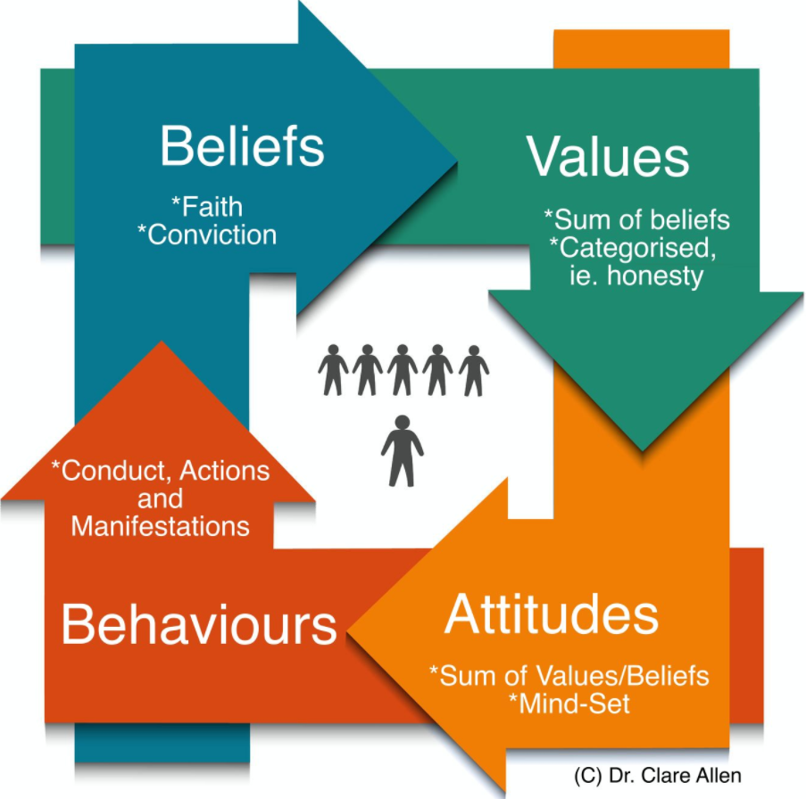
(Allen, 2020)

Appendix 2

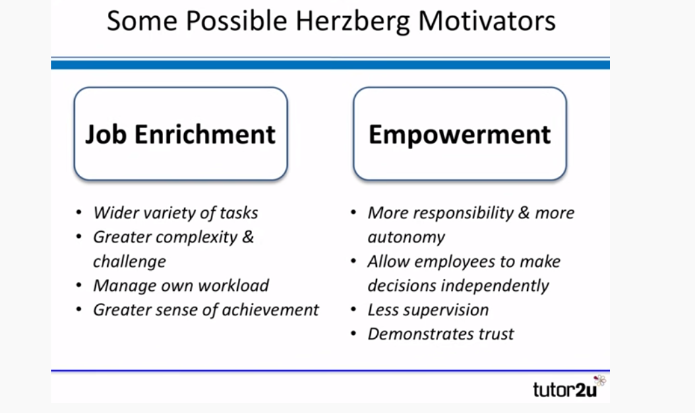
(tutor2u, 2016)

Appendix 3
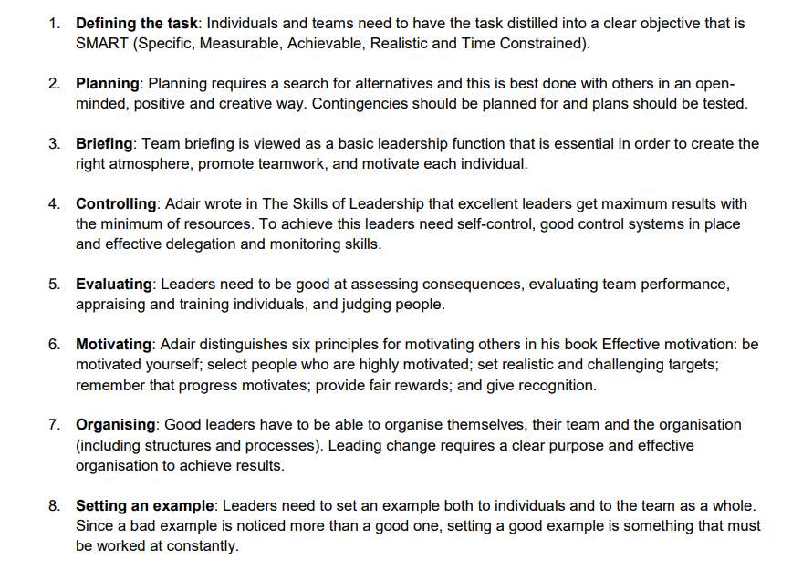
(CMI, 2016)

Appendix 4
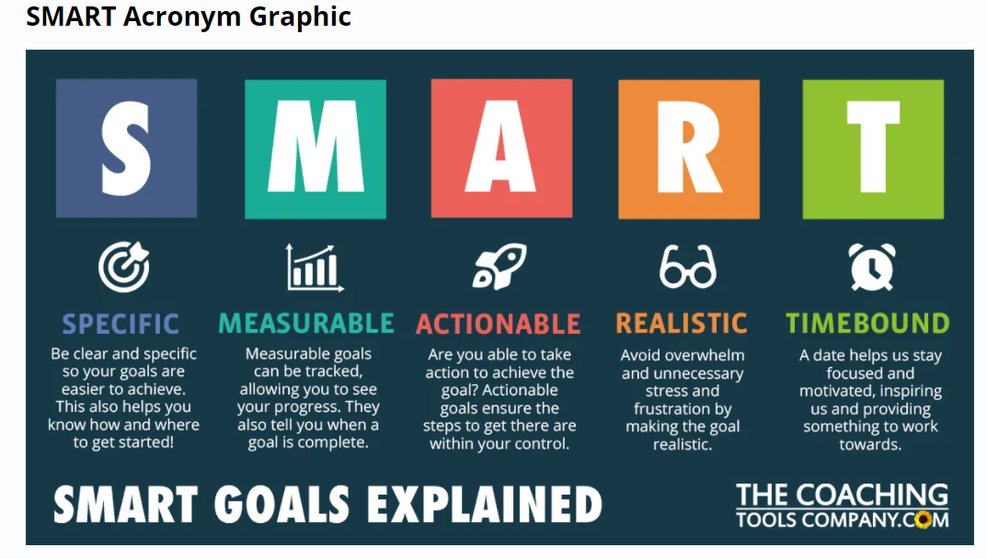
(The Coaching Tools Company, 2020)

Appendix 5

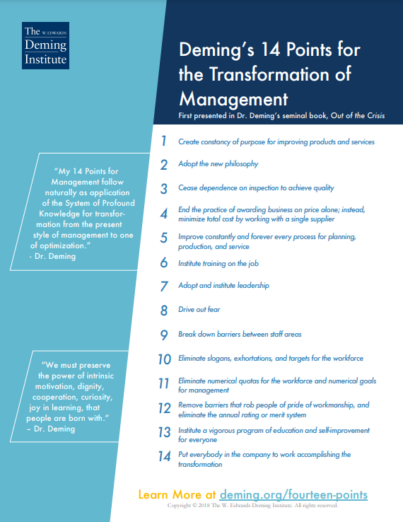
(The W. Edwards Deming Institute, 2018)

