The effects of visual filters and effects on a User’s Immersion in Virtual Reality

by
Gillean Yves Jofre

A Bachelor’s Dissertation
Submitted to the School of Applied Computing
University of Wales Trinity Saint David
In fulfilment of the requirements
For a Bachelor of Art Degree
April 2025

Supervised by Adam Head

Declaration Page
DECLARATION

I, Gillean Yves Jofre declare that I am the sole author of this Project; that all references cited have been consulted; that I have conducted all work of which this is a record, and that the finished work lies within the prescribed word limits.

This work has not previously been accepted as part of any other degree submission.

FORM OF CONSENT

I, Gillean Yves Jofre hereby consent that my Project, submitted in candidature for the B.A. (Hons) Computer Games Design degree, if successful, may be made available for inter-library loan or photocopying (subject to the law of copyright), and that the title and abstract may be made available to outside organisations.

Abstract
This dissertation explores the effects of different Visual Filters and Visual Effects on the user’s immersion experience while being in a Virtual Reality (VR) environment, and the significance of the psychology of immersion in this context.
From an interdisciplinary analytical perspective, the project scope and methodology focus on a review of available literature in relevant fields and case studies, to identify key factors influencing or determining the immersion experience in the context of visual filters and effects. Based on preliminary results, a prototype of a Virtual Reality Game (VRG) is developed where the immersion experience is enhanced through the use of visual filters and effects. Using live test subjects, the prototype’s effectiveness to enhance the user immersion experience was measured and further analysed though the use of surveys and statistical tools. Overall results suggest that the use of visual filters and effects in VR has a considerable potential to enhance immersion experiences, and consequently, further research in the area, particularly in case studies within application in the game industry is needed.

Contents Page

Table of Contents
Declaration Page 2
Abstract 3
Contents Page 4
Table of Figures 6
Chapter 1: Introduction 8
Chapter 2: Literature Review 10
Chapter 2.1: Psychology Behind Immersion and Visuals 12
Gestalt Principles 12
Chapter 2.2: Immersion in Video Games and Virtual Reality 15
The Psychology of Immersion (In Video Games) 15
Immersion in Virtual Reality 16
Immersive Study of Gestalt Variables in Uncanny Geographies 17
Chapter 2.3: Conclusion of Literature Review 18
Chapter 3: Existing media case studies 19
Chapter 3.1: Video games (2D Based) 19
Golden Light (2022) 19
Hyper Demon (2022) 21
Repose (2025) 23
Return to the Obra Dinn (2018) 25
Cruelty Squad (2021) 26
Chapter 3.2: Virtual Reality Games 27
Thrasher (2025) 27
REZ Infinite (2017) 28
Chapter 3.3: Miscellaneous Media (TV Shows, YouTube Videos) 29
Sin City (2014) 29
The Backrooms (Found Footage) (2022) 30
Chapter 3.4: Conclusion of Chapter 3 32
Chapter 4: Research Data and Prototype work 33
Chapter 4.1: Questionnaire 33
Chapter 4.2: Prototype work and testing results 39
Prototype Environment showcase and testing ideology 39
Visual Filters showcase and explanation 41
Prototype Test Results and Data breakdown 43
Chapter 5: Prototype results review and summary 47
Chapter 6: Conclusion of Dissertation 48
References 50
Bibliography 52
Appendix 56

Table of Figures

Figure 1: Figure of continuity principle taken from [4] – page 13
Figure 2: Figure of Closure principle taken from [4] – page 14
Figure 3: Golden Light title page [10] – page 19
Figure 4: In game screenshot [10] – page 20
Figure 5: Hyper Demon Title Card [11] – page 21
Figure 6: Screenshot of Hyper Demon [11] – page 21
Figure 7: Screenshot of Hyper Demon [11] – page 21
Figure 8: Repose Title Card [12] – page 23
Figure 9: Screenshot of Repose [12] – page 23
Figure 10: Screenshot of Repose [12] – page 23
Figure 11: Repose Title Card [13] – page 25
Figure 12: Screenshot of Return of the Obra Dinn [13] – page 25
Figure 13: Cruelty Squad Title Card [14] – page 26
Figure 14: Screenshot of Cruelty Squad [14] – page 26
Figure 15: Thrasher Title Card [15] – page 27
Figure 16: Screenshot of Thrasher [15] – page 27
Figure 17: Rez Infinite Title Card [16] – page 28
Figure 18: Screenshot of REZ Infinite [16] – page 28
Figure 19: Sin City: A dame to kill for DVD box art [17] – page 29
Figure 20: Screenshot of scene from Sin City: A dame to kill from [17] – page 29
Figure 21: The Backrooms (Found Footage) Title Card taken from [5] – page 30
Figure 22: Scene from The Backrooms (Found Footage) [5] – page 31
Figure 23: Section 2 of questionnaire – page 33
Figure 24: Section 3 of questionnaire – page 34
Figure 25: Results from Question 1 of Section 2 – page 34
Figure 26: Results from Question 2 of Section 2 – page 35
Figure 27: Results from Question 1 of Section 3 – page 36
Figure 28: Results from Question 2 of Section 3 – page 36
Figure 29: Results from Question 3 of Section 3 – page 37
Figure 30: Results from Question 4 of Section 3 – page 38
Figure 31: Screenshot 1 of prototype environment – page 39
Figure 32: Screenshot 2 of prototype environment – page 39
Figure 33: Screenshot 3 of prototype environment – page 40
Figure 34: Filter 1 in prototype (Dithering based Filter) – page 41
Figure 35: Filter 2 in prototype (ASCII based Filter) – page 41
Figure 36: Filter 3 in prototype (“PSX” based Filter) – page 41
Figure 37: Picture of participants during prototype test – page 43
Figure 38: Picture of participants during prototype test – page 43
Figure 39: Results of question 3 from questionnaire – page 45
Figure 40: Results of question 4 from questionnaire – page 45
Figure 41: Results of question 5 from questionnaire – page 46

Chapter 1: Introduction
This dissertation explores the effects of different Visual Filters and Visual Effects on the user’s immersion experience while being in a Virtual Reality (VR) environment, and the significance of the psychology of immersion in this context.
From an interdisciplinary analytical perspective, the project scope and methodology focus on a review of available literature in relevant fields and case studies, to identify key factors influencing or determining the immersion experience in the context of visual filters and effects. Based on preliminary results, a prototype of a Virtual Reality Game (VRG) was developed where the immersion experience is enhanced through the use of visual filters and effects. Using live test subjects, the prototype’s effectiveness to enhance the user immersion experience was measured and further analysed though the use of surveys and statistical tools. Overall results are used to determine the value of the research proposal in the context of VRG in the video game industry and other context where the use of VR is also relevant, and potential directions for further research in the area are also discussed.
The structure of this dissertation is as follow:
Chapter 2 looks at the existing research conducted into two fields; the psychology of immersion with focus on the Gestalt principles and secondly, the research on the immersive nature of VR.
Chapter 3 includes several case studies of existing media (video games, virtual reality and traditional, as well as movies and videos) making use of different visual styles, visual effects and visual filters to create a more immersive and engaging experience for the viewer.
The practical research and data gathered, as well as the testing approach and methodology is included in Chapter 4 that consist of two sections: A preliminary questionnaire study that was conducted at the beginning of the project; and a second study ( test) that was conducted at the end of the project using a prototype developed to test different visual filters in a contained virtual environment.
Results of the practical project are summarised and discussed in Chapter 5, while conclusions of the dissertation are presented in Chapter 6.

Chapter 2: Literature Review
Due to the rise in popularity of VRGs, particularly in the ‘indie’ segment [1], there is an increased need to improve and diversify the immersive gaming experience of users. In this context, visual filters are commonly employed to manipulate images and create visual effects that can influence the game experience, with both intended and unintended results. However, as of today, there is no available research in the field of games focusing on the use and effects of visual filters in VRG users. The following literature review, investigates the potential effects of visual filters on the immersive experience of VRG users from an interdisciplinary perspective, attempting to identify potential correlations between the use of visual filters and the enhancement of a player’s immersion experience in VR.
The idea of using visual filters – here understood as visual effects overlaid onto a final rendered image that distort and manipulate the image to an intended visual effect – to alter the game experience has been indirectly tested with modders adding VR onto games developed for 2D platforms like desktop computers and game consoles [2]. However, some other games, like Half life: Alyx [3] have similar elements but are designed to be viewed in virtual reality and it allows for another level of immersion for the player.
Thus, I argue that further research into this might not only have relevant consequences on visual design in VRG, but also in VR applications in general. If we can design better immersion through visual effects with known results on the user’s experience, the application and diversification of VR in the game industry, and other relevant industries, could be very promising.
This review is divided into two sections: Chapter 2.1 focusing on the psychology behind immersion, and Chapter 2.2 is the research conducted into VR and immersion in VR. In addition, a further discussion on these subjects is conducted from the perspective of psychology principles relevant to VR.

The lack of available research on these topics in the specific context of the games industry implies that some inferences were based on relevant cases and studies within other field of research such as media and communications and psychology. Thus, conclusions emerging from this review, although relevant to the area of research in general, must be observed with caution and within the context of each case study.

Chapter 2.1: Psychology Behind Immersion and Visuals

Gestalt Principles
Gestalt principles refer to a set of rules of the organization of perceptual scenes [4]. This applies to immersion and visuals by it pertaining to how humans would perceive a complex scene (or in the case of a Video Game, a complex environment) and how they would mentally organise the objects within an environment to create an understanding of what is being seen.
These principles cover several types of visual association and how they work in different ways.
These principles are [4]:
- Figure-Ground Articulation
- Proximity principle
- Common fate principle
- Similarity
- Continuity principle
- Closure principle
- Good Gestalt principle
- Past experience principle
In this review, the focus will be on Past experience principle, Closure principle and Continuity principle.

Past Experience Principle
This principle follows the idea of humans organising a visual input, where elements tend to be group together if they are associated with elements that they’ve often seen together before. For example, this allows people to view text written in their language to be viewed even if its slightly obscured or distorted.
This can apply to immersion in VR by using ‘nostalgic’ elements to help enhance the visuals in a scene. For example, in the popular YouTube Series ‘The Backrooms’ [5], it makes use of aspects in the world’s environment that are reminiscent of old environments that the viewer has possibly seen before. This amplifies the horror shown together with a contorted view of the world they are familiar with.
In terms of integration with VR, this principle can be used to guide the structure of the game environments, while visual filters can be used to alter the ‘feel’ or ambience of a scene within that environment like creating a sense of reminiscence that could enhance the player’s immersive experience.

Closure Principle and Continuity Principle
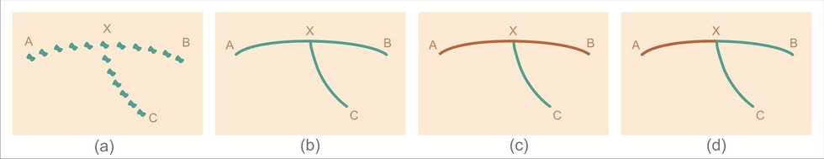
The Closure and Continuity Principles work in similar ways, where the idea is how an observer of an environment will group together object that form a line or group within logical lines. For example, an assortment of objects laid out on the floor in the shape of arrow with still produce the effect of an arrow being painted onto the ground in the same fashion, same applies for a circle, in terms of the closure principle. These effects can also be disrupted by changing the objects used to split up the group into two, for example by changing a colour used. Refer to example Figures 1 and 2 below.
Figure 1: Figure of continuity principle taken from [4]
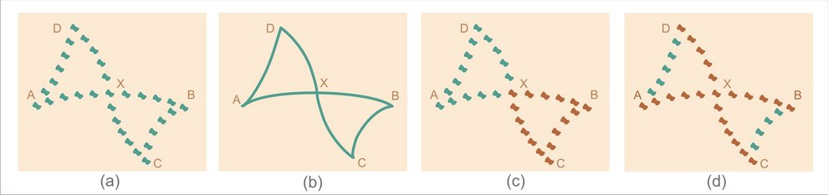
Figure 2: Figure of Closure principle taken from [4]

This can be applied in visual filters by having filters change how objects are viewed in a scene, for example a filter that changes the shading of an object to one which is dither based and entirely in black and white. Small artifacts will appear on an object, disrupting its overall look, but if its silhouette can be group together logically using these filters, players will still be able to associate it to an item or environment that makes sense to them.
Rather than this being a principle that can be manipulated to enhance immersion in a scene, this can be used as a gauge when creating visual filters for use in VR, so as not to create and entirely uncomfortable and disorientating environment.
Now that a basis for what immersion can be dissected into, the next section of the paper will delve into the psychology of immersion within the realm of video games and VR experiences and how they tie into the Final Major Project as well as the Gestalt Principles of visuals.

Chapter 2.2: Immersion in Video Games and Virtual Reality

The Psychology of Immersion (In Video Games)
This part touches upon immersion and how one can split it up into three proposed areas: sensory-based, challenge-based, and lastly imaginative. Sensory-based refers to the use of audio and how it affects a player’s immersion, while challenge-based focuses on the use of gameplay mechanics, and imaginative is an umbrella term for how the entire game can activate a player's imagination and how that can be immersive [6].
According to Ermi and Mayra [7], immersion in Video Games can be akin to the psychological state of non-meditation, a state when a person is fully immersed in a different reality, in this case, a computer-generated reality. This state can be achieved by having a balance between all three of the above mentioned areas of Video Games based immersion; having an imbalance of any of the three can in the end, be more disorienting and damaging to the players immersion (for example if the Video Game’ content largely outshines the audio, visuals and possibly the story, the player might lose focus and view the Video Game at face value). This balance is important in VR too because to enhance immersion the use of Visual Filters, needs to be aligned with the overall environment and gameplay mechanics.

Immersion in Virtual Reality
This part focuses on the work of an academic journal (In the context of how VR could be use in a Business orientated setting) that views how interaction and immersion play a role in a VR setting, where the part on immersion will be highlighted and how it can affect an observer’s satisfaction of the VR experience [8].
This paper suggests that an immersive experience in a non-gaming setting usually leads to higher user satisfaction, compared to similar tests being conducted on the immersion of individuals while playing either single-player or multiplayer video games, which show that an increased level of immersion might not actually improve user satisfaction. Therefore, one can argue that while immersion might help enhance a positive VR experience in general, the level of user satisfaction does not fully depend on the immersion but also on the user’s perception of the VR environment. This consideration can be used to our advantage in certain cases, such as for example in horror VRG experiences, where the user’s satisfaction can be increased by balancing the use of ‘unsettling’ scenes and or environments and Visual Filters to enhance the immersion experience, increasing the psychological effect of an intended feeling or emotion (e.g., fear, dread, or paranoia).

Immersive Study of Gestalt Variables in Uncanny Geographies
This paper is included in Chapter 2.2 due to how it corelates to ‘Immersion in VR’ by expanding upon the idea that environments and experiences that are considered ‘Uncanny’ and possibly ‘negative’ can be immersive.
‘Uncanny’ in this case works with the idea of haunted, sacred and or enchanted spaces that illicit enhanced human emotions [9].
Following the study (the study conducted on immersion had only a handful of participants, hence why the overall data is taken as an exploratory look into this area) it was shown that participants did have an increased level of immersion, correlating to an enhanced response to Gestalt Principles in environments that were considered to be ‘uncanny’. A detractor of the trend was ambiguity due to uncomfortable layout of the environments that the test was conducted in.
These results go hand in hand with the previous study conducted on Immersion in VR, where negative experience that were felt with enhanced immersion led to an often-negative perception in overall immersion and possibly satisfaction to what was desired by participants on either study.

Chapter 2.3: Conclusion of Literature Review
A key finding in this review is that Gestalts principles can be applied to enhance the immersion in VR. This potential application follows two key aspects; Past experience principles can be applied in the context of using nostalgic visual effects to evoke a heightened level of immersion in an observer; while following the principles of Continuity and Closure to strategically design and deploy visual effects to enrich the user’s experience by adding visual layers that although subtle in form, can have a powerful effect over the immersion experience. These visual layers must be balanced and fully aligned with the overall visual design and mechanics of the game, to avoid an overly distracting visual experience that lowers immersion and satisfaction.
With that in mind, the ‘emotion’ of the environment that is visualised plays a large role in the immersion of an observer, whether positive or negative, this must be aligned to match the intended effect of the visual experience. Balancing these aspects together with the mechanical and auditory experience in VR can create an experience that is much fulfilling and exiting than in traditional 2D platforms.
This suggests that by altering a scene in a specific way (In this case with the use of visual filters) a more (or less) immersive experience can be achieved in VR. This can have significant effects in users’ satisfaction, and therefore it is important for the successful commercialization and diversification of VR technologies. For VRG, the use of visual filters offers innovation opportunities to enhance and enrich the immersion experience and users’ satisfaction, particularly in the segment of indie games where the discussed Gestalts principles match the visual trends in retro and horror games.
Further research into this field is needed to fully understand the role of visual effects in the enhancement of immersion in VR and VRG. Advancing knowledge in these issues is not only important for the game industry but also for other areas where VR and immersion are (or can be) increasingly applied.

Chapter 3: Existing media case studies
This section will go over examples of existing media that to push immersion by using unique and alternative visual styles and filters.
This will be broken into three different sections:
- Video games, that are 2-D based.
- VR games.
- TV shows, YouTube videos and other forms of miscellaneous media that fall under the criteria.

Chapter 3.1: Video games (2D Based)
Video games in this section are featured due to their utilisation of visual filters and alternatives visual styles compared to other video games (Mostly from ‘AAA’ Studios; EA Studios, Ubisoft, etc,.) that came out during the same time. These alternative visuals can include the use of different textures and modelling techniques, the use of particles within an environment or a unique style that the visuals are presented. These will be the main points focused on for the creation of the Final Major Project and research moving forward.


Golden Light (2022)
Figure 3: Golden Light title page [10]

Golden Light (2022) [10] is an Indie game developed by ‘Mr Pink’ and released on Steam, that is a First-Person, horror, Roguelike (see Figure 3). It makes use of several techniques to create an “immersive” environment that fits into the story and setting of the game.
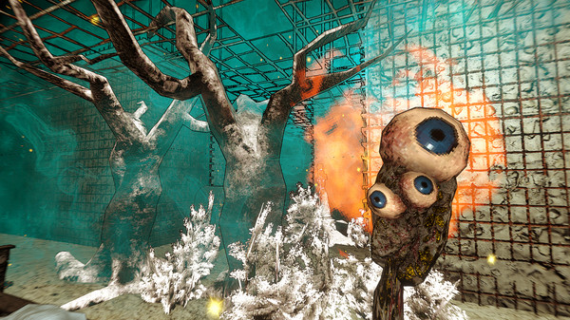
Figure 4: In game screenshot [10]
For example, this section of the game, uses a filter overlaid over the final rendering of the game to add a ‘highlight’ to all the objects in a scene (see Figure 4). This distorts the visuals slightly by having harsh borders always visible to the player. Together with the low resolution used in the rendering of the game overall, this creates an immersive experience for the player in the sense that it adds to the unrealistic and ‘corrupted’ visual style of the world.
Another part that adds to the ‘immersive’ aspect of the game is the use of particle effects. These are used to show different effects within the game world but are also used to disorientate the player.


Hyper Demon (2022)
Figure 5: Hyper Demon Title Card [11]
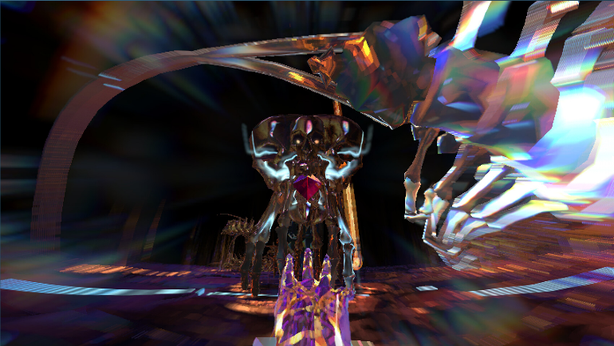
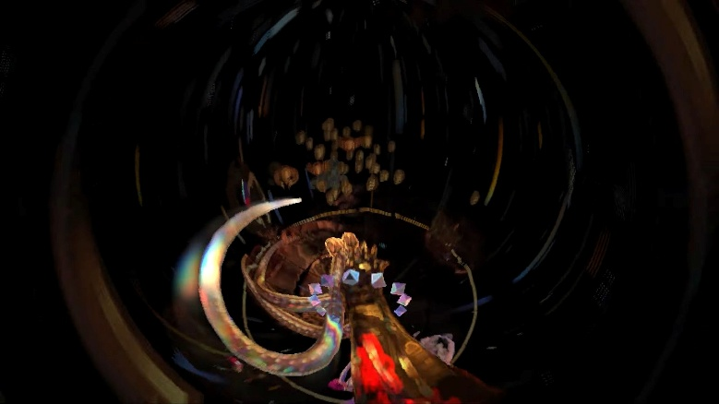
Hyper Demon [11] is a Video game created by Sorath and released on ‘Steam’, that is a First-Person, Arena Shooter (see Figure 5). Compared to ‘Golden Light’ this game makes use of certain camera effects in its visual style on top of its visual style and filters.
Figure 7: Screenshot of Hyper Demon [11]
Figure 6: Screenshot of Hyper Demon [11]

The camera in Hyper Demon makes use of a fish-eye filter together with a bokeh blur applied (see Figure 7). This together with a glitch effect (see Figure 6) creates a unique visual style, unseen in other games. The use of these effects adds to the overall chaotic colour scheme and gameplay, enhancing player immersion overall.
Another way this game uses unique visual effects is the pixelation of certain objects that are interacted with in an environment to add emphasis and ‘chaos’ to the scene.
The game’s art style is also rather simplistic when compared to its heavy use of visual effects and filters, with the environment being generally a black void, with low-polygon characters and entities.


Repose (2025)
Figure 8: Repose Title Card [12]
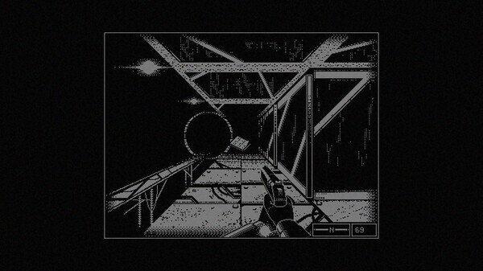
Repose [12] was created by Bozó Attila Bertold and published by Akupara Games, it is a First-Person Dungeon crawler horror game (see Figure 8). It makes use of a 1-Bit visual style (The game is rendered in only black and white, with no in-between colour).
Figure 9: Screenshot of Repose [12]
This sort of rendering was commonly used in the first First-Person shooter created in 1973 (Maze War[13]). While at the time it was used due to the lack of processing power available in Personal Computers at the time, it is used in this game for an immersive and nostalgic experience.
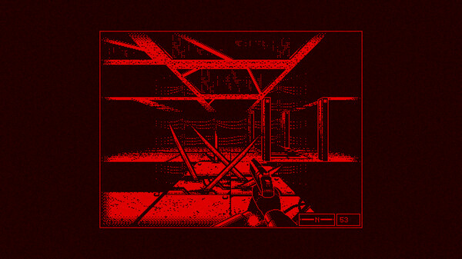
Figure 10: Screenshot of Repose [12]

Repose alternates the colours used in the game (Red, white and blue) (see Figure 9 and 10) to represent different environmental changes in the game, an immersive way to tell the player what is occurring in the game without either writing it down or having another visual aid for the player that breaks immersion.


Return to the Obra Dinn (2018)
Figure 11: Repose Title Card [14]
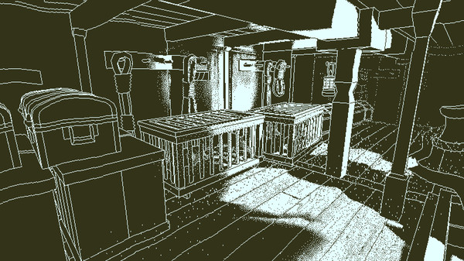
Return of the Obra Dinn [14] was created by Lucas Pope and was published by 3909 (see Figure 11). This Video Game makes use of the same 1-Bit visual style as Repose; however, it uses another technique call dithering.
Figure 12: Screenshot of Return of the Obra Dinn [14]
Dithering allows for real-time lighting with proper shading to be built into the game, while only keeping the colours used to two (see Figure 12). This does also have the added effect of making the visual style of the game to look like that of a Black and White comic book or illustrations in a book. Depending on its use, it can add immersion to a player’s experience by enhancing the story and or gameplay.


Cruelty Squad (2021)
Figure 13: Cruelty Squad Title Card [15]
Cruelty Squad [15] was created and published by Consumer Softproducts, it is a ‘Immersive-sim’, First-Person shooter (see Figure 13) that relies on its visual art style to create an immersive experience and to enhance its story as well as gameplay.
Figure 14: Screenshot of Cruelty Squad [15]
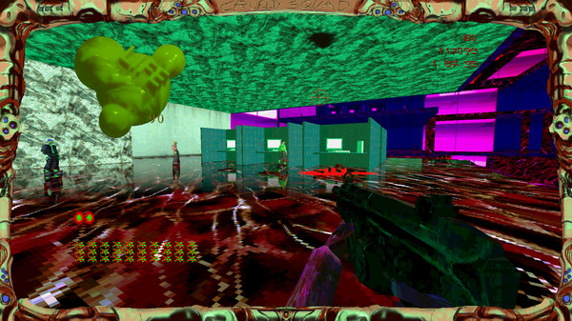
The game’s art style is a chaotic mix of clashing textures that do not fit the intended look for the object in the environment (see Figure 14). This creates an unreal and unsettling visual experience for the player that enhances the rather ‘retro’ looks of the game environment. This also emphasises the sort of twisted and distorted world that the game is set in. All these combined, add to the immersive experience for the player.

Chapter 3.2: Virtual Reality Games
This section will look at VRG that try to have more unique and varied visual styles than that of other VRG.


Thrasher (2025)
Figure 15: Thrasher Title Card [16]
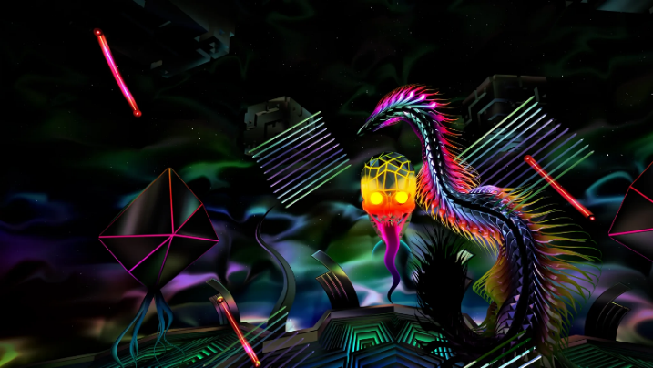
Thrasher [16] was created by Puddle and published by Creature, with it being a rhythm game developed exclusively for the Meta Quest 3 (see Figure 15). Compared to other rhythm games in VR (e.g., Beat Saber), it has a more unique and contrasting visual style.
Figure 16: Screenshot of Thrasher [16]
The visuals consist of a simplistic, multicoloured background, with an assortment of shapes and object populating the environment (see Figure 16). The main item players interact with is a highly detailed ‘serpent’ that has a shimmer effect added on top of it and the main ‘enemy’ is a brightly coloured ‘skull’. This, combined with the gameplay and story of the game makes for a more immersive experience, by having the ‘chaotic’ Visual Style match the fast paced rhythm gameplay and music.


REZ Infinite (2017)
Figure 17: Rez Infinite Title Card [17]
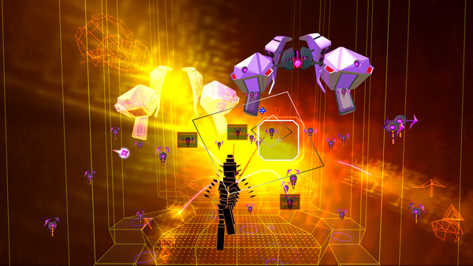
REZ Infinite [17] is a modern remaster of a game originally developed for the SEGA DreamCast system (2001), created by Monstars Inc and Resonair, and published by Enhance (see Figure 17). The game is an on-rails shooter with rhythm mechanics. Its unique visuals make it a similar case to Thrasher where it stands out when compared to other similar VR experiences. As a side note, it can be played in both VR and on a desktop and monitor setup with the gameplay being the same.
Figure 18: Screenshot of REZ Infinite [17]
The Visual style of the game is made up of either Wireframe or Low-Polygon Objects that immerse the player in the ‘cyberspace’ world of the game. Another way this game is unique in its visuals is the way the shadows are rendered in game, making the 3D objects look 2D, as well as having the environment be slightly pixelated, immersing the player more in the world and its story (see Figure 18).

Chapter 3.3: Miscellaneous Media (TV Shows, YouTube Videos)
These are other forms of media (non-interactive) that make use of unique visually filters and effect choices to immerse the viewer in the story that they are telling.

Sin City (2014)
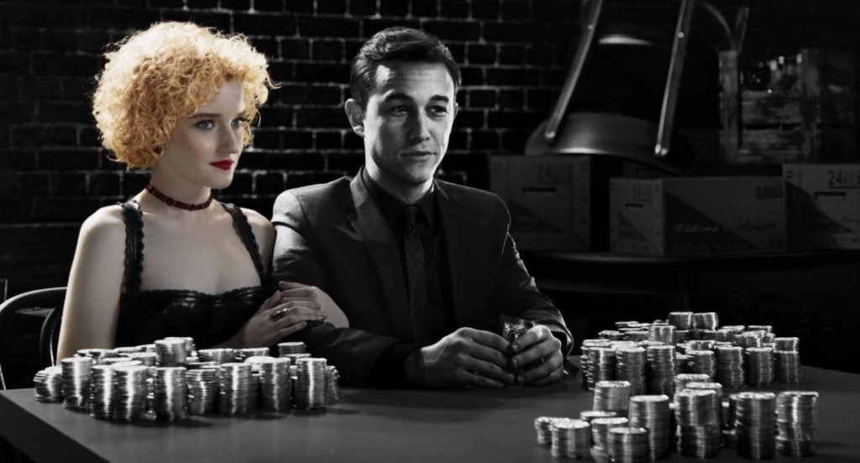

Figure 20: Screenshot of scene from Sin City: A dame to kill from [18]
Figure 19: Sin City: A dame to kill for DVD box art [18]

‘Sin City: A dame to kill for’ [18] is a movie that makes use of a difference in colour to highlight an objects importance and standing within the story of the movie (see Figure 19). For example, in the shown scene of the movie, the environment and main character is entirely in black and white. However, the secondary character is shown in full colour, to highlight that she is something almost ‘otherworldly’, the main ‘MacGuffin’ of the movie. This can help to immerse the audience in the ideals and motives of the characters shown in the movie (see Figure 20).

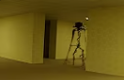
The Backrooms (Found Footage) (2022)
Figure 21: The Backrooms (Found Footage) Title Card taken from [5]
The Backrooms (Found Footage) [5] is the first part in a series of YouTube Videos created by Kane Pixels that are about the idea of humans being transported to alternate realities set in the 1980s (see Figure 21).
The way that the creator makes this video immersive, especially for a animated video created entirely on Blender [19], is how they managed to make the in-engine camera to look like a ‘Camcorder’ from the 1980s. Kane Pixels achieves this by overlaying a ‘VHS’ filter, together with the aspect ratio of 4 by 3 and finally the addition of slight artifacts that make it seems like it was recorded onto tap. Another way this enhances immersion is when the main enemy is present on screen, all the visual effects are increased, heavily influencing what the viewer is meant to feel in that situation: Fear and anxiety. (see Figure 22)
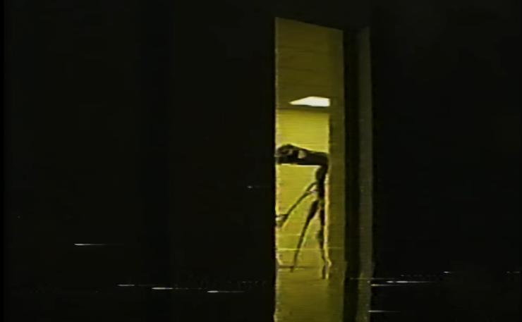
.
Figure 22: Scene from The Backrooms (Found Footage) [5]

Chapter 3.4: Conclusion of Chapter 3
In conclusion to the study on existing media that make use of unique visual filters and visual effects, we can take away to make a piece of visual media immersive, it plays on a few different techniques and immersive principles.
For example, when it comes to video games, nostalgia plays a large factor into making a game immersive. This can be the use of a render style that is reminiscent of old, 1-Bit games, in the case of Repose [12] or in the way that Cruelty Squad makes use of ‘low-poly’ models for its environment [15].
When it comes to games that are made in VR, it comes down to creating a balance between the mechanics as well as the visuals of the game, leading to one help the other, and be showcased in a way that compliments each other.
Similar to how VRGs are immersive with unique visual effects, non-interactive media can be as well, with its use of different techniques (e.g., a difference in colour or the use of heavy visual effects) to let the viewer know more of the story, the characters involved, as well as their motivations.
All of these techniques can be applied to create visual filters in VR enhancing player immersion.

Chapter 4: Research Data and Prototype work
This will go over the two points in this project where I conducted real-life research and prototype work over two sections: Chapter 4.1, where I will discuss a questionnaire that was used to gather preliminary information on the opinions of participants on VR and secondly, in Chapter 4.2, the prototype that was created and tested will be showcased. To view any of the questionnaire question mentioned in Chapter 4, refer to Appendix.

Chapter 4.1: Questionnaire
This questionnaire was made up of multiple choice and open-ended questions that asked participants general questions about their thoughts and opinions on games that use visual filters and distinctive art styles, as well as how versed people are in VR and VR gaming. In total, eight students participated in this first study.
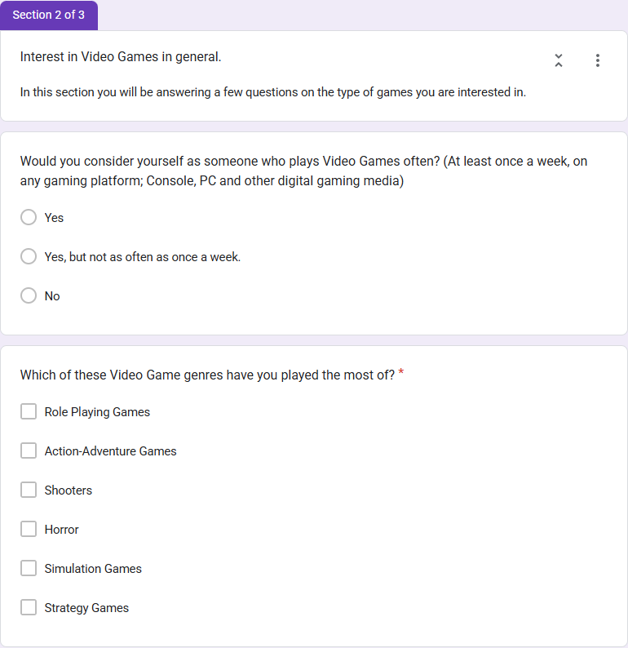
The questionnaire was structured into three sections. Section 1 included basic information questions such as student number and name (not included in this study due to privacy), Section 2 which gathered data on what participants ‘gaming’ preferences were, and Section 3, which asked questions about VR Gaming. The questionnaire was implemented using Google Forms (see screenshots in Figure 23 and 24).

Figure 23: Section 2 of questionnaire
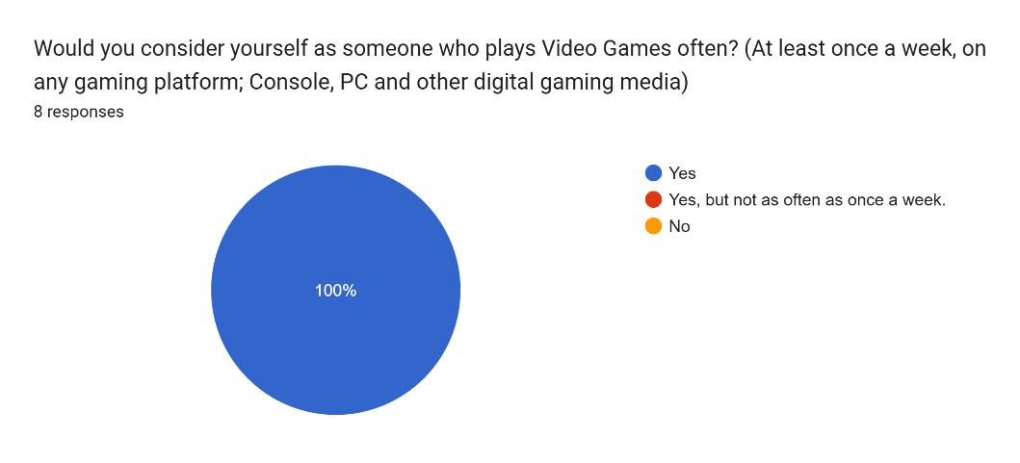
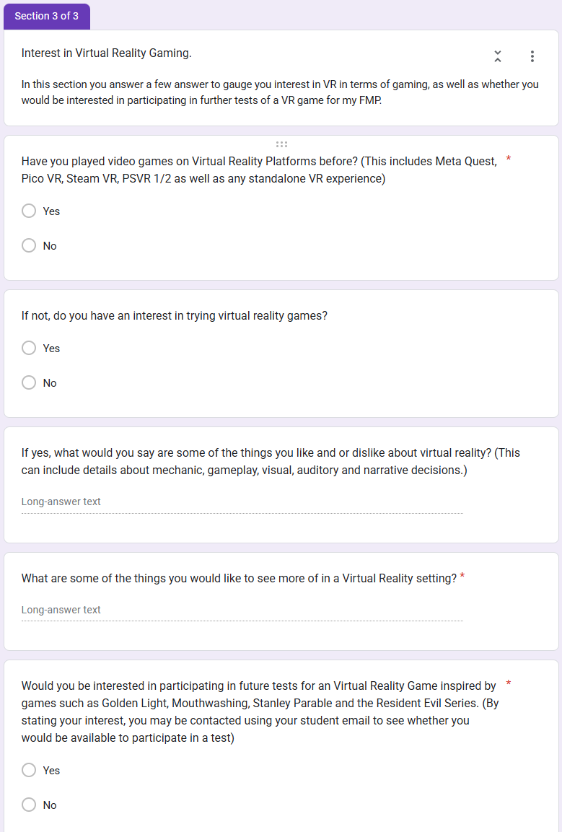
The first two questions in section 2 gathers information on whether participants would consider themselves as someone who plays video games often regardless of platform, as well as what genre of video games do they prefer (see Figure 25 and 26).
Figure 25: Results from Question 1 of Section 2
Figure 24: Section 3 of questionnaire

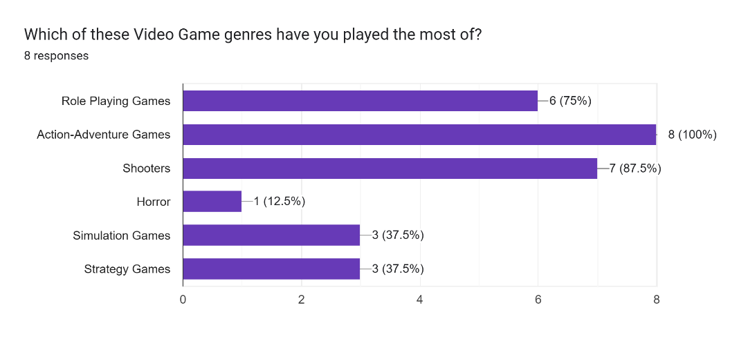
The results of question one of this questionnaire shows that the entirety of the eight participants do play video games often, with question two showing that of the group, majority have played more video games that are Role-Playing games (Baldur’s Gate 3 [20] or The Witcher [21]), and Action-Adventure games Max Payne [22] and Uncharted [23]) as well as shooters (Call of Duty [24] and Apex Legends [25]). Simulation and strategy games were also selected by at least half of the participants (see Figure 26).
Figure 26: Results from Question 2 of Section 2
This first section shows that the participants are possibly more inclined into playing video games that are could be deemed to be more interactive and immersive than other titles.

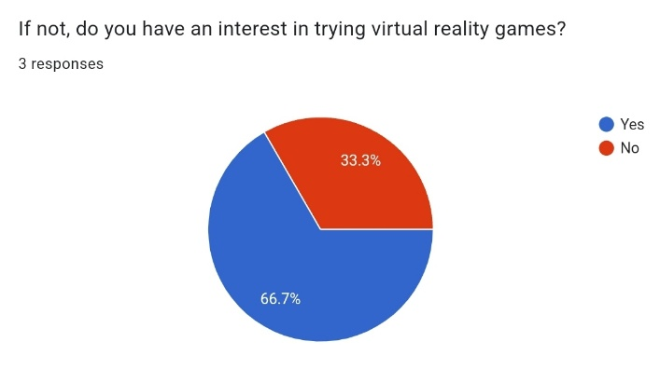
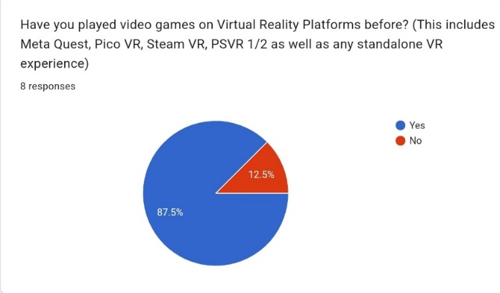
In the second section of the questionnaire, participants had to answer questions that were tailored towards gathering data on VR and VRG in general.
Figure 28: Results from Question 2 of Section 3
Figure 27: Results from Question 1 of Section 3
These first two questions gather information on how experienced the group is with VR and if there is an interest in experiencing it if they have not.
The results from these questions show that it is not wrong to say that many people have already had some experience with VR gaming, with only 1 in 8 of the participants having not tried it yet (see Figure 27). However, when it comes to interest in VR, the results of a third of the participants not having a true interest in VR, shows some hesitation when it comes to the use of the platform (see Figure 28).
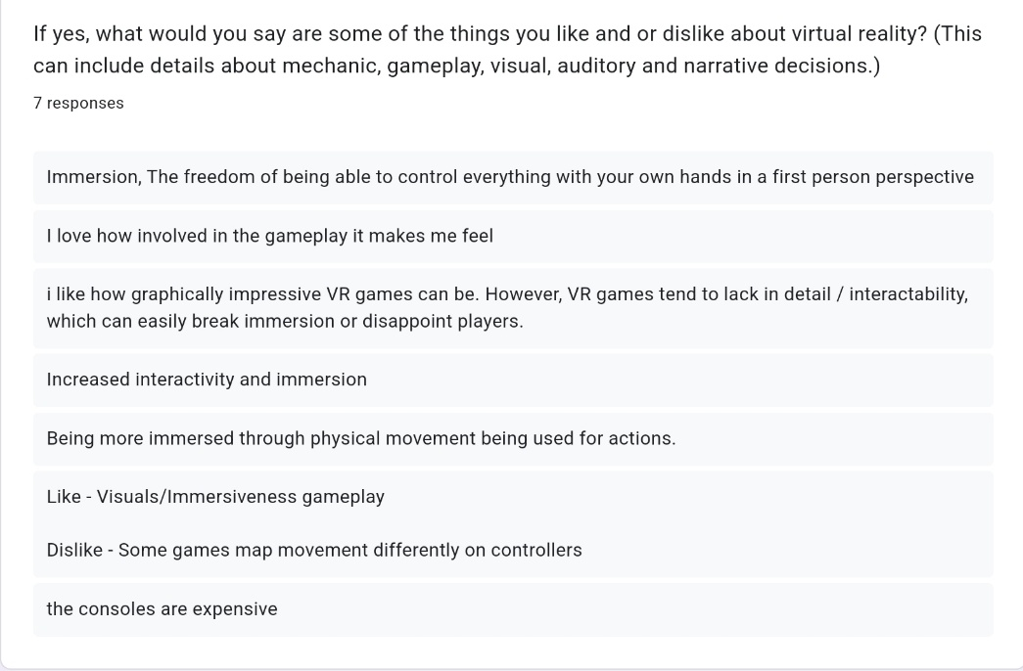
Question 3 asked participants what they liked and or disliked about VR gaming. A few of the major points brought up in the results was how much they liked the immersive and interactive aspect of VR gaming (see Figure 29).
Figure 29: Results from Question 3 of Section 3
One of the responses stated that the consoles that made use of VR were too expensive. This had a huge impact on defining my final major project and focusing it on creating a VR game that could be played natively on a Meta Quest, specifically the Meta Quest 3 and 3s.

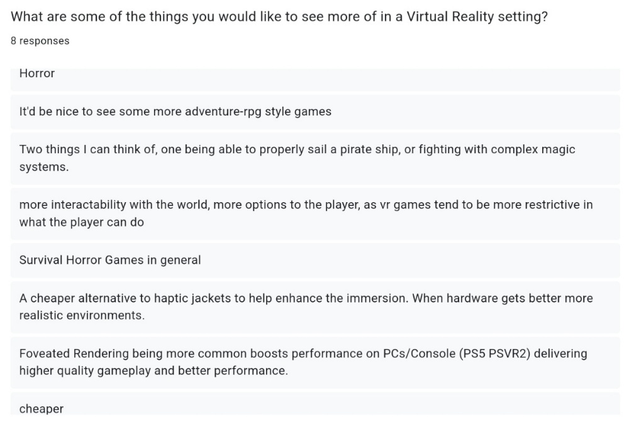
The final question, Question 4, was aimed at gathering pointers on what participants would like to see in a VRG and see if they coincided with what I was tailoring my VR experience towards. A few responses wanted to see more horror games created in VR, with another wanting more interactable environments. One response did mention Foveated rendering, which would be something investigated for the final version of the game depending on the hardware (see Figure 30 for more details).
Figure 30: Results from Question 4 of Section 3

Chapter 4.2: Prototype work and testing results

Prototype Environment showcase and testing ideology
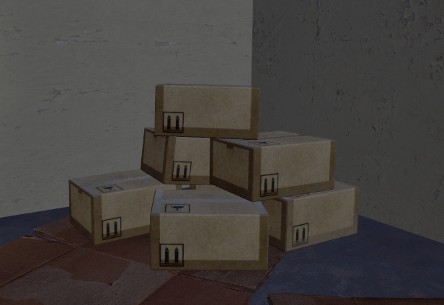
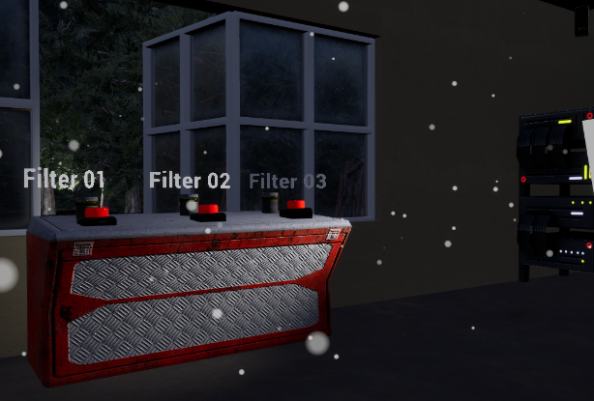
Based on the results of the first questionnaire as well as case studies into similar media, a prototype was made. This was used in an in-person test to gather real-time data on what participants thought of having visual-distorting filters in a VR Experience. The test was conducted in-person using University provided Desktops as well as Meta Quest 2s. The screenshots of prototype environment are shown in Figures 31 to 33.
Figure 32: Screenshot 2 of prototype environment
Figure 31: Screenshot 1 of prototype environment

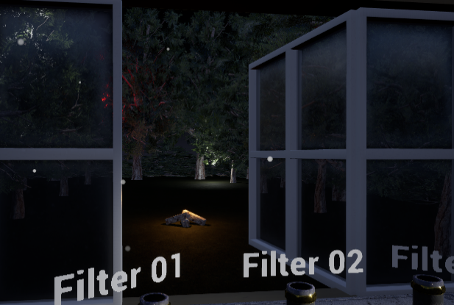
The prototype environment was made up of three different focus areas. The main room that participants spawn into has different lighting –darker environments with objects that have small bright lights, as well as brighter areas (see Figure 31); two areas where participants can interact with boxes (see Figure 32); and lastly, an area that allows participants to view a forest scene (see Figure 33).
Figure 33: Screenshot 3 of prototype environment
These three areas test three things: 1) How participants view an enclosed room with different lighting areas with different visual filters, 2) how said filters affect a participant’s perception of distance and outdoor spaces, and 3) how does it affect a participant’s ability to interact with simple objects.

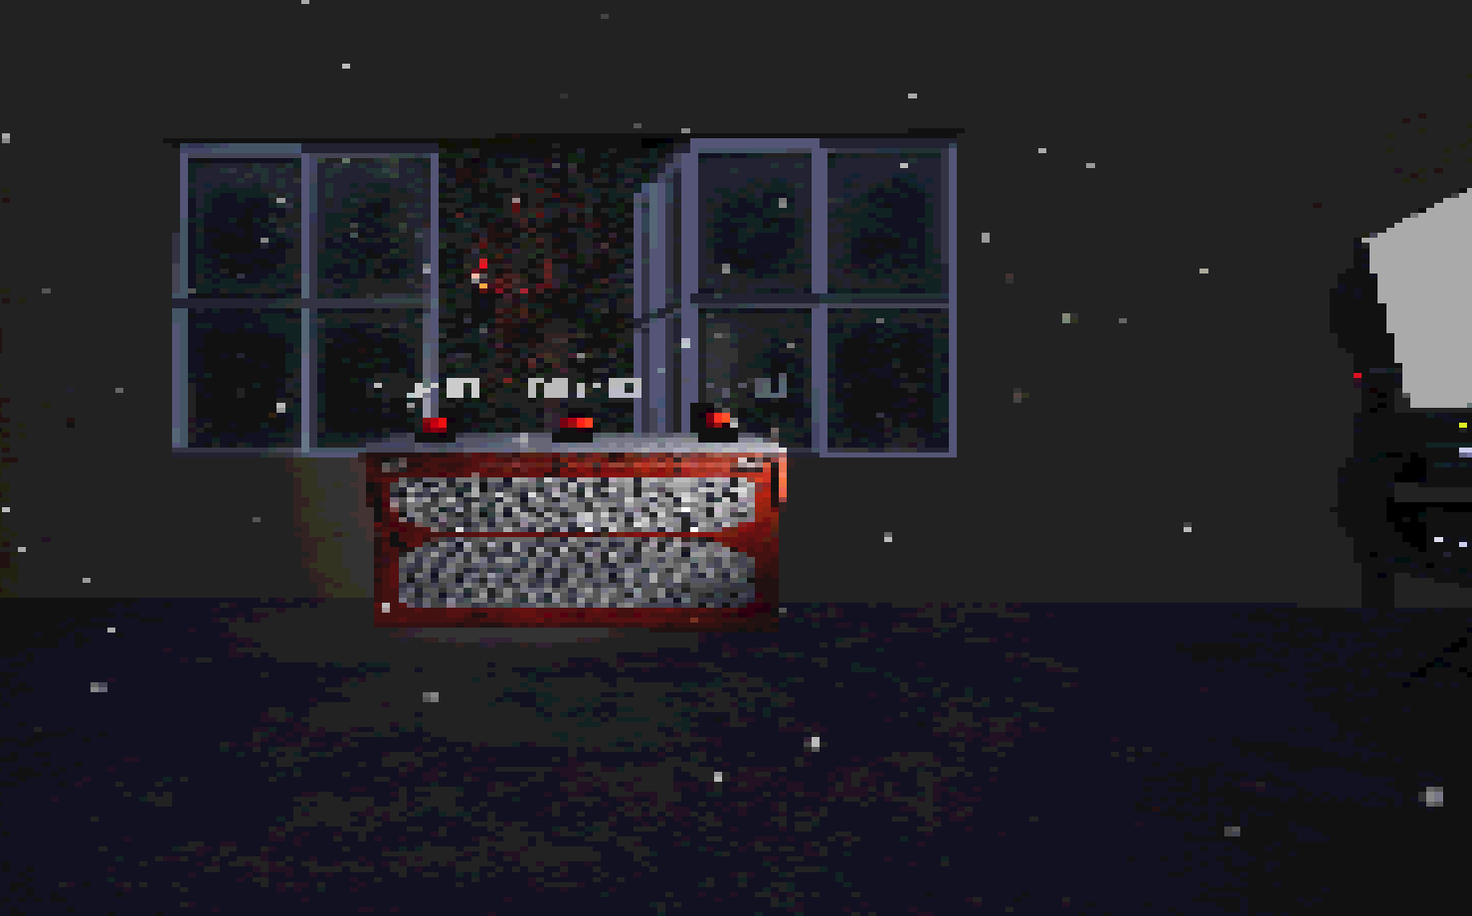
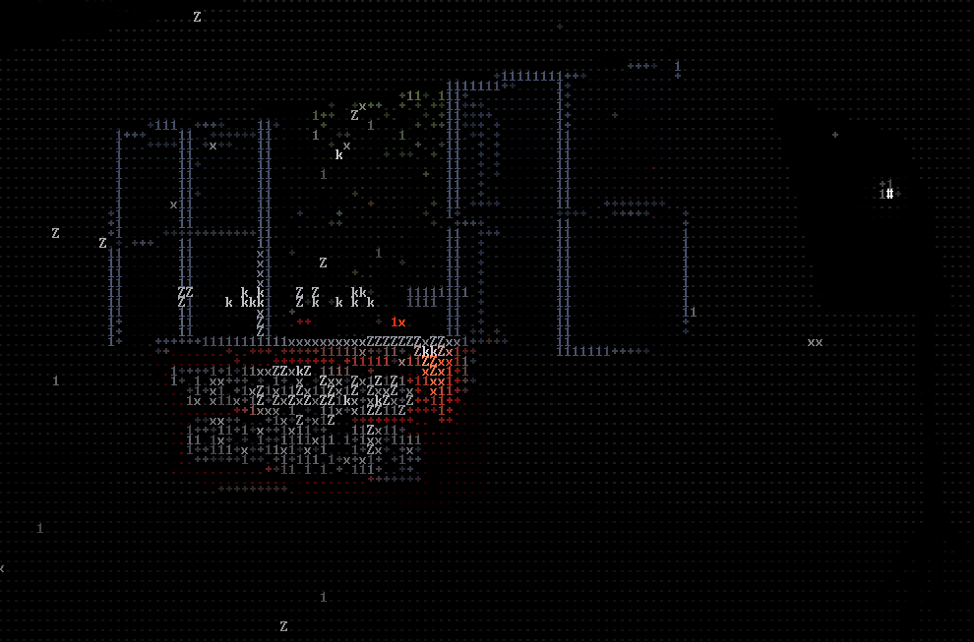
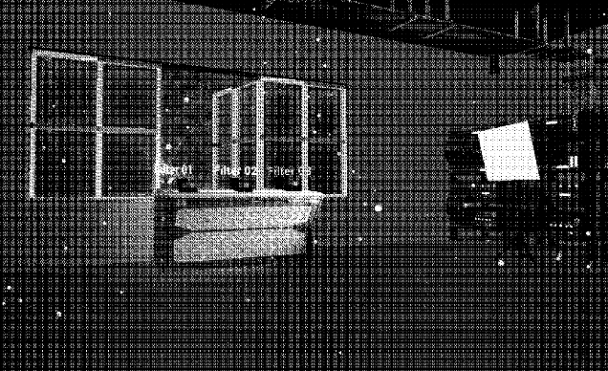
Visual Filters showcase and explanation
Figure 36: Filter 3 in prototype (“PSX” based Filter)

Figure 35: Filter 2 in prototype (ASCII based Filter)

Figure 34: Filter 1 in prototype (Dithering based Filter)

Three different filters have been tested, namely, Dithering based filter, ASCII based filter, and “PSX” based filter, as shown in Figures 34 to 36:
- Dithering based filter: This filter was originally featured in the video game “Return to Obrah Dinn [14]”, where it adds an almost “comic book” filter onto of the image as well as making the visuals black and white.
This tested how participants would feel in an environment that was distorted, as well as lacking colour.
- ASCII based filter: This filter was chosen to test out how far I could potentially push the visual filters in the prototype. This was inspired by a recent trend of video games using a form of “LIDAR” Filter [26].
- “PSX” based filter: A lot of recent indie titles have been making use of PSX visuals and filters to enhance the immersion of the game, hence why it was chosen to be tested in this prototype. It reduces the overall fidelity of the image by reducing the resolution rendered as well as changing how shadows are rendered.
These filters are just an example of what could possibly be applied in a further test, with the application of these filters in Unreal Engine [27] being relatively simple to achieve.

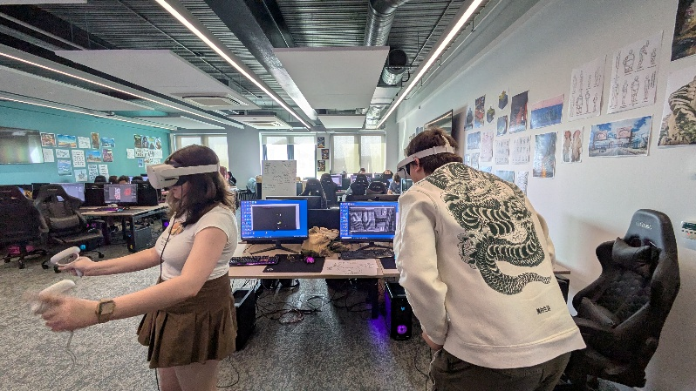
Prototype Test Results and Data breakdown
Figure 38: Picture of participants during prototype test

Figure 37: Picture of participants during prototype test

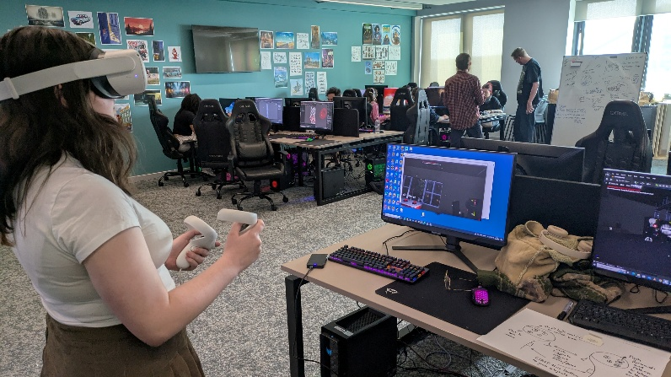
As previously mentioned, the test was conducted in person with participants making use of Meta Quest 2 VR headsets and University Provided desktops.
Participants were asked to complete a questionnaire after the test to gather their opinions of how they thought the visual filters impacted their immersion as well as what they thought of the visual style in general (This information would be used to develop the experience further for submission for the Final Major Project).
A total of 9 participants were involved in this test, with a mix of Year 2 and Year 3 Students from the BA Games Design Degree. Figures 37 and 38 includes some pictures take during the testing.
The results of question 2 are described in Table 1. (Question 2 asked what participants thought of each filter and how it affected their view of the prototype environment).
Table 1. Question 2 results.
Filter Type | Opinions of participants summarised
Filter 1 (Dithering Filter) | Participants found this filter to be somewhat comfortable compared to Filter 2, however its “static” nature made it slightly disorientating, as reported by some of the participants.
Filter 2 (ASCII Filter) | This was the filter that had the most divided opinion amongst participants. Half of the participants found that this was too harsh to use as an actual visual filter in a VR experience while the other half thought it was interesting and comfortable enough to use in an VR experience. Main reason of discomfort was how fast the characters switched when looking at a scene due to how much visual movement is present when wearing a VR headset.
Filter 3 (PS-X Filter) | This was the filter that was liked the most, with two thirds of the participants enjoying it. A participant brought up the fact that this worked best with the visual style of the test environment. Some criticism was that this was only best when used in an “indoor” setting, when compared to Filter 1.

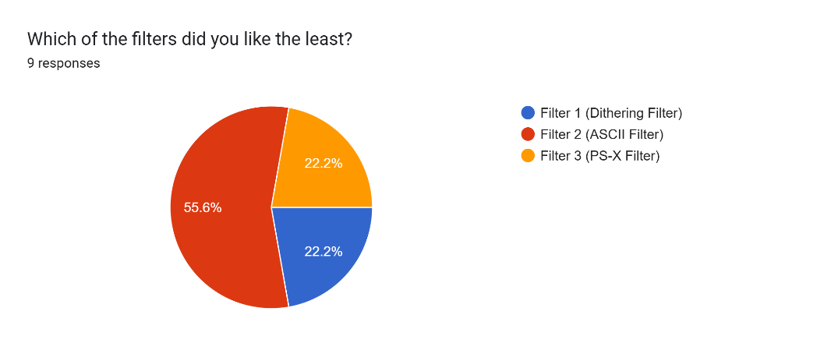
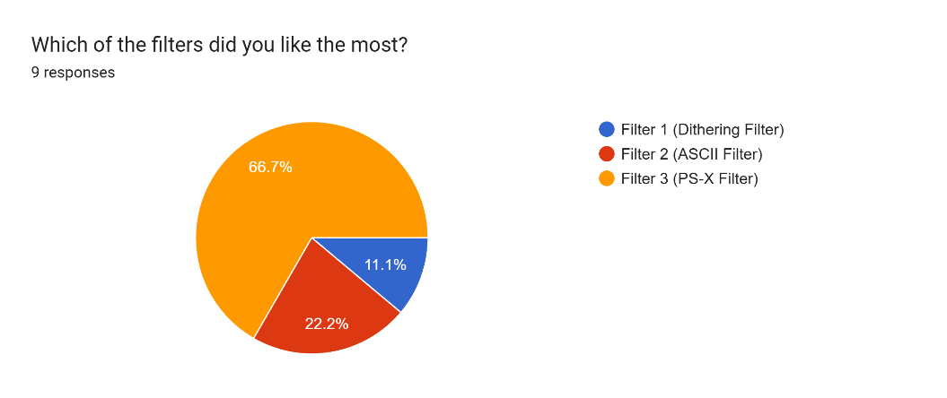
Question 3 and 4 asked participants which filter they liked the most and the least respectively (see Figures 39 and 40).
Figure 40: Results of question 4 from questionnaire

Figure 39: Results of question 3 from questionnaire

From these questions, we can see that Filter 3 (PSX Filter) was the favourite of two-thirds of the group of participants, with the least favourite being Filter 2 (ASCII Filter) (see Figures 39 and 40). Filter 1 (Dithering Filter) was one that participants thought was the most mediocre, meaning that participants do prefer filters that follow a “active” approach to how the filter works, changing whenever they move their head in-game compared to a static filter, like Filter 1. However, most disorienting filters such as Filter 2 (ASCII Filter) would be less preferred to use in a finished video game (this was gathered through verbal feedback given during the test.).

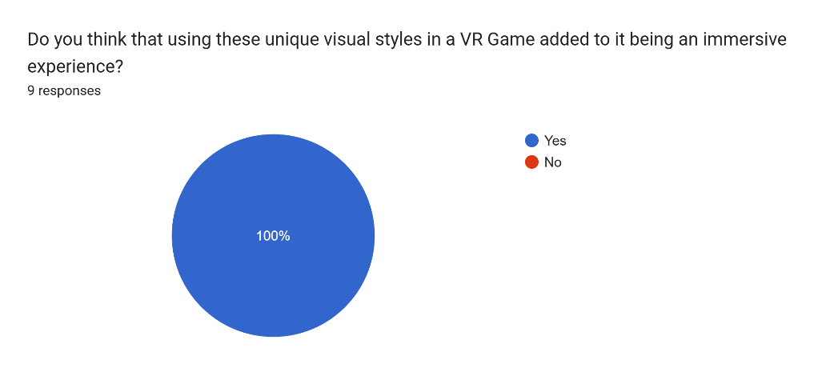
The final question looked at whether participants found that the visual filters added to their immersion (which is directly linked to my hypothesis). As we can see from Figure 41, 100% of participants answer “Yes” to this question.
Figure 41: Results of question 5 from questionnaire

Chapter 5: Prototype results review and summary
The results of the questionnaire conducted after the prototype test fall in line with the previous discussion of Gestalt Principles and other aspects of immersion in VR.
Participants from the test thought that the filter which obscured the silhouette and shape of an object was the most disorientating (see Table 1 and Figure 40), since this visual filter was the one that went against the Gestalt Continuity and Closure Principles.
Another point that indirectly links back to Gestalt Principles was how participants were more receptive to the ‘PSX’ visual filter than other filters (see Table 1 and Figure 39). This is a result of the nostalgia factor triggered by the ‘PSX’ filter, possibly helping people feeling more connected and immersed in an environment that emulates retro video games.
Finally, the last question of the questionnaire showed that there is an interest in the idea of using unique visual filters and visual effects in VR, with a 100% of the participants answering that they do agree with the statement that using the visual techniques does improve immersion.
Considering these results, further research and work will be tailored towards testing different visual filter and effect techniques (such as those shown in Chapter 3), with a fully-fledged VR experience, that combines engaging and interactive gameplay mechanics with hi-fidelity audio (see Chapter 2.2).

Chapter 6: Conclusion of Dissertation
This dissertation investigated and tested the research question on whether visual filters and effect can enhance the immersion experience of users in a VR environment that can be applied to VRG and other relevant applications.
The literature review reviewed explored the different aspects of immersion in VR in the context of the Gestalts Principles and other phycological aspects of visual and sensorial perception to establish a correlation and better understanding on how a person would organise visual elements to make logical sense while experiencing VR, and how visual filters could affect the perception of such an experience, like for example in the case of adding excessive visual distortion that could make the overall experience less immersive and satisfying. Similarly, visual and psychological factors that could enhance the user immersion, as well their satisfaction were also identified and discussed. The research on case studies suggested different visual techniques that are used in interactive media (Video Games) and non-interactive media (Movies and YouTube Videos) that increase immersion. Based on these learnings, a library of techniques and requirements was constructed to guide the development and testing of a VRG prototype version for my project. In addition, research in user preferences and needs regarding VGR was conducted at the beginning of the project. This research investigated the participants gaming habits and opinions about VR, using a questionnaire. Results suggested that the majority of participants presented a general interest in VR, but are looking for a ‘unique’ and rounded immersion experience.
The prototype created during the second part of the research tested three different filters that are commonly applied in video games but not yet in VR, but that could be used to enhance the immersion experience. To measure the results of this novel application of filters, another questionnaire was developed and distributed among eight live test subjects to assess their overall experience. Results suggests that in general, the use of filters can affect the immersion experience, and that participants preferred visual filters that did not fully distort the environment that they were immersed in, in alignment with the Gestalts Principles stating that observers need to make visual sense of their environment through familiarity of forms and contexts. When using the filters according to the Gestalts Principles, the perception of the VR environment was enhanced. Eventually, the final question in the questionary, asking participants whether they thought the use of visual filters added to their VR immersion experience, was unanimously answered in favour, highlighting the potential use of this concept in VR and VGR applications. In addition, this finding also suggests that more research in the area is needed, particularly in case studies of applications in the game industry.

References
- P. Grabarczyk, “Virtually indie,” Routledge eBooks, pp. 58–74, Aug. 2020, [Online] doi: https://doi.org/10.4324/9780367336219-5. [Accessed Mar. 05, 2025]
- FastLawyer, “Half-Life: VR Mod (PCVR) - Full Review - Rate 6/10,” YouTube, Sep. 16, 2023. https://www.youtube.com/watch?v=-0pYsYus5O4 [accessed Mar. 22, 2025].
- Half Life Alyx. [Software], United States of America: Valve, 2020.
- D. Todorovic, “Gestalt principles,” Scholarpedia, vol. 3, no. 12, 2008, [Online] doi: https://doi.org/10.4249/scholarpedia.5345. [Accessed Feb. 20, 2025]
- K. Parsons, “The Backrooms (Found Footage),” www.youtube.com, Jan. 07, 2022. https://www.youtube.com/watch?v=H4dGpz6cnHo [accessed Mar. 14, 2025].
- A. Fedoseev et al., The Cutting Edge of Larp. Knutpunkt, 2014, pp. 81–91. Accessed: Mar. 19, 2025. [Online]. Available: https://citeseerx.ist.psu.edu/document?repid=rep1&type=pdf&doi=16be632ff0e78a50b7d399363360f85dd856618c#page=8 [Accessed Apr. 08, 2025]
- L. Ermi and Frans Mäyrä, “Fundamental Components of the Gameplay Experience: Analysing Immersion,” Digital Games Research Association Conference, vol. 3, May 2005. [Online] https://www.researchgate.net/publication/221217389_Fundamental_Components_of_the_Gameplay_Experience_Analysing_Immersion [Accessed Apr. 08, 2025]
- S. Hudson, S. Matson-Barkat, N. Pallamin, and G. Jegou, “With or without you? Interaction and immersion in a virtual reality experience,” Journal of Business Research, vol. 100, no. 1, pp. 459–468, Jul. 2019, [Online] doi: https://doi.org/10.1016/j.jbusres.2018.10.062. [Accessed Mar. 21, 2025]
- J. Houran, R. Lange, B. Laythe, and R. Ironside, “Immersive Study of Gestalt Variables in Uncanny Geaographies,” Immersive Study of Gestalt Variables in Uncanny Geaographies, vol. 87, no. 2, pp. 65–100, 2023, Accessed: Mar. 14, 2025. [Online]. Available: https://www.researchgate.net/publication/373110983_IMMERSIVE_STUDY_OF_GESTALT_VARIABLES_IN_UNCANNY_GEOGRAPHIES [Accessed Mar. 03, 2025]
- Golden Light. [Software], Russia: Mr Pink, 2022.
- Hyper Demon. [Software], Australia: Sorath, 2022.
- Repose. [Software], Hungary: Bozó Attila Bertold, 2025.
- Maze War. [Software], United States of America: S. Colley, G.Thompson, H. Palmer, 1973.
- Return of the Obra Dinn. [Software], United States of America: Lucas Pope, 2018.
- Cruelty Squad. [Software], Finland: Consumer Softproducts, 2021.
- Thrasher. [Software], United States of America: Puddle, 2024.
- REZ Infinite. [Software], Japan: Monstars Inc., Resonair, 2017.
- F. Miller, R. Rodriguez, Directors, Sin City: A Dame to Kill For, [DVD], New Orleans: Aldamisa Entertainment, 2014.
- Blender, Version 4.4, [Software], Netherlands: Blender Foundation, 2025.
- Baldurs gate 3. [Software], Belgium: Larian Studios, 2023.
- The Witcher. [Software], Poland: CD Projekt Red, 2007.
- Max Payne. [Software], United States of America: Rockstar Games, Remedy Entertainment, 2008.
- Uncharted: Drake’s Fortune. [Software], United States of America: Naughty Dog, 2007.
- Call of Duty: Black Ops 6. [Software], United States of America: Treyach, Blizzard Activision, 2024.
- Apex Legends. [Software], United States of America: Respawn, 2019.
- The Voidness. [Software] SteelKrill Studio, 2023.
- Unreal Engine, Version 5.5, [Software], United States of America: Epic Games, 2025.

Bibliography
- A. Fedoseev et al., The Cutting Edge of Larp. Knutpunkt, 2014, pp. 81–91. Accessed: Mar. 19, 2025. [Online]. Available: https://citeseerx.ist.psu.edu/document?repid=rep1&type=pdf&doi=16be632ff0e78a50b7d399363360f85dd856618c#page=8
- “The Psychology of Immersion in Video Games,” Webmobril - Building Congenial App, Aug. 16, 2023. https://www.webmobril.com/psychology-of-immersion-in-video-games/
- Ashty, “How to make your own customizable PS1 Shader in 4 minutes (UE4/UE5),” YouTube, Nov. 16, 2022. https://www.youtube.com/watch?v=ST_JTXuGmv0
- Blender, Version 4.4, [Software], Netherlands: Blender Foundation, 2025
- Bounty Hunter, “The Psychology of Immersion: How RPGs Influence Identity and Empathy,” Geeks, 2025. https://vocal.media/geeks/the-psychology-of-immersion-how-rp-gs-influence-identity-and-empathy
- D. A. Bowman and R. P. McMahan, “Virtual Reality: How Much Immersion Is Enough?,” Computer, vol. 40, no. 7, pp. 36–43, Jul. 2007, doi: https://doi.org/10.1109/mc.2007.257.
- Repose. [Software], Hungary: Bozó Attila Bertold, 2025.
- The Witcher. [Software], Poland: CD Projekt Red, 2007.
- Cruelty Squad. [Software], Finland: Consumer Softproducts, 2021.
- Enrique Ventura, “Unreal 5.1 - 1-bit dithering postprocess shader (Easy tutorial),” YouTube, Feb. 10, 2023. https://www.youtube.com/watch?v=at8BSkAQ-V0
- Unreal Engine, Version 5.5, [Software], United States of America: Epic Games, 2025.
- L. Ermi and Frans Mäyrä, “Fundamental Components of the Gameplay Experience: Analysing Immersion,” Digital Games Research Association Conference, vol. 3, May 2005. [Online] https://www.researchgate.net/publication/221217389_Fundamental_Components_of_the_Gameplay_Experience_Analysing_Immersion
- FastLawyer, “Half-Life: VR Mod (PCVR) - Full Review - Rate 6/10,” YouTube, Sep. 16, 2023. https://www.youtube.com/watch?v=-0pYsYus5O4
- C. J. Ferguson et al., “Video games, frustration, violence, and virtual reality: Two studies,” British Journal of Social Psychology, vol. 61, no. 1, Jun. 2021, doi: https://doi.org/10.1111/bjso.12471.
- C. Fictum, VR UX : Learn Vr ux, Storytelling and design. CreateSpace Independent Publishing Platform, 2016.
- P. Grabarczyk, “Virtually indie,” Routledge eBooks, pp. 58–74, Aug. 2020, [Online] doi: https://doi.org/10.4324/9780367336219-5.
- J. Houran, R. Lange, B. Laythe, and R. Ironside, “Immersive Study of Gestalt Variables in Uncanny Geaographies,” Immersive Study of Gestalt Variables in Uncanny Geaographies, vol. 87, no. 2, pp. 65–100, 2023, Accessed: Mar. 14, 2025. [Online]. Available: https://www.researchgate.net/publication/373110983_IMMERSIVE_STUDY_OF_GESTALT_VARIABLES_IN_UNCANNY_GEOGRAPHIES
- S. Hudson, S. Matson-Barkat, N. Pallamin, and G. Jegou, “With or without you? Interaction and immersion in a virtual reality experience,” Journal of Business Research, vol. 100, no. 1, pp. 459–468, Jul. 2019, [Online] doi: https://doi.org/10.1016/j.jbusres.2018.10.062.
- J. Jerald, The VR Book: Human-Centered Design for Virtual Reality. Acm / Association For Computing Machinery, 2015.
- S. LaMotte, “The very real health dangers of virtual reality,” CNN, Dec. 13, 2017. https://edition.cnn.com/2017/12/13/health/virtual-reality-vr-dangers-safety/index.html
- Baldurs gate 3. [Software], Belgium: Larian Studios, 2023.
- Return of the Obra Dinn. [Software], United States of America: Lucas Pope, 2018.
- J. Madigan, “The Psychology of Immersion in Video Games,” The Psychology of Video Games, Jul. 28, 2010. https://www.psychologyofgames.com/2010/07/the-psychology-of-immersion-in-video-games/
- F. Miller, R. Rodriguez, Directors, Sin City: A Dame to Kill For, [DVD], New Orleans: Aldamisa Entertainment, 2014.
- REZ Infinite. [Software], Japan: Monstars Inc., Resonair, 2017.
- Golden Light. [Software], Russia: Mr Pink, 2022.
- K. Nancy, Playing with Reality: How Games Shape Our World, 1st ed. Allen Lane, 2024.
- F. Pallavicini and A. Pepe, “Comparing Player Experience in Video Games Played in Virtual Reality or on Desktop Displays,” Extended Abstracts of the Annual Symposium on Computer-Human Interaction in Play Companion Extended Abstracts - CHI PLAY ’19 Extended Abstracts, pp. 195–210, 2019, doi: https://doi.org/10.1145/3341215.3355736.
- [32]F. Pallavicini, A. Pepe, and M. E. Minissi, “Gaming in Virtual Reality: What Changes in Terms of Usability, Emotional Response and Sense of Presence Compared to Non-Immersive Video Games?,” Simulation & Gaming, vol. 50, no. 2, pp. 136–159, Mar. 2019, doi: https://doi.org/10.1177/1046878119831420.
- K. Parsons, “The Backrooms (Found Footage),” www.youtube.com, Jan. 07, 2022. https://www.youtube.com/watch?v=H4dGpz6cnHo
- R. Pausch, D. Proffitt, and G. Williams, “Quantifying immersion in virtual reality,” Proceedings of the 24th annual conference on Computer graphics and interactive techniques - SIGGRAPH ’97, 1997, doi: https://doi.org/10.1145/258734.258744.
- Maze War. [Software], United States of America: S. Colley, G.Thompson, H. Palmer, 1973.
- Thrasher. [Software], United States of America: Puddle, 2024.
- Quinn Kuslich, “Create Your First VR Project in Unreal Engine 5 | Meta Quest 3 | Quick Setup Guide for Beginners,” YouTube, Aug. 17, 2024. https://www.youtube.com/watch?v=i3xNb5R_xos&list=PL6hVyRoWTF6_yMZr4Q6ToWL3ZRGRsiUg2
- Apex Legends. [Software], United States of America: Respawn, 2019.
- Max Payne. [Software], United States of America: Rockstar Games, Remedy Entertainment, 2008.
- D. C. Rusch, Making deep games : designing games with meaning and purpose. Boca Raton, Fl: Crc Press, Taylor & Francis Group, An Informa Business, 2017.
- J.-C. Servotte et al., “Virtual Reality Experience: Immersion, Sense of Presence, and Cybersickness,” Clinical Simulation in Nursing, vol. 38, pp. 35–43, Jan. 2020, doi: https://doi.org/10.1016/j.ecns.2019.09.006.
- W. J. Shelstad, D. C. Smith, and B. S. Chaparro, “Gaming on the Rift: How Virtual Reality Affects Game User Satisfaction,” Proceedings of the Human Factors and Ergonomics Society Annual Meeting, vol. 61, no. 1, pp. 2072–2076, Sep. 2017, doi: https://doi.org/10.1177/1541931213602001.
- Hyper Demon. [Software], Australia: Sorath, 2022
- The Voidness. [Software] SteelKrill Studio, 2023.
- D. Todorovic, “Gestalt principles,” Scholarpedia, vol. 3, no. 12, 2008, [Online] doi: https://doi.org/10.4249/scholarpedia.5345.
- Call of Duty: Black Ops 6. [Software], United States of America: Treyach, Blizzard Activision, 2024.
- Half Life Alyx. [Software], United States of America: Valve, 2020.
- VenediktVad, “UE5 ASCII PostProcess,” itch.io, 2025. https://venediktvad.itch.io/ue5-ascii-postprocess
- J. Wagemans et al., “A century of Gestalt psychology in visual perception: I. Perceptual grouping and figure–ground organization.,” Psychological Bulletin, vol. 138, no. 6, pp. 1172–1217, 2012, doi: https://doi.org/10.1037/a0029333

Appendix

- Link to Questionnaire: https://forms.gle/sZfPVuwzoQT5bysMA
- Link to Prototype feedback Questionnaire: https://forms.gle/NUJX3QGDYesY8xuh6

