Paula Belda Highcock
CONTEXTUAL STUDIES: WAYS OF PERCIEVING
Curational Project

UNCERTAINTY

Introduction:
Welcome to this exhibit based on the idea of having no idea, also defined as being uncertain.
Uncertain: noun, to not be certain. Unreliable or unpredictable.
This exhibit is composed by different pieces that express the feeling of being lost or proof that sometimes that step forward without knowing what is about to happen can be successful and change your life or even history.
Being a relevant topic, specially during our university years, the anxiety and waiting for answers for what future beholds can drown our mind with unanswered questions and lead us to float in a sea of overthinking habits and stress. This exhibit hopes to give you some clarity and trust on our instincts and practice.

Theory and context:
In this exhibit we are focusing into the pioneers of certain changes within abstract and performance art. Ranging from the first pieces of abstract art to some of the most relevant performance pieces of our age.
Abstract art started during the start of the XX century as a questioning of what art really was and a reaction to overly complex and realistic portrayal of life and proof of wealth. Performance art was almost unnoticeable until the 60s when acting become more accepted outside of the musical scene and was used as a form of self expression instead of imitating a character. During the 70s a great sprout of performance art and interpretational dance grew thanks to the consumption of psychedelics that allowed people to become ‘more connected’ with nature and earth and topics like war were brought to the spotlight. They were effective ways to riot or create and impact to the mainstream by performing in public spaces or the street itself. Nowadays we can still find some of these street performances being put up by activist groups.

Layout:
The chosen building is the Mission Gallery in the Swansea Marina but ideally reimagining it as if the back room from it was actually the back exhibit room from the Saatchi Gallery in Central London.
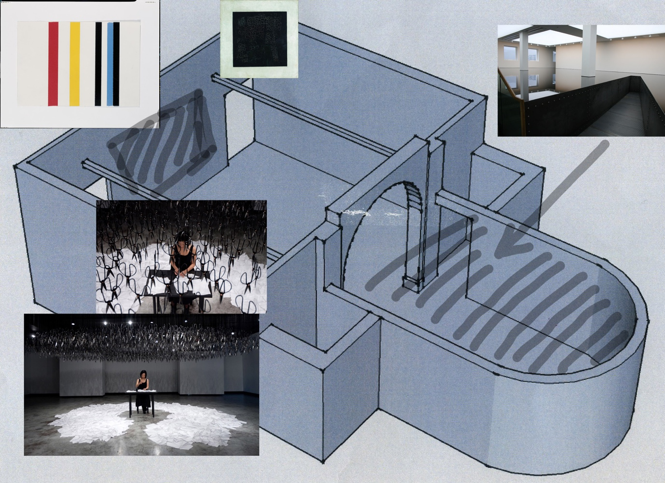

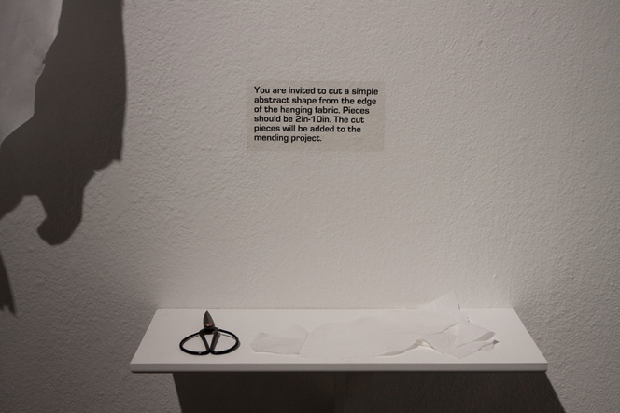
As you walk into the building, in the entrance hall before the actual exhibits, the visitors will find a big piece of white fabric and some Chinese scissors, attached to the wall with some nice black silky ribbon.

Some instructions on the wall telling them to cut a piece, of any shape or size and t take it in to the exhibit. As they walk in they encounter The mending project by Beili Liu (http://www.beililiu.com/The-Mending-Project).
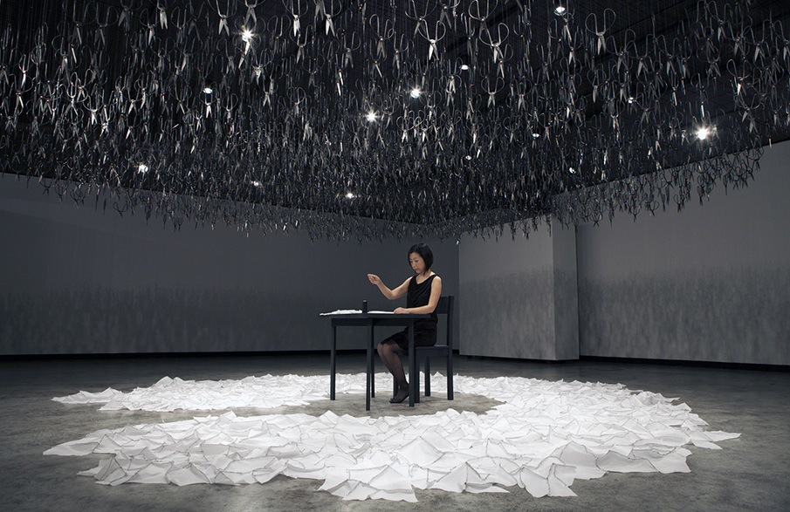

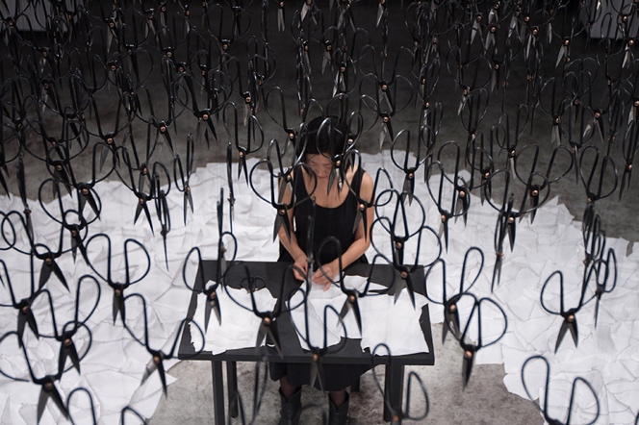
This performance art piece consists on Beili Liu sitting on a chair with a desk in front of her, where she get handed the pieces of fabric the visitors have taken from the entrance and slowly stitches them all together, creating an irregular and experimental textile piece where all shapes come together. Floating over her we can find a loud of Chinese scissors floating over her, hanging from the ceiling. These represent the risks and the feeling of uncertainty itself. She takes a risk by sitting under a cloud of sharp instruments that could tear apart what she is building. She describes it as a symbol of confidence, being confident on your own steps and being aware of what could happen but hoping it will not and that these hard times full of pressure will pass.

Just opposite her, on the wall next to the entrance, we see a canvas sized 28 x 15.5 cm in the middle of the wall. This abstract and minimal piece inspired in neo-Dadaism and pop art from 1964 is 5 adhesive tapes by Chalotte Posenenske. (https://artsation.com/en/journal/editorial/minimalismus-daimler-berlin)

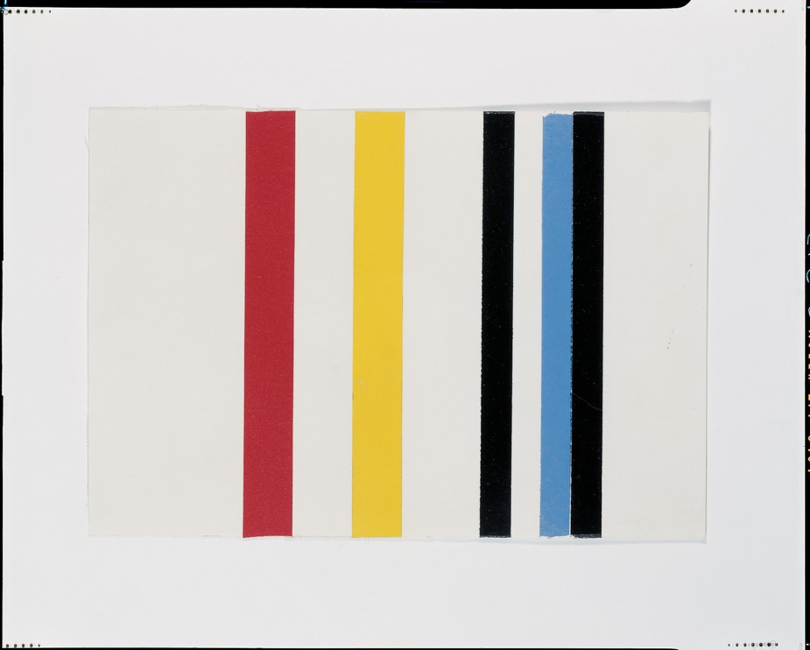

This piece is by one of the
pioneers of abstract art
nowadays but also one of
the first first females in the
abstract art world as an
artist and not a muse. At
the time, sexism just recently being combated against, trying to publish your work in a relatively new and experimental movement such as minimalism in Germany, was a huge risk and a big step forward into uncertainty, exposing herself to rejection. Which she was, it wasn’t until the 80s when her work was finally recognised and go the chance to experiment further with her minimalism based on lines and shapes.
I consider appropriate that her piece is just opposite Beili Liu’s performance to represent two women looking at each other from completely different points of view yet with so much in common about their situation and artistic practice.

On the top left corner of the room, past Beili Liu, we can spot a modest sized painting, in the same position than the first time it was ever exhibited. The first ever abstract painting itself, The black square by Kashmir Malevich (http://www.tate.org.uk/art/artists/kazimir-malevich-1561/five-ways-look-malevichs-black-square) . Again, abstract art was not a thing in 1913 when this painting was first made or 1915 when it was first exhibited in St Petersburg, this being a brave step that has changed history itself is a n important piece for this exhibit. This canvas represents the epitome of unpredictability and questioning the mainstream, an icon without being one. During his life, the black square became a representation of himself, as when going back to figurative painting he would sign it with a black square, an now aside of a mark on his grave has become a symbol not only of his style but of twentieth century art.
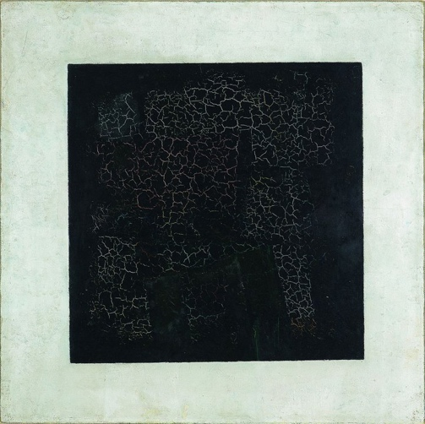

Last but not least, the back room of the Mission Gallery, as mentioned, becomes the room exhibit from the Saatchi Gallery. I have chosen this room because the exhibit will be the installation 20:50 by Richard Wilson.
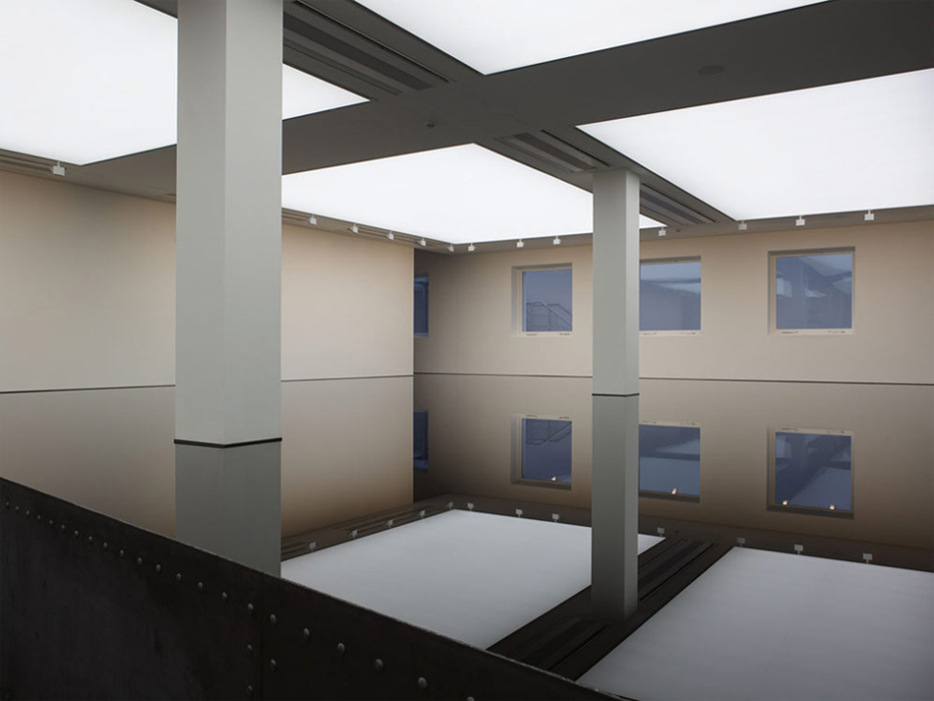

A room of total silence, separated by a black curtain between the room where Beili works and this one. The exhibit that consists in a room filled with reflecting black oil up to hip length allows you to walk into it thanks to a thin corridor taking you to the centre of the room. The oily gives an illusion of large space and even infinity to the visitor, allowing them to contemplate the imagery. This empty yet full space is a clear reference to the common saying “is the glass half full or half empty?” and again a brave step in installation art that leaves the spectator confused and facing the unexpected after such a different display in the past room.
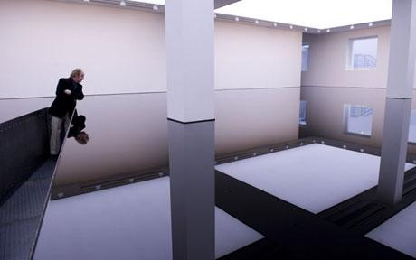

Conclusion:
The objective of this exhibit it is indeed to create a new perspective over the uncertainty of one’s life, making them wonder what unpredictable events will they face and how to face them, making them realise they are not the only ones uncertain.

