Joe Thomas
Jthomas.151048@student.uwtsd.ac.uk
Advanced Computational Methods
Ricardo WAVE

Contents
Introduction 2
Ricardo WAVE 3
About the Software 3
Dyno Data 3
Methodology 3
Triumph 675 Model 3
Provided dimensions 5
Base Run 6
Constants Table 7
Test 1 – Burn Duration 9
Test 2 – Exhaust Opening Point 11
Test 3 – Fuel Air Ratio 13
Test 4 – Intake Opening Point 14
Test 5 – 50 percent Burn 16
Ideal Run 17
Conclusion 19
Bibliography 20

Figure 1 - Ricardo WAVE model view 4
Figure 2 - Provided Table of Engine Geometry 5
Figure 3 - Peak Pressure Difference 6
Figure 4 - Area of Graph Difference 7
Figure 5 - Constants Table 7
Figure 6 - Peak Pressure Difference 9
Figure 7 - Test 1 Area Graph 10
Figure 8 - Test 2 Peak Pressure Difference 11
Figure 9 - Test 2 Area Difference 12
Figure 10 - Test 3 Peak Pressure difference 13
Figure 11 - Test 3 Area Difference 13
Figure 12 - Test 3 Peak Pressure Difference 14
Figure 13 - Test 4 Area Difference 15
Figure 14 - Test 5 Peak Pressure Difference 16
Figure 15 - Test 5 Aera Difference 16
Figure 16 - Ideal Conditions Test 17
Figure 17 - Simulation Run at 13000RPM 18

Introduction

The following report discusses an investigation conducted using the engine simulation software Ricardo WAVE, the main aim of the experiment is to gain a good understanding of the programme and to produce useful data by means of the software and dimensions provided.
Initially, a configuration process of the model will take place to reach a base setting prior to optimisation. This base setting will set the mark for the foreseeable test and will be reverted back to between tests to conduct a fair experiment.
Once a base setting has been reached, an experiment into altering five key variables of the software will be commenced, these variables include, burn duration, exhaust opening point, Fuel/Air Ratio, inlet opening point and 50 percent burn point.
Analysis of these tests will be formatted in the style of percentage difference of peak pressures and graph area to understand the immediate changes that the variables make to the engine simulation.
Finally, a comparison of the data gathered and the data provided will validate the model created for critical analysis to identify positive, inaccurate, and possible further work from the investigation.

Ricardo WAVE

About the Software

Ricardo WAVE software uses the 1D form of the Naiver-Stokes equation controlling the transfer of mass, energy and momentum for the compressible flow of gas, this includes sub models for combustion and emission simulation (Ricardo, 2020). In this experiment the main focus is fluid flow resulting in pressure data. Within this experiment, an average of the three cylinders has been taken.
WAVE allows the user to simulate and analyse a range of different individual components within the system on numerous levels of depth. In the testing phase of development, WAVE is used as simply simulation, or an incorporation of simulation and real-life experimentation (Ulhoa, 2016), this is to speed up the design process without the expenditure of producing parts for development when testing is necessary.
The Naiver-Stokes equations, in fluid dynamics, describe the flow of incompressible fluids. In this case the Air/fuel mixture entering, combusting and being forced out of the cylinder (Britannica, 2020).

Dyno Data
To validate the experiment, dyno data of the Triumph 675 has been acquired, the data provided will be used as a benchmark comparison throughout the investigation to refer to when investigating different methods in Ricardo WAVE.

Methodology

Triumph 675 Model

To start the investigation, a wave model has been provided.
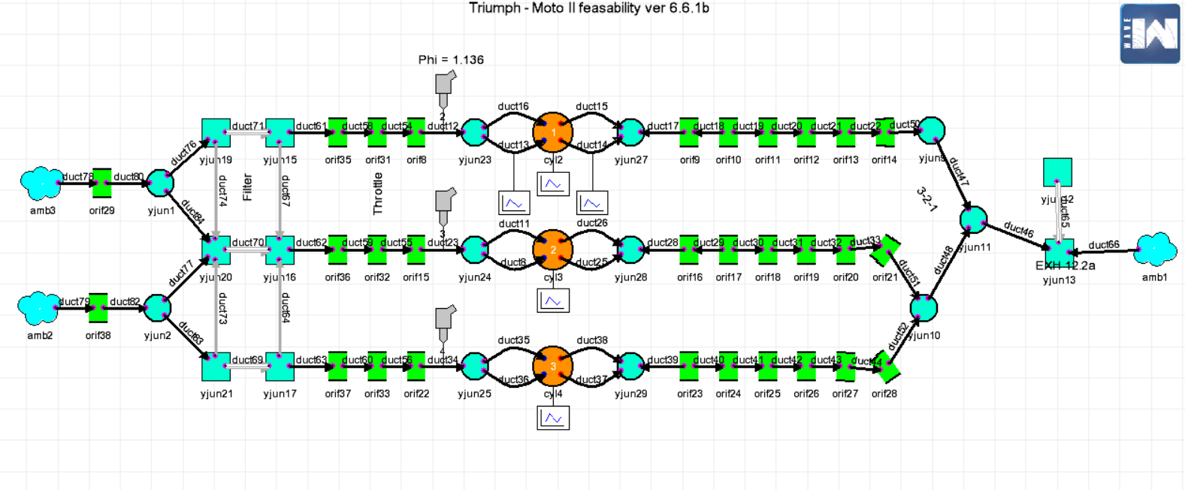
Figure 1 - Ricardo WAVE model view
- The WAVE model, although close to finished, needed some changes made to it before a run could be made.
- Starting from the left the intake ports are adaptable and can be changed in the settings.
- The air filter produces a restriction of air flow and can be altered.
- Junctions are imputed and the angles of junction can be changed to simulate fluid flow.
- The fuel can be altered using the injectors, as the fuel is not specified, no change has been made to what fuel has been utilised.
- The lift profiles and cam shaft dimensions can be changed in the valve section.
- In the cylinders, geometry such as the bore, stroke, clearance volume and con-rod length (that has been changed) can be altered. This makes a large amount of difference to the pressure of the engine give that;

$PV=nRT$;
- It is evident that volume is inversely proportional to pressure.
- The exhaust is split into junctions and, similar to the air filter, and offers restriction to air flow for more accurate simulation.

Provided dimensions

Once acquiring the base model for the Triumph 675 Daytona, it was necessary to make some changes concerning the setup of the Ricardo WAVE template before first running it (Williams, 2020).
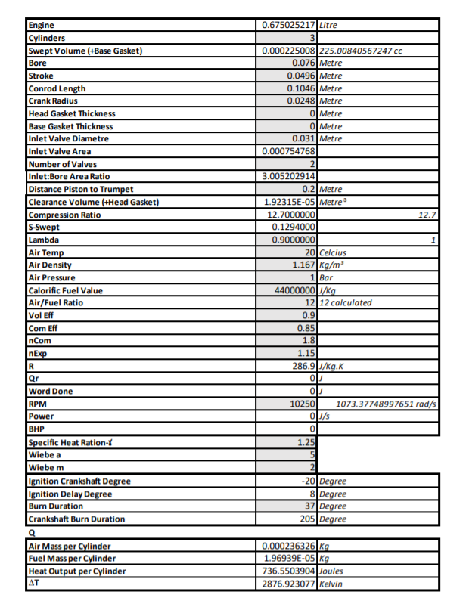
Figure 2 - Provided Table of Engine Geometry

- Figure 2 shows a table of the dimensions and initial settings inputted to the WAVE model prior to the first run of simulation. Alongside this, the inlet and exhaust profiles and flow coefficients are inputted into the necessary areas of the model.
- Once the base model has been acquired changes can be made to optimise the pressure difference.
- Other changes made to the provided data where changing the pressure data from gauge pressure to absolute pressure, and changing the volume from a percentage to a volume per degree in m³.
- It was necessary, using the curve fitting tool in Matlab, to find the mass fraction burnt (MFB) at 10%, 50% and 90% to find a Wiebe function and inputted into WAVE.
- When analysing the provided dimensions of the inlet valves, the data sheet shows 31mm in diameter, this however was not the case in WAVE as it stood at 29mm and was changed to suit the data sheet.
- Several ducts have also been changed in diameter to suit the computing procedure and prevent any errors when calculating.

Base Run

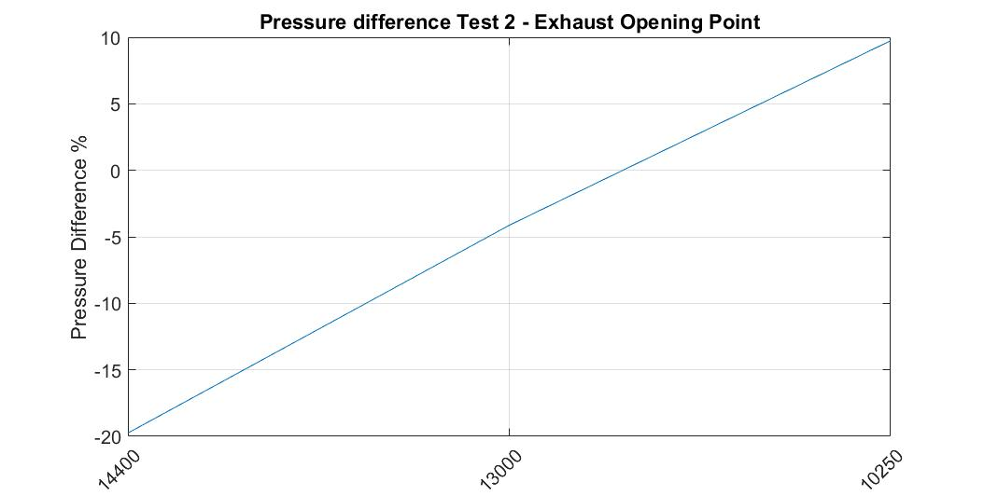
Figure 3 - Peak Pressure Difference
- The graph above shows the difference in peak pressure between the base run and the dyno data at each RPM.
- The graph shows a slight similarity around 13000 RPM however a large percentage difference at 14400RPM and 10250RPM.
- 14400RPM shows a peak pressure difference of -20% alongside 10250 showing peak pressures pf 10% above.

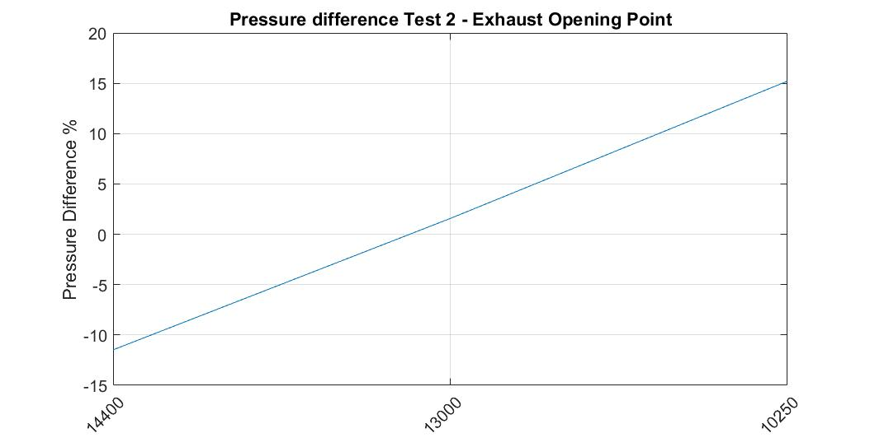
Figure 4 - Area of Graph Difference

- Figure 4 shows the difference in area of the 3 differed RPM’s used in the test.
- Once a run is finished and the pressure data is exported to Matlab, it is possible to calculate the area of the graph using the ‘trapz’ (Trapezoidal numerical integration) function.
- Rather than just using the peak pressures, the area will give a good idea to the general shape of the graph.
- Like the peak pressure graph, the area trend shows slight resemblance at 13000RPM however large fluctuation at 14400RPM and 10250RPM.

Constants Table

- WAVE allows the user to change certain aspects of the combustion process efficiently in an experimental format using the constants table

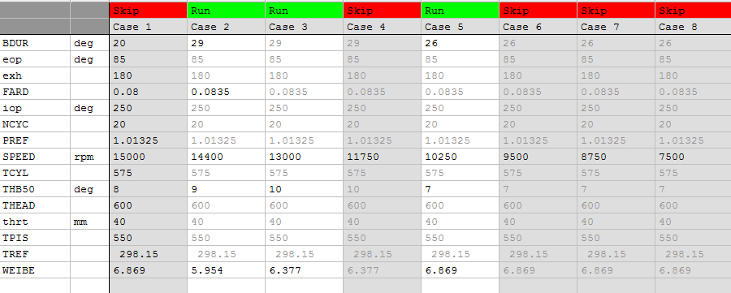
Figure 5 - Constants Table
- The above figure shows the constants table view from Ricardo WAVE.
- As can be seen from the table, certain aspects can be changed individually or used over every run.
- Figure 5 shows the constants used in the base run.

Test 1 – Burn Duration

- Using the constants table, the burn duration has been altered to simulate longer and shorter burn durations. The numerical figures changed are $x$ amount after top dead centre in crank angle.
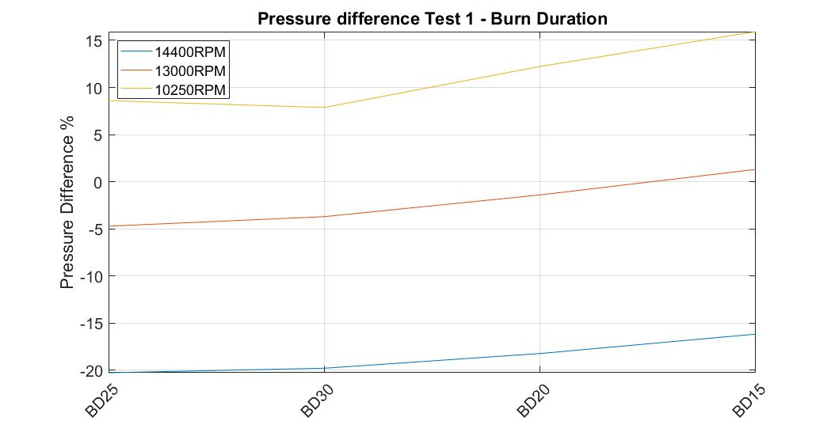
Figure 6 - Peak Pressure Difference
- The above figure shows the peak pressure difference in the first test.
- At a burn rate of 25 degrees after top dead centre (ATDC), 10250RPM shows a closer trend than the base setting, and increases in similarity at 30 degree ATDC, once the burn duration is decreased however the trends reduces in resemblance.
- 13000RPM and 14400RPM show similar trends while both start further away from the base run, 13000RPM concludes closer to 0% difference, where as 14400RPM increases in similarity but no closer than the base run.

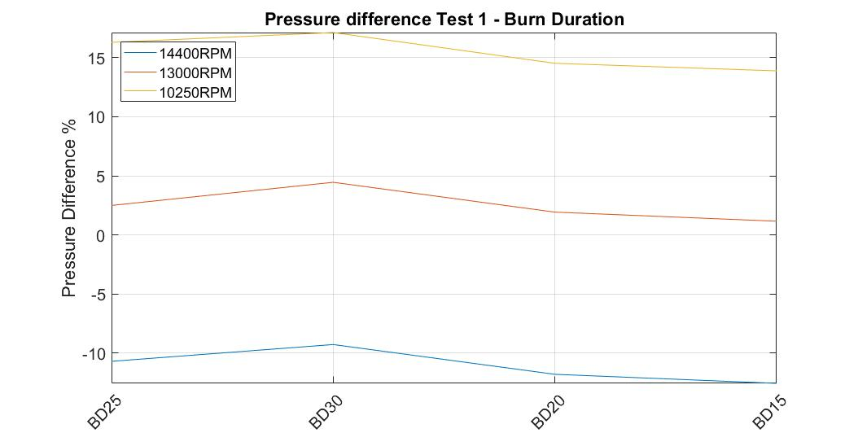
Figure 7 - Test 1 Area Graph
- Figure 7 shows the area of trend difference from Test 1, as can be seen from the graph, by increasing the burn duration, the overall pressure increases in similarity for 14400RPM, this however is not the case for 13000RPM and 10250RPM as the graph indicates.
- This is not the case as the burn duration is reduced, as the trends show the opposite tendency, by increasing similarity at both 13000RPM and 10250RPM, although decreasing resemblance at 14400RPM.

Test 2 – Exhaust Opening Point

- Once Test 1 has taken place, it is necessary to restore the burn rate back to original state for the sake of a fair investigation.
- Furthermore, test 2 consists of changes being made to the exhaust opening point.
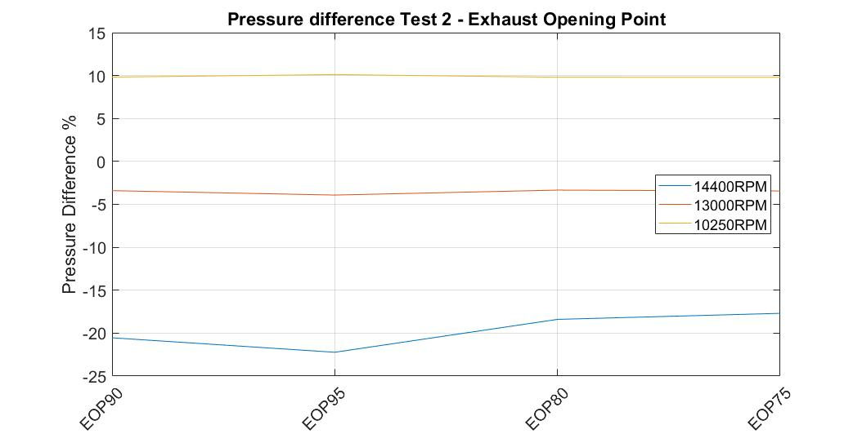
Figure 8 - Test 2 Peak Pressure Difference

- Test 2 shows a small amount of change in peak pressure for 13000RPM and 10250RPM.
- This however is not the case for 14400RPM as the trend shows an initial decrease in similarity and continues to increase by only a small amount.

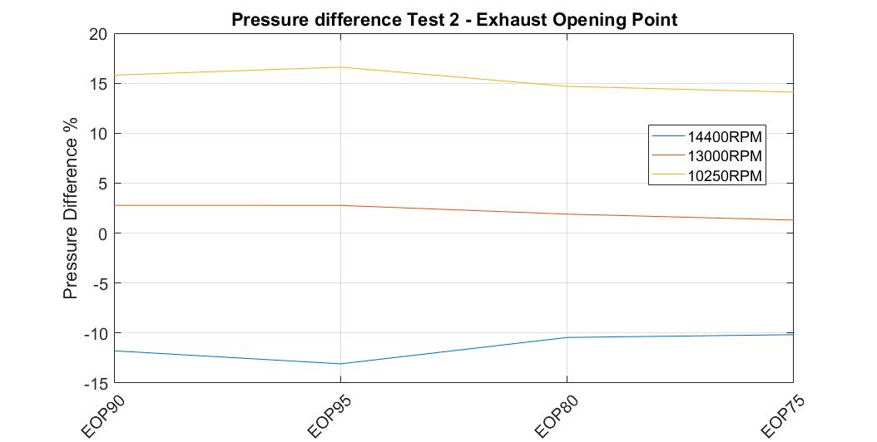
Figure 9 - Test 2 Area Difference
- Figure 9 shows little change in pressure difference however at all RPM’s the pressure difference is decreasing at exhaust opening point 75 degrees ATDC.

Test 3 – Fuel Air Ratio

- Once Returning exhaust opening point back to base setting, test 3 consists of alterations to the Fuel/Air Ratio (FARD).
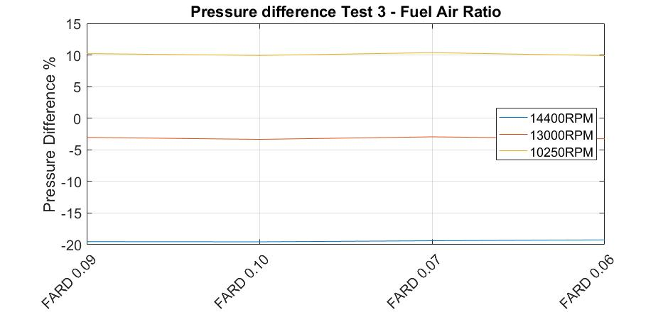
Figure 10 - Test 3 Peak Pressure difference
- As can be seen from the above figure, the FARD made small difference to the peak pressures at all RPM’s, this may be due to insignificant change made to the variable.

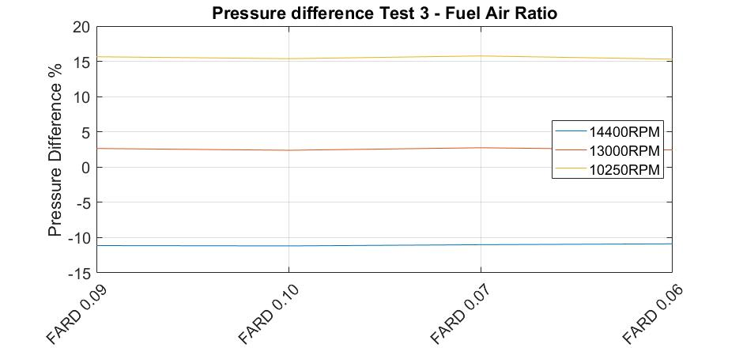
Figure 11 - Test 3 Area Difference
- The same applies for Figure 11 showing the area of the pressure graph, further investigation into greater changes made to the FARD would be beneficial.

Test 4 – Intake Opening Point

- After returning the FARD to base setting, an experiment into altering the intake opening point (IOP) has been tested.
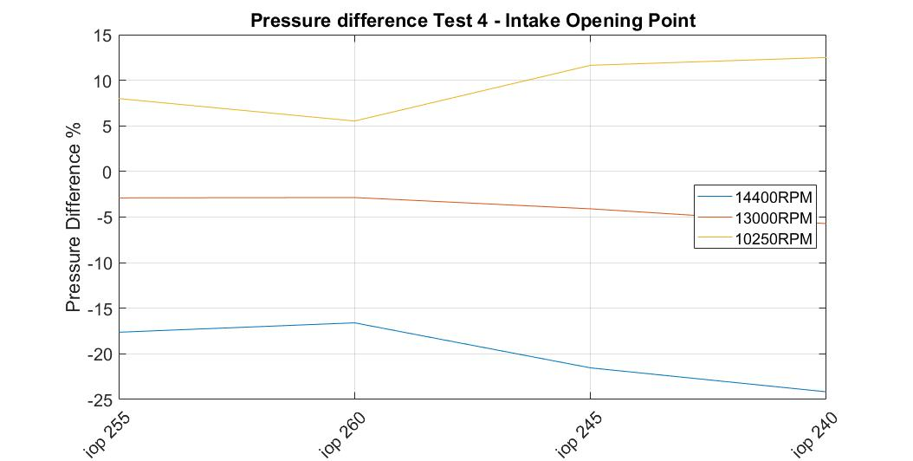
Figure 12 - Test 3 Peak Pressure Difference
- Figure 12 shows contrasted results as a large amount of change can be seen.
- As demonstrated in the above graph, the peak pressure difference at 14400RPM and 10250RPM is decreased from the 1st alteration and increases in similarity through to IOP 260 degrees ATDC.
- The trend of 14400RPM and 10250RPM then deviates away from the dyno data peak pressure as the IOP is changed the opposite way.
- A further investigation into increasing the IOP beyond 260 degrees ATDC would prove whether closer peak pressure could be found.
- The trend of the 13000RPM shows the trend decrease in similarity regardless of the IOP adaptation.

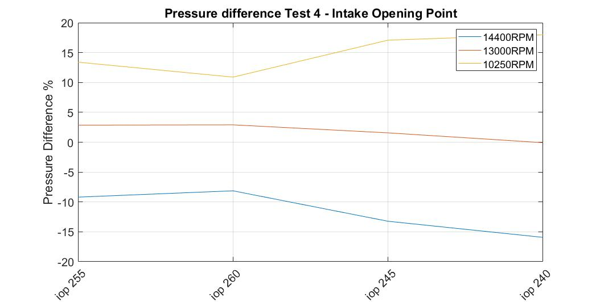
Figure 13 - Test 4 Area Difference
- In contrast to Figure 12, the area graph shows 13000RPM’s trend progressively conclude on 0% difference to the dyno data at an IOP of 240 degrees ATDC.
- 14000RPM and 10250RPM show similar trends as the both simulate more similar pressure areas at 255 and 260 degrees ATDC, however as the IOP is altered the other way, the pressure difference increases.

Test 5 – 50 percent Burn

- As per the experiment procedure it is necessary to input the IOP back to the base model.
- Test 5 includes an experiment into changing the 50% burn position (THB50).
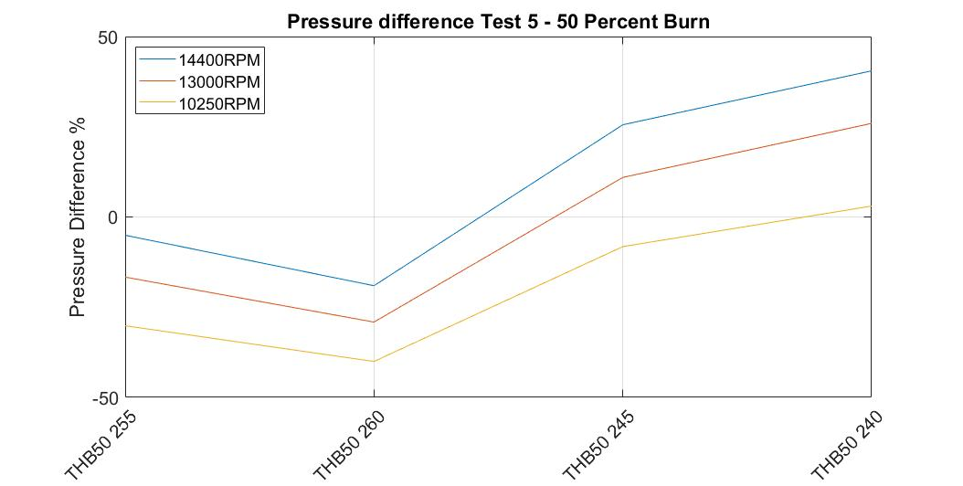
Figure 14 - Test 5 Peak Pressure Difference
- Test 5 proves for a range of varied results, 14400RPM shows a close similarity in the early stages of the test standing -5% from the dyno pressure data at THB50 255 degrees ATDC.
- The trend representing 10250RPM shows especially similar results at THB50 at 240 degrees ATDC.

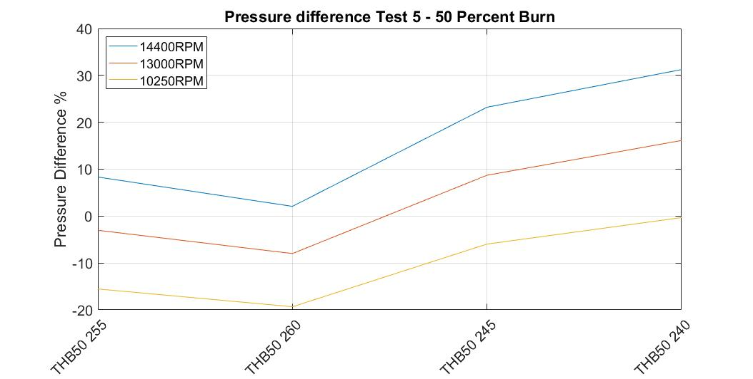
Figure 15 - Test 5 Aera Difference
- Figure 15 shows similar results to the peak pressures in respect to 10250RPM as the final run of THB50 240 degrees ATDC shows minimal difference to the pressure data provided.
- The graph also shows a similarity of pressure at 14400RPM in run 2 (THB50 260 degrees ATDC).
- THB50 255 degrees ATDC also shows similar results to the dyno data.
- The test has proven to provide adequate results throughout the runs and adaptations made, resulting in similarities in every RPM.

Ideal Run

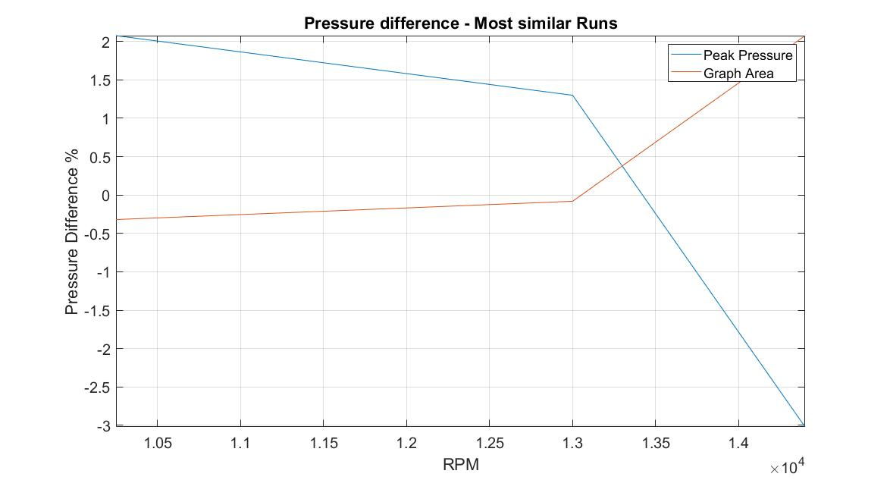
Figure 16 - Ideal Conditions Test
- The above graph shows the runs within the experiment producing the most similar pressure to the dyno data.
- This however, is an idealised solution of the tests gathered where the individual changes have no effect on each other.
- Further experimentation towards ideal results in all RPM’s in a single test would prove for interesting results and provide differed data to compare and gather a further understanding of the possible outcomes that WAVE produces.

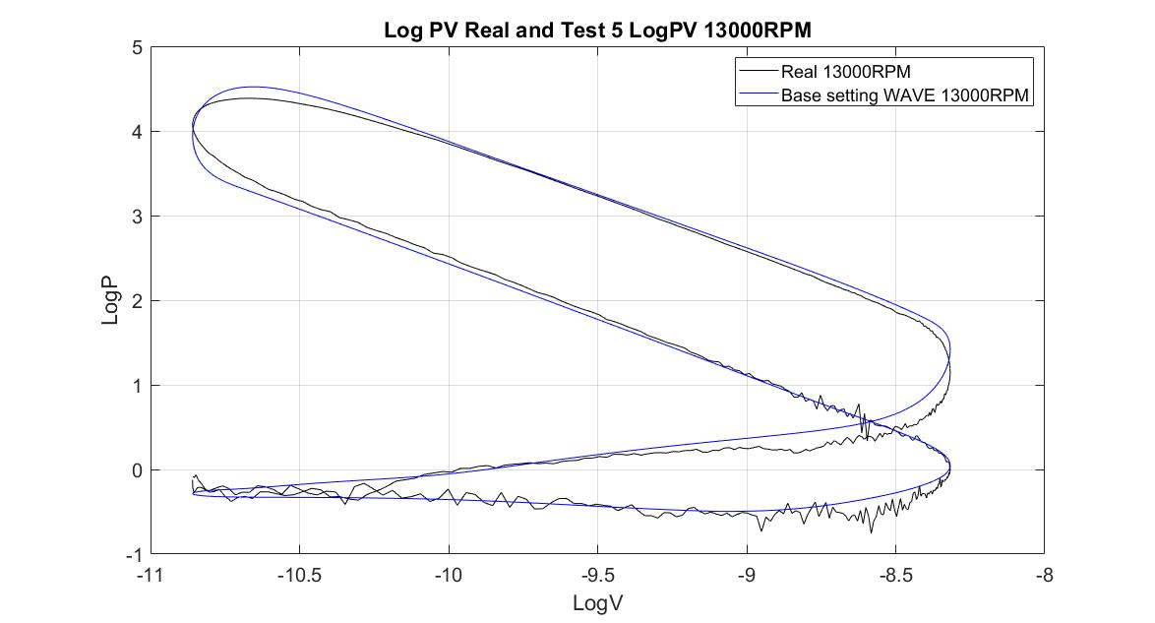

Figure 17 - Simulation Run at 13000RPM
- As can be seen from this LogPV diagram at 13000RPM taken from the IOP test, it is evident to see the difference in the simulated data and the real data.
- A large amount of fluctuation occurs around the green and red area in the dyno data in comparison to the WAVE data that doesn’t account for the fluctuation. This is because the pressure data is gathered in real circumstances that include such variables as, left over gas, friction and pulses of air caused by valves closing and opening.
- It is seen that small amount of difference occurs around the combustions area (Yellow area). This point is important and more tests would help to further correct the simulated data.
- 145hp has been simulated at 13000RPM using WAVE which is considerably higher than the found horse power which is seen to be around 110hp, this again is due to the unconsidered variables such as frictional losses.

Conclusion

- The investigation provided a good indication to the possible outcomes that are produced from the changes made in the experiment, this can be taken on into account when considering further usage of the software.
- In concern to the tests, although providing sufficient data, it may have been more beneficial if the variables had been altered by greater amounts, such as the Fuel/Air Ratio.
- In contrast to this, test 5 may have benefitted from finer Adjustments.
- Further consideration into a friction model will prove for more precise results and will be considered in future uses of the software.
- It can be said that the WAVE model provided is well suited to be ran when looking into changes made around the mid-range of engine speed (13000RPM), this would be reasonable as the Triumph 675 is road motorcycle that won’t be aggressively used and forced to the red line.
- WAVE may be used to simulate cases in which the Triumph 675 is used for racing where, in that case, would be more suited to the higher RPM range.

References
Britannica, E. (2020, 01 23). Navier-Stokes Equation. Retrieved from Encyclopedia Britannica: brittanica.com/science/Navier-Stokes-Equation
Heywood, J. (n.d.). The internal Combustion Engine.
Ricardo. (2020, 01 23). WAVE. Retrieved from Ricardo WAVE: software.ricardo.com/products/wave
Ulhoa, F. C. (2016). Computational Simulation of a High Performance Ethanol Engine Adapted for Forula SAE. SAE Brasil.
Williams, O. (2020, 01). Advanced Computational methods. (O. Williams, Performer) UWTSD IQ, Swansea, Swansea, South Wales.

