Guidance document (legislation and employment relations)
The employment relationship is about building and maintaining a positive and productive working relationship between an organisation and its people. It is important because people are the driving force behind any business and without them, the business couldn’t function but also because good ‘employee engagement has been proven to increase employee productivity’ (Stone, 2023).

AC 3.1: Work-life balance (WLB)
WLB is the amount of time someone spends doing their job versus the amount of time they spend doing things that are important to them outside of work. Employers play a key role in helping employees achieve a better WLB and some of the ways in which they can support their employees include flexitime, home-working and flexible working opportunities. WLB and wellbeing are intrinsically linked and it is important that an employer demonstrates concern for their employee’s wellbeing as this will help foster a positive employee relationship but also because having wellbeing practices and policies in place at work has been shown to increase employees productivity and performance as statistically people will be healthier as they will feel less stressed and anxious, therefore reducing sick days and the risk of burn-out. According to Personio, ‘When work-life balance is aligned, employees find meaning in their work, are able to ‘log off’ when they need a break, and their best work is completed’ (2024). Overall investing in a good WLB will keep employees happy whilst also benefiting the company.
As well as an employers’ own WLB policies, there is also employment legislation in place to protect employees which employers must adhere to including the working time directive which ensures that employees ‘are given enough time to rest and recuperate’ (PeopleHR, 2024) and stipulates that employees cannot work more than 48 hours a week unless they sign an ‘opt-out’ agreement. It also states that employees are entitled to 5.6 weeks paid time off per year and are allowed 11 hours of consecutive rest per 24-hour period. As per the Flexible Working Act 2014, employees can make up to two requests for flexible working within a twelve-month period to amend their working pattern or reduce/increase their working hours per week and employers must provide an outcome to this request within two months and if declining the request then the response must be reasonable providing a sound business reason for the decision.
AC 3.2: Wellbeing in the workplace
How an employee feels at work will directly affect their performance and dictate how long they will stay within an organisation as if they feel respected and appreciated, they are likely to stay loyal to the company for longer. Wellbeing in the workplace is about an employee’s health and the ‘quality and safety of the physical environment’ (Waite et al. 2021, p.140) but it is also about how an employee feels psychologically at work and CIPD have identified a further six areas which play into wellbeing which are:
Good work- Ensuring that the work environment and culture is supportive and inclusive and that you have effective people management policies in place.
Values/principles- An employer practicing what they preach and being principles and values led. It’s about demonstrating ethical standards and being inclusive.
Collective/social- This focuses on the importance of employee voice and consultation before implementing changes.
Personal growth- The importance of providing employees with career development opportunities and learning resources.
Good lifestyle choices- Employers taking an interest in supporting their employee’s physical activity and healthy eating.
Financial well-being- Ensuring fair pay for employees and providing financial support when needed. (CIPD, 2023).
Employers can support their employee’s wellbeing through encouragement to take annual leave, having an open-door policy where employees can raise any issues they have and having employee assistance programmes offering 24-hour access to free counselling. Ultimately, ‘companies that care about their employees’ health and wellbeing will be more likely to have employees who care about the company’s health and well-being too’ (Kelly et al., 2021). It is important that employers take an interest in their employees’ wellbeing from an ethical perspective but also from a business stance as stress can lead to decreased productivity known as presenteeism where due to the lack of positive wellbeing practices in the workplace employees feel forced to attend work in an unfit state due to illness or exhaustion and are unable to perform resulting in burn-out, absenteeism and ultimately resignation which in turn costs the business. Investing in wellbeing will create a more productive and happier environment for all those concerned, reducing sickness levels and staff turnover.
AC 3.3: Discrimination legislation.
It is an employer’s responsibility to act ethically, ensure that all people are treated lawfully and with respect and make reasonable adjustments where possible. A businesses’ HR department will ensure that the organisation has updated and relevant procedures that conform with legislation to protect the business and its people and strive to foster an equal and diverse work environment.
The principal legislation regarding discrimination is set out in the Equality Act 2010 which protects all people from discrimination under the nine protected characteristics which are:
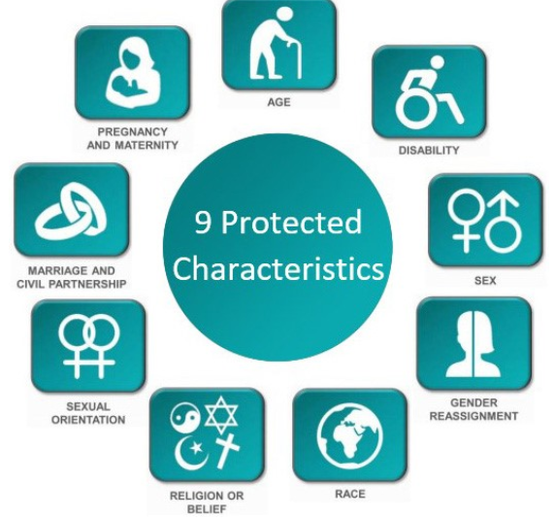
(Cardwell, 2024).
Discrimination can be direct whereby someone is ‘put at a disadvantage and treated less favourably because of a protected characteristic they have’. (Acas, 2023).
Indirect discrimination is when a working practice or policy is the same for everyone but indirectly effects someone in a negative way because of a protected characteristic and this form of discrimination could be unintentional.
Another area of discrimination is Harassment where the behaviour of an individual is perceived as offensive or threatening by the recipient and makes them feel intimidated or humiliated.
Lastly, victimisation is when somebody is treated badly or unfairly because they have done a protected act such as whistleblowing.

AC 3.4: Diversity and inclusion
Promoting diversity and inclusion in the workplace is fundamental to good people management as it reflects an organisations’ aim to achieve fairness and equality in every area of its business and in turn ‘establishes a sense of belonging among employees, making them feel more connected and productive’ (Wong, 2024).
According to the CIPD, Diversity represents the differences in colour, ethnicity, abilities, age, gender, beliefs and other characteristics and that the differences should be recognised and celebrated as they contribute to a diverse workforce which is enhances ‘decision making, innovation and problem solving as people bring a diverse range of backgrounds and experiences with them’ (2022).
Inclusion is about treating all employees fairly, ensuring people feel valued by listening to their contributions and allowing people to feel comfortable to be themselves. Overton summarises inclusion as ‘a sense of belonging, connection and community at work’ (2024). Fostering an inclusive workforce is important as it boosts employee morale, encourages employee contribution and engagement and builds positive working relationships where all individuals feel valued and respected.

AC 3.5: Fair and unfair dismissal.
If an employer needs to terminate an employee’s contract, they must ensure that the dismissal is for a fair reason and that they handled the dismissal process in a reasonable manner, one way to ensure this is by following the Acas Code of Practice as an employer’s actions will be considered if the case reaches an employment tribunal.
The Employment Rights Act 1996 sets out the reasons for fair dismissal which include:
- Capability referring to an employee’s aptitude or skills to do the job and their qualification referring to their academic or professional qualification.
- Conduct which can be ordinary or gross misconduct in line with company policy.
- Redundancy where the role is no longer required.
- Legal restriction or statutory ban whereby the law prevents them from being able to carry out their role.
- Another substantial reason where the employer can demonstrate that they have acted reasonably.
Unfair dismissal reasons include:
- Pregnancy or maternity leave
- Taking family leave
- Being a trade union member or representative
- Asking for a legal right
- Jury service
- Whistleblowing.
(Waite et al. 2021, p.155).
Once the decision has been made to dismiss an employee, you must inform them why they have been dismissed, when their employment contract will end, what their notice period is and that they have the right to appeal the decision and what the process is.
To conclude, creating good employment relations will result in a positive, trusting and productive work environment with reduced conflict and increased performance and business efficiency.
Word count: 1,374.

References
Acas (2023) Discrimination at work Discrimination and the Equality Act 2010. Available at: https://www.acas.org.uk/discrimination-and-the-law (Accessed: 25 May 2024).
Cardwell Primary School (2024) Protected Characteristics. Available at: https://www.cardwellschool.co.uk/Protected-Characteristics/ (Accessed: 04 June 2024).
CIPD (2022) Equality, diversity and inclusion (EDI) in the workplace. Available at: https://www.cipd.org/uk/knowledge/factsheets/diversity-factsheet/ (Accessed: 25 May 2024).
CIPD (2023) Wellbeing at work. Available at: https://www.cipd.org/uk/knowledge/factsheets/well-being-factsheet/#the-key-domains-of-wellbeing (Accessed: 25 May 2024).
Kelly, E. et al (2021) 7 Strategies to Improve Your Employees’ Health and Well-Being. Available at: https://hbr.org/2021/10/7-strategies-to-improve-your-employees-health-and-well-being (Accessed: 25 May 2024).
Overton, J. (2024) 11 essential traits of an inclusive workplace. Available at: https://www.limeade.com/resources/blog/inclusive-workplace/ (Accessed: 25 May 2024).
PeopleHR (2024) Employers' Guide To Working Time Regulations UK. Available at: https://www.peoplehr.com/en-gb/resources/blog/employers-guide-to-working-time-regulations-uk/#:~:text=The%20purpose%20of%20these%20regulations,by%20the%20EU%20in%201994. (Accessed: 04 June 2024).
Personio (2024) How Can You Help Employees Find Better Work-Life Balance? Available at:https://www.personio.com/hr-lexicon/work-life-balance/ (Accessed: 24 May 2024).
Stone, K. (2023) The impact of employee engagement on productivity. Available at: https://engagedly.com/blog/impact-of-employee-engagement-on-productivity/#:~:text=Employee%20Engagement%20Increases%20Productivity&text=Engaged%20employees%20are%20innovative%20and,leads%20to%20increased%20workplace%20productivity. (Accessed: 25 May 2024).
Waite, K. et al. (2021) People Practice a Complete Guide. London: Kogan Page Limited
Wong, K. (2024) Diversity and inclusion in the workplace: Benefits and challenges. Available at: https://www.achievers.com/blog/diversity-and-inclusion/ (Accessed: 25 May 2024).

