

LCBM 7000

HUMAN RESOURCE MANAGEMENT

ASSESSMENT 1

BEATA DUDAK

STUDENT NUMBER 2010697

MODULE LEADER DR GLADIUS DAVID KULOTHUNGAN

11/12/2020

Table of Contents

1.0 Introduction 3

2.0 Company Background 4

3.0 Strategic Resourcing (a key component of SHRM and SIHRM) as an instrument to reach business goals 5

4.0 Critical analysis of internal and external environmental factors of Apple, Inc in context of people resourcing strategies. 6

5.0 The strategic response to the environmental changes by Apple 11

6.0 Conclusion 13

7.0 Recommendation 13

References 14

1.0 Introduction

The current complex world is constantly changing and evolving (Muhammad, 2014). To stay competitive and reach the targeted goals, it is essential for the organizations to carry out major strategic changes (Engberg et al,2015). In a management context, Wheelen and Hunger (1995, p. 3) defined it as to undertake the set of “managerial decisions and actions that determines the long-run performance of a corporation” i.e. strategic management – the process of constant adjustments of the “values of senior management, the environment, and the resources available” (Bratton, 2007). Many scholars therefore argue that strategic resourcing i.e. “matching human resources to the strategic and operational requirements” of the company (Armstrong, 2014, p.209), builds a competitive advantage that company utelizes to achieve its bussines goals.
The purpose of this work is to critically evaluate the current and predicted changes in the external environment by relating to people resourcing strategies in reference to Apple Inc. It also concentrates on addressing how Apple has responded to the changes by application of the effective resourcing strategies. The report uses PESTEL tool to understand the external environment of Apple and further highlights the way Apple moves to apply the various strategies, and finally summarises findings and recommends future HR actions.

2.0 Company Background

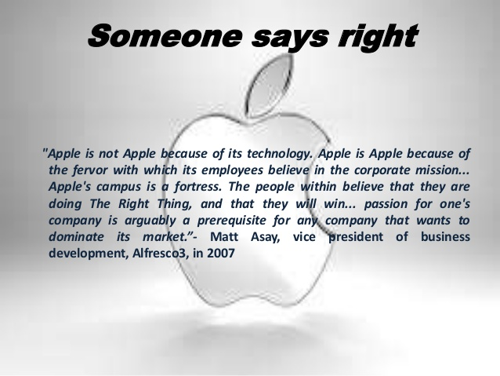
(Source: https://www.slideshare.net/Krits8/apple-culture)
Steve Jobs & Co originated pure IT company in 1976 which later became known as Apple Inc. The company gained its recognition later-on using its market diversification strategy and focusing on the consumer wants and need - offering computers, mobile phones, music players, television, tablets, laptops, computer software and on-line services. The company is well known for its glamorous product designs, innovative technology and customer’s loyalty (Khan et al, 2015). Apple Inc is one of the biggest job providers in the US. 50 states of America benefit from two million employment engagements in thousands of professional fields. All 80,000 of Apple’s Employees with the job span ranging from “designers, scientists, construction, manufacturing, retail, customer support, marketing, hardware and software engineers benefit from health insurance, retirement schemes and stock purchases plans” (Anon., 2018). 450,000 jobs were created through U.S.-suppliers. With the launch of the App Sores in 2008 over 1,500,000 jobs were generated over App design and development earning more than $16 billion in App Store sales worldwide (Anon., 2018). Apple Inc is championing equal pay around the globe with 53% of new employees in the U.S. are from historically minority groups in tech, 45% of leaders are women under 30 (Anon., 2018). Although in 2017 Apple became the second most valuable brand in the world, it lost to the companies like Samsung Electronics or IBM in terms of staff employment numbers (Tankovska, 2020). In 2019 Apple Inc topped the list of the “The Most Admired for HR” companies with a score of 8.51 (O'Brien, 2019).

3.0 Strategic Resourcing (a key component of SHRM and SIHRM) as an instrument to reach business goals
Definition:
Human Resourcing is concerned with the variety of methods used by the company in resourcing their staff in the way to enable the workforce to achieve company main goals and objectives (Armstrong, 2014).
Wright, 1998; Becker et al., 1997; Kim et al., 2010 “suggest that employees' core competencies and capabilities are the key resources for competitiveness” (Altarawneh, 2011). Apple Inc operates in a highly competitive, talent-intensive industry. Consequently, the success of the business depends on the personal and practical skills of its employees: their aptitudes, originality, hard work, their commitment and attitude. Therefore, Apple’s employees are the most important company’s resources. Moreover, the strategy of attracting outstanding staff and making efficient use of their talents, abilities and potentials in the ever-evolving world of the economy became a task of adjusting practices of existing resourcing strategies (Altarawneh, 2011) to meet the environmental changes. Resource planning allows a business to adapt to new tendencies and use new opportunities. As differentiation can be made between “soft” and "hard” resource planning (Armstrong, 2014). Apple adopts a soft approach, which was described by Marchington et al., 1996 as focusing on the culture creation within the organisation that allows integration between business goals and employees’ “values, beliefs and behaviours”. Braidy, 2016 identified two types of human resources strategies used by Apple Inc:
- Overarching HR Strategies are used to attract and retain employees, attend to their needs and ensure that staff are committed, motivated and engaged. (Armstrong, 2006).
- Specific HR Strategies:
Talent management – the way corporation attracts best-qualified employees and intends to „win the war for talent‟ (Cristian et al., 2020).
Development of an Organization’s Employee Value Proposition and its Employer Brand – implementation of approaches that would allow the corporation to retain new candidates and experienced existing employees. (Armstrong, 2014).
Knowledge management – approaches that enhance learning and performance to create, acquire, capture, share and use knowledge (Cristian et al., 2020).
Resourcing – attracting and retaining highly-skilled and creative people (Cristian et al., 2020).
Employee Learning and Growth – creating an environment in which people are encouraged to learn and advance (Cristian et al., 2020).

4.0 Critical analysis of internal and external environmental factors of Apple, Inc in context of people resourcing strategies.
External Environment
Businesses operating in the global environment are exposed to pressures from a number of macro-environmental external forces. In a business context, it is important to understand these forces, so that managers could make constructive decisions for the company future direction (Pratap, 2019). This paper identifies these factors using PESTLE analysis and further examines the respond of the corporation to external changes in context to human resourcing of the business.
PESTLE Analysis:
Factors | Description
Political | The political environment of any country is in a direct relationship with the economics and stability of the region. Apple Inc with a revenue of 29.32 Billion US Dollars has been in the centre of the many political influences (Statista, 2020):  - Trade policies, trade disputes. The U.S. and China trade dispute affect Apple performance and market share in China (Farooq, 2019). The increased tariffs on $300 billion worth of Chinese products by Trump Administration led to countermeasures by Chinese officials to impose higher tariffs on American’s products. “This harm or disrupt international commerce and the global economy, and has a material adverse effect on the Apple Inc and its customers, suppliers, contract manufacturers, logistics providers, distributors, cellular network carriers and other channel partners” (Anon., 2018). The Increase in tariffs led to the cost increase on Apple products, their components and raw materials. The China-US trade barriers are damaging businesses and, by extension, employment. The first quarter of 2019 showed the slowdown in job creation (NationMaster, 2020).  - Apple is facing a seriously tensing situation in China since there has been a rise in nationalism and anti-US sentiment among the workers (Yevgenyevna and Igorevich, 2019).  - Apple’s close connection with China has been putting the organisation’s operation under question in different countries like Japan, the US, EU nations and others, specifically, after the emergence of Covid-19 pandemic. A rising chance of boycotting Apple is looming high.  - The Future implication of the US-China dispute: With a focus on the bottom line to improve efficiencies and reduce costs, the Apple is looking to shift its operations to India, Latin America and the Middle East. This is a scenario where Apple will miss out on Chinese talents pool of highly-skilled employees.  HR Response:  - Hunt for new talents. HR is on the constant lookout for talented individuals, even if the company doesn’t need immediate replacement of the staff. HR uses recruitment as one of the growth strategies (Frue, 2019)  - Focus on talent-based management. HR shifts the management style from performance-based to talent-based. Where emphasis made on the group performance, cultivating and motivating employees to maintain high performance (Frue, 2019).  - Individualism in payment methods. Specific people may have different benefits and perks even if they have a similar position and experience. Very often depending on the geographical location of the staff (Frue, 2019)
Economic | - Increased labour cost in China seems to have been drying up the cost advantage that Apple used to enjoy. With the global economy “thrown out of gear” by COVID pandemic, Apple’s Chinese manufacturer and supplier Foxconn incurred a significant loss of at least 89% in revenue generation, was forced to lay off more than 50,000 employees (Nytimes.com, 2020).  - With the growing trend of increasing the import-export rates by many countries with the aim to protect the domestic companies, Apple’s business is getting severely hit whose impact can be seen in its recruitment of the new employees and employee retention process (Wiedner et al., 2017).  - The global spread of COVID-19 affected the production of Apple devices around the world (China, Italy, South Korea, the United States and etc). Apple had to shut down all retail stores and offices in China and then in the USA. After the outbreak of the coronavirus on Apple supplier’s sites, where workers live in close quarters, Apple had to shut its operations in China. Travel restrictions and mandatory quarantine, low labour return rates attributed further to the delays in production. All of the above as well as government-imposed travel bans, and the public's fear over catching coronavirus had significantly affected the sales and economic growth. Apple implemented travel restrictions for its employees to China as a result the orders for phone chips and other components were delayed, as well as the launch of the new gadgets (Clover, 2020). The workforce had to adapt to new working conditions and learn new soft/digital skills. Allot of talents had been redeployed into new areas putting additional presser on workers (Starner, 2020).  HR Response:  - Hiring new talents remotely from the talent pool very often from the overseas candidates, saves company’s costs and brings new highly-skilled workforce.  - Enhanced training technics to keep everyone on the same page  - New COVID-19 safety protocols (Frue, 2019)
Social | - Apple majorly acquires the highly-skilled and experienced candidates, offers exquisite benefits to the employees as retention policy which technically helps it to brand itself effectively to the prospective candidates.  - Steve Jobs authoritative leadership policy impacted negatively on the organisational culture. Tim Cooks implemented transformational and laissez-faire working environment that helped Apple to boost the employee’s direct involvement with the operations and engagement in decision making process.  - Apple gives value to the employees with higher innovative skills, critical thinking abilities, decision making capabilities which help it to get support from the workforce.  HR Response  - Understanding importance of Demographics in the work settings. HR ensures employees have access to information, proper training, compensation, and follow the company’s regulations (Frue, 2019).
Technological | - Growing investment in R&D does indicate that Apple promotes significant innovation and technological creativity which technically helps Apple to develop a close relationship with the workforce.  - With the growth in the demand of iPhone, there has been a fall in demand of iPad, Mac Book and other personal gadgets. The teams engaged with these sectors of development get comparatively less funding and less credit which of course denounces their abilities and engagement with the organisation (Cnbc.com, 2020).  - Technical sophistication allows Apple’s products to be charged at the higher price, but with expert employees need to pay higher for investing their contribution in the technological revolution Apple’s products and services are required to be charged prime prices, enabling it to lose a section of customers.
Legal | - Apple follows closely the labour laws of the various countries that it operates (Yevgenyevna and Igorevich, 2019). However, in many cases, the franchisers, distributors and suppliers of Apple, spread in different countries, are complained to ignore the legal strictures which taint the reputation of the organisation.  HR Response  - To prevent legal issues, HR verifies joining employees by carrying out background checks. All employees adhere to confidentiality agreements, ethical and legal responsibilities.
Environmental | - Although Apple has adopted environmental sustainability in its operation, it often faces a challenge from its own workforce voicing against the disposal of non-functioning electronic devices.  - The concerns regarding the growing pollution in the manufacturing facilities in China is increasing rapidly, making the employees vow against the optional policies.
Table 1: PESTLE Analysis

Internal Environment
The annual report states that the organisation has been home, directly and indirectly, to employees in 25 nations. Apple has accepted multiculturalism and stood against the gender gap. There were 36.29% female employees in the workforce while 29% of senior management posts are represented by female workers across the globe. As per a report published by the organisation in 2017, it appears that Apple’s US workforce is represented by 54% Whites (down by 2% than the past year), 21% Asian (up by 2%), 13% Hispanic (up by 1%), 9% Blacks and 4% other races (Aboulamer, 2018). It is clearly visible that the current workforce of Apple should be having higher participation in diversified cultures. 66% of the senior positions of Apple are still occupied by the white people and at least 71% of the senior positions are held by men, enforcing the autocracy of the male being in the senior positions (Nickless, 2017).
Cultural challenges in people resourcing:
Apple has elaborately adopted multiculturalism in its workforce and accommodates employees of various status, belief and religion. However, since the organisation is required to work in various nations worldwide with different cultural values, encountering challenges are quite common to the corporation. For example, Asian countries (i.e., China) are having communist culture while the EU and American nations follow individualistic culture (Cnbc.com, 2020). For masculinity parameter, as stated in Hofstede’s cultural dimension model, which is also known as career success value, the EU and the American nations stand towards the top in comparison to various Asian and Latin American countries, implying the Europeans and Americans give more importance to the money acquisition and assertiveness rather than relationship building which is common among the Asian nations. Impact of culture difference can also be seen on the overall workforce operations and corporate culture. For example, when Europeans and Americans emphasize more on short-term bottom-line benefits while Asian workforce appears to be more confident on assessing the future values along with understanding the advantages of actions. Naturally, the cultural differences do require the organisation bring changes in its policies.
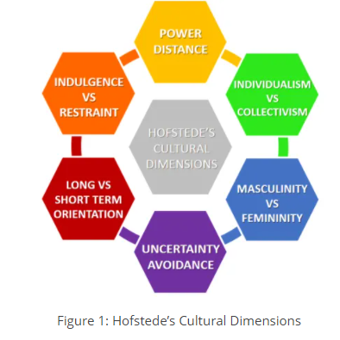
(Source: https://www.business-to-you.com/hofstedes-cultural-dimensions/)
The employees of different culture with different expectation and satisfaction level when work within a single space, the cultural differences practically impact on the overall human resource policies of the organisation (Albon et al. 2016). In many a cases Apple has been seen to face challenges like higher employee turnover rate, poor employee satisfaction rate and others, negatively impacting on its overall operations. In many situations, due to the cultural differences Apple appears to face challenges in applying ethnocentric approaches, restricts it to send the expatriates to the host country as it becomes equally challenging for the expatriates to cope with the different work culture. The HR policies of Apple are therefore required to be flexible and dynamic with transparent policies to keep the workforce motivated and highly engaged to the operational development process.

Future possible changes:
The spread of Covid-19 pandemic backed up by economic recession is going to further put the business of Apple into distortion. The followings are some of the possible issues that Apple might have to face in the longer term.
- The growing nationalism trend across the globe might put Apple’s business into serious turmoil. Possibly, the countries which the corporation is majorly deals with would start focusing more on domestic values, restricting people to work with overseas companies. For example, the growing nationalistic sentiment in China is obstructing the growth of the business.
- Due to the economic downturn, chances are high that the labour cost in different countries will increase, bringing down the total profit margin that Apple used to enjoy and proud of (Tidd and Bessant, 2020).
- Economic recession might restrict customers to invest comparatively low for the high-end products. For example, iPhone sales were down by 20% before the launch of iPhone 12 when compared to the same period as the previous financial year.
- With the growing inflation across the globe, there is a higher chance that to procure the talented corporate employees Apple will have to spend more. It will also result in higher spending for the training and retention purposes.

5.0 The strategic response to the environmental changes by Apple
In order to manage the growing challenges in the external and internal environment and to minimise its impact on people resourcing, Apple has adopted a number of policies and strategies. The followings are some of the approaches that Apple has taken up.
Application of resource-based view by Apple:
Apple selling its products at a higher price range, to maintain exclusivity in the brand value in comparison to the other competitors of the market, appears to be important. Since Apple along with its main competitors (Samsung or IBM), enjoys the same resources (tangible of financial, physical, technological and organisational resources and intangible human, innovation and reputational resources) it is very easy for competitors to adopt the same strategies that Apple is implementing and follow the same path, consequently nothing competitive gains will be there (Armstrong, 2016). To gain a competitive advantage the innovative approach to Talent Management component of resource strategy seems to have been applied: further offering the employees an innovative and dynamic environment help Apple to attract the highly talented workforce which is used for the structural development process of the organisation.

VRIO analysis:
In order to understand which particular resource helps Apple to attain the benefits, this report looks at the VRIO analysis - “an analytical technique for the evaluation of company's resources; VRIO stands for the names of the evaluation dimensions: Value, Rareness, Imitability, Organization” (Managementmania, 2011)
Resources | Value | Rarity | Imitability | Organised to exploit | Impact on the competitive advantages
Strong global presence | Yes | Yes | Yes | Yes | Sustainable competitive advantages
Specialized in technology | Yes | No | No | Yes | Competitive
Highly talented workforce | Yes | Yes | No | Yes | Temporary competitive advantages
Table 2: VRIO analysis
Application of strategic HRM policy in response to the environmental changes
VRIO analysis identifies talented workforce as one of the competitive advantages that the organisation uses to stay ahead of its competitors. Hence practices adopted by Apple to overcome the environmental challenges focus on the Talent Management (employee recognition, performance management, screening & selecting, talent acquisition); Employee Value Proposition and Flexibility plans. Apple fundamentally concentrates on the behavioural and attitudinal characteristics of the staffs while letting them to work within the organisation and to retain them. Although this policy is considered risky, Apple being an adaptive and innovative organisation looks for unconventional people who can invest their talent to ‘buck the system’ (Walford-Wright and Scott-Jackson, 2018). Apple’s HRM strategy in resourcing purpose henceforth focuses on matching the resources to the organisational requirements, which means to maintain the status of the company, but also does indicate to radical changes in the overall thinking process regarding the skills and attitudes needed in attaining future achievements, growth and should be distinctly linked to cultural change. Systematic policies applied for human resource planning which further moves through proper recruitment, selection and induction of the skilled workers in the talent pool, followed by application of effective performance management policy, training and development policy and rewarding and recognition policy used for the retention purpose. With the global pandemic of coronavirus showing no signs of lessening its grip, HR’s outstanding moment for 2020 was to be able to instantaneously manage to direct the workforce to remote working, implement the COVID-19 safety protocols within the corporate dwellings and manage “the policies for quickly emerging laws to address the needs of the workforce for both employee and continuing business operations” (Kloss, 2020).

6.0 Conclusion
All throughout the report the main focus has been centred within highlighting the strategic resource management approach and policies of Apple Inc. It has been observed that organisations within the same market sector, selling similar or alternative products or services, targeting the same segment of customers, are required to act more comprehensive and innovative in nature so that both the internal and external challenges can be effectively addressed. Apple seems to have been applying the similar policies to meet the challenges in the existing market and the future market, but constantly innovating existing policies to address the change. This report has argued that Apple uses its best resources strategically i.e. matching the resources to the organisational requirements which allows corporation to deliver the aims of the business.
7.0 Recommendation
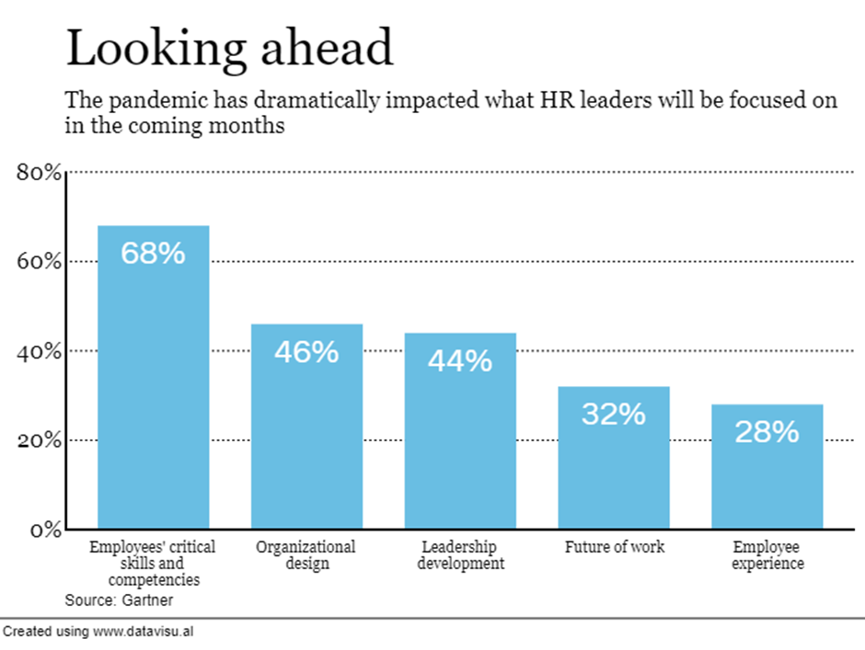
( Source: https://hrexecutive.com/these-are-hrs-priorities-for-2021/)
As a respond to the COVID-19, the accelerated digital transformation initiatives will bring widespread demand for digital skills, which will require HR professionals to adopt new approaches to reskill, redeploy talents according to the new needs arise. The upskilling will need to be implemented without overwhelming workforce, using employment value proposition strategies (Whittle, 2020).

References
Aboulamer, A., 2018. Adopting a circular business model improves market equity value. Thunderbird International Business Review, 60(5), pp.765-769.
Albon, S.P., Iqbal, I. and Pearson, M.L., 2016. Strategic planning in an educational development centre: motivation, management, and messiness. Collected Essays on Learning and Teaching, 9, pp.207-226
Altarawneh, A., 2011. Strategic Human Resources Management (SHRM) inJordanian Hotels. International Journal of Business and Management, Vol.6(No10), p. 14.
Anon., 2018. https://www.apple.com/job-creation/, United States: Apple Inc.
Armstrong, M., 2014. Armstrong's handbook of humanresource management. 13th ed. London: Kogan Page
Armstrong, M., 2016. Armstrong's handbook of strategic human resource management. Kogan Page Publishers.
Bratton, J., 2007. Human Resource Management:Theory and Practice. 4th ed. Palgrave, p.38-70.
Clover, J., 2020. COVID-19 Coronavirus: Impact on Apple's iPhone, Mac and WWDC. [online]
Available at: https://www.macrumors.com/guide/covid-19-coronavirus/
[Accessed 10 12 2020].
Cnbc.com, 2020. The coronavirus pandemic helped boost Apple’s iPad and Mac sales. [online] Cnbc.com. Available at: <https://www.cnbc.com/2020/07/31/the-coronavirus-pandemic-helped-boost-apples-ipad-and-mac-sales.html> [Accessed 10 Dec. 2020].
Faruq.U.,2019. Apple Pestle Analysis. [on-line] Available at: https://www.marketingtutor.net/apple-pestle-analysis/ [Accessed 30 11 2020]
Frue,K., 2019. PESTLE Analysis for Human Resources: How PESTLE Affects HR. [online]. Available at: https://pestleanalysis.com/pestle-analysis-for-human-resources-how-pestle-affects-hr/ [Accessed 10 12 2020].
Gallardo, E. and Thunnissen, M., 2016. Standing on the shoulders of giants? A critical review of empirical talent management research. Employee Relations, 38(1), pp.31-56.
Hong, J., Zhang, Y. and Ding, M., 2018. Sustainable supply chain management practices, supply chain dynamic capabilities, and enterprise performance. Journal of Cleaner Production, 172, pp.3508-3519
J.M, O., 2019. Apple defends its ‘Most Admired for HR’ crown. Human Resource Executive, pp. on-line.
Khan.U, A. A., 2015. A Critical Analysis of Internal and External Environment of Apple Inc. International Journal of Economics, Commerce and Management, Vol. III(6), p. 956.
Kloss, B., 2020. ‘Strategic’ will be the word of the year in 2021, USA: Human Resource Executive.
Managementmania, 2011. VRIO Analysis. [on-line]. Available at:
https://managementmania.com/en/vrio-analysis#:~:text=Corporate%20Strategy-,VRIO%20Analysis%20is%20an%20analytical%20technique%20briliant%20for%20the%20evaluation,%2C%20Rareness%2C%20Imitability%2C%20Organization [Accessed 10/12/2020].
Muhammad, 2014. Strategic Planning and Reality of External Environment of Organizations in Contemporary Business Environments [online]. Available at: https://www.researchgate.net/publication/271712548_Strategic_Planning_and_Reality_of_External_Environment_of_Organizations_in_Contemporary_Business_Environments [Accessed 20 Nov 2020].
NationMaster, 2020. The Impact Of China-US Trade War On Employment. [online]
Available at: https://www.nationmaster.com/blog/the-impact-of-china-us-trade-war-on-employment/
[Accessed 09 December 2020].
Nickless, E., 2017. Resourcing future generations: A global effort to meet the world’s future needs head-on. European Geologist European Geologist, 42, pp.46-50.
Nytimes.com, 2020. Apple Signals Coronavirus’s Threat to Global Businesses. [online] Nytimes.com. Available at: <https://www.nytimes.com/2020/02/17/technology/apple-coronavirus-economy.html> [Accessed 10 Dec. 2020].
Starner, T., 2020. These are HR’s priorities for 2021. [Online]
Available at: https://hrexecutive.com/these-are-hrs-priorities-for-2021/
[Accessed 30 11 2020].
Tankovska, H., 2020. Apple's number of employees in the fiscal years 2005 to 2020 (in 1,000s), Worldwide: Statista.
Team, T., 2020. Will Apple’s iPhone Business Return To Growth This Year?. [online] Forbes. Available at: <https://www.forbes.com/sites/greatspeculations/2020/02/14/will-apples-iphone-business-return-to-growth-this-year/?sh=46dec3511685> [Accessed 10 Dec. 2020].
The Verge, 2020. Apple’s services business hits all-time record and helps lessen coronavirus impact. [online] The Verge. Available at: <https://www.theverge.com/2020/4/30/21243158/apple-q2-2020-earnings-coronavirus-covid-19-growth-watch-airpods> [Accessed 10 Dec. 2020].
Tidd, J. and Bessant, J.R., 2020. Managing innovation: integrating technological, market and organizational change. Wiley.
Walford-Wright, G. and Scott-Jackson, W., 2018. Talent Rising; people analytics and technology driving talent acquisition strategy. Strategic HR Review, 35(8), pp.214-222.
Wiedner, R., Barrett, M. and Oborn, E., 2017. The emergence of change in unexpected places: Resourcing across organizational practices in strategic change. Academy of Management Journal, 60(3), pp.823-854.
Whittle, 2020. These are HR’s priorities for 2021, USA: Human Resource Executive.
Yang, S.H., Nam, C. and Kim, S., 2018. The effects of M&As within the mobile ecosystem on the rival's shareholder value: The case of Google and Apple. Telecommunications Policy, 42(1), pp.15-23.
Yevgenyevna, A.Y. and Igorevich, M.M., 2019. Analytical review of Apple Inc. Sustainable development goals implementation. International scientific review, (LVIII).

