Programme: Employability Skills
Module: Digital Skills for Personal and Professional Growth
Module code: BMSW4008
Student ID: 2223775
Student Name: Katarzyna Mrotek
Rework

Contents
1. Task 1 – Linkdn Profile 3
2. Task 2 – Story Telling 4
3. Task 3 – Questionnaire Analysis 8
4. Task 4 – Website and Marketing Material 11
4.1. Questionnaire 11
5. Appendices 18

Task 1 – Linkdn Profile
Hello and to the best of my understanding welcome to the linked-in page that I have been developing for this assignment. My name is Katy, I am a Co-Partner of PureBeauty agency this company's goal is to make the concept of beauty better by introducing new ideas to this world, which is friendly to our planet. After completing 16 years in school and bearing the desire to make a great impact in beauty, academic research is sought in addition to advancing practice research in equal measure.
In PureBeauty I am placed in charge of product affairs, market strategy/feedback, and corporate/society interaction. To provide the progress of trend indicators, and constant adjustments to our offers for the potential customer base, I am our brand’s point person for all aspects of its administration. My goal is to create a brand that makes people beautiful while at the same time conserving the environment and helping fellow human beings.
I am a learner by profession because in my career learning is not a one-time event but a concentric cycle. To work more efficiently with modern knowledge and developments I use conferences, workshops, and online classes. This desire makes me able to think outside of the bar for PureBeauty to be established to compete well in the beauty market.
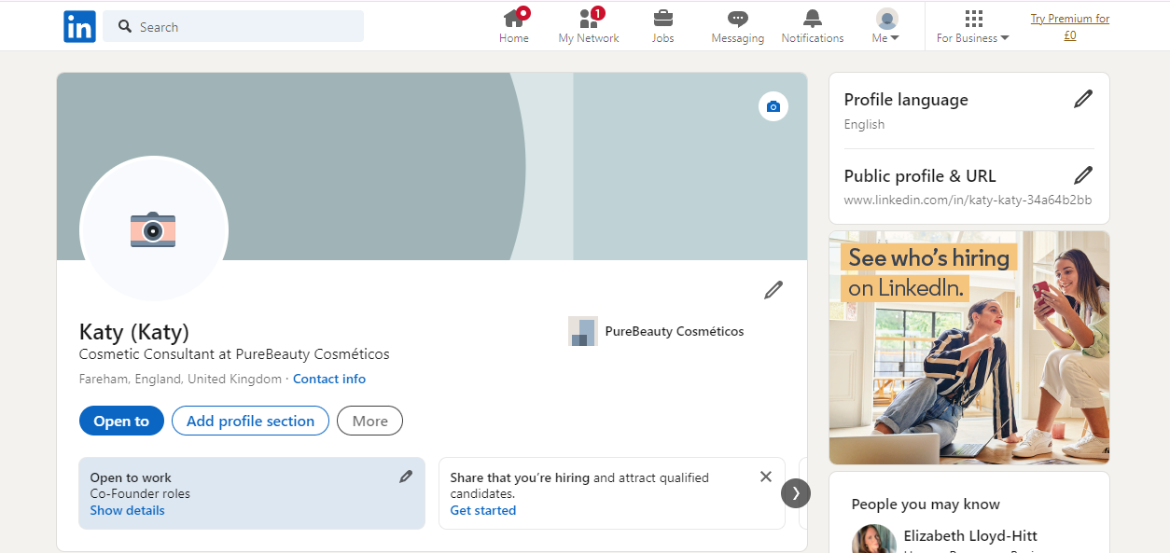
Figure 1 LinkedIn Profile
Another activity which is most relevant to me is the communication with other actors in the industry. I do this by that value due to the fact I find talented individuals to work with and provide services regarding projects that are in line with the mission statement of the company, chief of which is to make beauty sustainable and innovative. In other words, it will be possible to come up with appropriate further actions and produce positive shifts within the given sphere.
Apart from my duties in the assigned positions, I engage myself in the dissemination of information and knowledge on matters about the industry. This can comprise being on a panel to give a talk or write an article and being actively involved in debates, especially on social media pages. Thus, by regularly providing information on relevant topics and subsidiaries to the company, I want PureBeauty to become an industry leader in the sustainability of this line of business.
Moreover, I am eager to contribute to the development of the future specialist in the sphere of beauty. Showing them how they can achieve a better world through the beauty industry or supporting younger talents who have the same goal: is all I can do to spread the word positively and create a change.
I believe that describing my responsibilities in terms of the artefacts that I deal with at PureBeauty is easier and more accurately conveys the essence of the work I do since it comes from a genuine passion for sustainable development, constant improvement, and learning. In light of this consideration, it is my endeavour that through proper planning, careful market identification, and teamwork I shall take this brand towards a society that is in harmony with beauty as well as the environment. I hope you had a great experience visiting our LinkedIn page and I am looking forward to linking with people and companies who have the same passion as we do in increasing the positive impact in the beauty industry.

Task 2 – Story Telling
Story Telling and Brand Building
In the context of delivering content from a personal or business brand-building aspect, storytelling is the process of telling a compelling story where an emotional connection is developed with the audience. It creates a compelling narrative around the brand, its purpose, and character and taps into a deeply human need to bond emotionally with something that matters (Hofman-Kohlmeyer, 2017). When used to build brands, storytelling techniques employ parts of the plot including character, a problem, and a solution (Hofman-Kohlmeyer, 2017).
Role of Story Telling in Brand Building
- Storytelling is in a way reaching people, telling a story brings special feelings like happiness, longing, or compassion. Consumer bonding is therefore powerful and potentially dominant over reason or rationalisation, key facets being promoted through apparent product attributes (Hong et al., 2022).
- As a technique in advertising, storytelling makes brands easily distinguishable as it will highlight facets that are its identity, background, or core principles (Guttentag, 2019).
- In creating its audience, a story must do that in a way that forms a bond that people will not be able to break. Loyal advocates result from the feelings that the brand and the consumer have related values and experiences. In my opinion, establishing trust is always the key issue that occurs when companies are expected to tell stories that are credible and non-contradictory (Blal et al., 2018).
- Traditional narratives are quite memorable compared to data and statistics. This way it becomes easier for the brand so that the message if not almost stuck in the heads of consumers can be easily retrieved or recalled whenever needed important for long-term branding (Guttentag et al., 2018).
- ‘My story’ This statement is not as general and ambiguous as the previous one, but it also reflects an important aspect of generic narratives: Stories invite participation.
Example of Effective Brand Storytelling
- AirBnB
Airbnb’s storytelling plan shows just how sharing a story with a group may be effective in brand building. Airbnb doesn't simply provide rooms and houses to stay in; it provides rooms and houses that tell stories and create experiences (Casali et al., 2018). Their role re-creates the personalized and individualized experience that travellers and hosts have since gender feelings of affiliation. Airbnb applies the Community-Centric Branding strategy where the emphasis is made on the community and its members. This model is focused on the content contributed by the users, their interactions, and the feeling of the community that connects and relies on each other.
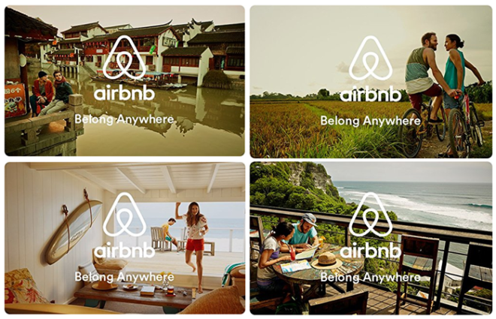
Figure 2 Air BnB advertising storytelling
Airbnb’s “Belong Anywhere” campaign is not just about a roof over the head, it is a narrative of an individual finding a home in literally a different world. Airbnb speaks directly to the problem of isolationism by telling the stories of individual transformation, growth, and connection -- something that is innate in every person (Chan and Parhankangas, 2017). It would help the company stand out from its competitors in the online travel space as Airbnb pays attention to what is probably the most asset of any trip – the experience (Rachinger et al 2018).
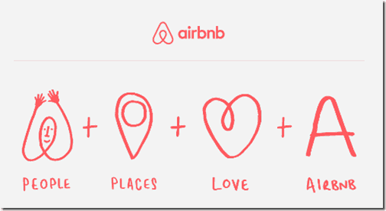
Figure 3 Air BnB advertising storytelling
- Nike
The brand story of Nike is a story of innovation and inspiration. Established in 1964 as Blue Ribbon Sports, it then changed its name to Nike in 1971 taking its name from the Greek goddess of victory. The current tag line of Nike “Just Do It” which was initiated in 1988 indicates the spirit of resistance.
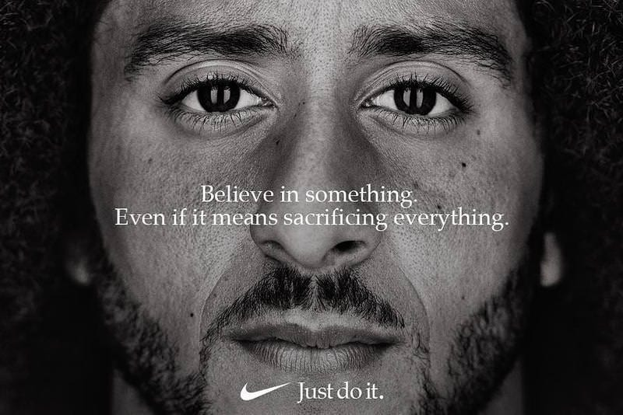
By using stars and advanced technologies in its shoes and clothes, Nike has become a symbol of people inspiring them to be themselves and unleash their inner athlete. By using Emotional Branding Model which aims to target the emotions of their customer the brand’s narrative revolves around the spirit of winning and pushing boundaries, which is why it is recognized as a worldwide emblem of sport and accomplishment.
- Burberry
Burberry is a brand with rich history starting from 1856 when it was founded by Thomas Burberry. The brand history dates back to the origin of gabardine outerwear fabric, which is the base of the brand identity. Thus, showcasing the historical aspect of the brand and at the same time incorporating modern ideas, the brand stands for timeless sophistication and high-quality products. Burberry uses the Heritage Branding model, which exploits the brand’s history and traditions to create a brand identity.
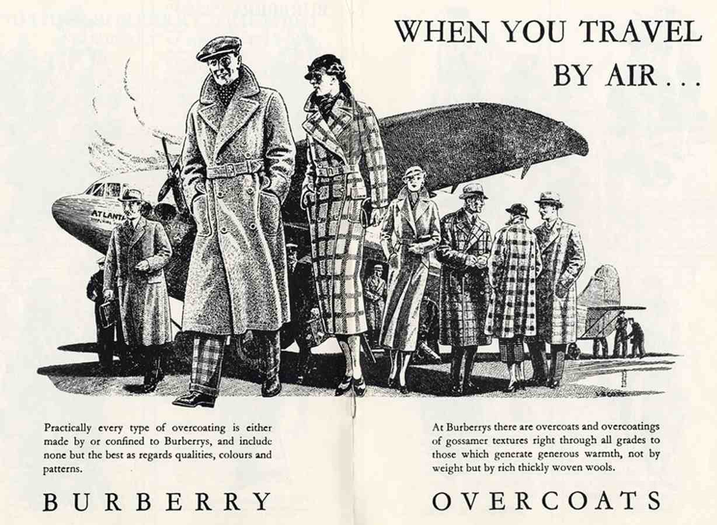
The major concept that is reflected in this model is the idea of the brand as authentic, high-quality and timeless. Burberry’s strategic application of its trench coat, the check pattern and the founding year 1856 underlines the brand as an authentic and luxurious British fashion house.
Conclusion
In brand building and promotion, storytelling plays an important aspect in brand marketing needs. Otherwise, through sharing an appealing and inspiring story, using storytelling to stand out from other brands and competitors, developing credibility and a strong bond with the audience, and using emotions to facilitate memorization and active participation, storytelling is a revolution in the way brands engage with the public (Nabi et al., 2018). The case of Airbnb is an excellent example of how proper storytelling is an excellent tool that makes audiences have brand-personal affection, a key aspect of brand-building. It is vital to look at storytelling not as an advertising strategy in the modern context of saturated markets when consumers are longing for meaning; it is a fundamental element of branding (Reinhold and Dolnicar, 2018).

Task 3 – Questionnaire Analysis
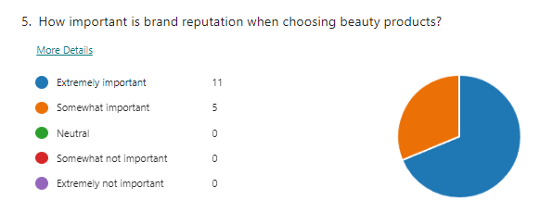
Interpretation
Even more (68.75%) of the participants reported that the brand reputation was important for buying beauty products. The median rating is much lower, equal to 25% of the importance of this issue. All the respondents were informed and none of them were indifferent or considered the issue unimportant.
Influence on Business Idea
When it comes to a beauty products business it is mandatory to pay specific attention to the brand image and its sustenance. Marketing messages and campaigns to the target consumers should revolve around product quality, customer satisfaction, and trust. Maintaining a positive image in the consumer’s mind garnered a lot of attention as one of the most important marketing determinants, apparently meaning that brand-building activities such as endorsements, social proof, and quality assurance are likely to reap big (Xie et al., 2017).
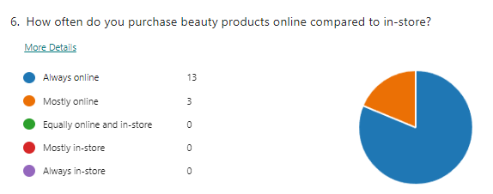
Interpretation
Data presented in the chart clearly show the audiences' inclination towards online shopping in the beauty products niche. Among the 16 respondents, 3 claimed to always buy the beauty products online and 10 reported that they mostly buy the products online. Out of 421 total participants, none reported that they shop in-store most often, equally, or all the time. There appears a prominent inclination in the direction of online buying in the beauty segment based on this information. It also shows that consumers prefer or prefer the Internet as a shopping medium in the case of beauty products. These reasons might include ease of access, options of the CA products available, cost comparison, and the convenience of not having to leave home to shop for the products.
Influence on Business Idea
Since consumers prefer buying products online more, especially beauty products, businesses in this industry ought to consider digital marketing. To meet this demand, it is necessary to invest in specifically in the easy-to-navigate e-commerce platform. Designing easy-to-use palatable websites, recommending relevant products, and implementing user-friendly navigation will help clients stick to a particular site and result in buying products online. Moreover, expanding the usage of digital marketing tools, attracting attention to social media accounts, and negotiating with influencers may help increase the site traffic of online stores. Furthering online purchases, free shipping or premiums, exclusive discounts, and membership menus should be incorporated (Aschemann-Witzel et al., 2021). This way, the business basing its strategies on such data makes informed decisions on the market and captures more of its share.
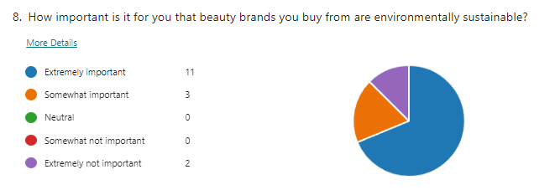
Interpretation
Inferring from the chart, there is an increasing consumer consciousness and consequent demand for environmentally friendly beauty brands. In response to another set question: ‘In your opinion, how important is it?’, 11 of the 16 respondents selected ‘very important’, while 3 chose ‘somewhat important’. As to the non-important aspect, the results show that only 2 respondents are extremely not important, with no respondent answering the question as either neutral or somewhat not important.
Influence on Business Idea
This is because the environment has been considered very sensitive in today’s world and as beauty brands seek to market their products, they should remain environmentally sensitive in what they do. This could automatically require the use of environmentally friendly materials, minimising usage of non-biodegradable materials or materials that do not readily decompose, and ensuring that the raw materials used in the preparation of foods that will be used are sourced in the right manner (Richter et al., 2017)

Task 4 – Website and Marketing Material

Questionnaire
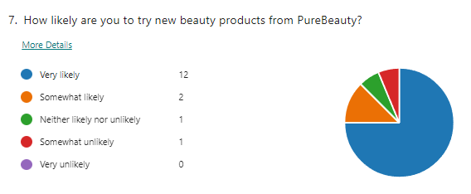
Referring to the data presented in the chart above, it can be suggested that the overall attitude of customers towards PureBeauty's new beauty products is rather positive. Of the 16 participants, 12 (75%) said they are very likely to try products in the future, and 2 (12. 5%) are somewhat likely to try these products in the future.
One respondent fell into the neither likely nor unlikely category and one – somewhat unlikely. Marketing with such high interest showed that there is a great potential market for PureBeauty to launch new products. This can be interpreted to mean that currently the company’s brand image and the products that it is selling are in harmony with consumer preferences. Therefore, to increase customer goodwill, PureBeauty should ensure that the products are improved in quality and that a marketing campaign emphasizes new product features. An added advantage of involving customers through feedback and reviews will help to improve this on the offered products. This favourable response also breaks a pointer to the fact that these customers must be retained while the brand continues to be trusted by the customers.

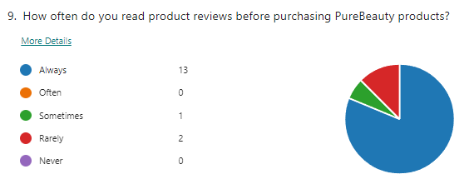
According to the chart, most consumers agree with reading the product reviews before buying PureBeauty goods. In total, 16 personnel responded to this question: 13 (81. 25%) always read reviews, and none checked the second option – "often. As for the frequency of reading reviews, which ranged from never, sometimes, rarely, and often, only one respondent sometimes reads reviews, and two respondents rarely do so, although none of the respondents indicated that they never read reviews. Thus, one can appreciate the fact that the reviews of products before purchase play a significant role among the customers of PureBeauty. Thus, review dependence stresses the importance of the company working actively to have many genuine positive customer evaluations. Some ideas on how to improve this could be sending employee follow-up emails to encourage customers to leave a review behind, giving actual discounts for customers who left their reviews behind, and making sure that the customers are easily able to locate the reviews on the product page. In addition, if there are any negative comments, it is important to respond in the proper way to solidify customer confidence in quality. These reviews, this reliance on reviews, can establish a real presence that can work to change the potential customers' mindsets and thus work on the perception customers have of the brand.

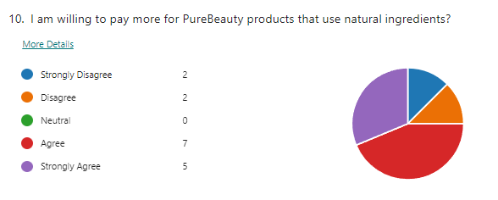
From the above chart, it is evident that the majority of the clients are willing to buy PureBeauty products that contain natural ingredients at a slightly higher price. Among the respondents, 7 out of the 16 are in support of the statement in the research while 5 out of the 16 strongly supported the statement. On the other hand, 2 people (12.5 %) strongly disagreed/disagreed and none considered the statement to be neutral. Hence, the willingness to pay a premium for natural ingredients demonstrates a shift in consumer preferences that puts a premium on the natural and potentially healthier composition of the produce. For PureBeauty, this insight means that it should focus on purchasing better quality natural ingredients to try and explain higher prices to the consumers and gain better consumers' attention. Marketing communication should closely align with the perception of natural ingredients as a positive value that underlines the company's environmentally friendly approach and product superiority. Moreover, clear information about sourcing practices and the environmental footprint also in the ingredients can increase consumers’ confidence and willingness to pay more. It also presents opportunities for new product line developments in products that are natural and organic mainly due to customers’ awareness and buying trends in the market.

  - Webpage
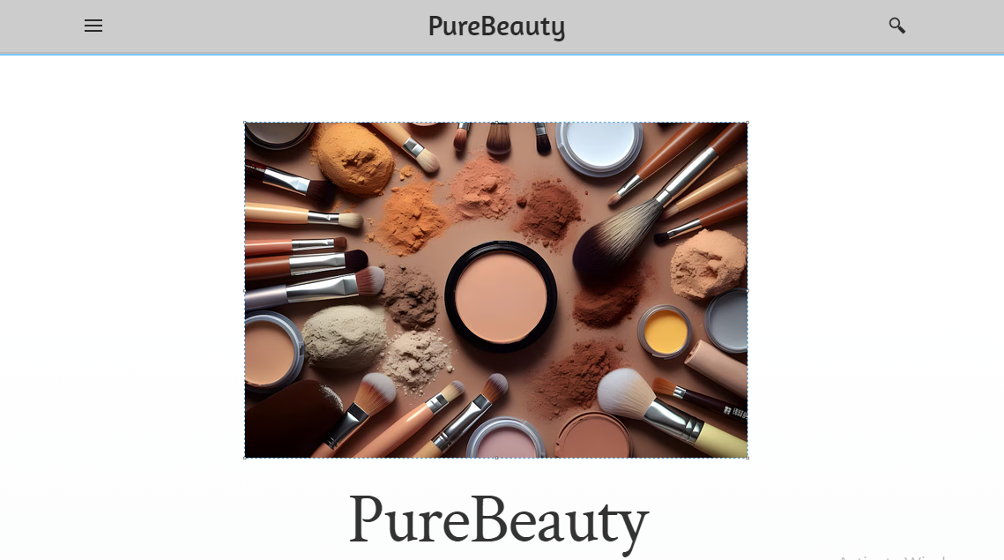

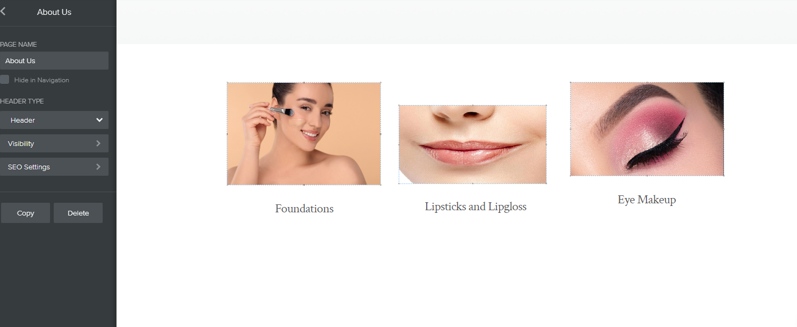
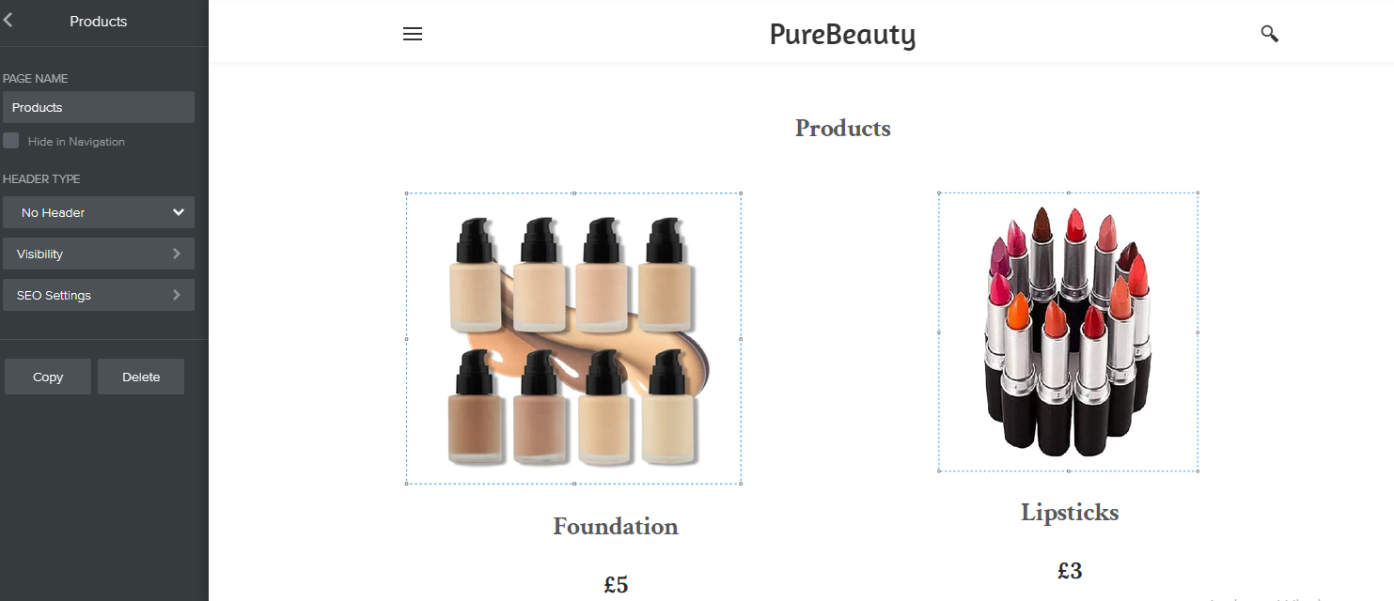

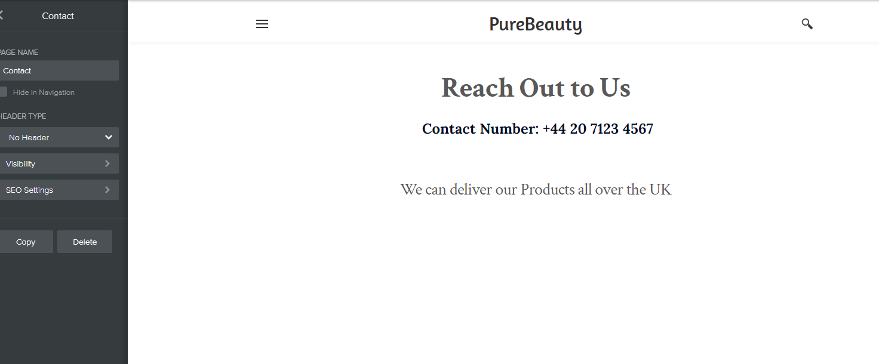

4.3 Marketing Materials
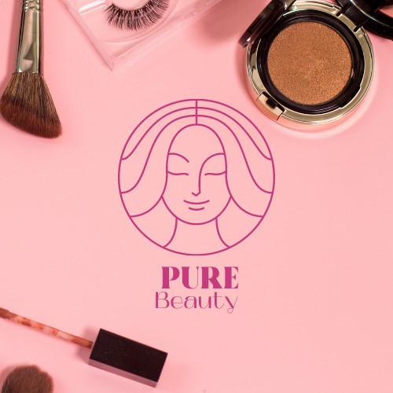
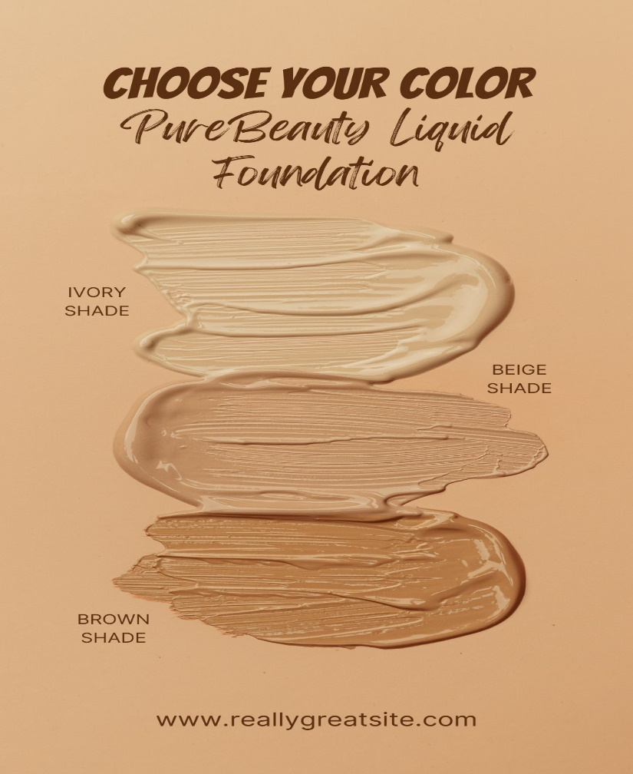
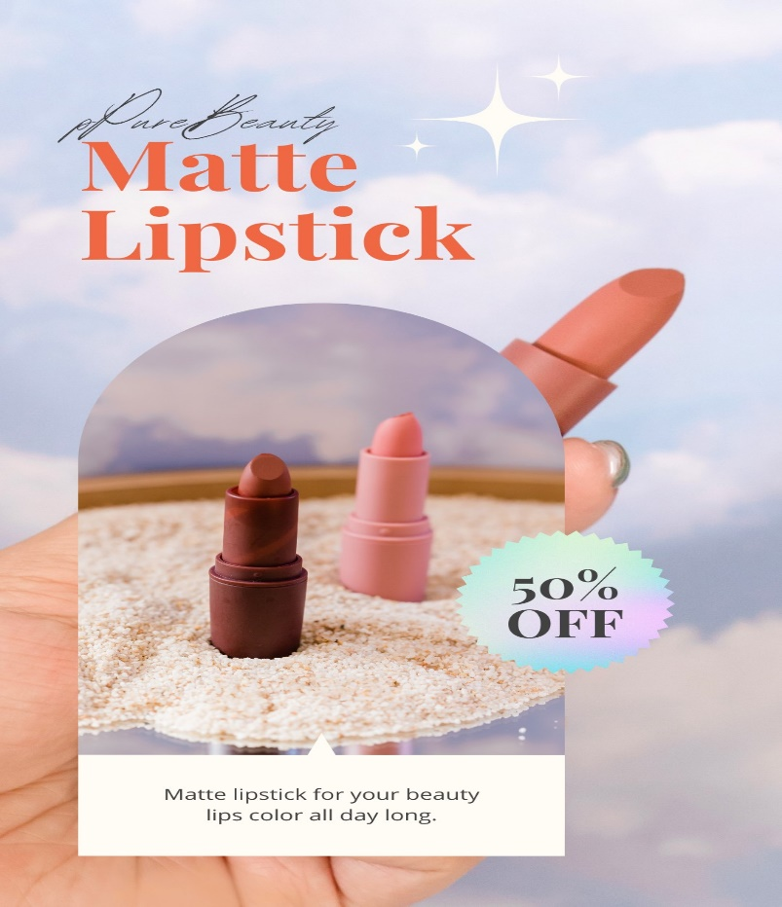
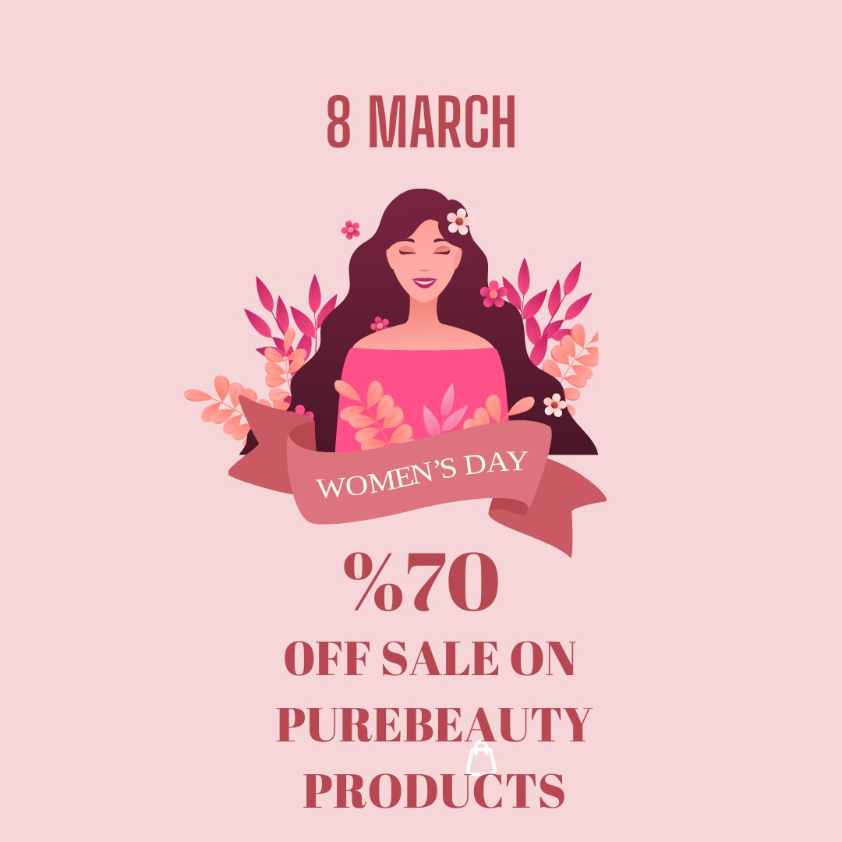

Appendices
Questionnaire
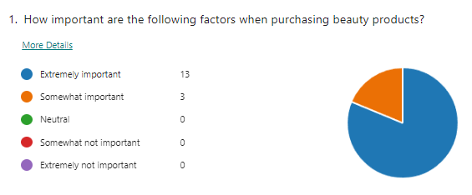
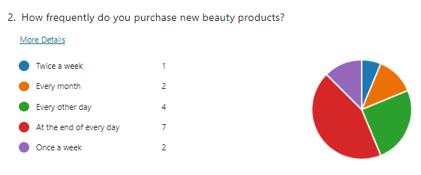
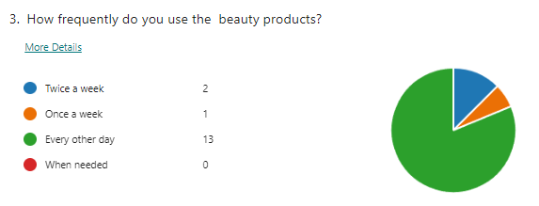
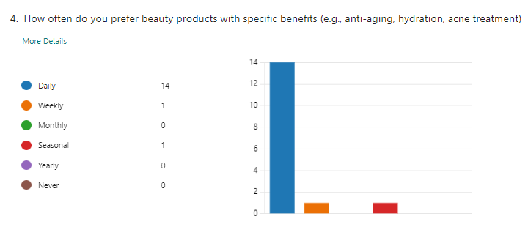
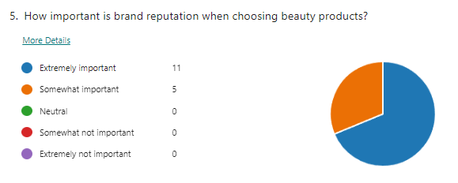
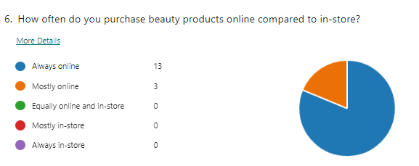
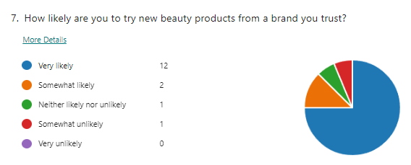
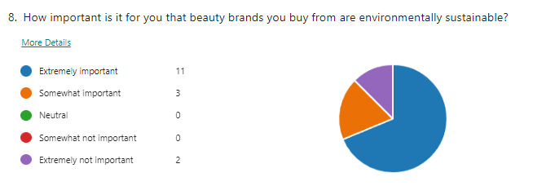
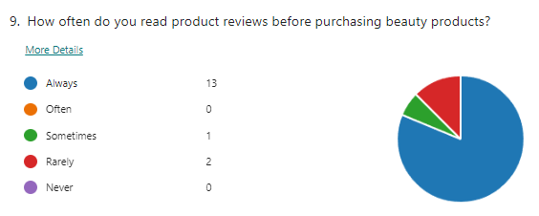
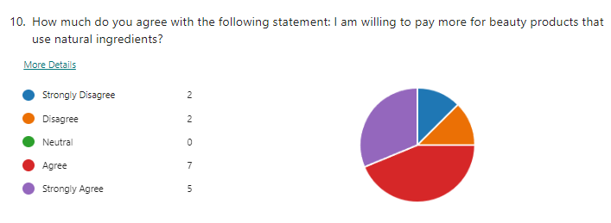

6. References
Aimé, I., 2023. The dynamic construction of brand storytelling. Journal of Strategic Marketing, 31(7), pp.1243-1262.
Aschemann-Witzel, J., Gantriis, R.F., Fraga, P. and Perez-Cueto, F.J., 2021. Plant-based food and protein trend from a business perspective: Markets, consumers, and the challenges and opportunities in the future. Critical reviews in food science and nutrition, 61(18), pp.3119-3128.
Blal, I., Singal, M. and Templin, J., 2018. Airbnb’s effect on hotel sales growth. International Journal of Hospitality Management, 73, pp.85-92.
Casali, G.L., Perano, M., Moretta Tartaglione, A. and Zolin, R., 2018. How business idea fit affects sustainability and creates opportunities for value co-creation in nascent firms. Sustainability, 10(1), p.189.
Chan, C.R. and Parhankangas, A., 2017. Crowdfunding innovative ideas: How incremental and radical innovativeness influence funding outcomes. Entrepreneurship Theory and Practice, 41(2), pp.237-263.
Dangi, N., Gupta, S.K. and Narula, S.A., 2020. Consumer buying behaviour and purchase intention of organic food: a conceptual framework. Management of Environmental Quality: An International Journal, 31(6), pp.1515-1530.
De Araujo Zanella, A.R., da Silva, E. and Albini, L.C.P., 2020. Security challenges to smart agriculture: Current state, key issues, and future directions. Array, 8, p.100048.
Fleșeriu, C., Cosma, S.A. and Bocăneț, V., 2020. Values and planned behaviour of the Romanian organic food consumer. Sustainability, 12(5), p.1722.
Guttentag, D., 2019. Progress on Airbnb: a literature review. Journal of Hospitality and Tourism Technology, 10(4), pp.814-844.
Guttentag, D., Smith, S., Potwarka, L. and Havitz, M., 2018. Why tourists choose Airbnb: A motivation-based segmentation study. Journal of Travel Research, 57(3), pp.342-359.
Hofman-Kohlmeyer, M., 2017. The role of storytelling in building a brand. Humanitas University's Research Papers Management, 18(3), pp.131-145.
Hong, J., Yang, J., Wooldridge, B.R. and Bhappu, A.D., 2022. Sharing consumers’ brand storytelling: influence of consumers’ storytelling on brand attitude via emotions and cognitions. Journal of Product & Brand Management, 31(2), pp.265-278.
Nabi, G., Walmsley, A., Liñán, F., Akhtar, I. and Neame, C., 2018. Does entrepreneurship education in the first year of higher education develop entrepreneurial intentions? The role of learning and inspiration. Studies in Higher Education, 43(3), pp.452-467.
Rachinger, M., Rauter, R., Müller, C., Vorraber, W. and Schirgi, E., 2018. Digitalization and its influence on business model innovation. Journal of Manufacturing Technology Management, 30(8), pp.1143-1160.
Reinhold, S. and Dolnicar, S., 2018. Airbnb’s business model. Peer-to-peer accommodation networks, p.27.
Richter, C., Kraus, S., Brem, A., Durst, S. and Giselbrecht, C., 2017. Digital entrepreneurship: Innovative business models for the sharing economy. Creativity and innovation management, 26(3), pp.300-310.
Xie, K.L. and Kwok, L., 2017. The effects of Airbnb’s price positioning on hotel performance. International Journal of Hospitality Management, 67, pp.174-184.

