
Portfolio 4 components
Foreign Languages & Cultural Awareness
BMIH5003



Giulia Chifari
Beatrice-Elia Gherasim
2241871

Table of Contents
Component 1 - Professional Reflection 2
Scenario of Cultural Misunderstanding 2
How Cultural Misunderstanding Can Occur 2
Skills and Behaviours 3
Component 2- Training Plan 3
The goal of the Training Plan 3
Training Curriculums 4
Completion Time 4
Target Employee Base 4
Key Performance Indicators 5
Equipment and Tools Needed 5
Program Coordinator 5
Component 3: Student self-reflection using Gibbs’ Reflective Model 5
Description 5
Feelings 6
Evaluation 6
Analysis 6
Conclusion 6
Action plan 7
Slide 1 7
Slide 2: Introduction 8
Slide 3: Concept Of Multilingualism 8
Slide 4: Importance of Language Awareness Skill 9
Slide 5: Italian- Modern European Language 9
Slide 6: Language awareness skills required for Ibis Budget Hotel Staff 10
Slide 7: Conclusion 10
Slide 8: References 11
Slide 9: Thank you 11
References 12

Component 1 - Professional Reflection

Scenario of Cultural Misunderstanding
I observed a cultural misunderstanding during my placement at Ibis Hotel. It occurred in the evening in the in-house restaurant area. While working at the counter, I observed an Afghan Muslim couple taking their seats and ordering dishes. However, while the staff brought the food to them, they asked him, in half-Urdu and half-English words, whether the food was halal or not. The staff member was a Bolivian Catholic, young and new in the industry, and had few interactions with Muslims. Due to cultural differences, he did not fully understand the importance of the word halal. Therefore, he casually told them that the food was not halal. After this, the Muslim couple angrily cancelled the order by calling the manager. Our manager rushed to the scene and told the couple that the food was a halal preparation, and the staff who served it did not know the word halal due to cultural differences. He also did not understand the language of the Muslim couple, as they spoke many Urdu words that the staff did not know. However, this incident was a valuable learning opportunity to enhance our cultural awareness and language skills. After this misunderstanding was cleared, the Muslim couple calmed down and sat at their table to proceed with the ordered food.

How Cultural Misunderstanding can occur
During my placement at Ibis Hotel, I realised that cultural misunderstandings could occur due to differences in communication languages and styles (Adanlawo et al., 2021). However, the most significant reason for cultural misunderstandings is the differences in cultural values and beliefs (Poturak et al., 2020). In the scenario mentioned above, the staff's lack of familiarity with the cultural significance of halal food led to a misunderstanding. Apart from these, cultural misunderstandings can occur due to the lack of empathy, which hampers the capabilities of understanding the emotions of the communication partner (Christiansen et al., 2020). If the staff in Ibis Hotel had realised that halal food is essential for the customer by detecting his emotions, he could have double-checked it with the manager before answering. Cultural bias can also cause cultural misunderstandings, as in this case, one believes their own culture is superior to other cultures, thus developing conflicts with different cultures (De Leersnyder, Gündemir and Ağirdağ, 2021). For example, in Chinese culture, people smile when they do not understand a statement, which can be misunderstood in American culture as the listener understands and agrees with that statement (Glowacka, 2024). Cultural misunderstandings can also occur due to different body language meanings in other cultures and communicating with people without knowledge about their culture (Abramson & Moran, 2018).

Skills and Behaviours
From this experience, I realised I need several skills to ensure that such cultural misunderstandings do not happen in my career. For instance, I need cultural awareness skills, which is essential for gaining a high level of knowledge regarding the customs and etiquette of different cultures (Yurtsever & Özel, 2021). High-level communication skills are imperative, encompassing active listening, non-verbal communication, and the virtues of patience and empathy. These skills are vital for effectively understanding the emotional and psychological nuances of individuals from diverse cultural backgrounds(Khanna, 2020). I also need honesty, genuineness, and integrity in my attitude, which will express my sincerity. These skills and behavioural attributes will collectively form my intercultural competence.

Component 2- Training Plan

The goal of the Training Plan
The main objective of this training plan is to improve the ability of Ibis Hotel employees to effectively navigate and communicate in diverse cultural environments, ultimately fostering a more inclusive and understanding work environment. This training program aims to achieve this goal within six months through workshops, interactive seminars, and real-world scenario-based learning experiences. This will be achieved by implementing specific and tailored curricula to address various aspects of intercultural communication, understanding, and sensitivity.

Training Curriculums
The curriculum for this training involves several activities. The first goal is to improve the cultural awareness of the employees, for which the employees will go through a 15-minute presentation depicting the importance of culture, differences among cultures, possible causes and solutions for intercultural conflicts, and the unique values and beliefs of different cultures (Sagiv & Schwartz, 2022). The activity will continue for one month, encompassing a total of eight presentations conducted bi-weekly. Following this, employees will partake in 30-minute practical training sessions and workshops on a weekly basis for two months. These workshops will teach language awareness, non-verbal communication, active listening, and empathy skills (Abdikarimova et al., 2021). After completing the written examination on intercultural competency, employees will engage in a series of four sessions spread over one month to assess their theoretical understanding of the subject. In addition, employees at Ibis Hotel will have the exceptional opportunity to participate in a 15-day transfer program to Ibis Hotels located in various countries across Europe, Asia, and America. This immersive experience aims to provide practical exposure to consumers from diverse cultural backgrounds, thereby strengthening their capacity to effectively interact with a wide range of clientele (Lam et al., 2022). The training program will consist of four separate batches, with each batch beginning once the previous one has been completed. This will result in a total duration of two months for the entire training. The training will cover theoretical and practical sessions; no prior qualifications are required to participate. The estimated cost for this training course is approximately £2000, with the primary expense going towards hiring workshop trainers.

Completion Time
Six months

Target Employee Base
The training is mandatory only for Ibis Hotel employees who have direct interaction with customers and guests.

Key Performance Indicators
The primary performance metric for this training session will be the written exam scores of the trainees, with a passing grade set at 60/100. Additionally, the feedback from Hotel managers at the trainees' future branches will be another important indicator. Satisfactory performance will be defined as receiving positive feedback in at least 60% of interactions with customers from diverse cultural backgrounds.

Equipment and Tools needed
The essential equipment and tools include presentation materials, projectors, auditorium setups, workshop arrangements, examination setups, and provisions for temporary employee relocations.

Program Coordinator
The human resources manager of Ibis Hotel Newport is in charge of organising and overseeing the logistics of this training program. The manager is responsible for managing all aspects of employee development and training within the hotel.

Component 3: Student self-reflection using Gibbs’ Reflective Model

Description
During my placement at Ibis Hotel, I was privileged to engage with guests from distinct cultural backgrounds, such as Asian, African, and Latin American. This invaluable experience served as a poignant reminder of the critical role that effective cross-cultural communication plays in guaranteeing customer contentment within the hospitality sector. It underscored the profound impact of cultural awareness on the overall guest experience, highlighting the need for a nuanced understanding of varying cultural norms and practices.

Feelings
I had a fantastic experience at Ibis Hotel during my placement, where I had the opportunity to explore new strategies for connecting with customers in the hospitality industry. During this time, I also gained valuable insights into the potential for unintentional miscommunication when interacting with individuals from diverse cultural backgrounds. This became particularly evident when dealing with the issue of halal food at the Ibis Hotel. Reflecting on this, I realised that I could have effectively handled the situation with my understanding of halal meat if I were in the staff's position. However, this experience also made me aware that I might face similar challenges when engaging with cultures that I am less familiar with.

Evaluation
Upon reflection, I came to appreciate the invaluable insight gained from this experience - specifically, the profound significance of cultural awareness. It became evident that obtaining a fundamental understanding of diverse cultures across the globe is crucial for any individual working within the hospitality industry (Maheshkar & Sharma, 2018). This comprehensively focuses on their greetings, salutations, everyday gestures, food habits, dressings, and general customs (Morady et al., 2023). On the contrary, a negative aspect was that I could not experience interacting with an unknown culture firsthand, which could have helped increase my practical experience in cross-cultural interactions (Alhazmi & Kaufmann, 2022).

Analysis
Through my placement and study experience, I understood the importance of language awareness in the hospitality industry, which I previously overlooked. I recognise the need to enhance my empathy skills and deepen my knowledge of various primary cultures worldwide, as I currently lack proficiency in these areas.

Conclusion
In retrospect, I could have engaged more actively with guests during my placement at Ibis Hotel. This would have provided me with valuable practical experience. I also acknowledge that I could have benefited more from studying cross-cultural communications before starting my placement.

Action plan
Skills to improve | Actions required | Resources needed | Timeline
Language Awareness | Study, having self-talk with common phrases in other languages (Zhang, 2022) | Books, Journals, Video Tutorials | Four months
Empathy | The study, practice during a conversation | Books, Journals, Video Tutorials, conversation partners | Three months
Cultural awareness | Study | Books, Journals, Video Tutorials | Four months
Table 1: Action plan
Component 4: Training presentation

Slide 1
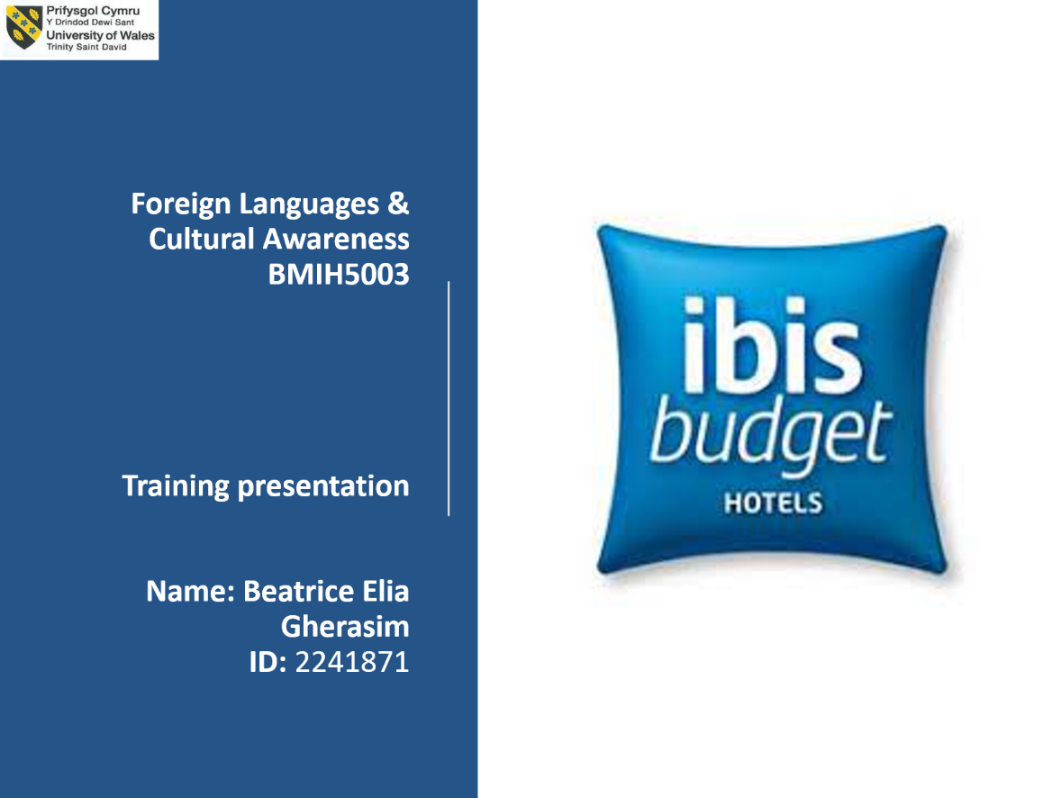

Slide 2: Introduction
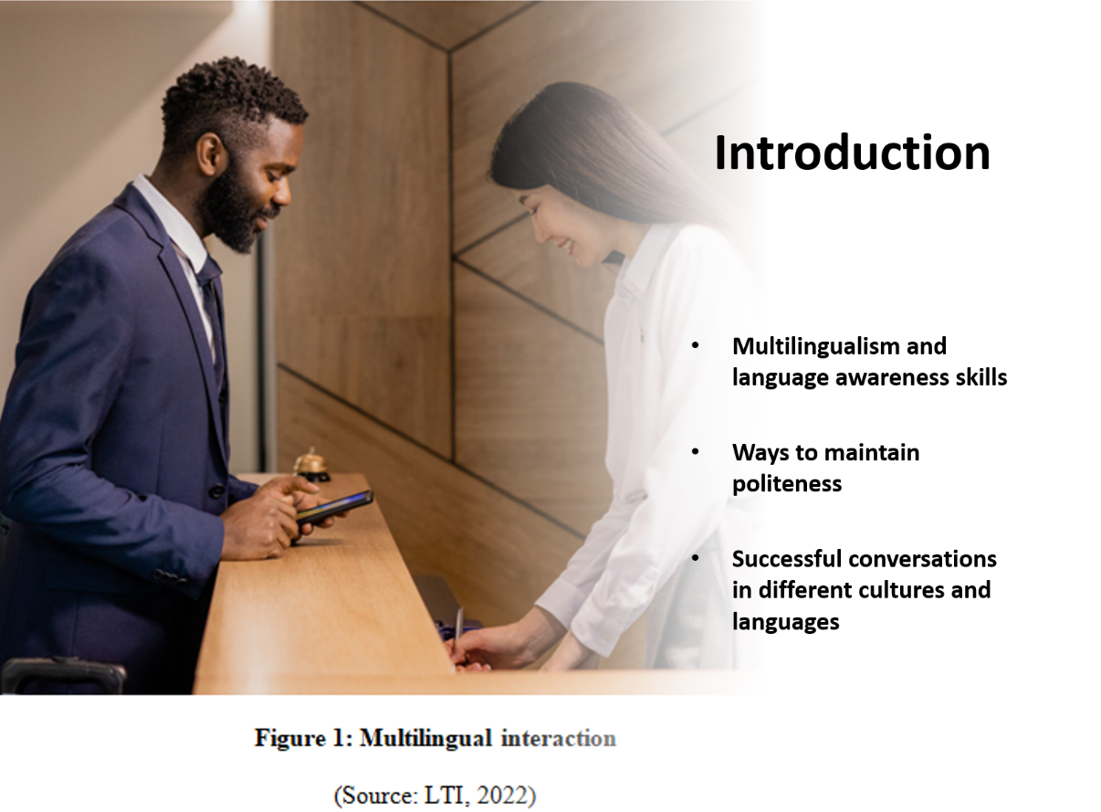

Slide 3: Concept Of Multilingualism
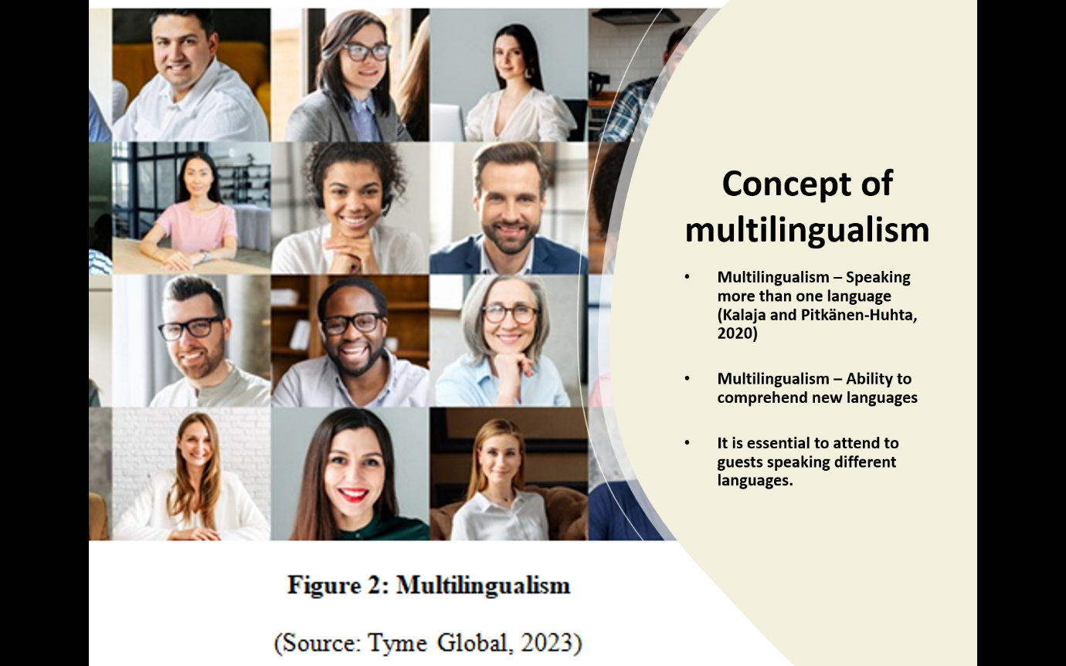

Slide 4: Importance of Language Awareness Skill
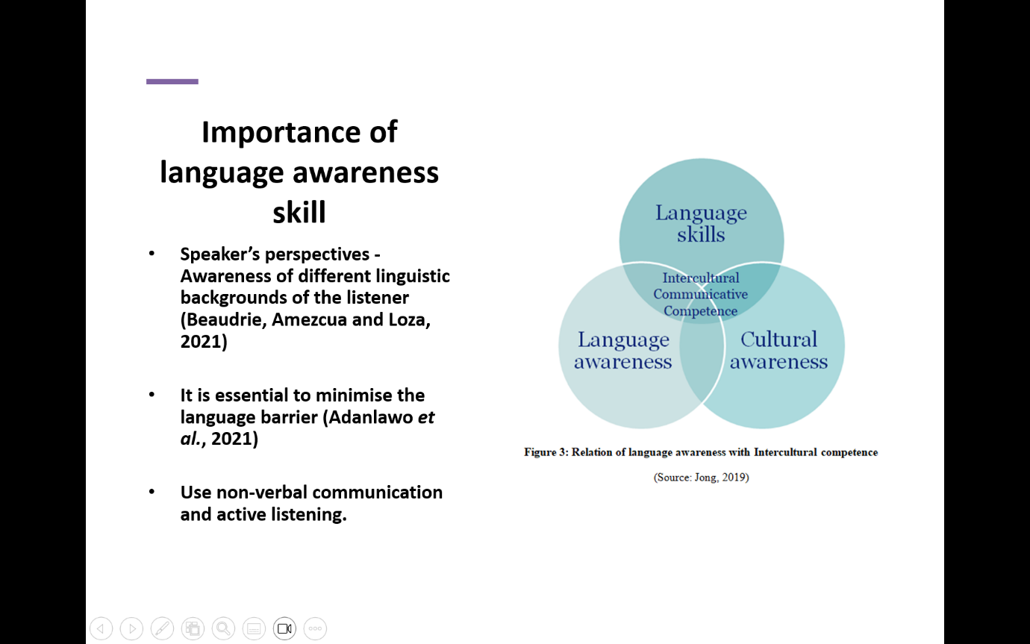

Slide 5: Italian- Modern European Language
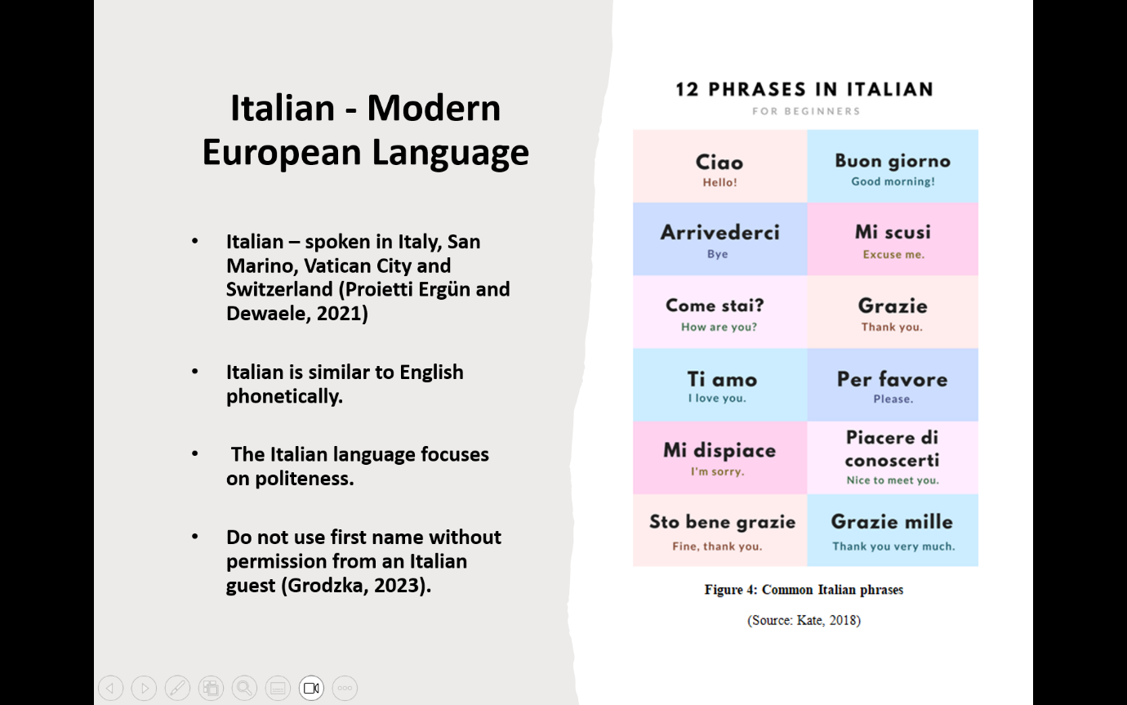

Slide 6: Language awareness skills required for Ibis Budget Hotel staff
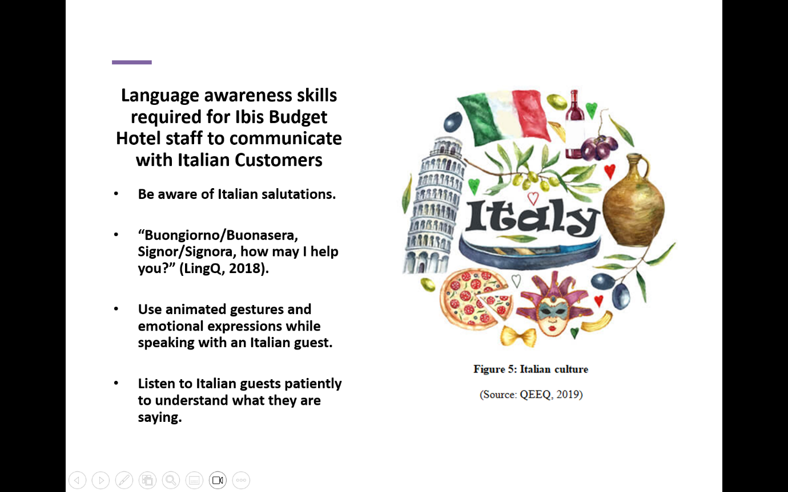

Slide 7: Conclusion
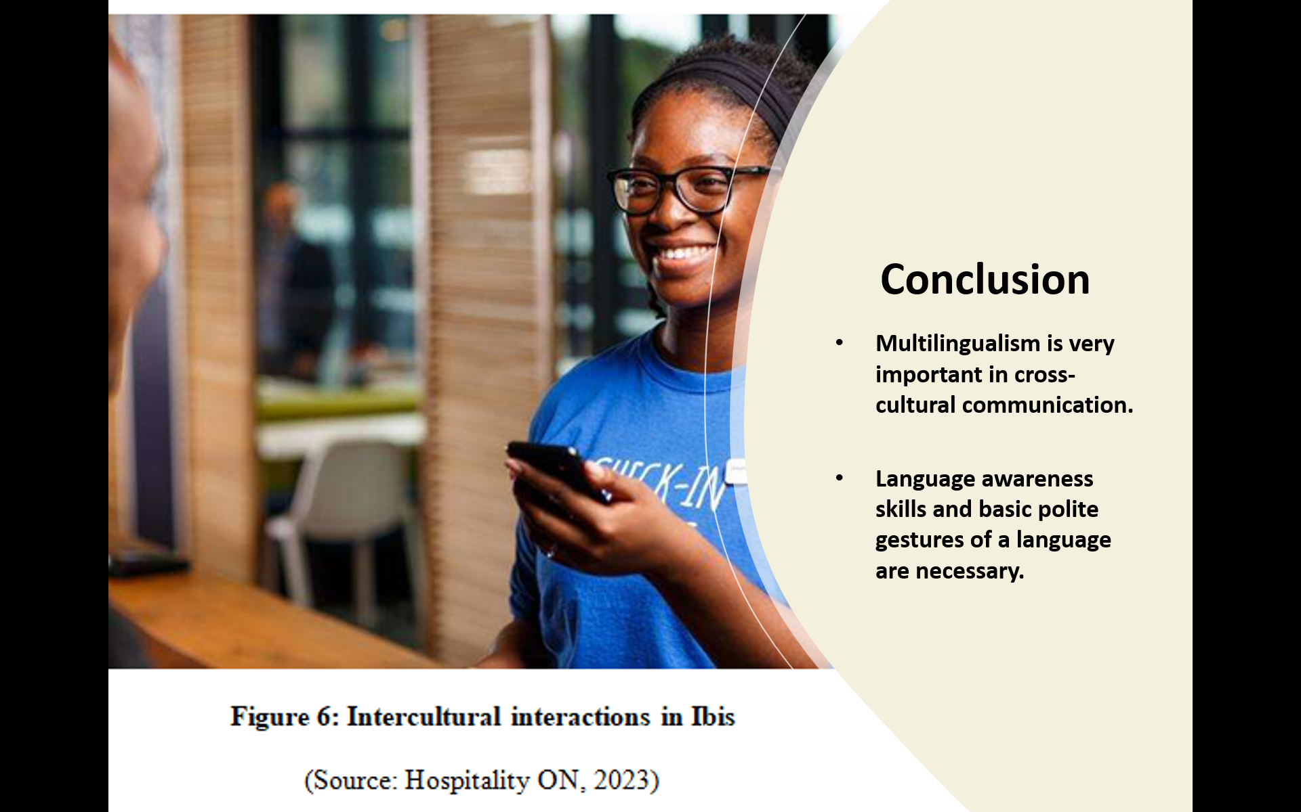

Slide 8: References
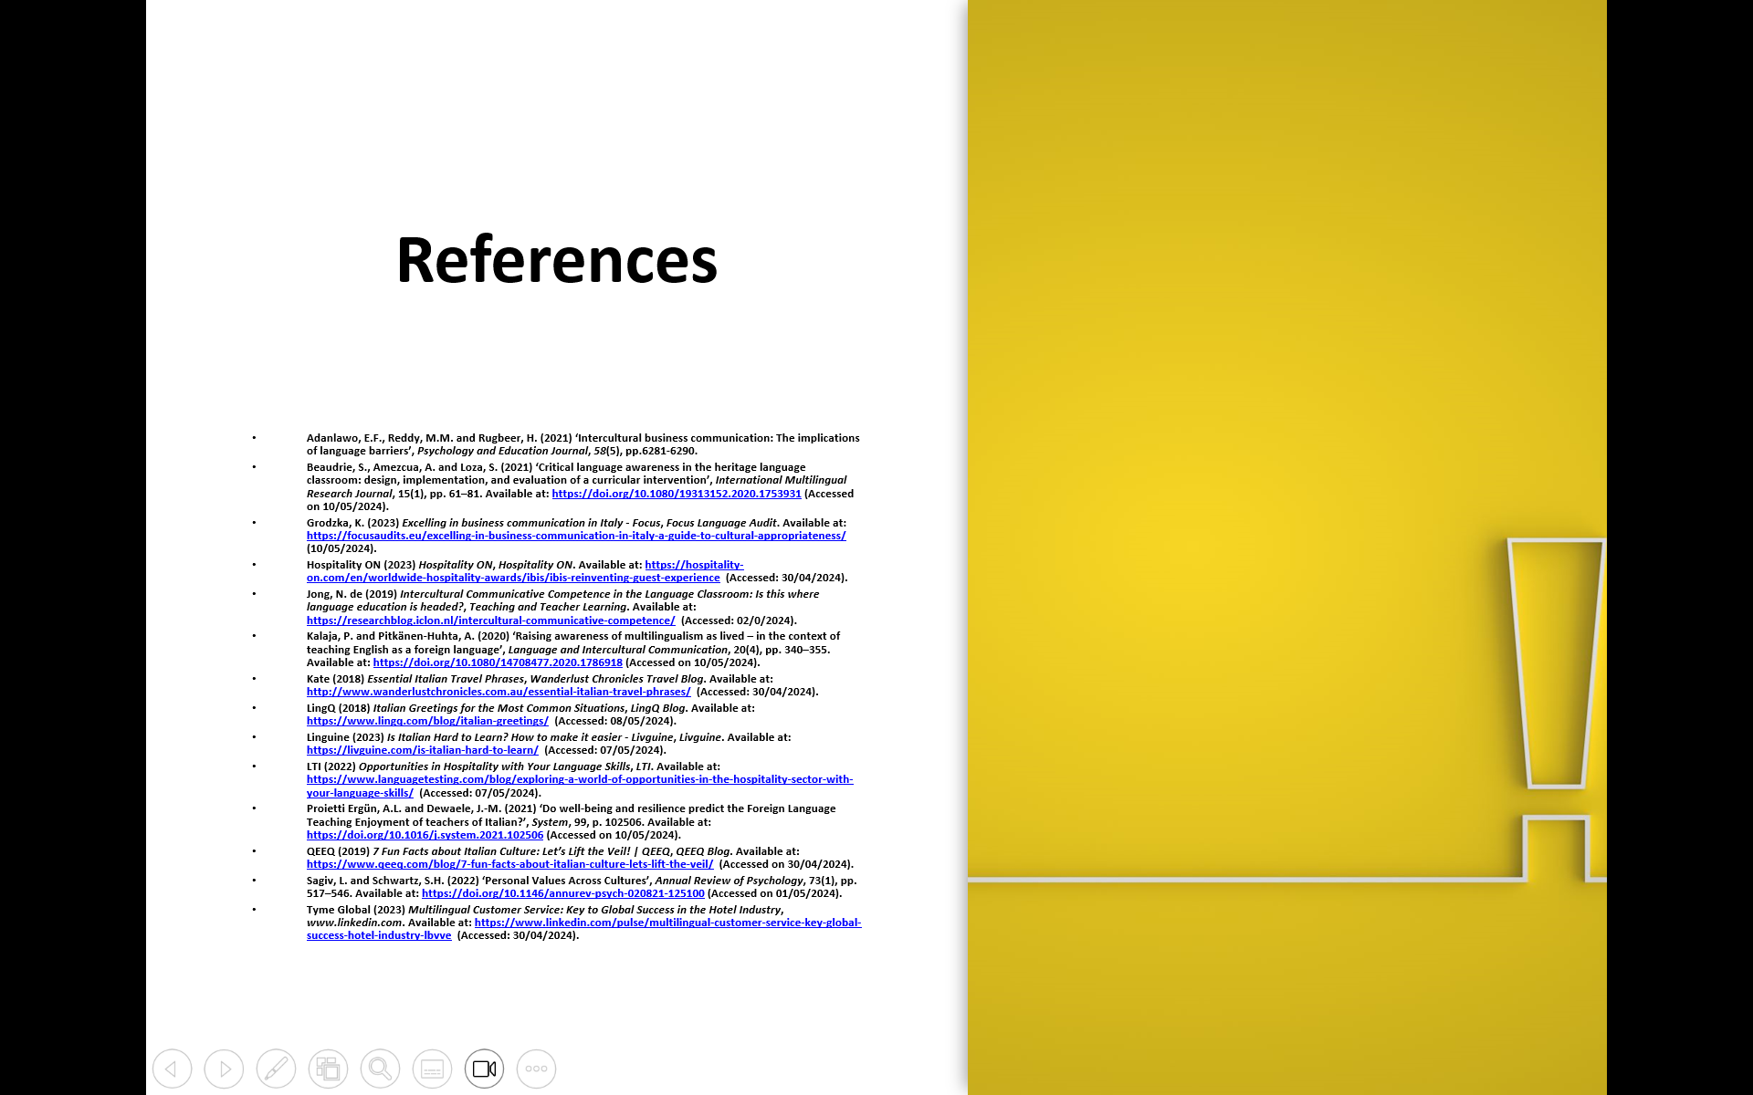

Slide 9: Thank you


References
Abdikarimova, M., Tashieva, N., Kyzy, A.T. and Abdullaeva, Z. (2021) ‘Developing Students Verbal Communication Skills and Speech Etiquette in English Language Teaching’, Open Journal of Modern Linguistics, 11(1), pp. 83–89. Available at: https://doi.org/10.4236/ojml.2021.111007(Accessed on 10/05/2024).
Abramson, N.R. & Moran, R. (2018). Managing Cultural Differences: Global Leadership for the 21st Century. 10th Ed. Abingdon: Routledge.
Adanlawo, E.F., Reddy, M.M. and Rugbeer, H. (2021). ‘Intercultural business communication: The implications of language barriers’, Psychology and Education Journal, 58(5), pp.6281–6290.
Alhazmi, A.A. and Kaufmann, A. (2022). ‘Phenomenological Qualitative Methods Applied to the Analysis of Cross-Cultural Experience in Novel Educational Social Contexts’, Frontiers in Psychology, 13(1). Available at: https://doi.org/10.3389/fpsyg.2022.785134( Accessed on 10/05/2024).
Beaudrie, S., Amezcua, A. and Loza, S. (2021). ‘Critical language awareness in the heritage language classroom: design, implementation, and evaluation of a curricular intervention’, International Multilingual Research Journal, 15(1), pp. 61–81. Available at: https://doi.org/10.1080/19313152.2020.1753931( Accessed on 10/05/2024).
Christiansen, B., Branch, J.D. and Karmowska, J. (2020) Cultural Factors and Performance in 21st Century Businesses. Hershey: IGI Global.
De Leersnyder, J., Gündemir, S. and Ağirdağ, O. (2021). ‘Diversity approaches matter in international classrooms: how a multicultural approach buffers against cultural misunderstandings and encourages inclusion and psychological safety’, Studies in Higher Education, 47(9), pp. 1–18. Available at: https://doi.org/10.1080/03075079.2021.1983534( Accessed on 09/05/2024).
Glowacka, M. (2024) Intercultural Misunderstandings: Causes and How to Avoid Them -Preply Business, preply.com. Available at: https://preply.com/en/blog/b2b-intercultural-misunderstandings/ (Accessed: 30/04/2024).
Grodzka, K. (2023). Excelling in business communication in Italy - Focus, Focus Language Audit. Available at: https://focusaudits.eu/excelling-in-business-communication-in-italy-a-guide-to-cultural-appropriateness/(Accessed on 10/05/2024).
Hospitality ON (2023) Hospitality ON, Hospitality ON. Available at: https://hospitality-on.com/en/worldwide-hospitality-awards/ibis/ibis-reinventing-guest-experience (Accessed: 30/04/2024).
Jong, N. de (2019). Intercultural Communicative Competence in the Language Classroom: Is this where language education is headed? Teaching and Teacher Learning. Available at: https://researchblog.iclon.nl/intercultural-communicative-competence/ (Accessed: 02/05/2024).
Kalaja, P. and Pitkänen-Huhta, A. (2020). ‘Raising awareness of multilingualism as lived – in the context of teaching English as a foreign language’, Language and Intercultural Communication, 20(4), pp. 340–355. Available at: https://doi.org/10.1080/14708477.2020.1786918 (Accessed on 10/05/2024).
Kate (2018) Essential Italian Travel Phrases, Wanderlust Chronicles Travel Blog. Available at: http://www.wanderlustchronicles.com.au/essential-italian-travel-phrases/ (Accessed: 30/04/2024).
Khanna, P. (2020). ‘Techniques and strategies to develop active listening skills: The armour for effective communication across business organisations’, The Achievers Journal: Journal of English Language, Literature and Culture, 6(3), pp.50–60.
Lam, R., Cheung, C. and Lugosi, P. (2022). ‘The impacts of cultural intelligence and emotional labour on the job satisfaction of luxury hotel employees’, International Journal of Hospitality Management, 100, p. 103084. Available at: https://doi.org/10.1016/j.ijhm.2021.103084 (Accessed on 05/05/2024).
LingQ (2018) Italian Greetings for the Most Common Situations, LingQ Blog. Available at: https://www.lingq.com/blog/italian-greetings/ (Accessed: 08/05/2024).
Linguine (2023) Is Italian Hard to Learn? How to make it easier - Livguine, Livguine. Available at: https://livguine.com/is-italian-hard-to-learn/ (Accessed: 07/05/2024).
LTI (2022) Opportunities in Hospitality with Your Language Skills, LTI. Available at: https://www.languagetesting.com/blog/exploring-a-world-of-opportunities-in-the-hospitality-sector-with-your-language-skills/ (Accessed: 07/05/2024).
Maheshkar, C. & Sharma, V. (2018). Handbook of Research on Cross-Cultural Business Education. Hershey: IGI Global.
Morady Moghaddam, M. & Tirnaz, M.H. (2023). ‘Representation of Intercultural Communicative Competence in ELT Textbooks: Global Vs. Local Values’, Journal of Intercultural Communication Research, 52(2), pp. 191–215. Available at: https://doi.org/10.1080/17475759.2022.2152076 (Accessed on 01/05/2024).
Poturak, M., Mekić, E., Hadžiahmetović, N. and Budur, T. (2020). ‘Effectiveness of Transformational Leadership among Different Cultures’, International Journal of Social Sciences and Educational Studies, 7(3). Available at: https://doi.org/10.23918/ijsses.v7i3p119 (Accessed on 01/05/2024).
Proietti Ergün, A.L. and Dewaele, J.-M. (2021). ‘Do well-being and resilience predict the Foreign Language Teaching Enjoyment of teachers of Italian?’, System, 99, p. 102506. Available at: https://doi.org/10.1016/j.system.2021.102506 (Accessed on 10/05/2024).
QEEQ (2019) 7 Fun Facts about Italian Culture: Let’s Lift the Veil! | QEEQ, QEEQ Blog. Available at: https://www.qeeq.com/blog/7-fun-facts-about-italian-culture-lets-lift-the-veil/ (Accessed: 30/04/2024).
Sagiv, L. and Schwartz, S.H. (2022). ‘Personal Values Across Cultures’, Annual Review of Psychology, 73(1), pp. 517–546. Available at: https://doi.org/10.1146/annurev-psych-020821-125100 (Accessed on 01/05/2024)
Tyme Global (2023). Multilingual Customer Service: Key to Global Success in the Hotel Industry, www.linkedin.com. Available at: https://www.linkedin.com/pulse/multilingual-customer-service-key-global-success-hotel-industry-lbvve (Accessed: 30/04/2024).
YURTSEVER, A. and ÖZEL, D. (2021). ‘The Role of Cultural Awareness in the EFL Classroom’, Turkish Online Journal of Qualitative Inquiry, 12(1). Available at: https://doi.org/10.17569/tojqi.776499 (Accessed on 10/05/2024).
Zhang, Z. (Victor) (2022). ‘Learner engagement and language learning: a narrative inquiry of a successful language learner’, The Language Learning Journal, 50(3), pp. 378–392. Available at: https://doi.org/10.1080/09571736.2020.1786712 (Accessed on 10/05/2024).

