Assignment : Software Solutions for Business

Student Name: Esteri Paloka
Student ID: 2528244
Module : Software Solutions for Business
Module Code: ACCA4026
Lecturer: Osman Elgawi
Submission Date: 21 March 2026

Table of Contents
Task 1: E-commerce Website Builders / Software Solutions 3
Task 2: Mind-map of Contemporary Software Applications 4
Software and Tools for Business 5
Task 3a: Office Applications for Creating, Storing, Presenting and Analysing Data 6
Task 3b: Data Analysis Using Microsoft Excel 8
Task 4: Communication and Collaboration Applications 9
Communication and Collaboration Tools (Practical Evidence) 11
Transferable Skills for Life and Professional Practice 12
References 13

Task 1: E-commerce Website Builders / Software Solutions
Introduction
E-commerce website builders are software platforms that allow businesses to create and manage online stores without needing advanced technical skills. These platforms provide tools for designing websites, managing products, processing payments, and communicating with customers. Two popular examples of modern e-commerce solutions are Shopify and Wix eCommerce.

Shopify

Shopify is a widely used e-commerce platform designed for online businesses [1]. It is a hosted solution, meaning users do not need to manage servers or technical systems. Shopify provides ready-made templates that allow users to create professional websites quickly.
One of the main advantages of Shopify is its ease of use as it has a simple user-friendly interface that allows users to add products manage orders and customise their website easily .Shopify also supports multiple payment methods, including its own system, which helps businesses manage transactions efficiently [1].
Another important feature of Shopify is its scalability. It can be used by small businesses as well as large companies. It offers tools such as analytics, reports, and integration with other applications. However, Shopify has some limitations. It requires a monthly subscription, and additional costs may apply for extra features. Advanced customisation may also require coding knowledge.

Wix eCommerce

Wix eCommerce is another popular platform that focuses on design flexibility [2]. It uses a drag-and-drop editor, making it easy for beginners to create and customise websites without coding.
One of the main strengths of Wix is its design flexibility. Users can choose from many templates and customise them to match their brand. Wix also includes built-in tools such as product galleries, secure payment options, and marketing features like email campaigns and search engine optimisation (SEO) [2], [3]
Wix is very user-friendly and suitable for small businesses or individuals. However, it has some limitations compared to Shopify. It may not be ideal for large businesses or stores with many products. Additionally, changing templates after creating a website can be difficult.

Comparison and Conclusion
Both Shopify and Wix eCommerce are effective tools for creating online stores, but they are suited to different users. Shopify is more suitable for businesses that want to grow and need advanced features, while Wix is ideal for beginners who want an easy-to-use platform with strong design options.
In conclusion, the choice between these platforms depends on the needs of the business. Shopify is better for larger or growing businesses, while Wix eCommerce is more suitable for smaller businesses or individuals starting out.

Task 2: Mind-map of Contemporary Software Applications

Mind mapping is a way of organising ideas visually around a main topic. It usually starts with a central idea, and then related ideas branch out from it. This helps people understand how different ideas are connected [4].
In business, mind mapping is useful for planning, brainstorming, and solving problems. It helps people think more creatively and makes it easier to generate and connect ideas.
Mind mapping also helps organise information clearly. Businesses often deal with large amounts of data, and mind maps make it easier to break this information into smaller parts and understand it better.
Another benefit is that it improves communication and teamwork. Teams can use mind maps to share ideas clearly, so everyone understands what needs to be done.
In addition, mind mapping can improve memory. Visual information is easier to remember than plain text, which is useful in meetings and presentations.
Overall, mind mapping is a useful tool in business because it supports creativity, organisation, communication, and decision-making.

Software and Tools for Business

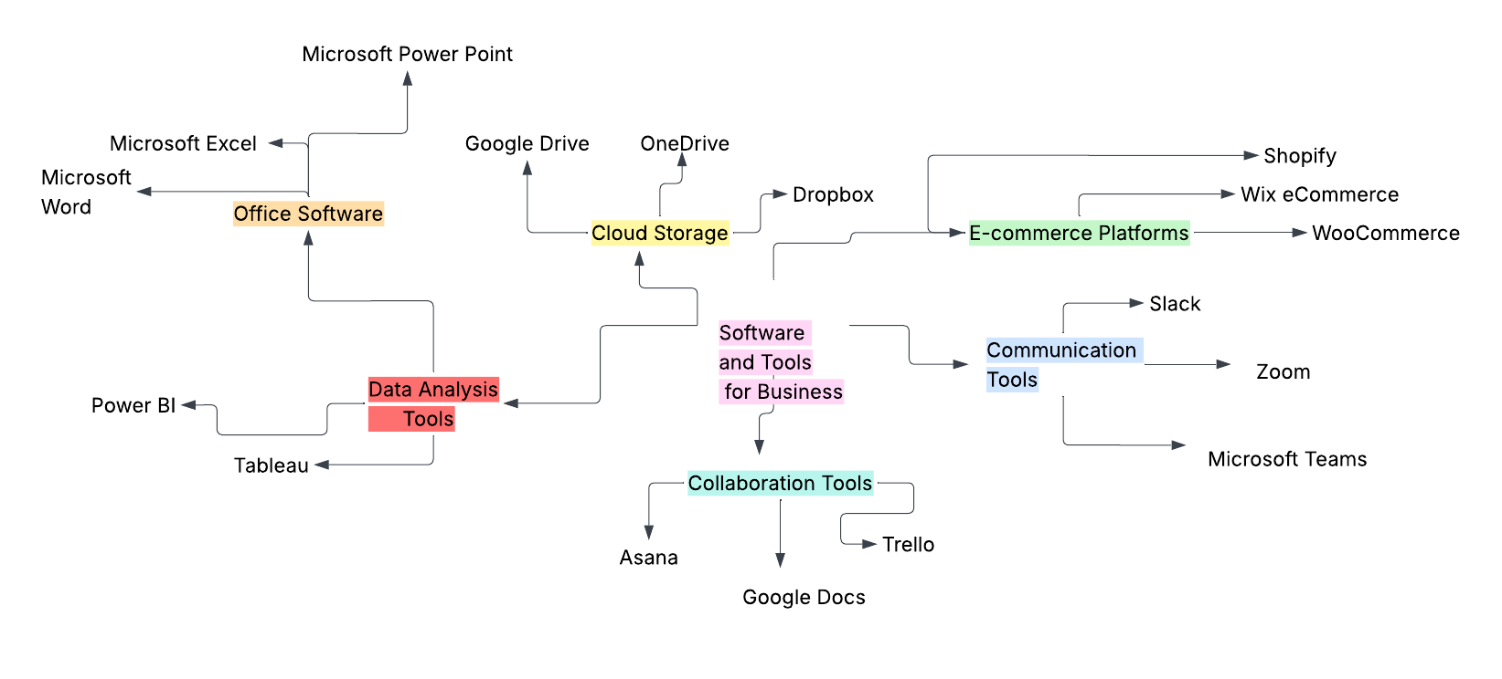
Picture 1: This mind map shows different types of digital tools and technologies used in business. It includes categories such as office software, cloud storage, data analysis tools, e-commerce platforms, communication tools, and collaboration tools. Each branch provides examples of commonly used applications, helping to organise information clearly and visually.
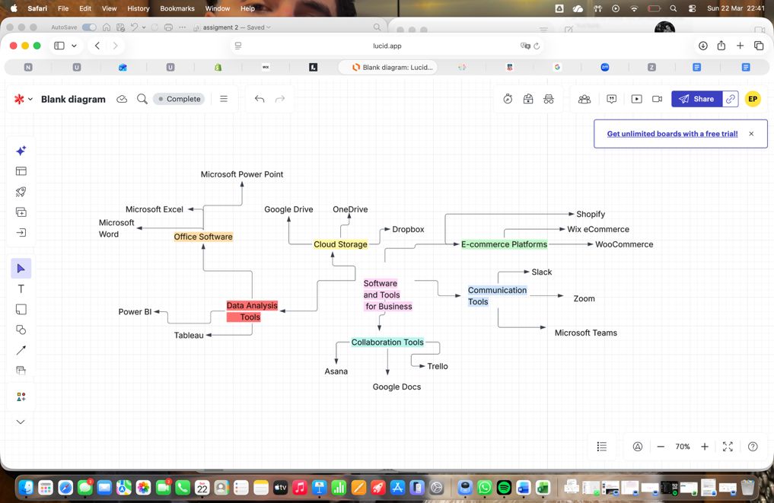
Picture 2: This screenshot shows the process of creating the mind map using an online diagram tool. The tool provides features such as adding branches, linking ideas, and organising categories in a structured way. It allows users to visually represent information, making it easier to understand the relationships between different types of digital tools and technologies. This method supports clearer communication and helps present complex information in a simple and organised format.

Task 3a: Office Applications for Creating, Storing, Presenting and Analysing Data
Introduction

Office applications are essential tools used in modern organisations to create, store, present, and analyse information and data. These applications improve productivity, enhance communication, and support decision-making processes. Commonly used office applications include Microsoft Word, Microsoft PowerPoint, Microsoft Excel, and Microsoft Access . Each of these tools serves a specific purpose and offers various features, benefits, and limitations.

Microsoft Word
Microsoft Word is a word processing application used to create, edit, and format text documents such as reports, letters, and academic assignments. [9]

Features
• Text formatting (fonts, styles, headings)
• Spell check and grammar tools
• Insert tables, images, and charts
• Mail Merge for bulk documents
Benefits
Microsoft Word allows users to produce professional documents efficiently. It supports collaboration through features like comments and track changes, making it suitable for team environments. Additionally, templates help save time when creating standard documents .
Limitations
Despite its advantages, Word can become complex when working with large documents. Formatting issues may occur, and advanced features such as Mail Merge may require training.

Microsoft PowerPoint
Microsoft PowerPoint is used to create visual presentations for meetings, lectures, and business proposals.

Features
• Slide creation with text, images, and videos
• Animations and transitions
• Presentation templates
• Presenter view
Benefits
PowerPoint enhances communication by presenting information visually, making it easier for audiences to understand complex ideas. It is widely used in business and education for delivering structured presentations.
Limitations
Overuse of animations or poor slide design can reduce effectiveness. Additionally, presentations rely heavily on the presenter’s delivery skills.

Microsoft Excel
Microsoft Excel is a spreadsheet application used for data organisation, analysis, and calculation. [10]

Features
• Formulas and functions (e.g. IF, VLOOKUP)
• Charts and graphs
• Pivot tables
• Data sorting and filtering
Benefits
Excel is highly effective for analysing large datasets and performing calculations quickly. It supports data-driven decision-making and financial analysis.
Limitations
Excel can be difficult for beginners due to complex formulas. Errors in formulas can lead to incorrect results, and very large datasets may affect performance.

Microsoft Access
Microsoft Access is a database management system used to store, manage, and retrieve structured data.

Features
• Tables, queries, forms, and reports
• Data relationships
• Data validation
• SQL support
Benefits
Helps organisations manage large amounts of data easily. It can be used to create databases for things like inventory, customer information, and daily business activities
Limitations
Not suitable for very large systems. It also requires some technical knowledge to create and manage database properly .

Task 3b: Data Analysis Using Microsoft Excel

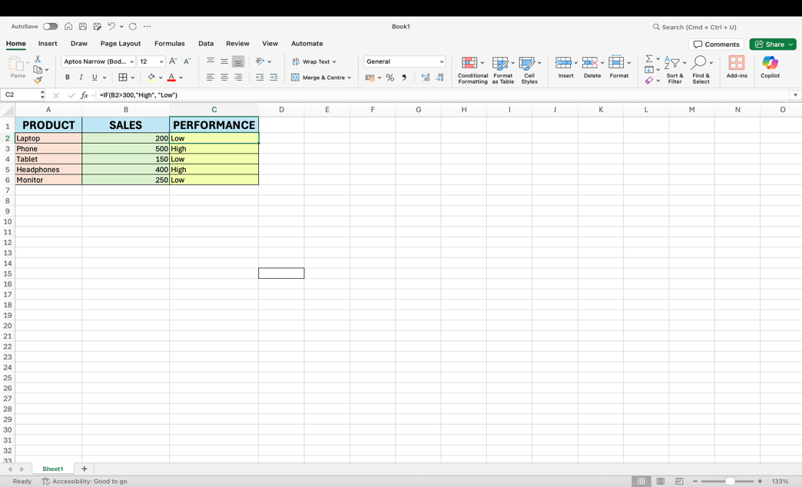
Picture 3: Use of IF Function in Microsoft Excel to Evaluate Sales Performance
The IF function in Microsoft Excel is used to perform logical tests and return different values based on specific conditions. In this example, the function checks whether the sales value is greater than 300. If true, it returns “High”; otherwise, it returns “Low”. The formula used is: =IF(B2>300, “High”, “Low”).

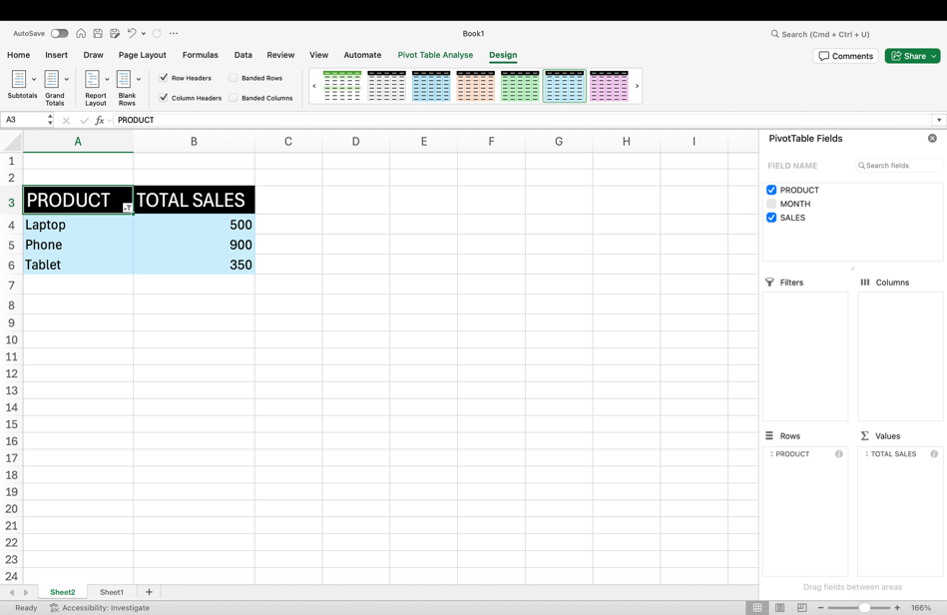
Picture 4: Pivot Table Analysis of Sales Data in Microsoft Excel
A Pivot Table is used to summarise and analyse data efficiently. In this example, it groups sales data by product and calculates total sales, allowing easy comparison of results. This makes it easier for businesses to identify trends and make informed decisions based on the data .

Task 4: Communication and Collaboration Applications

Introduction

Communication and collaboration applications are essential tools in modern business environments. They help teams communicate effectively, share information, and work together regardless of location. These tools improve productivity, support teamwork, and make it easier to complete tasks efficiently. This section will analyse one communication tool and one collaboration tool, highlighting their features, benefits, and practical use. [5]

Communication Application: Zoom

Zoom is a widely used communication platform that allows users to conduct video meetings, webinars, and online discussions. It is commonly used in businesses, education, and remote work environments. [6]

Features
• Video and audio conferencing
• Screen sharing
• Chat messaging during meetings
• Recording meetings
• Virtual backgrounds

Benefits
Zoom enables real-time communication, making it easier for teams to collaborate even when working remotely. The screen sharing feature allows users to present information clearly, which improves understanding during meetings. Recording meetings is also useful, as it allows users to review discussions later. Overall, Zoom helps improve communication efficiency and reduces the need for physical meetings.[6], [7]

Collaboration Application: Google Docs
Google Docs is an online collaboration tool that allows multiple users to create, edit, and share documents in real time. It is widely used in business and education for teamwork and document management.[8]

Features
• Real-time editing by multiple users
• Automatic saving (cloud-based)
• Commenting and suggesting changes
• Easy sharing with access control
• Version history tracking

Benefits

Google Docs improves teamwork by allowing multiple users to work on the same document simultaneously. The commenting feature helps users give feedback and communicate ideas clearly. Automatic saving reduces the risk of losing work, and version history allows users to track changes. This makes it easier to manage documents and collaborate efficiently. [8]

Practical Use
In a real workplace, Zoom can be used for team meetings, client discussions, and presentations, while Google Docs can be used to create reports, share ideas, and work on projects together. For example a team can meet on Zoom to discuss a project and then use Google Docs to collaboratively write and edit the report. This combination improves communication, organisation, and productivity. This demonstrates how digital tools can be integrated into daily business activities to improve efficiency , teamwork , and communication .

Conclusion
Communication and collaboration tools such as Zoom and Google Docs are essential for modern businesses. They enhance teamwork, improve communication, and support efficient working practices. By using these tools, organisations can save time, reduce costs, and ensure that employees can work together effectively, even from different locations. In addition , Microsoft Teams is another widely used workplace platform that supports messaging ,video meetings, file sharing ,and collaboration [7]. This demonstrates the practical application of digital tools in real world business environments and highlights their importance in modern professional practice.

Communication and Collaboration Tools (Practical Evidence)


Picture 5: This screenshot shows the use of Zoom for online meetings and communication. It demonstrates how users can join virtual meetings, use video and audio features, and interact in real time. Zoom supports effective communication in remote working environments and improves teamwork by allowing participants to collaborate from different locations.

Picture 6: This screenshot shows the sharing feature in Google Docs, which allows multiple users to collaborate on the same document in real time. It demonstrates how users can share access, edit content simultaneously, and provide feedback using comments. This feature improves teamwork, organisation, and communication in collaborative projects.

Transferable Skills for Life and Professional Practice

This assignment has enabled the development of several transferable skills that are essential for both academic study and professional practice. One of the key skills developed is communication, as I have improved my ability to present information clearly and effectively when explaining concepts such as the IF function and Pivot Tables in Microsoft Excel. Clear communication is important in professional environments to ensure that information is understood accurately and efficiently.
In addition, I have enhanced my organisational skills by structuring the assignment into clear sections and presenting information in a logical and coherent manner. This demonstrates the importance of planning and organisation when managing tasks and meeting deadlines, which are essential skills in any workplace [9].
Furthermore, this assignment has strengthened my problem-solving skills through completing practical tasks, particularly in Excel. Analysing data and applying functions required critical thinking and attention to detail, which are important for making informed decisions in business contexts. These skills are highly valuable in modern workplaces where data analysis plays a key role in decision-making [12].
Moreover, I have developed an understanding of the importance of continuous learning and self-improvement. Reflecting on my work has helped me identify areas for improvement and encouraged me to adopt a growth mindset, which is essential for personal and professional development [10], [11].
Overall, the transferable skills gained from this assignment, including communication, organisation, problem-solving, and continuous learning, will be valuable in both academic and professional environments. These skills will support my future career development and help me adapt to the demands of a rapidly changing workplace.

References

[1] Shopify Inc., “Shopify – Build an Online Store,” [Online]. Available: https://www.shopify.com.
[2] Wix.com Ltd., “Wix eCommerce – Create an Online Store,” [Online]. Available: https://www.wix.com/ecommerce.
[3] Google, “Search Engine Optimization (SEO) Starter Guide,” [Online]. Available: https://developers.google.com/search/docs/fundamentals/seo-starter-guide.
[4] University of Adelaide, “Mind Mapping,” [Online]. Available: https://www.adelaide.edu.au/writingcentre.

[5] Chartered Institute of Personnel and Development (CIPD), “Continuing Professional Development,” 2023. [Online]. Available: https://www.cipd.co.uk

[6] Zoom Video Communications, “Zoom Workplace,” 2024. [Online]. Available: https://zoom.us

[7] Microsoft, “Microsoft Teams,” 2024. [Online]. Available: https://www.microsoft.com/microsoft-teams

[8] Google, “Google Docs,” 2024. [Online]. Available: https://docs.google.com

[9] D. A. Kolb, Experiential Learning: Experience as the Source of Learning and Development. New Jersey: Prentice Hall, 1984.

[10] C. Dweck, Mindset: The New Psychology of Success. New York: Random House, 2006.

[11] Harvard Business Review, “The Importance of Lifelong Learning,” 2023. [Online]. Available: https://hbr.org

[12] World Economic Forum, “The Future of Jobs Report,” 2023. [Online]. Available: https://www.weforum.org

