Reflective Portfolio

Student Name: Georgiana Ionita
Student ID:2118802
Lecturer Name: Muhammad Islam
Module code: BMSW_4005
Module Name: Professional Career Development

Table of Contents
1. Introduction 3
2. Discussion based on the concepts learnt 4
2.1 REFLECTION: GIIBS REFLECTIVE CYCLE & SWOT analysis 4
2.2 Career options 7
2.3 Current trends in the selected industry 8
3. Assessment of concepts learnt 8
1.1 SWOT analysis 9
1.2 Johari Window Model 10
3.3 McClelland Theory of Motivation 11
Conclusion 12
References 13

Introduction
Information that provides key details about the job and career development module is presented in this assignment. In this way the essential aspects of contemplation and their peculiarities are emphasized and knowledge about them is extended. Make sure your conclusions are correct. All information discussed is gathered from reliable sources according to the current situation.
Additionally, to convey this topic, this report includes several practices. First, use a SWOT analysis to determine which of your skills are a good fit for your intended career path. Additionally, the Johari Window Model is used to examine existing open blind spots, hidden and unknown skills to pursue a desired career path. Going through all the steps that have been mentioned will support developing a plan from which to be understood what has been acquired so far, what is needed in the selected career, how the trends influence the whole operation and so on. In this way aspects of the career are being assessed to see if it would suit or not.

Discussion based on the concepts learnt

2.1 REFLECTION: GIBBS REFLECTIVE CYCLE & SWOT analysis
The GIBBS REFLECTIVE CYCLE plays a vital role in analysing the actions that have been done and undertaken to develop key skills. This reflective cycle should be used periodically to outline key improvements that need to be made to the knowledge that has been developed (Pendry, 2022)


As I mentioned in my resume and cover letter, I am willing to be working in the Quality Control Operative as I do consider that my skills will correlate well with the duties and tasks I will have to complete in this role. Based on my experience in this industry, I would like to continue this in a professional capacity. increase. Reflection is thinking seriously and looking back on past actions to improve them and create progress and development. There are still knowledge and skill gaps that need to be filled to become a professional. A SWOT analysis is applied to yourself to find out. Key aspects of his SWOT analysis applied include opportunities, threats, strengths, weaknesses, etc.
My strengths include I have particularly effective communication skills, teamworking, a diligent and motivated attitude
My Weaknesses do I lack time, my ability of speaking and writing in the English language are not perfect yet, I still must improve my time management skills.
Looking into opportunities, I consider that some of the opportunities can include taking part in different situations which to enhance my English language, attend all classes at the course so I can gather increased knowledge and information.
The threats are important as well as sometimes I tend to lose motivation when I am not being successful from the first time.

With the SWOT analysis background, I can conclude that I am one of those people who faces constant challenges to help develop and improve their existing skills. English ability is a prerequisite for the career I aim for, so I am thinking of turning my weaknesses into strengths. There is a constant stream of information that needs to be accurately shared and understood by others.
Quality Control operatives are always challenging new things, so it is the best position for those who have a strong spirit of challenge.

Considering the SWOT analysis and the reflection about me, I can say that I am an activist learner and this because I am learning by experience. This learning style is going to be used in the future development for both academic and professional performances. Honey & Mumford has introduced this learning style along with other three learning styles just as it can be seen in the diagram attached below.

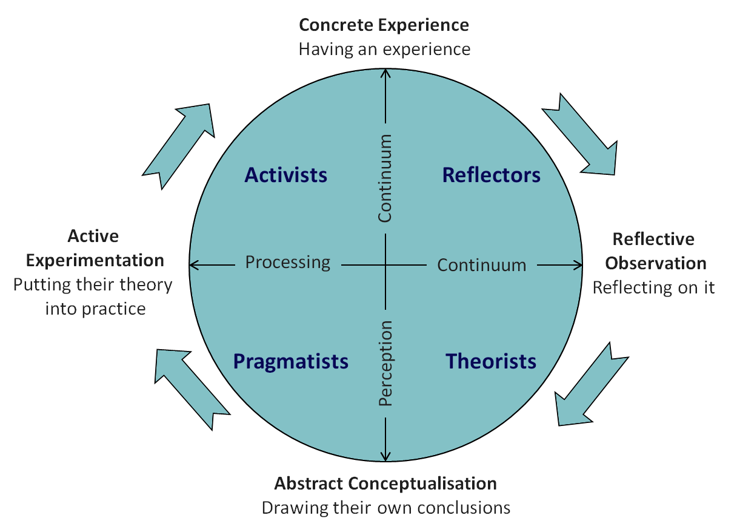

Apart from Honey & Mumford, learning styles are also listed by Kolb which produced his learning cycle as identified below.

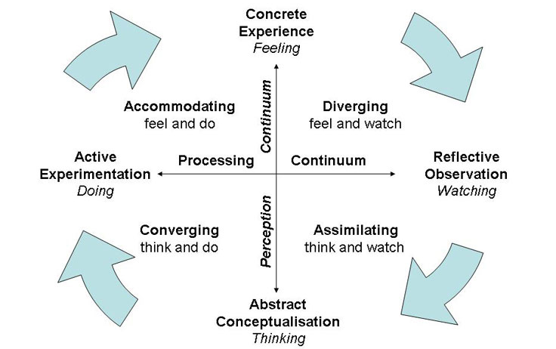

2.2 Career options

In the position of a quality control operative as I am aiming to develop, I have the main duty of being responsible for and ensuring superior product quality is maintained in accordance with quality standards. Report problems or issues as they arise, which may impact on product quality or Production activities. I am confident in my choices and focused on achieving them, so there are no other career options that I can rank.

Research various job postings online and in books to learn more about the roles, responsibilities, skills, and qualifications required.

- National Careers Service (2022) published by GOV.UK, Eligibility:
It is mentioned that there is needed a degree in production, business, or manufacturing paths, therefore, it is important to mention that the current course undertaken will help me be successful in the role.

- Skills and Information:
Operating, monitor quality standards, with the goal to maintain customers loyalty and company reputation. Requires diligence and excellent problem-solving ability.

- Routine tasks:
Tasks like making sure that all the products are made in a facility conform to the industry, company, and customer expectation. Minimizing the duration and cost of the work and maximizing the efficiency is also an important task.

Based on my experience in the industry, I am confident that I possess most of the listed skills. However, some skills are still lacking, such as the confidence to monitor the products quality and most important software packages.
Use of platforms such as Indeed, LinkedIn, Monster, and My Future to research potential jobs I can apply for and better understand the employer expectations for the role I aspire to play, it can do to fill the existing gap.

Current trends in the selected industry

The latest management techniques for managers to effectively guide their subordinates are called "latest trends in management," and concepts such as quality control, risk management, and crisis management are currently gaining popularity in management.
The globalization of business, transportation and communication systems and the new pace of economic development have created a variety of new management perspectives that managers must apply to today's challenges.

- Diverse Workforce: This includes having a diverse workforce representing age, gender, and ethnicity in our organization. Diversity is constantly increasing due to demographic changes, a growing workforce, social pressures and increasing globalization.

- The outsourcing: This requires obtaining an external resource. It is to outsource some operations to other companies to improve quality and specialize.

- Information Management: This is the procedure that aids organizations in selecting, selecting, organizing, disseminating, and transferring crucial knowledge and expertise for their success. It emphasizes that knowledge can be utilized for the organization's success by transforming it into business concepts. Knowledge management allows for efficient and effective problem solving, dynamic learning, strategic planning, and decision making in management. It focuses on identifying knowledge, explaining it in a way that makes it formal to share, and demonstrating the value of reusing it. Knowledge, as a form of capital, must be exchangeable and able to grow for an organization to succeed. Knowledge, on the other hand, must be recorded to facilitate problem-solving, which is necessary for knowledge management to foster organizational learning and further knowledge creation.

Assessment of concepts learnt
In this section of the report, we will be looking at three main concepts that have been learnt, these include the SWOT analysis tool, the Johari Window Model, and into the McClelland Theory of Motivation. These three concepts have been selected due to the importance they play in my learning and development.

SWOT analysis

According to Sarby (2016), the SWOT analysis is a strategic tool for studying the strengths, weaknesses, opportunities and threats of a person, thing or organization as mentioned in the previous section of the report. My main weaknesses at this time were determined to be my lack of English skills and inefficient time management. The result is a personal development plan according to his SWOT analysis, where you can explore ways to improve these. In. order to have efficient results from the SWOT analysis that has been applied on the self, there is need of good critical thinking and skills to be able to look from the external perspective towards everything that is being done, with the aim of having the opportunity to improve in the future.

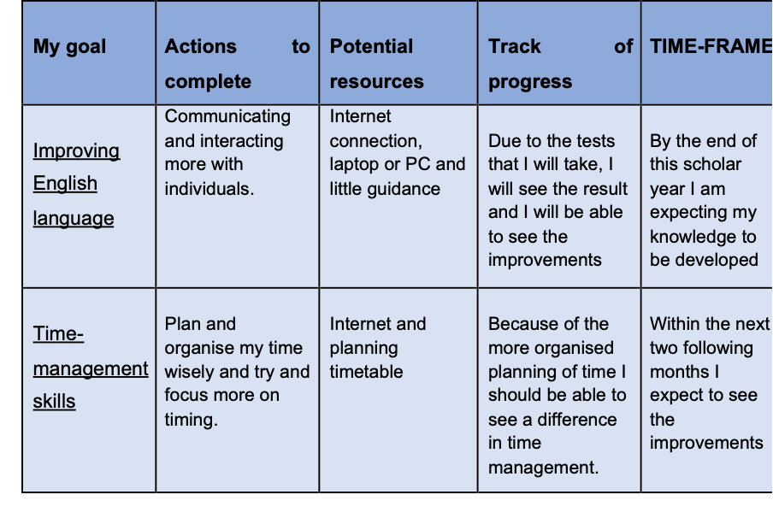

Johari Window Model
This version indicates that there are four distinct "self" facets. According to the theory, the individual is aware of those facets, however the different are regarded via way of means of individuals who interact with the individual due to the fact they may be seen. The individual's facets will extrude if they are advanced or advanced due to receiving comments on the one’s specific facets (Luft, 1969). The four classes, in line with the version, are as follows:

- Open: People who fall into those classes are greater receptive to the humans they stay with. Placing lots of religion of their relationships as a result.

- Blind: Because they do not know plenty themselves both, folks that belong on this segment do not speak in confidence to the folks that belong to it. This makes it difficult for this individual to believe different humans.

- Absent: These humans typically realize loads themselves, as indicated via way of means of their name, however they select now no longer to inform others. Indicating that they are greater reserved and snug preserving matters to themselves.

- Not regarded: These humans fall into this type of classes, and that they both display a few statistics themselves or none. They can be insecure because of their loss of self-knowledge (Bakerm, 2011).

According to Johari Window's 4 classes of humans, I fall into the open class due to the fact I communicate to humans round me loads something and do not hesitate to expose who I absolutely am. I am self-confident in the entirety I realize I can do well, and I will be pleased with myself after I entire a venture I realize I did well.

3.3 McClelland Theory of Motivation

Development particularly responsibilities and the fulfilment of useful effects are stimulated with the aid of using motivation. According to the McClelland theory, there are 3 essential key motivators for everyone.
- (McClelland, 1988)Accomplishment suggests that the person is centred on reaching the favoured final results, which means that they may be inclined to stand obstacles, get beyond them, and hire techniques if you want to efficiently attain the goal.

- Affiliation suggests that this person will favour to paintings in a collection placing and make use of teamwork competencies so long as they sense valued and needed. As a result, running collectively to acquire the favoured results reduces chance-taking with the aid of using those individuals.

- .Power suggests that the person believes they need to be reputable due to the fact all obligations rely upon them. They experience going their personal manner due to the fact they have whole control. According to Neergaard & Ulhoi (2007), triumphing can be one in every of their pinnacle priorities, main to extra aggressive behaviour.

The supervisor must be capable of use this to decide which motivation works first-class for every worker with the aid of using watching how they technique the responsibilities. Main to the subsequent step, which is determining which management fashion must be in order that the group may be at its first-class. An appropriate task should be submitted to keep away from a high-chance task, which can also additionally bring about a loss of participation. The supervisor is capable of get to recognize their personnel higher as a result, which leads to higher and extra advanced task performance. Utilizing the previous examples of motivators makes it less complicated to finish high-chance responsibilities due to the fact you could efficiently shape a strength institution which can without problems collaborate. This would, therefore, bring about monetary awards in addition to tremendous effects like self-development.

Conclusion

Skills play a significant role towards the professional development which is following the academic journey. Despite the academic and professional paths are different, there are many aspects that make them very mutual. All the knowledge that is being acquired along with other skills during the academic phase of the life will contribute to the success in the professional life. Everything mentioned in the assignment is relevant to the development in the selected career and at the same time everything discussed is also relevant to the transition from academic to professional.

References



