ACUA6002 Big Data

“Big Data Labs”

Submitted in the partial fulfillment for the award degree of
BSC CLOUD COMPUTING

To

University of Wales Trinity Saint David, London

Submitted by:
1805315 Giuseppe Ventimiglia

Under the guidance of:
Terry Walcott

Academic Year 2020/2021



Abstract

This report analyses all the workflows presented in the exercises of the two books Knime Beginner’s Luck and Knime Advanced Luck. The exercises are grouped in 6 worksheets:
- Worksheet 1 introduces data exploration and the creation of models.
- Worksheet 2 focuses on data reporting.
- Worksheet 3 analyses database operations and how to retrieve data from the web.
- Worksheet 4 examines date and time operations.
- Worksheet 5 investigates the use of variables, loops, use cases, and advanced reporting techniques.
- Worksheet 6 presents a Cloud data warehouse solution for the Walmart case study.

Contents

Worksheet 1 5
1. Data Exploration 5
1.1 Yellow-small.data 5
1.2 Extending Yellow- small.data 5
1.3 Read adult.data 6
2.2 MLP using wine.data 8
2.3 Reading data “website 1.txt” 9
Worksheet 2 10
3. First Report 10
3.1 Evaluating Adult.data 10
3.2 Evaluating adult.data 2. 10
3.3 Evaluate worldcup2006.txt 11
Worksheet 3 15
5. Database Operations 15
5.1 Cars Database 15
5.2 Connecting KBCBOOKs.sqlite 16
5.3 Database Looping Nodes 17
6. Accessing Information from the Web 18
6.1 Chemical database information retrieval 18
Worksheet 4 19
7. Date and Time Manipulation 19
7.1 Adding Random Dates 19
7.2 Importing date and time 20
Worksheet 5 21
8. Flow Variables 21
8.1 Reading sales.csv 21
8.2 Using cars dataset 22
8.3 Maximum Engine Size 23
8.4 Wrapped Metanode 24
9. Loops 25
9.1 Generating data row 25
9.2 generating a full table 26
9.3 Deleting duplicate rows 27
9.4 creating an original file 28
10. Switches 29
10.1 IF switch node 29
10.2 Workflow control 30
11. Advanced Reporting 31
11.1 Movie Report 31
11.2 Product Report 32
11.3 Product Image Report 33
Worksheet 6 34
12. Big Data Warehouse 34
Conclusion 38
References 38

Worksheet 1

1. Data Exploration

Yellow-small.data
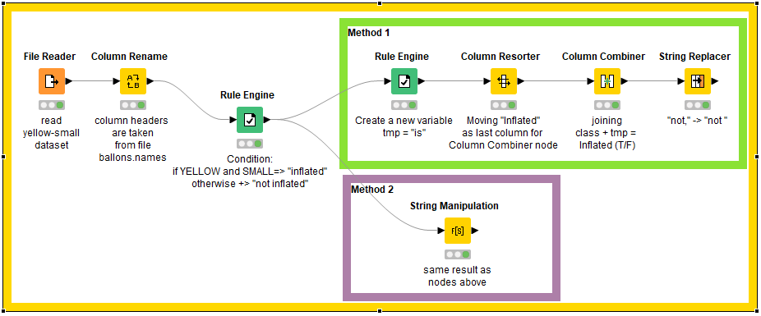
Figure 1: Exercise 1 focuses on the concept of Data Exploration through the String Manipulation and Rule Engine nodes.

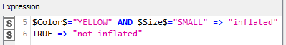  Figure 2 Example of Rule Engine logical operation | 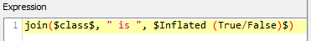  Figure 3 Example of String Manipulation operation

Extending Yellow- small.data
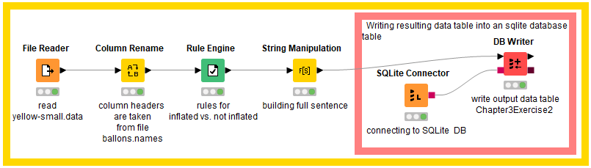
Figure 4 Exercise 1.2 is an extension of the previous workflow. The output is written using the DB Writer node in the table “Chapter3Exercise2” of the KBLBook.sqlite database.
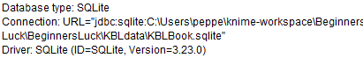
Figure 5 Connection to the Database is achieved through the JDBC driver.
JDBC is a Java API used to connect applications written in Java to the data stored in the relational databases [1].

1.3 Read adult.data
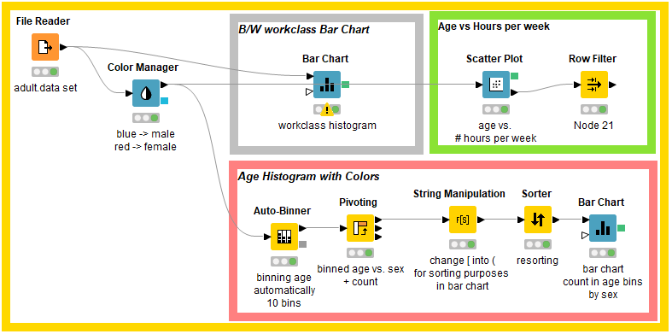
Figure 6 In this exercise, a dataset containing the worker’s information is presented. The dataset contains missing values that for the purpose of this exercise they have been ignored.
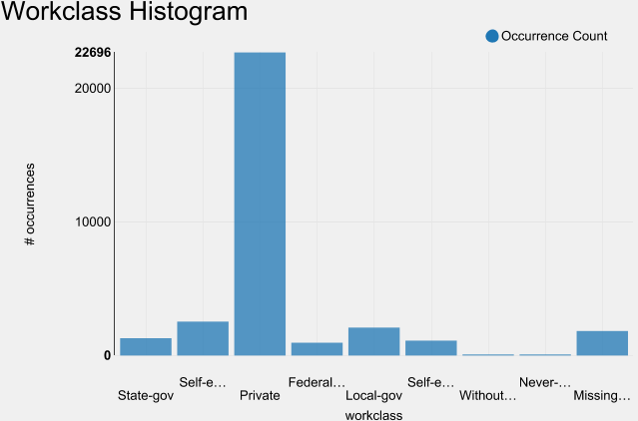  Figure 7 Work-class count. | 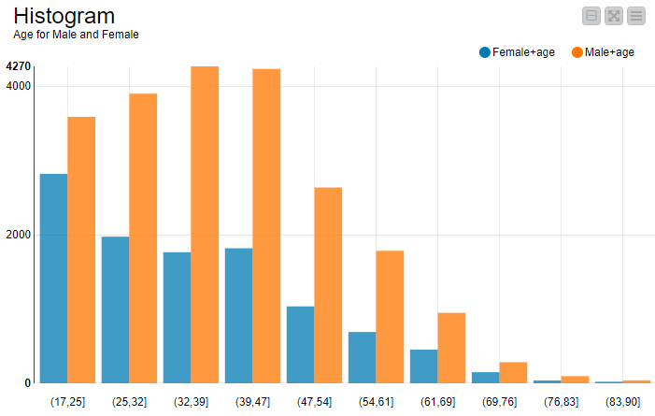  Figure 8 Age comparison Male-Female.
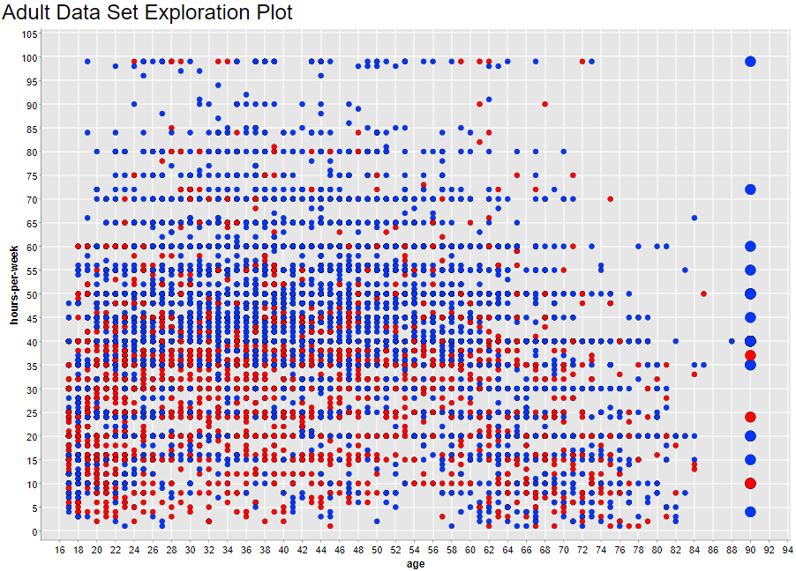
Figure 9 Comparison age vs hour-per-week and 90 years-old points highlighted.
2. First Model creation
2.1 Decision trees using wine.data

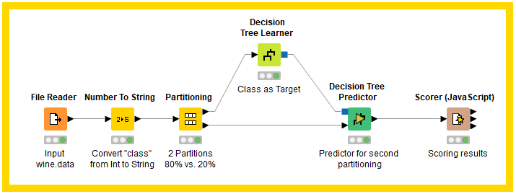
Figure 10 The exercise introduces a supervised learning method called “Decision tree”, a method similar to the human decision-making process [2].
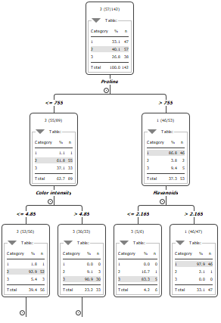  Figure 11 Initial structure of the Decision Tree. | 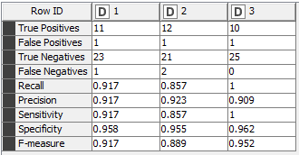  Figure 12 Scorer class statistics table.  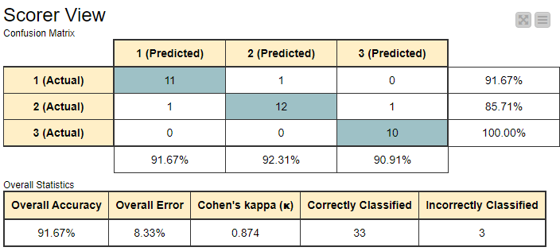  Figure 13 Scorer output including Cohen’s Kappa, a correlation coefficient that measures the agreement between two rates [3].

2.2 MLP using wine.data

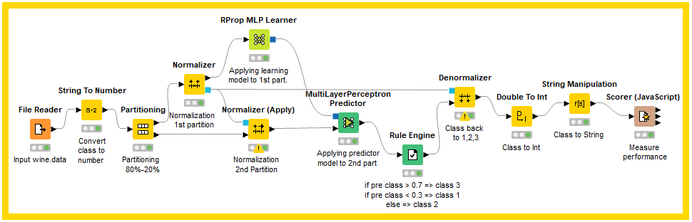
Figure 14 This exercise is a variation of the previous exercise. Two Multi-Layer Perceptron nodes are used for learning and predicting. MLP is a supervised learning technique that uses processing elements called “Neurons” that are interconnected together creating a system called Artificial Neural Networks, similar to the human neural system [4].

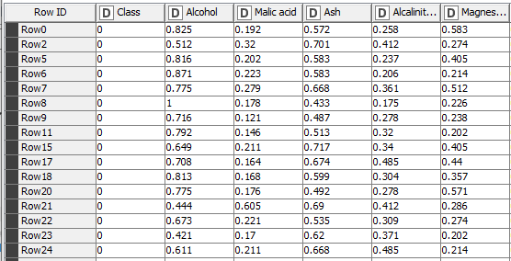  Figure 15 Example of a normalized table.  MLP can only take normalized values as input in the range 0-1. | 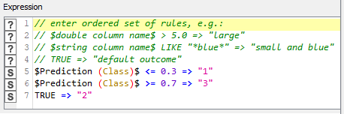  Figure 16 Predictions are converted into 3 values according to a conditional statement.
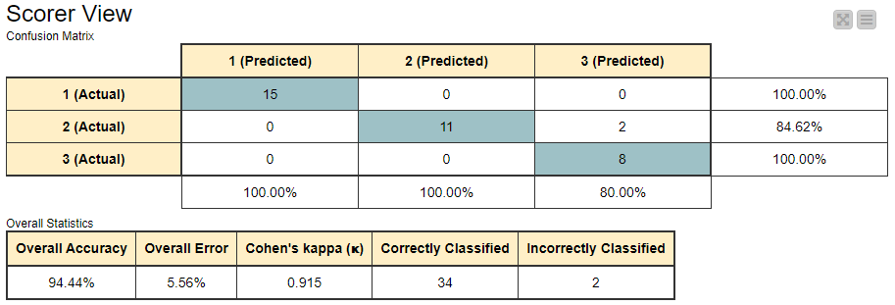
Figure 17 Scorer view. In this scenario, MLP is more accurate than the Decision Tree model.

2.3 Reading data “website 1.txt”
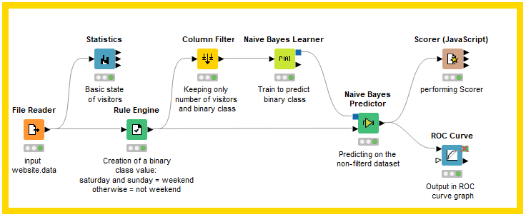
Figure 18 In this exercise, another supervised learning model is used to predict a binary value. Naïve Bayes Learner creates a statistical model, called the Bayesian model, where probability is used to represent all uncertainty in the given dataset [5].
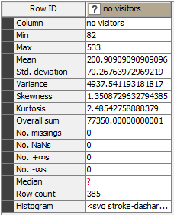  Figure 19 Visitor statistics generated by the Statistics node. | 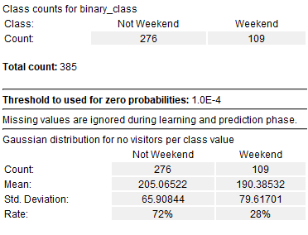  Figure 20 Bayes Learner training results.
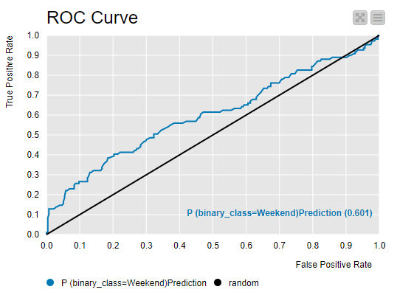
Figure 21 The ROC curve is used to show the difference between
True Positive Rate and False Positive Rate of the prediction. Values that give curves
closer to the top-left corner, indicates better performances [6].

Worksheet 2

3. First Report

3.1 Evaluating Adult.data
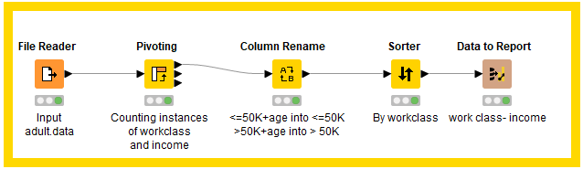
Figure 22 This exercise is a reporting task. After reading the dataset, a pivot node is executed to count the instances of the work-class and income columns. The output table is renamed, sorted, and exported to create a visual report.
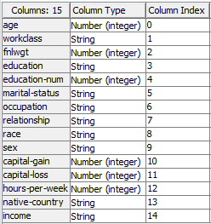  Figure 23 Columns of the input table | 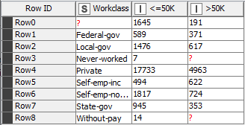  Figure 24 Pivot table exported for the report.

3.2 Evaluating adult.data 2.
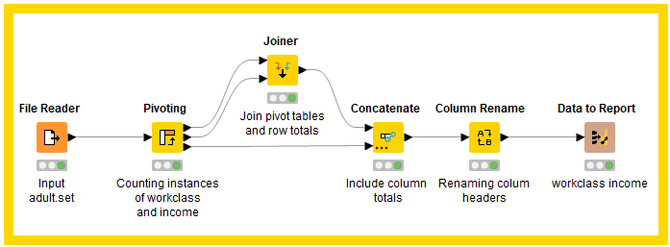
Figure 25 This task is also a reporting exercise based on the previous one. Group totals and Pivot totals are added together to the Pivot table. Column headers are renamed, and the result is exported.

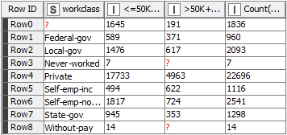  Figure 26 Joiner Node output. | 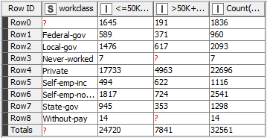  Figure 27 Concatenate node output.

3.3 Evaluate worldcup2006.txt
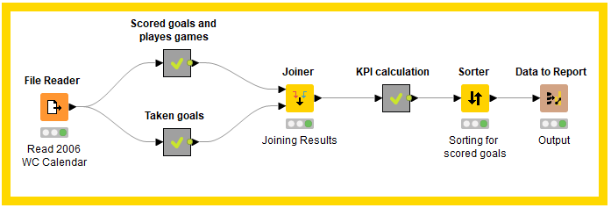
Figure 28 This reporting exercise analyses a dataset containing the results of the 2006 World Cup Soccer games. It determines the total and the average number of scored and taken goals for all matches and calculates a KPI index for each Team.
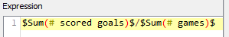  Figure 29 Calculation of average scored goals using  the Math Formula node. | 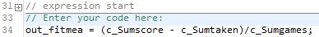  Figure 30 Calculation of the KPI index using a Java Snippet node

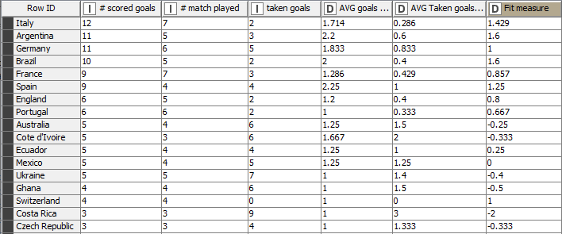
Figure 31 Top rows of the final table created for reporting.

4. First report

4.1 Work-class report

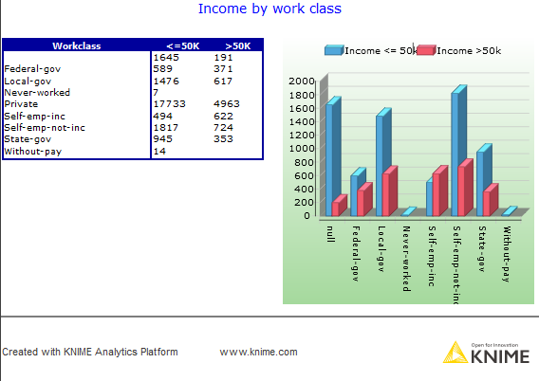
Figure 32 Visual report based on the exercise 3.2 Adult.data.

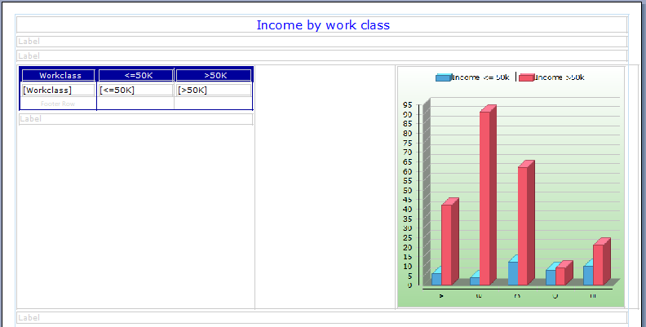
Figure 33 Report structure.

4.2 Work-class report 2
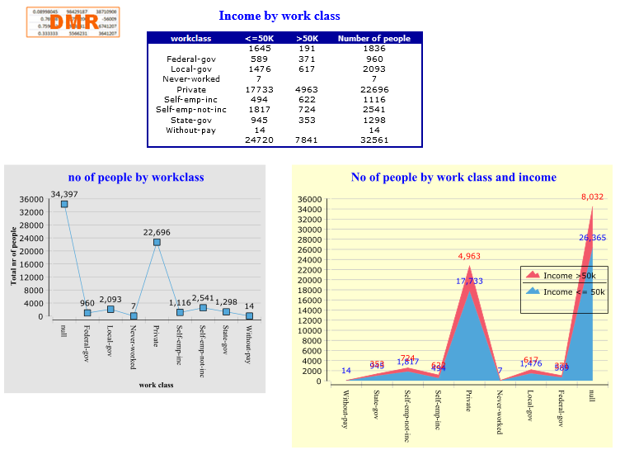

Figure 34 Visual report of exercise 3.2 “Evaluating Adult.data 2”

4.3 Football report
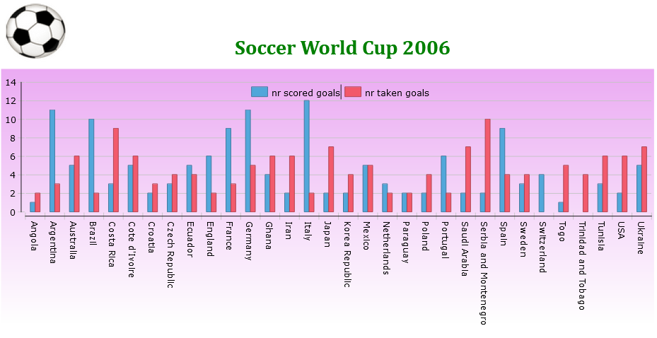
Figure 35 Bar Chart showing scored goals vs taken goals for each team.

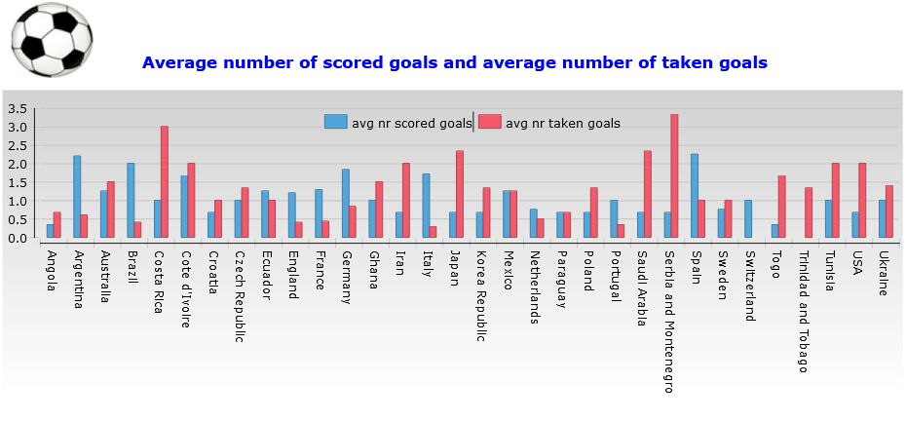
Figure 36 Bar chart showing average scored and taken goals for each team.

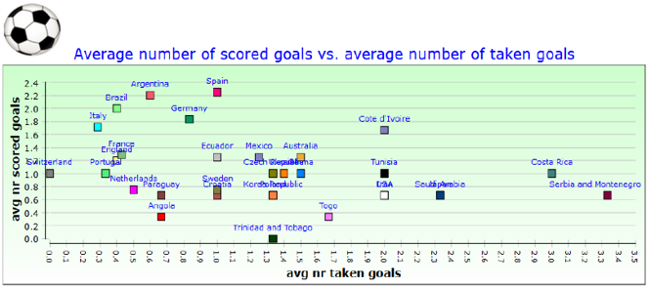
Figure 37 Scatter plot comparing the two averages.
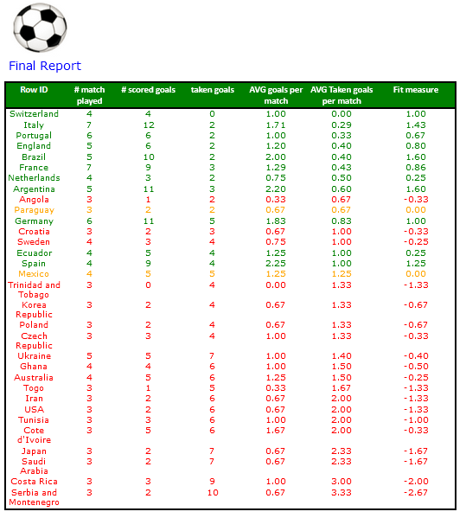
Figure 38 Table comparing all values calculated in the workflow.

Worksheet 3

5. Database Operations

5.1 Cars Database
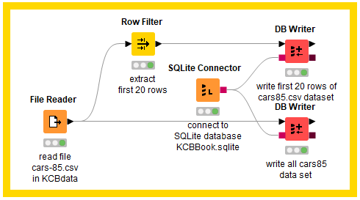
Figure 39 In this exercise, two different outputs are written in the same database: a DB writer writes only the first 20 rows that have been previously filtered and a second DB Writer is used to write the whole dataset to the database.

5.2 Connecting KBCBOOKs.sqlite
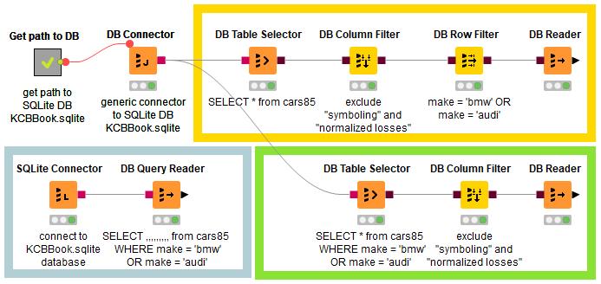
Figure 40 In this workflow, only the records containing specific car manufacturers are selected. The same result is accomplished using three different workflows.

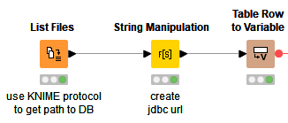  Figure 41 Overview of the Meta-node. “List files” creates a URL of the file contained in a folder that is combined with the Jdbc URL to create a flow variable. | 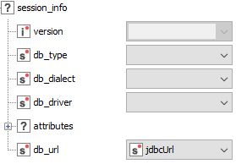  Figure 42 The db_url parameter is controlled by the created variable.
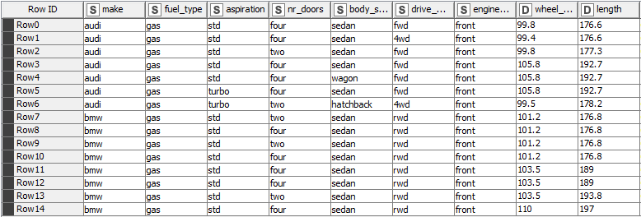
Figure 43 Example of the output.

5.3 Database Looping Nodes

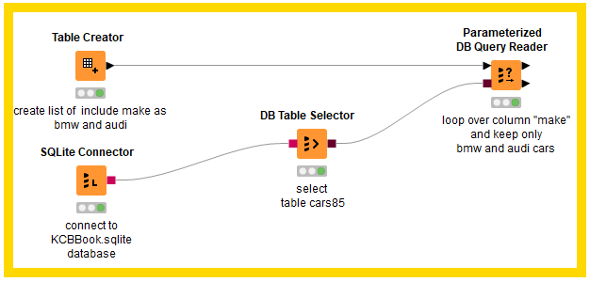
Figure 44 This exercise introduces the use of a loop function as a parameter query. A table with searching values is created and connected to the Parameterized DB Query Reader that loops a SQL statement selecting all rows containing the searching values. The query is applied to a specific table.

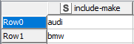  Figure 45 Table Creator output. | 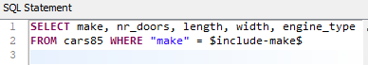  Figure 46 SQL statement executed by the quey reader.
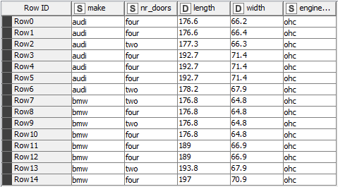
Figure 47 Query output.

6. Accessing Information from the Web

6.1 Chemical database information retrieval
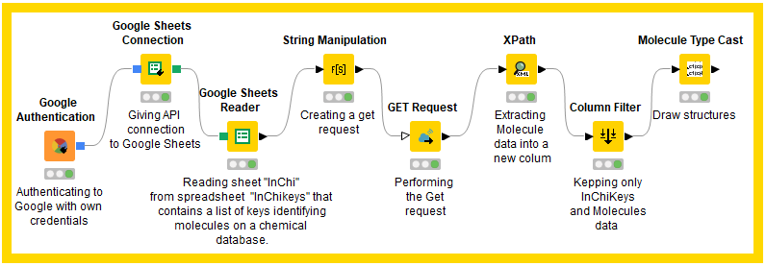
Figure 48 This exercise shows how to retrieve data from Google Sheets by creating a GET request.
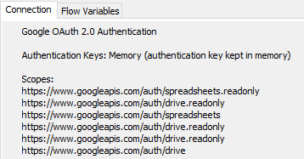  Figure 49 Connection from Knime to google API is managed through the OAuth protocol, an authorisation framework for delegating access to third-party applications [7] | 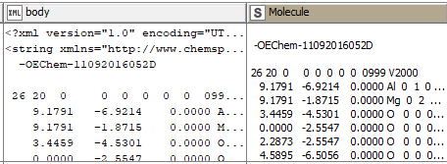  Figure 50 The Get request’s output is in XML format (body). The content of the request is extracted by using the Xpath node (Molecule)
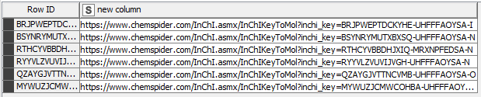
Figure 51 HTTP Get requests created with String manipulation.
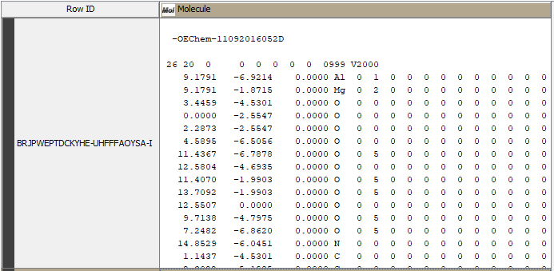
Figure 52 Example of a molecule structure obtained by converting the string to Molecule type.

Worksheet 4

7. Date and Time Manipulation

7.1 Adding Random Dates
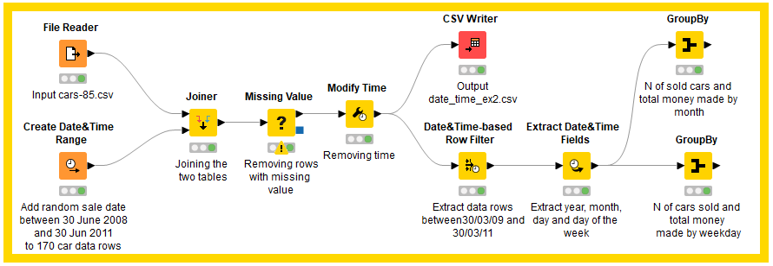
Figure 53 This exercise focuses on DataTime manipulation tasks.
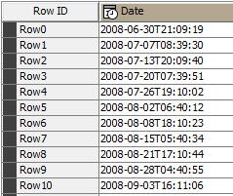  Figure 54 Example of the first 10 rows of the data &time  records generated. | 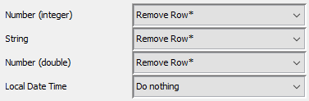  Figure 55 Missing values are removed except for date e time records.

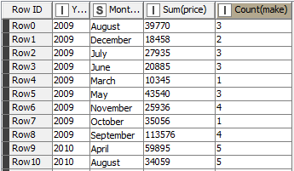  Figure 56 First 10 rows of the output query showing the number of cars and the amount of money made each month. | 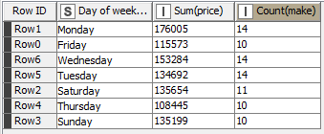  Figure 57 Number of cars and sales for each day of the week.

7.2 Importing date and time
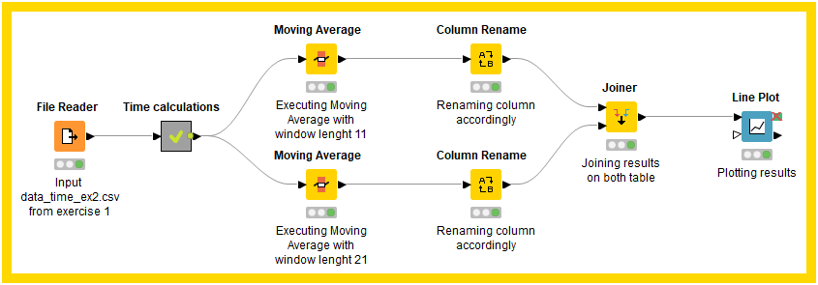
Figure 58 This exercise introduces the concept of “moving average”. A moving average is defined by [8] as “ a time series constructed by taking averages of several sequential values of another time series”.
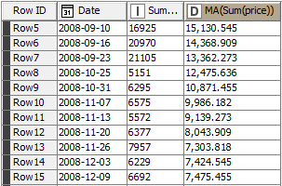  Figure 59 Moving average with window size 11. The window size represents the width of the timeframe slid along the time series to determine the average values [9]. | 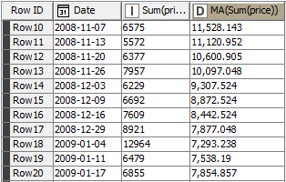  Figure 60 Moving average with window size 12.

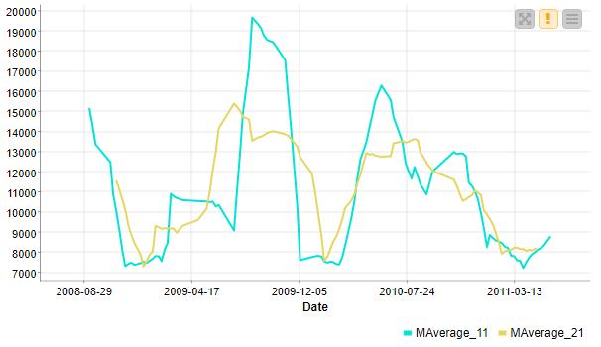
Figure 61 Comparison of MA obtained with window size 11 and 21.

Worksheet 5

8. Flow Variables

8.1 Reading sales.csv

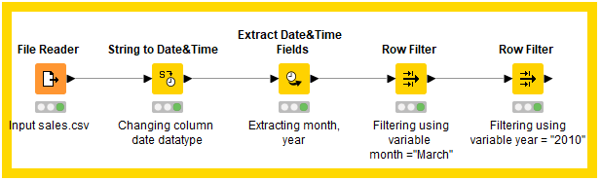
Figure 62 This exercise is based on the concept of the global variable. Global variables can be used in all the workflow nodes, as opposed to local variables that are limited to a single node.

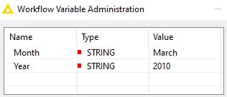  Figure 63 Global variables created in the workflow. | 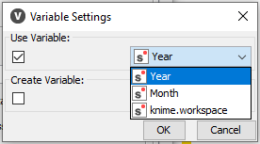  Figure 64 Overwriting Row filtering node’s configuration by accessing the “Pattern Matching” field and choosing a variable.
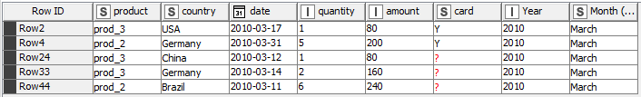
Figure 65 Workflow output after filtering for variables year (2010) and month (March).

8.2 Using cars dataset

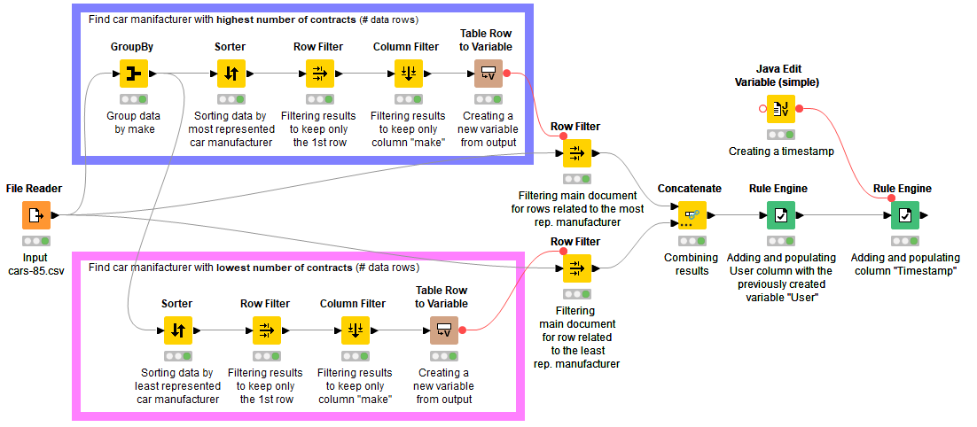
Figure 66 This exercise focuses on the creation of global and local variables. Two branches of the workflow are used to calculate the car manufacturer with the highest and lowest number of contracts. The output is concatenated and combined with username and date.
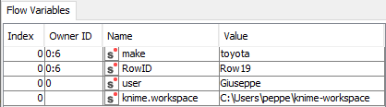  Figure 67 In the blue-highlighted branch of the workflow, the local variable “make” holds the value of the car manufacturer with the highest contracts. | 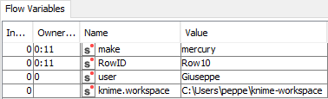  Figure 68 In the purple highlighted branch, local Variable “make” hold the values “mercury” as car manufacturer with the lowest contracts.
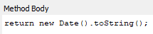  Figure 69 Timestamp created with Java edit Variable node. | 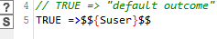  Figure 70 Variable user added to each column.
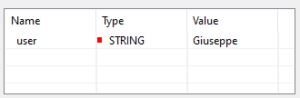
Figure 71 Global variable “user”.
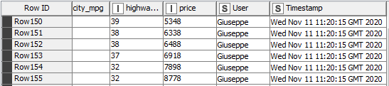
Figure 72 Final output example.

8.3 Maximum Engine Size
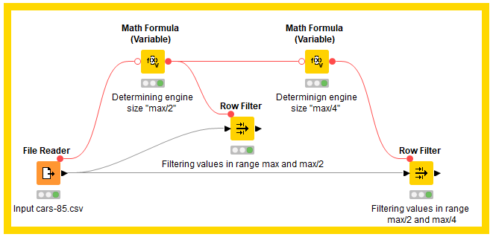
Figure 73 In this exercise, local and global variables are defined to create filtering ranges for the dataset. Both types of variables hold different engine size values.
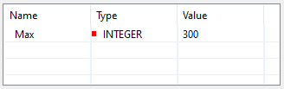  Figure 74 Global variable "Max" is defined with the value 300. | 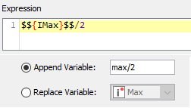  Figure 75 Local variable “max/2” is created with the Math Formula (Variable) node.
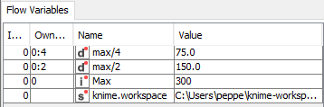
Figure 76 Local variable "max/4" and other variables.

8.4 Wrapped Metanode
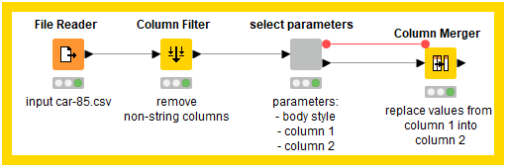
Figure 77 This exercise introduces the use of parametric nodes to filter records.
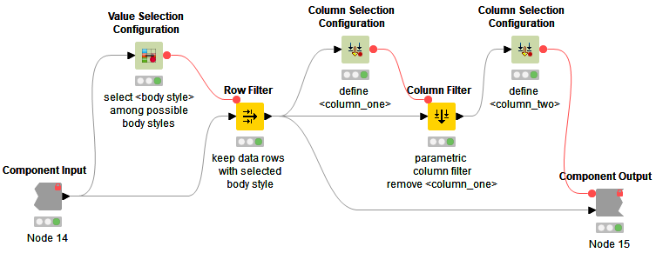
Figure 78 Overview of the “Select parameters” wrapped node.
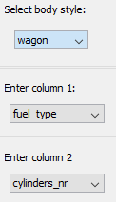  Figure 79 Wrapped node configuration. The node allows choosing e a “body style” and values in “column 1” that will replace values in “column 2”. | 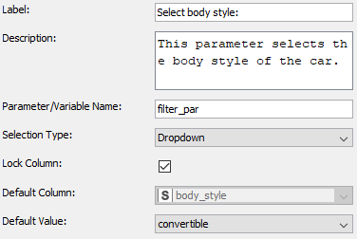  Figure 80 “Value Selection Configuration” node’s settings. The default column is set to “body_style”.
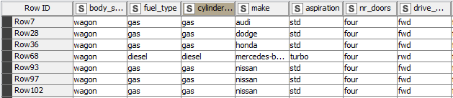
Figure 81 Example of the output (“fuel_type” and “cylinder_nr” share the same values).

9. Loops

9.1 Generating data row
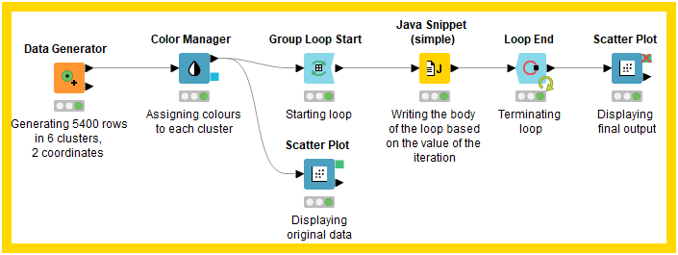
Figure 82 This exercise introduces the use of the loop function. The Group Loop Start and Loop End nodes are used to iterate mathematical operations on a group of 6 clusters, where each operation is applied to a specific cluster.
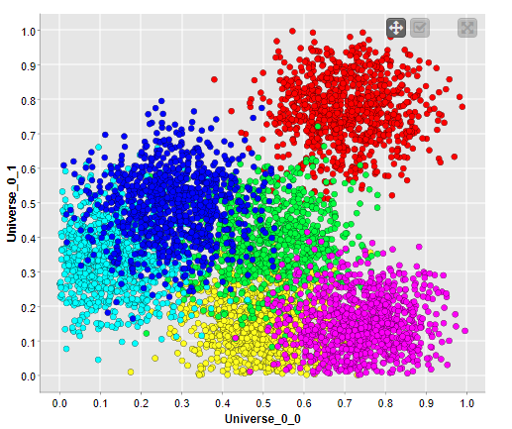  Figure 83 Scatter plot of the 6 clusters. | 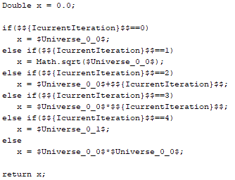  Figure 84 A Java Snippet (Simple) is used to create a conditional statement based on the number of iterations.
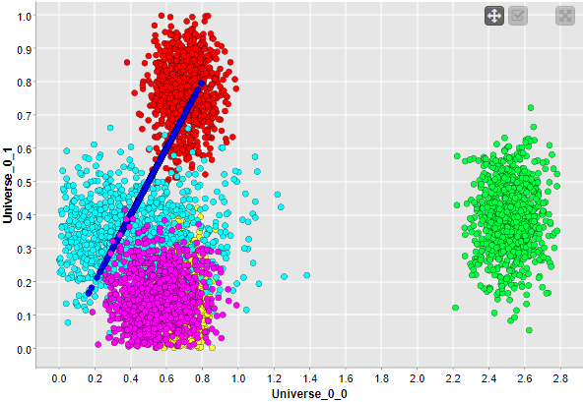
Figure 85 Output after the iterations.

9.2 generating a full table
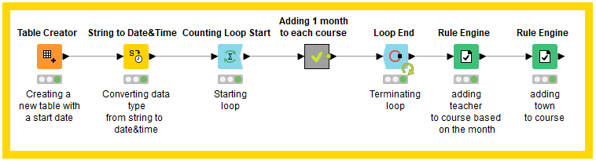
Figure 86 In this exercise, a “Counting Loop Start” is used to increment a date value by a month to create a course schedule for 12 Months. Depending on the month, a teacher and a teaching location are added.
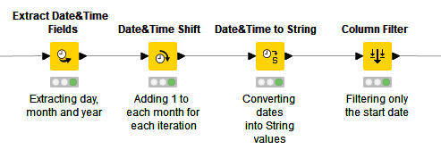
Figure 87 Metanode overview.
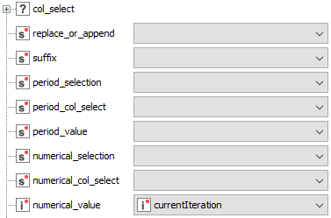  Figure 88 The “Date&Time shift” node has its “numerical_value” parameter controlled by the value “currentIteration”, which increases at each iteration. | 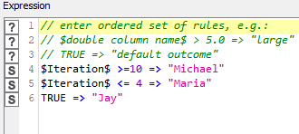  Figure 89 A Rule engine node is used to create a conditional statement that assigns a teacher to each month.
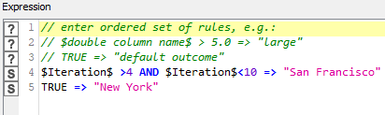  Figure 90 Another conditional statement is applied to assign the “Town” variable to each course. | 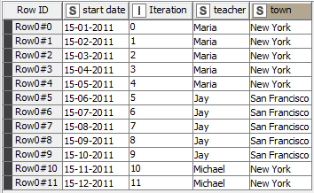  Figure 91 Final output

9.3 Deleting duplicate rows
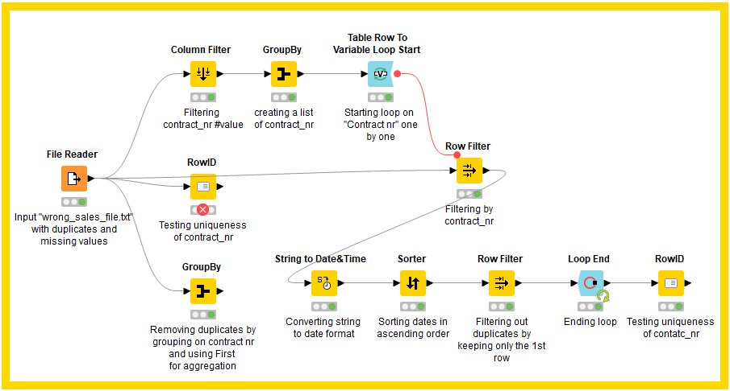
Figure 92 This exercise presents two different ways to remove duplicates from a dataset. The first method involves using only a “GroupBy” node instead the latter is more complex.
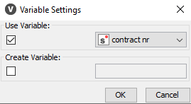  Figure 93 The dataset is filtered and grouped-by to show only the contract number value. A loop is also started to compare the values with the original dataset in search of duplicates. | 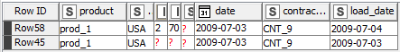  Figure 94 At the end of each loop, in the case of duplicates, only the most recent record (load_date) is kept.
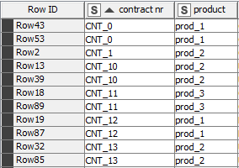  Figure 95 Original dataset with duplicates. | 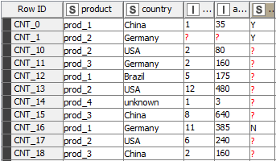  Figure 96 New dataset with unique contract number values.

9.4 creating an original file
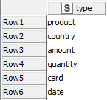  Figure 98 A table with the file name is created. | 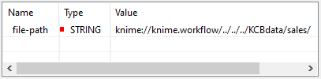  Figure 99 The global variable "file-path" is defined containing a path to the parent folder.
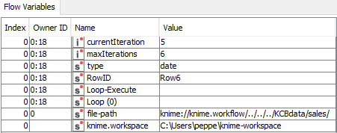
Figure 100 The Loop node is configured to execute maximum of 6 loops.
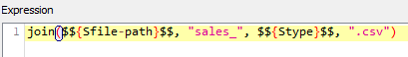
Figure 101 The string manipulation node creates a new path at each iteration. Each file is read and combined at the end of the loop.
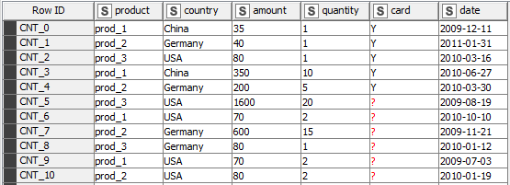
Figure 102 Example of the output.
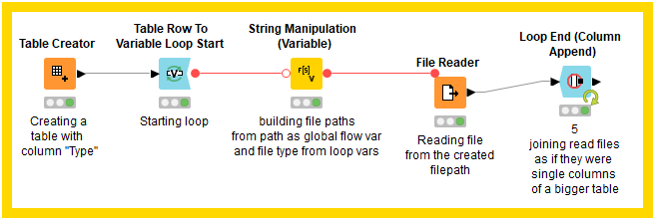
Figure 97 In this exercise, a loop is used to create 5 different file-paths for 5 files that are combined.

10. Switches

10.1 IF switch node
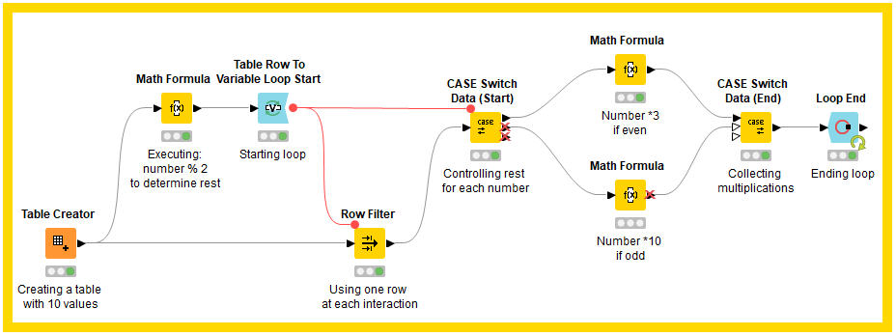
Figure 103 This exercise uses “Case Switch Data” nodes in conjunction with a loop to perform different mathematical operations on all the numbers depending on their reminder.

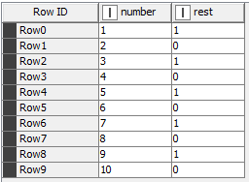  Figure 104 Calculating the remainder for each number. | 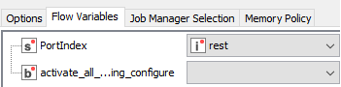  Figure 105 The Case Switch Data receives two inputs: filtered data from the main table and the variable rest from the previous operation.
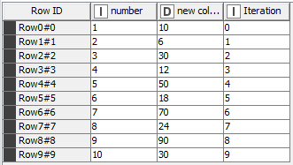
Figure 106 Output containing “number”,” product”, and “Iteration”.

10.2 Workflow control
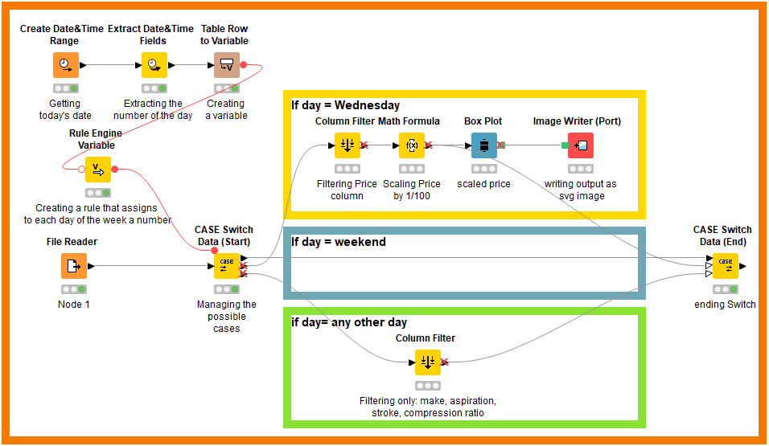
Figure 107 In this exercise, a Case Switch Data is configured to perform specific mathematical operations on a car sales dataset depending on the day of sales.
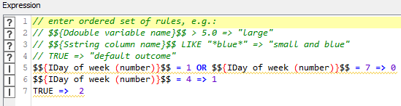
Figure 108 After the number of the day is extracted, a corresponding value is assigned depending on the day of the week.
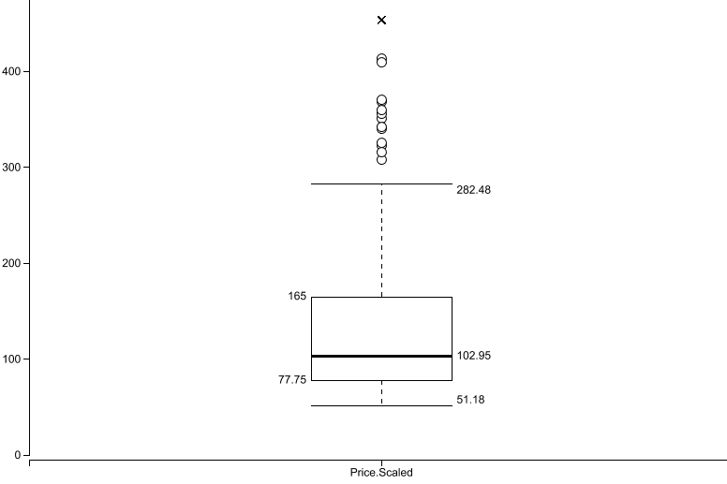
Figure 109 Box Plot output. If “Day” is Wednesday, the price is scaled 1/100.
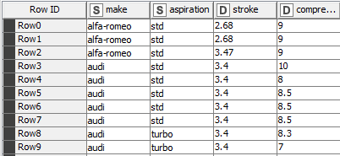
Figure 110 Example of the output if “day” is “any other day”.

11. Advanced Reporting

11.1 Movie Report
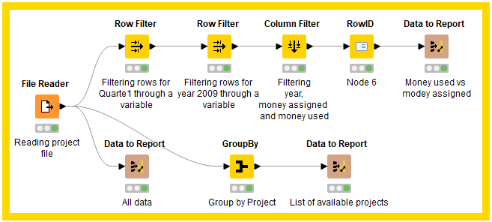
Figure 111 Workflow built for the report.
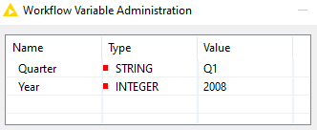  Figure 112 Two global variables have been defined. | 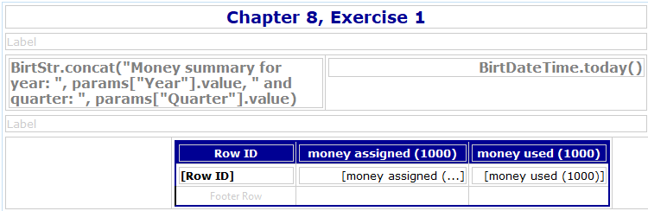  Figure 113 Graphical structure of the report.
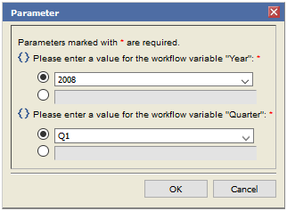  Figure 114 Report interface. Variables “Year” and  “Quarter” can be chosen from the dropdown list. | 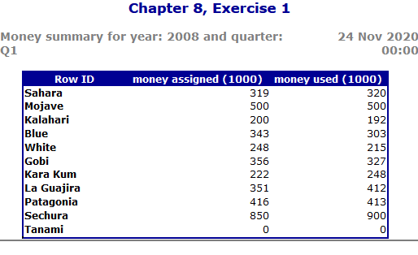  Figure 115 Example of the final output for the year 2008, quarter 1.

11.2 Product Report
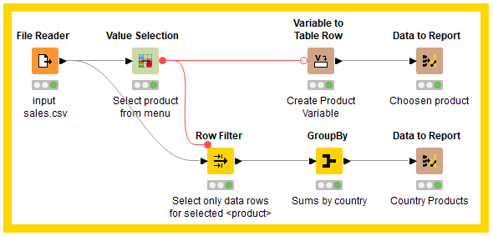
Figure 116 In this exercise, a sales dataset containing information about different products is presented.
For each product selected, a report containing “quantity”, “revenue”, and “country” is produced.
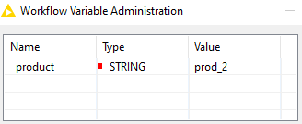  Figure 117 “product” is defined as a Global variable. | 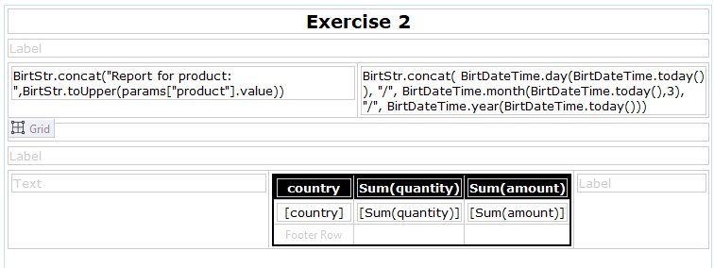  Figure 118 Structure of the report. The two “concat” functions show the product name and date.
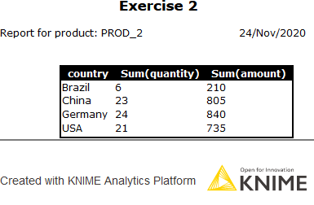
Figure 119 Final output of the report.

11.3 Product Image Report
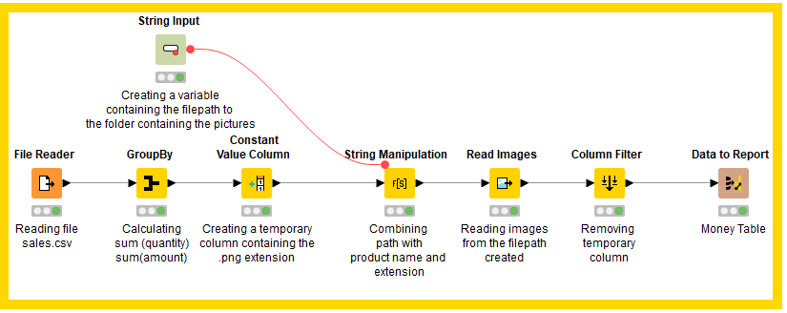
Figure 120 In this exercise, a dataset containing sales records is used to create a report. For each product, a customised image is loaded.
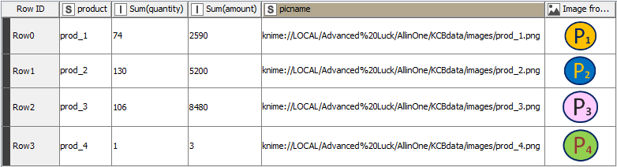
Figure 121 After the amount of quantity and sales for each product had been calculated, the file-path for each image is determined.
The image is loaded and appended in the table.

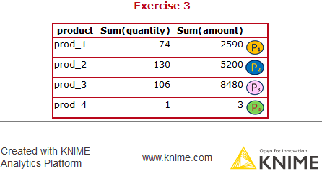
Figure 122 Report Output.

Worksheet 6

12. Big Data Warehouse
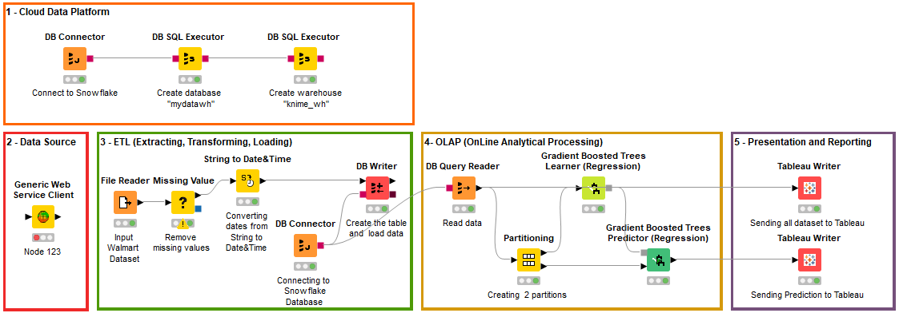
Figure 123 The workflow above depicts the structure of a cloud big data warehouse built for the Walmart case study.
A data warehouse is a system that fetches data periodically from a source system and stores it in a data store for data analysis to build business intelligence strategies [10]. The presented architecture has been numbered in each part and includes:
1 Cloud data Platform.
In this section, a connection to a cloud data platform called Snowflake is established to create a Cloud data warehouse. This type of data warehouse has been chosen for the many advantages that Cloud computing offers over the traditional on-premises data warehouse systems as shown in [11, Fig 124] compares the two types.
The DB connector node was configured to use Snowflake’s JDBC driver and the URL and credentials relative to the account used to access it. Once the connection was successful, two SLQ statements are executed to create a database that will store all the data and a virtual data warehouse that will work as the environment where all data processing is computed. For the data warehouse, size is also specified to determine the number of servers used for processing.

- Data Source  Data Source consists of the OLTP (OnLine Transaction Processing) system that captures and stores business transactions. In the presented scenario, data is already captured and stored in a CSV file, but for explanatory purposes, a “Generic web Service Client” node able to retrieve data from a web service, has been added.  - ETL  The ETL system performs three main types of operation: Extraction, on which data is fetched from different sources and combined; Transformation, where data is cleaned; Load, where data is loaded onto the data store.  In the workflow, the File Reader extracts the data and a transformation process is performed by two nodes: “Missing values” that has been configured to remove missing values and the “String to date” node to convert dates from string to Date&time data type. Cleaned data is loaded onto the database with the “DB Writer” node.  - OLAP  OnLine Analytical Processing is the system that enables business intelligence activities such as data analysis, statistical analysis, predictive analysis, and data mining using various operations like Slicing, Merging, Pivoting, Ranking, Spitting [12]. In the workflow, different activities are conducted: a query is created to read data from the database, and it is divided into two partitions that are used to train and test a regression model.  - Presentation and reporting  This section is related to data presentation and reporting. For this purpose, an interactive data visualization tool called Tableau has been implemented. The Tableau writer node’s output is in Hyper format that once stored locally, can be accessed through the Tableau app to generate charts, plots, tables, etc. | 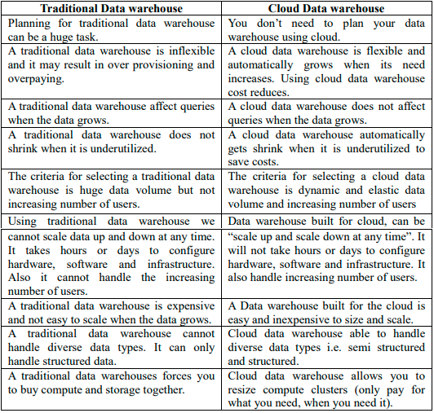  Figure 124 Comparison between Traditional and Cloud data warehouse [11].

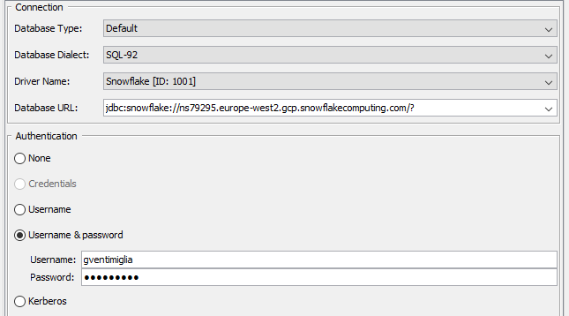
Figure 125 DB connector node using Snowflake’s settings.

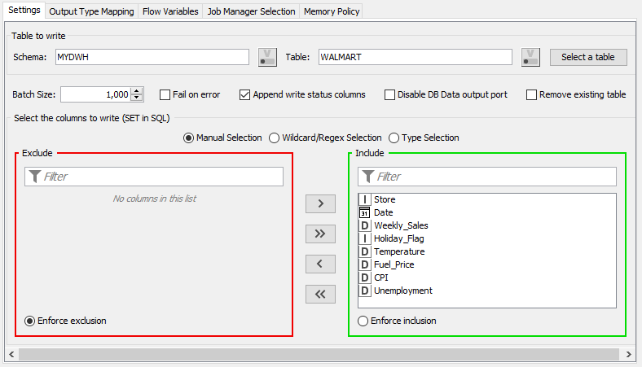
Figure 126 Importing data on Snowflake database
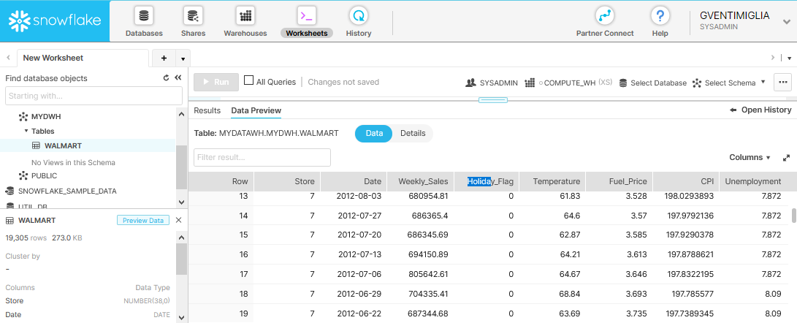
Figure 127 Example of data loaded on Snowflake.
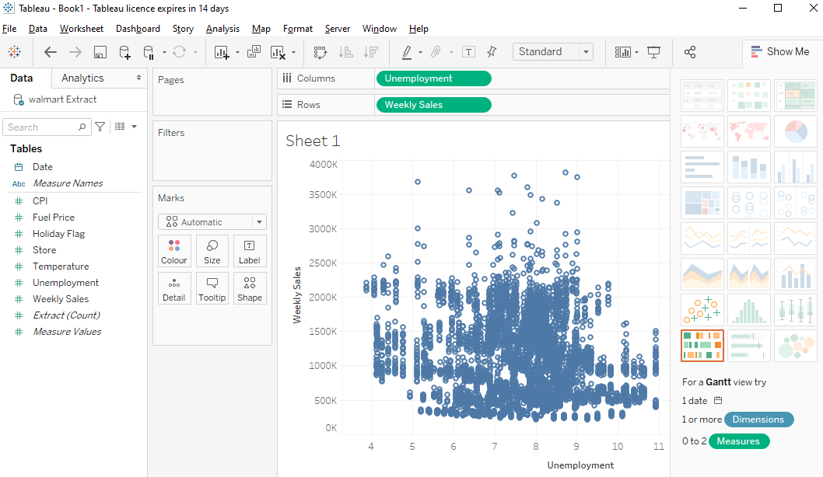
Figure 128 Tableau Editor.

Conclusion
In this work, all the aforementioned exercises have analysed the different ETL functionalities of Knime Analytics. A cloud data warehouse is also built for the Walmart case study.

‌

References
- Y. Zhang and L. Zhang, ‘JDBC-based middleware applications in instant message systems’, in The 2014 2nd International Conference on Systems and Informatics (ICSAI 2014), Shanghai, China, Nov. 2014, pp. 1044–1049, doi: 10.1109/ICSAI.2014.7009439.
- H. H. Patel and P. Prajapati, ‘Study and Analysis of Decision Tree Based Classification Algorithms’, IJCSE, vol. 6, no. 10, pp. 74–78, Oct. 2018, doi: 10.26438/ijcse/v6i10.7478.
- M. J. Warrens, “Five Ways to Look at Cohen’s Kappa,” Journal of Psychology & Psychotherapy, vol. 05, no. 04, 2015, doi: 10.4172/2161-0487.1000197.
- V. Aeinfar, H. Mazdarani, F. Deregeh, M. Hayati, and M. Payandeh, ‘Multilayer Perceptron Neural Network with supervised training method for diagnosis and predicting blood disorder and cancer’, in 2009 IEEE International Symposium on Industrial Electronics, Seoul, South Korea, Jul. 2009, pp. 2075–2080, doi: 10.1109/ISIE.2009.5213591.
- S. K. Ghosh, ‘Basics of Bayesian Methods’, in Statistical Methods in Molecular Biology, vol. 620, H. Bang, X. K. Zhou, H. L. van Epps, and M. Mazumdar, Eds. Totowa, NJ: Humana Press, 2010, pp. 155–178.
- S. Yang and G. Berdine, “The receiver operating characteristic (ROC) curve,” The Southwest Respiratory and Critical Care Chronicles, vol. 5, no. 19, p. 34, May 2017, doi: 10.12746/swrccc.v5i19.391.
- E. Ferry, J. O Raw, and K. Curran, “Security evaluation of the OAuth 2.0 framework,” Information and Computer Security, vol. 23, no. 1, pp. 73–101, Mar. 2015, doi: 10.1108/ics-12-2013-0089.
- R. J. Hyndman, ‘Moving Averages’, in International Encyclopedia of Statistical Science, M. Lovric, Ed. Berlin, Heidelberg: Springer Berlin Heidelberg, 2011, pp. 866–869.
- A. Z. Woldaregay, I. K. Launonen, E. Årsand, D. Albers, A. Holubová, and G. Hartvigsen, “Toward Detecting Infection Incidence in People With Type 1 Diabetes Using Self-Recorded Data (Part 1): A Novel Framework for a Personalized Digital Infectious Disease Detection System,” Journal of Medical Internet Research, vol. 22, no. 8, p. e18911, Aug. 2020, doi: 10.2196/18911.
- V. Rainardi, Building a Data Warehouse With Examples in SQL Server. Berkeley, CA: Apress, Inc., 2008
- K. U. Rehman, U. Ahmad, and S. Mahmood, “A Comparative Analysis of Traditional and Cloud Data Warehouse,” VAWKUM Transactions on Computer Sciences, vol. 15, no. 1, p. 34, Mar. 2018, doi: 10.21015/vtcs.v15i1.487.
- R. Kimball and M. Ross, The data warehouse toolkit: the definitive guide to dimensional modeling, Third edition. Indianapolis, IN: John Wiley & Sons, Inc, 2013.

