
bmsw4004 – Assessment 1
An analysis into the Problem at ASDA

BEN NSUKA
1816136

Word count: 3000

Executive Summary
In order to analyse the Problem at ASDA, it’s imperial to look at different factors that made this brand grow in customer numbers and profit in the past. This will lead us to understand what made ASDA face the challenge as many other supermarkets which are a developed form of markets nowadays. Markets are places where buyers and sellers assemble (Thorburn, 2011).

Them days, supermarkets were regarded as new, innovative, saving money and were for people making pennies count in the main (Ryle, 2013).

ASDA was established with local shopping, minimising the impact of competition from the high street. But today, competition is too high online, that it takes a revolution within its management in order to maintain its reputation. This competition is due to PESTLE factor, which according to Dobbs (2019) analyses context and covers factors and issues that may be beneficial or detrimental to a business unit and its operations.

Chandler knocks out that the new production technologies with their historically unprecedented output created a new type of competition. This competition is due to the modern trading environment and uncertainty over Brexit and undoubtfully the crisis caused by Coronavirus outbreak.

Contents

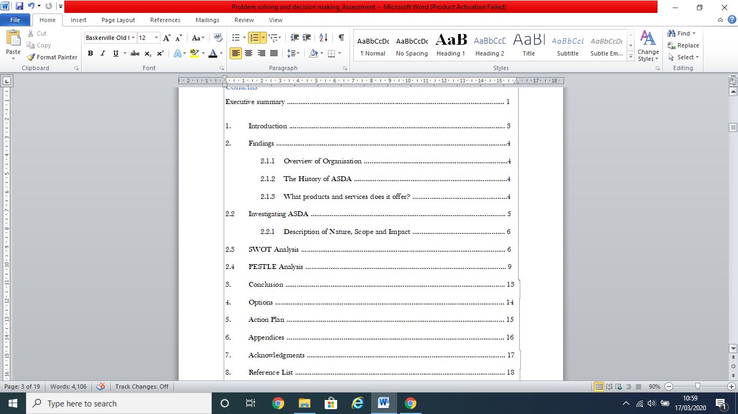

- Introduction

This professional 3000-word report was requested by lecturer Melanie Squire on 10 February 2020 and will look at ‘An analysis into the Problem at ASDA with the purpose of providing an analysis of the current problem faced by ASDA. Analytical tools such as SWOT and PESTLE will be used and applied to gather information. My lecture notes, verbal and written feedback from the lecturer, books, articles as well as my potential will be used to compile the findings of this report.

Compiled by Ben Nsuka (1816136) to be submitted to Turnitin on 3rd April 2020, by 3pm.

- Findings

    - The History of ASDA

ASDA is a British supermarket which headquarters are found in Leeds. It’s a subsidiary of the giant Walmart of the USA. The roots of the actual Asda can be traced back to the 1920s with a butcher’s shop ran by the Asquith family in Knottingley, West Yorkshire. This was eventually later expanded to seven shops. The two sons of W.R. Asquith (Peter and Fred) were actively involved in the family business and were later to become co-founders of Asda. A new public company will be formed in 1949 after the Asquith family met the Stockdale family, with Arthur Stockdale as Managing Director. During the 1950s and early 1960s, Noel Stockdale became the other co-founder of the future Asda (ASDA, 2020).
The board below details important events in ASDA’s timeline.
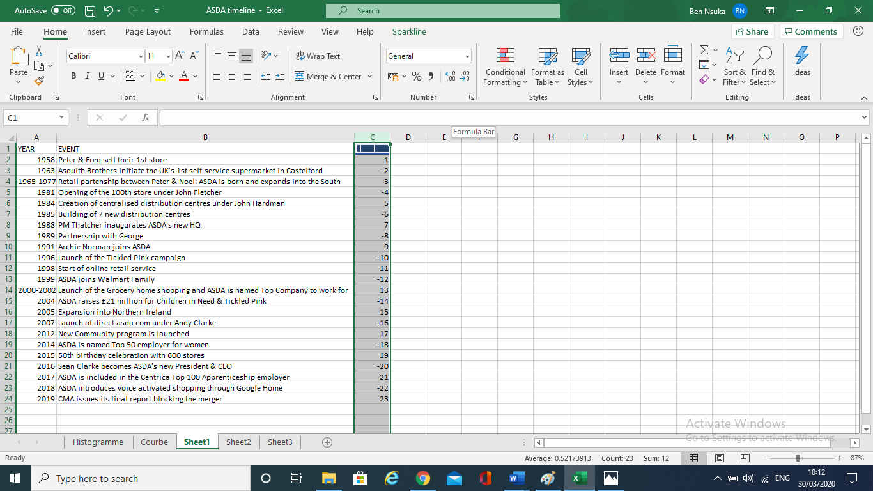

    - What services and products do ASDA offer?

ASDA offers services and products such as: Supercentres, George Clothing, Home and non-food, Superstores with Café, Pharmacy and Optician, Supermarkets, Click & Collect from all Supermarkets, ASDA Living stores, Travel Money services, Scan & Go, ToYou, Petrol Filling Stations, ASDA Grocery Home Shopping, Grocery Click & Collect and ASDA Logistics Services as well as ASDA mobile app (Corporate Asda).

  - Investigating ASDA

Recent investigations by the CMA (2018) show that ASDA was assessed to ensure prices are nor higher and quality services are not worse. (Competition and Markets Authority, 2018). However, many critics believe that ASDA is touched by the problems of US giant Walmart and has seen its reputation take a pummelling with analysts saying its performance was being strangled. This can lead to job losses (Buckland, 2016).

ASDA Employee Reviews on Indeed show that employees are being pressured by unprofessional managers who threaten to knock out staff members. Some go on stating that the culture of ASDA changed significantly since Walmart took over, as the pay has become horrendous after working long hours, although the brand issues discount cards.

    - Description of Nature, Scope and Impact of the Problem at ASDA

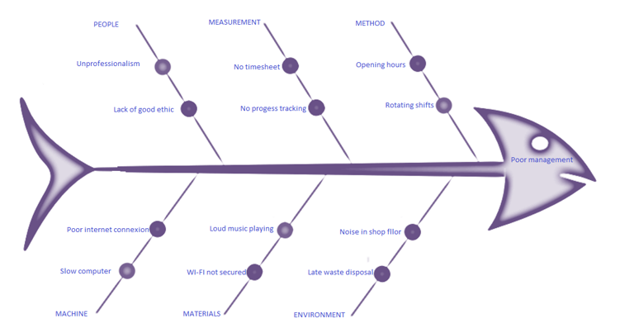

Despite the Nature of the Problem at ASDA, its People Plan for its 50th anniversary in 2015 explains:

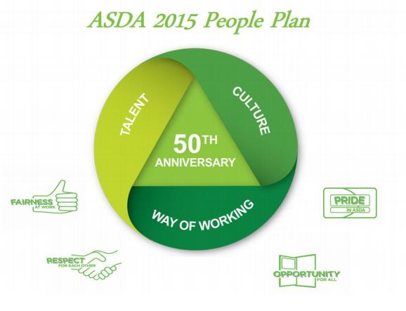
ASDA is working hard to save its reputation of the best-value retailer in UK. During ASDA’s 50th anniversary, customer reviews and feedback showed that ASDA has kept its promise: make customers spend less, save money and live better.

  - SWOT Analysis of Asda

- Strengths of ASDA
According to Prospects, UK industry is dominated by supermarkets. UK is a nation of shopkeepers (Wilkinson, 2010). With its 630 stores across the UK, ASDA is known for its lower prices, being a price cutter and a costs challenger. ASDA is dropping living costs with its turnover of over £630 million, bringing a sense of difference in pricing. The Pizza tasting experience showed that ASDA could sell a £14.99 pizza from Dominos at £3.12, making ASDA a leader in the take-away market.
ASDA convinced the government to change the law about selling medicines in supermarkets. For people wellness, ASDA introduced the NHS Prescription collection within its stores.
UK Essays notice that ASDA is known to have an updated knowledge of the competitors. On the other hand, Essay UK state that ASDA is in constant touch with its customers via social networking. It asks about feedback, conducts and competitions.
A study by Fern Fort University shows that ASDA has a strong dealer community. It has built a culture among distributor and dealers. ASDA also possesses a successful track record for product innovation with a highly skilled workforce through training and learning programs.
ASDA is known for valuing the consumer and putting money back to the consumer’s pocket with its “pocket tapping” policy. Its aim is to make people live better by reducing the environmental impact of its operations, goods and services. ASDA hires employees from other big international brands such as Carrefour. It has the tribute of introducing Clothing with the brand George.
ASDA has chosen to integrate sustainability principles into its business models in order to prioritize its long-term survival in business. This involves its connection to ecological, social and cultural systems (Mar, 2013).

The graphic below explains:
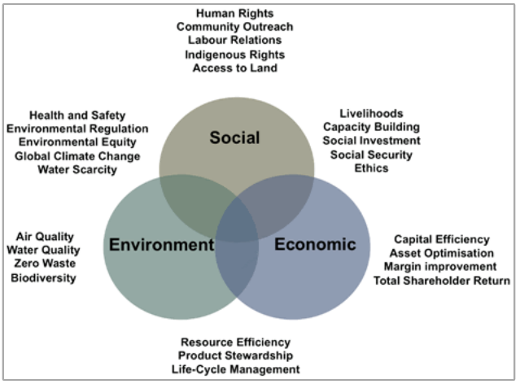

ASDA was declared Retailer of the Year 2019. It was also crowned the Chilled Retailer of the Year, Bakery Retailer of the Year, and Drinks Retailer of the Year 2019 (Sodry, 2020).
- Weaknesses of ASDA
Numbers of critiques say that ASDA has a limited global attendance and a poor management. Its ability to sell is restricted by some countries as those countries fear to compete with local vendors. ASDA does not have shorter stores like Tesco. ASDA has positioning problems. Some critics argue that ASDA products are not as good as those of Waitrose and other similar brands e.g. Sainsbury’s. It was found in 2007 that ASDA was engaged in price fixing of dairy products between 2002 and 2003 costing consumers around £270 million. ASDA has been also criticised for misleading advertising campaigns and its positions in horse meat scandal.

- Opportunities for ASDA
ASDA can secure more marker share, as more customers tend to be online shoppers. The brand can grow further by opening new stores and taking over smaller companies as it did with Focus DIY in 2011, converting five of six Focus DIY stores into supermarkets. Similarly going beyond the UK to explore opportunities abroad is worth the efforts, says Sodry. It has the reputation of expanding new areas like pharmacies, opticians, jewellery and photo department. Undertaking into markets that are growing like India or China is one of the opportunities ASDA. It can emerge its business to some growing markets. It can adapt its services to new technologies until about 2040. Marsh infers that the way goods are designed and made will become more complex. Process such as development, production and service will be spread across a global ‘value chain’ of operations. Across this value chain, there will be opportunities for business based in many countries, both high-cost and low-cost, to play a part.

- Threats to ASDA
ASDA has a constant pressure to maintain low pricing. A competitor like Tesco is keeping the position of the market leader, while Sainsbury’s is ASDA’s nearest rival. Other notable competitors are Morrisons, Waitrose, Aldi, Lidl, and Co-op. The more competition there is, the more likely are firms to be efficient and prices to be low (Bishop, 2016). It is also worth noting that growth of independent online retailers is also a threat to ASDA. It is a challenge for ASDA to hold more customers as they tend to switch to other retail shops. Discounting the future refers to our tendency to behave as if the future will never arrive (Drummond, 2012). ASDA is aware of that and gets ready to face any competition. But alongside with that awareness, ASDA needs to make the right decision; because one important skill is making the right decisions at the right time in the right way (Morgan, 2017).

  - PESTLE Analysis of ASDA

Political factor: ASDA is affected by national, international and EU regulations. These factors are affecting employment, legislation, consumer rights and taxes. Although ASDA benefits from a stable political environment in the UK, the brand is affected by Brexit. However, war and instability can also impact on ASDA’s decision-making, that’s why the brand is constantly monitoring political environment in order to comply with all the regulations. The minimum pricing is the most effective policy and prevents supermarkets from absorbing tax increases on alcohol as loss-leaders, says UK Essays.

Economic factor: ASDA is considering economic factors that can lead to a possible inflation and price rising. As per Bishop, Inflation means less bang for your buck, as it erodes the purchasing power of a unit of currency. It usually refers to consumer prices, but it can also be applied to other prices. The most important of all factors in hard times is macroeconomic policy (Clark, 2014).
These economic factors impact significantly on the pricing strategies of the company. The process of economic change in Britain, as elsewhere, has not been steady but subject to unbalance and fluctuation. Analysing the nature of these economic fluctuations is important, but also gives insights into the process of growth, the changing structure of the economy and the social hardships brought by industrialization and economic change (Mathias, 2011).
Coronavirus outbreak may be a factor that will affect negatively ASDA in its economy. Asda stores across the country are reducing their opening hours because of coronavirus, write Baron and Shaw (2020). ASDA and Tesco are closing service counters and imposes limits on the amount that can be purchased, reads The Guardian.

Social factor: ASDA is aware of social changes such as ageing population, celebrity following, and healthy lifestyle. ASDA is affected with the flea of Coronavirus, as buyers are worried, they would face shortages if the country is quarantined like Italy. Many ASDA’s outlets such as Leeds have run out of toilet paper. In some places, shoppers were spotted in a hazmat suit and a mask while filling their trolley. After the warning by the prime minister, Brits have been put on notice that they could face sweeping restrictions, including self-isolation for a week if they have a persistent cough, writes The Sun.

Technological factor: ASDA is aware of the ever-growing use of technology to ensure that customer satisfaction remains high. ASDA is driven by innovation and change. ASDA is equipping employees, enabling them to operate within complex and challenging environments. Employees can host and help customers with queries and can manage multiple checkout sites at one time, as over half of in-store transactions at ASDA now go through a self-scan checkout. Rapid growth in online and mobile shopping is also acting as a catalytic force for the business. Colleagues need skills to develop their capability, being challenged while dealing with different technology (Valuing Your Talent Team, 2014). ASDA is securing online shopping, knowing that many shoppers place online orders, believing that supermarkets are hit by the virus.

Legal factor: ASDA is abiding by the rules and regulations of the countries in which it operates, knowing that any breach may result in punitive actions by relevant authorities. For example, ASDA cannot pay any employee less than the minimum wage in the UK. Likewise, the company cannot dismiss an employee unfairly. Unlawful treatment can include unfair dismissal, discrimination and unfair deductions from the employee’s pay. Should it happen, the employee concerned can take ASDA to an independent employment tribunal that will listen to the claimant and the respondent before deciding, summarises GOV.UK. ASDA is aware of disciplinary practices, ranging from oral warnings to termination of the employment, knowing that there’s a framework of legal rights regulating the disciplinary process (Bratton and Gold, 2012).

Environmental factor: ASDA is determined to serve its millions of customers a green economy, zero pollution, zero waste and organic foods. Due to the pressure people put on ASDA to operate in an environmentally friendly manner, ASDA has managed to remove over 400 million bags from production each year. It’s the first food retailer to remove single-use carrier bags from both Online Grocery & in-store operations.
By complying with environmental regulations, ASDA aims that its packaging will be 100% recyclable by 2025. ASDA reduced the plastic in their own brand water bottles by 250 tonnes so far, equal to the weight of twenty double decker buses (ASDA, 2020). With the quick spread of coronavirus, ASDA is battling to ensure in-store buyers and staffs are safe. Staying close to the government on the latest information and advice, ASDA has also topped up the cleaning stations at the front of its stores more frequently, making it easier to sanitize trolleys and baskets before and after use (ASDA, 2020).

- Conclusion

ASDA, which operates as a retail supermarket, is now experiencing huge changes in the grocery sector. ASDA is no more the cheapest supermarket although ‘always low prices’ is their unique selling point. In fact, Lidl and Aldi are well-known as discounters.
Market penetration strategy can be suitable for ASDA as it is operating lowest price in the market comparing to other competitors (Bitner, 2007).

- Options
The CEO of ASDA should consider the huge changes within the grocery sector and work on keeping the price as low as possible in order to face its competitors. As employees are being pressured by unprofessional managers, the CEO of ASDA to regularly organise trainings in management communication skills to save the image and the reputation of the brand.

- Action Plan
The actions must be communicated through a management platform such as a Management discussion group. The CEO of ASDA needs to make in place a committee to monitor the implementation of the actions taken to boost the brand’s management. The CEO and his board need to review the actions by collecting, analysing and evaluating feedbacks.

- Appendices

ASDA is known for its fight for lower prices. Its management/administration needs to keep its reputation, despite its position in misleading advertising campaigns and horse meat scandal that lead to tarnish the brand’s reputation. Constant and effective communication is the useful tool to save the brand.

- Acknowledgments

Heartfelt thanks to Mel, a highly intelligent individual who can apply her vast knowledge and experiences while lecturing, giving feedback or advising in a one-to-one. She uses her perspicacity to always offer me the best knowledge I need in the way I have chosen.
Many thanks to Meta, Benitto and Gerty for sharing their time and space with me during the preparation of this report. They took me to different libraries to collect the material I needed.

- Reference List and Bibliography

- Thorburn, G. (2011) Remembering the high street: A nostalgic look at famous names. Pen & Sword Books Ltd, Barnsley, p.20.
- Ryle, S. (2013) The making of Tesco: A story of British shopping. Transworld Publishers, London, p.95.
- Dobbs, B. (2019) Making the best of PESTLE, Vol. 28. Pavilion Publishing & Media Ltd, p.78.
- Chandler, A. D. (2004) Scale and scope: The dynamics of industrial capitalism. Harvard University Press, London, p.30.
- Available at https://corporate.asda.com/our-story (Accessed: 06 March 2020).
- Available at https://www.asda.com/about/instore?cmpid=ahc-_-ahc-_-asdacom-_-about-asda-_-sections-_-in-store-services (Accessed: 10 March 2020).
- Available at https://www.gov.uk/government/news/cma-launches-sainsburys-asda-merger-investigation (Accessed: 12 March 2020).
- Available at https://www.express.co.uk/news/uk/744618/Walmart-US-stores-business-impact-Asda-Britain (Accessed: 11 March 2020).
- Available at https://www.indeed.co.uk/cmp/Asda/reviews (Accessed: 10 March 2020).
- Smith, J. (2019) Overview of the retail sector in the UK. Available at: https://www.prospects.ac.uk/jobs-and-work-experience/job-sectors/retail/overview-of-the-retail-sector-in-the-uk (Accessed: 03 March 2020).
- Available at http://www.ukessays.com/essays/marketing/swot-analysis-of-asda-marketing-essay.php (Accessed 09 March 2020).
- Available at http://www.essay.uk.com/free-essays/business/analysis-asda.php (Accessed: 09 March 2020).
- Available at http://fernfortuniversity.com/term-papers/swot/1433/1162-asda.php (Accessed: 09 March 2020).
- Mar, A. (2013) What is Business Sustainability? Available at: https://business.simplicable.com/business/new/what-is-business-sustainability (Accessed: 08 March 2020).
- Sodry, S. (2020) SWOT analysis of ASDA. Available at: https://www.howandwhat.net/swot-analysis-asda/ (Accessed: 09 March 2020).
- Available at http://www.essay.uk.com/free-essays/business/analysis-asda.php (Accessed: 09 March 2020).
- Sodry, S. (2020) SWOT analysis of ASDA. Available at: https://www.howandwhat.net/swot-analysis-asda/ (Accessed: 10 March 2020).
- Marsh, P. (2012) The new industrial revolution: Consumers, globalization and the end of mass production, TJ International Ltd, Padstow, p.214.
- Bitner, M. (1997) Services marketing. 1st Edition. Greenwich, Conn. [u.a.]: JAI Press.
- Available at https://corporate.asda.com/20200309/steps-we-have-taken-in-response-to-the-coronavirus-outbreak (Accessed: 09 March 2020).
- Available at www.valuingyourtalent.com , Asda valuing your talent Case study. (Accessed: 12 March 2020).
- Available at https://www.gov.uk/emplyment-tribunals (Accessed: 13 March 2020).
- Bratton, J. and Gold, J. (2012) Human resource management, theory and practice, 5th Edition, Palgrave Macmillan, p.456.
- Available at: https://www.asda.com/creating-change-for-better/better-planet/packaging-and-plastic (Accessed: 06 March 2020).
- Mathias, P. (2011) The first industrial nation: The economic history of Britain 1700-1914, 2nd Edition. Taylor & Francis Group, p. 206.
- Baron, O. and Shaw, N. (2020) Available at https://www.cornwalllive.com/news/asda-reduces-opening-hours-because-3955540 (Accessed: 16 March 2020).
- Butler, S. and Smithers, R. (2020) UK supermarkets impose tight new rules to prevent hoarding.
- Available at: https://www.theguardian.com/business/2020/mar/18/asda-puts-restrictions-on-shoppers-to-limit-stockpiling-coronavirus (Accessed: 18 March 2020).
- Winter, A. (2020) Coronavirus panic buyers. Available at https://www.thesun.co.uk/news/11168210/cononavirus-panic-buyers-queue-tesco-asda-costco-wilko/ (Accessed: 13 March 2020).
- Bishop, M. (2016) Economics, an A-Z guide, Profile Books Ltd, London, p.68.
- Drummond, H. (2012) Guide to Decision making, Profile Books Ltd, London, p.157.
- Morgan, P. (2017) The business student’s guide to study and employability, 1st Edition, Sage Publications Ltd, p.235.
- Available at https://www.ukessays.com/essays/marketing/swot-and-pestle-analyses-of-asda-marketing-essay.php (Accessed: 12 March 2020).
- Bishop, M. (2016) Economics, an A-Z guide, Profile Books Ltd, London, p.171.
- Clark, T. (2014) Hard times: The divisive toll of the economic slump, TJ International Ltd, Padstow, p.223.
- Keegan, W. (2019) Nine crises: 50 years of covering the British economy from devaluation to Brexit, Biteback Publishing Ltd, London.
- Chandler, A. (2004) Scale and scope: The dynamics of industrial capitalism, Harvard University Press, London.
- Bratton, J. and Gold, J. (2012) Human resource management: Theory and practice, 5th Edition, Palgrave Macmillan.
- Chislett, H. (2009) Marks in time, 125 years of Marks & Spencer, The Orion Publishing Group, London.
- Dougherty, C. (2007) Introduction to Economics, 3rd Edition, Oxford University press, Oxford.
- Kristoffersson, S. (2014) Design by Ikea, Bloomsbury Publishing Plc, London.

Thorburn, G. (2011) Remembering the high street: A nostalgic look at famous names. Pen & Sword Books Ltd, Barnsley, p.20.
Ryle, S. (2013) The making of Tesco: A story of British shopping. Transworld Publishers, London, p.95.
Dobbs, B. (2019) Making the best of PESTLE, Vol. 28. Pavilion Publishing & Media Ltd, p.78.
Chandler, A. D. (2004) Scale and scope: The dynamics of industrial capitalism. Harvard University Press, London, p.30.
Available at https://corporate.asda.com/our-story (Accessed: 06 March 2020).
Available at https://www.asda.com/about/instore?cmpid=ahc-_-ahc-_-asdacom-_-about-asda-_-sections-_-in-store-services (Accessed: 10 March 2020).
Available at https://www.gov.uk/government/news/cma-launches-sainsburys-asda-merger-investigation (Accessed: 12 March 2020).
Available at https://www.express.co.uk/news/uk/744618/Walmart-US-stores-business-impact-Asda-Britain (Accessed: 11 March 2020).
Available at https://www.indeed.co.uk/cmp/Asda/reviews (Accessed: 10 March 2020).
Smith, J. (2019) Overview of the retail sector in the UK. Available at: https://www.prospects.ac.uk/jobs-and-work-experience/job-sectors/retail/overview-of-the-retail-sector-in-the-uk (Accessed: 03 March 2020).
Wilkinson, P. (2010) The high street: 100 years of British life through the shop window, Quercus, p.6.
Available at http://www.ukessays.com/essays/marketing/swot-analysis-of-asda-marketing-essay.php (Accessed 09 March 2020).
Available at http://www.essay.uk.com/free-essays/business/analysis-asda.php (Accessed: 09 March 2020)
Available at http://fernfortuniversity.com/term-papers/swot/1433/1162-asda.php (Accessed: 09 March 2020).
Mar, A. (2013) What is Business Sustainability? Available at: https://business.simplicable.com/business/new/what-is-business-sustainability (Accessed: 08 March 2020).
Sodry, S. (2020) SWOT analysis of ASDA. Available at: https://www.howandwhat.net/swot-analysis-asda/ (Accessed: 09 March 2020).
Available at http://www.essay.uk.com/free-essays/business/analysis-asda.php (Accessed: 09 March 2020)
Sodry, S. (2020) SWOT analysis of ASDA. Available at: https://www.howandwhat.net/swot-analysis-asda/ (Accessed: 10 March 2020).
Marsh, P. (2012) The new industrial revolution: Consumers, globalization and the end of mass production, TJ International Ltd, Padstow, p.214.
Bishop, M. (2016) Economics, an A-Z guide, Profile Books Ltd, London, p.68.
Drummond, H. (2012) Guide to Decision making, Profile Books Ltd, London, p.157.
Morgan, P. (2017) The business student’s guide to study and employability, 1st Edition, Sage Publications Ltd, p.235.
Available at https://www.ukessays.com/essays/marketing/swot-and-pestle-analyses-of-asda-marketing-essay.php (Accessed: 12 March 2020).
Bishop, M. (2016) Economics, an A-Z guide, Profile Books Ltd, London, p.171.
Clark, T. (2014) Hard times: The divisive toll of the economic slump, TJ International Ltd, Padstow, p.223.
Mathias, P. (2011) The first industrial nation: The economic history of Britain 1700-1914, 2nd Edition. Taylor & Francis Group, p. 206.
Baron, O. and Shaw, N. (2020) Available at https://www.cornwalllive.com/news/asda-reduces-opening-hours-because-3955540 (Accessed: 16 March 2020).
Butler, S. and Smithers, R. (2020) UK supermarkets impose tight new rules to prevent hoarding. Available at: https://www.theguardian.com/business/2020/mar/18/asda-puts-restrictions-on-shoppers-to-limit-stockpiling-coronavirus (Accessed: 18 March 2020).
Winter, A. (2020) Coronavirus panic buyers. Available at https://www.thesun.co.uk/news/11168210/cononavirus-panic-buyers-queue-tesco-asda-costco-wilko/ (Accessed: 13 March 2020).
Available at www.valuingyourtalent.com , Asda valuing your talent Case study. (Accessed: 12 March 2020).
Available at https://www.gov.uk/emplyment-tribunals (Accessed: 13 March 2020).
Bratton, J. and Gold, J. (2012) Human resource management, theory and practice, 5th Edition, Palgrave Macmillan, p.456.
Available at: https://www.asda.com/creating-change-for-better/better-planet/packaging-and-plastic (Accessed: 06 March 2020).
Available at https://corporate.asda.com/20200309/steps-we-have-taken-in-response-to-the-coronavirus-outbreak (Accessed: 09 March 2020).
Bitner, M. (1997) Services marketing. 1st Edition. Greenwich, Conn. [u.a.]: JAI Press.

