Academic and Employability Skills (Sian Harris)
Lubna Begum
Student Number: 1704803
University of Wales Trinity Saint David

Executive summary
This report is on nursing it aims to the highest quality. There are daily challenges in treating patients who are suffering, injured and sick.
Nurses who monitor people take a diligent care in supporting them emotionally and physically. Nurses save and improve lives of patients. They are responsible professionals caring for patients and the patient’s family. Caring is the essential component of nursing profession as they are mainly there to provide care for patients especially with illnesses that are incurable such as diabetes, hypertension, dementia. Nurses are on their feet always trying their best to help patients and must have good strength, empathy and compassion for others.
The skills that I will be talking about in this report will be communicational skills, organisational skills, time management and team working skills. All these skills are important when working as a nurse as it mostly involves working in a team where everyone is communicating with each other to achieve the same goal.

Contents Page

Content Page Number

- Terms of reference…………………………………………………………...4

- Procedure…………………………………………………………………......5

- Findings………………………………………………………………………6-8

- Conclusion……………………………………………………………………9

- Recommendation…………………………………………………………….10

- Appendices......................................................................................................11

- Acknowledgements.........................................................................................12

- References.......................................................................................................13

- Terms of reference

The report was asked to be produced by University of Wales Trinity Saint David on the week starting 8th October 2017. The purpose of the report is to outline the academic and employability skills. The report was compiled by Lubna Begum and will be defining communication and how important it is when seeking for a new employment. The date of submission was by the 10th November 2017 but as it is a resit the submission date is 20th July 2018.

2.0 Procedure

Lubna has used the library to get books and journals for information about nursing. Newspaper articles have also been read as well as e-books online on the university library catalogue.

- Findings

  - Examination of the candidate’s skills
The candidate wants to become a nurse therefore, they choose this field because they want to build their career in this field. The candidate should have effective communications skills such as effective listening, exchanging knowledge and using simple and easy language. Having a good attitude, perception and knowledge of the work is really important. Ability to display characteristic leadership is also an important skill in this field.
There are many activities that the nurses must participate in distinct roles in the nursing industry. This type of career has continuous learning process. Nurses should think clearly and logically because their thoughts are important in the nursing care process. The candidate wants to do something interesting and challenging and make a significant difference in people’s lives via managing and making plans.
3.1.1 Communicational skills: Communication involves the interaction between two or more people. It helps to express feelings and thoughts by expressing it to each other.
“Good communication is an essential tool in achieving productivity and maintaining strong working relationships at all levels of an organization”. (Page, M. 2018).
Communication is very important in the nursing job as when someone is talking being able to see their expressions, gestures and signs is important to understand the message. Communication is giving and receiving it gives messages. Listening to patients paying attention to them is compulsory. A nurse must try and understand the requirements of the patients to be able to resolve their problem.
The candidate already has communicational skills as have been working as a care home nurse for over three years. This has helped to develop the knowledge and understanding of the nursing job and what it entails. The candidate as a carer has to care for residents who live in a care home making sure all their needs are met and that they are content and happy. Communicational skills are a key in this job as without communicating it will be difficult to understand the needs of the patients that they are caring for. As well as that the candidate also had really good writing skills as after seeing each patient they have to make notes of the checks that have been done on the patient and if they require any further action.

3.1.2 Team working skills: Working in a team is important and essential because working together makes the task easy. A nurse job requires working in a team to care for patients. Performing together in a team works the best as the best results are achieved. Making the correct decision is very important that works perfectly when working together as a team. Team work consists of team structures and team processes.
“A teamwork is when a group people are moulded into a team. The team is focused, relationships are good, members are confident in their roles and performance is maximised”. (Mason, I. 2016).
Team working skills is really important when seeking for employment as this means that the candidate is able to work individually as well as working in a team. Good team workers are required in any type of job as this means different people who have different views and opinions can come together to bring knowledge and understanding into any organisation.
The candidate has team working skills as have been working as a care home nurse for over three years. The candidate in the workplace has to work in pairs where they take turns in doing the rounds where all the patients are checked and the notes are made by the other team worker. Being able to work together is really important in the job that the candidate is currently doing and this have also improved their ability to understand team work and how it helps them to perform better in the workplace.
3.1.3 Time management skills: Time management skills is an important part when working in any type of job or generally in life as this means being organised and planning according to that.
“Taking time at the end of the day to prepare for the next morning, managing appointments, carefully planning projects, and managing phone, electronic, and paper mail”. (Bill, T. 2012).
Time management as a nurse has to be exact as the hospitals are open 24 hours there are nurses who work different shifts. If one person is not on time then the other person would not be able to leave the patients alone although they have finished their shift. There are different needs and requirements of patients that needs to be taken care of which needs to be done on time as it can be really fatal if anything is missed regarding medications or treatment of the patients.
The candidate has time management skills as they work night shift which is really difficult they have to be on time and ready to attend patients. During night shifts there are limited number of care home nurses available and that makes it even more hard as the candidate has to constsantly check on the patients to make sure they are treated accordingly. This has helped the candidate manage their time appropriately throughout the day and accordingly to their work.

3.1.4 Organisational Skills: Organization is the key of every successful day in a nursing job. It’s very important to be organized for a nurse. Being organised is to make arrangements and take responsibilities such as making notes, writing a to do list. Being motivated speaking out and making sure it’s all done. Planning strategies and remaining focused is also part of organisational skills.
“Organizational skills are some of the most important and transferable job skills an employee can acquire”. (Doyle, A. 2018).
Organisational skills as a nurse is important as this means being able to keep all the files, documents and papers related to each patient safe and in one place where everyone can access it when it is required. Being organised does not only mean organising papers it also means to organise oneself in terms of being prepared of any major issues arising at the hospital which requires immediate action to be taken. Working as a nurse also means to be able to take care of the people around them as well as oneself.
The candidate has organisational skills and have improved on it by working as a carer nurse for over three years. The job of the carer is similar to the job of a nurse apart from the patients are the residents who live in the care home permanently and have to be taken care of properly in terms of food, washing, changing, cleaning etc. Keeping everything organised and prepared for any emergencies is what the candidate has learnt over the years they have worker in the care home.

- Conclusion

The conclusion drawn from this report is that the candidate already has all the skills that are required in seeking employment in the nursing industry. Over the years they have improved their skills by working as a care home worker gradually growing towards their goal.
In a nursing job communication and team work is an important role as there are a lot of patients on different wards that need to be taken care of. When the team leader delegates the tasks to each team member allocating a job each it is easier to achieve it rather than working individually. When working as a team communication is also necessary with patients and with the other team members. A team is effective when roles and relationships between each other is understood and accepted. “Working as part of a team is critical to effective management within nursing throughout practice the importance which team work presents for the team to improve their motivation and to establish methods of functioning, which are both efficient and effective”. (UKEssays. 2013).
The candidate is currently working as a care home nurse for over three years and has done a nursing course which has helped develop the skills and ability to understand what the job involves. The candidate has experience and the confidence that they would be able to deal with any sort of situations and would like to progress further into the career and be certified nurse for NHS.

- Recommendations

The candidate although has all the skills would need to improve further to be successful in their chosen career path. The skills that the candidate needs to improve on are:
Problem Solving: Although the candidate has been solving problems for the patients in the care home when working in a hospital there is more responsibility involved where decisions have to be taken. The candidate would need to improve on this as the candidate is used to working in a pair or a team and has been solving issues in the team together. This can be achieved by taking on more challenging tasks that involve more issues that need to be resolved within a set time frame.
Time Management: The candidate has been managing their time accordingly as they have been working night shift constantly throughout the three years in the care home. However, when working with NHS there are different shifts that are available which involves morning, evenings or nights. The candidate has to be flexible to be able to work any of these times according to requests by the team leaders and should be able to manage their time effectively around work. Being on time and fulfilling all the duties in a set time frame are the challenges that the candidate would be facing. This can be improved by taking on different shifts of the day where they have different patterns to their work.
Networking/Social: As a nurse networking is not that important although being social with other people is really important. When working through NHS there would be several people that the candidate has to deal with which included patients, co-workers, team leaders, doctors. Socialising with each other will bring on a pleasant atmosphere to the workplace as well as bringing on a smile to everyone’s face. As hospitals tend to be a stressful place for patients and for nurses it is good to socialise with each other by exchanging words and being happy so it creates a great ambience. The candidate already has these skills as have been working in the care home which is similar to a hospital but on a smaller scale. Sometimes it is difficult to not show the sadness on the face and be happy for others. The candidate would need to improve on that. This can be improved by starting the day out motivated and planning it out accordingly. Making friends and good relationships between the co workers can also help each other to settle in quicker and this can in return create a great atmosphere for everyone.

- Appendices

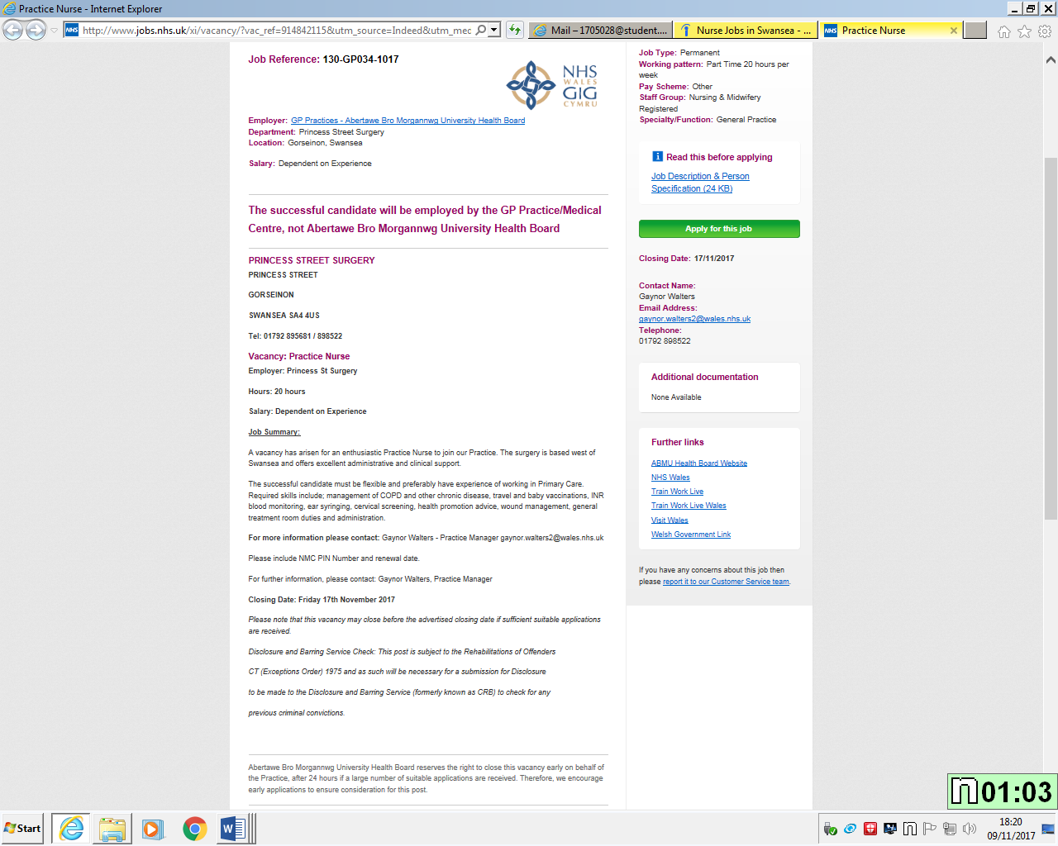

- Acknowledgements

I wish to thank my colleague at work who is a nurse Mr Amer Sahouri he has given me basic information and guidance regarding the nursing job. He has also motivated me to become a nurse in the future.
I would also like to thank the librarians and the lecturer Sian Harris who have helped me to understand the assignment and helped with Harvard referencing.

- References

References
Bill, T. (2012). Time Management For Todays Workplace Demands. Workplace health and safety, 01 May, 60(5), pp. 201-203.
Doyle, A. (2018). Organizational Skills List With Examples. [Online]
Available at: https://www.thebalancecareers.com/organizational-skills-list-2063762
[Accessed 18 07 2018].
Gallagher, K. (2013). Skills Development for Business and Management Students. second edition ed. Oxford: Oxford University press.
Mason, I. (2016). The Science Behind Wales Remarkable TeamWork. Wales: i News The Essential Daily Briefing.
Page, M. (2018). the importance of good communication. [Online]
Available at: https://www.michaelpage.co.uk/advice/management-advice/development-and-retention/importance-good-communication
[Accessed 18 07 2018].
UKEssays. (2013). Discussing the importance of Teamwork in Nursing. [online]. Available at: https://www.ukessays.com/essays/nursing/discussing-the-importance-of-teamwork-in-nursing-nursing-essay.php?vref=1
[Accessed 18 July 2018].

