MANAGEMENT THEORY

COSTEL GRIGOREAN

Developing Workplace Critical Thinking (BMSW5101_SWAN)

S. KHAN
University of Wales
Trinity Saint David
Swansea
Date:26.03.2020

MANAGEMENT THEORY
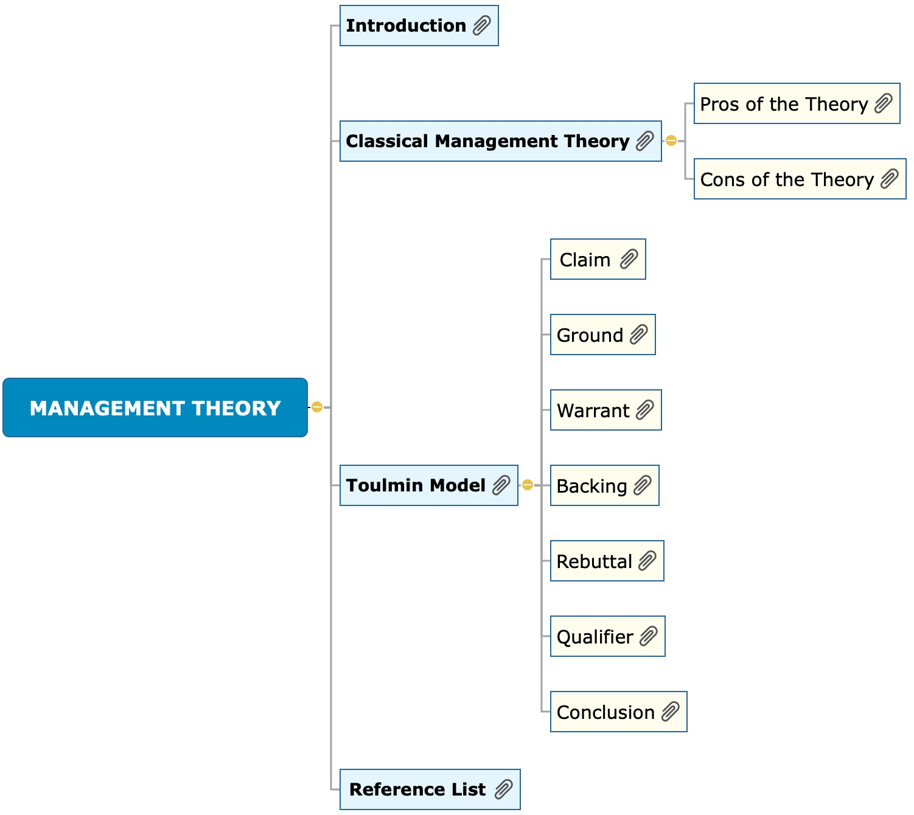
Introduction 3
Classical Management Theory 5
Pros of Theory 6
Cons of Theory 6
Toulmin Model 7
Claim 7
Ground 8
Warrant 8
Backing 9
Rebuttal 9
Qualifier 10
Conclusion 10
References 12

Introduction
Primark Company is in international business dealing with global supply chain whereby the company has accepted the responsibility to trade ethically. It has lived up to its values that are embedded on employees and its management. The company has more than a thousand suppliers in more than fifteen countries that points towards a huge management concern (Sulieman, 2019). It requires ethical responsibilities along the supply chain to fulfil its declarations in kits works practices and employment. Primark is renowned for being an international retailer that offers latest fashion, beauty and homeware at the best values on the high street.
The company opened its doors to customers in 1969 under the name Penny’s and currently operates over 370 stores in 12 countries across Europe and America. However, the country has faced controversies with trade unions and NGOs on human rights issues. Along the supply chain, it is believed the company has employed child labour to meet the high demands of their products which is on low costs of operations (Omalaja, and Eruola, 2011). The labour conventions contravene such conduct by organizations whereby the law requires the employment of human resource that can be paid the average wages. In addition, there has been alleged use of illegal immigrant labour whereby the worker is paid less than the legal minimum in the U.K. A company management is liable to ensure that they meet labour rights towards their workers while implementing their production. Changes in management have pre-empted the company to operate at the low-cost end of the market since it is popular with shoppers seeking the latest fashions items at modest prices.

Management Theories
Management takes place in a structured organizational setting whereby roles are directed to employees (Mahmood, Basharat, and Bashir, 2012). The aim is to achieve aims and objectives through influencing the efforts of others. Management theories are approaches which organizations run their directives based on the suitability of the model within their framework. A management theory suitable to Primark is based on their extensive activities and supply chain in changing fashion industry. Besides, it requires incorporation within the existing organisational structure. Hence, such considerations dwell on the division of work, authority of the administration, discipline, unity of command, centralisation and scaler tenure of personnel (Kitana, 2016). All these aspects have to be in line with an organisation to achieve the best output. However, management theories are not perfectly suitable in an organisational framework; hence there are weaknesses and strengths observed. Organisations require to motivate employees in their responsibilities to maximise output and commitment (Mena, Humphries, and Choi, 2013). Besides, allocation of company resources requires a comprehensive understanding of the company needs. Managers are an integral factor in the success of an organisation whereby management theories are significant in achieving a standard part of the business practices.
The workplace is changing dramatically with changes in management theories which require modern management (Huarng, and Ribeiro-Soriano, 2014). It is vital to note that management theories revolve around similar concepts whereby managers have to handle processes, people, and information and other similar duties. Primark management thrives on similar concepts whereby management model will require a theory to handle the responsibilities successfully. Management theories have an integral role in modern business practices.

Classical Management Theory
The theory focuses on operations and the creations of standards towards increasing production output (Martin, 2014). Compensation is considered the primary motivation for employees whereby the manager is focused on improving the output. Employees can improve their output when their human-related needs are met and remain motivated in the organisation. Rewards occur in form of improved and bonuses from their productivity. In addition, rewarding employees based on quantitative measures is significant to an organisation. Primark focuses on the fashion industry that experiences changes over time. The employees are executors of the strategies that the company operates within.
Classical management theory would imply a large quantity of supply is made based on clients will lead to rewards (Holt, and Ghobadian, 2009). Besides, in the production department, a higher number of quantitative outputs will lead to bonuses. It is not an easy task for a manager to keep employees motivated when their commitment remains low. The level of productivity should meet the motivation measures within the resources of the company. Primark requires a department that is concerned with creativity and innovation. The manager is liable to implement such changes through equipping employees with a frontier that regards improved creativity. The global competition and fashion will require adequate research which should be established too. The classical model implies that the manager remains in control of the success of a company. The success of Primark within the classical management theory is based on the ability of the company to make high sales of their product. It is possible when employees' creative aspect is rewarded and encouraged through motivation measures.
The classical theory is divided into three, but the relevant theory in line with Primark is administrative management theory. The theory is concerned about limiting the primary tasks of a manager and getting involved in the business itself (Harmon, Green Jr, and Goodnight, 2015). The manager of Primark has concerns on remaining relevant in the fashion industry that will require constant communication from the customers whereby the company ventures in low-cost end products. Thus, it is important to pay attention to the sources of the raw materials, operation costs and the production methods. The aim, in this case, is to achieve high profits within the low cost of production by utilising modern methods of production. However, the weakness of the model dwells on the limited roles of the manager.

Pros of Theory
A manager who requires the opinion of employees will be overlooked when it comes to the success of the company. Equipping employees within the classical model in their roles risks the company fall out when employees feel there are undervalued. Thus, employees have to be included in decision making in line with their curative aspects which is key to the company. The success of a company is based on the evaluation of the progress of the company towards its goals. A manager should ensure that supervisors meet the goals through the adjoining responsibilities of employees (Alexander, Walker and Naim, 2014). However, it is only possible with the correct measures of motivation and rewards. Global changes in the competition have prompted people to shift towards entrepreneurship which is the basis of the fashion industry. Dissatisfied employees leave a company to seek their interest elsewhere. Primark has a supply chain which requires large quantities of products. Failure to meet the latter by Primark risks customer loyalty. In addition, the theory stipulates that the company manager is the primary contact of success (Green Jr, and Nohria, 2009). Thus, decisions making, resource allocation and employee productivity are based on the manger. The success of the theory in Primark lies within a consultation with employees, equitable resource allocation for maximum productivity and high motivation towards the employee in order to achieve high responsiveness by consumers.

Cons of Theory
Classical management theory operates on formal structures that requires adherence of each department or levels. In the same way, the decision-making process is hindered due to the extensive consultation process (Ehiobuche and Tu, 2012). There is limited attention to human needs concerning the employees as the general interest is based on market demand. Remuneration is limited, especially when the company is concerned about meeting the market demand along the supply chain. High investments go to the production processes. Employees feel low sensitivity of their needs by the management. When there are problems relating to the employees, they are addressed within the organizational structure, which may take time for a comprehensive decision to be made. Primark is a large organisation which cannot cover employees' needs as required; hence they may feel alienated and lead to changed behaviour that may affect production patterns (French et al., 2009). The company has to deal with employee labour issues that require high consultation and may affect employees' ability to stay committed. As a result, employees may not operate on contractual agreement; hence the company uses the available labour force like illegal immigrants whom they pay wages below the average requirement. Thence, classical management theory requires high coordination of supervisors and top management in achieving the set goals. Besides, it requires a manager to pass down the requirements often to ensure productivity is achieved over time.

Toulmin Model
A company analysis requires comprehensive coverage of all aspect of administration activities. Toulmin model aims to achieve an effective way of getting to the how and why levels of the outcome of the analysis (Raduan et al., 2009). The arguments about Primark will be carried out into six basic parts which will focus on support and analysis against the argument. These aspects include a claim, evidence, warrant, backing, counterargument and qualifier. Since it is a framework that is testing the validity of the latter, the outcome will indicate the effectiveness of the model. Besides, the Toulmin Model will assess the problems in Primark Company and provide solutions within the management scope.

Claim
Primark Company has been violating the labour laws by employing children and immigrants in the company. The trade unions have been in constant contact with the company to abolish child abuse and enforce labour rights to employees. Besides the company has been employing school leavers who also face the payment of below-average minimum wage according to U.K. labour laws. It affects the company marketing, which implies that the company does not uphold the law. Such a large institution in the fashion industry needs to invest in growth in its products which will require regulations by trade unions in meeting the required standards. The availability of opportunities for school dropouts encourages students to seek employment instead of pursuing education.

Ground
Employment agencies require skilled personnel to work in large institutions such as Primark. In their hiring process, they will require presentation of educational background backed up by evidence of experience (Saxena, 2019). The poor state of management in Primark can be viewed by the company's audacity to employ children in their supply chain line as a form of cheap labour to supplement their increased market demand. The law requires that companies meet trade union and labour laws in their production and employment process. However, Primark must have observed the loopholes in the law to implement child labour and immigrants on low wages, which would improve their profitability. As a result, the company focused on profits and violated the law, which led to stage up the company to the law.

Warrant
The dire need to stay in the production while the market wage rate increased prompted the company to seek cheap labour. Also, skilled labour requires salary remuneration and rewards, which is an additional cost to the company (Blomquist et al., 2010). The market demand has to remain steady over time and production process will be imperative to the company. Low-cost end prices of goods must be maintained by hiring a significant number of children in Bangladesh for the production process of clothing. It resulted in children seeking employment rather than education. Inadequate economic income in Bangladeshalso was an opportunity for the children to take of their families. A salary that was considerably stable while working for Primark indicated that their families would look up to the income for their basic needs. Besides, immigrants require o meet their necessities which makes them a target towards cheaplabour.

Backing
Growth in demand of a growing population in more than fifteen countries warrants increased production. In this concern, Primark is concerned with the production of fashions products for consumers whose preferences and low-cost items. Hence, the returns are based on low purchase power of consumer; hence the quantities have to be available in large quantities. Such large distributions achieve the returns for the company (Cucchiella et al., 2012). Employing skilled and qualified individuals will lead to a high demand for income which remains unsustainable for the company based on large bulks of clothing to be produced. Thus, there was an opportunity to remain in the market by utilisation of cheap labour which was consistently available for the production process. The wages were within the company budget, which enabled Primark to utilise large numbers of personnel for the latter.

Rebuttal
The agencies liable to implement labour laws in organisations have failed. The process of hiring of the outlawed immigrants and children would have been identified by labour laws representative in the company (Ascaniis, 2012). Besides, the company seems to operate through inadmissible localities whereby monitoring of employees would have noted a large number of children moving into such factories. Thus, the law is also relentless in observing the law in companies. Immigrations offices are established at customs offices with the help off border securities. A large number of immigrant’s flock large companies which affect the wage rate and increase unemployment of qualified and experienced individuals. It shows the relenting nature of the law in concern with the immigration of people into the U.K.

Qualifier
Labour laws should be strengthened to ensure that employee registration is met by companies in ensuring they reduce child labour. Besides, it is also important that immigration offices observe a large number of immigrants in the country that is affecting workers employment opportunity (Bell and Martin, 2012). In the end, laws that will improve workers unions towards employment is vital. It will increase the frontier of employees in production by being adherent of their rights whereby they should have pointed out the illegalities.

Conclusion
Compensation is considered the primary motivation for employees whereby the manager is focused on improving the output. Employees can improve their output when their human-related needs are met and remain motivated in the organisation. Rewards occur in form of improved and bonuses from their productivity. Besides, rewarding employees based on quantitative measures is significant to an organisation. Primark focuses on the fashion industry that experiences changes over time. The employees are executors of the strategies that the company operates within. Classical management theory would imply that a large quantity of supply made based on clients will lead to rewards. Besides, in the production department, a higher number of quantitative outputs will lead to bonuses. It is not an easy task for a manager to keep employees motivated when their commitment remains low. The level of productivity should meet the motivation measures within the resources of the company.
The success of a company is based on the evaluation of the progress of the company towards its goals. A manager should ensure that supervisors meet the goals through the adjoining responsibilities of employees. However, it is only possible with the correct measures of motivation and rewards. Global changes in the competition have prompted people to shift towards entrepreneurship which is the basis of the fashion industry. Dissatisfied employees leave a company to seek their interest elsewhere. Remuneration is limited, especially when the company is concerned about meeting the market demand along the supply chain. High investments go to the production processes. Employees feel low sensitivity of their needs by the management. When there are problems relating to the employees, they are addressed within the organisational structure, which may take time for a comprehensive decision to be made.

References
Alexander, A., Walker, H. and Naim, M., 2014. Decision theory in sustainable supply chain management: A literature review. Supply Chain Management: An International Journal.
Ascanius, S.D., 2012. Criteria for designing and evaluating argument diagramming tools from argumentation theory. Educational technologies for teaching argumentation skills, pp.3-27.
Bell, R. and Martin, J., 2012. The relevance of scientific management and equity theory in everyday managerial communication situations. Journal of Management Policy and Practice, 13(3).
Blomquist, T., Hällgren, M., Nilsson, A. and Söderholm, A., 2010. Project-as-practice: In search of project management research that matters. Project Management Journal, 41(1), pp.5-16.
Cucchiella, F., Koh, L., Walker, H. and Jones, N., 2012. Sustainable supply chain management across the U.K. private sector. Supply Chain Management: An International Journal.
Ehiobuche, C. and Tu, H.W., 2012. Towards the relevance of classical management theories and organisational behaviour. ASBBS Proceedings, 19(1), p.310.
French, B., Thomas, L.H., Baker, P., Burton, C.R., Pennington, L. and Roddam, H., 2009. What can management theories offer evidence-based practice? A comparative analysis of measurement tools for organisational context. Implementation Science, 4(1), p.28.
Green Jr, S.E., Li, Y. and Nohria, N., 2009. Suspended in self-spun webs of significance: A rhetorical model of institutionalisation and institutionally embedded agency. Academy of Management Journal, 52(1), pp.11-36.
Harmon, D.J., Green Jr, S.E. and Goodnight, G.T., 2015. A model of rhetorical legitimation: The structure of communication and cognition underlying institutional maintenance and change. Academy of Management Review, 40(1), pp.76-95.
Holt, D. and Ghobadian, A., 2009. An empirical study of green supply chain management practices among U.K. manufacturers. Journal of Manufacturing Technology Management.
Huang, K.H. and Ribeiro-Soriano, D.E., 2014. Developmental management: Theories, methods, and applications in entrepreneurship, innovation, and sensemaking. Journal of Business Research, 67(5), pp.657-662.
Kitana, A., 2016. Overview of the managerial thoughts and theories from the history: classical management theory to modern management theory. Indian Journal of Management Science, 6(1), p.16.
Mahmood, Z., Basharat, M. and Bashir, Z., 2012. Review of Classical Management Theories. International journal of social sciences & education, 2(1).
Martin, X., 2014. Institutional advantage. Global Strategy Journal, 4(1), pp.55-69.
Mena, C., Humphries, A. and Choi, T.Y., 2013. Toward a theory of multi‐tier supply chain management. Journal of Supply Chain Management, 49(2), pp.58-77.
Nhema, A.G., 2015. The relevance of classical management theories to modern public administration: A review. Journal of Public Administration and Governance, 5(3), pp.165-179.
Omalaja, M.A. and Eruola, O.A., 2011. Strategic management theory: Concepts, analysis and critiques concerning corporate competitive advantage from the resource-based philosophy. Economic analysis, 44(1-2), pp.59-77.
Raduan, C.R., Jegak, U., Haslinda, A. and Alimin, I.I., 2009. Management, strategic management theories and the linkage with an organisational competitive advantage from the resource-based view. European Journal of Social Sciences, 11(3), pp.402-418.
Saxena, N., 2019. An Overview of Classical Management Theories. BICON-2019, p.173.
Sulieman, M.S., 2019. Roots of Organisational Knowledge in Classical Management Theories: A Literature Review. International Journal of Business and Social Science, 10(10).

