

Alun Morris

UWTSD Swansea
ACDA 5023 – Nuclear Safety
Assignment H
Provided by HMS Sultan

Abstract
This report analyses a radiation incident at a research materials irradiation facility involving a cobalt-60 sealed source. A mechanical fault caused the source carrier to stop short of its fully shielded position, resulting in a maintenance technician being exposed to a higher-than-expected gamma radiation field. The report uses the cobalt-60 half-life, specific gamma-ray dose constant, inverse square law and reconstructed shielding factors to estimate the dose received by the technician. The calculated effective dose was approximately 17.3–41.2 mSv, which was consistent with the 34 mSv recorded by the technician’s electronic personal dosemeter (EPD). The thermoluminescent dosemeter (TLD) recorded 46 mSv, with the difference requiring further consideration due to the TLD being incorrectly positioned. The health implications, compliance with the Ionising Radiations Regulations 2017 and the event against relevant ONR Safety Assessment Principles are discussed. The report concludes that weaknesses in defence in depth and engineered safety barriers allowed the mechanical fault to progress into a personnel exposure. Recommendations are proposed to improve source interlocking, radiation monitoring, maintenance, operating procedures and safety culture in order to reduce the risk to ALARP.

Contents
Abstract 2
1 Introduction 4
1.1 Report outline 4
1.2 Cobalt-60 sealed source 4
1.3 The Irradiator 4
2 Technical exposition 5
2.1 Cobalt-60 Decay 5
2.2 Radioactive Decay (Half-life) 6
2.3 Inverse Square Law and Point Source Dose Rate 7
2.4 Radiation Attenuation 8
2.5 Dose Quantity 9
2.5.1 Absorbed Dose 9
2.5.2 Equivalent Dose 10
2.5.3 Effective Dose 10
2.5.4 Dose Rate 11
3 Case analysis – narrative of the incident and dose reconstruction (see annex A for detailed calculations) 11
3.1 The Incident January 17th, 2025 11
3.2 Source Activity at the Time of the Incident 12
3.3 Unshielded Dose Rates 12
3.4 Dose During Initial Access Phase 13
3.5 Dose During Inspection Phase 13
3.6 Equivalent and Effective Dose 13
4 Discussion – interpretation of calculated doses and regulatory implications 13
4.1 Calculated vs. Recorded Doses 13
4.1.1 Health Implications 14
4.2 Regulatory implications 14
4.3 Safety Assessment Principles (SAPs) 15
5 Recommendations 16
6 Conclusion 17
7 References – Harvard style 18
8 Annex A – detailed calculations 19
8.1 Source Activity calculation 19
8.2 Unshielded dose rates 19
8.3 Dose during Initial Access Phase 20
8.4 Dose During Inspection Phase 20
9 Annex B – supplementary material 21
9.1 Radiation Weighting Factors 21
9.2 ‌Tissue Weighting Factors 22
9.3 EKP.3 Defence in Depth table 22

Introduction

Report outline
This report will discuss an incident at a research materials irradiation facility that occurred on January 17th, 2025, resulting in a maintenance technician receiving a higher-than-expected radiation dose. The report includes an explanation of the dose calculations relevant to this incident, the health implications of the exposure, an assessment of compliance with the Ionising Radiations Regulations 2017 (IRR 2017) and relevant Office for Nuclear Regulation (ONR) requirements, and proportionate improvements that could be made in accordance with ALARP (as low as reasonably practicable) principles.

Cobalt-60 sealed source
The facility used cobalt-60 sealed source pencils arranged in a cylindrical carrier rack. Cobalt-60 is commonly used in sealed-source irradiators due to its high specific activity. Activity is defined as the rate at which radioactive nuclei undergo decay and is measured in becquerels (Bq), while specific activity is the activity per unit mass. Cobalt-60 decays by beta decay to nickel-60, emitting two high-energy gamma photons (1.17 MeV and 1.33 MeV) which are highly penetrating. These characteristics make cobalt-60 well suited to sealed-source irradiators, as a high activity can be contained within a relatively small source while the penetrating gamma radiation can effectively irradiate dense materials. The 5.27-year half-life also provides a practical balance between source longevity and radiation output.

The Irradiator
The following is a description of the Irradiator as provided in the incident report document:
“The irradiator comprises a heavily shielded irradiation cell with the source carrier mounted on a vertically translating mechanism. In normal operation, the source is returned to a fully shielded position within the irradiator base before access is permitted.”
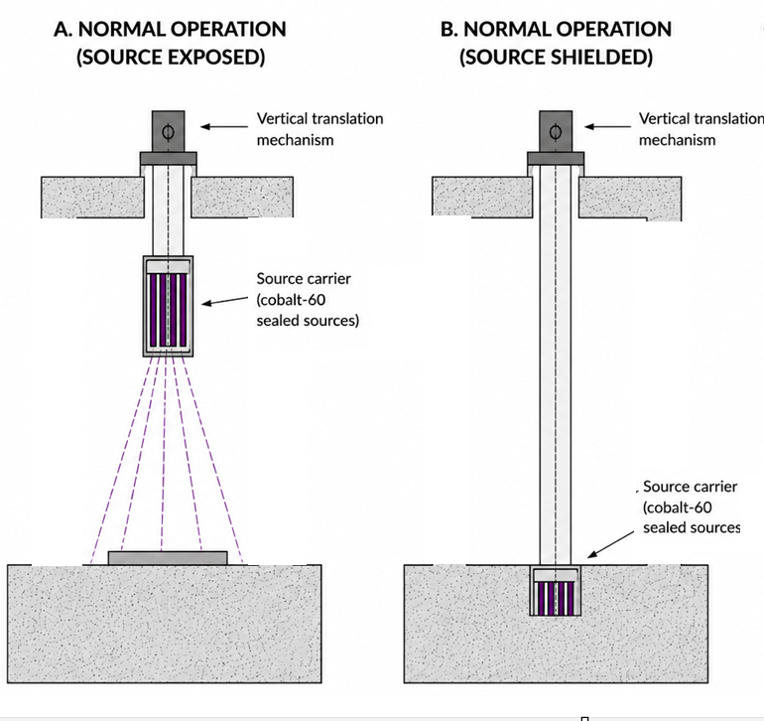
Figure 1: AI generated Vertical Irradiator Diagram

Technical exposition

Cobalt-60 Decay
As stated in the introduction, cobalt-60 undergoes beta-minus decay where one of its neutrons transforms into a proton, emitting an electron (beta particle) and an antineutrino and forming nickel-60. The resulting nickel-60 nucleus is initially in an excited state and releases this excess energy through the emission of two high-energy gamma photons (1.17 MeV and 1.33 MeV).
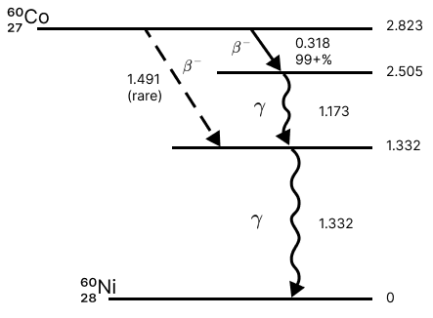)
Figure 2: Cobalt-60 Decay (Ann, K. (2025). UCSB Physics.)
Although beta particles are emitted, they are not sufficiently penetrating to escape the cobalt-60 sealed source pencil casing (Charles, M.W., 2007). Therefore, the calculations relevant to this report will only include the highly penetrating gamma radiation.

Radioactive Decay (Half-life)
The number of unstable nuclei in a radioactive isotope decreases exponentially over time. The activity of the source at the time of the incident was not supplied and therefore needs to be calculated using the radioactive decay law (LibreTexts, 2016).
$$A=A_{0}e^{-λt}$$
Equation 1: Radioactive Decay Law – Activity
Where:
A = Activity
A₀ = Initial Activity
λ = decay constant
t = time

Inverse Square Law and Point Source Dose Rate
The dose rate from a point source can be estimated using the following equation:
$$D=\frac{ΓA}{d^{2}}$$
Equation 2: Dose rate of a point source
Where:
D = Dose rate
Γ = Specific Gamma-Ray Dose Constant
A = Acitivty
d = Distance
For this report the specific gamma-ray rate constant of Co-60 will be referenced from computed ICRP 107 gamma and x-ray emission data and ICRP 116 dose coefficients, with units of mSv h⁻¹ MBq⁻¹ contained within the Osti.gov. (2017). Specific Gamma-Ray Dose Constants with Current Emission Data [online]. The rate constants for isotopes in the Osti document were calculated at 1 metre from the source.
The inverse square law states that radiation intensity, including dose rate, is inversely proportional to the square of the distance from a point source. Therefore, once the dose rate at 1 metre has been identified, the inverse square law can be used to estimate the dose rate at different distances from the source.
$$I ∝ \frac{1}{d^{2}}$$
Equation 3: Inverse Square Law
Where:
I = Intensity
∝ = proportional to
d = distance

Radiation Attenuation
Despite being highly penetrating, gamma radiation is attenuated as it passes through matter. Attenuation is the reduction in radiation intensity due to interactions between gamma-ray photons and the shielding material, principally through absorption and scattering. Dense materials such as lead, steel and reinforced concrete provide high levels of attenuation and are therefore used as biological shielding to reduce external radiation dose.
The reduction in radiation intensity due to shielding can be calculated using the exponential attenuation equation when the shielding material, its thickness and its linear attenuation coefficient are known. Alternatively, when the number of half-value layers (HVLs) is known, attenuation can be calculated using the HVL equation.
Gamma-ray photons also undergo Compton scattering within shielding material. During this interaction, a gamma photon transfers part of its energy to an electron and is deflected with reduced energy. This contributes to a complex radiation field that can be difficult to model accurately (Malcolm C. et al., 2004).
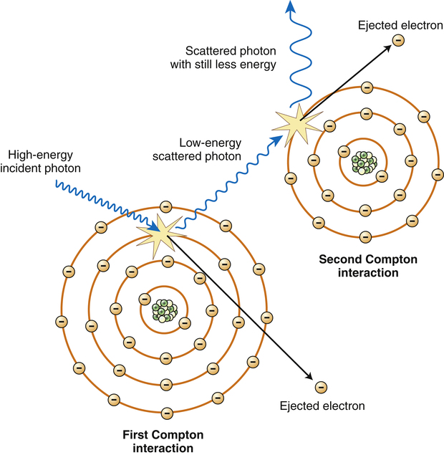
Figure 3: Compton Scattering (Image from radiologykey.com)
For the purposes of this report, the attenuation values determined during the post-incident reconstruction are used directly. The reconstructed radiation field was estimated to be 8–14% of the nominal unshielded dose rate at 1.8 m and 12–18% at 0.8 m. These attenuation factors are assumed to incorporate the effects of shielding geometry, source positioning and scattered radiation.

Dose Quantity
The ICRP uses absorbed dose as the fundamental physical quantity from which equivalent dose and effective dose are derived. Weighting factors are then applied to account for differences in biological effects between radiation types and sensitivities between tissues (ICRP 103).

Absorbed Dose
Absorbed dose is the amount of energy imparted by ionising radiation per unit mass. Its SI unit is J kg⁻¹, known as the Gray (Gy).
$$D= \frac{\overline{ε}}{m}$$
Equation 4: Absorbed Dose
Where:
D = Absorbed Dose
ἐ = Mean energy imparted
m = Mass

Equivalent Dose
The Equivalent Dose is the average absorbed dose of a specific type of radiation to a specific organ or tissue. Types of radiation and specific organs or tissue has their own weighting factors which can be seen in their corresponding tables in Annex B. The SI unit for Equivalent dose is J Kg⁻¹ and are called Sievert (Sv) (ICRP103).
$$H_{T}= \sum_{R}{w_{R}D_{T,R}}$$
Equation 5: Equivalent Dose
Where:
H_{T} = Equivalent Dose
R = Type of radiation
W_{R} = Radiation Weighting Factor
D_{T,R} = Average Absorbed Dose in the volume of specific organ or tissue due to the type of radiation

Effective Dose
Effective dose accounts for differences in the sensitivity of organs and tissues to stochastic health effects.
$$E= \sum_{T}{w_{T}H_{T}}$$
Equation 6: Effective Dose
Where:
E = Effective dose
W_{T} = Tissue Weighting Factors
H_{T} = Equivalent dose

Dose Rate
Dose rate is the rate at which ionising radiation dose is received and is commonly expressed in mSv h⁻¹. Dose is related to dose rate and exposure time by:
$$Dose Rate= \frac{Dose}{Time}$$
Equation 7: Dose Rate

Case analysis – narrative of the incident and dose reconstruction (see annex A for detailed calculations)

The Incident January 17th, 2025
During the week prior to the incident, the irradiator was placed in maintenance test mode to investigate hesitation in the downward travel mechanism. Wear debris and slight misalignment in the carrier assembly were also noted, increasing the likelihood of the source failing to become fully seated in the shielded position.
On the day of the incident, the irradiator had not returned to a fully shielded position but had been left in maintenance mode. Staff misinterpreted the system information as a routine error and authorised access to the maintenance vestibule.
A supervisor carried out a gamma survey in the concrete labyrinth and obtained a reading of approximately 8 µSv h⁻¹. A maintenance technician then entered the vestibule, unaware that the irradiator was not fully shielded. The technician's EPD alarmed at 100 µSv h⁻¹ while moving through the labyrinth. Due to a blocked ear, the technician initially did not identify the source of the alarm and only withdrew after noticing the flashing indicator on the EPD.
Post incident reconstruction indicated the following for the technician:
Initial access phase
- Inside maintenance Vestibule for approximately 70 - 100 s
- Torso distance from source 1.8 m
- Shielding at this distance provided approximately 8–14% of the nominal unshielded dose rate.
Close inspection phase
- Approximately 8 - 12 s
- Torso distance from source 0.8 m
- Shielding at this distance provided approximately 12–18% of the nominal unshielded dose rate.

Source Activity at the Time of the Incident
Around 6 years since the initial certified activity of 140 TBq.
Approximate activity on at the time of incident = 63.6 TBq.

Unshielded Dose Rates
At 1 metre = approximately 19.4 Sieverts per hour.
At 1.8 metres using inverse square law = approximately 6 Sieverts per hour.
At 0.8 metres using inverse square law = approximately 30.3 Sieverts per hour.

Dose During Initial Access Phase
Because the technician was in this phase for between 70 and 100 seconds with between 8% and 14% of the nominal dose rate a minimum and maximum estimation have been calculated. The same approach will be used for the inspection phase.
Minimum Dose = 9.3 mSv
Maximum Dose = 23.2 mSv

Dose During Inspection Phase
Minimum Dose = 8 mSv
Maximum Dose = 18 mSv

Equivalent and Effective Dose
It can be reasonably assumed that the technician received the gamma radiation dose to their entire body therefore the absorbed (Gy), equivalent (Sv) and the effective (Sv) dose can be calculated using the weighting factor of 1.
Sum of both phases minimum effective dose = Approximately 17.3 mSv
Sum of both phases maximum effective dose = Approximately 41.2 mSv

Discussion – interpretation of calculated doses and regulatory implications

Calculated vs. Recorded Doses
Post-incident dosimetry indicated an EPD dose of 34 mSv, an EPD peak dose rate of 3.2 Sv h⁻¹ and a TLD dose of 46 mSv. The EPD dose falls within the reconstructed dose range of approximately 17.3–41.2 mSv, while the peak dose rate is close to the reconstructed minimum dose rate at 0.8 m of 3.64 Sv h⁻¹.
The TLD result is approximately 4.8 mSv above the maximum reconstructed dose. However, the technician was wearing the TLD at waist level rather than at the chest/torso position. This introduces additional uncertainty because the radiation field was spatially non-uniform. Further investigation could therefore include a more detailed assessment of the cylindrical source geometry, a reassessment of the shielding attenuation, confirmation of the technician's exposure time and verification that elevated radiation levels were not present elsewhere in the labyrinth.

Health Implications
The reconstructed and recorded doses of approximately 17.3–46 mSv are below the levels normally associated with acute radiation effects such as skin reddening, burns or acute radiation syndrome. The main health implication is therefore an increase in stochastic risk, particularly the lifetime risk of radiation-induced cancer. Using the ICRP 103 risk coefficient of 4.2% per Sievert for adult workers, the exposure represents a less than 1% increase in lifetime cancer risk. Although this increase is relatively small, the exposure remains significant from a radiological protection perspective.

Regulatory implications
The annual effective dose limit according to IRR 2017 for an employee is 20 mSv annually. The technician surpassed the annual dose limit during the incident. According to regulation 24. Dosimetry for accidents etc for any person receiving an ionising radiation equivalent dose greater than 15 mSv caused by an accident the employer must arrange for a dose assessment from the approved dosimetry service and for a record to be kept for the assessment for at least 30 years (IRR 2017). According to the report the employer arranged for the service, and it was reported to the HSE in accordance with the regulations. For the technician to be able to continue working in an environment where they are exposed to ionising radiation after the incident the employer must then prove they have taken all the steps necessary to comply with IRR 2017 regulations 12 and 24.
Under the licence conditions (LC) set out by the Office for Nuclear Regulation (ONR) the licence could be audited for infractions against:
LC10: Training
as the operators were unaware of the error codes presented by the system during maintenance mode and although minor, technicians were not wearing their TLD correctly.
LC23/24: Operating Rules
Were appropriate operating instructions in place to safely assess that the maintenance vestibule was safe to enter. The location the supervisor took a gamma survey at which recorded 8 µSv h⁻¹ was likely not appropriate for forming a judgment involving the technicians safety.
LC27: Safety Mechanisms Devices and Circuits
Why was the technician able to enter the maintenance vestibule despite the system displaying errors? Furthermore, was the system safe despite the wear and tear on the carrier guide assembly.

Safety Assessment Principles (SAPs)
EKP.3 – Defence in Depth
Defence in depth requires multiple independent barriers to prevent faults progressing into accidents (ONR, 2014). The incident indicates that this principle was not adequately implemented. The mechanical failure of the source positioning system should have been contained by subsequent independent barriers, such as source-position indication, access interlocking and radiation monitoring. Instead, access depended on the operator correctly interpreting the system error and communicating the hazard to the technician.
EDR.1 – Engineering Principles: Design for Reliability
EDR.1 requires structures, systems and components to be designed to be inherently safe or fail in a safe manner, with potential failure modes identified where appropriate (ONR, 2014). The irradiator did not fail in a safe manner because the source could stop short of the fully shielded position while access remained possible. The previously identified wear and misalignment also suggest that the failure mode required greater consideration within maintenance and safety assessment arrangements.
MS.1 – Leadership and Management for Safety
MS.1 requires leaders to maintain high standards of safety and the characteristics of a high reliability organisation (ONR, 2014). The incident indicates weaknesses in training, communication and safety culture. Operators did not correctly interpret the maintenance-mode information, the supervisor's radiation survey was not representative of the technician's working position, and the technician's hearing problem was not identified as a factor affecting response to the EPD alarm.
Overall, the incident demonstrates weaknesses across engineering, procedural and human barriers rather than a single isolated equipment failure.

Recommendations
To reduce the risk of further incidents to As Low as Reasonably Practicable (ALARP), the recommendations are primarily focused on improving engineered barriers and reducing reliance on the human element.
- Prevent access to the maintenance vestibule unless the source is confirmed to be fully shielded - An independent interlock should prevent access following a source-position fault.
- Improve the irradiator design so that mechanical failure results in a safe condition - The source positioning mechanism should fail towards the fully shielded position and safety-significant components should be subject to appropriate inspection and preventative maintenance.
- Provide accurate source-position indication and fixed radiation monitoring - Clear visual indication of the physical source position and a fixed radiation monitor at the access point would provide independent confirmation of the radiation condition before entry.
- Improve SQEP and operating procedures - Operators and maintenance personnel should understand error codes, maintenance mode, radiation alarms and the actions required when an abnormal source position is indicated. Radiation surveys should also be carried out at locations representative of the technician's actual working position.
- Review safety culture and learning from experience - Personnel should understand the importance of reporting conditions that could affect safe working, such as impaired hearing, and should feel able to raise safety concerns. The incident should also be used to review similar irradiator systems for comparable failure modes.

Conclusion
The purpose of this report was to analyse a radiation incident involving a cobalt-60 sealed-source irradiator which resulted in a technician receiving a higher-than-expected dose of gamma radiation.
The dose reconstruction estimated an exposure of approximately 17.3–41.2 mSv, which is consistent with the EPD recorded dose of 34 mSv. The TLD recorded 46 mSv, with the difference likely requiring further investigation due to uncertainty in the reconstructed radiation field and the TLD being worn at waist level. The exposure is not expected to result in acute radiation effects, but it represents a significant occupational exposure and a small increase in lifetime stochastic risk.
The incident identified weaknesses in the facility's defence in depth, engineering reliability, operating arrangements and safety culture. The most significant finding is that the mechanical failure of the source positioning system was not adequately contained by independent safety barriers, allowing access while the source remained incompletely shielded.
The current arrangement is therefore unlikely to demonstrate ALARP. Independent source-position interlocking, fail-safe source positioning, improved radiation monitoring, preventative maintenance, improved operating procedures and stronger safety culture would reduce reliance on human intervention and reduce the likelihood and consequences of a similar incident.

References – Harvard style
Malcolm C, Peter M, Nobuhiro S, Nobuhiko S, and Arun B (2004). X-ray Compton Scattering. OUP Oxford. [online] p22,23.

, K. (2025). UCSB Physics. [online] Ucsb.edu. Available at: https://ilg.physics.ucsb.edu/Courses/20/20CL/index.html?linkfile=RA20CL [Accessed 18 July 2026].

Charles, M.W. (2007). ICRP Publication 103: Recommendations of the ICRP. Radiation Protection Dosimetry, [online] 129(4), pp.500–507. doi:10.1093/rpd/ncn187.

Radiacode.com. (2025). Cobalt-60. [online] Available at: https://www.radiacode.com/isotope/co-60?lang=en [Accessed 17 July 2026].

LibreTexts (2016). 10.4: Radioactive Decay. [online] Physics LibreTexts. Available at: https://phys.libretexts.org/Bookshelves/University_Physics/University_Physics_(OpenStax)/University_Physics_III_-_Optics_and_Modern_Physics_(OpenStax)/10%3A__Nuclear_Physics/10.04%3A_Radioactive_Decay [Accessed 18 July 2026].

Osti.gov. (2017). Specific Gamma-Ray Dose Constants with Current Emission Data [online] Available at: https://www.osti.gov/pages/servlets/purl/1607209 [Accessed 22 July 2026].

Chapter 5 Slide 1 H-117 -Introductory Health Physics External Dose Calculations. (n.d.). [online] Available at: https://www.nrc.gov/docs/ML1121/ML11210B521.pdf [Accessed 22 July 2026].

UK Government (2017) Ionising Radiations Regulations 2017, SI 2017/1075. [online] Available at: https://www.legislation.gov.uk/uksi/2017/1075 (Accessed: 17 July 2026).

ONR (2017). Licence condition handbook the standard licence conditions attached to nuclear site licences. [online] Available at: https://www.onr.org.uk/media/gixbe2br/licence-condition-handbook.pdf [Accessed 23 Aug. 2026].

ONR (2014). SAFETY ASSESSMENT PRINCIPLES FOR NUCLEAR FACILITIES. [online] Available at: https://www.onr.org.uk/media/pobf24xm/saps2014.pdf [Accessed 23 Aug. 2026].

Annex A – detailed calculations

Source Activity calculation
Initial activity = 140 TBq
Cobalt-60 T_{1/2} = 5.27 years
λ = ln(2) / 5.27 = 0.1315
A = 140e^{-(0.1315)*(6)} = 63.5 TBq

Unshielded dose rates
Cobalt-60 – Gamma rate constant = 3.062 × 10⁻⁴ mSv h⁻¹ MBq⁻¹
Activity = 63.5 x 10⁶ MBq
Distance = 1m
D = (3.062 x 10⁻⁴) * (63.5 x 10⁶) = 19444 mSv h⁻¹
19.4 Sv h⁻¹
Distance = 1.8m
19.4 * (1/1.8)² = 6 Sv h⁻¹
Distance = 0.8m
19.4 * (1/0.8)² = 30.3 Sv h⁻¹

Dose during Initial Access Phase
Minimum shielding
Dose rate = 6 * 0.08 = 0.48 Sv h⁻¹
Maximum shielding
Dose rate = 6 * 0.14 = 0.84 Sv h⁻¹
Initial access phase dose rate range = 0.48 – 0.84 Sv h⁻¹ (480 – 840 mSv h⁻¹)
Convert seconds to hours
70 seconds = 70/3600 = 0.0194 hours
100 seconds = 100/3600 = 0.0277 hours
Calculate the Dose
Minimum Dose = 0.48 * 0.0194 = 0.0093 Sv = 9.3 mSv
Maximum Dose = 0.84 * 0.0277 = 0.0232 Sv = 23.2 mSv

Dose During Inspection Phase
Minimum shielding
Dose rate = 30.3 * 0.12 = 3.64 Sv h⁻¹
Maximum shielding
Dose rate = 30.3 * 0.18 = 5.45 Sv h⁻¹
Initial access phase dose rate range = 3.64 – 5.45 Sv h⁻¹ (3640 – 5450 mSv h⁻¹)
Convert seconds to hours
8 seconds = 8/3600 = 0.0022 hours
12 seconds = 12/3600 = 0.0033 hours
Calculate the Dose
Minimum Dose = 3.64 * 0.0022 = 0.008 Sv = 8 mSv
Maximum Dose = 5.45 * 0.0033 = 0.018 Sv = 18 mSv

Annex B – supplementary material

Radiation Weighting Factors
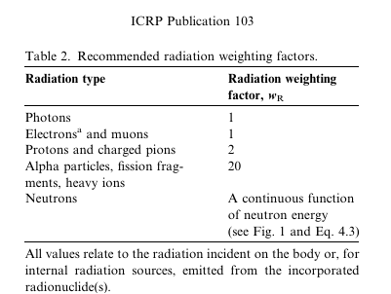

‌Tissue Weighting Factors
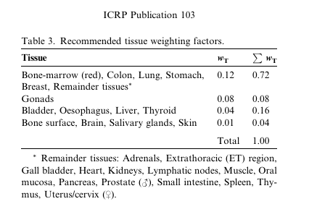

EKP.3 Defence in Depth table


