The Global Business Environment
Assignment 1

Student: Ionut Aurelian Stanciu
Student id: 2219322
Module code: LCBB4005
Lecturer: Nadeem Mirza

Table of Contents
Introduction 1
Brief introduction of the business 2
Globalization 3
Strategy 4
SWOT analysis 5
PESTLE analysis 6
Conclusion 7
References 8

Introduction:
Kapoor, (2019) agrees that business environment is a comprehensive account for the Fourth Industrial Revolution that apprehends current shifts in the global environment.
The purpose of this essay is to identify the best strategies for a business in order to become global, to identify the treats, opportunities, and everything else we need in order for the business to succeed in the developing country. To identify all the factors, we need the PESTLE analysis and SWOT analysis also, to be used in this paper.
For this paper I have chosen to use a logistic company that is based in the UK, to be globalised in Romania. Furthermore, in this paper will be a short introduction of the business and where the idea for globalisation the company came from. Why do I believe that the logistic company will be success among globalisation, the steps the challenges that must be overcome, and if is cost effective to globalise it.

Business introduction:
The logistic company was founded in 2017 in London, at first the business started providing logistic services for other small companies. Due to the high demand from other companies the business grew from a man with a van, and it became a man with a lorry and as the time passed by the business flourished, being extremely popular and high demands of our services. However, at first the business did not have a plan in place for services, it was just delivery from point A to point B. Now being immensely popular the business also had to upgrade the services for the customers making sure that our customers are fully satisfied and use our services again every time. The business now provides logistics consulting, making sure that the goods are stored properly prior and after transportation, arrangements for road permits, and distribution management. However, it will not stop here and upgrades to the policy and services will become available for our customers satisfaction and requirements. The idea of globalising the logistic company came after I discussed with some of my fellow Romanian friends who already have a logistic company running in Romania and across Europe.

Globalization:
According to Worthington and Britton, (2009) globalisation does not have only one definition; however, it is used to describe the process of incorporation on a worldwide scale of markets and production.
Moreover, the authors believe that the globalisation is changing, as we can see how the economy has been affected after Brexit and it is changing continuously due to changes around the world, such as the war.
On the other hand, Motohashi, (2015), believes that the AAA framework is a particularly effective way to explain the globalisation of a company. 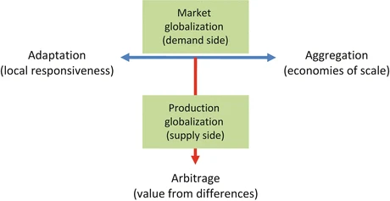
A business must have a perfect balance for national and regional market differences.
Furthermore, the author believes that the research and development (R&D) framework it is highly effective to indicate the three basic areas such as acquiring, production, and offshore development. Furthermore, the author believes that it is essential for the R&D to incorporate advanced technology from overseas marketing. 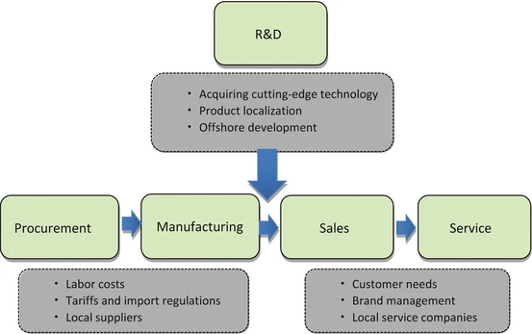

Furthermore, Jansson and Sandberg (2008), define the globalization as a procedure of unification and interconnection people, processes, government, and businesses of different nations.
To globalise a logistic company is not easy, there are many steps to be followed and barriers to overcome. Especially that UK is not longer part of the Europe, there will be challenges and threats, however after a brief calculation and analysing the cost of having a logistic company in Romania and in UK it is worth the risk.
The authors claims that economically national boundaries are not important, due to the free trade and movement of labour results in the disintegration of these boundaries.
The term of globalization has become rather popular among business, even if the company is large or small, shareholders tend to want to achieve more, and expand on a larger scale.
In order for the logistic company to thrive in UK as well as in Romania there must be certain steps to be followed and strategies in place.

Strategy:
Motohashi, (2015), agrees that management strategies increase the value of any company. Collective strategy focuses on mid-to-long term path of action and important partners. Mid-to-long term it is used as part of the company strategy because it justifies for the integration of the business activities for a distant future.
Furthermore, the author believes that strategy for a company is the plan that helps achieving the objectives. Moreover, the objectives of a business are what a business tends to achieve in a timespan. Usually, the objectives are announced for a longer period, and most of the objectives are the same in many companies, such as revenue or company growth.
According to Johnson and Scholes, (2003), there is a direction and scope that an organisation must follow over long term to achieve advantages through its own resources while the environment is in a continuously change, so the organisation can meet the requirements and needs of the market and shareholders.
For a business to be successful after the globalization there, we must think creatively and use different marketing strategies. By using different marketing strategies, research of the market must be done. Why there must be different marketing strategies used as the ones on the UK? – since UK has different rules and costs when it comes to businesses, while in Romania other. As previously mentioned, the idea of globalising the logistic company in Romania came after few discussions with some of my fellow friends that have a logistic company in Romania and across Europe. With the information gained from them I could easily identify:
- the competitors,
- what the needs of the future customers are,
- know how to find potential suppliers and build relationships with them,
- Paperwork
- Costs and equipment
As previously seen the R&D framework it is incredibly important as well as the other technique tools that will be used in this paper to make the right decision for the company. A good strategy in place with the right technique tools and research will help the board make the right decision when globalising the company is a ‘’GO’’.

A SWOT analysis is an exceptionally good technique tool to help us make the decision on the steps we must follow to have a successful merge of the company overseas. Motohashi, (2015), states that the SWOT analysis is an effective way to determine the management strategies needed for the company.
Strengths:
- It is a company based in the UK, meaning that there are fresh ideas on the Romanian market
- It already has a large scale of customers that operates worldwide also
- It is a brand-new company on the market, however, not new in the business
- New and modern equipment, it is what most customers are looking for their business
- It has the cost advantage and knowledges to merge a branch of the business overseas
- 24/h customer service, which many logistic companies do not offer
- Good marketing skills
- Exchange rate, £ is higher than Romanian currency LEU, meaning less £ to invest

Weaknesses:
- The company is UK-based, which means there must be someone trustworthy to rule the company overseas
- language barrier
- The competitors that are already on the market
- Exchange rate, £ is higher than Romanian currency, meaning there could be less profit

Opportunities:
- Meeting new people with fresh ideas
- Having the company developing its success not just in Romania, but in Europe as well.
- Attracting new shareholders

Threats:
- Competitors
- The merge of the company may be a bit difficult due to Brexit and the changing laws

In this SWOT analysis for this paper, we can see that the company success is over 90%, as the strengths are the top winners. However, we cannot go ahead and merge a company overseas by having this research only. We must look at the PESTLE factors also, among other.
Moreover, our company has the means, the costs advantage and the knowledge of what a logistic company needs. The cost advantage is that globalizing a business that is already successful in a country with higher costs, such as UK, in a country with cheaper, yet has one of the best, labour and equipment. It is helping the mother company to start the business in Romania with less costs which means can offer to the potentials customers effective and good quality services at a smaller rate than most of the competitors on the market. Due to the economical breakdown now days, everyone is looking for cheaper yet good services. This is what our logistic company will offer to our new customers, good quality services at a cheaper rate.
Below we have a figure by Worthington and Britton (2009), that helps us understand better the idea of a business organisation system: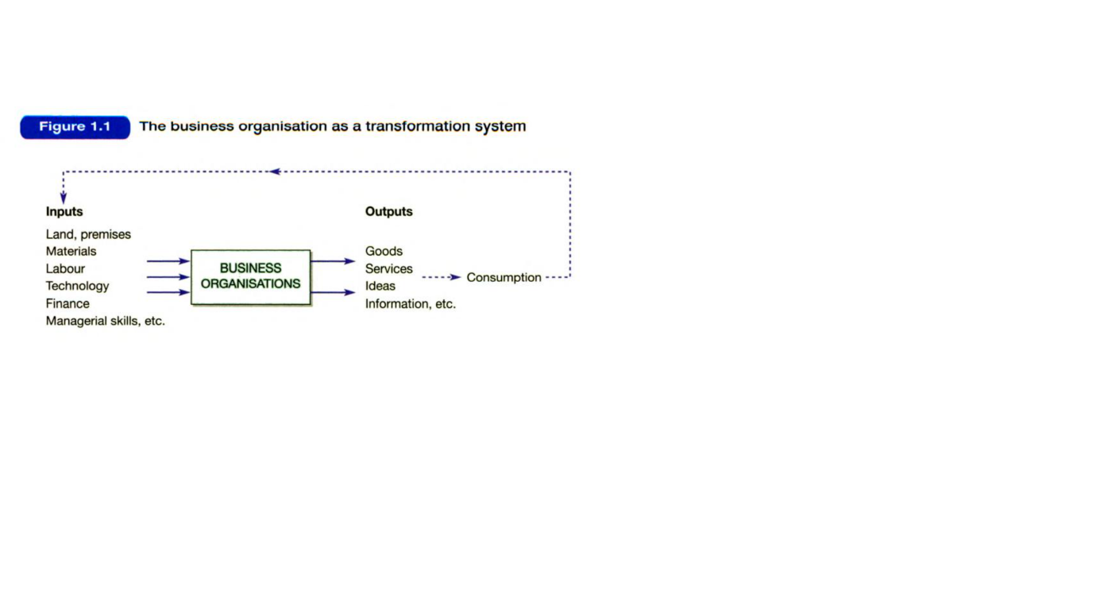

Worthington (2009), states that manufacturing business is diversly in many ways, however, they all have in common the transformation of the inputs into outputs. This process takes place in a background with an external environment that is complex, volatile, and interactive.

Furthermore, as mentioned earlier we must do a PESTLE analysis also, to get to know our chances of success when we start the globalisation of our organisation.

Gupta, (2013), sustains that the PESTLE analysis is one of the most used tools to evaluate the external company environment and it is highly dynamic.
Furthermore, from an online article on ‘’Google Scholar’’, we have a figure explaining the PESTLE analysis: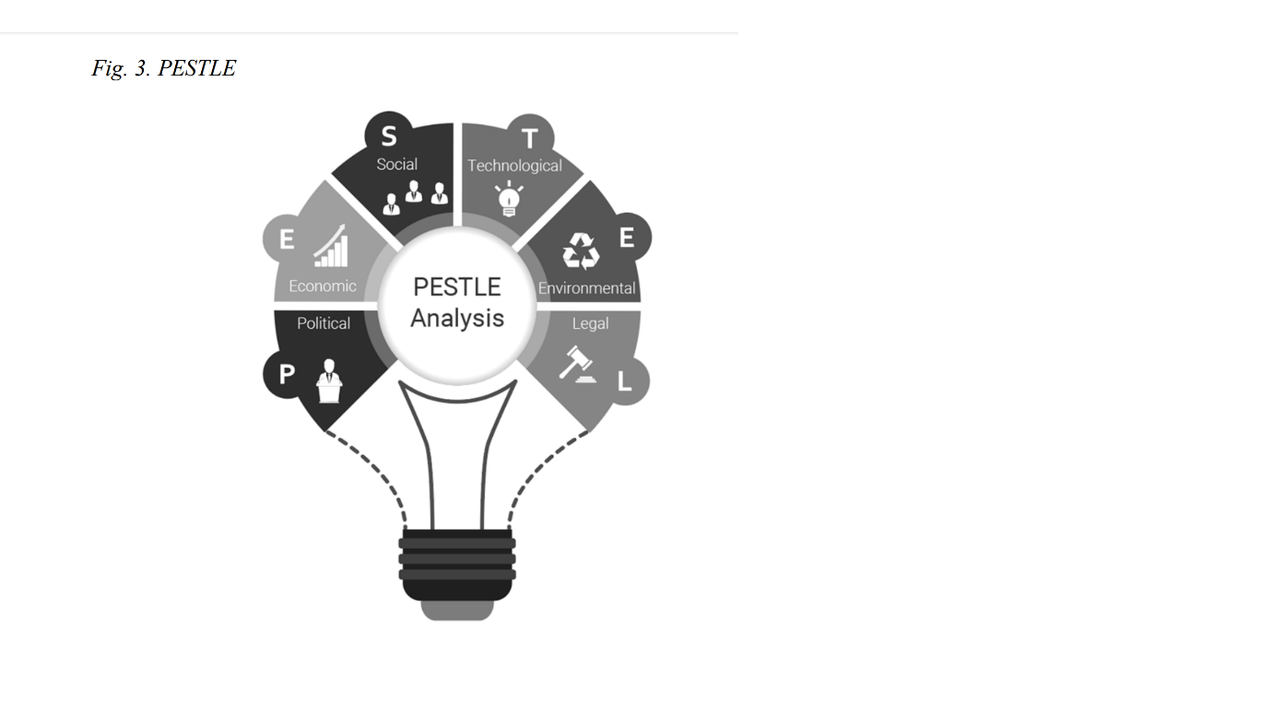

Political factors: -political environment according to Perera (2017), it is compelling to an organisation, especially when the business is foreign, like in our case, an established business in UK globalising to Romania, which makes the political support highly important for the organisation’s success.
The political factors involved in globalising to Romania our logistic company are the following:
- Taxes and regulations
- Import and export procedures
- Registration of the vehicles at RAR (Romanian Automotive Register)
- Compulsory employee benefits
- Trade and pricing regulation

Economic factors: - as the political factors are very important to our environment so are the economical factors. Perera (2017) agrees that economical factors are highly important for a business, especially a logistic business, as we must take in consideration every change at the income levels, taxes, rates, inflation, etc. moreover, if the economic environment it is favourable than the business’s success rate is higher.
- Taxes and regulations
- Labour wage
- Inflation and interest rate
- Economic growth
- Productivity
- The difference between the economic system from UK and Romania
- Infrastructure
- Exchange rates

Social factors: -Furthermore, Perera (2017), sustains that social factors are as important as the other factors. By deciding to globalise a company we must take in consideration the culture and ethical values of the chosen country. Moreover, for a business to thrive in a new country we should consider that the business environment is somehow connected to the cultural and traditional values of the respective country.
- Hierarchy and power in society
- Education
- Culture
- Religion and ethics

Technological factors: - the technological factors are usually important for companies based on technology; however, it is important to any business. For a logistic company is important to communicate with the customers and improve our services, due to the fact that technology has became a very important way of communication on the market, these days.
- Upgrade the system
- Communicate with customers, shareholders, and suppliers
- Research and improvement
- Automation

Environmental factors: - environmental factors are highly important, especially with our climate changing continuously and degrading. When opening a business every shareholder must have in mind how waste disposal will affect the environment. What is the best option to ensure less pollution.
- Wheater
- Recycling
- Waste management and pollution
- Global climate change

Legal factors: - legal factors are as important as all the other factors in our analysis. Especially if we want our business to be a success, we must look after our employees and have in mind discrimination factors and health and protection. If these two are in place, any business with happy employees is a success.
- Discrimination law
- Health and safety
- Data protection
- Consumer protection

Having in mind all the factors and following the laws and regulation of the chosen country for globalisation, I believe that the business globalisation will be a success. However, we must have in mind that we must value our customers and respect the social factors that we will encounter in Romania or any other country.

Conclusion:

In conclusion the globalisation of the logistic company will be a success after analysing the factors and the market. I believe that because the company has already a high success in UK, and it has the means and knowledge it will be a success in Romania too. The used techniques such as SWOT and PESTLE helped us understand the on what we must look after when the globalising begins. The fact that the costs, labour, equipment, etc. are smaller in Romania compared to the UK it is a plus when opening the business. Is a plus because the company invest less money than it will comparing to UK or other country, and it can start with smaller prices and promotions for customers. Smaller prices and promotions attract customers, but so the quality and promptitude of the services provided by the company. There will be challenges to overcome but I am very positive that there is nothing that a company with a solid background won’t accomplish and overcome.

References:
Kapoor, M., (2019), Global Business Environment, Shifting Paradigms in the Fourth Industrial Revolution, 1st Ed., Sage Publication
(online)Google Scholar
https://books.google.ro/books?hl=en&lr=&id=09uqSNHNT9EC&oi=fnd&pg=PR18&dq=pestle+analysis+of+business+globalisation&ots=tju5-D8B19&sig=tEvpCgIHfiB89IxmJSQOSAFAJqM&redir_esc=y#v=onepage&q=pestle%20analysis%20of%20business%20globalisation&f=false
accessed on the 10th of November 2022
Worthington, I. and Britton, C., (2009), The Business Environment, 6th Ed., Pearson Education LTD., Edinburgh Gate, Harlow.
Motohashi, K., (2015), Global Business Strategy: Multinational Corporations Venturing into Emerging Markets, 1st Ed., Springer Japan
Johnson, G, and Scholes, K., (2003), Exploring Corporate Strategy, 6th Ed., Pearsons Education LTD.
(online) Google Scholar
https://www.sciencedirect.com/science/article/abs/pii/S1075425308000069 accessed on the 10th of November 2022
Gupta, A., (2013), Environment & PEST Analysis: An Approach to External Business Environment, International Journal of Modern Social Sciences
(online) Google Scholar
https://books.google.ro/books?hl=en&lr=&id=ZWpLDwAAQBAJ&oi=fnd&pg=PA2&dq=pestle+analysis+factors+affecting+business&ots=Dud4tS3wKz&sig=HJdBSkVLBU1ewgNtTcx8hImEKl8&redir_esc=y#v=onepage&q=pestle%20analysis%20factors%20affecting%20business&f=false
accessed on the 11th of November 2022
Perera, R., (2017), The PESTLE Analysis
(online) Google Scholar
http://anteportas.pl/wp-content/uploads/2020/10/AP.XIV_.pdf#page=93
accessed on the 11th of November 2022

