Global Business Environment
Task 2 PPT Slide

BA Business Management
Global Business Environment
LCBB4005
Lectured: Dr Hossein Shokri
Student: Ivelina Georgieva-Draganova (2235428)



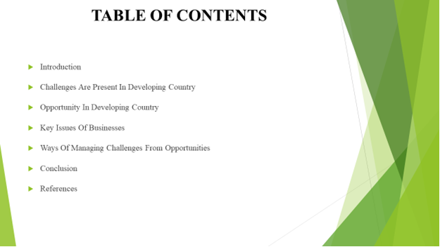

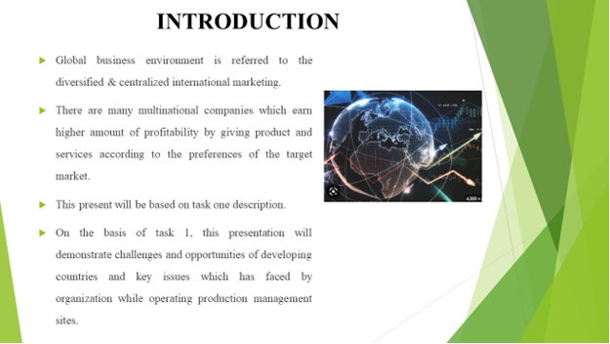

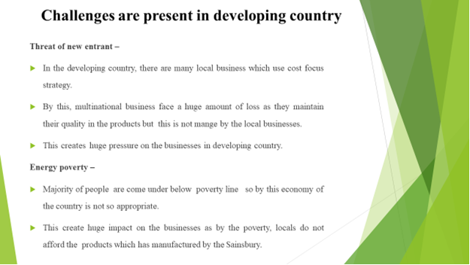
This create huge impact on the businesses as by the poverty, locals do not afford the products which has manufactured by the Sainsbury. It is a global business by that they maintained their brand image consistency in the products quality (Le Menestrel,, 2023).
Marginalization- it is one of the most crucial factor by which company not able to attain abundant amount of profitability from the target market. Marginalization basically relate to the difference between the cost and selling price of the products. In the developing country, businesses do not attaining higher amount of margin on the product offering (Sewpersadh, 2023).

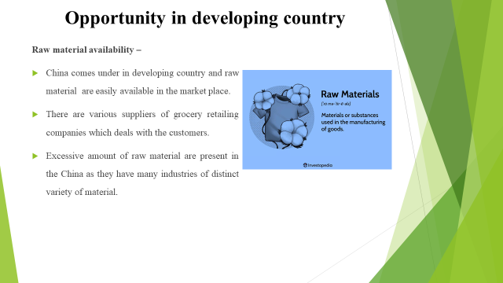

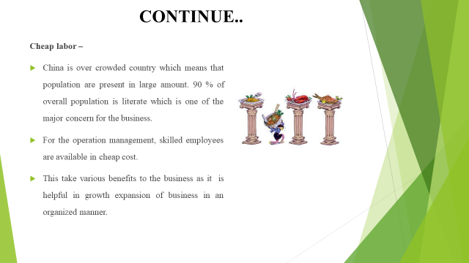



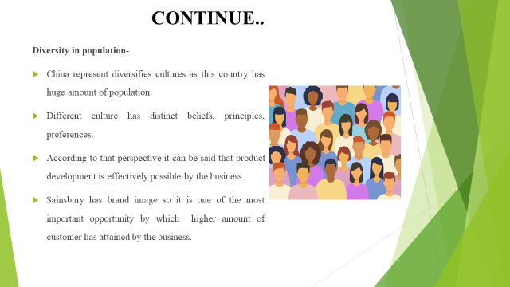

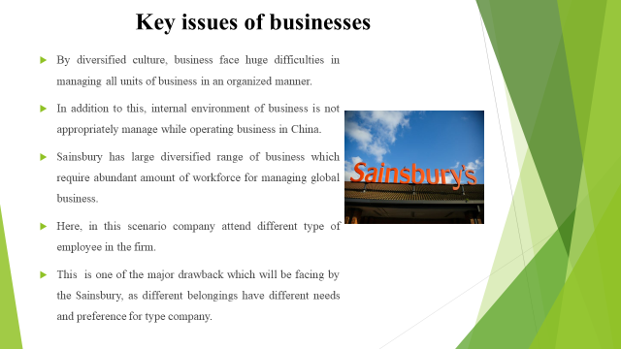
For the effective managing of diversified work force company must focus on very employee which is not possible. The mismanagement leads in the cultural clashes and subsequently declination in the productive can attained (de Oliveira, 2023 ).




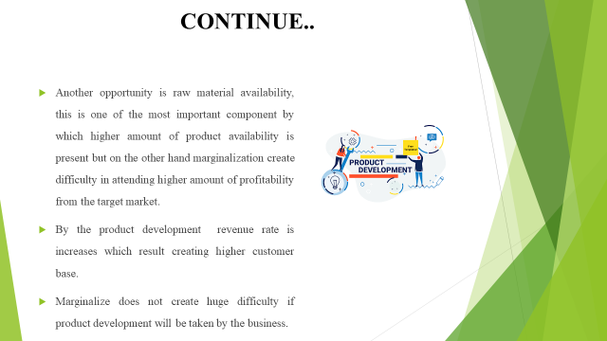

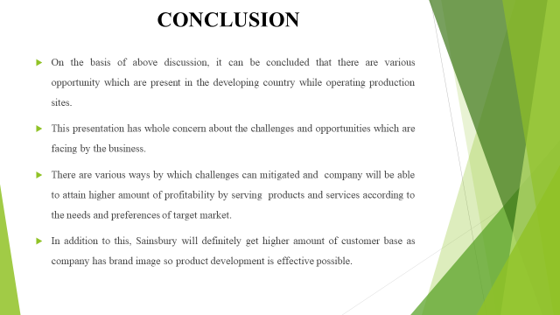

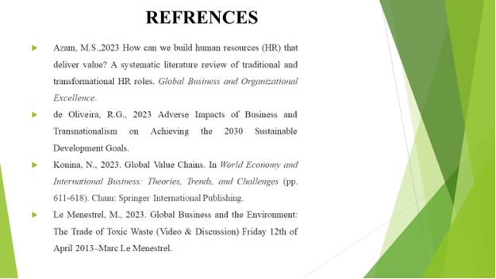
Lee, S., Chung, S. and Lee, E., 2023. Globalization of the public relations agency industry: a country-level analysis of global public relations agencies and environmental factors. Journal of Communication Management, (ahead-of-print).
Mandrinos, S. and Lim, W.M., 2023. De‐internationalization: An organizational institutionalism perspective. Global Business and Organizational Excellence. 42(3). pp.58-73. Sewpersadh, N.S.,
2023. Disruptive business value models in the digital era. Journal of Innovation and Entrepreneurship. 12(1). pp.1-27.


