Maricela Gheorghica-2109476
Module: Effective Team Working and Communication
Module Code: BMSW4002
Lecturer: Khaza Ahmed
Assignment Title: Effective Teamworking for team success



Effective Team
Team effectiveness is the capacity of a group of people, usually with complementary skills, to work together to accomplish goals set out by an authority, members, or leaders of the team. Team effectiveness models help us understand the best management techniques to get optimal performance from our teams. There are several critical factors to achieve maximum group effectiveness as the six models of team working below will show.
Good leaders and project managers should be aware of unique dynamics and relationships within their teams and create room to consistently improve team performance.
For example, Google, a company known for their innovative models of team effectiveness, spent years analysing what makes some teams better. It’s less about who’s on the team and more how well they work together.
Understanding these team effectiveness models will help you figure out which of the team models would be best to optimize your team by shedding a light on what works and what needs to be improved
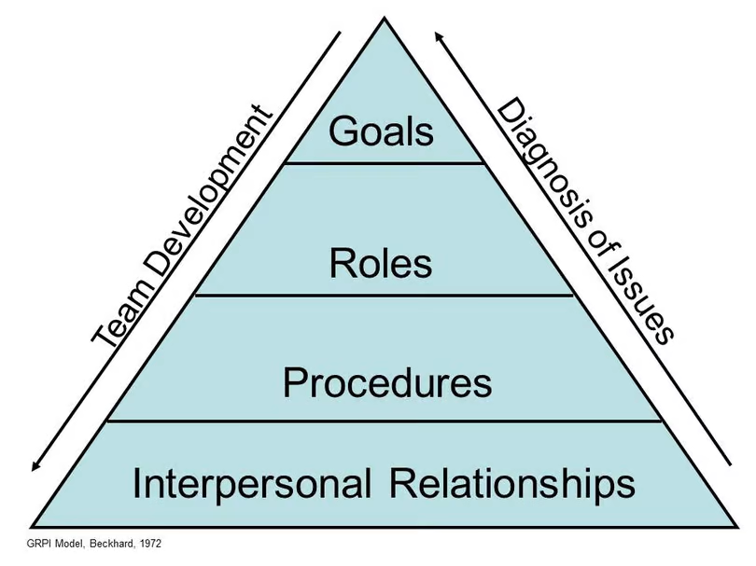
Rubin, Plovnick, and Fry's GRPI Model of Team Effectiveness
This model of team effectiveness was proposed by Rubin, Plovnick, and Fry as early as 1977. It is also known by the acronym GRPI, which stands for Goals, Roles, Processes, and Interpersonal relationships. Represented as a pyramid diagram, this model outlines four parts teams need to be effective:
Goals: well-defined objectives and desired results, plus clearly communicated priorities and expectations
Roles: well-defined responsibilities and acceptance of a leader
Processes: clear decision-making processes as well as work procedures
Interpersonal relationships: good communication, trust, and flexibility

Therefore, Abdul should further develop his part of communication and his role in his team. So, he can think about his wanted goals and interpersonal relationships to have a good communication and flexibility to have a good team and complete his tasks.
On my opinion, Abdul should create his own skills, to meet weekly to his member staff, to keep the members in the loop and take advantages of tools that improve communication.
In my experience, at a former job, the manager didn’t know how to organize his teams and how to communicate with them. This has affected his relationship with the team, and I think he should have sharpened his team skills. At the same time, he should think about his goals and of the team to work together.

Types Of Roles for An Effective Team
Working in a team takes organization and collaboration. For teams to be most productive, everyone should have a specific role that aligns with their strengths.
Action-oriented team members are ready to put things in action and they do well with strict deadlines. Thought-oriented team members are critical thinkers who may bring new ideas to the team and people-oriented team members can have strong communication skills, which I think can them support the entire team.
Teams’ roles can balance better your team and drive them more to productivity.

1.SHARPER-
Can be team members who drive the team forward. They are more action-oriented, motivating themselves and others despite any issues that arise.

2.IMPLEMENTER
Implementers are also action-oriented team members, and they maintain order in their environments. Although, implementers like to take action, they are highly disciplined and they may be ‘backbone’ of the team because they can confidently support other team members.
Some examples for the implementer team role are : can be a data-driven business analyst on the marketing team, and have ways to make the organisation’s processes more efficient

3.COORDINATOR
Moving on the people-oriented team roles, the coordinator is a team member with great communication skills. Coordinators are often in leadership positions because they promote collaboration and motivate the team to accomplish their goals, and other members look up to coordinators and trust them to make a decision.
Examples for coordinator team role: Coordinator enjoy collaborating and motivating others, so they’d thrive as the lead of the team to make a decision.

4. TEAMWORKER
Team workers are also people oriented. Their extroverted personalities help them function well with others and listen to their teammates. These team members can adapt easily to changes in their environment and they know how to create harmony if conflicts arise.
Examples of the team worker role: Because team workers are natural collaborators, they’d excel as a product marketer within a larger team.

How to create a balanced team
Creating balanced teams at work can be more of challenge when you have a variety of personalities and strengths at play. It’s unlikely that most teams will have the people to fill all the teams roles, which is why it’s critical to know how to work with the team you have and utilize each team member’s strengths.

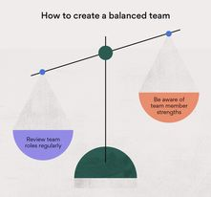
Every team role has its strengths and weakness. Being aware of these can help you create a more balanced team. For example, a plant may be less comfortable communicating, but they know how to solve complex problems.
So, we can see how Abdul can solve his problems with his members team. He can be a much better coordinator and implementer for his team.
Even if they were all the time on online because of Covid-19. He should check more his work team and to see if all tasks are completed.
He should have done his best to coordinate the team when the problems arose and give them advice on his role.

Effective teamworking on team success
A term which gets thrown around rather frequently in pretty much every business, day in, day out. We talk about building a team and working together as a team, but very few people understand how to develop an effective and collaborative team environment. And of course, it’s imperative to work as a team to ensure truly efficient performance, maximum output and to retain a happy and motivated workforce.

- Leadership
We often think of teams as highly democratic entities whereby each member contributes equally to ensure a project is completed. However, without a clearly defined leader, the whole foundation could dissolve which is why a team leader is essential for success.

2.Roles and responsibilities
When team roles and responsibilities are clearly defined, duplicated work will be significantly reduced, as will conflict, last-minute ‘scrambling’ and finger pointing. And, when a team is performing at its best, you’ll usually find that each team member has clear responsibilities. It’s important to make sure each employee is clear on who does what, who collaborates with whom and who contributes to each deliverable.

3.Establish a relationship with your team
As a leader, do you really know your team? What are their skillsets, strengths/weaknesses and what motivates them? This information is invaluable to leaders as it enables the matching of expertise to specific tasks which will ultimately result in increased productivity, motivation, and job satisfaction. A valued employee is a happy one and this attitude will resonate throughout the entire team.

4.Purpose and goals
A successful team cannot exist without a common goal, so make sure this is clearly defined. What is your team supposed to deliver? Map out the actions needed by working backwards from your desired outcome and setting deadlines for each step. Involve your team in this process where possible. Giving voice to each member of the team will give you the best shot at getting commitment and clarity of purpose.

5.Communicate
Poor communication hinders each aspect of life. A team which communicates effectively will complete projects in a more efficient amount of time than those where lack of communication is prevalent.

7.Make decision together
Making decisions should be based upon an open dialogue with all team members in an open environment whereby they feel able to offer their ideas and solutions to problems. Everyone should have their team’s support and commitment not only when making the decision but when carrying them out. When it comes to important, big decisions, make sure you include your entire team.

8.Continually review your process
Your team’s progress should be regularly reviewed. What’s stopping them from moving forward? Constructive feedback is key here and any issues or conflicts should be dealt with in a timely manner. Feedback should be focused on ideas and positive where possible, providing suggestions for improving work processes. Everyone should help one another in developing and using strategies to achieve their goals.

9.Facilitate coaching
Over time you will find team members become more positive, accepting and inclusive of one another and as a result, production, quality and profits should soar.

Teamwork creates an efficient working environment, whereby employees learn from one another and innovate faster. A team is more cohesive than a group as it has a unity about it. Teamwork success is not automatic. Team member selection is vital, as is ensuring the team purpose is clear and agreed. The difference between team failure and success depends on the behaviour of team members.

By and large, teams reflect their leaders, so ensuring an effective, proactive leader will increase your team’s chances of achieving success.

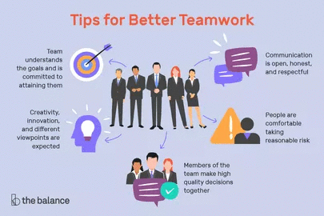

Now, we can see again some tips for Abdul in how to maintain a strong relationship with his team member. One of the most important and effective teamwork would be in which Abdul should be a more attentive leader and his relationship with his colleagues.
He should communicate and see what problems they have and try to make decision together and resolve existing costumer issues.

The barriers to effective teamwork identified in the scenario are variable, we can see poor communication and maybe a toxic work atmosphere. While good communication can foster teamwork, poor communication can create a toxic work atmosphere.
Staff members what will not communicate or are unaware of the proper communication channels to use within the team, can create breakdowns that inhibit team development.
One of the biggest barriers to changing attitude is a lack of communication as a pressure, managers need to be aware of the ‘double-edged’ sword of the team communication and be able to identify when the group is in a poor communication.
So, Abdul should have stopped this lack of communication and tried to get to know better each other’s and help the members to discuss their problems and opinions.
Sometimes the barriers to communication may be literal, such as separate office spaces reducing employee interaction. Use daily team meetings to ensure everyone is on the same page and start doing conversations between co-workers.
We can see the lack of managerial involvement as well. Managers create teams of qualified staff members to complete predetermined tasks or projects. But when the manager cannot find the time to be involved in the team’s execution off its duties. Every team needs a leader and I think Abdul should be a better team member/leader for his team and support them on their duties.
Simultaneously, teams that contains members who are not working for the general benefits of the group will have a difficult time developing into an effective unit. Individual staff members are assigned roles within a team, but if the staff members feel that they can take on other roles and interface in the work of teammates, the group dynamic is threatened. Team members need to keep egos in check and work on assigned tasks to develop an effective team.
For example, a competitive industry often fosters a sense of distrust among co-workers eager to stand out when a job opens. To build a more cohesive team in an intense environment, explain to employees that the ability to work as a team in the workplace and key to rising through the ranks.
I think in this scenario, Abdul didn’t know how to implement his role and lack of communication to see how everyone can be helped by making decisions as a team and this made the team lack of effective work in team.

References
Howell, J. P., & Mendez, M. (2008). Three perspectives on followership. In The art of followership: How great followers create great leaders and organizations (pp. 25-39). New York, NY: Warren Bennis

Hughes, R., & Jones, S. (2011). Developing and accessing college student teamwork skills. New Directions for Institutional Research, 149, 53-64.

