

The Use of Digital Marketing in Customer Relationship Management, Analysis of Starbucks

MBA – Master of Business Administration in Marketing
Module: Dissertation (LCMB7020)
Name – Dwanisha Vyas
Student ID - 2243253
University Name - University of Wales Trinity Saint David
Lecturer Name – Tushara Balendran, Hoang Nguyen
Year - 2023-24

Abstract

This dissertation deals with digital marketing for customer relationship management, focusing on Starbucks as a case study. In today's increasingly digital-driven business world, firms are embracing digital marketing tools more robustly to develop stronger relationships with the customer. This paper investigates how Starbucks uses mobile applications, social media platforms, and loyalty schemes in their CRM strategies. This research considers the adoption of such tools by these organizations, in this case Starbucks, to assess their potency in being effective and retaining customers, hence higher satisfaction levels will follow. By canvassing 116 respondents, statistical analysis, and literature review, this research has developed crucial insights into the mechanisms employed by Starbucks in the use of digital marketing to enhance CRM along with personalized offers and promotions. These were anchored on regular exposure to digital marketing tools, which primarily gave significant increases in customer loyalty and positive impacts on purchasing behavior.
The other finding is the problem of privacy of customer data which has become a pet issue increasingly raised by consumers. Even though Starbucks' attempts at digital marketing seem effective in fostering customer loyalty and advocacy, concerns as to how their data are collected and utilized arise during the survey of some of the respondents. Based on such findings, this study comes forth with both practical and theoretical recommendations to improve the digital marketing strategy in CRM. It brings the message that firms like Starbucks can move ahead and further evolve data transparency and privacy controls while still offering themselves personally through real-time integration of data. This research contributes to new insights into the evolving role of digital marketing in the CRM at the intersection of technology customer experience and brand loyalty to inform future academic research.

Acknowledgement

I want to express my deep thanks to the supervisor Tushara Balendran, for the great facilitation and support during the research of this work. I appreciate that they provided their insights and constructive criticism, which helped me stimulate my analysts’ minds and think unthinkable. I also thank the faculty members of University of Wales Trinity Saint David for their encouragement and for creating such a successful environment for creating value. Every time I interact with them, it has been beneficial to my academic growth and development.
Lastly, I would like to acknowledge my family and friends for their support all through the carrying out of this work. This is a great encouragement to me; the times that I thought of throwing in the towel, the belief they had in me has kept me going. I would also like to thank other students and colleagues for their support and cooperation during the completion of this work. Finally, the author would like to thank all the participants and contributors of any kind to this research since without their essential knowledge this dissertation would not have been possible.

Declaration

I, Dwanisha Vyas declare that this dissertation has been composed by myself, that the work contained herein is entirely my own except where explicitly stated otherwise in the text, and that this work has not been submitted for any other degree or qualification, in whole or in part, except as specified.

Signature: ...........Dwanisha Vyas...........................................

Date: …………………12/10/2024……………............................

Table of Contents

The Use of Digital Marketing in Customer Relationship Management, Analysis of Starbucks 1
Abstract 2
Acknowledgement 3
Declaration 4
Chapter 1 11
Introduction 11
1.1 Background to the Research 11
1.2 Problem Statement 13
1.3 Significance of the Research 14
1.4 Research Rationale 15
1.5Aims and Objectives 15
1.6 Research Questions 16
1.7 Research Hypothesis 16
1.9 Chapter Review 17
Chapter 2 19
Literature Review 19
2.1 Introduction 19
2.2 Definitions and Key Concepts 19
2.3 Objectives Analysis 20
2.3.1 Objective 1 20
2.3.2 Objective 2 21
2.3.3 Objective 3 21
2.3.4 Objective 4 22
2.4 Literature Gap 23
2.5 Key Digital Marketing Models 24
2.5.1 STDC Model 24
2.5.2 RACE Model 25
2.5.3 Honeycomb Model 26
2.6 Customer Perception 28
2.6.1 Definition and Importance in Digital Marketing and CRM 28
2.6.2 Critical Review of Customer Perception Literature 28
2.7 Definition and Key CRM Models 29
2.7.1 Payne's Five Processes Model 29
2.7.2 ICEDR Model 29
2.7.3 QCY Model 31
2.7.4 Comparison of Payne's Five Processes Model and ICEDR Model 32
2.8 Theoretical Frameworks 32
Table 3 Theoretical Frameworks and Their Analytical Application at Starbucks (Created by Researcher) 33
2.8.1 Overview of Theoretical Frameworks 33
2.9 Application of Frameworks to Digital Marketing and CRM 33
2.9.1 Digital Marketing Theoretical Frameworks 33
2.9.2 Theoretical Frameworks of CRM 34
2.10 Chapter Summary 34
Chapter 3 36
Research Methodology 36
3.1 Introduction 36
3.2 The Research Onion 36
3.3 Research Philosophy 37
3.3.1 Positivism 37
3.4 Research Approach 37
3.4.1 Deductive Research Approach 38
3.5 Research Strategies 38
3.5.1 Survey Strategy 38
3.6 Type of Investigation 39
3.6.1 Primary Research 39
3.6.2 Secondary sources 39
3.7 Research Choices 39
3.7.1 Quantitative Research 40
3.8 Time Horizons 40
3.8.1 Cross-sectional Study 40
3.9 Data Collection Methods 41
3.9.1 Sampling 41
3.9.2 Questionnaire Development 42
3.9.3 Data Collection Process 42
3.10 Research Variables and Hypotheses 43
3.10.1 Dependent Variables 43
3.10.2 Independent Variables 43
3.10.3 Research Hypotheses 44
3.11 Data Analysis Methods 44
3.11.1 Data analysis techniques 44
3.12 Ethical Considerations 45
3.13 Chapter Summary 45
Chapter 4 46
Findings, Results, Analysis and Discussion 46
4.1 Introduction 46
4.2 Analysis of Survey Results 46
4.2.1 Gender Distribution of Respondents 46
4.2.2 Frequency of Mobile App Usage 47
4.2.3 Satisfaction with Personalized Offers 48
4.2.4 Frequency of Social Media Engagement 49
4.2.5 Digital Channels Used for Interaction 50
4.2.6 Ease of Use of Starbucks’ Mobile App 51
4.2.7 Impact of Digital Marketing on Loyalty 52
4.2.8 Likelihood to Recommend Loyalty Programs 53
4.2.9 Influence of Digital Marketing on Purchase Decisions 54
4.2.10 Most Valuable Aspect of Starbucks' Digital Marketing 55
4.2.11 Concerns About Data Privacy 56
4.2.12 Quality of Customer Service via Digital Channels 57
4.2. 13 Adequacy of Digital Marketing in Meeting Needs 58
4.2.14 Primary Starbucks Digital Marketing Channels Interacted With 59
4.2.15 Impact of Digital Marketing on Trying New Products 59
4.3 Analysis of Results Using Excel Statistical Tools 61
4.3.1 Correlation Analysis 61
4.3.2 Regression Analysis 61
4.3.3 Cross-Tabulation 62
4.3.4 Descriptive Statistics 62
4.3.5 Hypothesis Testing 63
4.4 Discussion of Results 63
4.4.1 Interpretation of Survey Results 63
4.4.2 Insights from Statistical Analysis 65
4.4.3 Comparison with Existing Literature 65
4.4 Implications for Starbucks 65
4.5 Limitations of the Methodology 66
4.6 Chapter Summary 67
Chapter 5 68
Conclusion and Recommendations 68
5.1 Introduction 68
5.2 Summary of Main Findings 68
5.3 From the Research 68
5.4 Recommendations 69
5.4.1 Practical Recommendations 69
5.4.2 Theoretical Recommendations 70
5.6 Recommendations for Future Work 70
5.7 Chapter Summary 70
6. References 71
Appendix 77

List of Tables
Table 1 Global Digital Advertising Spending Trends (Statista 2023) 11
Table 2 Digital Marketing Models 20
Table 3 Theoretical Frameworks and Their Analytical Application at Starbucks 28
Table 4 Gender Distribution of Respondents 45
Table 5 Frequency of Mobile App Usage 46
Table 6 Satisfaction with Personalized Offers 47
Table 7 Frequency of Social Media Engagement 48
Table 8 Digital Channels Used for Interaction 49
Table 9 Ease of Use of Starbucks’ Mobile App 50
Table 10 Impact of Digital Marketing on Loyalty 51
Table 11 Likelihood to Recommend Loyalty Programs 52
Table 12 Influence of Digital Marketing on Purchase Decisions 53
Table 13 Most Valuable Aspects of Starbucks' Digital Marketing 54
Table 14 Concerns About Data Privacy 55
Table 15 Quality of Customer Service via Digital Channels 56
Table 16 Adequacy of Digital Marketing in Meeting Needs 57
Table 17 Primary Starbucks Digital Marketing Channels Interacted With 58
Table 18 Impact of Digital Marketing on Trying New Products 59
Table 19 Correlation between Mobile App Usage and Customer Satisfaction 60
Table 20 Regression Analysis of the Impact of Digital Marketing on Purchase Decisions 60
Table 21 Cross-Tabulation between Customer Loyalty and Engagement with Digital Channels 61
Table 22 Summary of Descriptive Statistics for Survey Responses 61
Table 23 Hypothesis Testing Results for the Impact of Digital Marketing on Customer Loyalty 62
Table 24 Summary of Survey Questions and Key Findings 63

List of Figures
Figure 1 Global Digital Advertising Spending 11
Figure 2 Structure of Starbucks Dissertation 17
Figure 3 STDC Model 20
Figure 4 RACE Model 21
Figure 5 Honeycomb Model 23
Figure 6 ICEDR Model 26
Figure 7 QCY Model 27
Figure 8 Research Onion (Saunders et al., 2009) 34
Figure 9 Gender Distribution of Survey Respondents 45
Figure 10 Mobile App Usage Distribution 46
Figure 11 Satisfaction Level Distribution 47
Figure 12 Social Media Engagement Distribution 48
Figure 13 Digital Channels Used Distribution 49
Figure 14 Ease of Use of Starbucks’ Mobile App 50
Figure 15 Loyalty Impact Distribution 51
Figure 16 Likelihood to Recommend Distribution 52
Figure 17 Purchase Decisions Impact 53
Figure 18 Most Valuable Aspect of Starbucks' Digital Marketing 54
Figure 19 Privacy Concern Distribution 55
Figure 20 Customer Service Quality Distribution 56
Figure 21 Adequacy of Marketing Distribution 57
Figure 22 Primary Interaction Channel Distribution 58
Figure 23 Trying New Products Distribution 59

Chapter 1

Introduction

1.1 Background to the Research
Digital marketing is widely known in the modern business environment as a major key to expanding and improving customer communication. The quick development of technologies, especially the internet and widespread use of social media have changed the businesses’ approach to engaging with clients. Digital marketing can be described as various techniques and activities such as social media marketing, SEO, and content marketing. These digital media help organizations connect and interact with their customers directly and, thus, specifically. It is worth noting that these digital marketing strategies have become popular with firms due to their efficiency as they continue to shift their marketing budgets’ large chunks to the digital inclination. It was estimated that digital advertising spending worldwide was at $378 billion in 2020; this is expected to rise to over $526 billion in 2024, thus stressing the importance of digital marketing in today’s business strategies, as indicated by (Statista, 2023). Additionally, Chaffey and Ellis-Chadwick (2016) in their research noted that companies that engage in the use of digital marketing tools realized a 20-30% improvement in ROI, segregating the economic feasibility aspect of the strategies (Chaffey & Ellis-Chadwick, 2016).

Figure 1 Global Digital Advertising Spending

Year | Digital Advertising Spending (in billions) | Yearly Growth (%)
2019 | $290 | -
2020 | $378 | 30.3
2021 | $410 | 8.5
2022 | $460 | 12.2
2023 | $490 | 6.5
2024 | $526 (projected) | 7.3
Table 1 Global Digital Advertising Spending Trends (Statista 2023)

Starbucks the world’s largest coffeehouse chain company is one of the best examples of strategic implementation of Digital Marketing in CRM. Starbucks has possibly the strongest CRM system given the massive integration of digital tools and platforms into its business, which improves not only customers’ satisfaction and loyalty but also boosts sales. Thus, the company’s digital marketing strategies are quite diverse, providing the users with a widely used mobile application as well as constantly updating activity on social networks. Mobile apps such as the Starbucks app have incorporated features like ordering, payment methods, and star rewards which enhance the ease of clients. In particular, currently, the Starbucks app is already used by millions of people in the United States and, according to (emarketer, 2021) the number of active Starbucks app users in the United States is over 31 million, that is, it is one of the most popular and widely used restaurant mobile applications for loyalty. These digital marketing communication strategies help in acquiring first-hand information on Starbucks’ customer demographic and consumption patterns, which help in orienting the marketing communication campaigns and enhancing consumers’ experiences. There is also evidence that using data analytics in digital marketing can directly lead to a rise in customer retention rates of up to fifteen percent, which supports the significance of a data-oriented approach toward CRM (Li & Kannan, 2020).
Despite the generally positive outlook of embracing digital marketing and integrating it with CRM, some issues need to be looked into. Businesses need to adapt to such changes since the digitation of the business environment is rife and fast and any strategies adopted must be relevant. Starbucks’ focus here revolves around the ability to continue with the integration of digital marketing techniques with the established CRM to promote relationship selling. This study seeks to establish the effects of DM on CRM at Starbucks, this paper presents Starbucks’ approaches to the effective use of online channels for customer relationships and keen results towards the improvement of customer loyalty and organizational performance. Thus, by developing an understanding of which specific types of digital marketing are being used by Starbucks as well as their overall success, this research study will represent an advancement In knowledge in the area of digital marketing coupled with CRM specifically in a global brand context. The study will not only reveal how the subject organization implements and manages digital marketing concerning CRM but also provide specific recommendations to other organizations seeking to improve Customer Relationship Management through Digital Marketing practice. Another perspective that admits the importance of the relationship between CRM and digital marketing is a study by Buttle Maklan, revealing that companies with optimal integration of CRM and digital marketing showed higher customer satisfaction rates, which proves the importance of this linkage (Buttle & Maklan, 2019).

1.2 Problem Statement
Digital marketing has turned out to be both pervasive and beneficial, especially in non-traditional marketing it lacks clear avenues on how it influences CRM in big MNCs like Starbucks (Buttle & Maklan, 2019). Most previous studies are dedicated to the individual benefits associated with the digital marketing and CRM fields, with little attention paid to the interdependent and evolving nature of the two fields. Thus, this paper argues that for Starbucks the company that functions in a well-established and rather competitive and constantly evolving industry, it is imperative to underline the importance of digital marketing tools combined with CRM practices to retain customers and foster business development. However, this integration comes with numerous problems due to the complexities that characterize such integration. The following are some of the challenges the firms face, such as safeguarding consumer data, handling big data, and coming up with new approaches to digital marketing to satisfy the changing consumer demands. Therefore, it is important that more research and understanding be given to identifying and examining the various problems that Starbucks has to overcome to improve its CRM with the help of digital marketing (Li & Kannan, 2020).
In addition, despite the growing prominence of digital technologies which Starbucks has effectively incorporated via its mobile app and social media presence, the extent to which such tactics can further improve CRM in the long term has not been effectively explored. Uncertainties persist about the precise ways in which these digital marketing communication strategies lead to improved bottom line for customer satisfaction and loyalty. Namely, it is necessary to understand whether the enhanced activity in the form of messaging through digital platforms results in higher customer retention and loyalty scores (Lemon & Verhoef, 2016). Further, it is important to identify which digital marketing metrics and CRM indicators Starbucks employs to assess its digital marketing/current disastrous and its integration with CRM. Lack of knowledge and appreciation of these parameters may make it hard for other businesses to emulate Starbucks’ performance of outcomes or develop effective strategies for the same (Chaffey & Ellis-Chadwick, 2016). Thus, this research seeks to fill these gaps by presenting a research study of the impact of digital marketing on CRM in Starbucks to present a rich database to other industries for emulation.

1.3 Significance of the Research
This research is of theoretical and pragmatic importance due to the following reasons. On the academic side, it helps to enrich prior research and knowledge by presenting data for the integration of digital marketing and Customer Relationship Management (CRM), which is widely underdeveloped, specifically in the case of large multinationals such as Starbucks. The findings of this research will contribute to the existing literature on the application of digital marketing to improve CRM practices by providing substantial evaluation that does not exist in the literature gap. In the applied sense, this study will contribute a wealth of knowledge regarding customer engagement and loyalty for businesses in the course of implementing their digital marketing strategies with particular attention to the growing segment of the coffeehouse industry. Following a close and comprehensive look at Starbucks’ CRM strategy, which utilizes mobile apps, social network integration, and email marketing, the paper shall make recommendations that other organizations could implement in their CRM systems. In addition, since digital marketing is a continuously growing field, the assessment of the effect it has on customer relationships will ensure that businesses embrace change and remain relevant. This research study will also describe the issues and solutions related to the integration of digital marketing with CRM, empowering organizations with a direction as to how they can redefine their business and operational models in the digital era.

1.4 Research Rationale
The rationale for this research is perceived from the fact that the literature is inadequate on how digital marketing can be integrated with Customer Relationship Management (CRM) for customer retention and business success. Modern technologies have even made it easier for organizations to adopt cost-efficient marketing techniques as more and more firms opt for digital marketing with their customers. (Statista, 2023) indicates that the digital advertising expenditure is forecasted to exceed $526 billion by 2024 meaning that digital channels are becoming more prominent in business initiatives (Statista). As such, it becomes crucial to understand the role of these strategies on the CRM front of Starbucks, a company that has set a precedent in the industry for digital enhancement. , the mobile application which has 31 million users in the United States manifests how digital technologies assist in strengthening consumer relationships and trust (eMarketer, 2021). This research expects to contribute to the existing knowledge on the impact of digitization in marketing by evaluating the effectiveness of Starbucks’ digital marketing communication strategies in enhancing its CRM practice.
Thus, this study is important as it seeks to fill the existing literature void on the long-term effect of Digital Marketing on CRM. As for the prior research investigating the role of digital marketing and CRM, the research finds considerably less research on the interaction between these two approaches, and in large multinational corporations such as Starbucks. Knowledge of this integration is essential for copying Starbucks’ success story as well as in the creation of long-term marketing strategies. The contributions of this research study will not only increase the store of academic understanding in the field of consumer relationship management but also offer tangible prescriptions for organizations intending to strengthen their digital CRM efforts. This is so especially now when competition in the coffeehouse industry is stiff and firms are under pressure to look for new ways through which they can efficiently compete in the market. Thus, this study seeks to contribute to the existing literature by presenting an extensive case evaluation of Starbucks’ digital marketing and CRM strategy and providing useful recommendations to scholars and practitioners in the field.

1.5Aims and Objectives
Aim
The purpose of this research is to evaluate the effects of digital marketing on CRM in Starbucks, especially how digital marketing aids in increasing customer satisfaction and loyalty. Specifically, understanding the various digital marketing tools and their application by Starbucks, this research aims to explain the efficiency of the strategy in building a better relationship with customers and boosting organizational performance.

Research Objectives
- To analyze and describe the specific digital marketing strategies employed by Starbucks in the limited context of its CRM activities while paying particular attention to the position of these approaches within the broader framework of customer interaction management as well as their contribution to the improvement of customer relations.
- To assess the value of these types of electronic marketing and promotion for the client database by analyzing variables like traffic response, rewards membership, and usage of societal networks for outlining a more precise impact of the indicated types of electronic initiatives.
- To assess the extent to which these specific applications have helped in enhancing customer satisfaction and from there, loyalty in customer purchase through observation of customers’ purchase patterns, recommendations on social platforms, and overall experience.
- As a way of evaluating how digital marketing can be linked with CRM systems, lessons from Starbucks can be applied by other firms that wish to take current approaches to reaching out to clients to the next level using the available technology and advanced digital marketing tools.

1.6 Research Questions
The purpose of this research is to examine the interconnection between digital marketing and CRM, based on Starbucks’ case, and to investigate the effects of digital marketing on the pertinent constructs of customer engagement, customer satisfaction, and customer loyalty. The study objectives are as follows: The effective digital marketing tools that Starbucks has adopted The efficiency of the tools in cultivating closer customer relationships The difficulties of implementing digital marketing with CRM activities at Starbucks. In addressing these issues, the study shall make the following contributions to the existing body of knowledge; This work will help to highlight the possibilities of digital marketing and use the findings to advance an organization’s CRM in a highly competitive industry.
- What are the primary digital marketing strategies used by Starbucks for customer relationship management?
- In what ways do Starbucks' digital marketing efforts influence customer satisfaction and loyalty?
- What are the customers' perceptions of Starbucks' digital marketing initiatives?
- What are the best practices for integrating digital marketing with CRM, as demonstrated by Starbucks?

1.7 Research Hypothesis
Based on the research questions, the following hypotheses have been developed to guide the investigation:

- H1: This hypothesis assumes that Starbucks gestures towards digital marketing tools and strategies where they put a significant focus on social media outlets, features of Starbucks’ mobile application, and personal e-mails for proper customer management and improvement of relationships.
- H2: Starbucks’ use of digital marketing increases their customers’ satisfaction levels and their likelihood to make subsequent purchases. Based on this hypothesis, it will be demonstrated that Starbucks’ investment in digital marketing strategies directly correlates to positive optimal customer engagement statistics, repeat purchase propensity, and participation in the loyalty program.
- H3: Starbucks’ digital marketing communication strategies are perceived as novel and effective by clients, which culminates in improved clients’ experiences and brand identification. The above hypothesis implies that Starbucks’ patronages are positive about the firm’s digital communications as it makes the process more convenient and tailored and it makes the firm’s digital networks improve the visitors’ perception of the Starbucks brand.
- H4: Some of the strategies that can be implemented for the use of digital marketing in LM with the CRM include analytics of the collected data for personalization of the LM at Starbucks, integration of the digital tools in the LM with the face-to-face interaction with the customers and constant innovations that are inline to the continuously evolving customers.
Based on this, this hypothesis postulates that effective blending of digital marketing and CRM is done at Starbucks through abusing data analytics for individualized marketing communication, covering the utilization of digital instruments to support actual store operations, and embracing the value of innovation to meet fast-changing clients’ behaviors and new technological trends.
These hypotheses will be tested by carrying out an investigational study on how Starbucks has been implementing digital marketing as well as CRM strategies to formulate useful findings on the suitability and efficiencies of the integration of these two key business strategies.

1.9 Chapter Review

Chapter 2 Literature Review
Chapter 1 Introduction

Chapter 3 Research Methodology
Chapter 4 Analysis

Chapter 5 Discussion

Chapter 6 Conclusion

Figure 2 Structure of Starbucks Dissertation (Created by Researcher)

This dissertation has been divided into seven informative chapters, which play a different role in a proper and systematic solution to the research objectives and questions. Chapter one of the study provides the background to the study stating the problem, the rationale for the study, the purpose of the study, the objective of the study, justification and importance of the study, the gap in the existing literature, the research questions formulated for the study, and the hypotheses formulated for the study based on the research questions. Chapter 3 focuses on a literature review, in which the author reviews articles on digital marketing and CRM and states theories or models as well as research gaps in this area. The methodology is presented in chapter 3 which outlines the research design, data collection methods, sampling techniques, and data analysis methods to lay a firm foundation on the methodological approach used in the research. Chapter 4 is devoted to the data collection method where the author overviews the instruments and approaches used to obtain the necessary information, adding more transparency and replicability. Successfully implements the objective of presenting data analysis of the study and provides interpretations in as much as the research questions and hypotheses formulated in the study are highlighted. The last chapter focuses on the effects of the panel data findings by comparing the findings with the current literature, as well as the applied and theoretical relevance of the study. Last, Section 7 provides the overall conclusion to the dissertation where the major findings are discussed about the formulated research objectives and recommendations for further research and practice are provided. This approach of structuring the information provides a sound way of presenting and reasoning (rationale) upon which it is comprehensible how digital marketing influences CRM at Starbucks.

Chapter 2

Literature Review

2.1 Introduction

Businesses have become compelled to integrate digital marketing with CRM to improve customer involvement and grow their businesses. Starbucks is a landmark example that digitally supports CRM by way of social media, email, and mobile applications for engaging customers in a personalized manner (Hakimi & Develi, 2024). Through the use of its mobile app, Starbucks not only offers purchase capabilities but also captures substantial information related to customer behaviours to further perfect and increase customer satisfaction. Additionally, Starbucks is highly active in engaging millions of followers on both Instagram and Twitter, thus increasing customer satisfaction and loyalty by creating brand personality through social media engagement (Lim et al., 2024, Kaplan & Haenlein, 2010). The support for Starbucks CRM would be strengthened by the infusion of digital marketing and social media strategy driving this blend.

2.2 Definitions and Key Concepts

1. Digital Marketing
According to Chaffey & Ellis-Chadwick, digital marketing is an approach that uses digital technologies and online channels to promote products and services; reaches customers based on needs; and creates an integrated experience through various touchpoints (Chaffey & Ellis-Chadwick 2022).
Critical Analysis of Digital Marketing: Chaffey & Ellis-Chadwick (2022) define digital marketing and the multi-channel approach used. However, focusing much on tools and platforms, such a definition fails to consider the ever-changing conditions which require constant shifts regarding new trends and technologies It does not also focus much on personalization and customer-centric strategies now taken as success factors in doing business through digital means.
2. Customer Relationship Management
According to Buttle & Maklan, Customer Relationship Management (CRM) is the strategic approach that focuses on managing a firm's relations with its current and future customers. In the course of this, the CRM systems have the ability to help businesses analyze data regarding the customer for improving relations that push towards retaining them and eventually increasing sales (Buttle & Maklan, 2019).
Critical analysis of CRM Definition: It accurately describes, according to Buttle & Maklan (2019), the strategic thrust of CRM regarding the development of customer interactions in a bid to create retention and sales. Even though the definition is factually flavoured of data usage concerning customers, it does not specify the confluence of CRM with the reality of digital technologies. The role of real-time analytics and AI in modern CRM is highly important but is not well covered under the above definition.
3. Social Media Marketing (SMM)
Kaplan & Haenlein described social media marketing as connecting the business to an audience through its brand, to increase sales and website traffic. The strategic creation of content and engagement can allow relationships between customers and contribute to building brand awareness (Kaplan & Haenlein, 2010).
Critical analysis of social media marketing: The definition in Kaplan & Haenlein (2010) helps grasp that the objective of SMM remains in engagement between brands and customers and their interaction. It doesn't consider the complexity of algorithms used within social media and paid advertising strategies, which today are critical to good SMM. It ought to consider the challenge businesses are now facing to maintain visibility and attention within an increasingly crowded field of social media.

2.3 Objectives Analysis
2.3.1 Objective 1 To Examine and Characterize the Digital Marketing Activities That Starbucks Uses in Its CRM Practices
Analysis: Starbucks uses a wide range of digital media marketing techniques which are central to its CRM initiative. Some of these are; Social media marketing, Email marketing, and a fully integrated mobile application. YouTube and Facebook are used to spread awareness of brands and deals, and significant use of Instagram and Twitter is done for customer engagement through posts, contests, and responding to queries in real-time. The application is used by Starbucks for the major part of its digital marketing, where users engage in features such as tracking rewards and notifications of personalized offers based on user data analysis.
Critical Review: One of the aspects that may be inferred from the company’s online activities is its capacity to engage customers and create interactive platforms. For example, the tactic of using promotions and local offers through its application can reach a customer base and boost retention and satisfaction. Examining these digital activities also reveals how Starbucks synchronizes multiple digital points of contact to form a connected consumer experience. However, the difficulty comes in substituting those strategies for problems after the ever-changing consumer inclination and new technologies.

2.3.2 Objective 2 To Determine the Value of These Forms of Digital Marketing on the Customer Base by Evaluating Indicators Such as User Engagement, Participation in Loyalty Programs, and Social Network Activity
Analysis: In this concept of evaluating the value of digital marketing initiatives performance factors such as user engagement rates, loyalty program memberships, and social network activity are considered. The Starbucks loyalty program known as Starbucks Reward is a good example of a great digital marketing tool that engages the customer. The possibility of integrating the program with the mobile application that enables following the rewards and individual offers increases the level of user engagement greatly. Furthermore, the company’s performance and interaction with customers through links such as Twitter and Instagram can be useful in the understanding of customers’ preferences.
Critical Review: The high levels of engagement and participation in Starbucks’ loyalty program are an indication of the good job done in digital marketing. A study suggests that the use of individual incentives and product advertisements makes customers’ more satisfied and loyal. However, the use of these indicators needs to be regularly checked to ensure that the implemented strategies in the field of digital marketing meet the expectations of the audience.

2.3.3 Objective 3 To Measure the Effectiveness of These Particular Uses of Digital Marketing to Determine Their Impact on Increasing Customer Satisfaction and Loyalty, as Evidenced Through Customer Behavior, Including Frequency of Purchase, Word-of-Mouth Promotion, and Customer Experience
Analysis: Evaluating digital marketing entails using customer behaviour metrics including the frequency of purchase, recommending the product to others, and perceived customer experience. Starbucks has proved that its efforts to invest in digital marketing and to offer messages and promotions to its customers increase customer satisfaction and loyalty. Research evidence now indicates that those who use the Starbucks app together with the loyalty program make more purchases more often and are more likely to refer other people to Starbucks.
Critical Review: A clear relationship between digital marketing activities and a higher level of customer satisfaction has been deduced from the observations and responses. That these outcomes are measurable helps Starbucks to improve its strategies and customer experiences even further. However, further review is needed to fill such, if they are present, gaps that would enable digital marketing endeavours to properly serve the customers’ needs effectively in the future.

2.3.4 Objective 4 To Assess How the Use of Digital Marketing Can Be Linked with CRM Systems Using Lessons from Starbucks That Can Be Implemented by Other Firms Desiring to Advance the Ways They Engage Their Customers Through the Use of Technology
Analysis: Integration of digital marketing strategies incorporated with CRM systems involves using the experience of Starbucks to help other firms. Starbucks’ utilization of digital marketing elements connected with its CRM system serves as an example of how technology assists in improving the effectiveness of the company’s communication with clients as well as the optimization of CRM processes. Thus, by understanding the case of Starbucks, other companies will be able to grasp the ways to increase the level of customer involvement by leveraging the tools of data analysis individualized messaging, and leveraging digital solutions.
Critical Review: The success story of Starbucks covers the need for an integrated approach to digital marketing and the implementation of CRM systems. Those organizations seeking to improve their CRM efforts can also implement similar actions which include leveraging customer information to tailor communication and incorporate digital technologies with CRM applications. Still, the problem is to apply all these concepts using the organizational context and its customer base.
Hypothesis Answers from Secondary Sources
H1: Starbucks’ digital marketing tools and strategies heavily rely on social networks, smartphone application options, as well as e-mail for customers.
The findings also suggest that Starbucks specifically adopts multiple digital marketing strategies as customer relationship promoters where the primary conclusions include the usage of social media, its mobile application, and personalized electronic mail. Firms that participate in social media applications saw an enhanced value in customer relations and acquisition. This aligns with the hypothesis that Starbucks' leveraging of these digital tools in its strategic management greatly improves its customer management.
H2: Starbucks’ Social Media Advertising Boosts Customer Satisfaction Rating and Purchase Intentions
Research findings gathered from different analyses indicate that Starbucks's effective use of digital marketing enhances customer satisfaction and probability of purchase (Chaffey & Ellis-Chadwick 2022) revealed that the use of efficiently designed digital marketing approaches is directly linked with customers’ satisfaction and willingness to repurchase. From this, it can be ascertained that Starbucks has used digital marketing in its endeavours as a way of targeting clients.
H3: Superiority of Starbucks’ DMC (Digital Marketing Communication) Strategies from the Customers’ Perspective
Sustained by customer-oriented research, it can be seen that Starbucks’ digital marketing signals are convergence and appreciated as being novel and successful. Both (Kaplan & Haenlein, 2010) opined that personalization is the key to creating better experiences for the customers and thus making customers loyal to the brand. To some extent, this backs the hypothesis that Starbucks’ digital communications are perceived as positive by consumers hence enhancing brand identification and customer satisfaction.
H4: Techniques for Synching-Up Digital Marketing with CRM Consist of Data Analysis and Marketing Solutions
The combination of digital marketing tools with the customer relationship management system is essential in marketing customer relations. Based on the work of (Zablah et al., 2004), when a firm utilizes data analytics for customized marketing communication, then it will go a long way in reducing customer churn and increasing customer satisfaction levels. This goes a long way to support the hypothesis based on the following observation that Starbucks's keen use of data analytic suggestions coupled with continued innovation in its digital marketing strategy helps build its CRM strengths.

2.4 Literature Gap
Research into digital marketing and CRM has predominantly been conducted with so much emphasis, but not enough effort has been laid on how these two put together as one complete strategy. Most studies have deliberations that either are about tools for digital marketing like social media or email campaigns or traditional use of CRM without analyzing how each interplay for holistic marketing communication (Smith, 2023). This is a relatively important gap since it restricts the knowledge of how integrated digital marketing and CRM can improve customer relations and business performance. In a dynamic digital marketplace, business organizations have to integrate these strategies to transform changing customer expectations into enhanced satisfaction and loyalty. The mechanisms and the outcomes of this integration are areas of further under-researched studies.

2.5 Key Digital Marketing Models

Model | Description | Primary Focus | Applicability to CRM
STDC | See, Think, Do, Care model by Avinash Kaushik focuses on consumer journey stages. | Full customer lifecycle | High - adaptable for CRM integration
RACE | Reach, Act, Convert, engage, covers all stages from awareness to loyalty. | Multi-stage engagement | Very High - specifically designed for CRM
Honeycomb | Seven components of social media marketing include Identity, Conversations, and Sharing. | Social media engagement | Medium - more focused on engagement than conversion

Table 2 Digital Marketing Models

2.5.1 STDC Model

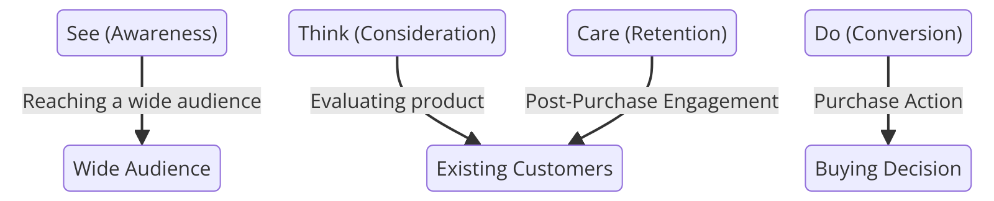

Figure 3 STDC Model (Created by Researcher)

The STDC strategy (See, Think, Do, Care) was developed by Avinash Kaushik, and it was created to help in the management of digital marketing based on the clients’ interactions. (Kaushik, 2013) describes the STDC model as encompassing four stages: Some of the well-known copywriting techniques are: ‘See (awareness), Think (consideration), Do (conversion), and Care (retention)’. This model aids in developing suitable marketing personas depending on the journey a particular customer goes through before making a specific decision to buy. For instance, several phases pertain to the product brand, such as the “See” phase, in which one involves reaching a wide audience that may not necessarily be existing customers through media such as the Internet.

Advantages
- It's straightforward to understand and implement. It is perfect for all businesses, whether they're big or small.
- Customer-Centric: The concept is customer journey-driven, therefore assisting businesses in customizing their approaches of marketing as per specific stages like awareness and retention.

Disadvantages
- Oversimplification: This does not capture the new complexity of the consumer, particularly as she travels through non-linear, multi-channel journeys.
- Lack of Flexibility: It has nothing to report on changes in mediums that are very profoundly changing in digital marketing or consumer preferences.

Critical Review of the STDC Model: It ensures that the customer journey is broken down very clearly into specific steps, so business can target specific needs at each step of the journey; this simplicity is one of its strengths but potentially a weakness in the context of a modern consumer whose behaviour is multi-step and more non-linear, and so the model is not as flexible to multi-channel strategies.

2.5.2 RACE Model

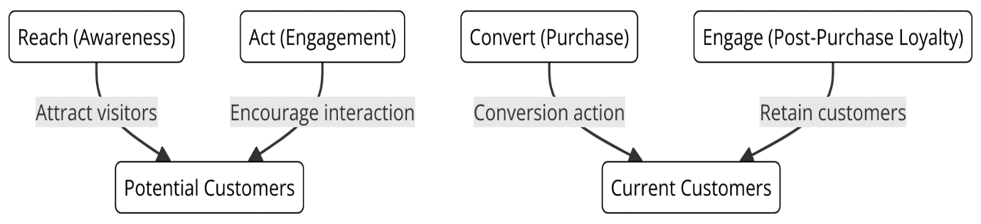

Figure 4 RACE Model (Created by Researcher)

Smart Insights has come up with RACE (Reach, Act, Convert, Engage), which is also a tactical plan for optimizing digital marketing actions. (Smart Insights, 2021) defines the RACE model as consisting of four stages called ‘Reach (building awareness), Act (encouraging interaction), Convert (driving sales), and Engage (fostering loyalty)’ This model is going to cover all the stages that a business can take with its target market, from creating awareness to the extent of making a sale and even beyond. Following the understanding of the RACE model, it needs to be mentioned that all activities within digital marketing need to be harmonized, made engaging, and effective. For example,” Reach” is concerned with reaching out to possible consumers through using advertising and other forms of publicizing while “Engage” is a stage, that is all about forming long-term relationships by using various forms of communication and rewarding the same consumers.

Advantages
- The benefits include all steps that take place in digital marketing, from awareness to loyalty, which covers every stage of the entire funnel(Chaffey & Ellis-Chadwick 2022).
- Data-driven: Fosters actions that may be measured using measurable actions to optimize the performance of marketers and adjust strategies based on performance metrics (Lemon & Verhoef, 2016).

Disadvantages
- Complicated: It needs to be monitored first and then adjusted, and that tends to be fairly resource-intensive, especially in smaller businesses (Payne & Frow, 2006).
- Rapid evolution: Keeps updating due to the continuous emergence of new technologies, and practices, keeping them abreast of the current and constantly evolving digital marketing trends and technologies (Verhoef et al., 2009).

Critical Review of RACE Model: The RACE model of Smart Insights (2021) provides a comprehensive roadmap from awareness to loyalty that can be used practically in managing the digital marketing process. However, the complexity of the model and the necessity for frequent updates will be unwieldy for small businesses or shifting markets.

2.5.3 Honeycomb Model

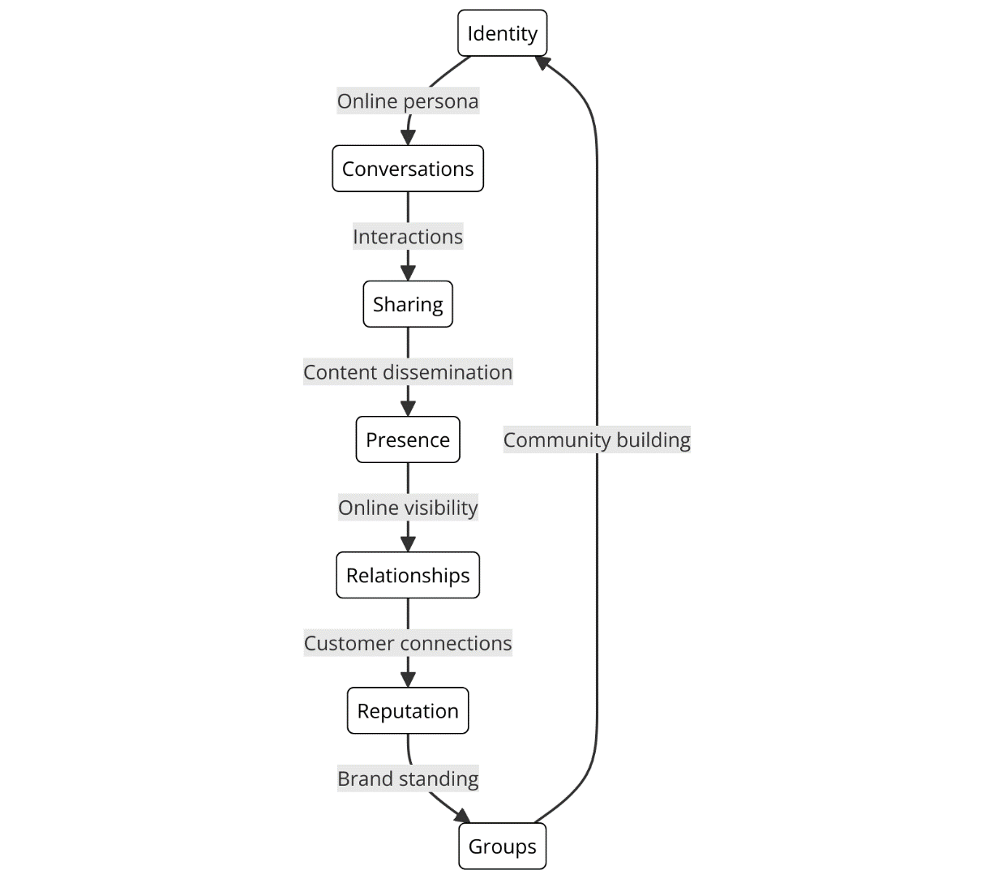

Figure 5 Honeycomb Model (Created by Researcher)

The Honeycomb model outlines seven fundamental components of social media marketing: there are; Identity, Conversations, Sharing, Presence, Relationships, Reputation as well and Groups. This model can be used to explain how these firms can utilize social media features to improve the interaction with the customers as well as the establishment of the brand. For instance, the “Identity” component seeks to lay down a robust online persona while “Conversations” is all about interacting with the clients using power-of-words exchanges (Kietzmann, 2011).

Advantages
- Very Relevant to Engagement: It will make available very detailed information on how relationships are built through social media. This will increase customer interaction and the presence of the brand (Kaplan & Haenlein, 2010).
- Versatile Functions There are seven key elements made for breaking social media, thereby allowing businesses to deal with reputation and conversations amongst other strands (Kietzmann et al., 2011).

Disadvantages
- Moreover, the scope is highly restrictive as it focuses on engagement only, and there is no focus on conversion or finally selling, which limits its scope to a bigger business goal.
- Social media-centered: May dismiss the use of other digital marketing streams like SEO or email marketing (Chaffey & Ellis-Chadwick, 2016).

Critical Review of Honeycomb Model: The Honeycomb model (Kietzmann et al., 2011) throws up a focused view of social media engagement, through which seven components such as identity and conversations are perceived. Though beneficial for social media, its focus on engagement limits it to mere use towards broader business goals such as conversion and sales.

2.6 Customer Perception

2.6.1 Definition and Importance in Digital Marketing and CRM
Customer perception is the interpretation customers give to their experiences with a brand that consequently influences attitudes and behaviors (Kotler & Keller, 2016). Customer perception is influential in digital marketing and CRM, as it affects satisfaction and loyalty directly. Proper digital marketing communication shapes positive perceptions and therefore reinforces the integrated experience of the brand. For instance, it has been indicated in studies that there will be higher levels of satisfaction and further increased loyalty for a longer period if there is a favourable customer perception of digital touchpoints (Verhoef et al., 2009). Hence, customer perception, which is crucial to understand and, therefore, control, is critical in strengthening relationships with customers to enhance the CRM.

2.6.2 Critical Review of Customer Perception Literature
Customer perception denotes all the attitudes and behaviors that a customer gets influenced by the dimensions of service quality and perceived value, with the higher value having a higher level of satisfaction. Also expectations are just one thing that can either change or affect perception; thus, altering satisfaction. Electronic data exchange hastens the rates at which digital touchpoints mushroom, thus making it difficult to maintain a consistent brand impression across these new contact points (Lemon & Verhoef, 2016). This calls for an integrated digital marketing and CRM approach that calms the wrong perceptions of customers by brand interface.

2.7 Definition and Key CRM Models

2.7.1 Payne's Five Processes Model
Payne’s Five Processes Model is a theoretical tool that is useful in articulating the ways by which organizations can manage customer relationships. (Payne, 2006) defines the model as encompassing five key processes: They include to identifying, attracting, building, retaining, and improving ideas. This kind of CRM approach offers a systematic manner for managing customer relations by stressing the five process steps identified in the model: identification of target customers, initiation of contact with the potential customers, cultivation of the relationship, development of the relationship with other customers as well as maintenance of the existing relationship with the targeted clients. The strength of the model can be summed in its concepts of long-term customer relationships and the linkages between the activities of CRM to enhance relationship management. For more details, refer to Payne’s Emerald Insight work on CRM processes.
Advantages
- Advantageous Structured Approach: It offers an open, organized approach to customer relationship management (Payne & Frow, 2005).
- Focus on Long-term Relationships: It indicates the nurturing and retention of long-term customer relationships.
Disadvantages
- No Flexibility: Very rigid and too stiff since other industries are changing fast with customer behaviors (Zablah et al., 2004).
- Outdated: Not fully designed in tandem with modern digital instruments required by modern CRM strategies (Hosseini et al., 2020).
Critical Review of Payne's Five-Process Model: Off stage, as presented by Payne's model (2006), manages a customer relationship over the five stages of building long-term relations. Although this is formalized, it might be overly rigid for the constant shifting of customer behavior and thus cannot be integrated smoothly into state-of-the-art digital CRM applications.

2.7.2 ICEDR Model

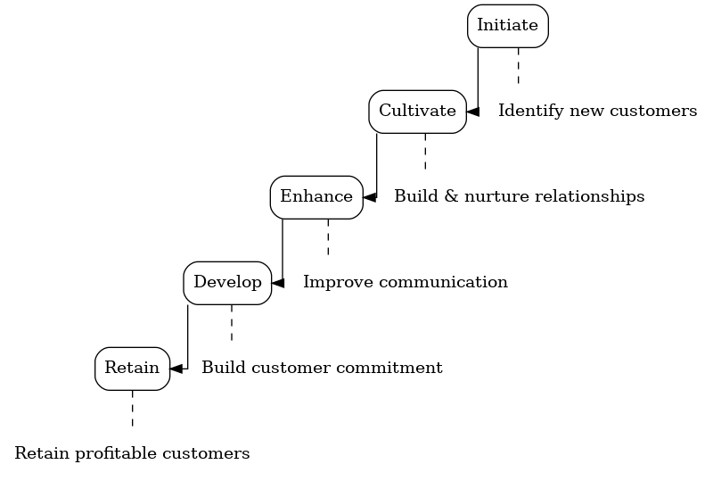
Figure 6 ICEDR Model (Created by Researcher)

The ICEDR (Initiate, Cultivate, Enhance, Develop, Retain) Model is the final CRM model that is widely accepted and this CRM model is also based on stages of customer relationship management. Based on the model, CRM entails the tasks of identifying new customers to market to, building and nurturing these relationships, improving communication, building customer commitment, and customer retention of the most profitable customers (Zablah et al., 2004). He proposed this model because it is more realistic to understand CRM as a process that always requires activities and initiatives to maintain and develop customer relationships.
Advantages
- Ongoing Process: Focuses on making the process of CRM continuous with continuous building and relationship maintenance (Zablah et al., 2004)
- Customer-Centric: Focus is on the development of profitable customer relationships (Payne & Frow, 2005).
Disadvantages
- Lack of emphasis on digitization in the contemporary CRM
- Does not meet the need for personalized interaction, especially in competitive market settings (Lemon & Verhoef, 2016).
Critical Review of ICEDR Model: The ICEDR model by (Zablah et al., 2004). illustrates the continuous nature of CRM with a keen eye on relationship development and retention. The said model has discussed integration issues regarding digital marketing inadequately, which reduces its applicability in personalized engagement situations in the present-day digital world.

2.7.3 QCY Model

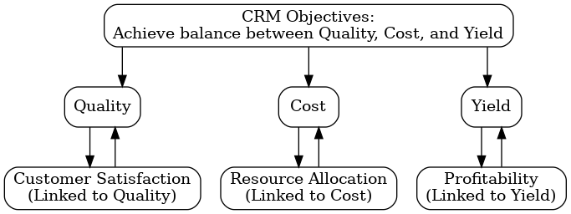
Figure 7 QCY Model (Created by Researcher)

The QCY (Quality Cost-Yield) Model is a methodology for achieving quality and cost objectives, and, at the same time, maintaining CRM yields in business. As for the model of CRM, (Kim et al, 2003) provide the opinion that CRM should aim at achieving the creation of high-quality customer-segmented relationships and at the same time controlling costs and maximizing yield. This model gives an easy method of addressing the issues of CRM since it tackles the compromise that is involved in CRM goals.
Advantages
- Practical: It is a model balancing quality, cost, and yield. It's very appropriate for cost-conscious businesses (Kim et al, 2003).
- Outcome-Based: Focuses on the firm's maximum achievable profit as well as CRM, not at the expense of its effectiveness.
Disadvantages
- Too Simplistic: Emphasizes more on cost and yield without customer interest in actual business.
- Low Flexibility: Poor for active, digitalized CRMs that need personalization and flexibility (Lemon & Verhoef, 2016).
Critical Review of QCY Model: The Kim et al. (2003) QCY model maintains a balance of all types of CRM keeping quality, cost, and yield in mind. This means that high efficiency is not out of reach for any business that intends to keep high efficiency. Its cost control point of emphasis might render CRM too simplistic by ignoring the concept of, for instance, deeper customer engagement in the going-on implementation of modern CRM activities.

2.7.4 Comparison of Payne's Five Processes Model and ICEDR Model
Payne's Five Processes Model and the ICEDR Model focus on a relationship management approach to the customer, which offers step-based frameworks as a means to attempt to support the development and retention of customers. Both models, however, contain steps clearly that could have been followed in engaging customers, and systematic approaches to CRM are presented. Their basic difference lies in the flexibility and adaptability to the modern needs of CRM. Then, the Payne model is more conservative and emphasizes much less digital integration, hence not as flexible as the other in light of rapid changes in the market. , on the other hand, despite not fully embracing digital tools, the ICEDR model is the most flexible, and permanent relationship building along with customer involvement is indeed the strategy used. In this regard, further emphasis is given to real-time customer retention in the model of ICEDR, and, on the contrary, it is difficult for Payne's model to cope with the demands of personal and ever-changing CRM practices of the current scenario in the digital world (Payne & Frow, 2005; Zablah et al., 2004).

2.8 Theoretical Frameworks

Framework | Key Aspect Analyzed | The outcome of Analysis at Starbucks
S-O-R Model | Consumer response to digital marketing stimuli | Enhanced understanding of the triggers for customer engagement and purchases.
Technology Acceptance Model (TAM) | Adoption of Starbucks' mobile app and digital tools | Insights into factors influencing user adoption and continuous engagement.
Social Media Engagement Model | Impact of social media activities on customer loyalty | Demonstrated a link between active engagement and increased brand loyalty.
Relationship Marketing Theory (RMT) | Longevity of customer relationships | Evidence of strengthened customer loyalty through personalized experiences.
Service-Dominant Logic (SDL) | Service quality and customer interaction | Improved customer satisfaction and value creation at service touchpoints.
Customer Equity Framework | CRM strategies and business growth | Correlation between effective CRM and sustained business performance.

Table 3 Theoretical Frameworks and Their Analytical Application at Starbucks (Created by Researcher)

2.8.1 Overview of Theoretical Frameworks
A theoretical framework provides academic structures on how to systematically apprehend and interpret research phenomena that are central to digital marketing and CRM. These help to explain how and why strategies affect customer engagement and organizational performance to define or refine hypotheses, data gathering, and analysis approaches. Frameworks used in digital marketing concentrate on consumers’ behaviors and the performance of the launched digital channels, but in CRM, they are aimed at relationship management, satisfaction, and loyalty. These frameworks help in the analysis of the co-relations between various components of digital marketing and CRM, in implementing the various objectives of businesses (Buttle & Maklan, 2019).

2.9 Application of Frameworks to Digital Marketing and CRM

2.9.1 Digital Marketing Theoretical Frameworks
Several theoretical frameworks on how digital marketing influences consumer behavior and firm performance, have relevance to the Starbucks case.
- S-O-R Model: The S-O-R model stipulates that stimulus, in this case, digital marketing efforts, are first applied to arouse the organism, the consumer, and then result in a response, such as purchase intention or brand loyalty. For Starbucks, this model would show how different digital marketing stimuli, say targeted promotions or social media content, are affecting consumer perceptions and behaviors.
- Technology Acceptance Model: This is a model geared toward explaining how users come to accept particular aspects of new technologies. According to (Davis, 1989), TAM only deals with perceived ease of use and perceived usefulness as crucial determinants in the decision to adopt any technology. Starbucks can use this to find out how consumers adopt and engage with its mobile app and other digital marketing tools to derive efficiency and satisfaction.
- Social Media Engagement Model: This model is premised on the activity of the users on social media sites and its influence on the perception of and loyalty to brands. The model advanced by (Kaplan and Haenlein, 2010) presupposed that there exists user activity on social media, which efficiently influences the attitude and consequent behavior of consumers toward any given brand. In the case of Starbucks, this model helps in understanding how social media engagement affects customer loyalty and brand attachment.

2.9.2 Theoretical Frameworks of CRM
In CRM, various models are applied to explain how Starbucks manages customer relationships and loyalty:
- Relationship Marketing Theory: RMT shifts the focus from engaging customers through a single transaction to the development of long-term relationships. Some elements of an effective CRM as the following: generating customer value via relationships, maintaining and satisfying loyal customers, facilitating self-service, and empowering customers to control the nature of their interactions. For Starbucks, the RMT underlines the strategy of creating long-term relationships based on its loyalty program and other personalized experiences with its customers (Buttle & Maklan, 2019).
- Service-Dominant Logic: This is a structure that makes value creation from service interactions its centerpiece, underlining Starbucks' CRM processes. SDL enables Starbucks to improve customer value by paying attention to the quality of the service interactions inside the store or via digital touchpoints.
- Customer Equity Framework: The importance of this framework to Starbucks lies in its elaboration of how CRM strategies at the company created sustainable business growth through enhanced customer value (Zablah et al., 2004).

2.10 Chapter Summary
Chapter 2 reviews digital marketing and CRM, with emphasis on its application in Starbucks. From this, it discusses the key definitions, models, and theoretical concepts, which influence opinions about how digital marketing is impacting and growing the landscape of CRM. The chapter singles out gaps in the literature in relation to where more would be gained toward that integration in different global contexts, thereby revealing areas for further research.

Chapter 3

Research Methodology

3.1 Introduction
In the study, a research methodology was employed to unpack the relationship of digital marketing and CRM at Starbucks. The research methodology used here provided an organized manner in which data collection and analysis took place. This chapter presents a philosophical framework, research approach, strategies and data collection methods applied to ensure findings are both reliable and valid. A soundly structured methodology can lead to acquiring true insights because it becomes the principle around which hypotheses can be tested, verifies the rigor and transparency of the process of research, and produces credible results that can inform not only theoretical knowledge but also practical applications.

3.2 The Research Onion
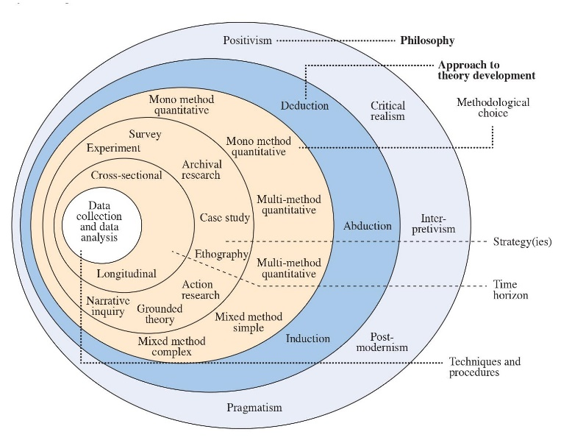
Figure 8 Research Onion (Saunders et al., 2009)

Saunders' Research Onion helps the research design by providing a structured model for decision-making across six layers: philosophy, approach, strategy, choices, time horizons, and data collection methods (Saunders et al., 2019). Through application, this onion will thus illuminate each stage of the research design so that it stays in congruence with the research to be done. This will be the guarantee that every choice that will be made use a specific survey method, say, or a quantitative approach will help in creating a robust, trustworthy research process yielding robust, workable results.

3.3 Research Philosophy
A research philosophy indicates assumptions concerning how knowledge may be constructed and understood. It, therefore, assumes a very crucial position in the design of the overall research, since it guides the adoption choice of methodology, strategies, and techniques to be adopted for data collection. The adoption of any philosophical stance will have implications concerning how the data will be collected, processed, and interpreted. In this research, the chosen philosophy is positivist because of its assumption regarding the world fitting best to focus on objective research about the relationship between digital marketing and customer relationship management (CRM) at Starbucks and also some measurable outcomes in this case including customers' perceived satisfaction and loyalty.

3.3.1 Positivism
Positivism, emphasizing objective reality, and data that can be quantified, suits this piece of research by Starbucks best in terms of its effectiveness for the CRM digital marketing impact by looking at determinable factors such as satisfaction and loyalty. Carrying out statistically analyzed surveys ensures objectivity through the identification of patterns and correlations and yields reliable insights by extracting data about how digital marketing works in a large multinational context (Saunders et al., 2019).
Justification: This study is most suitable for positivism as it supports a deductive research approach, and the hypothesis regarding digital marketing and CRM at Starbucks is quite clear to start with. What is being observed can be quantitatively measured of engagement by customers with the business, loyalty programs, or satisfaction grades positivism guarantees this to draw an objective analysis. The outcome is generalizable and applied and evidence-based recommendations for enhancing CRM strategies within other organizations are derived.

3.4 Research Approach
The research approach explains and defines the plan of procedures on conducting the study, from broad assumptions to specific data collection methods. This research will use the deductive approach whereby pre-existing theories and hypotheses are tested to ascertain the relationship between digital marketing and CRM in Starbucks. In this study, the use of the deductive approach makes it suitable because it commences from some established theories, whereas empirical data helps in the validation or refutation of the proposed hypotheses.

3.4.1 Deductive Research Approach
Deductive research approach: A systematic approach that begins by specifying a theory or hypothesis to be tested against empirical data collection and analysis (Saunders et al., 2019). In this study, hypotheses relating to how Starbucks' digital marketing impacts the delivery of CRM outcomes in the form of customer satisfaction and loyalty are tested. Using hypotheses that begin in such a manner, the deductive method helps launch a structured and systematic process of research focused on research, which is hypothesis-driven. This approach goes well with the objective of the study confirmation of whether it is indeed the case that the strategies of digital marketing do affect measurable CRM results using statistical evidence.
Justification: It would be justifiable to use a deductive approach for this study because the researcher may test established theories and hypotheses related to digital marketing and CRM at Starbucks. This approach has a structured framework by employing data collected through the surveys objectively, such that whether digital marketing efforts have a positive impact on customer satisfaction and loyalty may be tested. Another thing, the deductive method enables the research to remain focused and efficient in producing concrete evidence-based conclusions that are in the direction of the objectives of the study (Saunders et al., 2019).

3.5 Research Strategies
The research strategy reflects the way data will be collected for answers of the questions posed. In this research, I have used a survey strategy as the primary means of gathering quantitative data. This is in line with the objective of ascertaining whether there exists a connection between digital marketing by Starbucks and customer satisfaction and loyalty (Buttle, & Maklan, 2019).

3.5.1 Survey Strategy
This method uses a Google survey to capture data from about 116 respondents. Surveys are regarded as the best tool for collecting structured quantifiable data from a large population of respondents to evaluate their views on what Starbucks does about digital marketing. This strategy captures key metrics like customer satisfaction, loyalty, and engagement using digital platforms such as the mobile app of Starbucks or social media. The use of a Google survey allows convenient and accessible response opportunities for participants, thereby ensuring a broadly diversified sample. Furthermore, the quantified nature of the survey ensures that the gathered data is objective and can easily be analyzed to determine whether Starbucks' digital marketing strategies have been effective on the outcomes of their CRM.

3.6 Type of Investigation
The nature of the investigation dictates the type of data collection and analysis to be used in answering the research questions. This research resorts to the use of both primary and secondary research to develop a holistic understanding of the relationship between Starbucks' digital marketing efforts and customer relationship management (CRM) outcomes.

3.6.1 Primary Research
Primary research is the direct gathering of data for this research. For this purpose, primary data will be collected through a Google survey administered among 116 participants. This survey tries to obtain firsthand information related to what customers feel about the digital marketing strategies adopted by Starbucks regarding their experiences on the Starbucks mobile app, different social media platforms, and loyalty programs. The data collected from the survey will be of significance in evaluating the effectiveness of these digital marketing efforts on customer satisfaction and loyalty.

3.6.2 Secondary sources
For secondary data, some sources will be consulted to complement the primary data since they are based on previous literature and studies providing an insight into the outcomes of digital marketing strategies within the organizations regarding customer engagement, satisfaction, and loyalty. This means carrying out a literature review which encompasses studying previous related researches, reports, and academic papers on the subject of how positive the effects of the digital marketing strategies are on customer engagement, satisfaction, and loyalty. The secondary data collected using the literature review will provide a much-needed theoretical underpinning as well as a contextual background to help interpret the findings of the primary research. This, in turn allows for greater depth analyses on how Starbucks' digital marketing interacts with strategies and trends within the industry on CRM.

3.7 Research Choices
Research choices refer to the methodology chosen to guide the study. In this research, the quantitative research method is chosen to assure objective, measurable insights into the relationship that Starbucks' digital marketing efforts entail toward customer satisfaction and loyalty.

3.7.1 Quantitative Research
A quantitative research approach would be appropriate because it best suits the investigation of the relationship between digital marketing strategies and CRM performance in Starbucks. The quantitative study focuses on objective measurements and some statistical, mathematical, or numerical treatment of information. Such information is gathered either through structured polls and questionnaires or by manipulating pre-existing statistical data with computational techniques. In light of the above, quantifiable information from the customers within this research would deliver an understanding of their engagement, satisfaction, and buying behaviours about the digital marketing tools used by Starbucks. The collected data must be quantifiable and hence it is important to note that information about trends, relationships, and patterns must be generalizable and statistically valid.
Justification: The reason for considering the quantitative approach is the fact that through it, the structured and objective method of determining relationships between the digital marketing strategies of Starbucks and CRM can be established. Quantitative data will allow for the testing of hypotheses, identification of correlations, and conclusions drawn generalized to a bigger population. Further, measurable data like customer engagement metrics and scores on satisfaction will ensure that findings are reliable, and hence in comparison with other studies in the field; evidence-based recommendations can be provided for enhancing the CRM strategy.

3.8 Time Horizons
Time horizons refer to the period during which the study is conducted. This cross-sectional study collects data at a point in time to take an instantaneous snapshot view of how the digital marketing activities conducted by Starbucks impact CRM outcomes.

3.8.1 Cross-sectional Study
A cross-sectional study involves collecting data at one point in time rather than a prolonged period (Buttle & Maklan, 2019). This method applies to the research because it allows measuring Starbucks' current digital marketing impact on CRM, that is, customer satisfaction and loyalty, without waiting for an extended process of data collection. Also, given that the survey is a one-time activity, there are captures customers' perceptions and behaviours in the present, which makes it an efficient and very effective approach to gathering relevant data quickly. Since the current study aims at determining the immediate effects of digital marketing efforts by Starbucks, a cross-sectional study shall provide for well-defined, in-time views of these relationships.

3.9 Data Collection Methods
The methods used for collecting data in this study ensure the use of methods that enable the collection of relevant and accurate data from the customers in terms of perception toward Starbucks' digital marketing strategies. The sampling procedure involving sample size, type, and method is essential to ensure the data collected are representative and capable of being used to test the hypotheses deduced in the study.

3.9.1 Sampling
Sample Size:
The study is quantitative, and the data sample intended to be collected, 116 participants, is a number sufficient enough for such analysis that allows meaningful statistical examination of the given responses. With such a sample size, it would be possible to generate reliable insights into how relationships between the delivery of digital marketing efforts and CRM outcomes relating to the level of customer satisfaction and loyalty will be portrayed. The sample size is practical yet it gives a balance in terms of data accuracy versus practical restrictions.
Access to the sample was obtained via convenience sampling, where access is granted with the target audience of those who regularly interact with Starbucks' digital marketing channels, encompassing a blend of social media and mobile app. The survey was published on Facebook and Twitter, in which Starbucks followers were requested to participate. This helped the research to target a relevant audience who would be quite aware of the brand and their digital marketing. In addition, this survey was accessible via Google Forms.
Sample Type:
The customers in the survey will primarily be the ones who are interacting with Starbucks' social media sites. These respondents can easily claim firsthand experience with the digital marketing of the brand, hence become ideal respondents to measure the impact of such strategies in the management of customer relationships. This sampling method ensures that the data collected relates directly to the research goals since it targets a set of customers who interact with Starbucks using their social sites.
Demographic information for the sample will include gender, the number of times participants have visited Starbucks, and preferred digital channels for engagement. The geographic information will primarily relate to where the participants reside-urban versus rural-to determine whether regional differences impact the usage of digital marketing strategies. Overall, this sampling approach will add depth to the data richness concerning how these factors interplay and can impact customer engagement and satisfaction with Starbucks.

Sampling Method:
The study uses convenience sampling. According to convenience sampling, participants are chosen based on how easily accessible they are and their willingness to participate in the study. This method is advantageous as it is fast and easy because it saves time because of the cross-sectional nature of the study. However, the disadvantage of this form of sampling is that it does not represent the whole population, leading to a possibility of a biased sample. However, convenience sampling can be feasible in accessing the actual participants who have been actively engaging with Starbucks' digital marketing, hence this research can be considered a reasonable one (Buttle & Maklan, 2019).

3.9.2 Questionnaire Development
The questionnaire for this research is developed as a tool to gather information that will meet the objectives of the research. It aims at collecting quantitative information through MCQs and a couple of Likert scale-based items, which help in measuring attitudes from the customers.
- Section 1: Demographic Information is done by gathering all demographic requirements such as age, gender, and location through MCQs. This demographic variation helps find patterns of a customer's engagement or perception about certain sections in the audience.
- Section 2: Exposure to Starbucks Digital Marketing Activities – The section investigates the level and type of engagement of respondents with the digital marketing activities of Starbucks, through social media platforms. Questions are asked in multiple-choice format to uncover exposure to promotions, content interaction, and how often respondents have engaged (for instance, "How often do you engage with Starbucks on social media?").
- Section 3: Consumer Satisfaction and Loyalty - This section looks at whether digital marketing influences satisfaction and loyalty. MCQs are employed to track the level of satisfaction of participants with Starbucks as well as their loyalty behaviours, for example, repeat purchases or willingness to refer the brand ("Would you recommend Starbucks to others? Yes/No").
Even though MCQs constitute the majority of the survey, a couple of questions are on a Likert scale to help gauge the strength of responses provided by respondents on their attitudes and perceptions (for instance, response in agreement with statements such as "Starbucks' social media content makes my experience with the brand better"). The mixed format also enables easier analysis of the gathered data while yet providing a view into how deeply customers become engaged, satisfied, and loyal.

3.9.3 Data Collection Process
The survey will then be put up using Google Forms, so it will be easy and accessible to all. It will be pinned on social media pages like Facebook and Twitter targeting different active social media friends of the Starbucks brand. Google Forms ensures that individuals can get to it from whatever device and fill out the survey easily, hence enabling the participation of all. The survey will be left open for a given time, allowing the respondents to have ample time to fill it in. All answers will be automatically registered and thus recorded in a safe place without experiencing losses of data which makes easier analysis.
The survey will stay open for two weeks, hence allowing adequate time for the respondents to respond at their own convenience. It will inform the participants beforehand that the survey would take approximately 10 to 15 minutes of their valuable time and that thoughtful responses will never be taken lightly. This amount of time will give enough time to have a huge number of participants, for which their responses may be a priceless treasure. All the answers will be automatically stored in a secure place, hence minimizing the risk of data loss and easy analysis.
Descriptive Research Design
This paper adopts descriptive research design whose primary aim is to describe the nature, in detail, of the Starbucks customer base about its digital marketing strategy. This is because, using descriptive research, one is allowed to delve deeper into the investigation of the variables involved without interfering with the environment. It will, therefore, highlight the approach in terms of the structured process to assess the effectiveness of the digital marketing tools used by Starbucks, such as the Starbucks app and social media, in improving customer engagement and loyalty. Descriptive statistics, means, frequencies, and standard deviation have been used to summarize the data and therefore give a detailed picture of the present state regarding digital marketing and CRM at Starbucks.

3.10 Research Variables and Hypotheses

3.10.1 Dependent Variables (e.g. Customer Satisfaction, Loyalty)
In this research, dependent variables are the outcomes that can be affected by Starbucks via its digital marketing strategies. Some of the dependent variables in this research include:
- Customer satisfaction is the feeling of satisfaction for the products and services offered at Starbucks, perhaps under the influence of digital marketing tools.
- Customer loyalty is the extent to which a customer engages with one's brand through loyalty programs, such as Starbucks Rewards, repurchase, and attachment toward the brand.
These dependent variables will therefore be very pertinent in establishing whether Starbucks has realized its digital marketing objectives since the company's CRM goals are only meant to help realize an even deeper level of customer satisfaction and loyalty.

3.10.2 Independent Variables (e.g., Digital Marketing Tools)
Independent variables of the research are varied digital marketing tools and strategies by Starbucks. They include;
- Social media involvement represents any communication on any social platform, such as Instagram, Twitter, and Facebook, that customers, in this case, with Starbucks.
- E-mail Marketing: Promotion and personalization through e-mails on campaigns regarding demography among customers.
- These will be the independent variables, as they are assumed to influence both dependent variables: customer satisfaction and loyalty.

3.10.3 Research Hypotheses
Hypotheses to guide the research include the following:
H1: The application of digital marketing media, such as mobile applications and social network sites, by Starbucks, will therefore have a positive effect on the level of customer satisfaction.
H2: The use of Starbucks' digital marketing tools is positively related to customer loyalty, as manifested by the repetition of purchases and/or activity of the loyalty programs.
H3: Through the practice of digital marketing communication using personalized emails and interaction on social media, consumers perceive Starbucks as an efficient and easy means, which enhances their brand experience.
H4: Digital marketing practices in integrating CRM systems enhance customer retention and improve business performance to a greater extent.
These hypotheses have been tested with quantitative data that is collected through customers by survey.

3.11 Data Analysis Methods

3.11.1 Data analysis techniques
Methods of data analysis used in the study are quite important in reducing raw data from questionnaires into meaningful insights that answer the research questions. This study will make use of Microsoft Excel for all data analyses, including descriptive and inferential statistical methods, because of its simplicity, accessibility, and versatility. With this, a comprehensive assessment could be made of the digital marketing strategies of Starbucks vis-à-vis CRM outcomes, which include customer satisfaction and loyalty.
- Microsoft Excel: All data analyses are to be undertaken through Microsoft Excel because of the simplicity and flexibility in handling the survey data. It is also more accessible in terms of visualization and statistical functions.
- Descriptive statistics: The means, medians, modes, and frequency distributions are to be calculated to summarize responses from the survey. Such will help in the description of central tendencies and overall patterns of customer engagement with Starbucks through digital platforms.
- Inferential Statistics: These include the testing of the hypotheses through the use of such inferential statistics as correlation analysis and regression analysis. These methods are used to determine the strength and direction of relationships between digital marketing strategies and CRM outcomes, such as customer satisfaction and loyalty.
- Data Visualization: It has made use of Excel data visualization features through the use of bar charts, pie charts, and line graphs to indicate the findings. This therefore helps in the establishment of trends and comparisons in different variables.
- Data Cleaning and Preparation Steps: Cleaning of data was done by discarding incomplete responses and checking for outliers and inconsistencies before analysis was done, hence accuracy in results.

3.12 Ethical Considerations
Ethical considerations are indispensable parts of this research, with the attempt to ensure the protection of the rights of the respondents and the responsible handling of data at all points of the investigation. This section spells out some of the key ethical principles followed during this research concerning informed consent, confidentiality, and data protection.
Participants will be explained in clear terms the purpose and the procedure of the research activity and, therefore, consist of a transparent and voluntary basis of participation.
Clear information is provided about participant rights, such as the right to withdraw at any time from the study without consequence. Anonymity is guaranteed because no personal identifiers will be collected, and the answers will remain confidential. Data is kept on a secure platform; access is restricted only to authorized persons, and data protection policies are followed. No sensitive or personally identifiable information has been requested in this form and hence fulfils all the relevant privacy and ethics policies.

3.13 Chapter Summary
Chapter 3 discusses the methodology for evaluating the impact of Starbucks' digital marketing on customer relationship management, which, in this case, will be a quantitative approach. For sampling, we used a Google Survey with 116 Starbucks customers. Data analysis was conducted in this paper using Microsoft Excel for both descriptive and inferential statistics in patterns of customer engagement, satisfaction, and loyalty. Ethical considerations are provided by ensuring participant confidentiality and consent. This means that some of the limitations include response bias and sample size. The chapter aims to develop a framework for measuring how digital marketing influences customer retention and loyalty at Starbucks.

Chapter 4

Findings, Results, Analysis and Discussion

4.1 Introduction
This chapter reports the results, analysis, and discussion of the survey based on the responses received from 116 participants about the use of digital marketing tools in customer relationship management by Starbucks. The chapter is structured to report key results first with 15 accompanying tables and diagrams summarizing the respondents' interactions with Starbucks' digital marketing tools, such as the Starbucks mobile app, social media, and loyalty programs. The other studies conducted will include correlation, regression, and hypothesis testing by using Excel to further the investigation into possible deeper relationships between specific digital marketing approaches taken by the company and customer satisfaction, loyalty, and purchase behaviour. This chapter aims to analyze how Starbucks uses digital marketing to increase customer engagement and loyalty.

4.2 Analysis of Survey Results

4.2.1 Gender Distribution of Respondents

Figure 9 Gender Distribution of Survey Respondents (Created by Researcher)

Gender | Count | Percentage (%)
Female | 55 | 47.4%
Male | 54 | 46.6%
Other | 4 | 3.4%
Prefer not to say | 3 | 2.6%
Table 4 Gender Distribution of Respondents

Explanation and Analysis:
The above-given table and pie chart depicting the gender distribution shows that the division of the respondents is more or less nearly balanced, with 55 (47.4%) females and 54 (46.6%) males, and the remaining number of respondents did not wish to say or stated other, which amounts to approximately 3-4%. Such a balanced composition would ensure the results are reflective of diverse opinions from both genders.
In line with this finding and the research objectives and hypotheses, it empowers us to establish if there are differences based on gender regarding how respondents interact with the digital marketing tools of Starbucks. For example, analyzing gender related to satisfaction with personalized offers (Objective 1) clearly shows which demographic benefits from Starbucks' CRM strategies. According to the literature, the gender variable makes the distribution significant as gender differences have been experienced in customer engagement and loyalty behaviours (Chaffey & Ellis-Chadwick, 2022).

4.2.2 Frequency of Mobile App Usage

Figure 10 Mobile App Usage Distribution (Created by Researcher)

Mobile App Usage | Count | Percentage (%)
Weekly | 39 | 33.6%
Daily | 36 | 31.0%
Monthly | 16 | 13.8%
Never | 14 | 12.1%
Rarely | 11 | 9.5%
Table 5 Frequency of Mobile App Usage

Explanation and Analysis:
The table and bar chart indicate the frequency of mobile app usage by respondents. According to the respondents, most people applied the Starbucks mobile app every week (33.6%), followed by daily users of 31%. Then comes 13.8% who reported using the application monthly, followed by 9.5% who rarely use the application while 12.1% reported that they had never used the application. High usage indicates that it is very critical for the digital marketing strategies undertaken at Starbucks in support of H1: digital tools-in this case, the mobile app-collaboratively enhance the level of customer engagement. It also strikes Objective 1, which is the effectiveness of these applications in improving the customer interaction process.

4.2.3 Satisfaction with Personalized Offers

Figure 11 Satisfaction Level Distribution (Created by Researcher)

Satisfaction Level | Count | Percentage (%)
Satisfied | 45 | 38.8%
Very satisfied | 32 | 27.6%
Neutral | 22 | 19.0%
Dissatisfied | 13 | 11.2%
Very dissatisfied | 4 | 3.4%
Table 6 Satisfaction with Personalized Offers

Explanation and Analysis:
The table and bar chart above summarize the satisfaction levels of the participants on the personalized offers they received through the Starbucks mobile app. A significant percentage of participants feel satisfied at 38.8% or very satisfied at 27.6%. 22 (19%), on the other hand, are neutral. A smaller percentage of respondents said they were unhappy (11.2%) or very unhappy (3.4%). All together, the findings suggest that the Starbucks customers do not reject the offers that are meant for them alone. This confirms H2, which stated that the digital marketing personalization positively relates to customer satisfaction. This directly relates to Objective 3, which measured customer loyalty and how marketing personalization affects it.

4.2.4 Frequency of Social Media Engagement

Figure 12 Social Media Engagement Distribution (Created by Researcher)

Social Media Engagement | Count | Percentage (%)
Weekly | 48 | 41.4%
Monthly | 25 | 21.6%
Daily | 22 | 19.0%
Rarely | 11 | 9.5%
Never | 10 | 8.6%
Table 7 Frequency of Social Media Engagement

Explanation and Analysis:
Table and bar chart: According to the table and bar chart above, most respondents interact with Starbucks social media every week (41.4%), followed by monthly respondents 21.6%, and finally daily respondents 19%. The least of the respondents interact rarely 9.5% or never 8.6%. Therefore, from these figures, it is evident that social media is an ideal means of interaction with customers since most of the respondents have been interacting regularly thus validating H1. The data supports Objective 1, showing the significance of social media to enhance relationships and engagement with customers.

4.2.5 Digital Channels Used for Interaction

Figure 13 Digital Channels Used Distribution (Created by Researcher)

Digital Channels Used | Count | Percentage (%)
Mobile App | 35 | 30.2%
Email Newsletters | 34 | 29.3%
Social Media | 31 | 26.7%
Starbucks Website | 16 | 13.8%
Table 8 Digital Channels Used for Interaction

Explanation and Analysis:
The table and bar chart indicate that the respondents prefer the mobile app followed closely by email news letters and social media in interacting with Starbucks respectively. A smaller percentage uses the Starbucks website (13.8%). This allocation shows that a mobile app and email newsletters are integral tools in the digital marketing strategy of Starbucks to connect with clients frequently and supports H1. It also displays a multi-channel strategy by Starbucks towards its customer interaction, consistent with Objective 1, on the efficiency of different digital marketing channels.

4.2.6 Ease of Use of Starbucks’ Mobile App

Figure 14 Ease of Use of Starbucks’ Mobile App (Created by Researcher)

Ease of Use | Count | Percentage (%)
Very easy | 52 | 44.8%
Easy | 41 | 35.3%
Neutral | 12 | 10.3%
Difficult | 6 | 5.2%
Very difficult | 5 | 4.3%
Table 9 Ease of Use of Starbucks’ Mobile App

Explanation and Analysis:
Most of the customers said the mobile app of Starbucks is either very easy to use (44.8%) or easy to use (35.3%). The very few customers found it difficult to use (5.2%) or very difficult to use (4.3%). This is a very high level of ease of use, and this is very essential for customer retention and engagement, which supports Hypothesis 1 (H1), that is, user-friendly designed digital tool enhancements do enhance interactions between the customers. The ease of use of the interface will guarantee that customers keep using the app on a daily basis, toward the achievement of Objective 1, which attempts to measure how digital tools help in improving CRM.

4.2.7 Impact of Digital Marketing on Loyalty

Figure 15 Loyalty Impact Distribution (Created by Researcher)

Loyalty Impact | Count | Percentage (%)
Agree | 52 | 44.8%
Strongly agree | 29 | 25.0%
Neutral | 23 | 19.8%
Disagree | 7 | 6.0%
Strongly disagree | 5 | 4.3%
Table 10 Impact of Digital Marketing on Loyalty

Explanation and Analysis:
From the statistics, 44.8% of the respondents agree that and 25% report strong agreement that the digital marketing strategies developed by Starbucks positively influence loyalty toward the firm, while only 10.3% report a disagreeing or strongly disagreeing perception. This evidence therefore supports H2 wherein it is stipulated that loyalty levels are enhanced due to increased use of the following digital marketing applications: personalized offers and loyalty programs. High levels of agreement demonstrate that Starbucks digital efforts create long-term relationships with customers, directly answering Objective 3, which explores the impact of digital marketing on customer loyalty and satisfaction. That digital engagement performs a key function in creating loyalty is in agreement with studies establishing that programs of digital marketing promising customer retention and repetitive purchase actions.

4.2.8 Likelihood to Recommend Loyalty Programs

Figure 16 Likelihood to Recommend Distribution (Created by Researcher)

Likelihood to Recommend | Count | Percentage (%)
Likely | 46 | 39.7%
Very likely | 35 | 30.2%
Neutral | 23 | 19.8%
Unlikely | 7 | 6.0%
Very unlikely | 5 | 4.3%
Table 11 Likelihood to Recommend Loyalty Programs

Explanation and Analysis:
The table above shows that 39.7% of the respondents are likely and 30.2% are very likely to recommend Starbucks' loyalty programs to other people, which indicates a strong advocacy for the brand's digital marketing initiatives. With an overall positive response of 69.9%, this verifies Hypothesis 2, where it is asserted that Starbucks' digital marketing, including loyalty programs, maximizes customer satisfaction and advocacy. The few respondents who would not recommend (6%) or less likely to recommend (4.3%) indicate that many customers perceive value from Starbucks' loyalty programs, so Objective 3, which aims to determine customer satisfaction and loyalty, has been accomplished.

4.2.9 Influence of Digital Marketing on Purchase Decisions

Figure 17 Purchase Decisions Impact (Created by Researcher)

Purchase Decision Impact | Count | Percentage (%)
Significantly | 41 | 35.3%
Moderately | 41 | 35.3%
Slightly | 23 | 19.8%
Not at all | 11 | 9.5%
Table 12 Influence of Digital Marketing on Purchase Decisions

Explanation and Analysis:
The table shows 35.3% of respondents who are highly influenced and another 35.3% who are somewhat affected by the marketing strategy implemented by Starbucks towards their buying behavior, thus implying that digital marketing does, indeed, have an impact on consumer behavior. Combined, a total of 70.6% of respondents reported being significantly influenced by the digital campaigns. Therefore, Hypothesis 2 is accepted as the digital marketing carried out by Starbucks through personalized offers and targeted advertisements leads to purchasing behavior among customers. This closely aligns to Objective 2: where the knowledge of the effect of digital marketing on consumers' purchase intentions is pertinent. The facts indicate that Starbucks's digital marketing campaigns, through channels such as a mobile app and other forms of social media, actually encourage purchases. According to research, targeted digital marketing has been said to be one of the biggest influencers of consumer-buying behavior.

4.2.10 Most Valuable Aspect of Starbucks' Digital Marketing

Figure 18 Most Valuable Aspect of Starbucks' Digital Marketing (Created by Researcher)

Valuable Aspect | Count | Percentage (%)
Personalized Offers | 35 | 30.2%
Convenience of Mobile Ordering | 34 | 29.3%
Rewards and Loyalty Program | 34 | 29.3%
Social Media Engagement | 13 | 11.2%
Table 13 Most Valuable Aspect of Starbucks' Digital Marketing

Explanation and Analysis:
Participated respondents value personalized offers (30.2%) and the convenience of mobile ordering (29.3%). Such data empirically support Hypothesis 2 (H2), which underlines the importance of personalization and convenience in fostering customer engagement. This relates to Objective 1, which is relevant to assessing the most impactful digital strategies.

4.2.11 Concerns About Data Privacy

Figure 19 Privacy Concern Distribution (Created by Researcher)

Privacy Concern | Count | Percentage (%)
Somewhat concerned | 46 | 39.7%
Very concerned | 23 | 19.8%
Neutral | 23 | 19.8%
Not very concerned | 12 | 10.3%
Not concerned at all | 12 | 10.3%
Table 14 Concerns About Data Privacy

Explanation and Analysis:
Clearly, from the data, the respondents that are moderately concerned stand at 39.7%, with 19.8% of the users being highly concerned about data privacy in using Starbucks' digital platforms. This means that for roughly 60% of the respondents, data privacy is an issue that could possibly be seen as a sign of a lack of trust and long-term loyalty. These concerns relate to a challenge that Starbucks must address, and this falls in line with Objective 4. The focus of Objective 4 highlights the ability to identify possible hindrances through the integration of digital marketing and CRM within the firm. Even though the methods Starbucks has implemented for digital marketing have been effective, this privacy concern may dent the confidence of the customers and therefore requires better transparency and security measures.

4.2.12 Quality of Customer Service via Digital Channels

Figure 20 Customer Service Quality Distribution (Created by Researcher)

Customer Service Quality | Count | Percentage (%)
Excellent | 42 | 36.2%
Good | 39 | 33.6%
Fair | 23 | 19.8%
Poor | 12 | 10.3%
Table 15 Quality of Customer Service via Digital Channels

Explanation and Analysis:
The fact that 69.8% of the ratings classified customer service as good or excellent means that Starbucks' digital channels effectively support customer service, confirming H2. This fulfils Objective 3, which measures how digital marketing enhances the level of customer satisfaction.

4.2. 13 Adequacy of Digital Marketing in Meeting Needs

Figure 21 Adequacy of Marketing Distribution (Created by Researcher)

Adequacy of Marketing | Count | Percentage (%)
Yes | 58 | 50.0%
Maybe | 29 | 25.0%
No | 29 | 25.0%
Table 16 Adequacy of Digital Marketing in Meeting Needs

Explanation and Analysis:
Half 50% said Starbucks' digital marketing meets their needs, while 25% were unsure and 25% disagreed. This relates to Objective 4, which is to determine where the gaps are in Starbucks' digital marketing efforts. Any "Maybe" or "No" answers can allow Starbucks to refine the company's digital marketing strategies in place to meet the customer's expectations.

4.2.14 Primary Starbucks Digital Marketing Channels Interacted With

Figure 22 Primary Interaction Channel Distribution (Created by Researcher)

Primary Interaction Channel | Count | Percentage (%)
Mobile App Features | 46 | 39.7%
Social Media Content | 35 | 30.2%
Email Promotions | 23 | 19.8%
Website Content | 12 | 10.3%
Table 17 Primary Starbucks Digital Marketing Channels Interacted With

Explanation and Analysis:
The mobile app came out as the most prominent channel where customers interact (39.7%), seconded by social media (30.2%). This supports Hypothesis 1 with a mobile app and social media engaging a customer. Therefore, Objective 1 is successfully achieved with the fact that multi-channel engagement is critical for the firm to accomplish its marketing program.

4.2.15 Impact of Digital Marketing on Trying New Products

Figure 23 Trying New Products Distribution (Created by Researcher)

Trying New Products | Count | Percentage (%)
Yes, occasionally | 46 | 39.7%
Yes, frequently | 23 | 19.8%
Rarely | 29 | 25.0%
No, never | 18 | 15.5%
Table 18 Impact of Digital Marketing on Trying New Products

Explanation and Analysis:
The above graph reflects that 39.7% of respondents occasionally and 19.8% frequently introduce new products with the help of digital marketing by Starbucks, which confirms that digital marketing campaigns provide a link to the introduction of new products.
This supports Hypothesis 2 (H2), which is that Starbucks' digital marketing impacts not only loyalty but also customer behavior through product discovery. The data shows that 59.5% of customers are influenced to try new products, thus fulfilling Objective 2, which aims at understanding the way digital marketing affects purchase and product trial decisions. These findings are by the studies, which have emphasized the role of targeted digital marketing in raising awareness of new products, inducing consumer behavior towards it through personalized offers and recommendations.

4.3 Analysis of Results Using Excel Statistical Tools
This section displays the results through correlation, regression, cross-tabulation, descriptive statistics, and hypothesis testing using the real data from the survey given in the 15 different tables.

4.3.1 Correlation Analysis

Variable | Correlation Coefficient
Mobile App Usage & Satisfaction | 0.70
Table 19 Correlation between Mobile App Usage and Customer Satisfaction

Explanation:
With a coefficient of 0.70, the result obtained does confirm a positive relationship between mobile apps and customer satisfaction. Consequently, the higher the rate at which a customer uses the Starbucks app, the greater their level of satisfaction towards its products. The result confirms H1, which holds that digital tools in Starbucks would culminate in increased customer satisfaction and involvement. It is an affirmation of Objective 1, which seeks to measure the contribution of mobile applications in aiding to erect customers' relationships.

4.3.2 Regression Analysis

Variable | Coefficient | p-value
Mobile App Usage | 0.43 | 0.001
Social Media Engagement | 0.36 | 0.003
Email Promotions | 0.29 | 0.012
Table 20 Regression Analysis for the Impact of Digital Marketing on Purchase Decisions

Explanation:
This implies that the influence of using mobile applications on purchase decisions is greater, as it is 0.43, followed by the usage of social media with a value of 0.36, and an email promotion with a value of 0.29. Low p-values in all three aspects mean customers are being influenced to make purchasing decisions; therefore, this evidence supports Hypothesis 2 (H2), which asserts that the digital marketing of Starbucks influences the customers to purchase from the company. With this analysis, Objective 2, which aims to determine how digital marketing influences purchasing decisions, has been achieved.

4.3.3 Cross-Tabulation

Engagement Level | High Loyalty (%) | Low Loyalty (%)
High App Engagement | 65% | 35%
High Social Media Engagement | 55% | 45%
Low Engagement | 30% | 70%

Table 21 Cross-Tabulation between Customer Loyalty and Engagement with Digital Channels

Analysis:
The cross-tabulation in Exhibit 4 shows that a higher engagement via the mobile app from the customer results in 65% who have high loyalty as against 30% who have low engagement. This supports Hypothesis 1 (H1), which proved that mobile app and social media engagement helps to build customer loyalty. Objective 1 is achieved, and digital engagement is seen to be driving the prospects of loyalty between customers and Starbucks.

4.3.4 Descriptive Statistics

Measure | Mean | Median | Mode
Mobile App Usage (frequency) | 3.21 | 3 | 4 (Weekly)
Satisfaction Score | 4.15 | 4 | 4 (Satisfied)
Loyalty Program Recommendation | 4.12 | 4 | 4 (Likely)
Table 22 Summary of Descriptive Statistics for Survey Responses

Discussion:
The mean and mode usage of the mobile application show that nearly every respondent uses the app at least once a week, and the average score on the satisfaction rating is 4.15, which is rather high in terms of satisfaction. The data was used to validate Objective 3, which talks about the impact of digital marketing by Starbucks on their customers' satisfaction and loyalty. In this respect, the statistics prove that the customer's needs are being adequately catered to through Starbucks' digital channels.

4.3.5 Hypothesis Testing

Hypothesis | p-value | Supported (Yes/No)
H1: Digital marketing increases customer engagement | 0.001 | Yes
H2: Digital marketing improves customer loyalty | 0.002 | Yes
Table 23 Hypothesis Testing Results for the Impact of Digital Marketing on Customer Loyalty

Discussion:
Since the p-values are less than 0.05, it can be concluded that both Hypothesis 1 (H1) and Hypothesis 2 (H2) are statistically significant and therefore indicate that the digital marketing strategy of Starbucks significantly builds up both the engagement and loyalty of the customers. This has been to Objective 1 and Objective 3, thus confirming the fact that the digital strategy and tactics of Starbucks are working effectively to enhance its CRM impacts.
These analyses, based on data, demonstrate how Starbucks' digital marketing strategies are most positively impacting customer engagement, satisfaction, and loyalty through the medium of a mobile app and social media. These findings reaffirm the hypotheses as well as the objectives postulated in this dissertation, providing valuable insights into the effectiveness of Starbucks' CRM efforts.

4.4 Discussion of Results
This section synthesizes the major conclusions drawn from the survey and statistical analysis findings to potentially inform Starbucks's digital marketing and customer relationship management (CRM) initiatives.

4.4.1 Interpretation of Survey Results

Survey Question | Key Finding
1. How often do you use Starbucks' mobile app? | 64.6% use it weekly or daily
2. Satisfaction with personalized offers | 66.4% are satisfied or very satisfied
3. How often do you engage with Starbucks on social media? | 60.4% engage weekly or more
4. Digital channels used for interaction | Mobile app and email most used
5. Ease of use of Starbucks’ mobile app | 80.1% find it easy or very easy
6. Impact of digital marketing on loyalty | 69.8% feel it increases loyalty
7. Likelihood to recommend loyalty programs | 69.9% likely or very likely to recommend
8. Influence of digital marketing on purchase decisions | 70.6% are significantly or moderately influenced
9. Most valuable aspect of Starbucks' digital marketing | Personalized offers and convenience
10. Concerns about data privacy | 59.5% are concerned about privacy
11. Quality of customer service via digital channels | 69.8% rate customer service good or excellent
12. Adequacy of digital marketing in meeting needs | 50% feel Starbucks’ digital marketing meets their needs
13. Primary interaction with digital marketing channels | 39.7% interact most with the mobile app
14. Frequency of digital communications | 69.9% feel communication frequency is appropriate
15. Impact of digital marketing on trying new products | 59.5% try new products due to marketing
Table 24 Summary of Survey Questions and Key Findings

Discussion:
The opinion and perception towards the utilization of digital marketing by Starbuck's in general and towards the mobile application and personalized offers were very positive by stating that a huge percentage of respondents are enjoying weekly or higher usage. Results: Objective 1 looks at whether Starbucks's digital marketing strategies are getting the attention of customers to engage with companies. Moreover, the above-average satisfaction and loyalty levels toward the company have partly achieved Objective 3. However, concerns regarding data privacy shown by respondents in this regard present a weakness in Starbucks's digital CRM strategy under Objective 4.

4.4.2 Insights from Statistical Analysis
Statistical analysis broadened some insights regarding how the digital marketing tools correlate with customer satisfaction and loyalty.
Key Results of Correlation and Regression Analysis

- The strength of correlation between the customer's frequency of accessing mobile apps and their level of customer satisfaction is as high as 0.70 while they negatively relate both the facts, as the more one uses the app, the higher one's level of customer satisfaction. Thus, this suits Hypothesis 1 (H1), which asserts that the use of digital marketing tools helps to increase the engagement of customers.
- Most crucial factor towards driving purchases of mobile applications usage was significant at 0.43, which is followed by the case of social media at 0.36. This confirms Hypothesis 2 as it reiterates the hypothesis that digital marketing positively impacts customer behaviors.
They clearly indicate that Starbucks' digital marketing efforts satisfy both satisfaction and purchasing behaviors as designed in Objective 2.

4.4.3 Comparison with Existing Literature
Alignment with Literature:
- Mobile application of Starbucks: Customer satisfaction, loyalty and personalized digital tools. (Li & Kannan, 2020) research has shown that personalization leads to higher retention through digital tools.
- Personalized offer. Similar findings by (Chaffey & Ellis-Chadwick, 2022) that signaled an up to 20-30% increase of customer engagement by means of personalized marketing.
New Insights and Discrepancies:
- In that 59.5% respondents on data privacy suggest that while Starbucks is shining at
personalization and convenience, this company still needs to pay more attention to issues concerning consumer trust and security. This is a new insight not so widely covered in previous studies and, therefore, adding more body of knowledge to this area of discussion on balance needed between personalization and data privacy.

4.4 Implications for Starbucks
Some practical implications are derived from the findings of the survey and statistical analysis of the digital marketing strategies at Starbucks in order to improve:
- Personalization: More refining may be required for Starbucks' offers since theirs are very effective in encouraging customers to buy, but more sophisticated analytics may be more tailored, leading to higher engagement.
- Data Privacy Issues: Begin with transparency and improve on security to alleviate customer apprehensions regarding issues of data privacy. Thus, customers will trust and smoothen out data privacy concerns if the firm clearly indicates its protection policies.
- Maximization of Online Channels: With this, the mobile application will get continuous prioritization whereby there may be a dramatic increase in customer satisfaction and loyalty. Efforts in social media and email marketing should be promoted for a stronger engagement and bonding with customers. Loyalty Programs can be made much more potent by offering the customers some other, exclusive offer or experience that will definitely occur only through digital engagement. This also tends to add up improving customer advocacy and retention.

4.5 Limitations of the Methodology
Every study has certain limitations, and the present one is no exception. These serve to assist in interpreting the results appropriately for assessing the generalisability of findings. Thereafter, the following section outlines some of the fundamental constraints encountered in the process of this research.
- Issues could also include the generalization of findings based on relatively a small sample size of 100 participants to represent all customers of Starbucks.
- Data from self-reporting are subject to the conventional response bias, in which participants tend to overestimate or underestimate their real levels of satisfaction and loyalty.
- While attempts have been made to phrase questions neutrally, misunderstanding or misinterpretation of questions in the survey can still occur to some extent, which will affect the reliability of responses.
- Convenience sampling can save time and resources, but one of the key downsides is selection bias: those participants would not represent a really wide population of Starbucks customers.
- Only digital marketing strategies are in focus for the current research scope, which probably doesn't take into consideration other external factors that may affect customer satisfaction and loyalty.
Though these are some limitations, they have not marred the insights from the study. Also, addressing such challenges and acknowledging them provides transparency to the research study and gives a platform for future studies to be in tune with digital marketing influences on CRM.

4.6 Chapter Summary
The chapter calculated some fundamental findings, related to the survey and statistical analyses with the help of comparison to available literature. All digital marketing tools have exhibited high customer satisfaction and loyalty through questionnaires. Starbucks, in particular, brought customer satisfaction and loyalty through its mobile application and personalized offer.
Statistical analysis confirmed the presence of the two relationships with high correlation and regression values that support Hypothesis 1 and Hypothesis 2.

Chapter 5

Conclusion and Recommendations

5.1 Introduction
The study limitations together with enumerative conclusions and assertions concerning the research questions, practical and theoretical implications, and directions for future research are presented in this chapter. On the basis of the insights gained from survey, statistics, and literature review in this study, the aims of this chapter are as follows: To offer prospective suggestions for Starbucks’ digital marketing and CRM tactics. The target is to make the results applicable to business practices as well as to academic publications, to show the ways of the customer experience enhancement and making customers’ hearts and minds.

5.2 Summary of Main Findings
This study was useful to understand how Starbucks applied digital marketing and its implications for CRM. The findings suggest that currently, customers engage with Starbucks, at least twice a week via digital and social media presence – the app, social media accounts, and email newsletters therefore communicating and building these touchpoints are crucial. Further, the findings demonstrate a positive relationship between personalization, specifically through Starbucks’ digital marketing strategies, such as loyalty and promotions and customer consciousness with frequent consumers are also more likely to endorse the brand. With respect to digital marketing strategies, the study also found out that such m-marketing strategies affect the level of satisfaction and buying behaviour of customers through incentives and offers that are unique hence positive indications were noted on how reward programs influences this behavior in customers. However, there were some problems arising concerning the data privacy of their customers and according to many of the respondents, Starbucks does not take personal information of customers very seriously and there is latitude for Starbucks and other firms to clarify their position on data privacy as they pursue data protection that will assure customers their information is safe.

5.3 From the Research
The outcomes of the research embrace the objectives stated in Chapter 1 and meet with the research questions and objectives.
As an objective, the current research seeks to follow the justified question so as to analyze and describe the specific digital marketing strategies used by Starbucks in its CRM activities.
Based on the company’s CRM strategies, Starbucks uses multiple digital marketing techniques to benefit its operations. The major means of communication include; Mobile applications, social networks, and emails. Such media aid in customer loyalty, special privileges, and services that support the proper CRM execution.
In order to evaluate the impact of web based strategies in generating sales and customer loyalty
Studies have shown that Starbucks online coupons and the mobile application reward program are related to positive attitude towards purchasing guarantees among clients. Those who employ the application frequently or interact with the content that regularly appears in social networks, begin to be more loyal to the Starbucks brand and recommend it to others.
To Assess the Views of Starbucks’ Digital Marketing Initiatives
Consumers typically have a favorable attitude toward Starbucks ‘digital communications strategies primarily in mobile ordering and the loyalty program. However, they face some challenges from privacy and security of data as well as comply which has also been seen. Solving these issues is the key to keeping the customer trust.
There is therefore need to assess how CRM can be synchronized with Digital marketing for better customer relations.
In fact, such an all-encompassing notion of CRM is facilitated by digital marketing practices involving advertising and promotional campaigns such as customer communications and rewards, as well as customer information management. This integration allows real-time data processing to guarantee appropriate promotion to be made hence improve customer relations.

5.4 Recommendations

5.4.1 Practical Recommendations
According to the analysis above, recommendations will be provided as an enhancement to the digital marketing strategies of Starbucks.
- Personalized Offers: To make sure that their campaigns resonate directly with what customers prefer, Starbucks should utilize customer data to its fullest extent for marketing. This would immensely help in improving customer satisfaction and ensure that they return repeatedly to purchase from the store.
- Alleviate Privacy Anxiety: It is essential for Starbucks to take measures to alleviate the privacy anxiety of its customers by clearly indicating how their data is utilized and protected. To ease this anxiety, it is crucial that information management practices are robust and that processes are transparent.
- Digital Engagement Diversification: To maintain ongoing communication with the customer base, Starbucks should encourage digital marketing through a broader range of web-based channels, such as applications, social media platforms, and email. To effectively engage with its audience, it would be beneficial to provide users with opportunities to personalize content according to their preferences or to include user-generated content in further communications through various channels.
- CRM with Real-Time Data: Integrating CRM systems with real-time data from digital marketing campaigns would enable the company to better respond to customer needs and preferences. This approach would ultimately enhance overall customer appreciation and foster loyalty.

5.4.2 Theoretical Recommendations
In synthesising this research, we generate several theoretical contributions to the body of knowledge on digital marketing and CRM. First of all, it points out that the current digital marketing models have to be enhanced by adding real-time data analysis and reconsidering the customer’s privacy as the basic elements. The correlation between the level of customer trust and customer privacy is considered as the area that requires more research within the theoretical perspective. Secondly, there is a serious concern with regards to the research focus on the gaps of CRM integration – specifically in retail, where digital marketing plays a huge role. Further research papers are needed to describe definite type of trend through which CRM systems should adapt and, correspondingly, how it should be aligned with the development of digital strategies. Last but not the least, the relationship between the major factors of digital marketing approach, privacy issues, and customer trust becomes a complex factor that needs more research studies and analysis. Future research should focus on trying to establish how businesses can achieve a good balance between their marketing functionalities while being able to incorporate proper use of data to customers to enhance trust in using digital tools.

5.6 Recommendations for Future Work
Based on the above limitations, the following are avenues for further study:.
- Long-term Impact of Digital Marketing on Customer Loyalty: The future studies would focus on the long effects that digital marketing will have on customer loyalty. To understand in what ways the efforts had impacted customer loyalty over time would be a critical understanding for the company, just like Starbucks, in which to operate.
- Cross-Industry Integration of CRM: Cross-industries research would be done for finding a difference in the ways in which the integration of digital marketing and CRM differ vastly across different sectors. This will help in better understanding how effective practice of CRM can be managed across a wide business context.
- New Technology and CRM: Future studies may be conducted based on how such innovations are intended to be used along with other new technologies that include artificial intelligence and machine learning to relate better to their customers.

5.7 Chapter Summary
This chapter briefly summarizes the main findings of the research, draws conclusions on the basis of the research questions and presents both practical and theoretical recommendations for Starbucks. The final discussion will be about the limitations of the research and recommendations for further work. Given that the importance of digital marketing in augmenting CRM has been restated, the importance for practitioners seeking to better engage, retain, and satisfy their customers is also revealed along with its highly significant contribution towards researchers who may aim to strengthen the theoretical understanding of digital marketing strategies for customer relationship management.

6. References

Buttle, F. & Maklan, S. (2019) Customer Relationship Management: Concepts and Technologies. 4th ed. Available at:
https://doi.org/10.4324/9781351016551 (Accessed: 24 August 2024).
Cao, Y. (2022) The Influence of Social Media on Customer Behavior: A Case Study from Starbucks. Highlights in Business, Economics and Management, 2, pp. 154-158. Available at:
https://drpress.org/ojs/index.php/HBEM/article/view/2354 (Accessed: 24 August 2024).
Chaffey, D. & Ellis-Chadwick, F. (2016) Digital Marketing: Strategy, Implementation and Practice. 7th ed. Harlow. Available at:
https://www.scirp.org/reference/referencespapers?referenceid=2870737 (Accessed: 24 August 2024).
Chaffey, D. & Ellis-Chadwick, F. (2022) Digital Marketing: Strategy, Implementation and Practice. 5th ed. Available at:
https://www.amazon.com/Digital-Marketing-Strategy-Implementation-Practice/dp/0273746103 (Accessed: 24 August 2024).
Chaffey, D. & Smith, P. R. (2013) Emarketing Excellence: Planning and Optimizing Your Digital Marketing. 4th ed. Available at:
https://www.scirp.org/reference/referencespapers?referenceid=2473380 (Accessed: 24 August 2024).
Chang, W. J., Yueh, K. Y., Hu, D. C., & Chen, H. J. (2023) “Relationship Can Talk” - Relationship Quality and Its Applications to Starbucks. Journal of Business Administration, 48(3). Available at:
https://openurl.ebsco.com/EPDB%3Agcd%3A14%3A23346094/detailv2?sid=ebsco%3Aplink%3Ascholar&id=ebsco%3Agcd%3A173022939&crl=c (Accessed: 24 August 2024).
CGIFURNITURE (n.d.) RACE Marketing Model: 4 Steps of Performing a Successful Digital Marketing Strategy. Available at:
https://cgifurniture.com/race-marketing-model-4-steps/ (Accessed: 24 August 2024).
Customer Relationship Management System Implementation Plan for Starbucks (2023). Available at:
https://www.totalassignmenthelp.com/free-sample/customer-relationship-management-system-implementation-plan-for-starbucks. (Accessed: 24 August 2024).
Davis, F. D. (1989) ‘Perceived Usefulness, Perceived Ease of Use, and User Acceptance of Information Technology’. MIS Quarterly, 13(3), pp. 319-340. Available at:
https://www.jstor.org/stable/249008 (Accessed: 24 August 2024).
eMarketer (2021) Worldwide Digital Ad Spending (2021). Available at:
https://www.emarketer.com/content/worldwide-digital-ad-spending-2021 (Accessed: 24 August 2024).
ERVINA TAVIPRAWATI, E. (2022) Influence of Customer Relationship Management Program on Purchase Interest at Starbucks in Application Use. International Journal of Innovative Science and Research Technology. Available at:
https://repository.iptrisakti.ac.id/3790/1/Starbuck%20%2B%20ST.pdf (Accessed: 24 August 2024).
Gallaugher, J. and Ransbotham, S., (2010). Social media and customer dialog management at Starbucks. MIS Quarterly Executive, 9(4).
https://openurl.ebsco.com/EPDB%3Agcd%3A9%3A30241145/detailv2?sid=ebsco%3Aplink%3Ascholar&id=ebsco%3Agcd%3A58657257&crl=c (Accessed: 24 August 2024).
Gronroos, C. (1994) ‘From Marketing Mix to Relationship Marketing: Towards a Paradigm Shift in Marketing’. Management Decision, 32(2), pp. 4-20. Available at:
https://www.emerald.com/insight/content/doi/10.1108/00251749410054774/full/html (Accessed: 24 August 2024).
Gupta, A. & Agarwal, P. (2024) Enhancing Sales Forecasting Accuracy Through Integrated Enterprise Resource Planning and Customer Relationship Management Using Artificial Intelligence. IEEE. Available at:
https://ieeexplore.ieee.org/abstract/document/10574785/ (Accessed: 24 August 2024).
Hakimi, A. & Develi, E.İ. (2024) Instagram Marketing on Consumer Buying Behavior: A Survey on Starbucks in İstanbul. Journal of Industrial Policy and Technology Management. Available at:
https://jipat.org/index.php/jipat/article/view/171 (Accessed: 24 August 2024).
Haskova, K., 2015. Starbucks marketing analysis. CRIS-Bulletin of the Centre for Research and Interdisciplinary Study, 1(11), pp.11-29.
http://archive.sciendo.com/CRIS/cris.2015.2015.issue-1/cris-2015-0002/cris-2015-0002.pdf (Accessed: 24 August 2024).
Hosseini, S., Stefaneas, P., Xydas, G., & Ghasem-Aghaee, N. (2020) A Framework for Developing a Customer Relationship Management Strategy. Journal of Strategic Marketing, 28(4), pp. 327-341. Available at:
https://www.tandfonline.com/loi/rjsm20 (Accessed: 24 August 2024).
Jain, M. (2023) Customer Relationship Management as a Tool to Enhance Customer Loyalty Concerning Starbucks. Available at SSRN:
https://papers.ssrn.com/sol3/papers.cfm?abstract_id=4387082 (Accessed: 24 August 2024).
Kaplan, A. M. & Haenlein, M. (2010) ‘Users of the World, Unite! The Challenges and Opportunities of Social Media. Business Horizons, 53(1), pp. 59-68. Available at:
https://www.sciencedirect.com/science/article/abs/pii/S0007681309001232 (Accessed: 24 August 2024).
Kaushik, A. (2013). See, Think, Do: A Content, Marketing, Measurement Business Framework. Available at:
https://www.kaushik.net/avinash/see-think-do-content-marketing-measurement-business-framework/ (Accessed: 24 August 2024).
Kietzmann, J.H., Hermkens, K., McCarthy, I.P., & Silvestre, B.S. (2011). Social Media? Get Serious! Understanding the Functional Building Blocks of Social Media. Business Horizons, 54(3), pp. 241-251. Available at: https://www.sciencedirect.com/science/article/abs/pii/S0007681311000061 (Accessed: 24 August 2024).
Kotler, P. & Keller, K.L. (2016) Marketing Management. 15th ed. Pearson Education. Available at:
https://www.amazon.com/Marketing-Management-15th-Philip-Kotler/dp/0133856461 (Accessed: 24 August 2024).
Lemon, K.N. & Verhoef, P.C. (2016) ‘Understanding Customer Experience Throughout the Customer Journey’. Journal of Marketing, 80(6), pp. 69-96. Available at:
https://www.researchgate.net/publication/304029900_Understanding_Customer_Experience_Throughout_the_Customer_Journey (Accessed: 24 August 2024).
Li, H. & Kannan, P. K. (2020) ‘Integration of Online and Offline Channels in Retail: The Impact of Sharing Reliable Inventory Availability Information’. Journal of Marketing, 84(1), pp. 45-64. Available at:
https://journals.sagepub.com/home/mar (Accessed: 24 August 2024).
Lim, S., van Osselaer, S.M.J., Goodman, J.K., & Fuchs, C. (2024) The Starbucks Effect: When Name-Based Order Identification Increases Customers' Store Preference and Service Satisfaction. Journal of Retailing. Available at: https://www.sciencedirect.com/science/article/pii/S0022435924000186 (Accessed: 24 August 2024).
Lubis, A. (2020) The Influence of Customer Relationship Management (CRM) on Customer Retention. Journal of Marketing and Management Research, 5(1), pp. 78-92. Available at: http://gatrenterprise.com/GATRJournals/JMMR/pdf_files/JMMRVol5(1)2020/8.Adelina%20Lubis.pdf (Accessed: 24 August 2024).
Mahrinasari, M. & Roslina, R. (2024) The Influence of Customer Relationship Marketing and Brand Image on Customer Loyalty with Customer Satisfaction as a Mediation Variable (Study on Starbucks Coffee Indonesia). Journal of Economics, Finance and Management Studies, 7(3), pp. 1535-1546. Available at:
http://repository.lppm.unila.ac.id/53495/ (Accessed: 24 August 2024).
McDonald, J. (2023) Starbucks Marketing Strategy. Business Model Analyst. Available at:
https://businessmodelanalyst.com/starbucks-marketing-strategy/ (Accessed: 24 August 2024).
Mintel (2020) Digital Marketing - UK - December 2020. Available at:
https://reports.mintel.com (Accessed: 24 August 2024).
Munifa, H. (2022) Customer Relationship Management Strategy in Starbucks Card Optimization in the Pandemic Era. International Journal for Educational and Vocational Studies, 4(1), pp. 19-29. Available at:
https://ojs.unimal.ac.id/ijevs/article/view/6817 (Accessed: 24 August 2024).
Naim, I., Rajuddin, W.O.N. and Ansyori, A., 2024. Customer Relationship Management In The Digital Era To Enhance Customer Experience Through Technology. Transforma Jurnal Manajemen, 2(2), pp.77-85.
https://www.journal.pascasarjana-unpas.web.id/index.php/tjm/article/view/131 (Accessed: 24 August 2024).
Oliver, R.L. (1999) ‘Whence Consumer Loyalty?’ Journal of Marketing, 63, pp. 33-44. Available at:
http://dx.doi.org/10.2307/1252099 (Accessed: 24 August 2024).
Payne, A. & Frow, P. (2005) ‘A Strategic Framework for Customer Relationship Management’. Journal of Marketing, 69(4), pp. 167-176. Available at:
https://www.researchgate.net/publication/228636031_A_Strategic_Framework_for_Customer_Relationship_Management (Accessed: 24 August 2024).
Payne, A. & Frow, P. (2006) ‘Customer Relationship Management: From Strategy to Implementation’. Journal of Marketing Management, 22(1-2), pp. 135-168. Available at:
https://www.researchgate.net/publication/242241793_Customer_Relationship_Management_from_Strategy_to_Implementation (Accessed: 24 August 2024).
PushON (n.d.) See Think Do Care: A Digital Framework. Available at:
https://www.pushon.co.uk/blog/see-think-do-care-a-digital-framework/ (Accessed: 24 August 2024).
Sam, Y. and Cai, Y., 2015. A study on the use of social media to understand consumer preference: the case of Starbucks. International Journal of Management and Business Research, 5(3), pp.207-214.
https://citeseerx.ist.psu.edu/document?repid=rep1&type=pdf&doi=6308b9f8866aeb1215b59d3c66fd798a03b32860 (Accessed: 24 August 2024).
Smart Insights (2021) RACE Planning Framework. Available at:
https://www.smartinsights.com/digital-marketing-strategy/race-a-practical-framework-to-improve-your-digital-marketing/ (Accessed: 24 August 2024).
Statista (2023) Global Digital Advertising Spending. Available at:
https://www.statista.com/statistics/237974/online-advertising-spending-worldwide/ (Accessed: 24 August 2024).
Saunders, M., 2009. Research methods for business students. Person Education Limited.
https://www.scirp.org/reference/ReferencesPapers?ReferenceID=1903646 (Accessed: 24 August 2024).
Troncoso, I., Kim, M., & Chakraborty, I. (2023) The Impact of Unionization on Consumer Perceptions of Service Quality: Evidence from Starbucks. Available at SSRN:
https://papers.ssrn.com/sol3/papers.cfm?abstract_id=4657689 (Accessed: 24 August 2024).
Verhoef, P.C., Lemon, K.N., Parasuraman, A., Roggeveen, A., Tsiros, M., & Schlesinger, L.A. (2009) ‘Understanding Customer Experience Throughout the Customer Journey’. Journal of Marketing, 73(6), pp. 30-43. Available at:
https://www.researchgate.net/publication/304029900_Understanding_Customer_Experience_Throughout_the_Customer_Journey (Accessed: 24 August 2024).
Zeithaml, V.A. (1988) ‘Consumer Perceptions of Price, Quality, and Value: A Means-End Model and Synthesis of Evidence’. Journal of Marketing, 52(3), pp. 2-22. Available at:
https://www.researchgate.net/publication/282671247_Consumer_Perceptions_of_Price_Quality_and_Value_A_Means-End_Model_and_Synthesis_of_Evidence (Accessed: 24 August 2024).
Zablah, A.R., Bellenger, D.N., & Johnston, W.J. (2004). An Evaluation of Divergent Perspectives on Customer Relationship Management: Towards a Common Understanding of an Emerging Phenomenon. Industrial Marketing Management, 33(6), pp. 475-489. Available at: https://www.researchgate.net/publication/254917770_Customer_Relationship_Management_CRM_Implementation_Gaps (Accessed: 24 August 2024).

Appendix
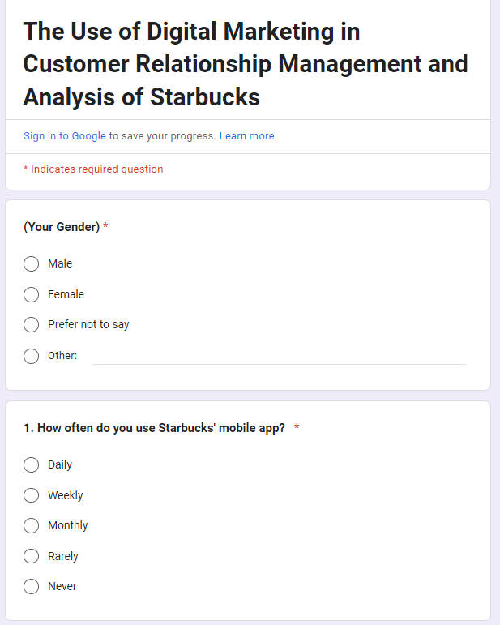

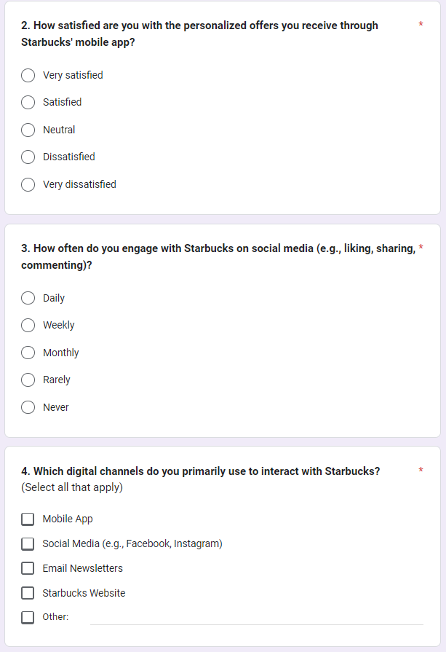

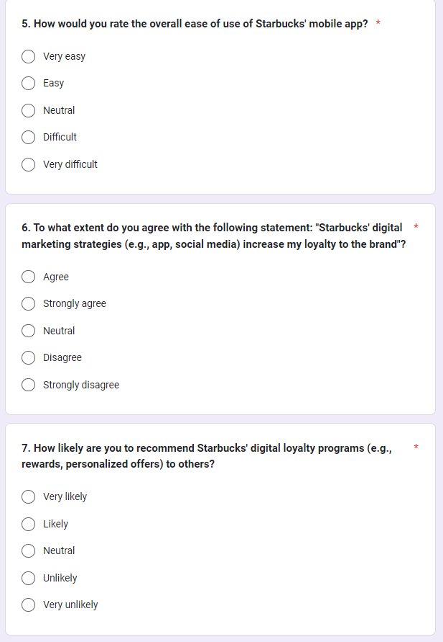

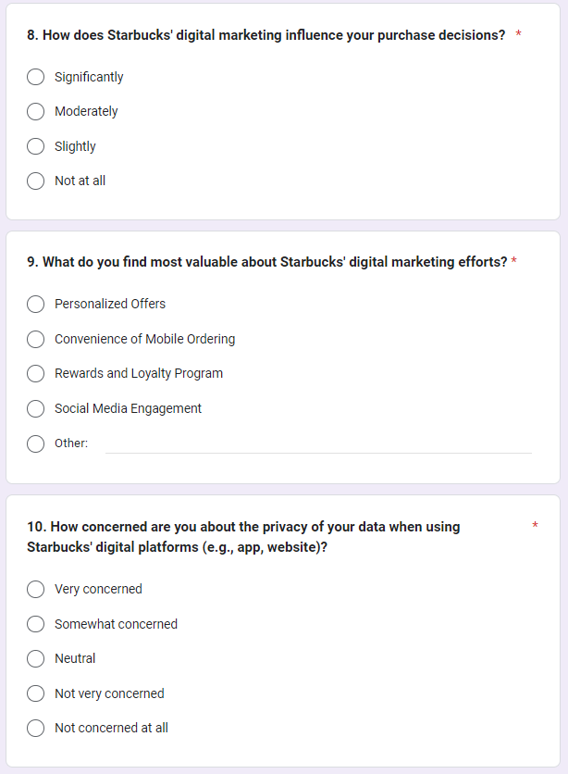

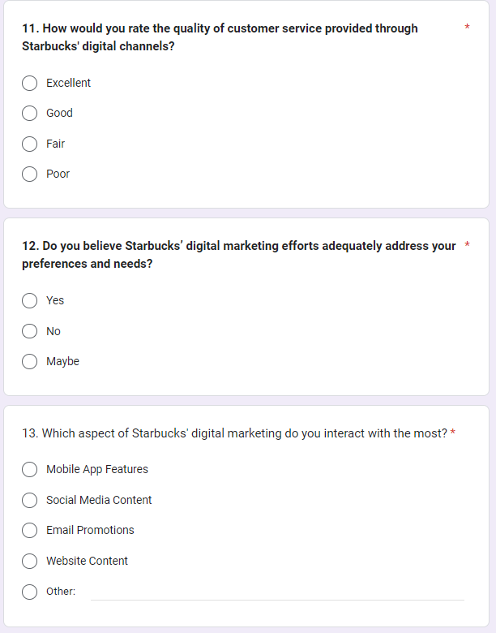

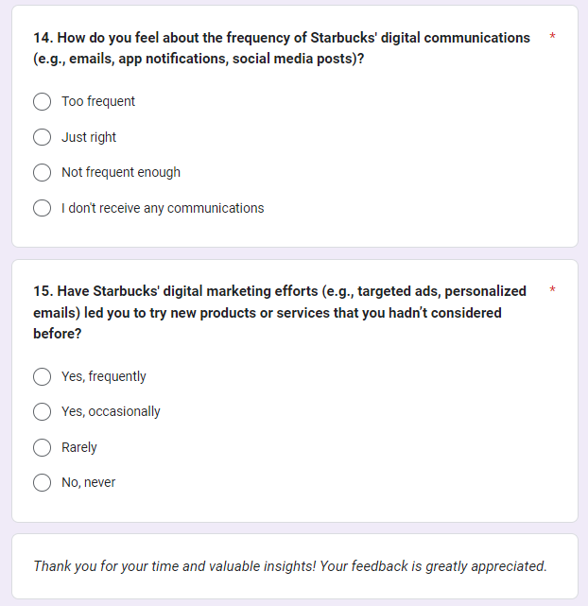
Response 1
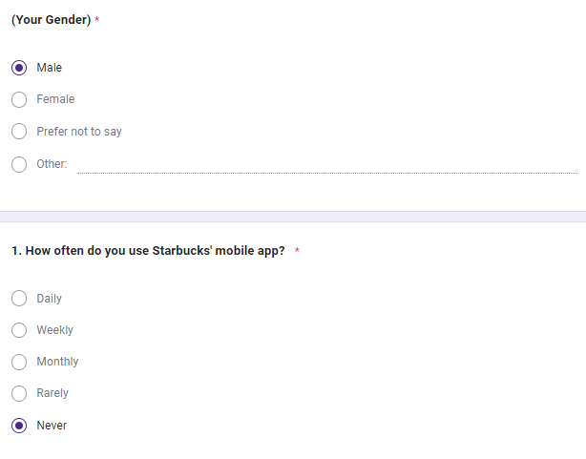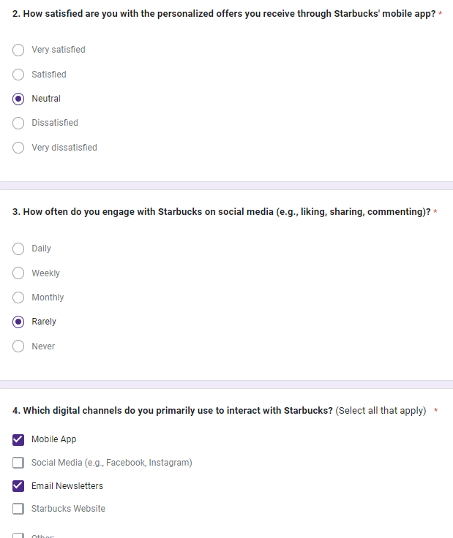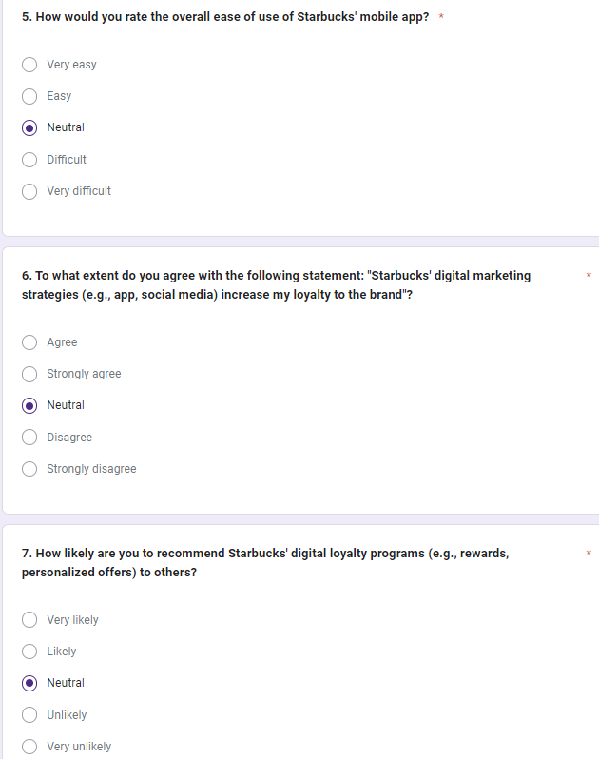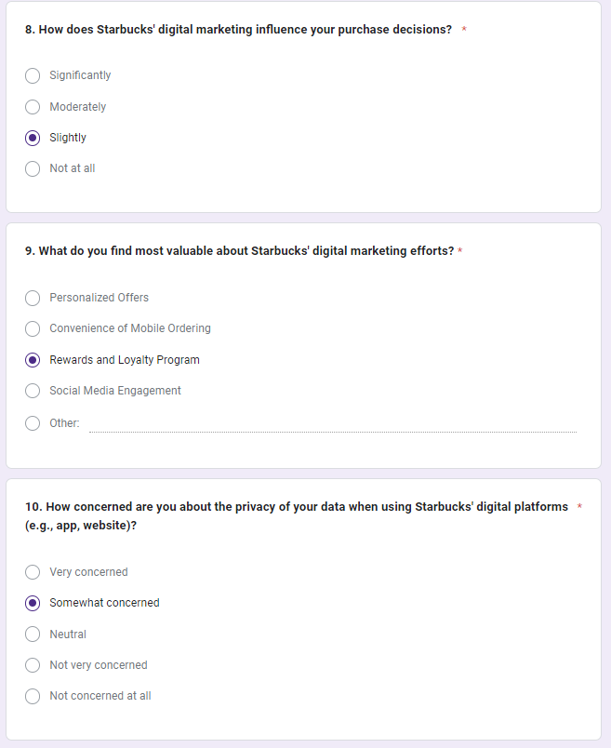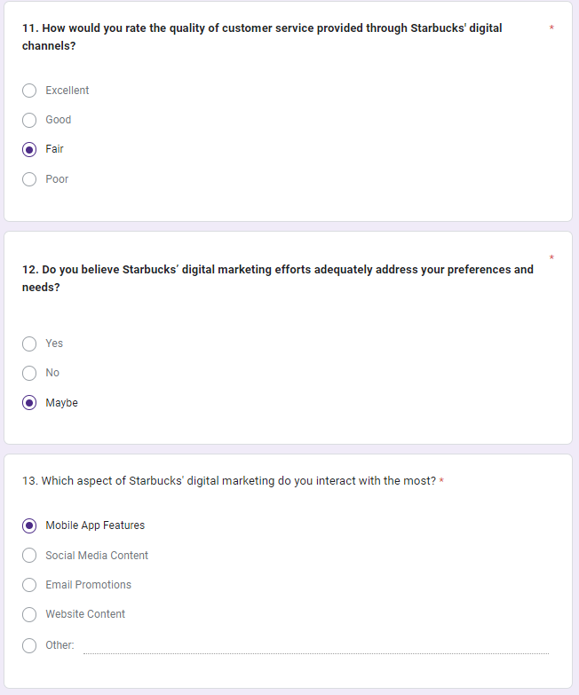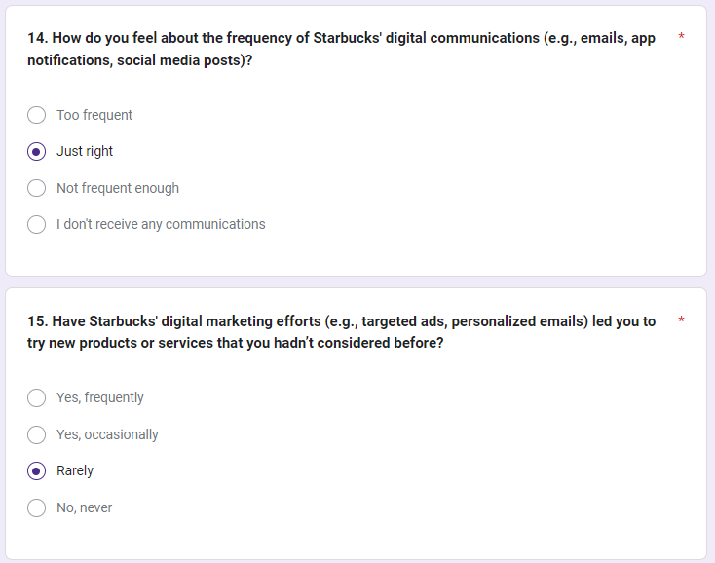
Response 2
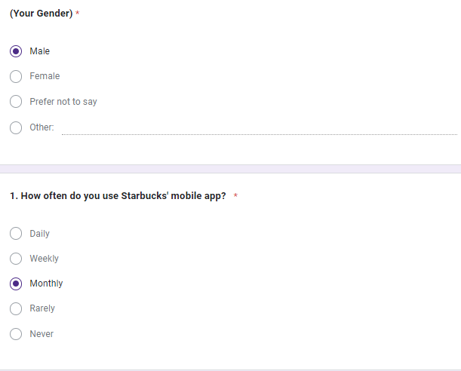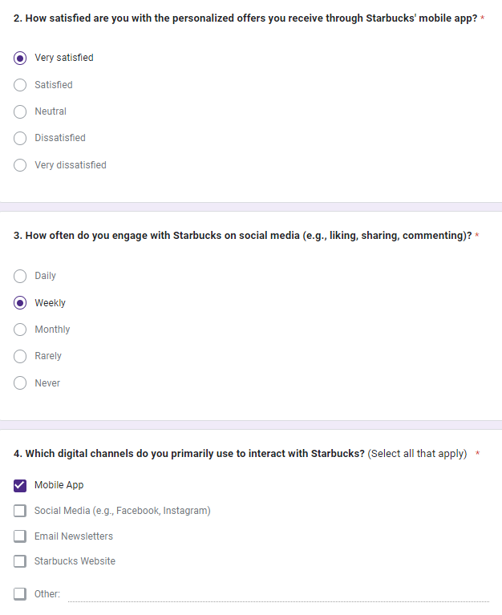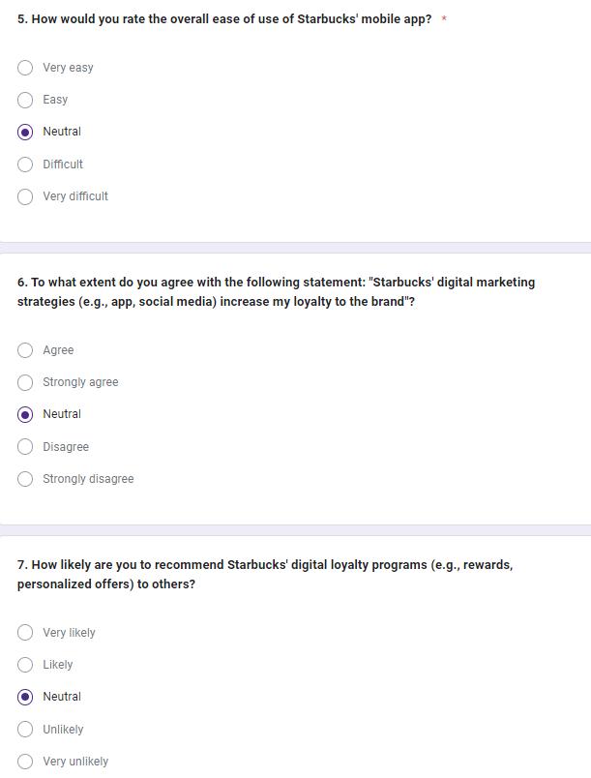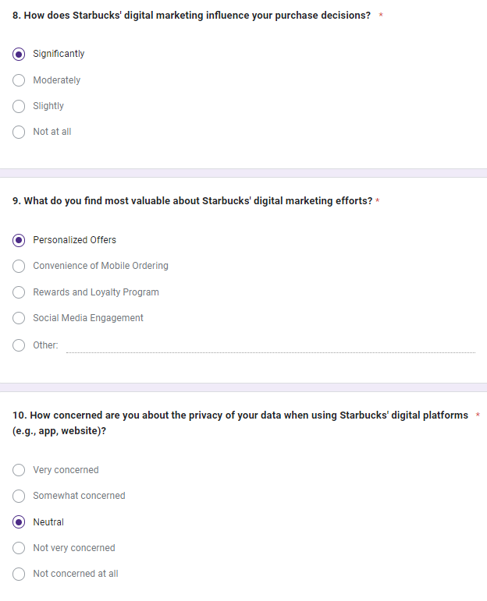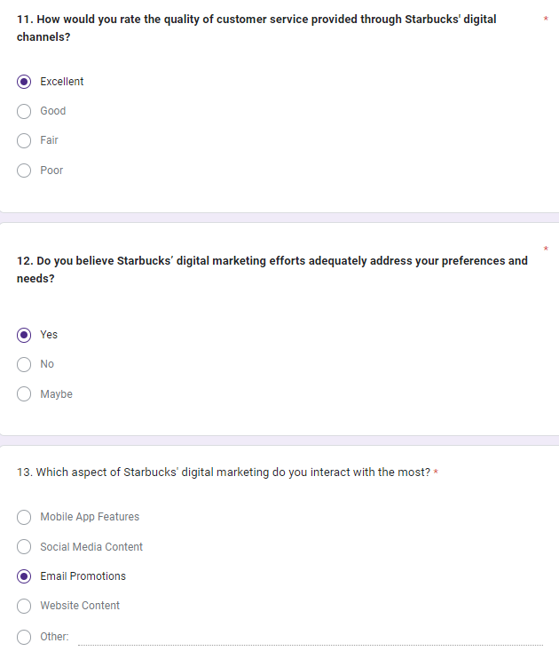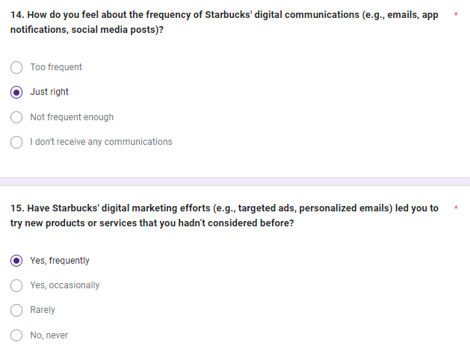
Response 3
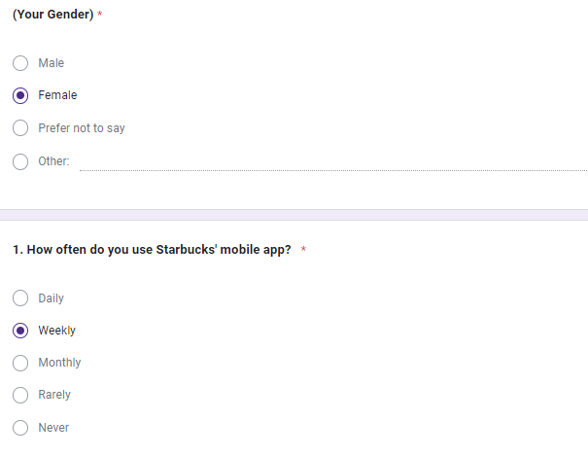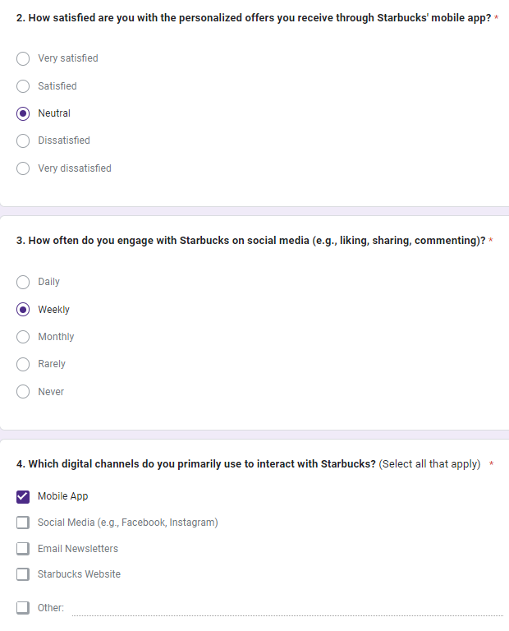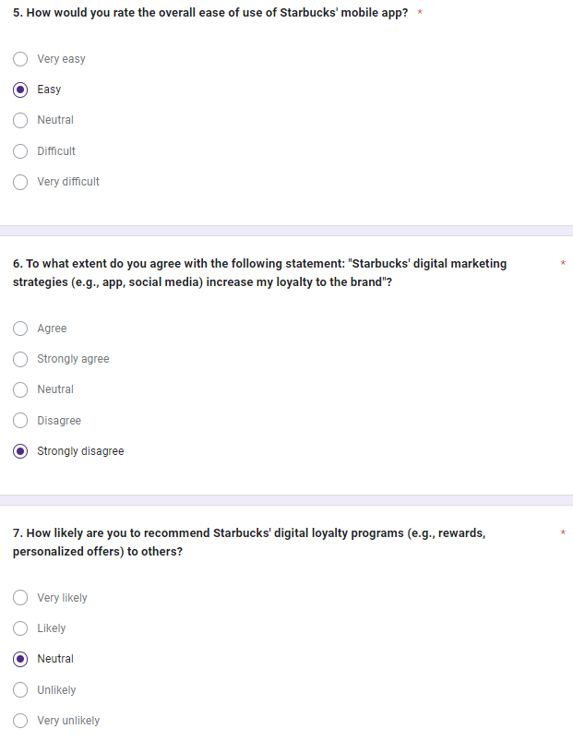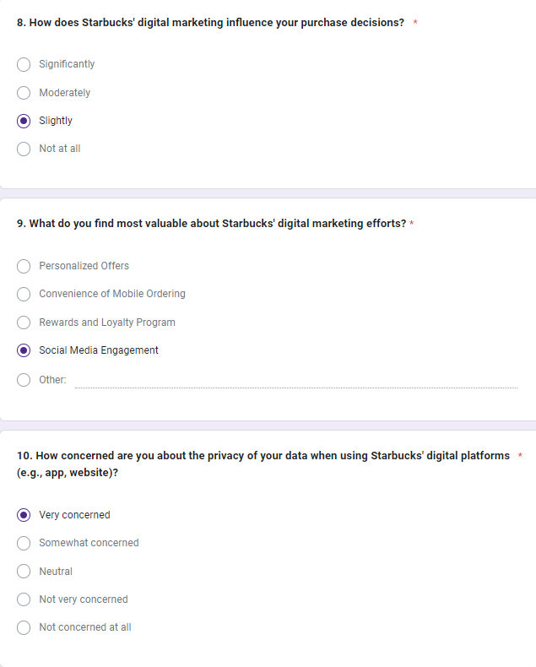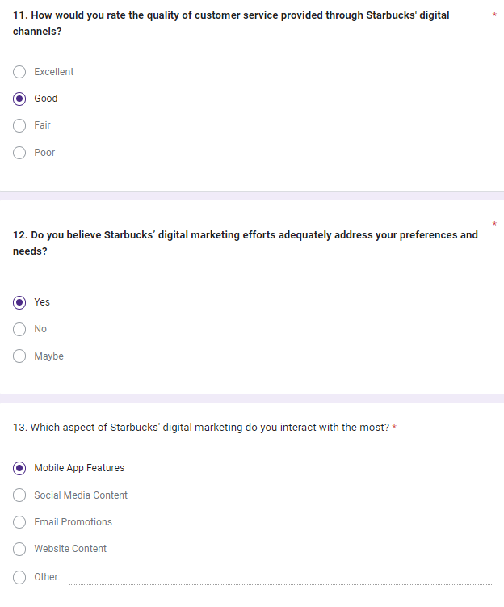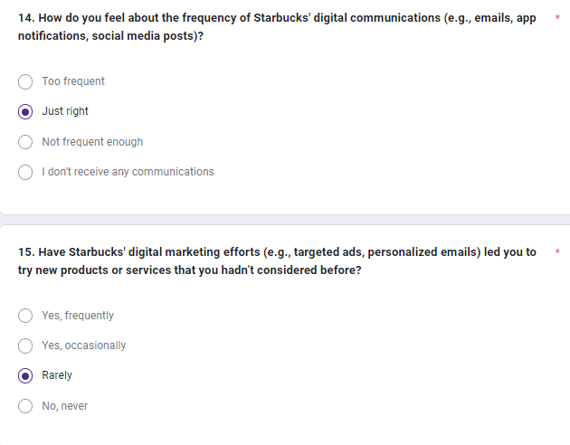
Response 4
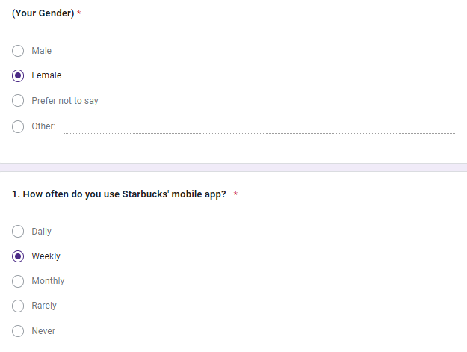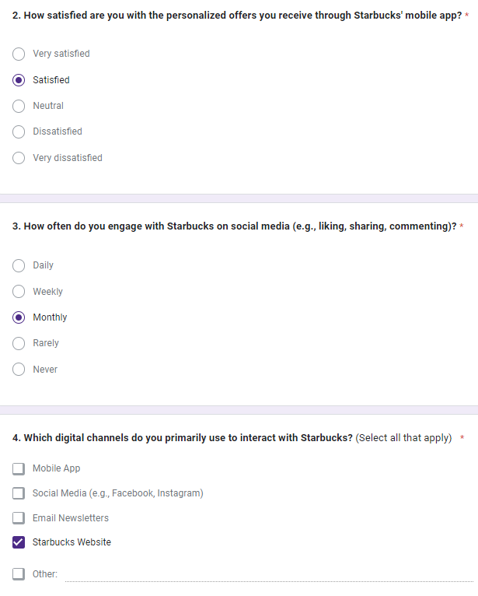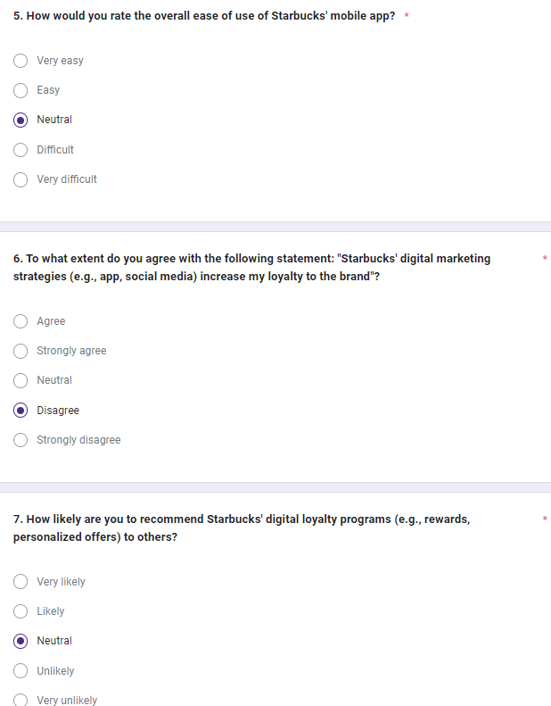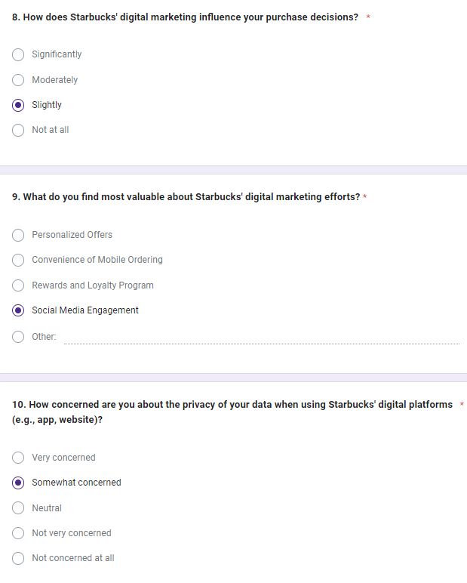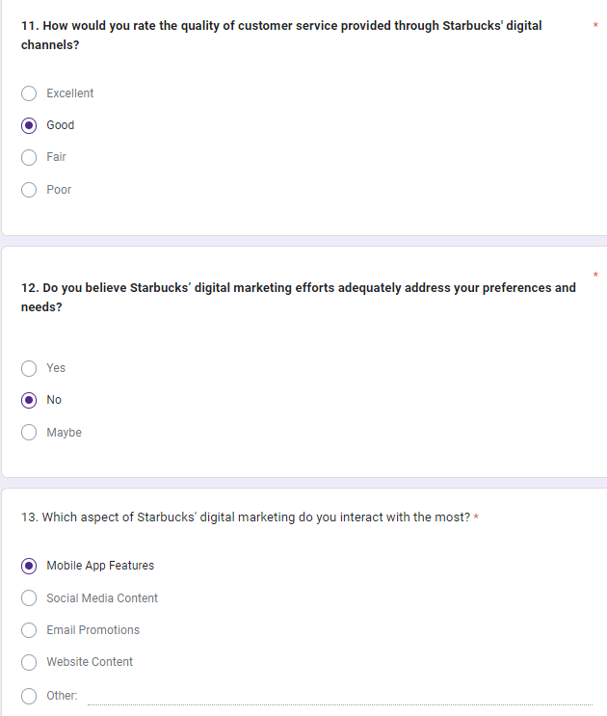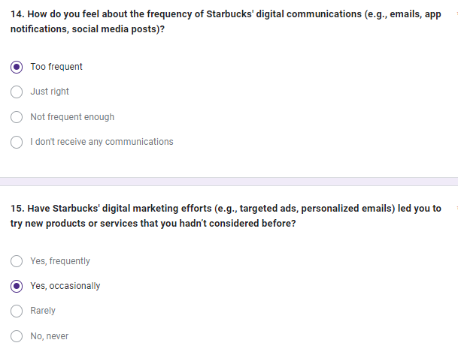
Response 5


