

BA (Hons) Business Management
Name: Manuel Fioranzato
Student ID: 2311107
Module code: LCBB4011
Module: Community Engagement
Assignment: Portfolio
Lecturer: Molly Jack
Contents
Element 1: Community Outreach at Workplace (Hilton Hotel) ……………………………...2
Demographic Considerations………………………………………………………………..2
Ethical Considerations……………………………………………………………………….3
Social, Economic, and Cultural Factors……………………………………………………...3
Impact on Engagement………………………………………………………………………4
Element 2: Stakeholder Mapping Exercise…………………………………………………….4
Stakeholders Overview………………………………………………………………………4
Interest Groups and Collaborative Partnerships……………………………………………...5
Communication Strategies………………………………………………………………...…6
Element 3: Community Engagement Plan……………………………………………………..7
Goals and Objectives………………………………………………………………………...7
Principles and Standards……………………………………………………………………..8
Strategies…………………………………………………………………………………….8
Collaborating Parties……………………………………………………………………….10
Element 4: Practical Discussion………………………………………………………………11
Importance of Stakeholder Engagement……………………………………………………11
Personal Experiences in Community Engagement…………………………………………12
Benefits of Stakeholder Engagement……………………………………………………….12
Leveraging Personal Experiences………………………………………………………..…13
Challenges and Considerations……………………………………………………………..14
Conclusion……………………………………………………………………………………14
Appendix……………………………………………………………………………………..15
References……………………………………………………………………………………26

Element 1: Community Outreach at Workplace (Hilton Hotels)
The chosen community is the workplace community, which is the Hilton Hotel on Park Lane. To connect with the Hilton Hotel's stakeholders—including workers, guests, local businesses, and people who lived nearby—it was important to know a lot about the hotel's different groups of people. There was a big goal to find out what these different groups needed and wanted so that the Hilton could make its community service programmes better (Paulina, 2007).

Demographic Considerations
The first step in the interaction was to look at the demographics of the Hilton Hotel on Park Lane stakeholders and the connected area of Mayfair in London, where the hotel is located. The hotel staff was made up of people from a variety of ethnic backgrounds, which shows that the hotel is an inclusive place to work (Huckestein and Duboff, 2013). Most of the guests were business people and tourists, and a good number of them were from other countries. Local suppliers and service providers were business partners, and people living close by came from a wide range of age groups, income levels, and cultural backgrounds (Manoharan and Madera, 2023). Understanding these differences was important for making sure the participation method was respectful and worked (Kumar and Sharma, 2014).

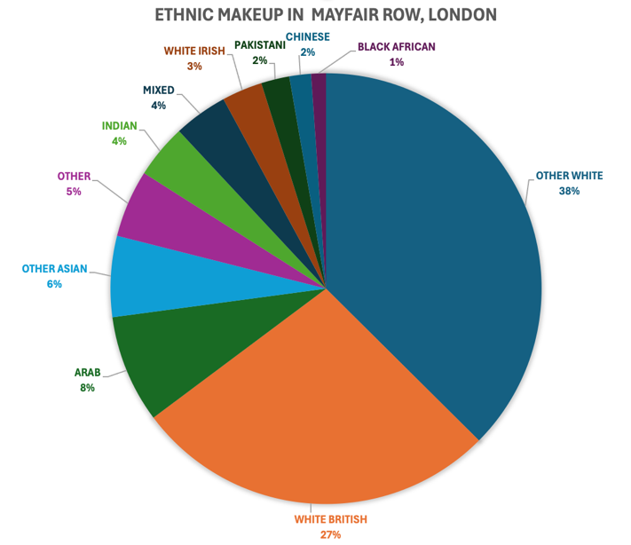

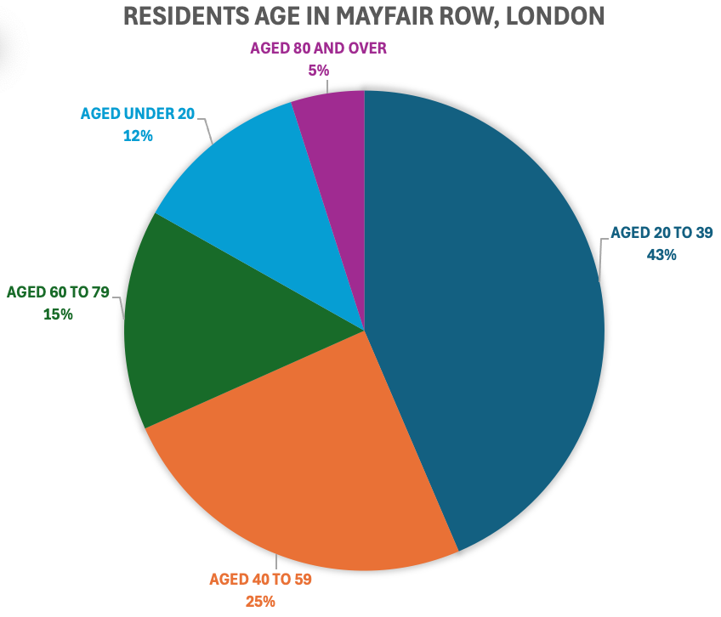

(Data Source: Crystal Roof, 2021, Fig: Author)

Ethical Considerations
During the outreach, ethical concerns were the most important thing. When getting comments from stakeholders, it was important to keep things private and get their permission first (Paulina, 2007). Because the participants came from a wide range of backgrounds, extra care was taken to make sure that all exchanges were respectful and sensitive to those backgrounds (Huckestein and Duboff, 2013). For example, when talking to employees, it was important to make sure that they were choosing to take part and that there was no pressure or suggestion that their jobs depended on what they said (Head, 2008).

Social, Economic, and Cultural Factors
A lot of the engagement process was affected by social, economic, and cultural issues. According to Manoharan and Madera (2023), the job stability, working conditions, and chances for professional growth are the most important things for the hotel staff. To work with them, is fundamental to be sensitive and acknowledge their worries while also asking for honest and helpful comments (Kumar and Sharma, 2014). Job security was especially important from an economic point of view since many employees saw their job at Hilton as a key way to make money and advance their careers (Paulina, 2007).
Guests, on the other hand, were mostly interested in how well they were served and how their stay was generally. To interact with this group, is crucial to know what they were hoping for and how their cultural backgrounds and the reason for their visit affected those things (Head, 2008). Manoharan and Madera (2023) say that business travellers valued convenience and services that helped them do their jobs, while tourists were more interested in fun and learning about the area.
For local business partners, the focus was on building ties that were good for both sides. Economic factors, like fair trade and on-time pay-outs, were very important (Kumar and Sharma, 2014). Making sure that the Hilton did business in an honest way and backed local businesses helped to strengthen these relationships.
The people who lived in the area showed a wide range of social and cultural traits. To work with them, is important to know how the local community worked, including things like noise pollution, traffic jams, and the hotel's part in community growth (Head, 2008). Residents really liked cultural events and projects that promoted local heritage; the Hilton's involvement in these events made the connection between the two groups better (Huckestein and Duboff, 2013).

Impact on Engagement
The tactics used for engagement were shaped by these racial, social, economic, and cultural factors. Focus groups and surveys, for instance, were used to get detailed feedback from hotel workers and guests, making sure that all points of view were heard (Paulina, 2007). Residents and business partners were more involved when there were community meetings and work with local business groups (Huckestein and Duboff, 2013). This helped address their specific concerns and build a sense of community involvement.
Overall, the outreach at the Hilton Hotel on Park Lane showed how important it is to be polite and adaptable when working with different groups in the community (Head, 2008). Manoharan and Madera (2023) say that the engagement was able to create useful insights and strengthen community relationships by taking into account differences in demographics and addressing moral, social, economic, and cultural issues. This approach not only met the immediate needs of the stakeholders but also contributed to the Hilton’s long-term goal of being a responsible and integral part of the local community (Head, 2008).

Element 2: Stakeholder Mapping Exercise
The community surrounding the Hilton Hotel on Park Lane comprises diverse stakeholders, each with unique interests and roles in the local ecosystem. Understanding these stakeholders and effectively communicating with them is crucial for fostering meaningful community engagement (Hilton, 2023).

Stakeholders Overview
Hotel Staff
The backbone of Hilton Hotel’s operations is the staff, which consists of individuals from various cultural backgrounds (Hilton ESG, 2024). They include front-line service personnel, managerial staff, and support teams. Engaging with them involves addressing concerns such as workplace conditions, career development opportunities, and job satisfaction (Hilton, 2023). Regular feedback sessions and transparent communication channels are essential to maintaining morale and productivity.
Guests
The Hilton Hotel attracts a diverse clientele, including business travellers, tourists, and conference attendees. Guests prioritise service quality, amenities, and overall experience (Hilton ESG, 2024). Understanding their expectations based on cultural backgrounds and travel purposes is the key. Feedback mechanisms such as post-stay surveys and personalised service offerings enhance guest satisfaction and loyalty (Ray and Miller, 2017).
Local Residents
Residents living near the Hilton Hotel on Park Lane are integral community members affected by hotel operations. They are concerned with issues like noise levels, traffic congestion, and the hotel’s impact on local infrastructure (Hilton, 2023). Engaging with residents involves participating in community meetings, supporting local initiatives, and addressing concerns through open dialogue and proactive measures (Ray and Miller, 2017).
Local Businesses
Suppliers, service providers, and business partners play a vital role in Hilton Hotel’s supply chain and local economy. Collaboration with local businesses involves fair trade practices, timely payments, and mutual support (Pryke and Smyth, 2012). Building strong relationships through networking events, joint ventures, and sponsorship opportunities strengthens community ties and promotes economic growth (Hilton ESG, 2024).

Interest Groups and Collaborative Partnerships
Cultural Organisations
Engaging with local cultural organisations enhances Hilton Hotel’s cultural footprint and community involvement (Ray and Miller, 2017). Collaborative initiatives include sponsoring cultural events, promoting local heritage, and integrating cultural themes into hotel offerings (Hilton, 2023). These partnerships enrich guest experiences and demonstrate commitment to cultural diversity and preservation.
Educational Institutions
Partnerships with nearby schools, colleges, and universities provide opportunities for educational programs, internships, and career development initiatives (Hilton ESG, 2024). Engaging with educational institutions fosters talent acquisition, supports community learning initiatives, and enhances the hotel’s reputation as an employer of choice (Pryke and Smyth, 2012).
Environmental Groups
Sustainability initiatives are a priority for Hilton Hotels, aligning with environmental groups’ goals for conservation and eco-friendly practices (Bohdanowicz and Novotna, 2011). Collaborative efforts include energy efficiency projects, waste reduction programs, and community clean-up events. Engaging with environmental groups demonstrates corporate responsibility and promotes a greener community environment (Hilton, 2023).
Government Agencies
Engaging with local government agencies ensures compliance with regulations, supports community development projects, and promotes responsible business practices (Hilton ESG, 2024). Collaboration involves participating in regulatory discussions, supporting local infrastructure projects, and contributing to community welfare programs. Effective communication and proactive engagement with government agencies strengthen civic partnerships and regulatory compliance (Ray and Miller, 2017).

Communication Strategies
Effective communication with stakeholders is essential for successful community engagement (Pryke and Smyth, 2012). Tailored strategies include:
Transparency and Open Dialogue
Establishing transparent communication channels builds trust and fosters a culture of openness (Mcphail and Phipps, 2020). Regular updates, feedback mechanisms, and town hall meetings enable stakeholders to voice concerns and provide input on hotel operations (Hilton, 2023).
Personalised Engagement
Recognising the diverse needs and preferences of stakeholders allows for personalised engagement strategies (Quinn and Thorne, 2014). Targeted communication and meaningful interactions are ensured by dividing stakeholders into groups based on their hobbies, demographics, and engagement preferences (Mcphail and Phipps, 2020).
Proactive Engagement
Being proactive with stakeholders means figuring out their wants and concerns ahead of time. Responding quickly to problems, making changes based on feedback, and looking for ways to work together show that one cares about stakeholder happiness (Hilton, 202333).
Community Involvement Initiatives
Getting people involved in community projects makes ties stronger and helps people work towards the same goals (Ray and Miller, 2017). Corporate citizenship is shown by taking part in local events, sponsoring community projects, and helping. These actions also improve the well-being of the community (Quinn and Thorne, 2014).
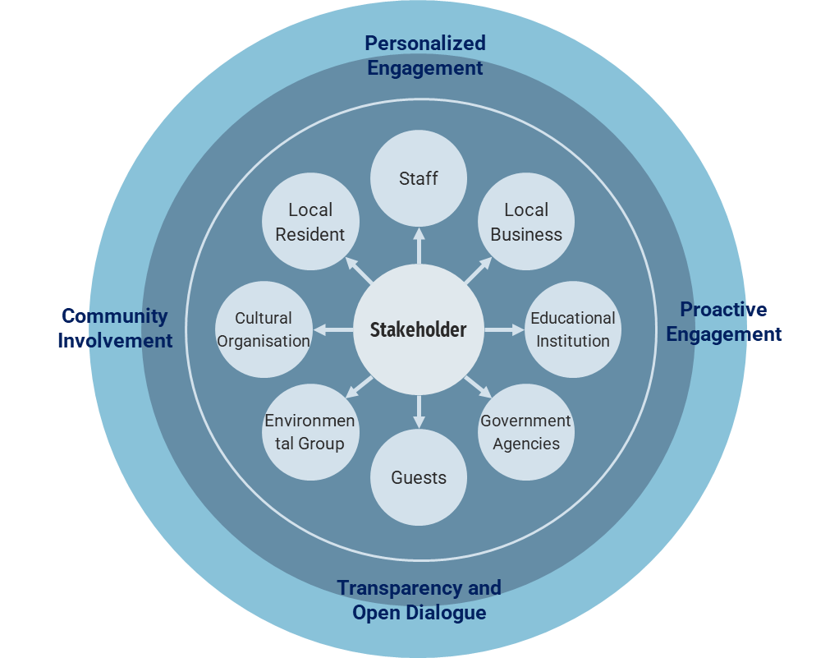
Fig: Communication among stakeholders (Source: Author)
For building meaningful relationships and promoting mutual gain, it is important to understand the different stakeholders in the community surrounding the Hilton Hotel and use customised engagement strategies (Hilton ESG, 2024).
Element 3: Community Engagement Plan
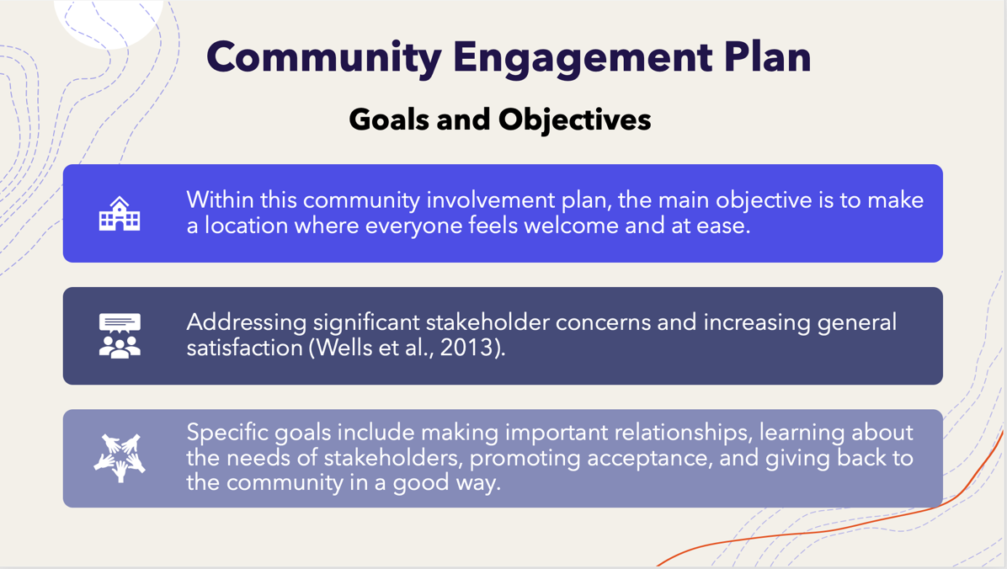

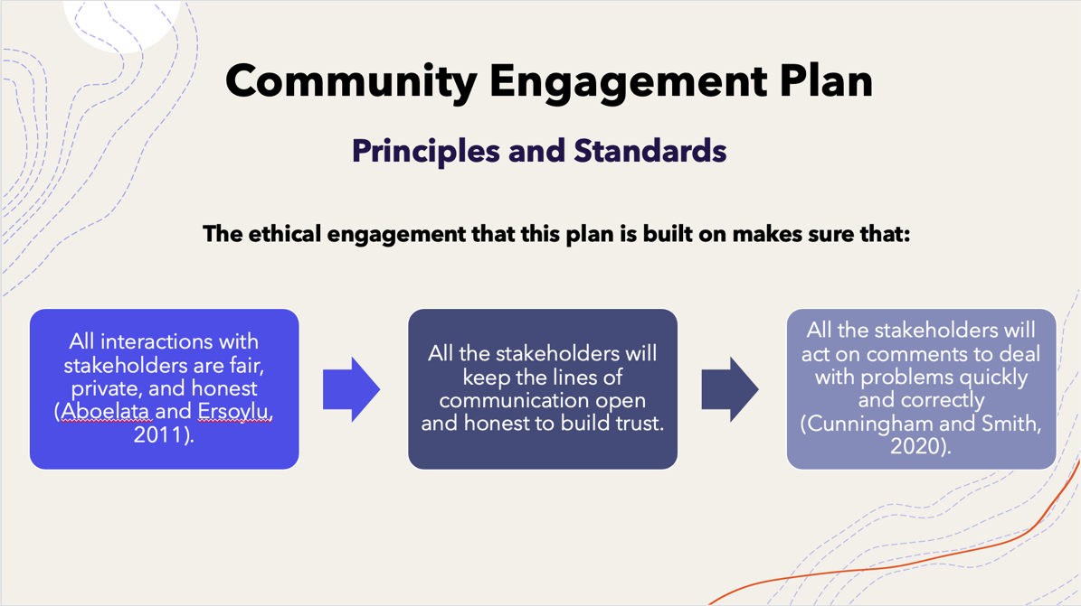
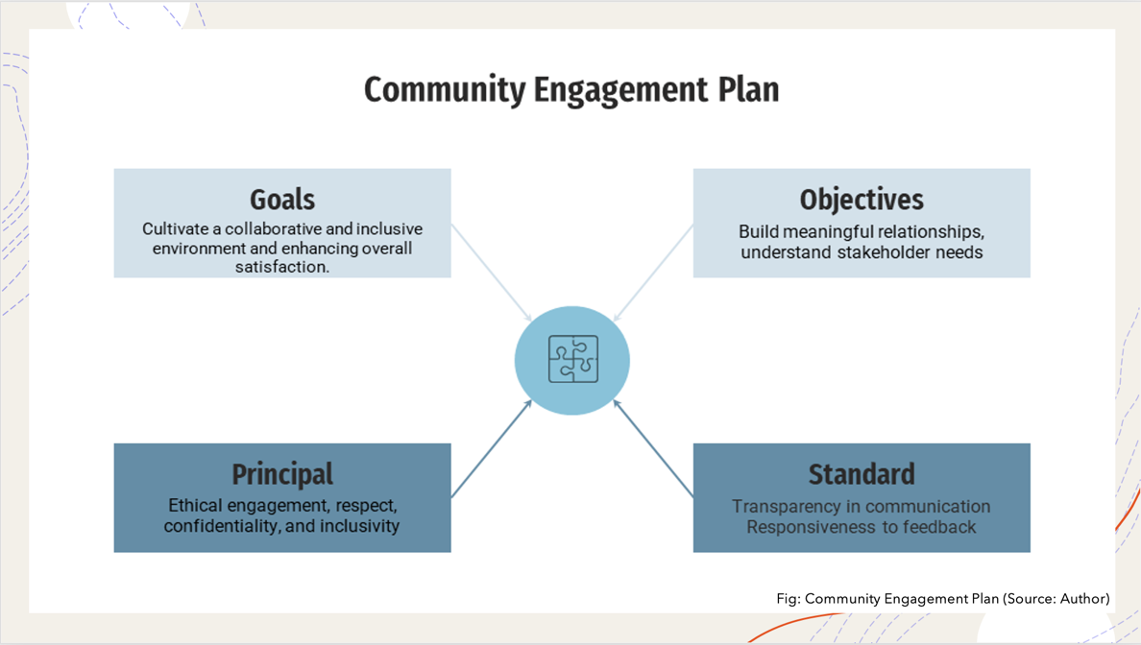
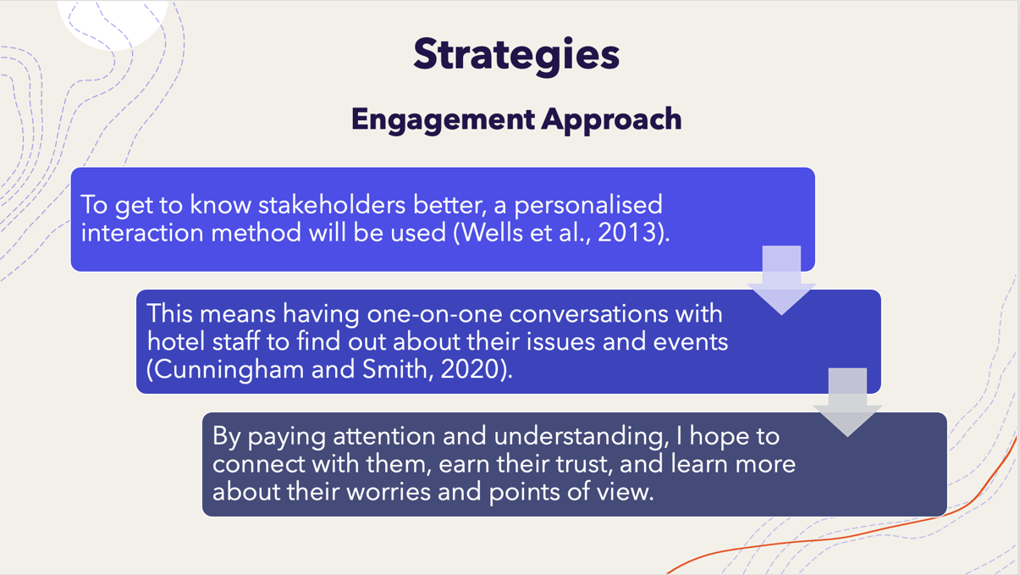
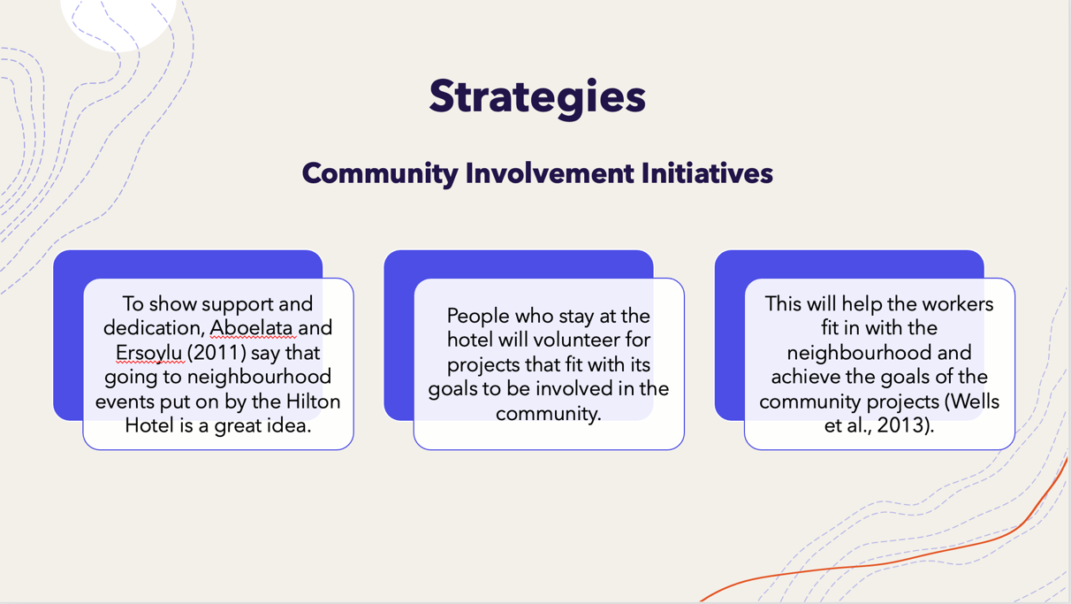
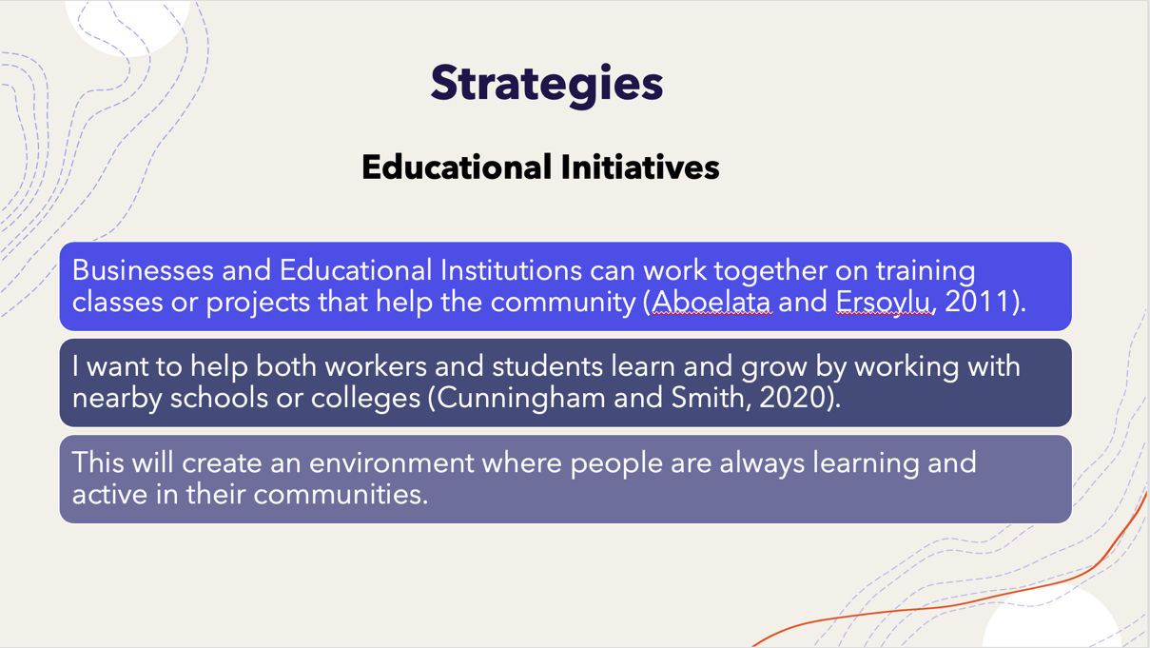
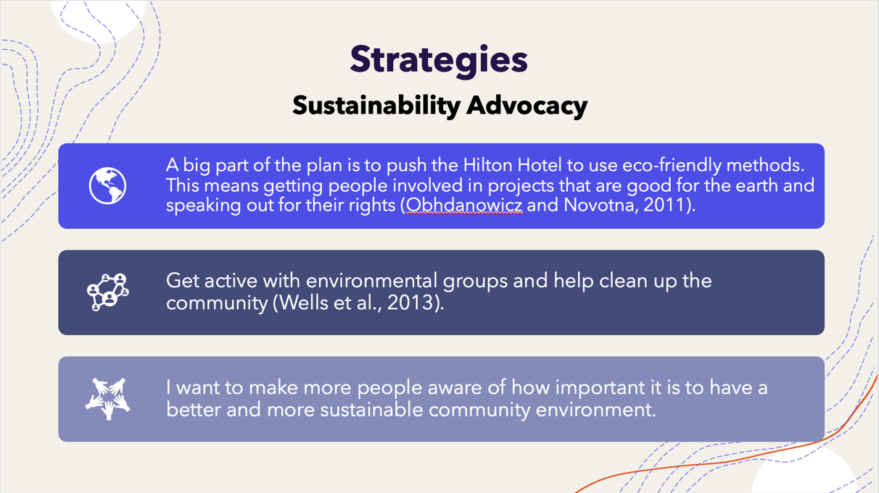
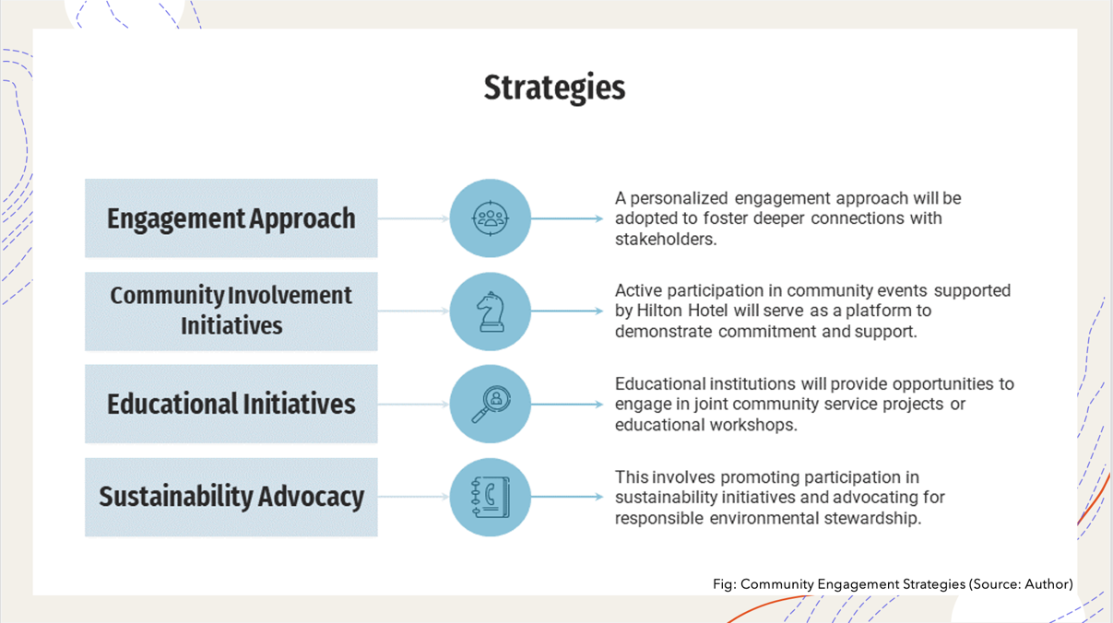
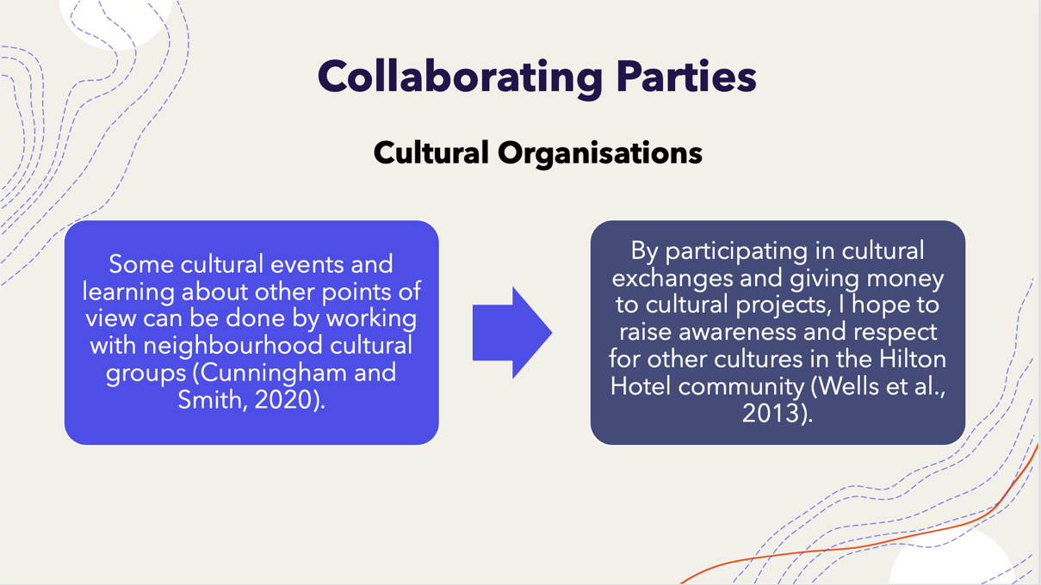
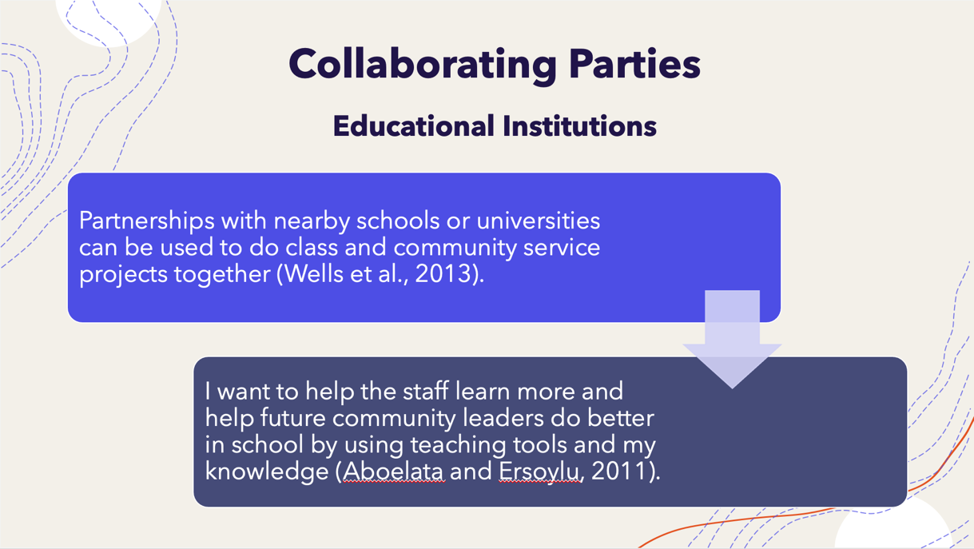
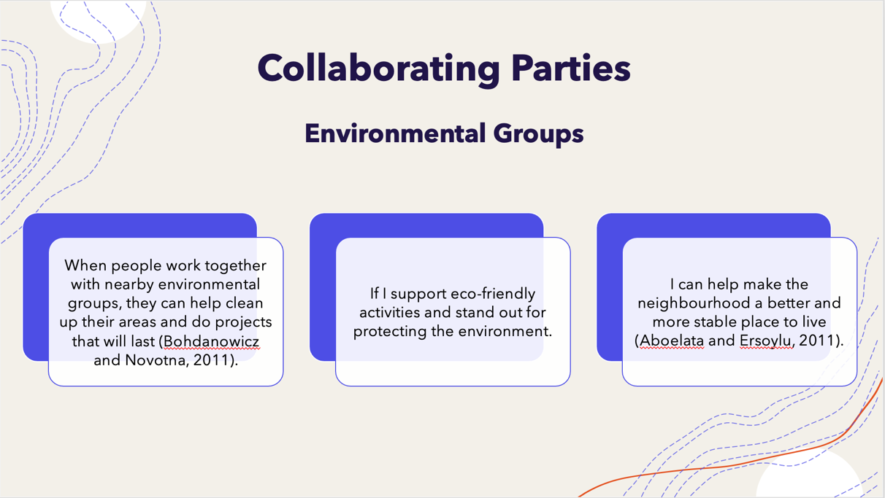
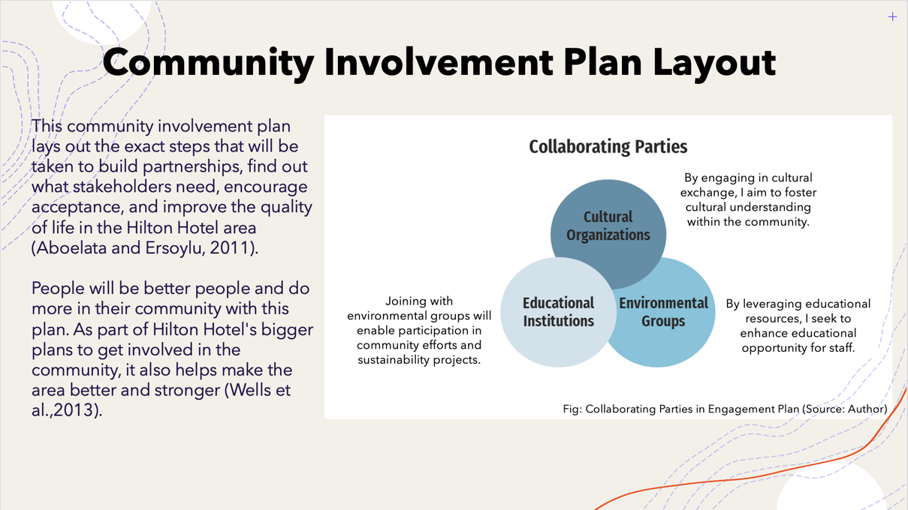

Element 4: Practical Discussion
People need to work together on community projects in order to learn about other points of view and get results that last (Stokes et al., 2006). This practical discussion looks at the benefits of actively involving stakeholders. This discussion evolves from my own experience as a part of the workplace community in London Hilton on Park Lane.

Importance of Stakeholder Engagement
Every stakeholder who has an interest in a community project needs to be active for it to work. People, groups, and companies who are interested in or affected by a project can help it move forward. This could lead to fresh thoughts, extra help, and group work (Dubach and Machado, 2012). The project is more useful and important when everyone knows about it. Engagement of stakeholders also builds trust among parties and individuals. Stakeholder engagement makes group and individual ties stronger (Stokes et al., 2006).

Personal Experiences in Community Engagement
Members of a community are involved in different activities, like cultural events and environmental projects. Involving stakeholders and their engagement can make a huge positive difference. I remember one example when working on a park restoration project with people from the neighbourhood, local businesses, and government agencies to bring a run-down green area back to life. Through open conversation, forum and working together to plan the project, it was accomplished successfully. Involved stakeholders gave their ideas, resources, and volunteer hours for planning and working. This community engagement in a project brought the park back to life and turned it into a spot where people could get together and have fun (Stokes et al., 2006). Another exemple is the organisation the ‘Mayfair Neighbourhood Forum’ in Mayfair (London), where, thanks to my job, I have had the opportunity to see how a well-structured community organisation works. The group operates with companies, residents, and community leaders to improve the neighbourhood planning process in Mayfair, which is the area around my workplace: the London Hilton on Park Lane. The forum’s activities include supporting consultation, preparing a neighbourhood plan, creating sub-committees, and running the Mayfair Heritage project. The projects comprise: The Tyburn, The Mayfair Green Route, and Mayfair Heritage. The Green Route intends to provide a one-mile green corridor that promotes health, well-being, and inclusivity while mitigating climate change. The Tyburn, an old underground river, will be revitalised with mixed-use retail frontage and public space enhancements. Mayfair Heritage will bring together people, companies, and community organisations to share archives, showcase heritage locations, and tell fascinating stories about Mayfair's past (Mayfair, 2019).

Benefits of Stakeholder Engagement
Enhanced Project Relevance and Effectiveness
When all the stakeholders of a community are involved in projects, they are more likely to meet the needs and wants of the community and address the real community priorities. According to Haberlein and Hovel (2023), projects can be modified to fit the problems and chances that have to be faced in the project if people who will be directly affected are involved by asking for input and comments.
Increased Stakeholder Buy-In and Support
If stakeholders of a community have a say in a community project about how the project is run from the beginning, they are more likely to push for its goals. This buy-in makes people feel like they own and are committed to the project, which makes them more likely to keep working on it and use the resources that are available (Dubach and Machado, 2012).
Diverse Perspectives and Innovative Solutions
Getting people in a community with different ideas, skills, and experiences involved brings them together. This variety leads to inspiration and new ideas, letting people try out new methods and ideas that they might not have thought of before (Stokes et al., 2006).
Building Trust and Strengthening Relationships
As Haberlein and Hovel (2023) say, open and honest conversation between project organisers and stakeholders builds trust. Long-term partnerships that last longer than the length of a project can be formed by building relationships based on mutual respect and understanding (Dubach and Machado, 2012).
Sustainable Outcomes and Long-Term Impact
Getting people involved in a project is more likely to produce results that last. Long-lasting changes can happen in a community when initiatives deal with deep-seated issues and make local organisations and groups stronger (Bohdanowicz and Novotna, 2011).

Leveraging Personal Experiences
As a volunteer and advocate in my neighbourhood, I have seen directly how getting people involved can make a difference. For instance, people who lived in the area, companies in the area, and city officials were all involved in making it look better. Working with partners and hearing what people had to say, we came up with a full plan that included community gardens, better lighting, and play places. This all-around approach got a lot of support and excitement, which kept people in the community active and helped things keep getting better. This way, the project not only made the place look better but also took care of issues with safety and access.

Challenges and Considerations
There are many good things about involving stakeholders, but there are also some bad things. These issues come up a lot:
Managing Expectations: It takes careful negotiation and compromise to find a good balance between the wants and needs of different parties (Mitchell et al., 2020).
Resource Constraints: Engagement events may not be as big or as interesting as they could be if they do not have enough money or room (Huzzard, 2020).
Overcoming Resistance: It takes time, honesty, and proof of the real benefits of participation to change the thoughts of stakeholders who are sceptical or do not want to take part (Mitchell et al., 2020).

Conclusion
Having customers and personnel from various backgrounds provides fresh insights to an hotel.
Differences pique curiosity and provide an excellent opportunity for customers and staff to interact and discover new ways of doing things. At the end of the day, one of the primary reasons individuals travel is to encounter other cultures.
Having a culturally varied workforce allows you to better attend to different types of quests, regardless of where they originate from. Facilitating cross-cultural conversation while fully understanding the needs of each guest.
To successfully manage a diverse workforce, it is necessary to establish policies that promote inclusivity, provide regular training, and emphasise the value of acceptance in daily staff meetings. Cultural diversity has an impact on the hospitality business, beginning with the conception of a hotel.
Getting people interested in community projects is important for getting results that work for everyone, last, and make a difference (Huzzard, 2020). As a member of the community, I know that having important people in a project makes it more useful, builds trust, and gets people to work together. When people value different points of view and share their knowledge, initiatives can solve tough problems and make changes that last in the community (Dubach and Machado, 2012). As long as people want to make sure that projects meet the needs and goals of the community, they will need to make sure that stakeholder involvement is a top priority (Mitchell et al., 2020).
Appendix

Seminar Activities
- Tell Us About Yourself
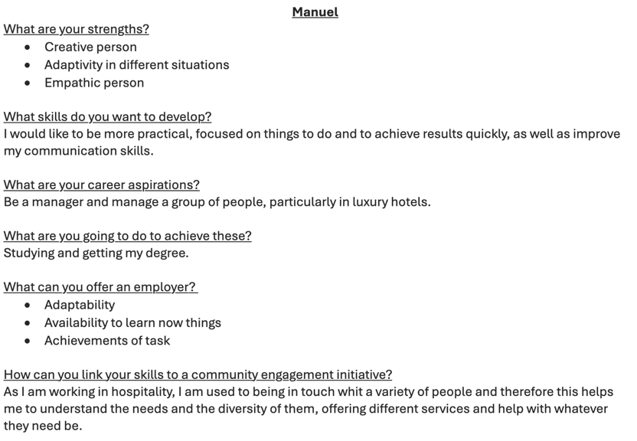
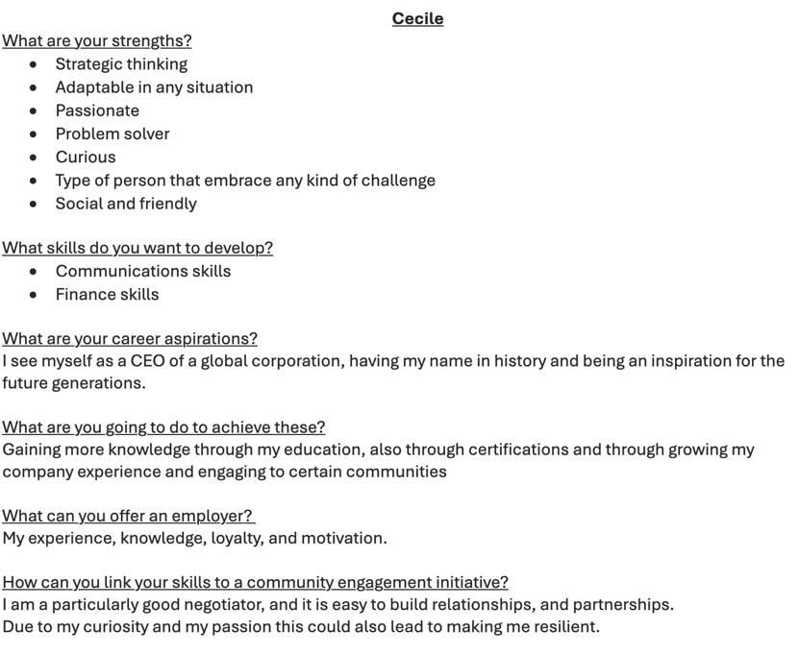
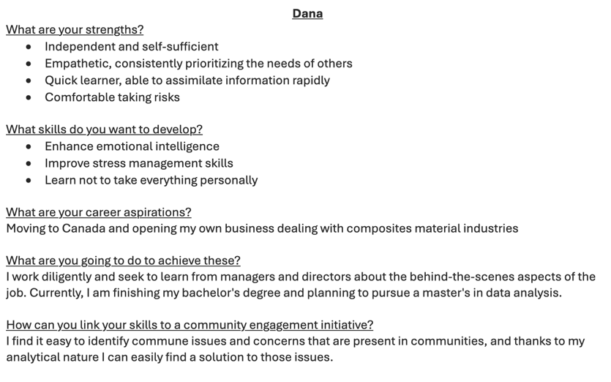
- Select An Organisation, Identify Its Key Activities And Stakeholders
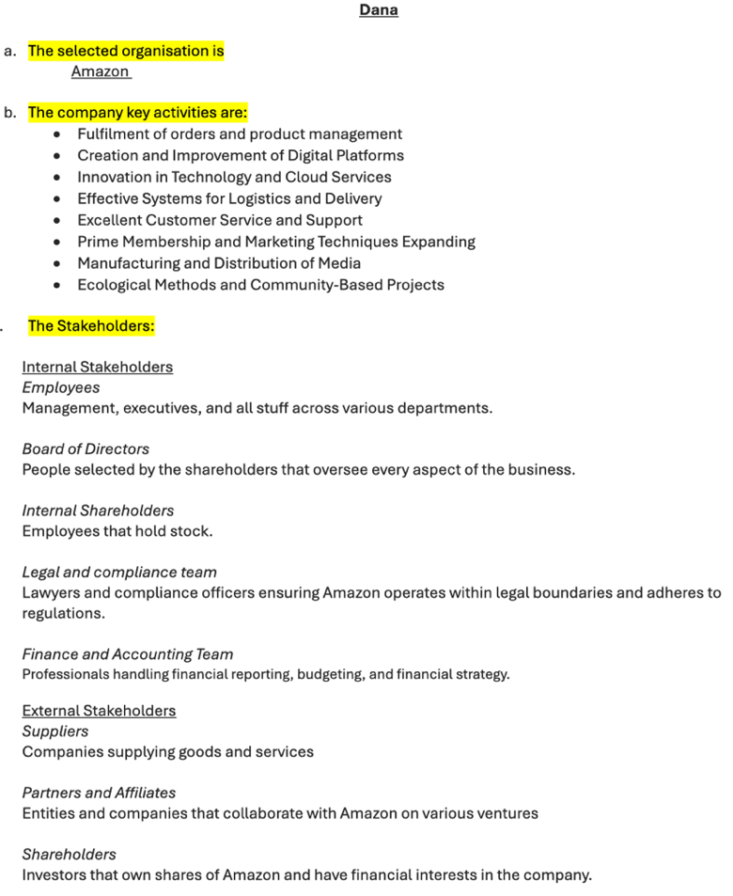
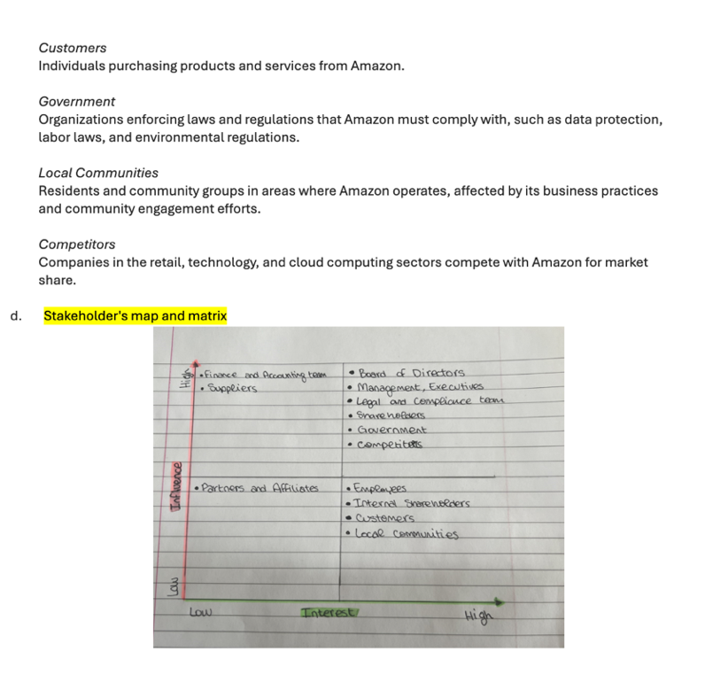
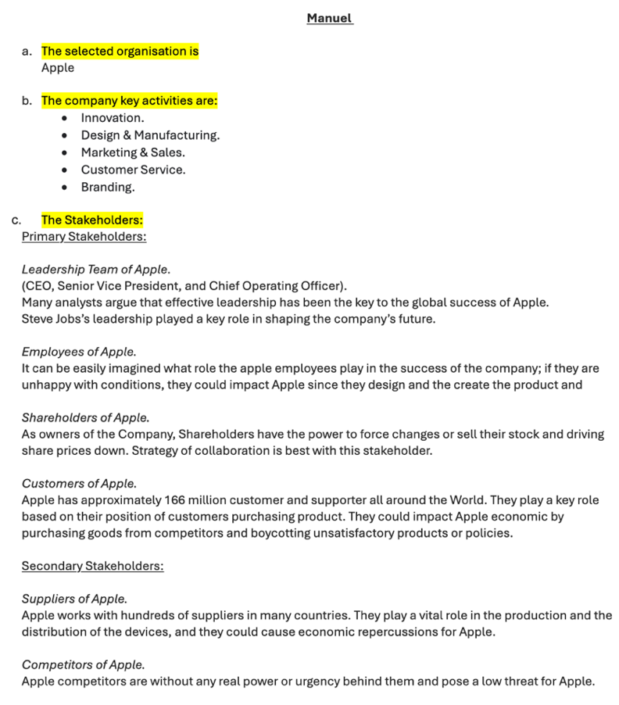
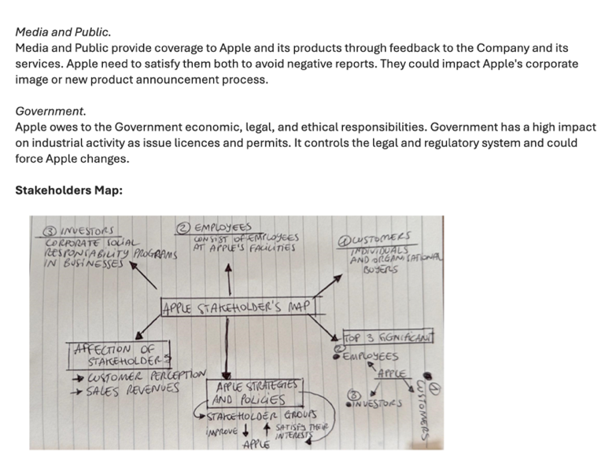
Rahman, M. (2020). Stakeholders of Apple (Analysis of Apple’s stakeholders). [online] howandwhat. Available at: https://www.howandwhat.net/stakeholders-apple-analysis-apples-stakeholders/
- Identifying And Addressing Challenges In Community Engagement Project
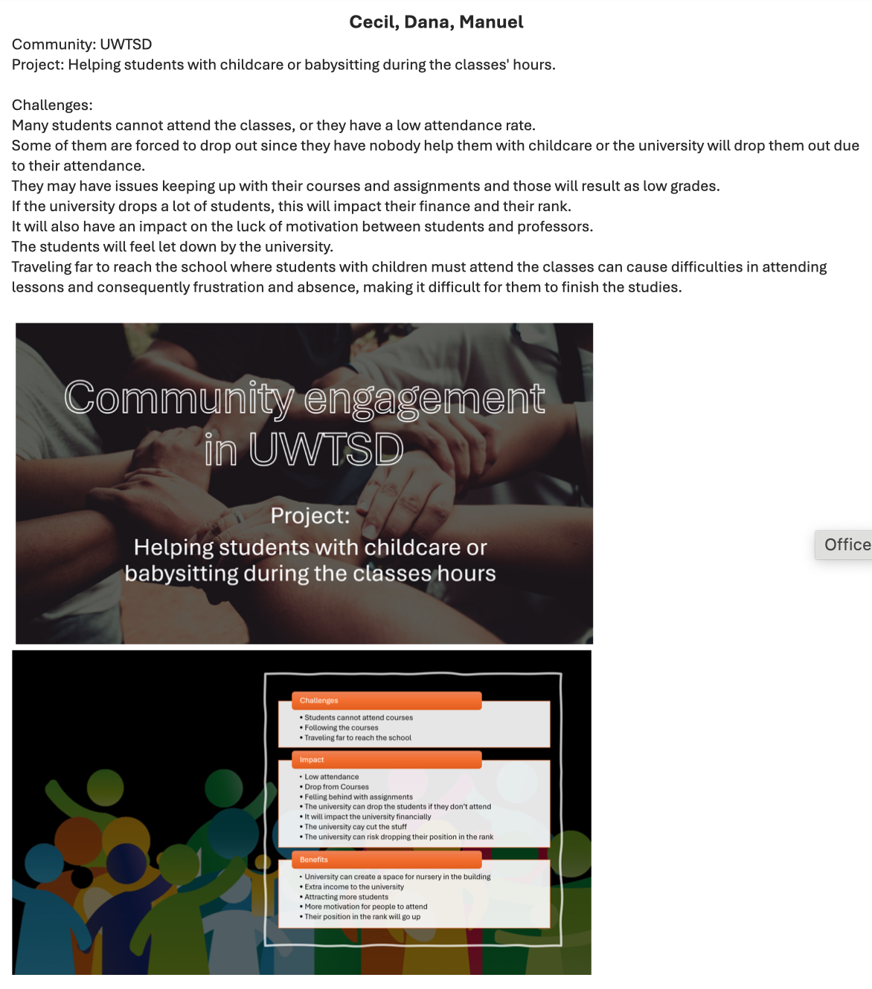

- Proposal For Any Community Engagement Project
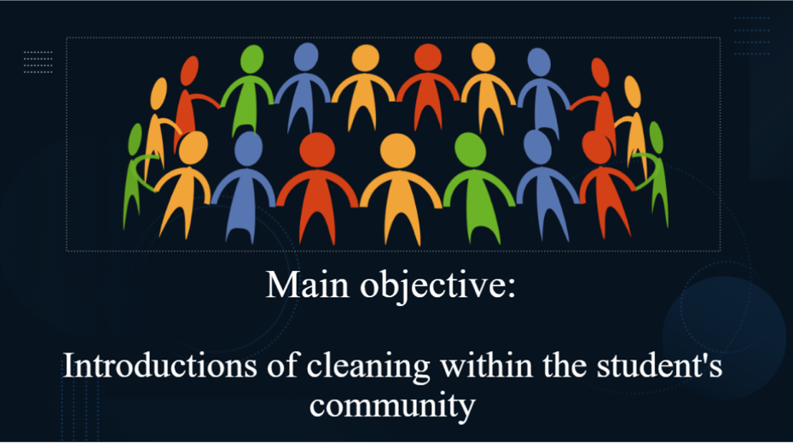
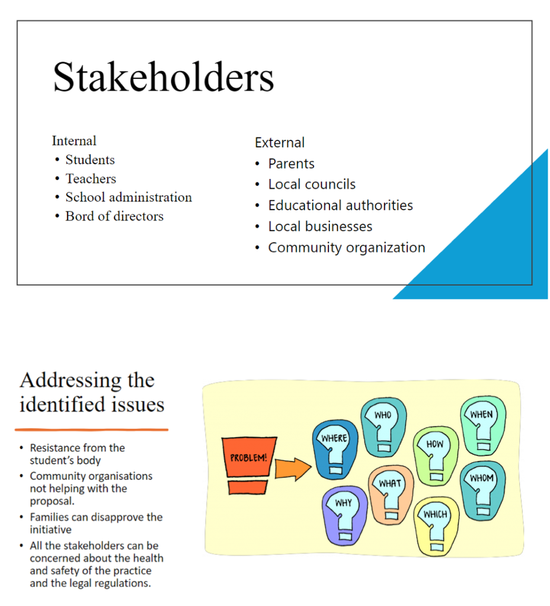
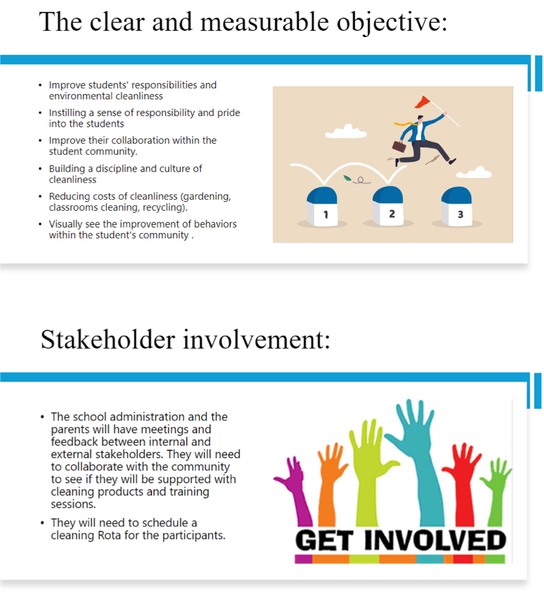
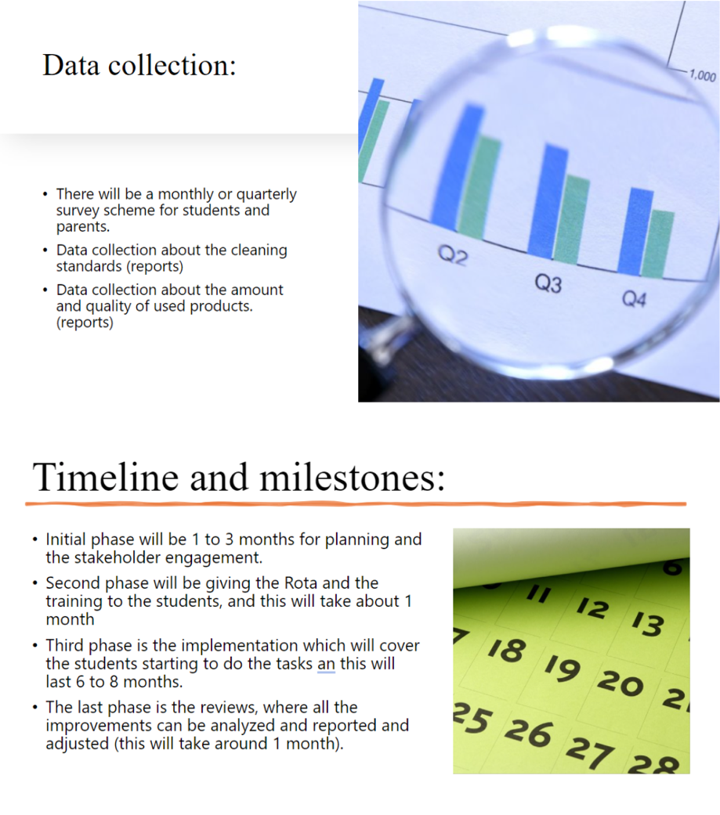
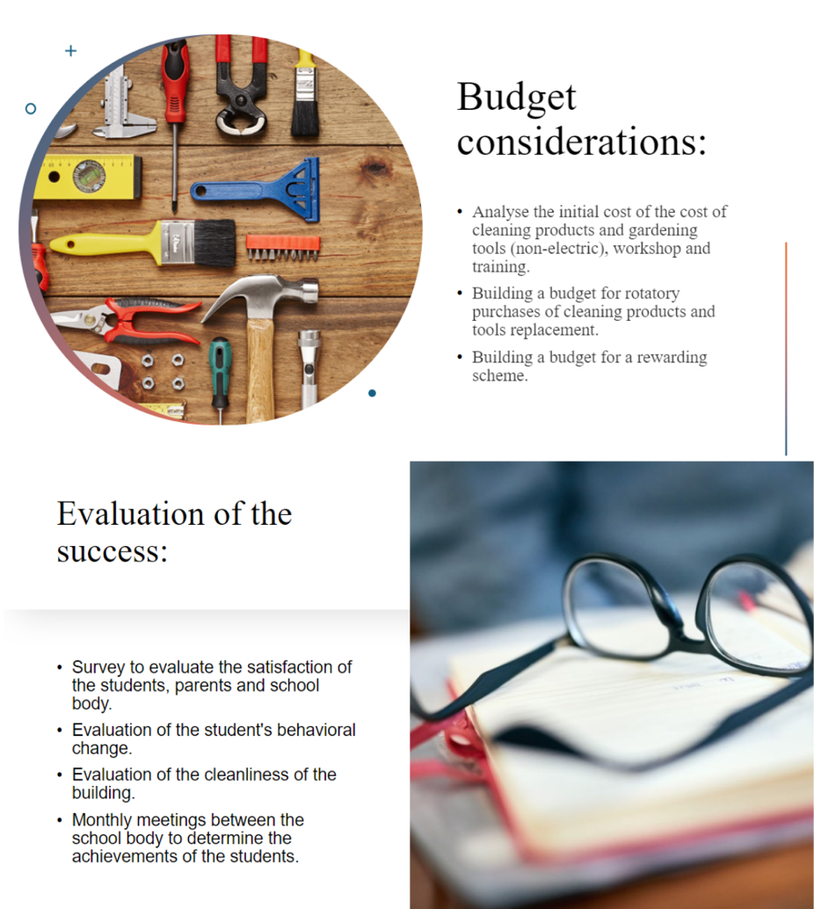
- Community Engagement Project Standard Implemenstation
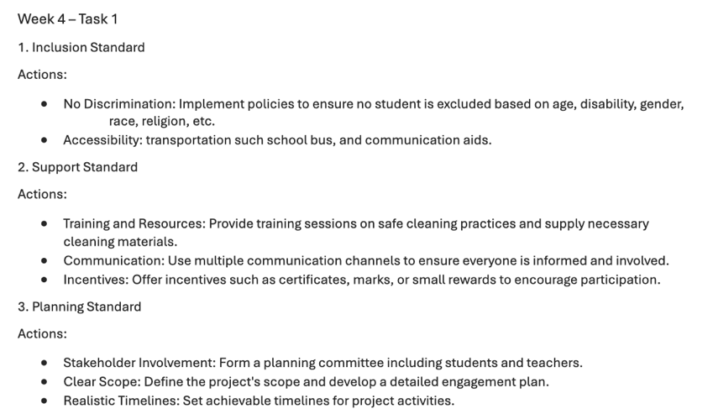
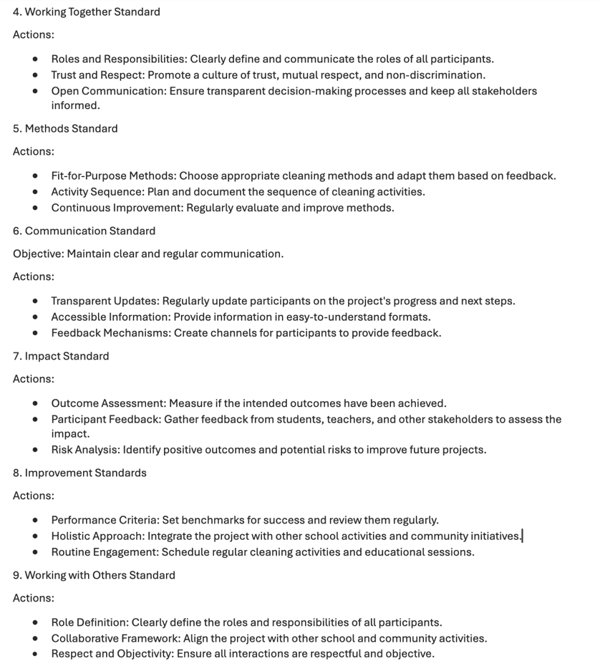
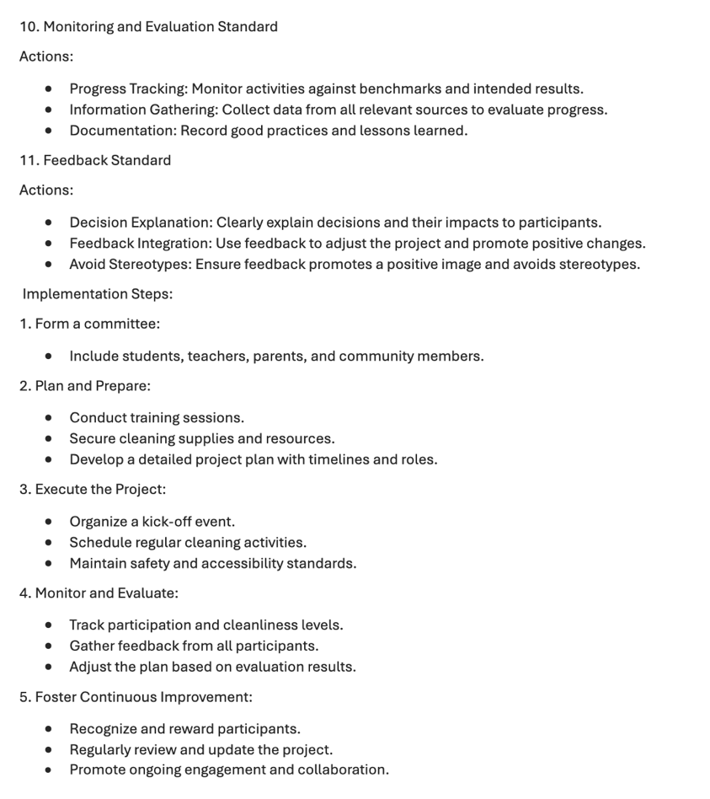
- Community Engagement Project: Hilton Hotels Company Poster and Tools and Platforms Adopted
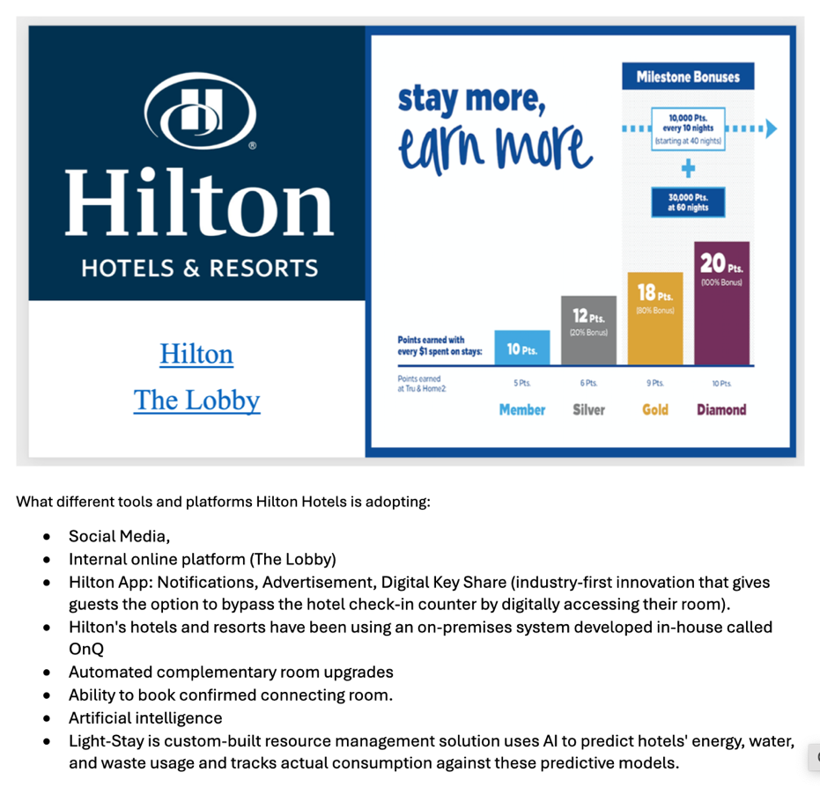
(Fig: Regalla, 2021)
- Community Engagement Practitioner, Methods, Plans and Principles
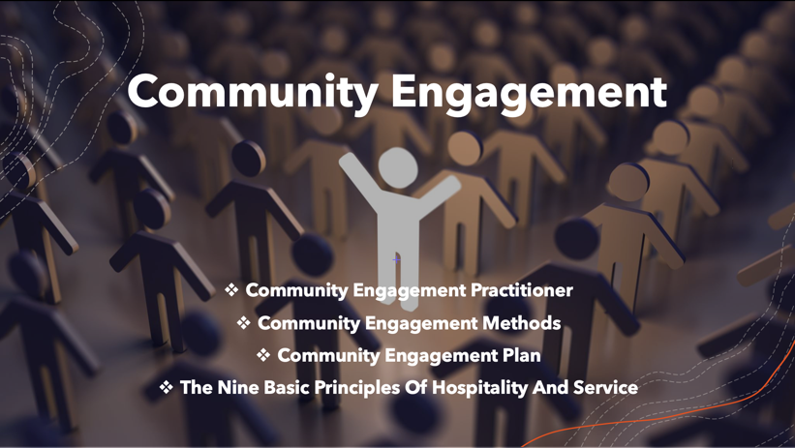
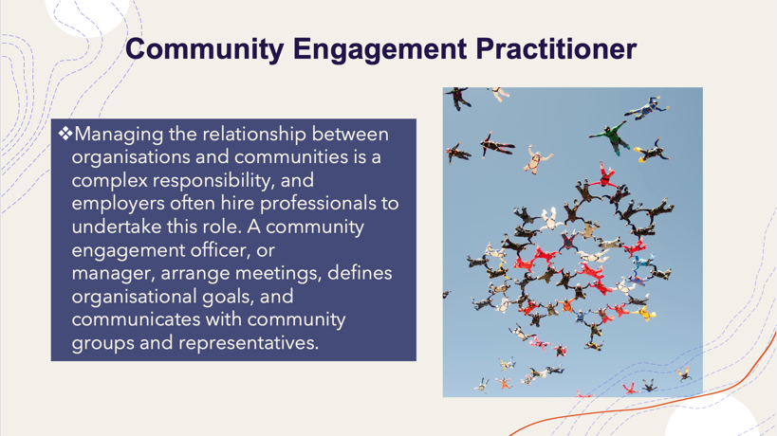
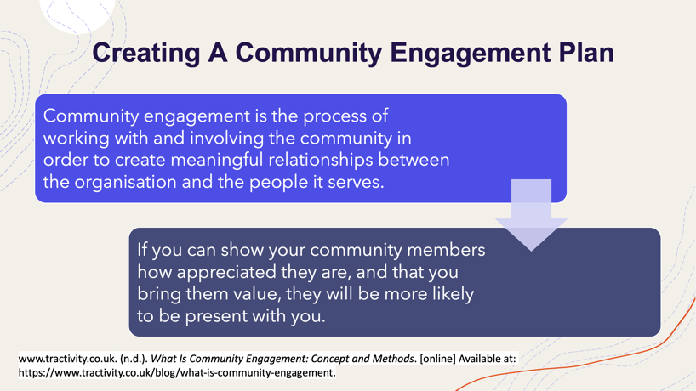
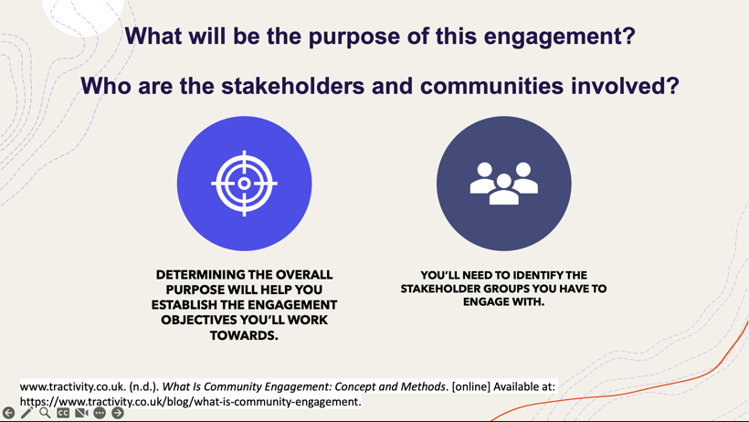
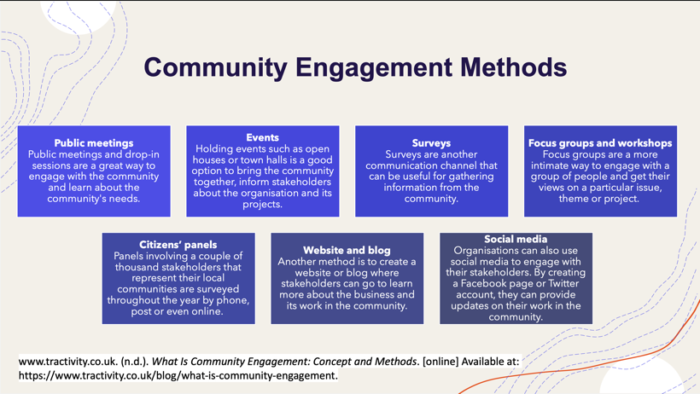
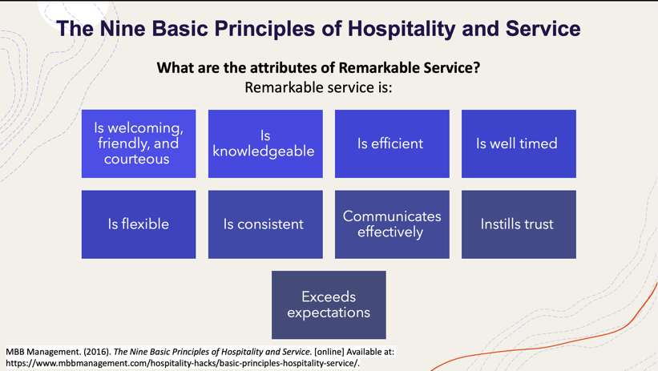
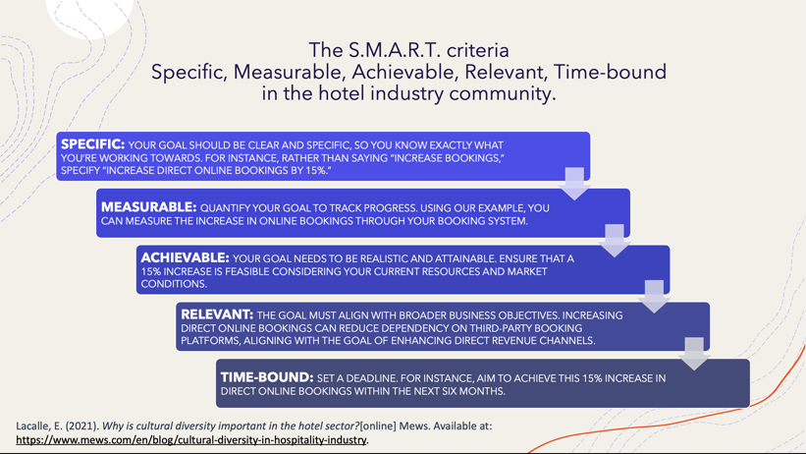
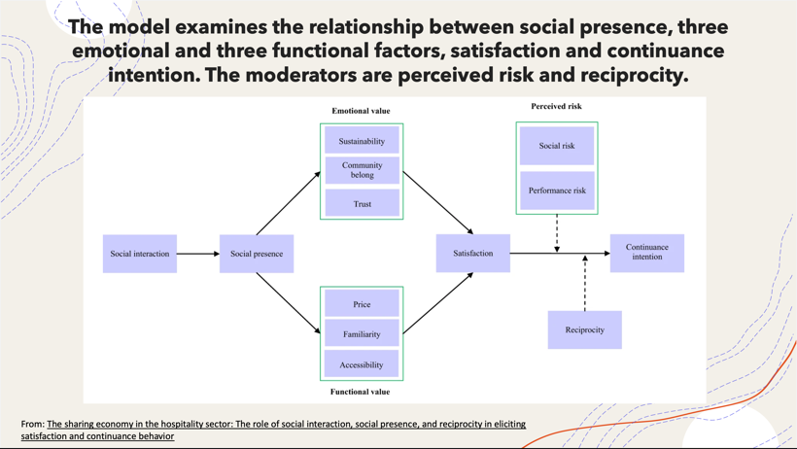

References
Aboelata, M.J. and Ersoylu, L. (2011). Community Engagement in Design and Planning. Making Healthy Places, pp.287–302. doi:https://doi.org/10.5822/978-1-61091-036-1_19.
Bohdanowicz, P. and Novotna, E. (2011). International hotel chains and environmental protection: an analysis of Hilton’swe care!programme (Europe, 2006–2008). Journal of Sustainable Tourism, 19(7), pp.797–816. doi:https://doi.org/10.1080/09669582.2010.549566.
Cunningham, H.R. and Smith, P. (2020). Community Engagement Plans: A Tool for Institutionalizing Community Engagement. Journal of Higher Education Outreach and Engagement, [online] 24(2), pp.53–68. Available at: https://openjournals.libs.uga.edu/jheoe/article/view/1696.
Crystal Roof. (2021). Demographics of Mayfair Row, London, W1J 7EA. [online] Available at: https://crystalroof.co.uk/report/postcode/W1J7EA/demographics# [Accessed 27 Aug. 2024].
Dubach, B. and Machado, M.T. (2012). The importance of stakeholder engagement in the corporate responsibility to respect human rights. International Review of the Red Cross, 94(887), pp.1047–1068. doi:https://doi.org/10.1017/s1816383113000404.
Haberlein, L. and Hovel, P. (2023). Importance and Necessity of Stakeholder Engagement. Importance and Necessity of Stakeholder Engagement, [online] pp.38–53. doi:https://doi.org/10.1007/978-3-031-33177-0_3.
Head, B.W. (2008). Community Engagement: Participation on Whose Terms? Australian Journal of Political Science, 42(3), pp.441–454. doi:https://doi.org/10.1080/10361140701513570.
Hilton (2023). STAKEHOLDER ENGAGEMENT. [online] Available at: https://cr.hilton.com/wp-content/uploads/2019/03/2018_Hilton_Stakeholder_Engagement.pdf.
Hilton ESG (2024). STAKEHOLDER ENGAGEMENT POLICY STATEMENT. [online] Available at: https://esg.hilton.com/wp-content/uploads/2021/04/Hilton-Stakeholder-Engagement-Statement.pdf.
Huckestein, D. and Duboff, R. (2013). Hilton Hotels. Cornell Hotel and Restaurant Administration Quarterly, 40(4), pp.28–38. doi:https://doi.org/10.1177/001088049904000411.
Huzzard, T. (2020). Achieving impact: exploring the challenge of stakeholder engagement. European Journal of Work and Organizational Psychology, [online] pp.1–11. doi:https://doi.org/10.1080/1359432x.2020.1761875.
Kumar, R. and Sharma, S. (2014). Asian Journal of Multidisciplinary Studies Corporate Social Responsibility-A study on hotel industry. [online] 2(4), pp.2348–7186. Available at: https://core.ac.uk/download/pdf/229670697.pdf.
Lacalle, E. (2021). Why is cultural diversity important in the hotel sector?[online] Mews. Available at: https://www.mews.com/en/blog/cultural-diversity-in-hospitality-industry.
Lho, L.H., Quan, W., Yu, J. and Han, H. (2022). The sharing economy in the hospitality sector: The role of social interaction, social presence, and reciprocity in eliciting satisfaction and continuance behavior. Humanities and Social Sciences Communications, [online] 9(1), pp.1–12. doi:https://doi.org/10.1057/s41599-022-01379-y.
Mayfair (2019). Mayfair. [online] Mayfair. Available at: https://www.mayfairforum.org [Accessed 29 Aug. 2024].
Manoharan, A. and Madera, J.M. (2023). The Routledge Handbook of Diversity, Equity, and Inclusion Management in the Hospitality Industry. [online] Google Books. Taylor & Francis. Available at: https://books.google.com/books?hl=en&lr=&id=Y4bSEAAAQBAJ&oi=fnd&pg=PT329&dq=hilton+hotel+community&ots=vNqH3m_pYd&sig=S_4YBRS9BePCYp0_Znqc4hZictY [Accessed 11 Jul. 2024].
Mcphail, T.L. and Phipps, S. (2020). Global communication : theories, stakeholders, and trends. 5th ed. Hoboken, Nj: Wiley Blackwell.
Mitchell, J.R., Mitchell, R.K., Hunt, R.A., Townsend, D.M. and Lee, J.H. (2020). Stakeholder Engagement, Knowledge Problems and Ethical Challenges. Journal of Business Ethics, 175, pp.75–94. doi:https://doi.org/10.1007/s10551-020-04550-0.
MBB Management. (2016). The Nine Basic Principles of Hospitality and Service. [online] Available at: https://www.mbbmanagement.com/hospitality-hacks/basic-principles-hospitality-service/.
Paulina, B. (2007). A Case Study of Hilton Environmental Reporting as a Tool of Corporate Social Responsibility. [online] www.ingentaconnect.com. Available at: https://www.ingentaconnect.com/content/cog/tri/2007/00000011/00000002/art00004.
Pryke, S. and Smyth, H. (2012). The Management of Complex Projects: A Relationship Approach. [online] Google Books. John Wiley & Sons. Available at: https://books.google.com/books?hl=en&lr=&id=uhAz26GuCRYC&oi=fnd&pg=PA131&dq=stakeholders+communication&ots=DbRHCT_EZ_&sig=yKXlr3YcH0xfD1eXZOEig7P4db8 [Accessed 11 Jul. 2024].
Quinn, F.F. and Thorne, D.M. (2014). Effective communication with stakeholders. [online] www.elgaronline.com. Available at: https://www.elgaronline.com/downloadpdf/edcoll/9781781003787/9781781003787.00012.pdf [Accessed 30 Apr. 2024].
Rahman, M. (2020). Stakeholders of Apple (Analysis of Apple’s stakeholders). [online] howandwhat. Available at: https://www.howandwhat.net/stakeholders-apple-analysis-apples-stakeholders/
Ray, K.N. and Miller, E. (2017). Strengthening stakeholder-engaged research and research on stakeholder engagement. Journal of Comparative Effectiveness Research, 6(4), pp.375–389. doi:https://doi.org/10.2217/cer-2016-0096.
Regalla, L. (2021). Customer Retention: Importance + Proven Retention Strategies. [online] Hiver. Available at: https://hiverhq.com/blog/customer-retention.
‌Stokes, K.E., O℉Neill, K.P., Montgomery, W.I., Dick, J.T.A., Maggs, C.A. and McDonald, R.A. (2006). The Importance of Stakeholder Engagement in Invasive Species Management: A Cross-jurisdictional Perspective in Ireland. Biodiversity and Conservation, 15(8), pp.2829–2852. doi:https://doi.org/10.1007/s10531-005-3137-6.
Wells, K.B., Tang, J., Lizaola, E., Jones, F., Brown, A., Stayton, A., Williams, M., Chandra, A., Eisenman, D., Fogleman, S. and Plough, A. (2013). Applying Community Engagement to Disaster Planning: Developing the Vision and Design for the Los Angeles County Community Disaster Resilience Initiative. American Journal of Public Health, 103(7), pp.1172–1180. doi:https://doi.org/10.2105/ajph.2013.301407.
www.tractivity.co.uk. (n.d.). What Is Community Engagement: Concept and Methods. [online] Available at: https://www.tractivity.co.uk/blog/what-is-community-engagement

