Effective Teamwork and Communication

BY
Student Name: Nekeisha Tamika Taylor Nee Rhoden
Student ID: 2028878

Executive Summary
The main objective of the study is to address the significant factors that the team members must possess and practice while working with and through others. This study will also demonstrate, as a team it requires all sorts of knowledge and understanding like cognitive and intellectual skills, practical skills, decision-making skills, conflict resolution skills, and hierarchical sensitivity. The data is collected from the available literature and researches in the field of teamwork and effective communication. Teamwork and communication are always contentious issues in the field of corporate culture. But, forming and operating an effective team is a challenging and arduous endeavor. Effective and conducive teamwork and communication can lead an organization to success and strive. On the contrary, the conflict between or among the team members will drive the organization to the breakdown and debacle.

Table of Contents
Executive Summary 2
Introduction 4
Stages of Group Development 5
Communication Frameworks in Teamwork 6
Causes and Effects of Poor Communication 8
Ways to Improve Poor Communication 9
Conclusion and recommendations 11
References 12

Introduction
A set of respondents working together in a harmonious and interdependent environment to achieve common goals and objectives by sharing content and resources is alluded to as teamwork. (Luca & Terricone, 2002). As current businesses are completely cross-connectional through their many departments, as a result, teamwork and effective communication have become an unavoidable concern for any organization. To sustain effective teamwork and communication through the entire organization as well as to the external parties, organizations need to ensure a few qualities. These are; adaptability, cooperation, planning, direction, the connection between or among the members, and rapport. The purpose of this study is to exhibit and scrutinize the knowledge and skills required to form a competent team and will also demonstrate the methods and different ways of effective communication.

Stages of Group Development
Bruce Tuckman first introduced the forming-storming-norming-performing-adjourning model of team development in the year 1965. In his model B. Tuckman claimed that these phases are essential and inescapable for a team to grow, and work with and through others. Tuckman postulated that interpersonal relations and skills would increase the four-stage of the model. And for this, the model has to be properly maneuvered and constructed an effective group function as these inevitable phases were crucial for the growth and development of the team. (B. Tuckman, The stages of group development). The following picture will illustrate the phases of the group development model.
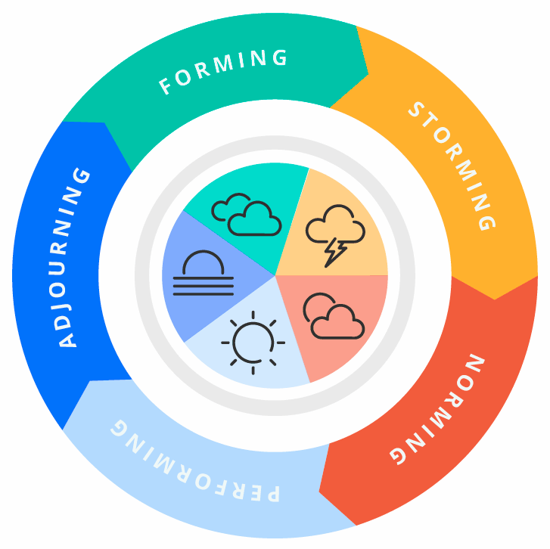
Figure: Tuckman’s stages of group development, (Sources: Pfrimmer, 2009)
Forming: This is the very beginning stage of a group. Here, the team gets and assesses the challenges and opportunities and then agrees on the goals and objectives and after that begins to tackle the task. In this stage, members are prone to working their own way.
Storming: This is the second phase of the model. Here, members express their opinions, thoughts, disagreements among the team members. When group members begin to work with each other they learn about each other. In this stage members also apprehend the hierarchy of position.
Norming: At this stage, every one of the team accepts the responsibilities and is motivated to work together. They begin to learn the rules and regulations of the team.
Performing: After establishing the norms and rules, group members focus on achieving the common goals of the team, and they often unexpectedly higher performance than the expected parameter. In this stage, group members will be able to be competent, self-sufficient, and qualified to make decisions and work in a dynamic environment. (B. Tuckman)

Communication Frameworks in Teamwork
It is obvious that an effective and competent team can foster and encourage the members to build a common sense of purpose to attain their goals and objectives. But, it is not just the competent team, effective communication frameworks are also required to develop a sense of belongingness and to strengthen the connection among the members. Now the questions arise, why some teams are successful and some are unsuccessful? What criteria and attributes are needed to strive? What can be the best way to communicate? How will the respondents provide feedback? The answers to these questions are essential to determine the models of communication. Scholars have developed several models of communication to explain the interpersonal flow of interactions. There are three most common models for communication. These are; Linear, Transactional and Interactional. Every model illustrates the formation and growth of the communication but, each consists of a variety of actions. (West & Turner, 2007).
Linear Models: This model was developed by Shannon and Weaver in 1948. This model illustrates how a sender, also can be called a speaker, conveys a message to a receiver also called a listener. It is a one-directional way of communication. The message is encoded by the sender who then sends it to the receiver using specific channels. Here, the sender is the only source of the message. It is a simple one-way and ono-interactive communication process where the sender passes the information through some channel. It’s a straight-line form of communication. (Alshanqiti et al.,). Noise can be a major obstacle to the effectiveness of this model. Any interruption in the transmission or message distortions can be referred to as noise. The following picture will simplify the linear model of communication:
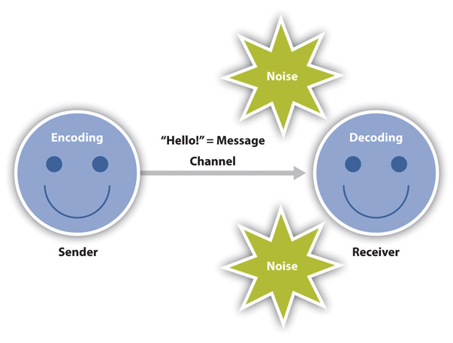
Figure: Linear Model of Communication (Andy Schmitz)
As this model of communication only supports one-way communication, it doesn’t show the context, receiver point of view, and impact on communication. To eradicate this limitation of the linear model researchers further developed the Transactional Model of communication.
Transactional Model: The transactional model of communication is the most dynamic model. The transaction from referring to people as senders and receivers to referring to them as communicators is one of the most eminent features. By sending and receiving messages to each other people communicate by this type of method. From this point of view, communication is a collaborative approach in which participants cross the interaction’s process. Participants’ engagement and feedback to each other make this model more dynamic and effective comparatively linear model. The following picture will demonstrate the process of the transactional model of communication.

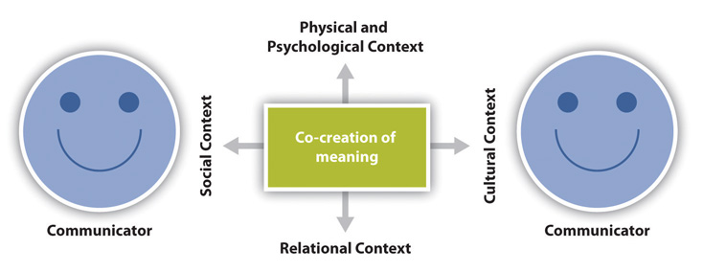
Figure: Transactional Model of Commutation (Andy Schmitz)
Interactional Model: The interactional or interactive model of communication construes communication as a process in which participants can change their position as sender and receiver. Unlike the linear model, the interactional model incorporates feedback rather than depicting the communication-way process, making the communication process more interactive and two-way process. The following picture will clarify the communication process of this model:
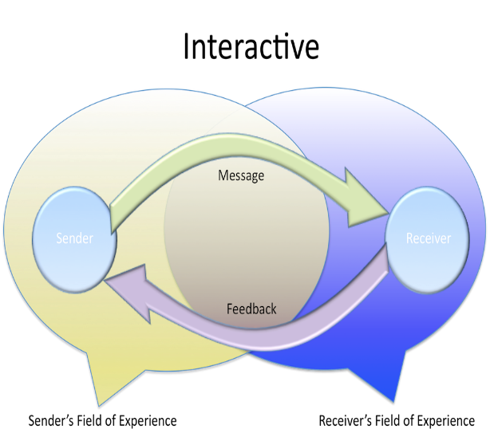
Figure: Interactional Model of Communication (Shannon and Weaver)

Causes and Effects of Poor Communication
When there is a divergence or discrepancy between what is said and what is heard in the workplace, it can be between co-workers or between an employee and management, causing poor communication. To be specific, when the individual to whom the sender wants to communicate, misunderstands what the sender is saying, is the root cause of poor communication. There are a few subtle causes of poor communication between or among the participants. These can be concluded as follows:
- Poor unity of direction
- Unclear context or objectives
- Limitations for feedback
- Poor leadership
- Cultural diversity
- Demotivated employees
- Interpersonal challenges
Accordingly, Robert Murray, communication may sometimes be the most severe issue that a company faces. He cited that there are numerous causes for poor communication breakdowns. And these are; ego, cultural barriers, opaqueness, political affairs, authority and position, intervening space and predetermined reasoning. Poor communication in the workplace indicates a lack of predictability and reliability, generating an undesirable working environment. Employees may not be able to apprehend the commands and directions from the top management. Therefore, the whole organization will suffer. And, the major effects of poor communication can be summarized as unpredictable workplace, lower effective cooperation, conflict among the personnel, demoralized employees, and emotional distraction. Though poor communication leads an organization through many unwanted scenarios, identifying the causes and finding the solutions can also bring convenient improvement.

Ways to Improve Poor Communication
The primary cause of poor communication is the misunderstanding between or among the respondents. Various misunderstandings can be raised in the phase of communication. Considering all the causes and facts that cause poor communication, respondents can adopt the following methods to improve and enhance communication skills.
Creating a uniform level of communication: Among the respondents, the level of communication should be uniform and standardized. There shouldn’t be any visible or implicit discrepancies in the process of communication. Any organization that maintains a proper uniform level of communication method will be able to swamp the communication gap.
Maintaining a formal mode of communication: Although informal and interpersonal communication brings more effectiveness to understanding the context, it leads to less priority and importance to the message most of the time. To alleviate all forms of unethical and immoral causes of communication formal mode of communication must be maintained.
Consistence with the methods of communication: Any type of contradiction or discrepancies will not have emerged if the firm follows almost the same type of communication method. As concerning the changing world, the communication methods can be upgraded and advanced but the respondents have to be dynamic and adaptive.
Providing feedback: Feedback is the final and the utmost essential part of communication. If the receiver doesn’t get what the sender was trying to convey, the sender will retry and repeat the message which is more arduous and time-consuming. (T.S and Rice, 2020).

Conclusion and recommendations
To wrap up this study, it can be said that the different methods of communication are developed to bolster communication among the respondents, senders-receivers. Teamwork largely relies on effective communication. Communication models contain many different components and features that certainly enhance team performance. However, the goal of constructing a communication method is to interact with one another effectively and in a relatively simple manner. Furthermore, effective communication skills are essential for management and employee relationship and to working with and through others. Here, some recommendations for both the sender and the receiver to enhance the communication.
Trust and rear can’t coexist: Team members must work together and need to construct a trustworthy atmosphere. When people do what they promised or what is ordered and others do the same, trust emerges.
The first is to understand then to be understood: The senders must be aware of what is in the context of the message and what can be the best way to convey it to the receivers. Then the senders have to ensure that his/her message was sent and at the end, there will be feedback.

References
- Alshanqiti, A.M. and Khozium, M.O., 2021. Communication Models Comparisons: Tackling Approach for Corporate Communication. Psychology and Education Journal, 58(4), pp.4075-4079.
- Dorius, C., Madeka, K., Bender, H.S., Johnson, J., Gillette, M.T. and Chapman, J., 2021. The readiness assurance process in online team‐based learning classrooms. New Directions for Teaching and Learning, 2021(165)
- Dyer, S., 2017. Seven root causes of poor communication: And tips for overcoming them. Professional Safety, 62(8), p.16.Leonard, M., Graham, S. and Bonacum, D., 2004. The human factor: the critical importance of effective teamwork and communication in providing safe care. BMJ Quality & Safety, 13(suppl 1), pp.i85-i90.
- Muksin, N.N., Shabana, A. and Tohari, M.A., 2021, June. Online Based Communication Model For Indonesian Migrant Workers In Hong Kong On Financial Management. In Journal Universitas Muhammadiyah Gresik Engineering, Social Science, and Health International Conference (UMGESHIC) (Vol. 1, No. 1, pp. 138-146).
- Murray, R.R., 2020. Improving young workers’ safety voice: a three-part study exploring safety voice interventions.
- Ntarladima, A.M., Karssenberg, D., Vaartjes, I., Grobbee, D.E., Schmitz, O., Lu, M., Boer, J., Koppelman, G., Vonk, J., Vermeulen, R. and Hoek, G., 2021. A comparison of associations with childhood lung function between air pollution exposure assessment methods with and without accounting for time-activity patterns. Environmental research.
- Pfrimmer, D., 2009. Teamwork and communication. The Journal of Continuing Education in Nursing, 40(7), pp.294-295.
- Rice, T.S., 2020. Process of communication.
- Schultze, U. and Brooks, J.A.M., 2019. An interactional view of social presence: making the virtual other “real”. Information Systems Journal, 29(3), pp.707-737.
- Tarricone, P. and Luca, J., 2002. Successful teamwork: A case study.

