University of Wales Trinity Saint David
School of Engineering
The development of circular economy to support achieving NetZero
Lauren Lloyd
2315243
Degree Apprenticeship in Logistics and Supply Chain Management
25th November 2024
Sustainability (ACMA4023)

Table of Figures
Figure 1: Annual Greenhouse Gas Emissions Worldwide from 1990 to 2023, by sector (European Commission, 2024) 4
Figure 2: Reverse Logistics in the Supply Chain (Jenkins, 2021) 6

Table of Contents
1. Introduction 4
2. Company Sustainability Background 5
3. Sustainable Logistics Practices 6
3.1 Shipment Consolidation 6
3.2 Reverse logistics 7
4. Management Practices 8
4.1 Single use plastics 8
4.2 Waste Management 8
5. Recommendations 9
6. Conclusion 11
7. References 12

Introduction
In this modern day and age, consumers have become more environmentally conscious which is evident in their purchasing choices. So, for businesses to continue to operate, it is key that they become more sustainable. But what is really involved in this? Sustainability is a concept which aims to prevent the depletion of resources in the world, so that the resources could be available indefinitely (Mollenkamp, 2023). Sustainability encompasses three core pillars, which are the environment, the economy, and social aspects, each very important.
A key target within sustainability is achieving net zero, which is where the amount of Carbon Dioxide released in the atmosphere is equal to the amount that is removed (World Economic Forum, 2021). As set out in the Paris Agreement, world leaders agreed to limit climate change to 1.5 degrees Celsius above pre-industrial times (BBC, 2024). By ensuring the world temperature doesn’t rise above this, the worst impacts of climate change, like rising sea levels and extreme weather conditions, can be contained to a level which avoids risk to human life (Hoegh-Guldberg, et al., 2018).
A crucial concept within sustainability is the circular economy, which is where existing products and materials are either repaired, re-used, or recycled to extend the life cycle of products, therefore waste is reduced to a minimum (European Parliament, 2023). Implementing more circular economy practices into a business would be an optimal way to reduce waste, and the business’ impact on the environment.
As sustainability is increasingly becoming a core consideration for customers, now is the time for businesses to step up and fully embrace becoming more sustainable, ideally through adapting circular economy practices. This report explores the sustainable logistics and management practices currently in operation within Sony UK Technology Centre, focussing on the company’s aim to achieve net zero by 2040, and the development of circular economy applications within the business to support with achieving that goal.

Company Sustainability Background
To clarify more in depth what Sony is doing overall to become more sustainable, this section will go over some recent improvements made on the road to achieving a company set target of net zero by 2040.
Although the first thought people can have when sustainability is mentioned is the environment, sustainability also refers to the economy and looking out for the community and the people within it. One aspect within this is the many volunteering events that take place, with the help of Sony employees. This has not only helped the environment with over 300kg of litter collected & recycled, but also helped employees to connect and engage with co-workers about things bigger than just work. There is also a school’s program in place to inspire the next generation of young people to want to work in manufacturing – this program helps children to learn coding, with over 30,000 participants to date.
In addition to this, to become more environmentally friendly, solar panels are installed to generate energy on-site. This currently generates around 14% of the total site demand. To improve, more solar panels are currently being installed which will take the total renewable energy generated onsite up to 25% of Sony’s total site demand to be sustainable.

Sustainable Logistics Practices

3.1 Shipment Consolidation
Logistics is a central activity within the supply chain, however, as seen in figure 1, the transportation sector is the second biggest contributor of greenhouse gases into the world (European Commission, 2024). This highlights the need for action to be taken within businesses to transform this sector into a sustainable one.
Figure 1: Annual Greenhouse Gas Emissions Worldwide from 1990 to 2023, by sector (European Commission, 2024)
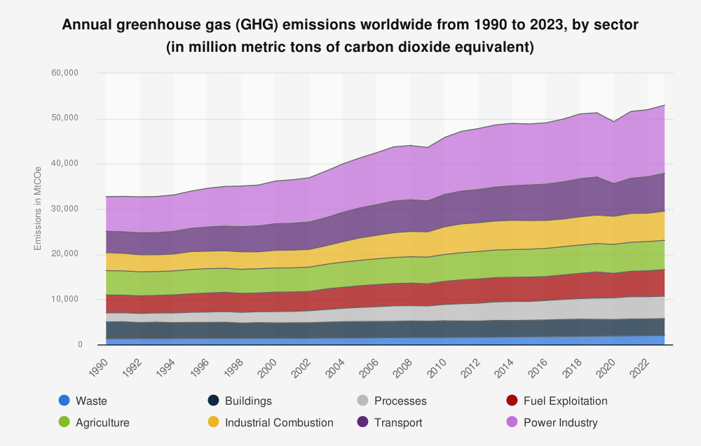
An action that businesses could take to become more sustainable is through shipment consolidation. This is where two or more smaller shipments are combined into one and are transported together, avoiding multiple unnecessary journeys by combining them to go together. By businesses adapting this model, the amount of energy required, and CO2 released into the environment is reduced (Ulku, 2012), which links very closely with the circular economy model. This model is already in use in Sony Pencoed, through both goods incoming from suppliers to Sony, and shipments from Sony to customers. This has not only been helpful in terms of environmental emissions reductions, but also through cost savings. Consolidating shipment aids business’ in reducing costs through many factors, such as space optimisation, reduced handling costs, and economies of scale due to one large shipment compared to multiple smaller shipments (TOC Logistics, 2024).
3.2 Reverse logistics
A key concept in circular economy is reverse logistics. Unlike traditional logistics, the starting point of reverse logistics is the consumer, and it encompasses the return of goods from the end customer back to the manufacturer or distributer (Brito, Dekker, & Flapper, 2005). Figure 2 demonstrates an example of this process.
Figure 2: Reverse Logistics in the Supply Chain (Jenkins, 2021)
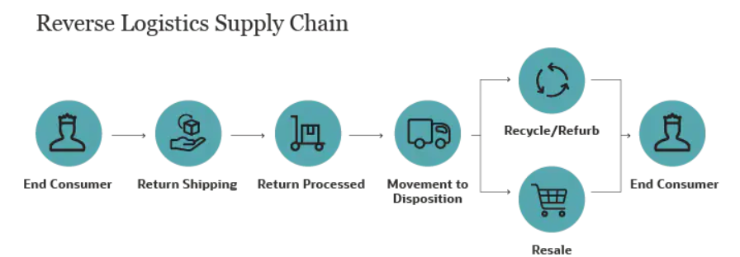
Reverse logistics is a good way to implement circular economy principles within a business. In Sony UK Technology centre, the 5 Rs of Reverse logistics are implemented – these are 1., Returns, 2., Reselling, 3., Repairing returned products, 4., Recycling, and 5., Recalls (Moreau, 2022). An example of this is in Sony is how Sony deals with customer returns. When returns are received, they get sorted by a dedicated team in one of the warehouses, and categorised into 3 categories – resell, repair, or recycle. If the returned items are deemed good enough to sell, these are posted on staff sales for a discounted price, to encourage people to buy them rather than having to scrap. Additionally, in Sony there is an in-house repair team, where customers can send both in-warranty and out-of-warranty products back to Sony where they will be repaired. This extends the life span of products and decreases the number of products that are being disposed of, which is better for the environment (Circular, 2022). However, even though this is a viable option for customers, notably, a study by Deloitte found that 40% of people choose to throw away defective products and replace with a new version (Deloitte, 2024). This shows that more needs to be done to encourage people to repair to minimise waste and step away from the current throwaway culture in operation.

Management Practices

4.1 Single use plastics
Currently, single-use plastics make up almost 40% of annual plastics produced globally (Ocean Conservacy, 2018). Moreover, it has been recorded that more than 80% of marine litter is made up of single use plastics (European Commission, 2021). Now is the time for businesses to tackle the use of single-use plastics in operations, to help to achieve net zero.
In Sony, to achieve net zero through circular economy practices, and move away from single-use plastics in operation, over recent months, instead of transporting goods back and forth between a supplier and Sony in single-use plastics which are then disposed of, a new method has been implemented. This includes purchasing a reusable container which the goods are sent to Sony in, Sony then use the parts from them and then send them back to the supplier to be re-filled, and the cycle continues. This has eliminated one aspect of single-use plastics in operation and encouraged a more circular economy of re-using goods.

4.2 Waste Management
Linking closely to the concept of circular economy, adequate waste management plays a vital role in companies moving closer to becoming fully sustainable. In fact, every year more than 2 billion tonnes of solid waste are produced from homes and businesses (World Economic Forum, 2024). Unless the world adopts a fully zero waste circular economy model, this figure is expected to more than double by 2050 (World Economic Forum, 2024). A clear example of how businesses can move to a zero-waste model is through increasing their recycling schemes. In Sony, all PWB’s that are made are sent offsite to the Royal Mint to be processed and have precious metals, including gold, reclaimed from it which is then made into jewellery. This is not only good for the environment as materials are getting repurposed, but also for Sony economically as Sony now does not have to pay for disposal, instead, Royal Mint pay Sony for the PWBs.
Achieving sustainable waste management is a major step forward for businesses to becoming net zero, and it can also bring them benefits such as cost savings and economic gains through reduced disposal fees and increased brand reputation (Greenify, 2023). This highlights the benefits that all businesses can gain from switching to sustainable business practices and adopting the circular economy methodology.

Recommendations
Overall, Sony is doing a lot to achieve the target of net zero by 2040, ahead of the Unites Nation’s goal of achieving net zero by 2050 (BBC, 2024). However, there is still more than can be done. One of the aspects that could be explored is the feasibility of Sony to create an in-house recycling centre. This could improve sustainability even further by having all recycling solutions done on site, without the need to transport goods to different locations, thereby cutting CO2 emissions and encouraging a circular economy as waste can be sorted and recycled, and potentially re-used in operations where applicable.
A recommendation for the Sony site in terms of becoming net zero would be to invest further in renewable energy generated onsite. Although Sony are using power derived from solar panels, it could be taken one step further by implementing even more solar panels, or perhaps an on-site wind turbine. This would help Sony to achieve the net zero target considerably faster and would reduce Sony’s reliance on non-sustainable energy.
An additional recommendation would be to have parts transported to Sony via sea transfers rather than air transfers. Currently, although this is hard to measure precisely, it is thought that air freighting releases 47 times more greenhouse gas emissions compared to the sea fright alternative (Baxter, 2022). This emphasises the extent of how bad air transfers are on the environment and shows how beneficial it would be if Sony were to arrange for parts to always be transferred via ship. However, this isn’t always possible due to long lead times from suppliers in further away countries, and ever-changing forecasts from customers meaning sometimes urgent deliveries via air are needed.
Another way to potentially become more environmentally friendly is to source from more local suppliers, which would reduce the carbon emissions released into the environment due to travel and increase flexibility of the plan due to shortened lead times (Daisy, 2024). Even though local sourcing may come at an increased cost, it is an option that is worth exploring for the benefits that are seen in the environment alone.
A final recommendation for Sony would be to improve resource efficiency and optimisation. Like Siemens and Toyota who are currently leading in resource efficiency (Jessen, 2024), businesses should look to adopt measures such as material substitution and energy recovery to ensure that the amount of waste produced is minimised, as well as the value of parts being maximised (Jessen, 2024). This could be an effective way for Sony to make a step towards having a more circular economy by making more with less.

Conclusion
In conclusion, the transition that is taking place in businesses to become sustainable is one that comes with many challenges. However, it is imperative that businesses adopt greener processes, not only for health of the planet, but also for the business to continue being successful. In alignment with that, a study by Gartner showed that the business priority for sustainability is up by 292% since 2021 (WIles, 2022), so sustainability as a core value for businesses is on an improving trend.
Ultimately, Sony has demonstrated some good circular economy practices in aid of achieving net zero, such as the in-house repair centre which encourages longevity of a product, and the precious metal reclaiming partnership with the Royal Mint. Nevertheless, there is always more that can be done to become greener, evident in the suggestions for future improvement.
Even though initially implementing circular economy practices and other methods of achieving net zero can be costly, it is important for companies to consider the impact beyond just their business, but how the climate crisis will affect the world if little or no action is taken. All points considered, circular economy business practices are a key step to achieving net zero in the future, and the earlier these sustainable practices are implemented in operations, the better.

References
Baxter, K. (2022, April 6). Air Freight vs Ocean Freight Carbon Footprint & Environmental Impact. Retrieved October 2024, from InTek: https://blog.intekfreight-logistics.com/air-freight-vs-ocean-freight-carbon-footprint-environmental-impact
BBC. (2024, November 13). What is net zero and how are the UK and other countries doing? Retrieved November 2024, from BBC: https://www.bbc.co.uk/news/science-environment-58874518#:~:text=What%20does%20%27net%20zero%27%20mean%3F%20Net%20zero%20means,so%20those%20that%20remain%20need%20to%20actively%20removed.
BBC. (2024, November 8). What is the Paris climate agreement and why does 1.5C matter? Retrieved November 2024, from BBC: https://www.bbc.co.uk/news/science-environment-35073297
Brito, M. P., Dekker, R., & Flapper, S. D. (2005). Reverse Logistics: A Review of Case Studies. Lecture Notes in Economics and Mathematical Systems, 544. doi:https://doi.org/10.1007/978-3-642-17020-1_13
Circular. (2022, April 27). Don't despair, repair: why repairing is on the rise. Retrieved November 2024, from https://www.circularonline.co.uk/features/dont-despair-repair-why-repairing-is-on-the-rise/
Daisy, D. (2024, January 7). Analyzing the Advantages and Disadvantages of Local Sourcing in Supply Chain. Sourcing, Global Trade. Retrieved November 2024, from Team Thomas: https://supplychainreport.org/analyzing-the-advantages-and-disadvantages-of-local-sourcing-in-supply-chain/
Deloitte. (2024). Right to Repair means more than a quick fix for environment, economy. Retrieved November 2024
European Commission. (2021, June 2021). EU restrictions on certain single-use plastics. Retrieved November 2024, from https://environment.ec.europa.eu/topics/plastics/single-use-plastics/eu-restrictions-certain-single-use-plastics_en
European Commission. (2024). Annual greenhouse gas (GHG) emissions worldwide from 1990 to 2023, by sector. Retrieved from Statistica: https://www.statista.com/statistics/1423179/global-ghg-emissions-by-sector-annual/
European Parliament. (2023, May 24). Circular economy: definition, importance and benefits. Europe. Retrieved October 2024, from https://www.europarl.europa.eu/topics/en/article/20151201STO05603/circular-economy-definition-importance-and-benefits
Greenify. (2023, October 21). How Sustainable Waste Management Can Benefit Your Business and the Environment. Retrieved November 2024, from https://greenifyhub.com/waste-management/sustainable-waste-management/
Hoegh-Guldberg, Jacob, O., Taylor, M., Bindi, M., Brown, S., Camilloni, I., . . . Zhou, G. (2018). Impacts of 1.5ºC Global Warming on Natural and Human Systems. Cambridge, UK and New York, NY, USA: Cambridge University Press. doi:https://doi.org/10.1017/9781009157940.005
Jessen, J. (2024, August 21). Top 10: Circular Economy Strategies. Retrieved November 2024, from Sustainability Magazine: https://sustainabilitymag.com/top10/top-10-circular-economy-strategies
Mollenkamp, D. T. (2023, December 13). What is Sustainability? How Sustainabilities Work, Benefits, and Example. (J. R. Brown, Editor) Retrieved November 2024, from Investopedia: https://www.investopedia.com/terms/s/sustainability.asp
Moreau, F. (2022, October 5). An Introduction to the 5 R's of Reverse Logistics. Retrieved October 2024, from Global Trade: https://www.globaltrademag.com/an-introduction-to-the-5-rs-of-reverse-logistics/
Ocean Conservacy. (2018). Opportunities and Impacts of Single-Use Plastic Source Reduction in the Global Plastics Treaty. Materials Economics. Retrieved November 2024, from https://oceanconservancy.org/wp-content/uploads/2023/05/05292023-OCGlobalPlasticReductionAnalysis-FINAL.pdf
TOC Logistics. (2024, March 28). Buyers’ Consolidations: A Strategy for Cost Reduction in the Supply Chain. Retrieved 2024, from https://www.toclogistics.com/buyers-consolidations-a-strategy-to-reduce-costs/
Ulku, M. A. (2012). Dare to care: Shipment consolidation reduces not only costs, but also environmental damage. International Journal of Production Economics, 139(6), 438-446. Retrieved November 2024, from https://www.sciencedirect.com/science/article/abs/pii/S0925527311004014
WIles, J. (2022, April 27). CEOs Turn a Sharp Eye to Workforce Issues and Sustainability in 2022-23. Retrieved 2024, from https://www.gartner.com/en/articles/ceos-turn-a-sharp-eye-to-workforce-issues-and-sustainability-in-2022-23
World Economic Forum. (2021, November 9). What does net-zero emissions mean and how can we get there? Retrieved November 2024, from World Economic Forum: https://www.weforum.org/stories/2021/11/net-zero-emissions-cop26-climate-change/
World Economic Forum. (2024, April 4). 4 charts to show why adopting a circular economy matters. Retrieved November 2024, from Nature and Biodiversity: https://www.weforum.org/stories/2024/04/circular-economy-waste-management-unep/#:~:text=In%20a%20circular%20economy%2C%20products%20and%20materials%20are,along%20with%20unsustainable%20use%20of%20the%20planet%E2%80%99s%20resources.

