AHAC5008 Palaeoenvironmental Archaeology
Autumn Term 2017-2018
Level 5, 20 Credits

Tuesdays 14.00-17.00 (3 hour, Arts 05)

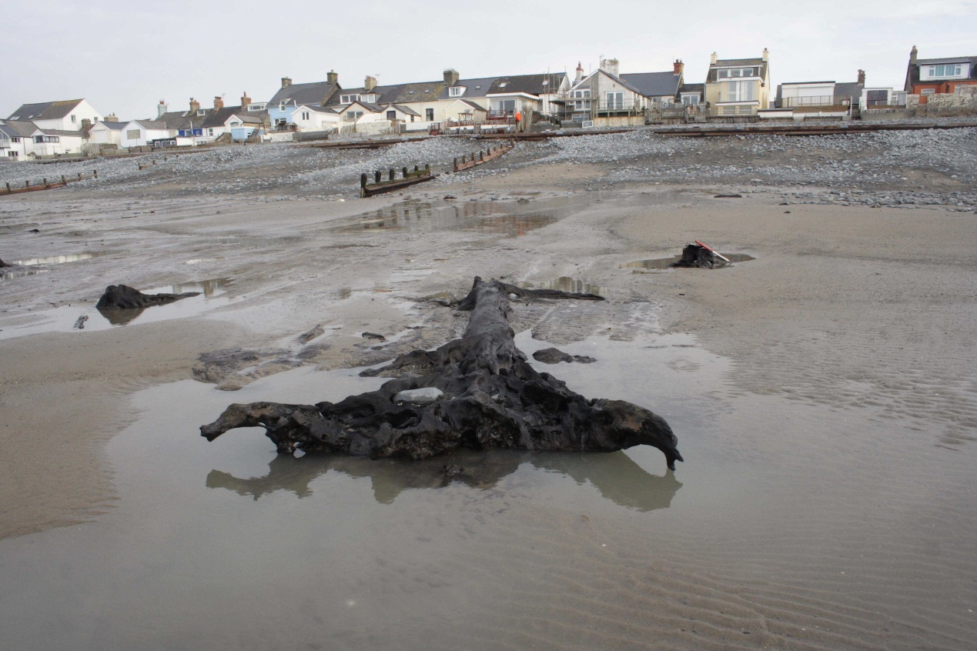

Teaching sessions: Tuesday 14.00-17.00 (Arts 05)

Welcome to the world of environmental archaeology. This module is delivered by a multi-disciplinary team including Martin, Ros, Nigel, and Astrid. Information may be posted by these staff as the module progresses- so keep looking. Should you need to know anything about the module contact Martin in the first place and then Ros. Please note: essay questions are in the Module Handbook - see link below. You should address one question from the list.

Course outline

The recovery, analysis and interpretation of archaeoenvironmental remains are of fundamental importance when attempting to interpret past human behaviour. The analysis of such remains can highlight the relationship people had with their environment in the past, how people shaped their environment and how the environment shaped their lives. This course introduces students to our ancient landscapes through the investigation of the material remains from a number of commonly occurring archaeological situations and depositional environments. It attempts to show how the recovery and detailed analysis of remains, such as pollen, seeds, soils and sediments, animal bones and wood, can enable the archaeologist to interpret peoples relationship with both landscape and climate change. This course introduces the theoretical frameworks in which palaeoenvironmentalists work and introduces case studies illustrating key areas of research and debate in the discpline.

Lecture list

Unit 1 Introduction
1 3/10/17 MRB Themes and concepts: reconstructing past environments
(1 hour)
2 3/10/17 MRB Dating the past: frameworks for change (2)
3 10/10/17 NN Radiocarbon dating (1)
4 10/10/17 RC Scientific theory (2)
5 24/10/17 RC Scientific theory (1)
6 24/10/17 MRB Preservation of materials (2 hours)

Unit 2 Environments
6 31/10/17 RC Bones (1)
7 31/10/17 RC Caves and rockshelters (2)
8 07/11/17 MRB Sediments (1)
9 07/11/17 NN Coasts and estuaries (2)
10 14/11/17 MRB Molluscs (1)
11 14/11/17 MRB Urban environments (2)
12 21/11/17 AC Plant remains (1)
13 21/11/17 NN Wetland environments (2)
13 28/11/17 MRB Soils (1)
15 28/11/17 AC Dryland landscapes (2)

Unit 3 Frameworks and key debates
16 05/12/17 MRB Integrating the evidence (1)
17 05/12/17 RC Animal extinctions & introductions in a changing
environment (2)
18 12/12/17 MRB The introduction of agriculture: Mesolithic/Neolithic
adaptations (1)

19 12/12/17 MRB Humans and the riverine environment (2)

