Analysis and Evaluation of the Marketing Strategies of Coats Group Plc

Name- Amaan Malik
Student ID- 2246841
Module code- LCBB4004
Module name- Marketing Fundamentals
Lecturer- Tushara Balendran


Table of Contents
Introduction 4
Overview of the Company 5
Definition of Marketing 6
Definition of Marketing Process 6
Stages of the Marketing Process 8
Situational analysis of the company 9
Segmentation, Targeting, and positioning strategies 11
Marketing mix of Coat Group Plc 13
Industry examples 15
Relating the PESTLE factors to the company 16
Relating Porter’s Five Forces model to the company 17
Advantages of Porter's Five Forces Model 19
Disadvantages of the Porter’s Five Forces Model 19
Credible Future Recommendations for the Company 21
References 23

Introduction
Coat Group plc was founded in 1755 to deal in textile-related products. It is a multi-national company that deals in consumer and intermediated goods. It is considered a pioneer in performance materials. The products of the company include but are not limited to yarns, fabrics, accessories, footwear threads, apparel, footwear, and software applications. It has its headquarters in the United Kingdom and endeavours to connect textiles, talent and technology to create a sustainable world. This report aims to analyze and evaluate the external environment of the company and throws light on the marketing process adopted by it. Further, it also takes into account the situational analysis of the company along with the objects, and strategies deployed by it. The strategies adopted by the company including positioning, targeting, and market segmentation strategies are reflected. Further, the 7 Ps of the marketing mix of the company has been incorporated under the marketing strategy of the company. The business models that include Porter's five forces model, PESTLE analysis, and SWOT analysis have been looked into to assess whether the aspects of the business are favourable or unfavourable along with the reasons thereof.

Overview of the Company
Coats Group Plc is a multi-national company that engages in consumer and intermediated goods. It makes available products that include accessories, apparel, footwear threads, yarns, fabrics, software applications, and structural footwear components. The company has expertise in the designing and supplying of a wide range of products that cater to a wide segment of the market. Further, the company takes into account the sustainability goals and develops useful strategies to fulfil them. Its vision is to Our vision is to become the textile leader and trusted partner globally aiming to deliver digital, innovative, and sustainable solutions with lasting value to all stakeholders (Coats, 2023).

Definition of Marketing
According to Dr. Philip Kotler, Marketing was defined as the art and science of creating, assessing, and exploring the value that aims to earn profit by satisfying the needs of the target market. Further, it aims to identify the desires and needs that are unfulfilled. It further measures and then quantifies the market size and the potential to earn a profit (Kotler, et al., 2018)
It is also defined as a process, activity, or set of institutions that creates, exchanges, communicates, and delivers offerings that aim to create value for partners, clients, customers, and society.
Further, Gary Armstrong defined marketing as a managerial and social process by which groups and Individuals get the desired products and involves exchanging products and values with others. (Kotler & Armstrong, 2013).

Definition of Marketing Process
The marketing process refers to the steps taken that assess the businesses in assessing, adjusting, and implementing the marketing strategy. It is often used by marketers to create value for their customers to maintain customer relationships. It further involves a series of steps to promote the products and services to its customers both new and potential. It also involves identifying the target customers, then creating a strategy for marketing, implementing the plan, and capturing the same (Kotler, et al., 2015).
The marketing process involves five stages which can be seen in the below mentioned diagram:
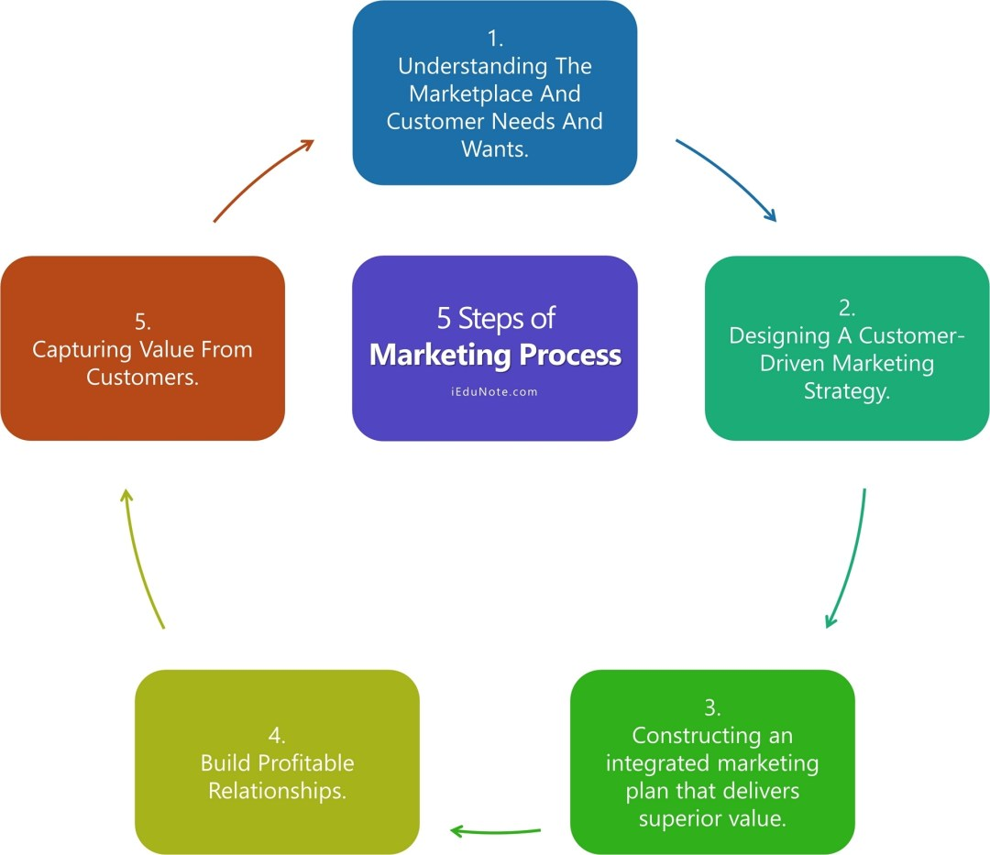
Figure 1: Stages of the Marketing Process
Source: (iEduNote, 2023).

Stages of the Marketing Process
The stages of the marketing process have been elaborated hereunder to understand the same clearly and unambiguously:
Understand Both the Marketplace and Customers
This implies deriving an idea about the target customers, their purchasing power, income level, and how much they are willing to spend on the product or services of the particular company.
Develop a Customer-Driven Marketing Strategy
It implies developing a Marketing strategy that means a “game plan” for the business that focuses on its limited resources to cater to the needs of customers both current and potential and attract them for the long term. There are two types of strategy for marketing, i.e. product-driven and other is customer strategy (Ifediora, et al., 2015).
Deliver High Customer Value
This means that the companies should focus on the value-for-money concept. This way it can attract as well as retain customers. Further, the customer values mean ratio of the perceived benefits and costs to the customer in purchasing the products of the company.
Grow Profitable Customer Relations
It is the secret sauce for every company to create profitable customer relationships. This step involves acquiring and growing the relationships with the customers. Further, it is the most difficult step in the marketing process.
Capture Customer Value in the Form of Profits
It means creating value for the customers both current and potential to derive more and more profit for the company. The increased loyalty of the customers will certainly ensure higher equity for them.

Situational analysis of the company
It refers to the process that assesses the internal and external factors that have a bearing on the organization. This analysis is often conducted before the marketing plan is implemented. It provides useful insights about the opportunities and challenges that the organization might face. It aids in ascertaining and determining the health of the company. It often involves conducting a SWOT analysis to ascertain the strengths, opportunities, weaknesses, and threats that may positively or negatively impact the business. It is undertaken to develop and implement the marketing strategy of Coat Group Plc to analyze and understand the market thoroughly (Clarke, et al., 2017).
SWOT Analysis
Strengths | Weaknesses | Opportunities | Threats
- Continuous innovations | - Low operating margin and gross margin | - Diversification of its business activities | A high degree of competition in the textile sector
- High investment in research and development activities | - Higher prices of the products | - Chances of high procurement of products due to Government green | - High imitation level
- Strong recognition of the brand | - Slow business processes | - Environmental policies | - Likely to face lawsuits due to fluctuations in the standards of its products
- Caters to a wide segment of the market | - Investment in new and advanced levels of technologies | - Low level of transportation costs | - Changes in the rules, regulations, and norms relating to the environment
- Geographic presence in more than 50 countries | - High level of employee attrition | - Differential pricing strategy due to new technologies | - Fluctuation in the rate of currency (Benzaghta, et al., 2021).
Its object is to lay down an accurate image of the current state of the company which will provide the required guidance for decision-making. It is conducted before starting a new project. Its implementation and control can be done by ensuring that all the employees of the organization make an effort to achieve a common goal by aligning their goals with the organizational goals. This is important to bind the entire organization to function as a single unit. The efforts should ensure that employees are committed to corporate values and goals. Further, necessary socialization programs and training should be conducted in this regard. It is noteworthy that the most relevant element of implementation is to create shared values and goals.

Segmentation, Targeting, and positioning strategies
Market segmentation: Market segmentation is done by identifying a group of customers and ensuring that the products of the company attract the consumers to purchase the same. It can be done demographically, geographically, behaviourally, and Psychographically. The marketing strategy of Coats Group Plc includes segmenting the market to ensure market penetration (Leisch, et al., 2018).
Demographic segmentation: It means segmenting the market in terms of, income level, age, gender, education, race, or occupation. The company usually targets customers of ages ranging between 20-45 years and 45-60 years. Further, its portfolio targets both males as well as females. Its consumers are from various life-cycle stages i.e. Single graduates, youngsters, married people, old people, etc.
Psychographic segmentation: It means segmenting the market in terms of characteristics including lifestyle, personality, interests, social status, attitudes, activities, and opinions. The company takes into account mostly the urban population and middle-upper classes. Further, they target those people who do not hesitate to try new products, and who are quite confident and desire a high living standard.
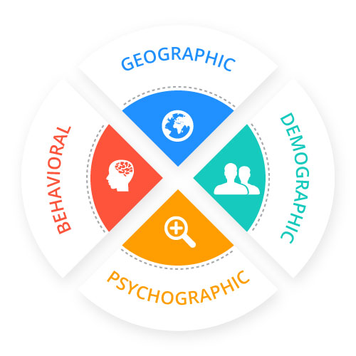
Figure 2: Types of market segmentation
Source: (NotifyVisitors, 2023).
Geographic segmentation: It means segmenting the market as per location. It has operations in various countries including America, the Netherlands, and the United Kingdom. Further, it incorporates in its strategy the urban population.
Behavioural segmentation: This means segmenting the market according to the behaviours of the consumers. It recognizes behaviours like hard work, confidence, ambition, and determination. The consumers of the company are mainly those who use the products frequently and look for emotional and functional benefits from the consumption of the product.
Targeting strategies: Coats Group Plc targets middle to upper-class people who are highly ambitious and are willing to purchase the products of the company while at the same time looking for affordability. In addition, the company lays its full emphasis on quality control to meet or even exceed the expectations of its customers. Moreover, it uses a customer-centric approach as its strategy to cater to the needs of its consumers.
Positioning strategies: The Company has a great standing in the apparel industry. It also acquired recently Rhenoflex GmbH (‘Rhenoflex’), which is among the leading manufacturers globally that provide material solutions for the manufacturing of sustainable footwear (Andaleeb, 2016).

Marketing mix of Coat Group Plc
The marketing mix of Coats Groups Plc comprises the seven (7) Ps which are provided hereunder:
Product: The portfolio of the products of the company is very broad and encompasses a diverse range of products for all segments of the market. Its products meet demands, needs, and specifications and also ensure continuous innovations.
Promotion: It engages in rigorous marketing and spends a substantial amount toward marketing activities. Further, it has also invested in digital marketing of its products.
Price: Its pricing strategy is such that the customers can easily afford it and find it quite reasonable. Further, it recognizes the relative pricing strategy (Boonpradub & Thechatakerng, 2015).
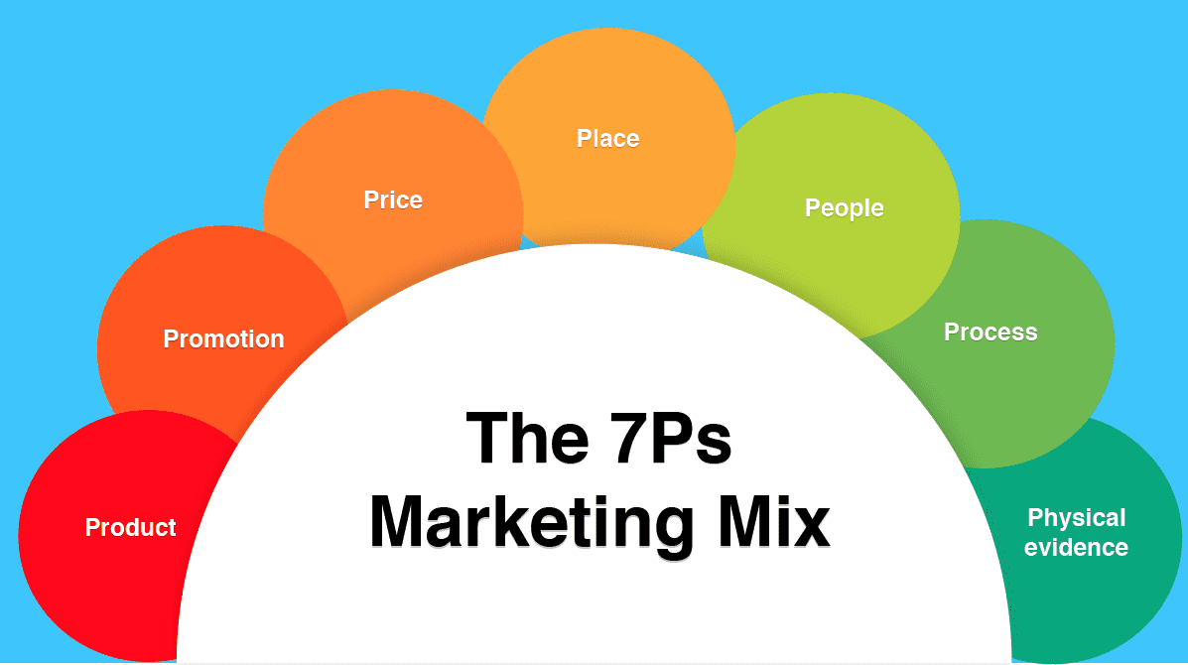
Figure 3: 7P’s of Marketing Mix
Source: (Smart Insights, 2023).
Place: It makes available its products using direct distribution channels and has high control over them to avoid any sort of discrepancies.
People: The Company has a substantial number of employees and treats them with equality and fairness. It ensures that there is no discrimination. It also renders requisite training to its workforce.
Process: There are systematic processes from the procurement of the raw materials to the final sale of the products.
Physical Evidence: The Company has designed and maintained a functional and appealing website that includes all the relevant information. Further, various stores allow the customers to purchase the products directly.

Industry examples
Marketing strategies by Grasim Industries
It has segmented its market into three parts: private/ public sector, Tier I/II/III cities and customer or builder. Further, its marketing strategy includes targeting builders and customers in all-tier cities. Further, it has the most unique strategies for content marketing and it engages in several campaigns. They market their products by recognizing and focusing on the socially relevant subject that helps them to get an edge over their competitors.
Marketing strategies by Severn Trent Plc
Its strategy includes offering such product that caters to the prevailing demand of the target market. Further, its products meet prescribed benchmarks or standards. In addition, it engages in various marketing activities to communicate its product to its target market and highlight the distinguishing features of its products.

Relating the PESTLE factors to the company
PESTLE analysis refers to a framework that analyzes the six factors namely Political, Economic, Social, Technological, Legal, and Environmental.
Political: The Company conducts its business activities given political stability. In addition, it receives the required funding and other support from the government to conduct its operations smoothly (Rastogi, et al., 2016).
Economic: The sales of the company are quite high due to the increase in the GDP. Further, the interest rates are lower to expand the business of the company more easily. The company has been financially very stable and the inflation rate is also low.
Social: The Company engages in various social activities like creating awareness and providing educational activities, and seminars that directly have a positive impact on the sales. In addition, it endeavours to understand the preferences of the customers and cater to their demands.
Technological: The company has adopted various new technologies relating to innovative techniques for marketing. Further, its technological trends led to social media campaigns that are creative enough to develop the brand online. It endeavours to recognize the ongoing technological innovations that help it to get an edge over its competitors.
Environmental: The Company takes into consideration the sustainable goals and aligns the same with the corporate strategy. It contributes towards Corporate social responsibility and ensures that it does not harm the environment in any manner.
Legal: The Company keeps itself abreast of all the national and international laws to which it is subject which are necessary for carrying on the activities of the company legally. Further, it abides by and complies with all the laws, rules, and regulations including discrimination laws, employment laws, and corporate and security laws.
Assessing the favourability of the PESTLE factors
All the factors of the company be it Political, Social, Economic, Legal, Technological, or Environmental are favourable for the company as the company enjoys high revenue, increased recognition, economic stability, etc. In addition, the company can retain its existing consumers and able to lure in potential consumers due to its compliance with the law in full letter and spirit. Moreover, it does not have any interference from the part of the regulators or the government due to a high level of faith.

Relating Porter’s Five Forces model to the company
Industry rivalry: There is a high degree of competition faced by the company in the textile sector. Several companies offer similar products. Further, the competitors engage in rigorous advertising and marketing to engage with the customers (Irfan, et al.,2019).
Threat of substitutes: There are an end number of substitutes available in the textile industry. Further, the competitors offer the products at a lower price, and the customers can switch to the other products easily.
The threat of new entrants: The new companies cannot easily enter the textile market as they will require a huge financial investment and updated technologies.
Bargaining power of buyers: The Company directly sells the products to the end consumers.
Bargaining power of suppliers: There are a high number of suppliers of the raw materials and this implies that the bargaining power of the supplier is low. Also, the company chooses its suppliers and enters into contracts with them.
Force | The degree of each force | Reason
Industry rivalry | High | There are several major competitors of the company in the textile industry
- Bargaining power of buyers | Low | The sales are directly made to the customers, thereby avoiding any middlemen
Bargaining power of suppliers | Low | It is low due to the high number of suppliers
- The threat of new entrants | Low | It is less likely that new companies will enter the market due to a high level of investment
- Threat of substitutes | High | Availability of the substitute at a lower price

Advantages of Porter's Five Forces Model
- It is considered to be the simplest and most effective tool for analyzing businesses.
- It aids in identifying and assessing the five forces of the model concerning the chosen industry or sector and determines the impact on the degree of competition and profitability.
- It further helps in ascertaining those factors that have a major bearing on the profitability of the company.
- It also helps in making informed decisions relating to increasing the capacity, and whether to enter into a specific market (Mathooko & Ogutu, 2015).

Disadvantages of the Porter’s Five Forces Model
- One of the major disadvantages of this model is its composition. It throws light on those aspects that prove to be fruitful only for developing short-term strategies.
- Furthermore, it is becoming narrow in scope due to the ever-changing factors in the external environment.
- It completely disregards internal factors such as availability of the resources and organizational culture.
- It takes into account the static approach and not the dynamic approach and thus provides outdated strategies that fail to resolve the realities of the market.
- It does not consider the quantitative aspects and thus relies heavily on the qualitative aspects. This is a major limitation and makes it difficult to compare the intensity of the forces.
- It is mainly designed for companies operating in a single sector and is not suitable for companies engaged in multiple businesses.

Credible Future Recommendations for the Company
It is hereby recommended that the company should apply the Ansoff matrix along with the other industry analysis and business tools, which include SWOT analysis, PESTEL, and Porter’s 5 Forces frameworks to reach more accurate and conclusive results by assessing the relevant factors or drivers of the business.
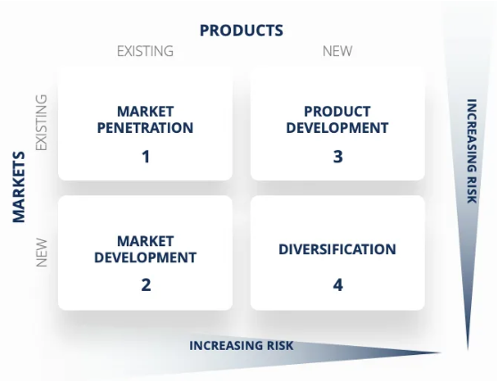
Figure 4: Ansoff matrix featuring markets and products
Source: (CFI, 2023).
This matrix consists of four elements namely market penetration, market development, diversification, and product development. Out of these four elements, the two elements i.e. market penetration and diversification are applied and explained hereunder:
Market Penetration: It implies that the company increases its revenues by selling more of its existing products in the markets where it currently exists. Thus, given the same, it is suggested that the company should endeavour to sell more products in the United Kingdom as it is very familiar with the same. In addition, it can simplify the process of distribution and engage in more rigorous marketing efforts that will eventually increase the sales of the company. Furthermore, another alternative is that it can acquire its competitor who may be the barrier to its revenue. Additionally, it can reduce the prices of its products so that new customers can purchase its products and may become its permanent customers.
Diversification: This aspect involves a very high amount of risk as it includes both market development as well as product development. As it is well accepted, that there are no rewards without taking risks, it has been suggested that the company should choose to diversify its range of products and enter the new markets to enhance its market reach and industry visibility. It has the potential to gain benefits by minimizing the dependence of the company on a single product or by creating new revenue opportunities. The management of the company can incorporate any of the two strategies for diversification which are provided hereunder:
Related diversification: It reflects that synergies can be created between the new product or market and the existing business of the company.
Unrelated diversification: It is just the opposite of related diversification and thus implies that no new synergies can be created between the new product or market and the existing business of the company.
Thus, Coats Group Plc considers and recognizes these recommendations to increase its sales and ensure that it achieves the maximum benefits and rewards it deserves.

References
Andaleeb, S.S., 2016. Market segmentation, targeting, and positioning. In Strategic marketing management in Asia: case studies and lessons across industries (pp. 179-207). Emerald Group Publishing Limited https://www.um.edu.mt/library/oar/bitstream/123456789/21433/5/Market%20Segmentation%20Targeting%20and%20Positioning.pdf
Benzaghta, M.A., Elwalda, A., Mousa, M.M., Erkan, I. and Rahman, M., 2021. SWOT analysis applications: An integrative literature review. Journal of Global Business Insights, 6(1), pp.55-73 https://digitalcommons.usf.edu/cgi/viewcontent.cgi?article=1148&context=globe
Boonpradub, W. and Thechatakerng, P., 2015. Brand endorsement by celebrity in Thailand: 7Ps of marketing mix and the impact of brand alliance. International Journal of Trade, Economics and Finance, 6(1), p.8 http://www.ijtef.com/vol6/433-M21026.pdf
CFI., 2023. Ansoff Matrix. [ONLINE]. Available at: https://corporatefinanceinstitute.com/resources/management/ansoff-matrix/ [Accessed on 27th August, 2023].
Clarke, A.E., Friese, C. and Washburn, R.S., 2017. Situational analysis: Grounded theory after the interpretive turn. Sage publications https://eprints.ncrm.ac.uk/id/eprint/804/1/ISSRM_Report_Public.pdf?utm_content=bufferabe93&utm_medium=social&utm_source=plus.google.com&utm_campaign=buffer#page=55
Coats., 2023. About Coats. [ONLINE]. Available at: https://www.coats.com/en [Accessed on 27th August, 2023].
iEduNote., 2023. Marketing Process: 5 Steps of Marketing Process. [ONLINE]. Available at: https://www.iedunote.com/marketing-process [Accessed on 27th August, 2023].
Ifediora, C.U., Igwe, A.A. and Ukpere, W.I., 2015. APPRAISAL OF THE ADEQUACY OF THE APPLICATION OF CUSTOMER-DRIVEN MARKETING STRATEGIES TO THE NIGERIA NATIONAL HOUSING FUND SCHEME. Risk Governance & Control: Financial Markets & Institutions, 5(3) https://pdfs.semanticscholar.org/8800/24992a1156a46e097d722fabb90b12c617de.pdf
Irfan, M., Zhao, Z.Y., Ahmad, M., Batool, K., Jan, A. and Mukeshimana, M.C., 2019. Competitive assessment of Indian wind power industry: a five forces model. Journal of Renewable and Sustainable Energy, 11(6) https://www.researchgate.net/profile/Muhammad-Irfan-73/publication/337369162_Competitive_assessment_of_Indian_wind_power_industry_A_five_forces_model/links/5dd6999f299bf10c5a26a322/Competitive-assessment-of-Indian-wind-power-industry-A-five-forces-model.pdf
Kotler, P. and Armstrong, G., 2013. Principles of marketing 15th global edition. Pearson. https://www.academia.edu/43149974/Kotler_Principles_of_Marketing_15th_Global_Editio_c2014
Kotler, P., Keller, K.L., Ang, S.H., Tan, C.T. and Leong, S.M., 2018. Marketing management: an Asian perspective. London: Pearson https://d1wqtxts1xzle7.cloudfront.net/58052402/marketing-management-an-asian-perspective-5th-edit-libre.pdf?1545609894=&response-content-disposition=inline%3B+filename%3DMarketing_Management_An_Asian_Perspectiv.pdf&Expires=1693170468&Signature=V7QXjhJdg8lIKW9bdr~9geye33tttd~D6VwlAYKcFn3~3aOEe009IySEw-SlEuYeTe~yDwA2VooIXtTffH0l9ouh5dewDh6DjT~S3FX63beEF4S-xeJMewpCJYELwXm~B3YGX2F782gRqr1MAUIoFGNNruVuPQ52YivtlwlyvD5sHOg9ym4jSCRWzGjZZ6hAhea~BF7aTfTKoXSd~iA-G1XKK3rYYmanxaa8cuFsr-8T-OocliHTMXNrLzJx1zK4dR1441vIbgHOavaIgIAvgvqHBeSoQM66wMvUjGumDE89~D1ozcmH3s~no9VmlIDfgHJho4u1g~cWY16OP59c-w__&Key-Pair-Id=APKAJLOHF5GGSLRBV4ZA
Leisch, F., Dolnicar, S. and Grün, B., 2018. Market segmentation analysis: Understanding it, doing it, and making it useful https://library.oapen.org/bitstream/handle/20.500.12657/51281/1/PUB_580_Leisch_Market_Segmentation_Analyses.pdf
Mathooko, F.M. and Ogutu, M., 2015. Porter’s five competitive forces framework and other factors that influence the choice of response strategies adopted by public universities in Kenya. International Journal of Educational Management, 29(3), pp.334-354 http://erepository.uonbi.ac.ke/bitstream/handle/11295/81090/Ogutu_Porter's%20five%20competitive%20forces%20framework.pdf?sequence=1
NotifyVisitors., 2023. What is Segmentation? How Does it Work? [ONLINE]. Available at: https://www.notifyvisitors.com/blog/what-is-segmentation/ [Accessed on 27th August, 2023].
Rastogi, N.I.T.A.N.K. and Trivedi, M.K., 2016. PESTLE technique–a tool to identify external risks in construction projects. International Research Journal of Engineering and Technology (IRJET), 3(1), pp.384-388 https://www.researchgate.net/profile/Manoj-Trivedi-2/publication/363640549_PESTLE_TECHNIQUE_-A_TOOL_TO_IDENTIFY_EXTERNAL_RISKS_IN_CONSTRUCTION_PROJECTS/links/6326de560a70852150026dfc/PESTLE-TECHNIQUE-A-TOOL-TO-IDENTIFY-EXTERNAL-RISKS-IN-CONSTRUCTION-PROJECTS.pdf
Smart Insights., 2023. How to use the 7Ps Marketing Mix. [ONLINE]. Available at: https://www.smartinsights.com/marketing-planning/marketing-models/how-to-use-the-7ps-marketing-mix/ [Accessed on 27th August, 2023].

