What helps me learn language and mathematics? An analysis of a child’s learning in mathematics and language with recommendations for ensuring progress.
The purpose of this assignment is to gain knowledge and understanding on how a child learns language and mathematics, discuss what resources and support in the classroom helped the child with their learning and how this impacted on the child’s progress and attainment. I also intend to discuss findings using the ASK model of learning – Attitudes, Skills and Knowledge (Nottingham, 2013). This will assist with analysing how the child’s attitude impacts on their learning of language and mathematics and how this might reflect upon the outcome of the activity or lesson.
Observations on how the child used their language and mathematics skills in wider school life were also made and this will be discussed to explain how this influenced the child’s experience in school and where the child came across challenges when using their language and mathematics skills. Furthermore, the child’s knowledge of language and mathematics will be evaluated and drawn upon from the data collected which includes, map-making, observations, interview with the pupil and samples of their work. Photographs were not taken as this adhered to the school’s safeguarding policy.
Data was collected using the Mosaic Approach. The Mosaic Approach is about gathering and piecing together information for dialogue, reflection and interpretation. It is aimed at creating a way to interact with young children and create a partnership between the child and the adult. It has allowed me to take a step back and reflect on the learning and assess what helps a child learn language and mathematics. (Clark and Moss, 2011).
Observing children allows ‘practitioners to assess how much progress children have made and whether they need further opportunities to consolidate their learning’ (Welsh Government 2008). I found this important during my time on placement as I was able to assess pupil progress and discover what types of learning suited them and what they individually found difficult. However, it was crucial to gather data and observe in an ethical way. Throughout the process it was made clear to the child that they always had the option to opt out of any activity, observation or interview if they did not feel comfortable.
Through Professional Teaching Experience (PTE), a range of data was collected, and analysis of the child’s work will be discussed in order to show achievement and how effective pedagogical choices were made to enhance the pupil’s learning and encourage further progress and improvement. Additionally, I will discuss what I would do to ensure the pupil continues to make progress and suggest next steps for the learner that are related to the work that is presented. I will reflect on the time spent on PTE, whilst teaching and observing lessons in language and mathematics.
The school in which I spent time on PTE was situated on the outskirts of Swansea and is split into three parts: a nursery site, infant site and junior site that are all within short walking distance from each other. The pupil I worked with during my time on PTE was a five-year-old girl in a Year 1/2 class who was deemed to be a ‘higher’ attainer within the class. For the purpose of this assignment I will refer to the pupil as ‘Student F’. The reason this pupil was chosen was due to the pupil being a particularly high achiever in aspects of language and this interested me. After discussions with the class teacher, it was suggested that this could be a good aspect to focus on and it would be interesting to see what helped the learner to learn language and how this compared with how she learnt and succeeded in mathematics.
At the start of a school year, pupils in Year 1 are generally attaining Foundation Phase Outcome 3. Throughout their time in Year 1, pupils are generally expected to be achieving Foundation Phase Outcome 4 in both language and mathematics, with the hope that by the end of the school year, some pupils will achieve Foundation Phase Outcome 5 in both. (Welsh Government, 2008)
The Foundation Phase Framework (2015) states that, children’s ‘skills develop through talking, signing/communicating and listening. They should be encouraged to communicate their needs, feelings and thoughts, retell experiences and discuss individual and group play.’ Whilst on PTE, many opportunities were taken to encourage children to develop their language skills. Activities were undertaken to encourage communication though different methods of teaching. When appropriate, children were encouraged to use their language skills in numeracy lessons such as taking part in discussions as part of a group and forming mathematical answers as sentences said aloud to the class.
According to Donaldson (2015), ‘when mathematics is taught well through relevant contexts, it can engage and fascinate children and young people of all interests and abilities. It provides strong support for the development of wider skills, particularly critical thinking and problem solving, planning and organisation, and creativity and innovation.’
This statement suggests that the pedagogy and planning is important when teaching mathematics in order to engage with pupils’ learning and to help pupils achieve their full potential. It also suggests that mathematics is of high importance as it supports other areas of learning and wider life skills. Therefore, mathematics should be one of the areas of learning at the forefront of a child’s education.
Language
Student F is achieving Foundation Phase Outcome 4 in Literacy, Language and Communications from the Foundation Phase Framework. This means that Student F listens with growing attention and responds appropriately to complex information and instructions. She also uses questions to clarify understanding. Student F’s range of vocabulary is increasing, and she made herself clear by choosing words and organising what she says. She can form upper- and lower- case letters which are usually clearly shaped and correctly orientated. She can also independently use written language for different purposes and can sequence content correctly. However, Student F is a very confident and competent reader and whilst I was undertaking PTE she moved from reading ‘Stage’ books to reading novels of her choice from the school library. Her reading fell more in line with the Foundation Phase Outcome 5 aspect for reading, as she can choose reading materials independently and can confidently use a range of strategies when reading suitable unfamiliar texts to establish meaning. She can track print more quickly than others in her class and her accuracy, fluency and expression was accomplished for her age. (Welsh Government, 2015).
An interview was undertaken between me and Student F, (Appendix 1). Student F explained how she loved to read and her favourite aspect of language in school was hearing new stories at story time. Student F’s attitude towards reading was positive and this may have been a reason as to why she was such a successful reader. She explained listening to new stories encouraged her to read. According to The Writers Bureau (2019), ‘children who can read well are likely to have higher confidence levels. This will benefit them in school as they’ll feel able to participate fully in activities.’ Student F was particularly confident in articulating herself and being able to reason with peers when working in a group or whilst playing outdoors.
Reading stories is key in the development of imagination. When children engage in a book, they imagine what the characters are doing. (Bonfiglio, 2017). It was apparent that Student F benefited greatly from reading and found pleasure in reading. In the class, children who did not read often outside of school were less able to articulate themselves and their reading skills were not as fluent or accurate.
Oxford Owl (2019), states that it is important to enjoy reading books at home where the parent and child can enjoy the experience together. The parent can model the story to the child emphasising correct use of punctuation and expression. Student F explained how her parents read with her often at home and this was very helpful. She said that her parents often read to her and she listened to the sounds in order to learn new words. According to Lucas (2010), ‘parent engagement in the educational development of their children improves attainment more than any other single factor.’ Student F benefitted from a good level of parent engagement and it was noted that the other children in the class who received support from parents with their reading and homework benefitted greatly in comparison to those who didn’t receive any support from home or very little.
Student F stated that she makes sure to do certain things in Language and Literacy lessons as she will get rewarded. Further to this, whilst undertaking an observation of Student F during a writing activity, she made sure to start her sentences with capital letters and finish them with full stops so that she would receive a sticker from the class teacher. Therefore, it is identified that rewarding good examples of work with stickers and rewards is something that helps Student F learn language. This method could be used across the curriculum to encourage and reward pupils for displays of good work and behaviour. Rewarding pupils is one of the most effective ways of establishing positive classroom environment, promoting good behaviour and incentivising students. It is important to give verbal praise and visual rewards like stickers, and jars, charts and prizes are ideal for reinforcing good behaviour and identifying good work. (Haughton, 2018).
Appendix 2 shows a sample of language work. The learning objective was ‘to order and retell the story ‘Dear Zoo’. This objective derived from the strand within the LNF: Writing across the curriculum. Element: Organising ideas and information. Aspect: Structure and Organisation. (Welsh Government, 2014)
Prior to the activity, the story, Dear Zoo was read aloud to the class many times and the class learnt the story by retelling and using actions. It was observed that repetition, using actions and including drawings to assist the ordering of the story were all effective ways of helping Student F learn. According to Catherine (2013), ‘predictable books can be stepping stones in the reading developmental process because they are engaging and interesting to young children. The listener can also participate in the reading.’ The story ‘Dear Zoo’ was chosen for this reason, because the predictable pattern of the story would be engaging to the reader and this also made it easier to memorize and use when writing.
Student F completed this piece of work to a high standard and presented good aspects of language within her work such as spelling correctly and representing the story correctly, accurately labelling drawings. According to Corbett (2003), ‘stories can be taught in a multi-sensory manner. Actions are used to make the tales, especially the key connectives, memorable. Each story has a story map or board as a visual reminder.’ In this activity, Student F created her own story map that became a visual reminder of the story. This helped Student F learn the story and gave her ownership of the story. The actions aided in making the story memorable and made reciting the story more enjoyable. A good exercise for Student F could be to highlight the nouns and adjectives within her story map in order to encourage further progress.
Appendix 3 is another sample of work based upon the story, ‘Dear Zoo’. The learning objective was to ‘draw and write about new animals for the story ‘Dear Zoo’ and to use adjectives to describe them. The class recited the story from memory, and they came up with new actions for the adjectives and new animals. The method of teaching used in this activity fell alongside Vygotsky’s Zone of Proximal Development theory (1978). I modelled the story verbally, gave examples of zoo animals and encouraged pupils to think of adjectives to describe them by asking a ‘more knowledgeable other’ to answer at first. Whilst working collaboratively, other pupils sought to understand the actions provided by me and they then used it to guide their own thinking. (McLeod, 2019).
Part of the activity was to underline the adjectives with a green highlighter. The purpose of this was to assess Student F’s learning to see whether she could identify adjectives within her work. Additionally, I found it helped to provide Student F with a word bank that consisted of many different adjectives. I observed Student F saying the adjectives out loud to see which one would be most suitable for their chosen zoo animal. By process of elimination, Student F identified suitable adjectives for her chosen animals. The word bank aided Student F in identifying adjectives and thinking of new ones. The word bank was a way of scaffolding for the pupil and to structure interaction between Student F and myself so that I could help Student F achieve the learning objective. (McLeod, 2018).
Some recommendations to progress Student F’s language further include focussing on her handwriting. This ties in with the strand from the LNF: Writing across the curriculum. Element: Writing Accurately. Aspect: Handwriting, Grammar, Punctuation, Spelling. (Welsh Government, 2014).
As shown in Appendix 2 and 3, Student F’s handwriting isn’t consistent in orientation and more practice could be made on writing on a line. This could be modelled by the teacher and an emphasis could be made on the shape of upper- and lower-case letters. This could be linked to her love of reading by practicing handwriting from a piece of text that she enjoys.
Another recommendation would be to focus on Student F’s oracy skills. In the interview, (Appendix 1), Student F stated that she enjoyed expressing herself through reading when reading speech. An activity to progress her speaking skills could be to create a role-play activity. This could be child-led and would allow her to get into character. It could encourage Student F to take risks and be creative with the role she is playing. (Millwood Education, 2016).
There is also the potential of progressing Student F to Foundation Phase Outcome 6 for reading. Appendix 7 is a report, summarising observations of Student F’s reading that I undertook during my time on PTE. I observed her reading each day during PTE and significant progress was made. However, it would be difficult for the class teacher to continue this intervention as time is limited in a school day and there may not always be the opportunity to listen to Student F read. This is one limitation of best practice but in Student F’s case, the parental engagement is invaluable and some of the extension to her reading work could be undertaken at home. It was a pleasure to be a part of this intervention and be part of Student F’s advancement in reading.
Student F could be identified as a More Able and Talented (MAT) pupil when it comes to their reading. Some of the ways of ensuring progress with pupils who are identified as MAT is to make sure that an individual learning plan is set to create challenging targets. Regular progress reviews should be made, with extensive input and feedback from the learner as this is key to understanding what the learner needs to learn and what will help them learn. (Welsh Government, 2016).
Mathematics
Student F is currently achieving Foundation Phase Outcome 4 with some aspects of her numeracy falling within Foundation Phase Outcome 5 in mathematics. She has shown that she is able to recite numbers in simple sequences to 100 but can also read and write numbers up to 100. Furthermore, she can partition two-digit numbers and can identify the value of each digit. She can perform more difficult additions and subtractions using her own strategy and mentally recall ’10 more’ or ’20 more’ within 100. She is beginning to understand the link between multiplication and division and use 2, 5 and 10 multiplication tables to solve problems. She can make sensible estimates of larger groups of objects and can pay for items up to 20p and give change from 10p. She can read hours on a clock and can name common regular 2D and 3D shapes. She can copy, describe and extend patterns including shape and number and can make whole and half turns. (Welsh Government, 2015).
In an interview with Student F, she explained that she likes mathematics and particularly enjoys adding and subtracting. It was clear that Student F enjoyed the challenges of mathematics and said that she felt that she was good at it. According to Dabell (2017), ‘teachers with a real passion for maths help children to question, challenge and reflect by creating an atmosphere of positivity.’ During my time on PTE, I noticed that the class teacher inspired the children in her class to enjoy maths and encouraged pupils to be curious and interested. When teaching my own maths lessons, I tried to adopt this way of teaching and aimed to be enthusiastic in maths lessons and make them fun and engaging for the learners. When observing Student F undertaking mathematics lessons, it was noticeable that she reacted positively to a more exciting and interesting lesson. It stimulated her enjoyment of maths and encouraged a more positive attitude.
She explained how she uses the maths ‘epic’ area in class and finds it challenging but usually completes the work. Teachers use enhanced provision to set challenges that link skills and concepts introduced during focussed teaching. These enable an individual to follow a strand of work in more depth. (Estyn, 2019).
She explained that work sheets usually help her in mathematics and having homework helps her to understand more. According to Atkinson (2019), ‘homework encourages students to take initiative and responsibility for completing a task’. Learners like Student F might be well equipped to deal with the responsibility of completing homework tasks. There are, nevertheless, arguments against setting homework or setting too much homework. Homework is set to target reinforcement of a skill however, there is a concern that children take work home to complete and may doubt themselves and get frustrated as they do not have the support of the teacher and the comfort of the classroom. (Berkowicz and Myers, 2017).
Another resource that Student F found that helped her during maths lessons or activities was having the reassurance of being able to call upon the teacher. This suggests that whilst Student F enjoys maths and is comfortable completing certain tasks, she still requires the teachers support at times to assist her with certain maths problems.
I felt it important to support Student F with elements of the lesson that she was unable to do herself and allow her to figure out problems that she could manage independently. This enabled Student F to reach her potential in maths lessons and in turn, boosted her confidence. (NRICH, 2019).
In the interview, Student F spoke about how she used a multiplication mat at home and explained that this helped her with multiplication at school. She said that she finds practising the 5 times table and 10 times table easy but struggles with the 2 times tables. A reason for this could be because the class would regularly practice reciting multiples of 2. Bald (2019) states that children may find it difficult ‘to replace two-four-six-eight with a table that alternates between single numbers and twos.’
Appendix 5 is sample of mathematics work that Student F completed in class individually. The learning objective was ‘to match time’. The objective derived from the strand: Using measuring skills. Element: Time. (Welsh Government, 2014).
The class had to match time shown on an analogue clock with a description of what ‘Pudsey Bear’ was doing at that time in the day. When teaching the introduction, I felt it important to show the hour hand on the clock and have the class recite from 1 o’ clock to 12 o’ clock. It is suggested by Sealy (2019), to start teaching time using the hour hand only and only when this is securely understood should you introduce the minute hand.
Student F coped well with this task and was given work that was differentiated to suit her ability. She had to match times that showed half past on the clock. Once I had observed her completing the activity and marked her work, I assessed that she could move on further with the activity in the next lesson.
Next steps that could be considered would be to create an activity that asked questions such as, what would the time be if it were half an hour later? And what would the time be if it were half an hour earlier? Eventually moving on to asking, what would the time be in an hour and a half? (Sealy, 2019)
The lesson was taught on Children in Need day and I incorporated the theme of ‘Pudsey Bear’ into the activity. On observing Student F, I asked whether she found the activity difficult and she explained that she didn’t find it too difficult and she liked that she could cut out and stick ‘Pudsey Bear’ in the activity. Using ‘Pudsey Bear’ provided a hook for the children that challenged them to get their minds thinking. Student F enjoyed matching the times to the description as she enjoyed that it was about ‘Pudsey Bear’. (Mayberry, 2019).
Appendix 6 is a sample of mathematics work that Student F completed individually. The lesson focussed on numeracy and place value. The learning objective was, ‘partitioning two-digit numbers.’ In the introduction to this lesson, I modelled partitioning using numicon and multi- link. The ‘Social Learning Theory, theorized by Albert Bandura (1977), posits that people learn from one another, via observation, imitation, and modelling.’ It was important for me to show the class what was meant by place value first by modelling. I then passed the activity onto the class and they imitated what I had shown them, encouraging their understanding. (Learning Theories, 2019).
Student F completed the task using numicon and multi-link, which assisted the activity and encouraged a multi-sensory way of learning. This encouraged learning to be auditory, visual and kinaesthetic and aimed to maximise learner participation. It allowed Student F to be practical with the activity and this brought upon discussion between Student F and myself. It also gave Student F the chance to touch and handle the resources and this in turn hopefully solidified mental images and aided understanding. (QIA, 2008)
To ensure future progress in Student F’s mathematics, the teacher might create activities that incorporate a multi-sensory method as this proved to help Student F’s learning in mathematics lessons. She might also benefit from being given homework that is more individual and that is adapted to her needs. However, there are limitations to this: there are around 30 children in a class, and it would be difficult for the teacher to provide the work to every pupil.
Student F is highly capable of reaching a higher level of attainment in mathematics and her attitude towards the learning helped in her achievements in mathematics.
With these limitations it still crucial to keep ensuring progress is made with Student F’s learning in both language and mathematics. It is key to maintain engagement and, in this case, give challenging homework as Student F benefits from a good home support system.

3848 words

Reference List
Atkinson, J. (2019) ‘Why is Homework Important?’ Scholastic, Date Unknown. [article]. Available at: https://www.scholastic.com/teachers/articles/teaching-content/homework-why-it-important/ (Accessed: 2nd April 2019).
Bald, J. (2019) Learning the 2 times table: Tips and Tricks. Available at: https://www.theschoolrun.com/2-times-table-learning (Accessed: 2nd April 2019).
Berkowicz, J. and Myers, A. (2017) ‘How is Homework Helping Students Learn?’ Leadership 360 [blog]. 17 October. Available at: https://blogs.edweek.org/edweek/leadership_360/2017/10/how_is_homework_helping_students_learn.html (Accessed: 2nd April 2019).
Bonfiglio, C (2017) Importance of Reading with Young Children: 10 Great Benefits. [article]. Available at: https://bilingualkidspot.com/2017/10/19/benefits-importance-reading-young-children/ (Accessed: 30th March 2019).
Catherine, M. (2013) Repetitive or Predictable Texts. Available at: https://astrugglingreader.wordpress.com/2013/04/09/repetitive-or-predictable-texts/ (Accessed: 1st April 2019).
Clark, A. and Moss, P. (2011) Listening to Young Children: The Mosaic Approach (2nd ed.) National Children’s Bureau
Corbett, P. (2008) Story Telling and Story Making. Available at: https://www.foundationyears.org.uk/files/2011/10/Story-Teling_Story-Making1.pdf (Accessed: 31st March 2019).
Dabell, J. (2017) ‘Building Children’s Confidence in Maths – Top 10 Teaching Strategies’. Busy Things. [blog] 21 November. Available at: https://www.busythings.co.uk/blog/building-childrens-confidence-in-maths-teaching-strategies/ (Accessed: 3rd April 2019).
Donaldson, G. (2015) Successful Futures. Available at: http://gov.wales/docs/dcells/publications/150317-successful-futures-en.pdf (Accessed: 28th March 2019).
Estyn (2019) Enhanced Provision. Available at: https://www.estyn.gov.wales/glossary/enhanced-provision (Accessed: 2nd April).
Haughton, V. (2018) Using reward systems in the classroom. Available at: https://www.tes.com/teaching-resources/blog/using-reward-systems-classroom (Accessed: 31st March 2019).
Learning Theories (2019) Social Learning Theory (Bandura). Available at: https://www.learning-theories.com/social-learning-theory-bandura.html (Accessed: 3rd April 2019).
Lucas, B. (2010) The impact of parent engagement on learner success: A digest of research for teachers and parents. [digest] Available at: https://www.thehampshireschoolchelsea.co.uk/userfiles/files/For%20Parents/Parental%20Engagement/The-Impact-of-Parental-Engagement-on-Learner-Success613583.pdf (Accessed: 31st March 2019).
Mayberry, C.S. (2019) Teaching Strategies for Every Teacher. Available at: https://sites.google.com/site/teachingstrategiesforall/home (Accessed: 2nd April 2019).
McLeod, S. A. (2019) What Is the Zone of Proximal Development? Simply Psychology [article] Available at: https://www.simplypsychology.org/Zone-of-Proximal-Development.html (Accessed: 1st April 2019).
McLeod, S. A. (2018) Bruner. Available at: https://www.simplypsychology.org/bruner.html (Accessed 1st April 2019).
Millwood Education (2016) Benefits of Role-Play in Early Years. Available at: https://www.millwoodeducation.co.uk/blog/post/07/2016/benefits-of-role-play-in-early-years (Accessed: 2nd April 2019).
NRICH (2019) Teachers. Available at: https://nrich.maths.org/teachers (Accessed 2nd April 2019).
Nottingham, J. (2013) Encouraging Learning. Oxon: Routledge.
Oxford Owl (2019) Building on Reading Skills (Age 5-6). Available at: https://www.oxfordowl.co.uk/for-home/reading/building-on-reading-skills-ages-5-6/ (Accessed: 30th March 2019).
Quality Improvement Agency (2008) Teaching and Learning Programme. Available at: https://learning.gov.wales/docs/learningwales/publications/140801-multi-sensory-learning-en.pdf (Accessed: 3rd April).
Sealy, C. (2019) ‘How to Teach Telling the Time to KS1 and KS2: Your Fail-Safe Step by Step Technique’. Third Space Learning. [blog]. 2 April. Available at: https://thirdspacelearning.com/blog/how-to-teach-telling-time-ks1-ks2-activities/ (Accessed: 3rd April 2019).
The Writers Bureau (2019) Why are Stories Important for Children? Available at: https://www.writersbureau.com/writing/Why-are-stories-important-for-children.htm (Accessed: 30th March 2019)
Welsh Government (2015) Foundation Phase Framework. Available at: https://learning.gov.wales/docs/learningwales/publications/150803-fp-framework-en.pdf (Accessed: 28th March 2019).
Welsh Government (2008) Observing Children. Available at: https://learning.gov.wales/docs/learningwales/publications/140828-observing-children-en.pdf (Accessed: 28th March 2019).
Welsh Government (2016) More able and talented learners: Guidance for the further education sector in Wales. Available at: https://learning.gov.wales/docs/learningwales/publications/160110-mat-guidance-for-fe-sector-en.pdf (Accessed: 2nd April 2019).
Welsh Government (2014) National Literacy and Numeracy Framework. Available at: https://learning.gov.wales/resources/browse-all/nlnf/framework?component=numeracy&year=6938344_2&selectedYear=col_7&lang=en (Accessed: 30th March 2019).
Welsh Government (2008) Framework for Children’s Learning for 3-7-year-olds in Wales. Available at: https://learning.gov.wales/docs/learningwales/publications/130424-framework-for-childrens-learning-en.pdf (Accessed: 30th March 2019).

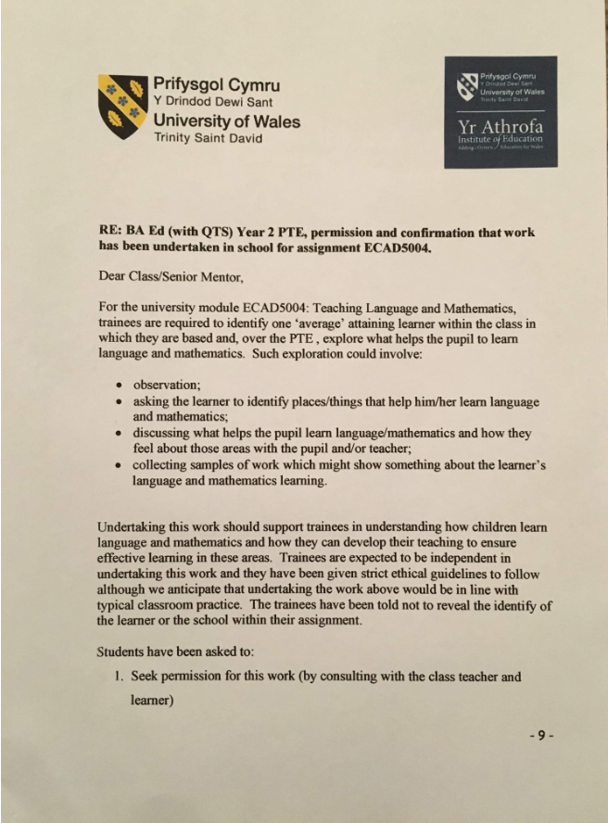

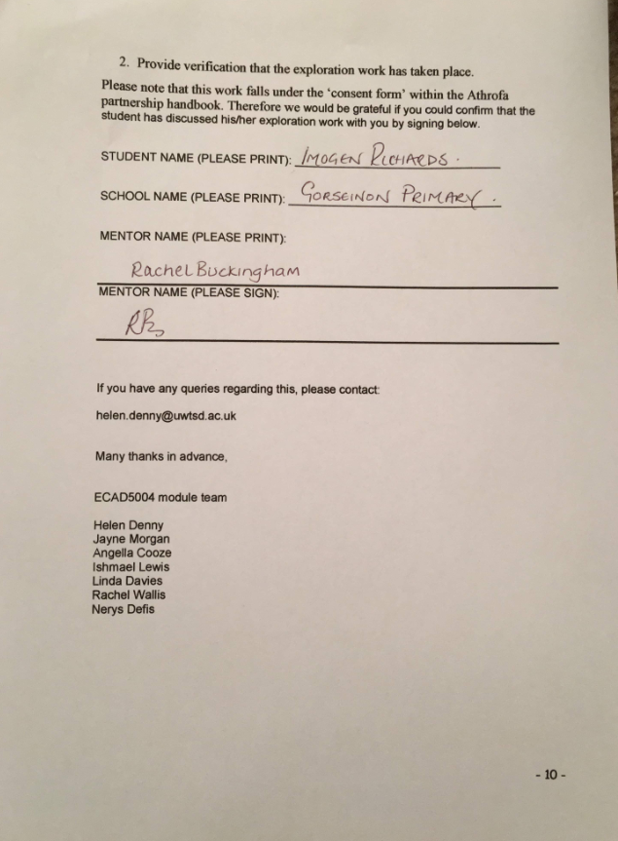

Appendix 1
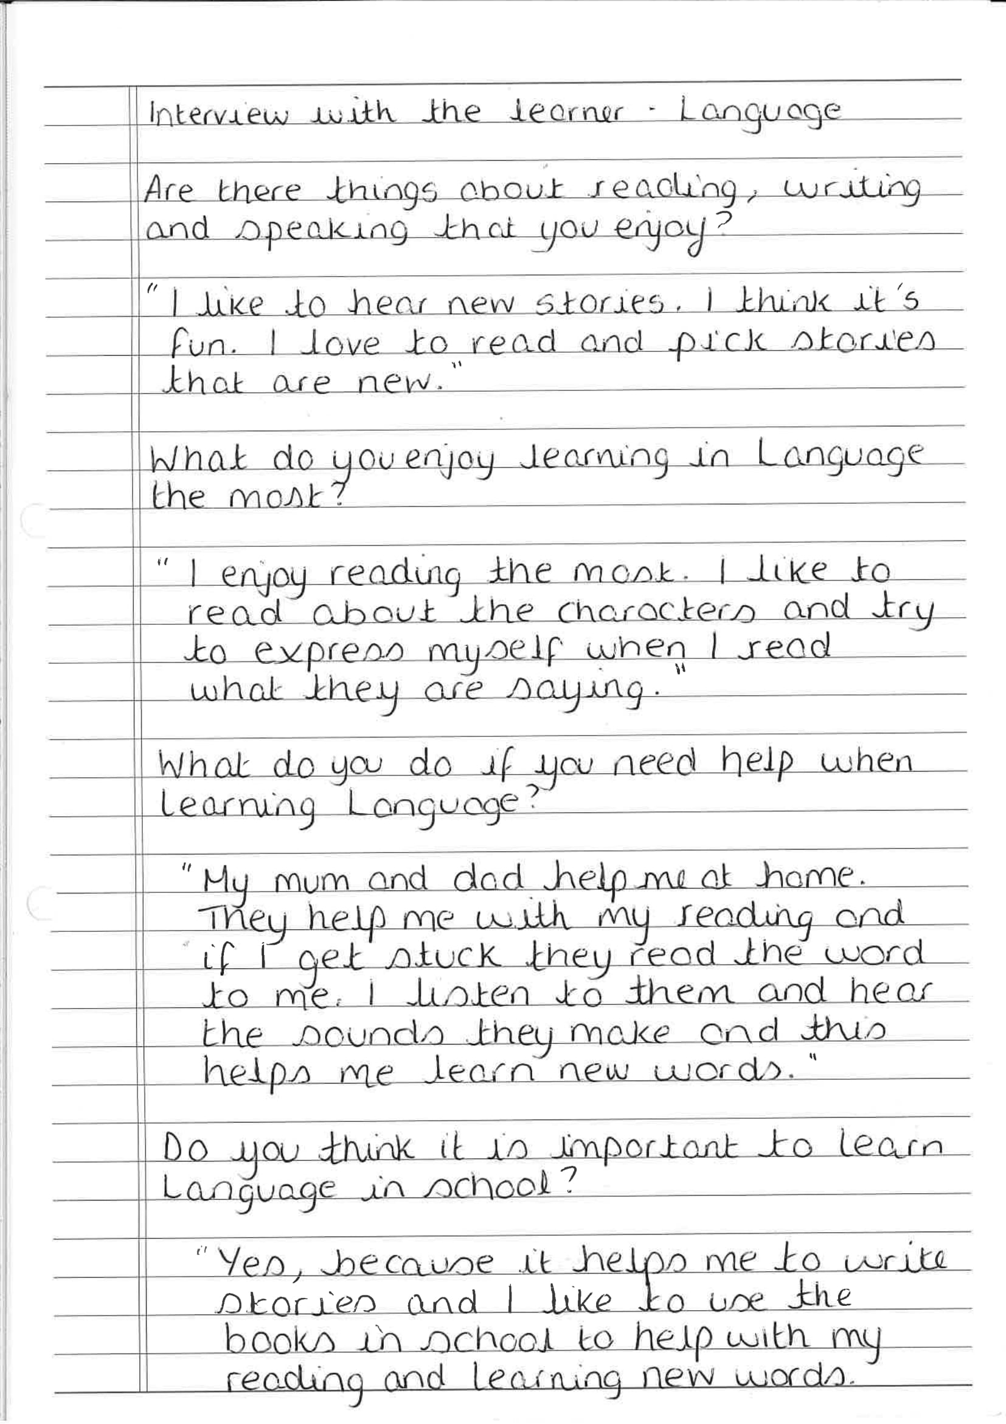

Appendix 2
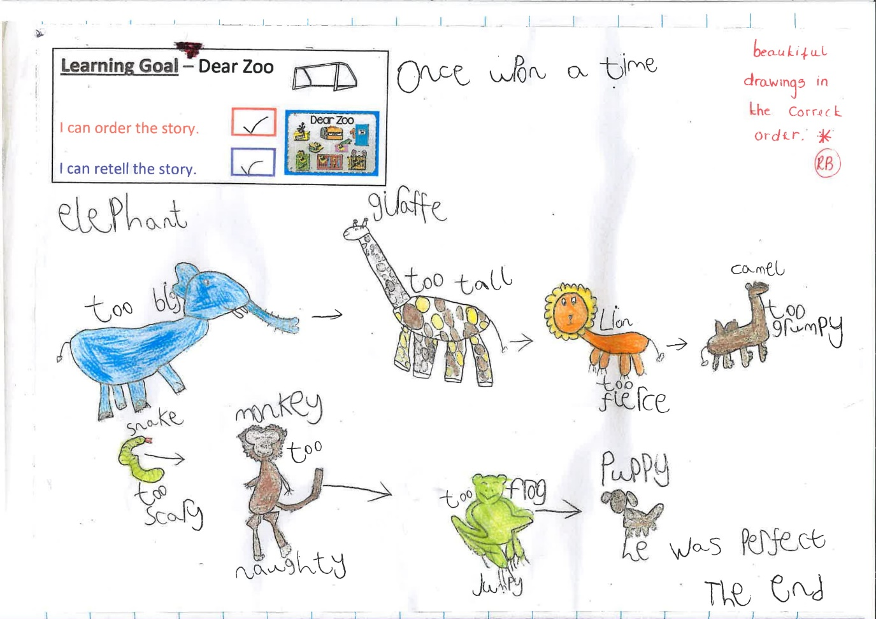

Appendix 3
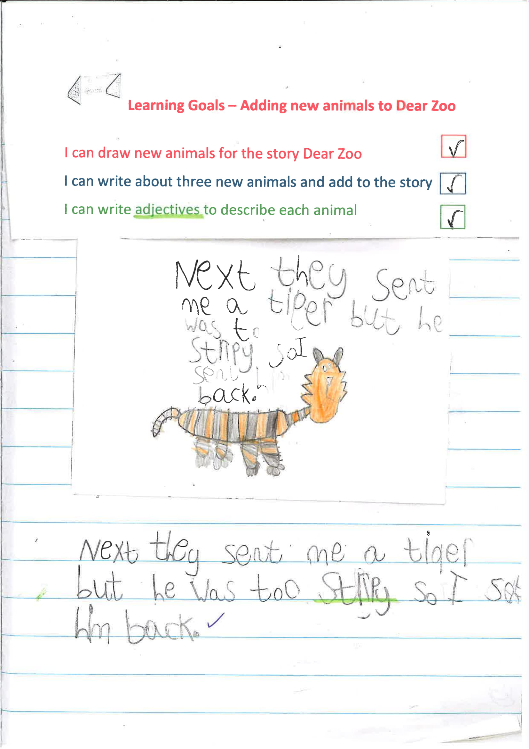

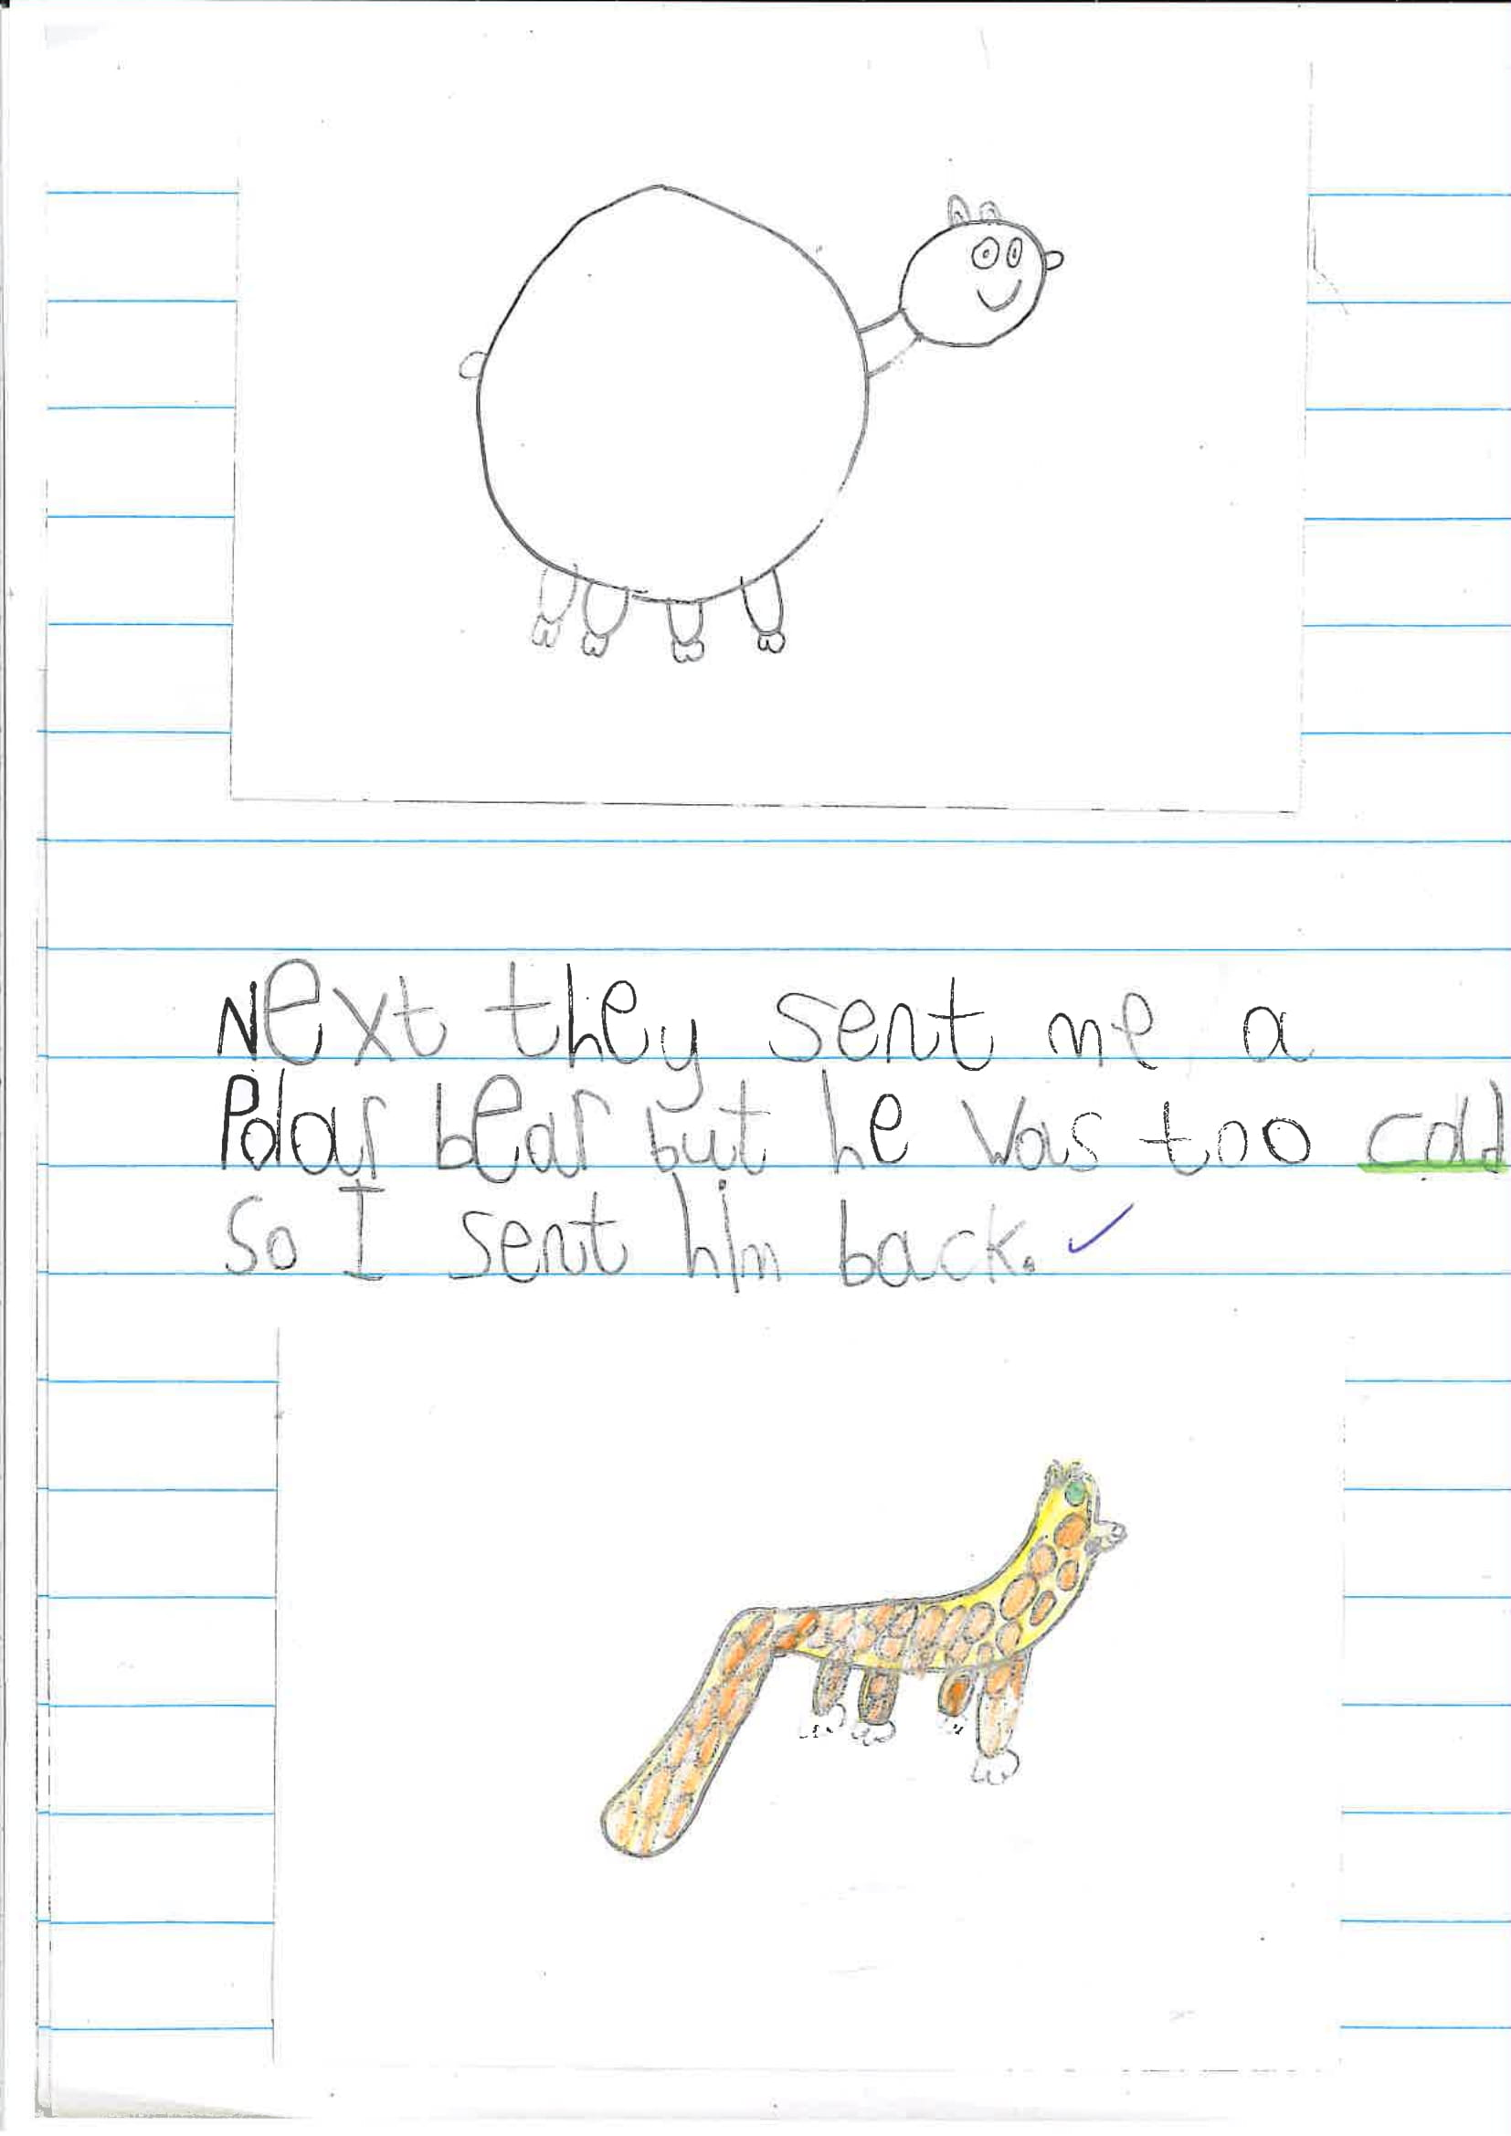

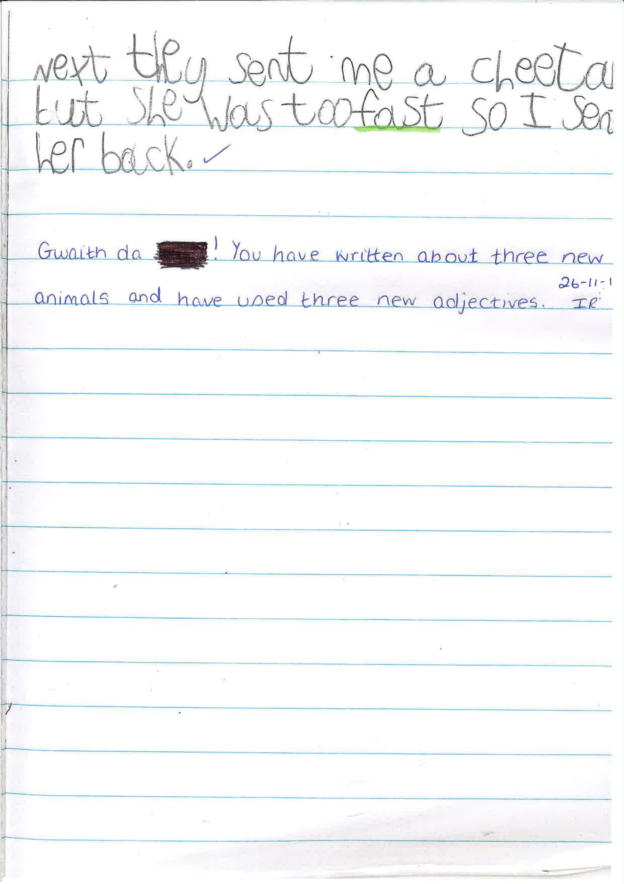

Appendix 4
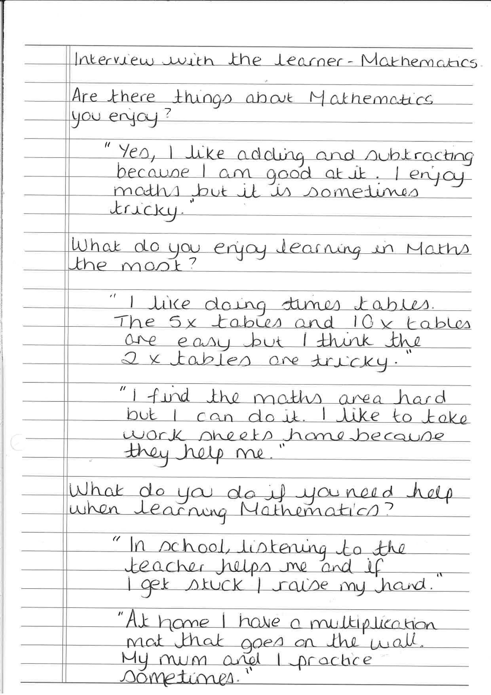

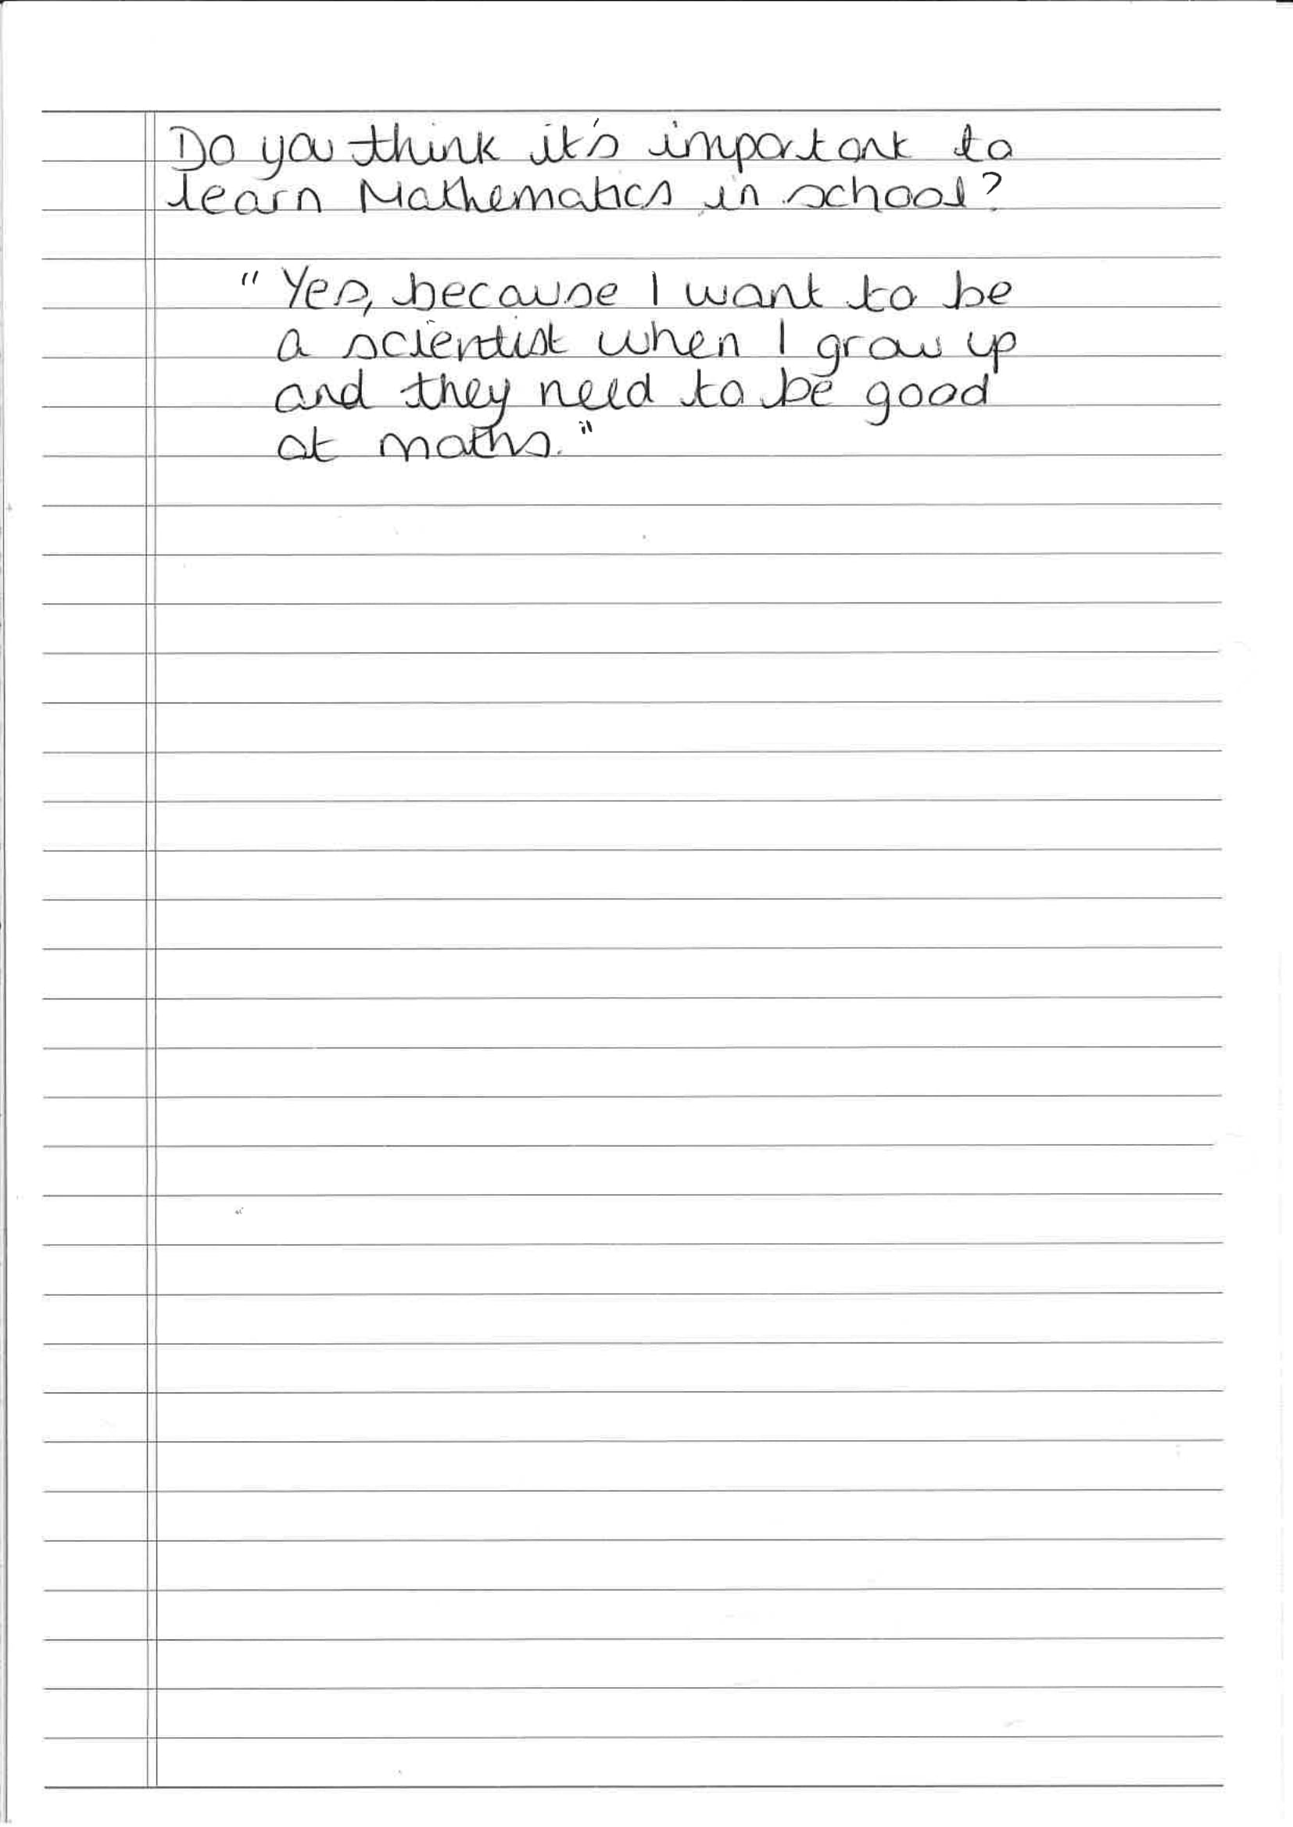

Appendix 5
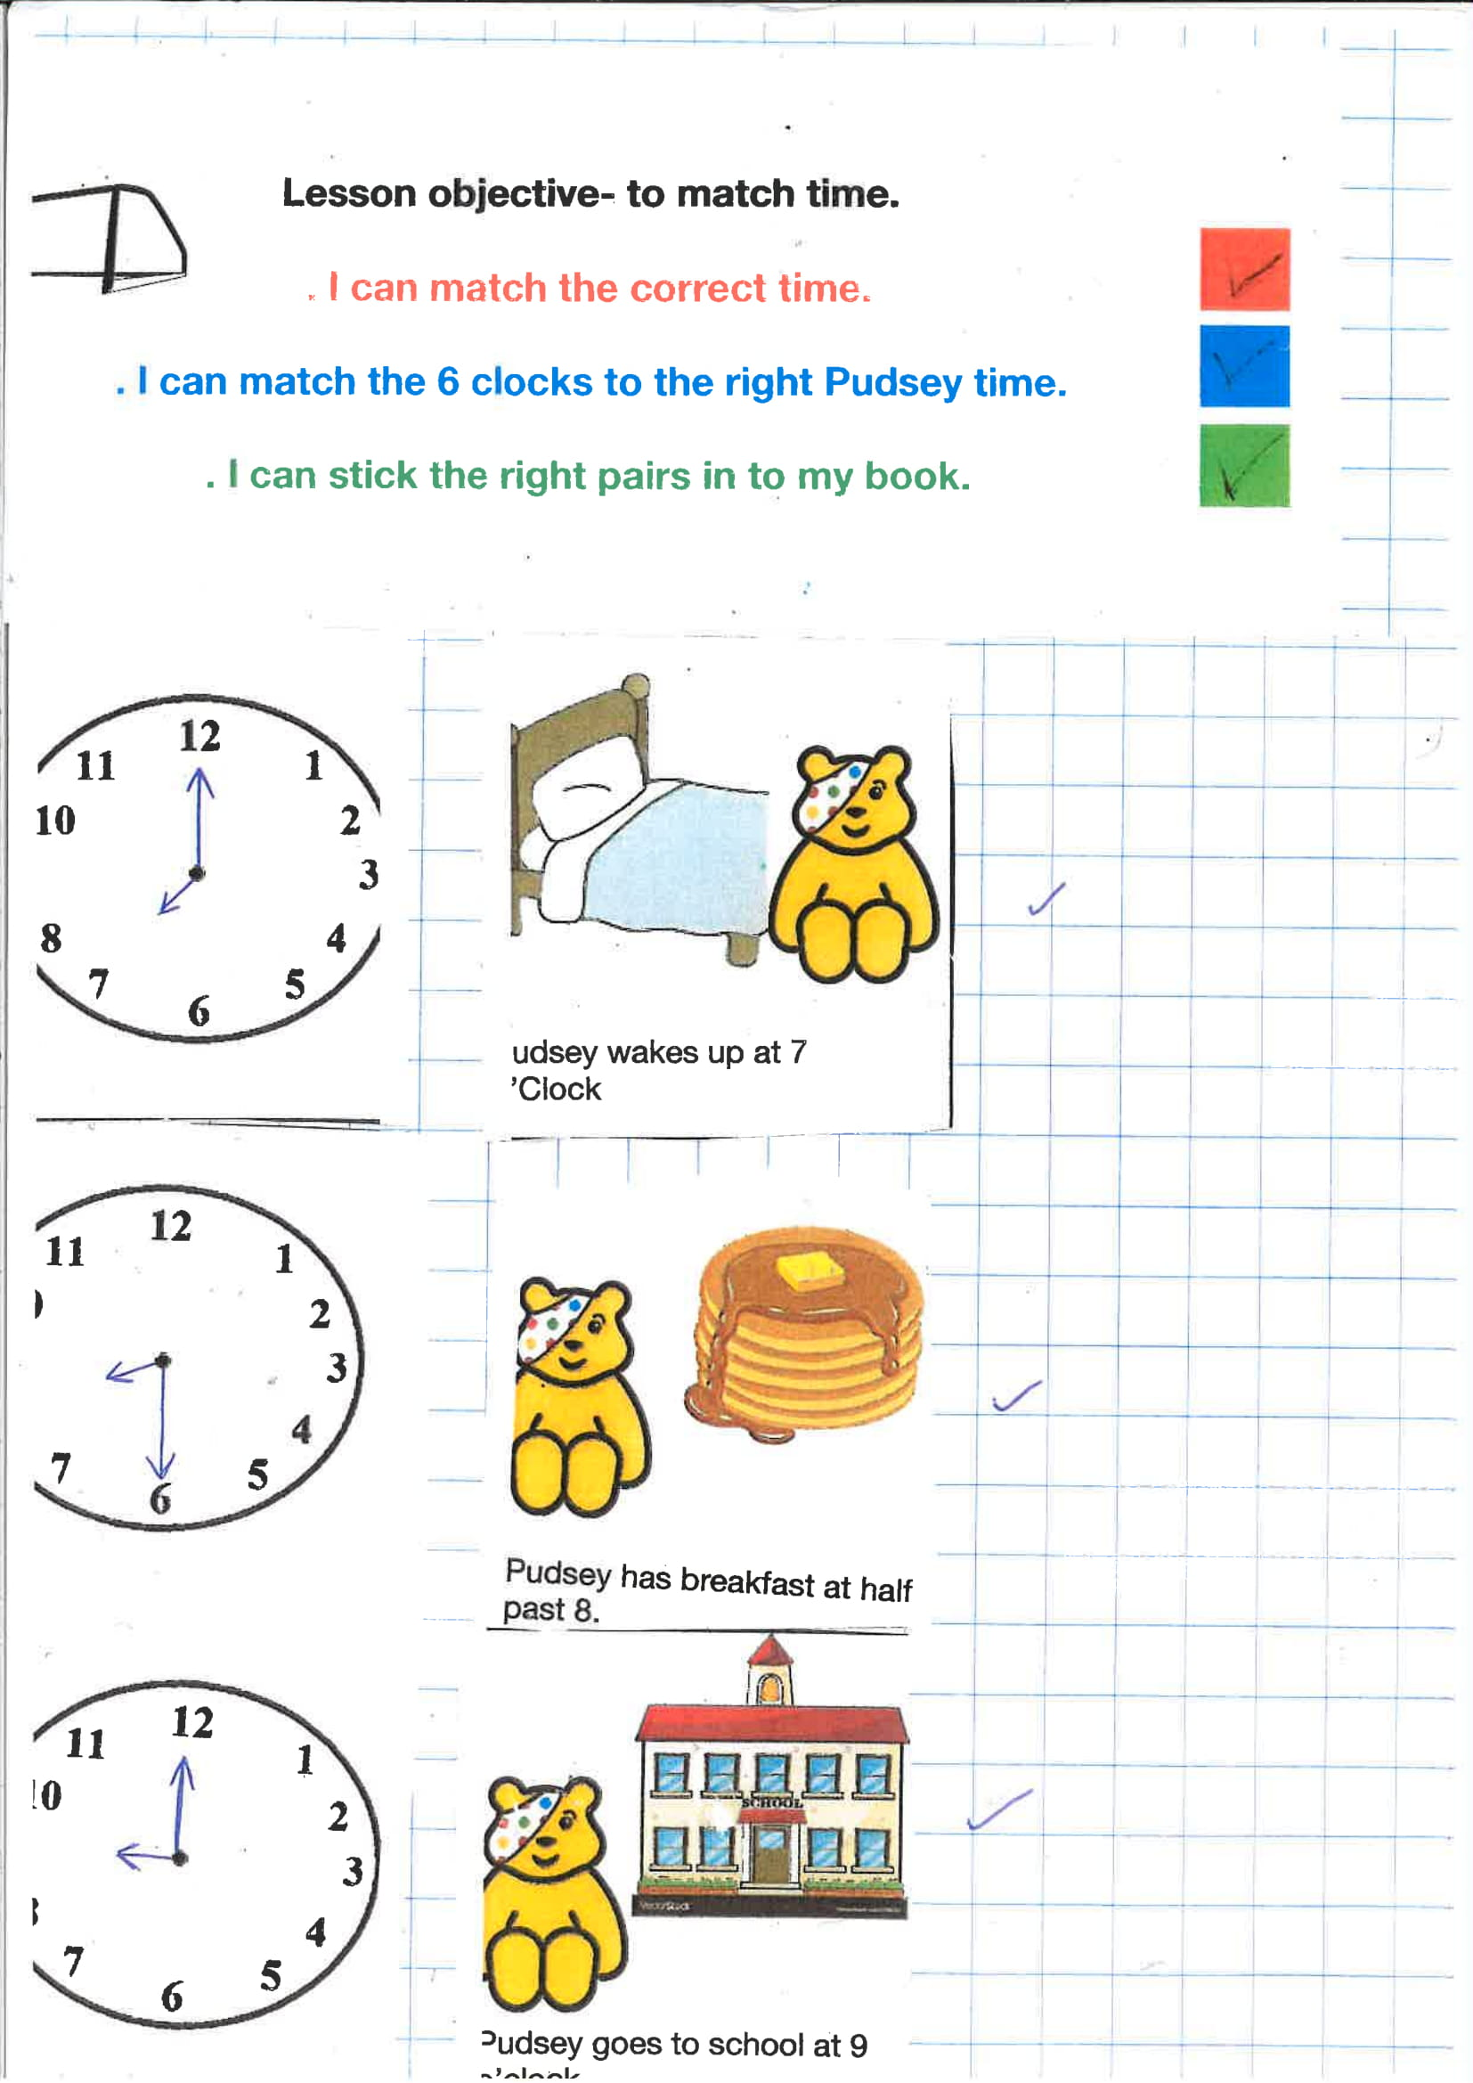

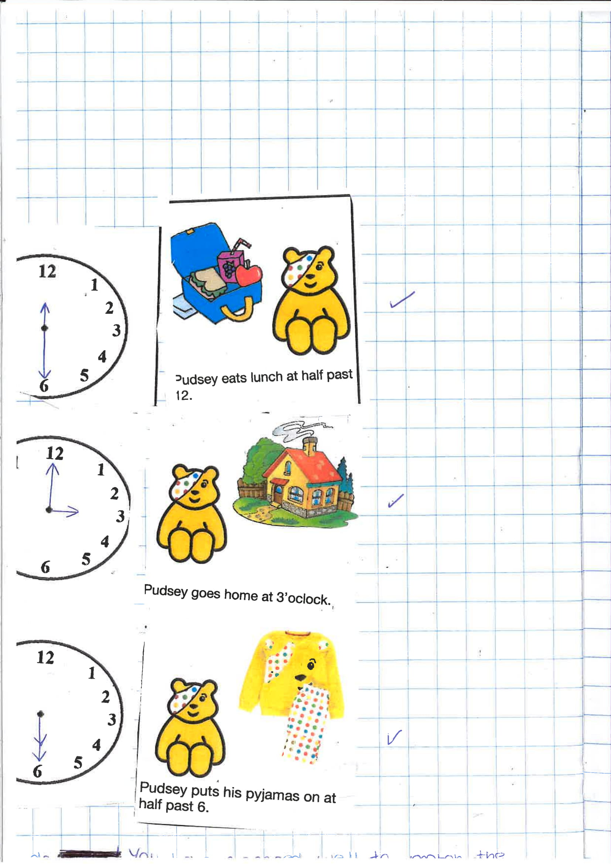

Appendix 6
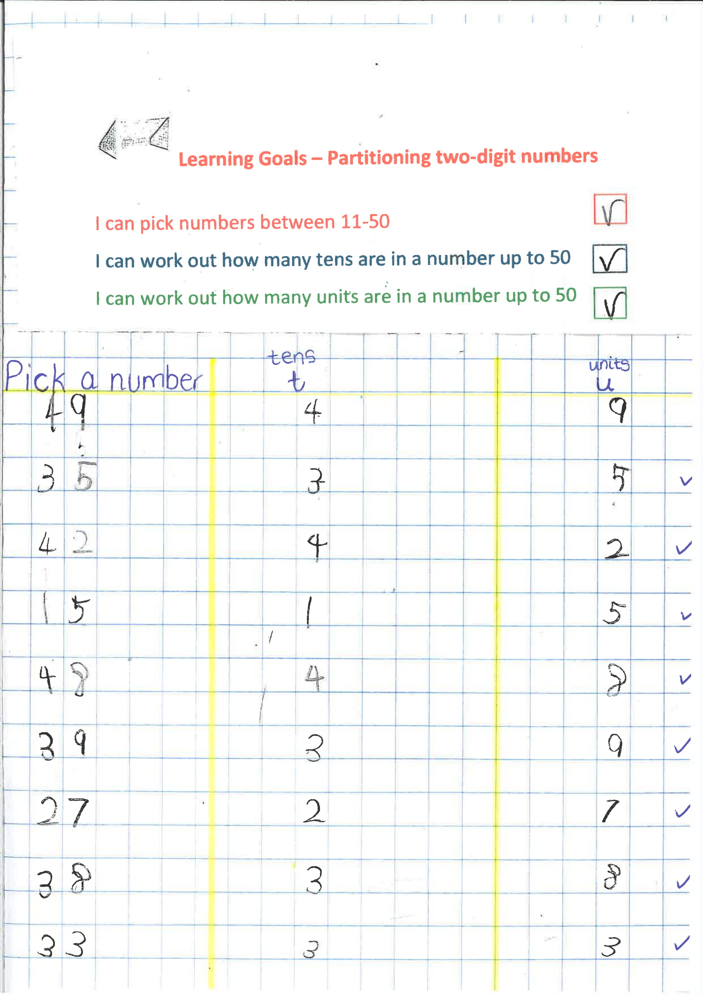

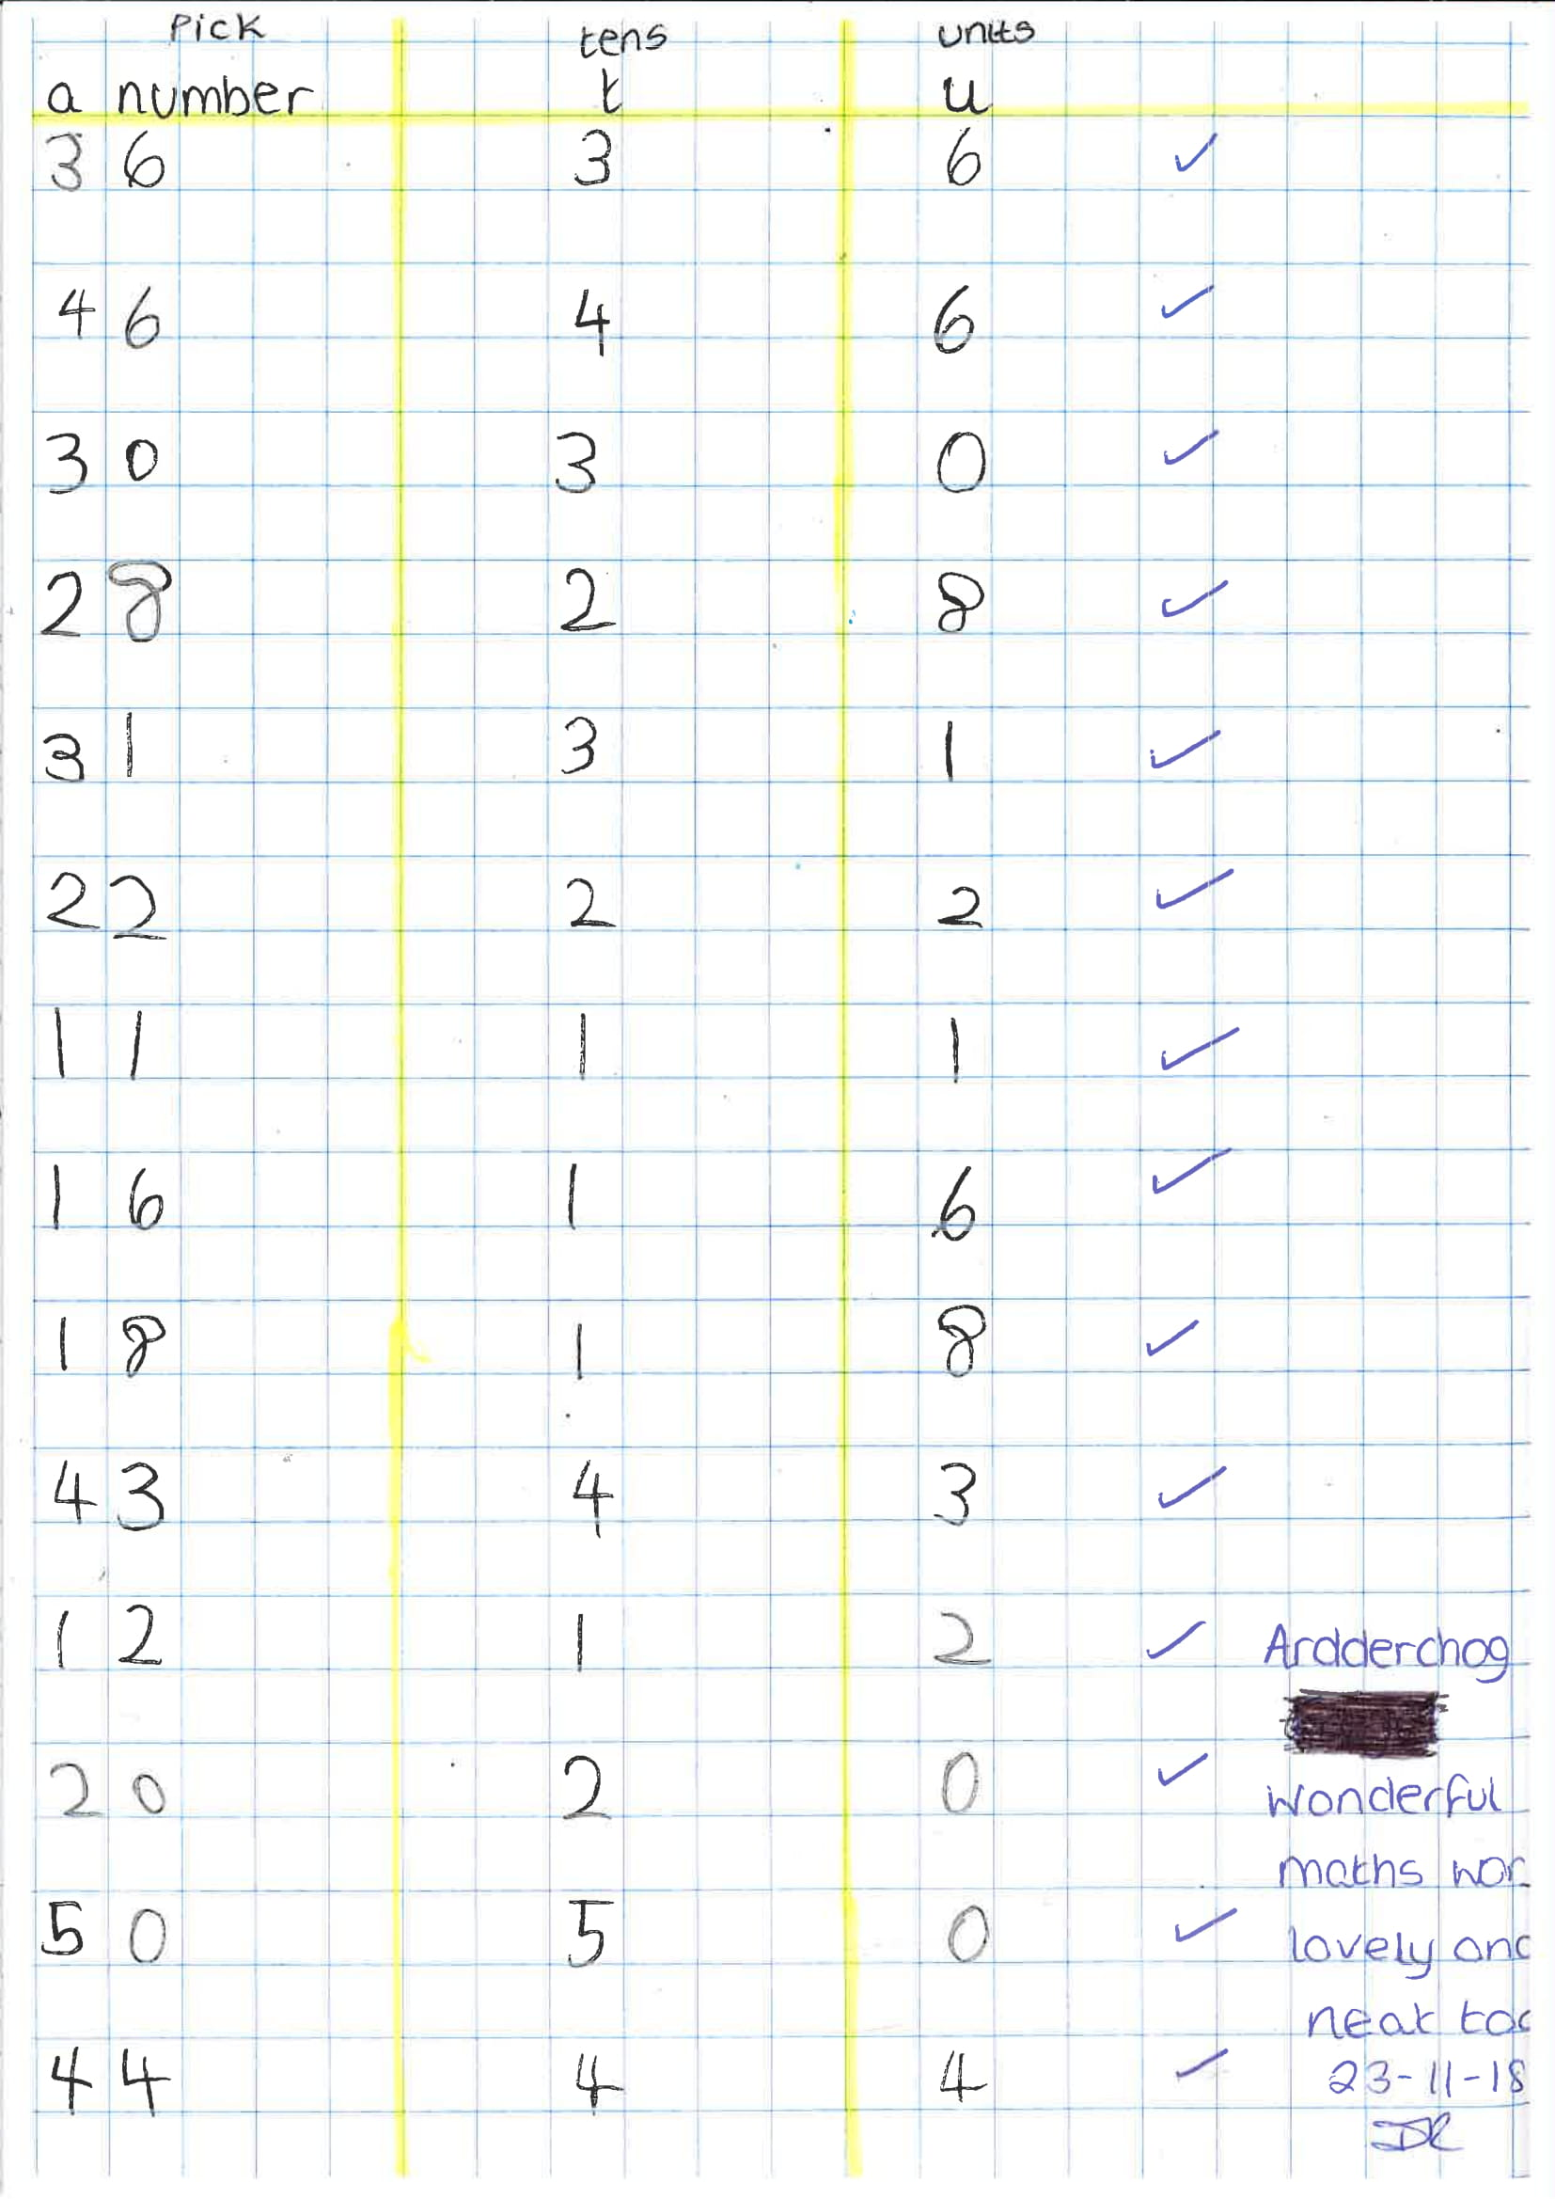

Appendix 7


