Placement-Managing Hotel Administration
BMIH6004
Student name: Diana Andrusko
Student ID: 2025664

Lecturer name: Lisa-Marie Bassler
Date: 22. October 2023.

Content Page
Content Page 2
Introduction 2
Gibbs Reflective Cycle Model 3
Description 3
Feelings 7
Evaluation 7
Analysis 7
Conclusion 10
Action plan 10
Summary 11
Reference 11

Appendices:
Appendix 1 Page 3
Appendix 2 Page 4
Appendix 3 Page 5
Appendix 4 Page 6
Appendix 5 Page 8
Appendix 6 Page 9
Appendix 7 Page 10

Introduction
The undersigned reflective learning journal provides an insight into my experience at the Delta Hotel Waltham Abbey London and analyses the positives and negatives in the Hotel Administration, Front Office area during my time there. During my time working at the front office desk, I found that, this area is responsible for most of the guests, example, they form the customer service and customer-oriented part of the hotel, Dollarhide (2021).
“The front office is where guests are greeted when they arrive at the hotel, where they’re registered, and where they’re assigned to a room.” (Rutherford, 2007, p. 78).
This is where most of the revenue is generated. The most important tasks include check-in and check-out, parking guidance, and maintaining contact with the cleaning service and maintenance. Dollarhide (2021).
“The front (or reception) desk is the heart of the front office department. It is not simply a place where guests check in and check out but often the focal point” (Wood, 2013, p.47).
Using Gibb's learning style, I analyse the experiences gained during my time in the front office.

Gibbs Reflective Cycle Model
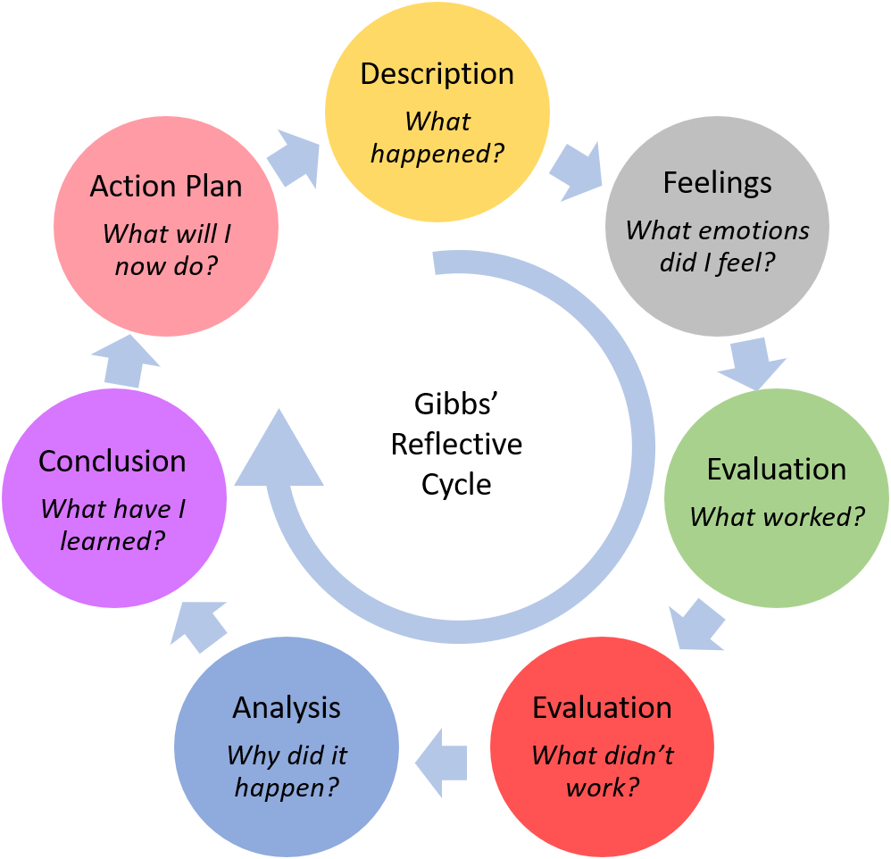
Figure1 Gibbon (2021)

Description
During my 4-week reception period, I learned increasingly every week as a reception assistant, such as forecasting,
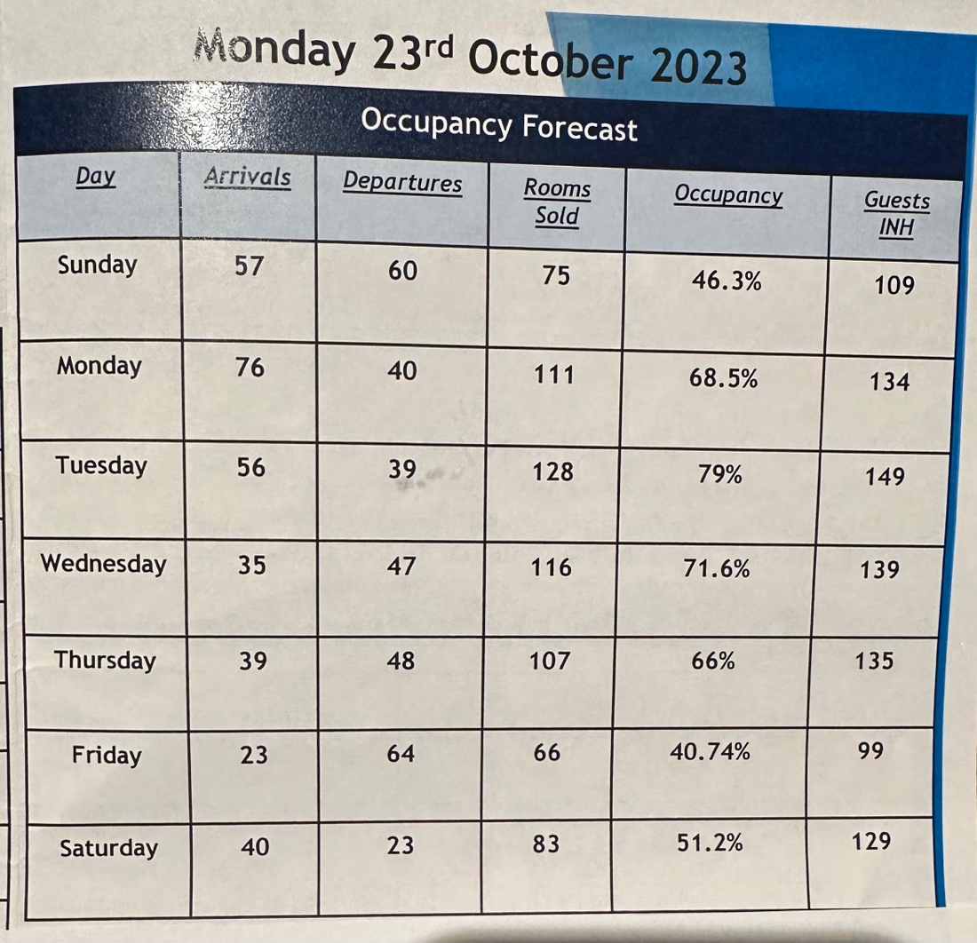
Figure2 By Learner (Occupancy Forecast)
check-in and check-out, parking lot registration, documenting papers in folders according to room numbers, communication with customers. I was able to see how the daily routine tasks were carried out in the system, Elphick (2023).

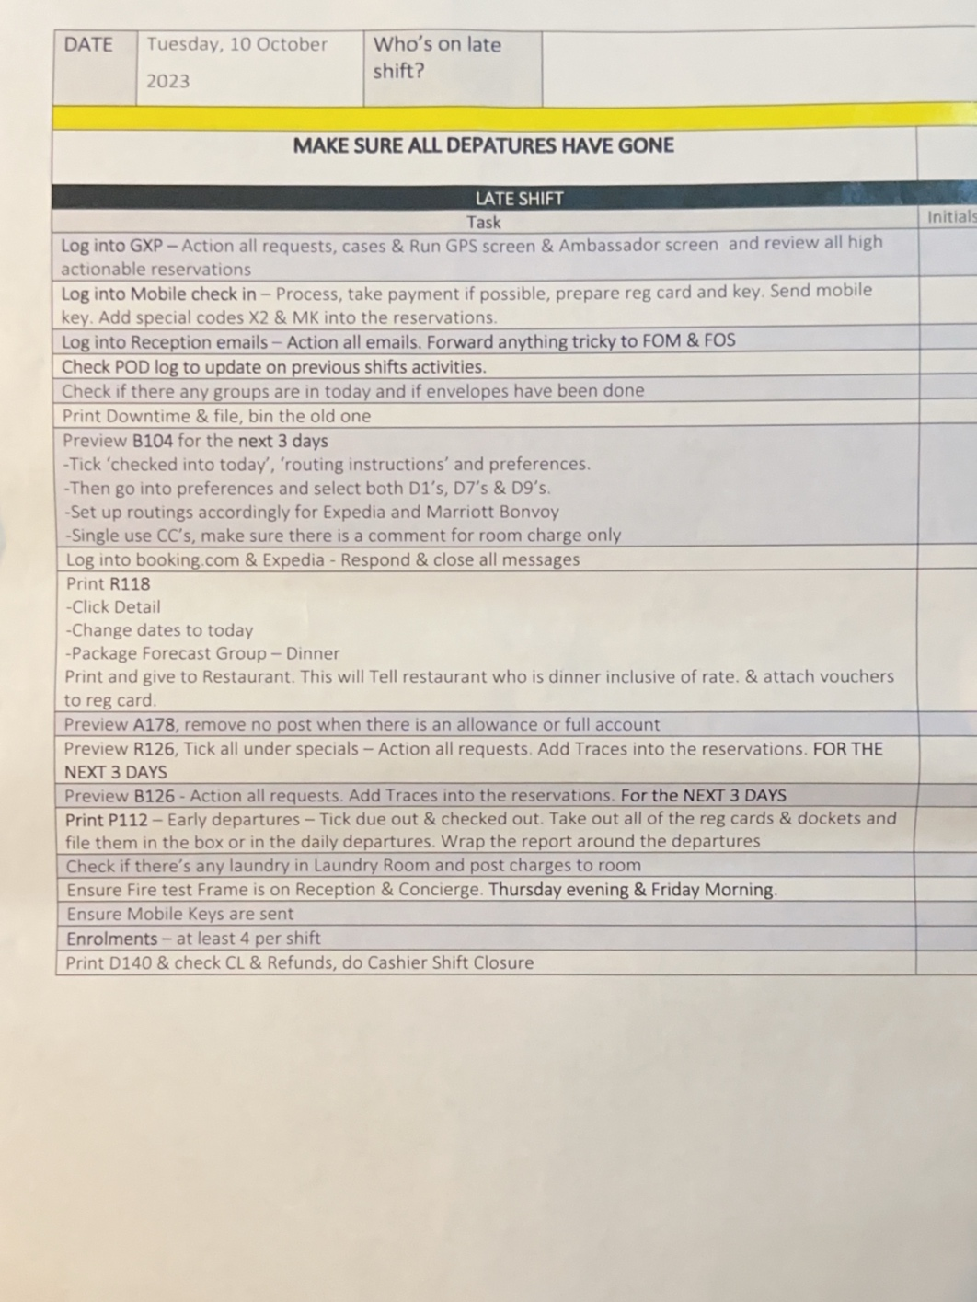
Figure3 By Learner (Team member reception daily check list)
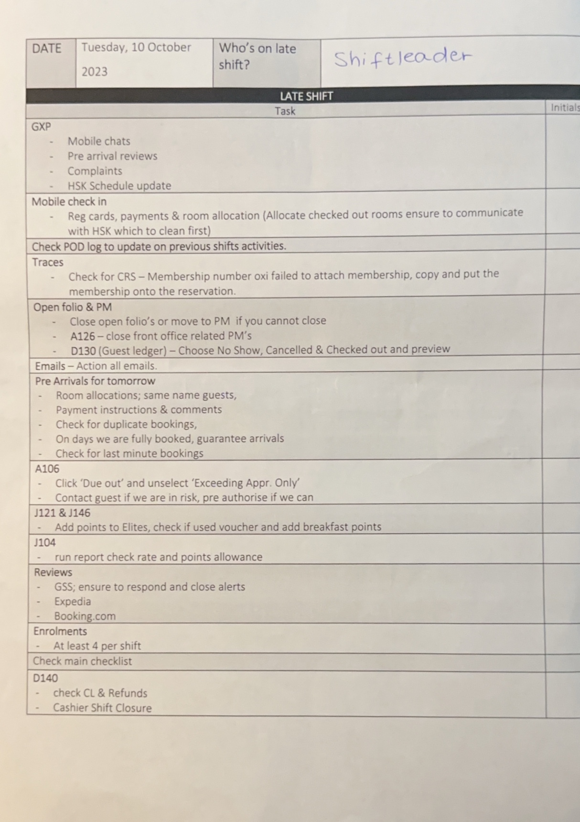
Figure4 By Learner (Shift leader reception daily check list)
My learning goal was to develop hard and soft skills such as English language development, communication skills, problem solving, multitasking, system knowledge such as how to use the PMS system, which was completely new to me because I had never used this system before. I wanted to learn as much as possible and gain experience and be able to apply it during my time here. Week after week, I experienced that the PMS system crashed several times, because of this the check-in was slow and the system became difficult to manage. This frustrated both staff and guests. Opera PMS, the popular property management system that helps manage reservations, front desk, housekeeping and more (Opera Reservation System, 2023). However, several unpleasant situations arose due to the system error.
The other experienced situation, which happened week after week, was that the schedule was very uncoordinated. The afternoon shift had to return to the hotel for the morning shift, and they worked together 9 days without day off, which negatively affected the workers. This situation arose due to a lack of staff, which the manager should have resolved. Managers must recognise when it is time to hire a new employee, Birt (2023). During the time spent at the reception, there was a change of manager.

Feelings
The guest's dissatisfaction due to the recurring system error was unpleasant, and my colleagues were also disappointed. I felt that guests should be compensated for these unpleasant experiences, because handling dissatisfied guests is a key skill in the service industry, as it directly affects customer satisfaction and the reputation of the business Kim Kim Campbell (2022). As I knew that the receptionists were tired due to many days and bad schedules, I always helped them with everything. Checking in and out and making phone calls were also complicated, as I was not familiar with the system, so I was given other tasks, which I really enjoyed. Unfortunately, these were lost opportunities. Looking back on the weeks spent there, we solved everything as a team, but I missed the actions of the department manager.

Evaluation
What went well was working together and helping each other. Good teamwork is important because tasks and problems can be solved well with cooperation (Indeed Editorial Team, 2023). This encouraged me to be even better. This contributed positively to the team work ethic. If we believe in ourselves and as a team, then we have successfully completed halfway to reach our goal, Panchal (2023). What has not worked well in several cases is that the guests are compensated for the unpleasant experience.

Analysis
I realised that the system error is recurring, and it affects the entire hotel. Because the communication of the departments resulted in many errors due to the system. For example: the guests were not included in the breakfast list, although they were in the front office data. Due to the system, there was a problem with booking in the past.
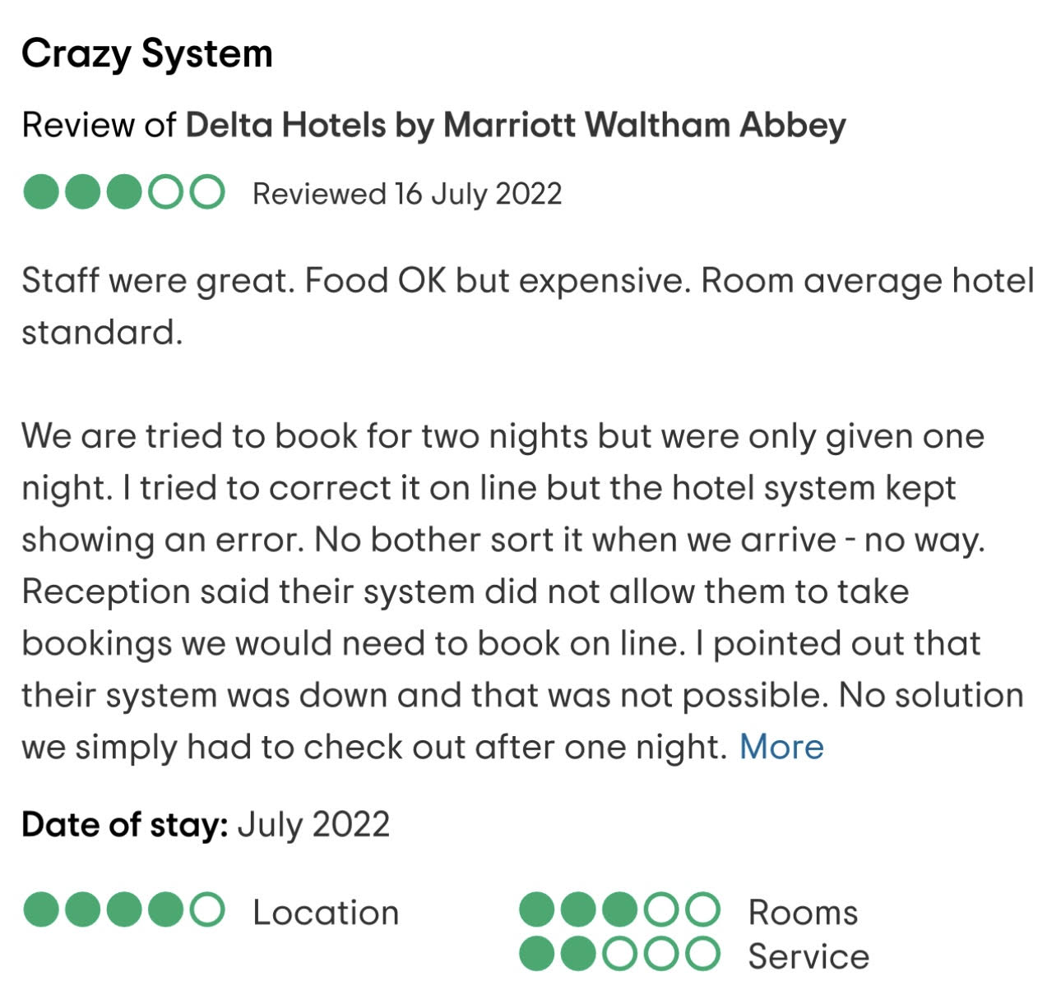
Figure5, Pastor, JM (2022)

PMS is a good system at idle, but if it is overloaded, it slows down, nevertheless it has many advantages, for example, low cost, higher income, can be tailored to individual needs, easier integration (Preno, no date). Given that this programme is used by the whole hotel network, it impacts every hotel brands worldwide, (Heimduo, 2020). It would be worth replacing PMS with PMS-cloud. That compiles information and makes it accessible to everyone, wherever, at any time.
It is not necessary to install the program on a physical machine. Instead, hotels only need a strong Wi-Fi connection, Yahya Shakhshir (2022). When I asked the general manager about this technology, he replied that the “Marriott operator does not purchase it since it is too costly”. Based on information from the Finance department, Marriott Abbey generated a 20% profit in the previous year, which would enable the system to be improved, but unfortunately, the operator ADIA (Abu Dhabi Investment Authority) does not invest back from the profit but takes the profit. Nevertheless, there are many arguments in its favour. Example:
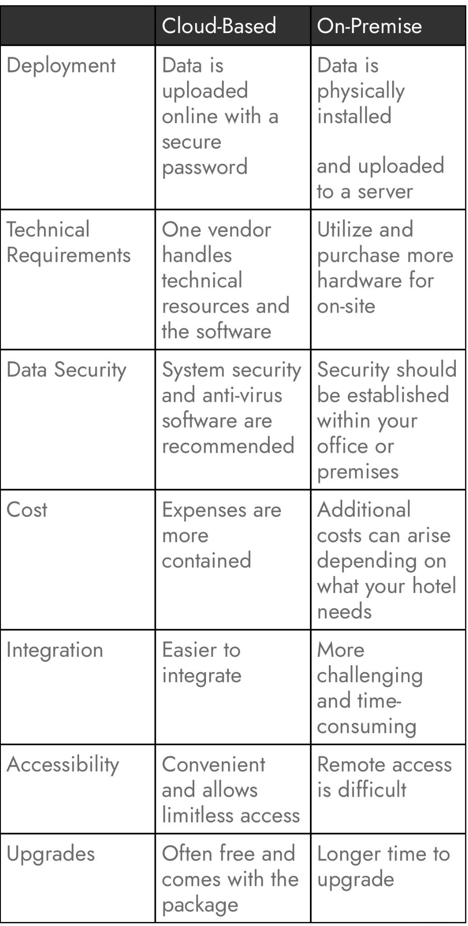
Figure6, Luxe Pricing (2023)
The front office staff consists of 15 people. Why do employees subordinate 9 days?
“There are four functions of management. They are planning, organizing, influence and control.” (Tesone,2010 p.9)
Jithin, (front office manager) knowledge the planning, and organisation of the front office manager is not the best, how can employee satisfaction be 100% after such a work schedule? What are the characteristics of a good manager?
A good manager is not a man who can do a job better than his people; but a man who can get his people to do a better job than him Kashyap (2023).
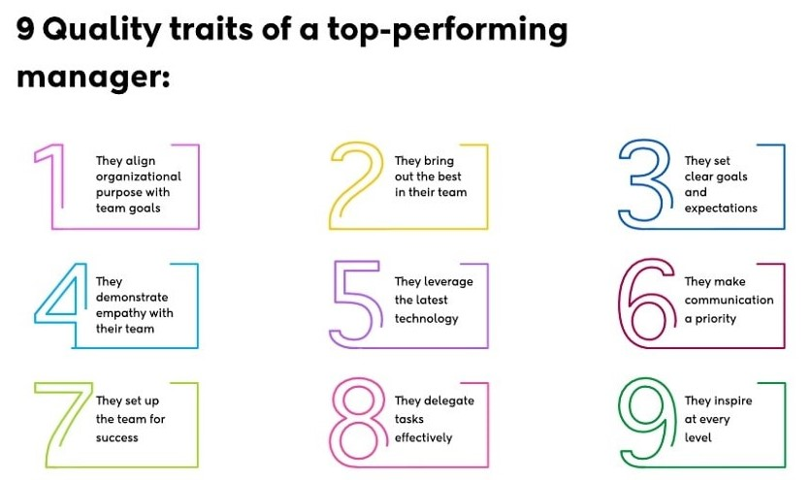
Figure7, Kashyap (2023)
“Planning involves selecting the various goals that an organization wants to achieve and the strategies (actions) to be taken to ensure that those goals are accomplished.” (Walker, 2021, p.352)

Conclusion
I gained experience how to deal with such inconvenient situations on days when the guest complains. I learned that everyone should do the tasks that suit them, which are their strengths, because everyone has strengths and weaknesses. In my case, I had little knowledge of the computerised PMS system, which I could have practiced outside of online work and the work would have gone better. For the guest complaint, if I were the manager, I would have offered a free dessert with room service or a free drink at the bar.

Action plan
The next time I work in group work in the same situation, I will be less nervous, since the guests can see. I will do my best to learn the system better, and I am asking for additional training so that it will be easier to check in and check out next time. To the manager Jithin must doit better rota to put it simply, forecasting is the process of predicting future behaviour by analysing historical trends and data. With this mindset, he prepares himself for the unknown, Kun (2023). To improve the guest experience, Marriott operators ought to give cloud-based PMS more consideration.

Summary
Overall, I am contented that I learned a many new things and that was able to be a part of this fantastic team in the Hotel Administration (Front Office) area. A group's creativity and productivity rise when its members collaborate well, producing work that is of a high calibre. Effective problem-solving and team performance are enhanced by management. Therefore, effective cooperation requires well-developed managerial abilities. In conclusion, the team became more cohesive because of the system's deficient performance, and we worked even harder on the issue, but management still must improve the way it handles situations like this and provide assistance.

Reference

Campbell K. (2022) Handling Guest Complaints: The Complete Guide for Hotels. [blog]. 26 January. Available at: https://www.cvent.com/en/blog/hospitality/handling-guest-complaints (Accessed: 18 October 2023).
Dean Elphick (2023) Hotel front desk guide and checklist: Front office responsibilities. Available at: https://www.littlehotelier.com/blog/running-your-property/hotel-front-desk-responsibilities/#:~:text=Here%20are%20the%20key%20front,as%20extra%20towels%20as%20required (Accessed: 22 October 2023).
Indeed, Editorial Team (2023) Characteristics of Good Teamwork (With Tips). Available at: https://www.indeed.com/career-advice/career-development/good-teamwork (Accessed: 10 October 2023).
Heimduo (2020) What property management system does Marriott use? Available at: https://heimduo.org/what-property-management-system-does-marriott-use/ (Accessed: 19 October 2023).
Jamie Birt (2023) 12 Management Challenges and How To Overcome Them. Availale at: https://www.indeed.com/career-advice/career-development/management-challenges (Accessed: 22 October 2023).
Jonathan Gibbon (2021) Personal Leadership. Available at: https://www.personal-leadership.co.uk/post/learning-from-reflection (Accessed: 25 October 2023).
Maya Dollarhide (2021) Front Office: Definition, Duties, Front Office vs. Back Office. Available at: https://www.investopedia.com/terms/f/frontoffice.asp (Accessed: 11 October 2023).
Mia Kun (2023) What is Hotel Forecasting - Models and Best Practices. Available at: https://www.hotelminder.com/what-is-hotel-forecasting-models-and-best-practices (Accessed: 20 October 2023).
Opera Reservation System (2023) What are the main benefits and challenges of switching from Opera PMS to Opera Cloud? Available at: https://www.linkedin.com/advice/3/what-main-benefits-challenges-switching (Accessed: 13 October 2023).
Rahul Panchal (2023) 117+ Words Of Encouragement For Team. Available at: https://behappyhuman.com/encouraging-positive-words-for-team/#:~:text=Team%20Building%20Words%20of%20Encouragement%201%20“Let’s%20build,bonds%20us%20and%20helps%20us%20achieve.”%20More%20items (Accessed: 14 October 2023).
Rutherford, & O’Fallon, M. J. (2007). Hotel management and operations (4th ed.). Wiley.(Accessed: 15 October 2023).
Shakhsir Y. (2022) The Big Jump From Opera PMS V5 to Opera PMS Cloud is Here! [blog]. 4 February. Available at: https://thinkbliss.ca/blog/from-opera-pms-v5-to-opera-pms-cloud/ (Accessed: 19 October 2023).
Tesone. (2010). Principles of management for the hospitality industry (1st ed.). Butterworth-Heinemann, an imprint of Elsevier. (Accessed: 14 October 2023).
Preno (no date) Hotel PMS Systems: Everything You Need to Know For Your UK Hotel. Available at: https://prenohq.com/blog/hotel-pms-systems-everything-you-need-to-know-for-your-uk-hotel/#SnippetTab (Accessed: 22 October 2023).
Pastor JM (2022) Crazy System. [TripAdvisor] 16 July. Available at: https://www.tripadvisor.co.uk/ShowUserReviews-g503793-d229504-r848178385-Delta_Hotels_by_Marriott_Waltham_Abbey-Waltham_Abbey_Essex_England.html (Accessed: 21 October 2023).
Pricing L. (2023) A Guide to PMS Systems Hotels, How They Work, and Why They Matter. 21 March. Available at: https://luxepricing.com/blog/pms-systems-hotels#:~:text=Most%20hotel%20businesses%20that%20operate%20year-round%20need%20real-time,convenience%20for%20hoteliers%20who%20cannot%20always%20be%20on-site. (Accessed: 18 October 2023).
Vartika Kashyap (2023) What Makes a Good Manager (The Ultimate Guide of Dos and Don’ts). Available at: https://www.proofhub.com/articles/what-makes-a-good-manager (Accessed: 14 October 2023).
Walker. (2021). Introduction to hospitality (Eight, Global edition.). Pearson. (Accessed: 13 October 2023).
Wood (Ed.). (2013). Key concepts in hospitality management. SAGE Publications Ltd. (Accessed: 12 October 2023).

