Student Name : Maria Nelly Basora Castillo
Student ID : 2022089
Programme : CertHE Skills for the Workplace
Module Name and Code : Academic and Employability Skills BMSW4001
Module Leader : Sylvia Hoffmann
Lecturer : Afzal Munna
Assignment Tittle : ACE Practical Portfolio ( Individual Report )
Word Count ( Where appropriate ) :

Maria Basora Castillo

Table of contents

- Introduction …………………………………………………………………….3
Gibb’s Reflective Circle
- Time management……………………………………………………………………4 to 9
- Academic Writing……………………………………………………………………9 to 11
- Paraphrasing………………………………………………………………………2 to 13
- Conclusion …………………………………………………………………………………14
- References ………………………………………………………………………………15 to 16

Introduction
In this assignment I would like to share all the activities and knowledge that I got about Time management, Academic writing, Paraphrasing. Therefore I learned a lot skills that I can use and develop in this entire year at university. Also I want to use a Gibb’s Reflective Cycle because that help me to develop what things went well or didn’t go well. However it is useful because that will help me to do better things in the future with this reflective cycle.
Gibb’s Reflective Cycle encourages individuals to think efficiently approximately the encounters they had amid a particular circumstance, occasion or movement. (Administrator, 2018)
It covers 6 stages:
- Description
- Feelings
- Evaluation
- Analysis
- Conclusion
- Action Plan

In the academic and employability skills we covered 10 different topics :
1. Time management / Organising study
2. Academic Writing
3. Paraphrasing
4. Summarising
5. Referencing
6. Reflection
7. CV writing
8. Cover letter writing
9. Public speaking and giving presentations
10. Online Learning Experience

These three highlight topics are the most interesting to me. There are several reasons why I choose those topics .Firstly I have been able to put them into practice in this module , planning how to handle my daily tasks , I was also able to pur into practice my academic writing by taking notes of important information, that will serve for the future . I can also paraphrase without any problem , because I learned a lot of news tips.

Time Management/Organising study

What is Time Management? Time management has been described using many different terms including spontaneity, balance, flexibility, and having control over time (M. Hellsten, 2012)
Advantages | Disadvantages
Reduction in stress level | Non-clear Objectives
Provides focus on the task | Can’t say NO
Challenge your productivity | Inactivity
Gain self-confidence | Fatigue and stress become part of life
A way to the goal | No time for rereation

I was listening to the explanation and ideas of the lecturer. This topic about time management was explained in the first week. I learned and got more knowledge about SMART Objectives, Swot Analysis, Personal and Professional plan and Time Management my colleagues were paying attention and very focus on this topic. Our lecturer gave us few websites to do a test skills and we share the results in Microsoft Teams. Also I completed a quizzes and I share the feedback with the lecturer. My colleagues sharing different opinions about what time management is and how they used it. However, I was very intrigued to be in this section because everything I learned can be valid when I deadline my assignment. Our lecturer gave us plenty of time to do our To Do List, the right time that I needed.
When the lecturer shared all the ideas with us I realized that there is still a lot to do and learn . It was all very interesting , as it was very clear and understandable explanation. I realized that we were all easily understanding the topic and that we were going to be able to handle the assignment .This has also helped me to come up with good ideas for my assignment . Looking back ,I feel happy that I can use that in my assignment.
The things that went well and worked well in each section was the factor that some colleagues shared their ideas and that helped me to be more creative. What clearly did not go well is that some colleagues did not do the tasks on time that the lecturer assigned and then they were a bit struggling to do it. Therefore, in general the lecturer had to explain the topic more than once.
I think the reason that at the beginning of the class everything went well was that each person in the class shared the knowledge that they had before our lecturer covered the topics. According to each explanation, knowledge and ideas I was able to identify what strengths I have and weaknesses in each thing. I have experience working in this way before and I have discovered that when I am working by myself, I enjoy working in areas that match my strengths. It seems natural to me.
I think that when we work by ourselves. focused on what we have to do , that save us time. Thus, none of us have to rush to do each practice assigned to us in a limited time in the class section.
I read a book about how I can improve my time management skills . According to the book , I can practice that in my daily life . I learned that sometimes I need to challenge myself to see what abilities , strengths and weaknesses I have .However, I can be more organized in all my tasks.
If I had to go back to performing or studying these topics again . I will try to feel free to give some discussion about it and give ideas to new colleagues about what teachings and knowledge I have . Potentially , I would suggest seek information and baing more organized with the activities. Also, I would like to be able to interact with others about our main skills.

skills Knowledge , virtue and intelligent activity have long been central subjects of philosophical request and are the subject of profound and broad wrangles about in modern philosophy. (Stanley , 2017)
Skill Areas is the types of activities you feel that you are able to do . Each area is related to the world of work . Based on the test that I made online these are the results:
- Creative Thinking
Comes up with new ideas and different ways for approaching issues.
- Working with Others
Works well with people by listening , understanding and helping others.
- Planning and Focusing on Detail
Plans own tasks and uses time effectively to produce high quality work.
- Convincing and Communicating
Convinces others and deals well with conflict . Expresses self clearly when speaking and writing .
- Showing Energy and Drive
Show energy and enthusiasm for meeting difficult goals and taking on new tasks.
- Handling Change and Pressure
Adapts to changes , remains calm and reacts positively to challenges .
- Solving Problems
Spots problems and gathers information , making judgements based on facts .
- Taking Responsibility
Takes responsibility for own actions and for leading others.
- Learning and Technology
Easily learns new information and quickly learns how to use new technologies .

How do I improve my time management skills ?
Prioritize
Automate or delegate
Get it out my head

Identify manageable actions

(BMJ,2019)

- Getting everything out of my head would be easier for me , since it would not stress me so much and everything will be more relaxing when making a plan tasks to do my activities or daily routine.
- Of all the list of tasks necessary to achieve the final goal and optimize time management, the most urgent should be prioritized, after the most important until reaching the extendable ones.
- Automate: If I can do something the same or better and in less time , I will always try it .
- When I feel stressed to do a plan task, I am able to identify the small action that I could develop without problems.

To Do lists – Weekly
A list of things that one needs to induce done or that got to get done (Dictionary.com,2021)
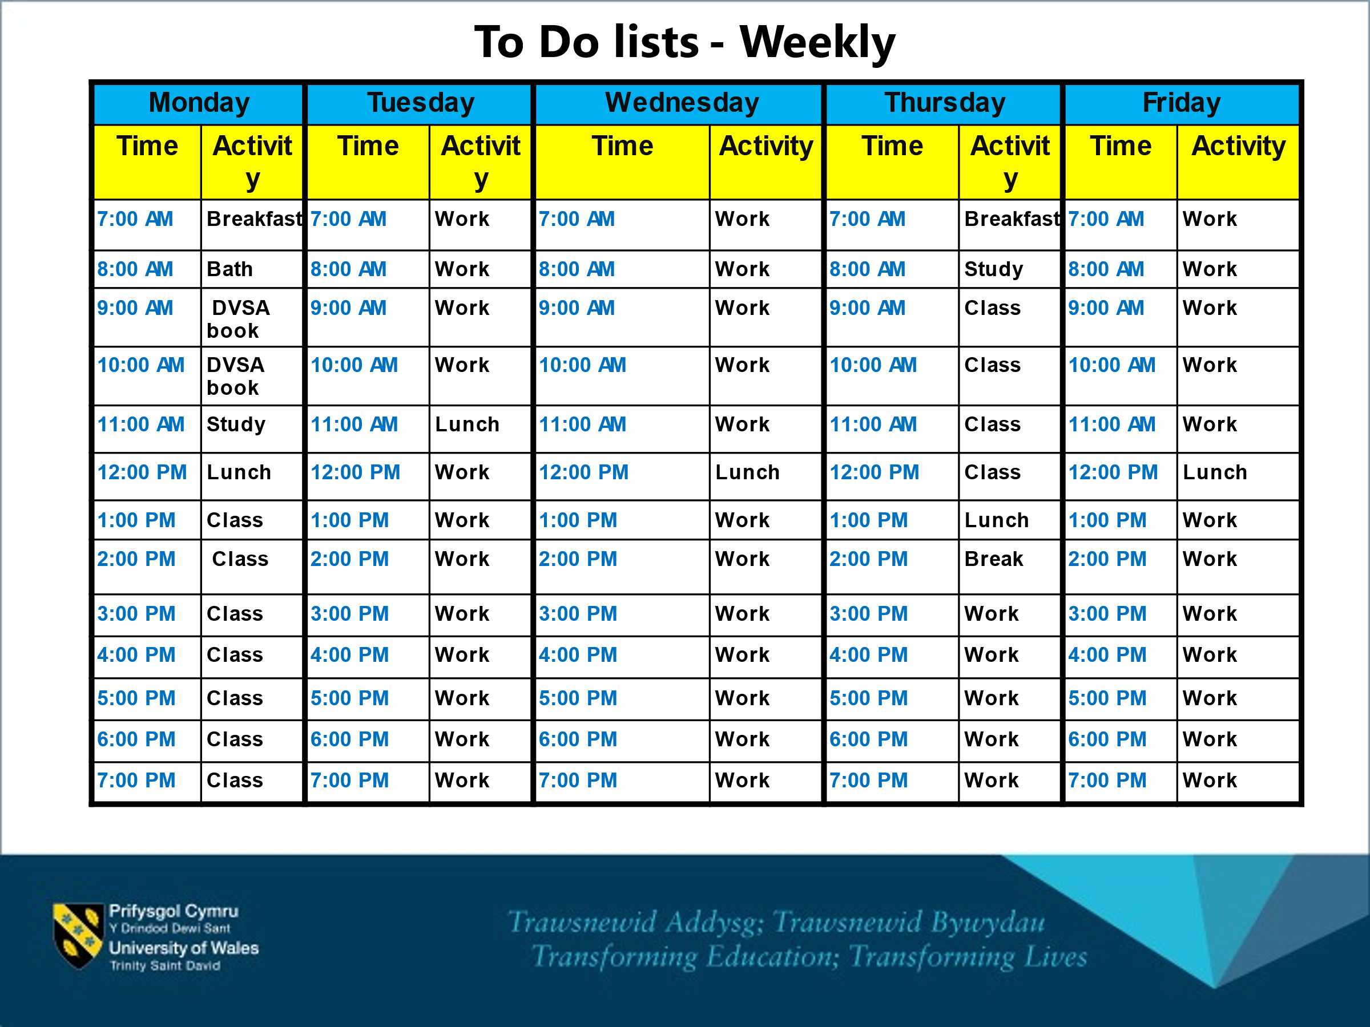

According to the table , every Monday is quite busy for me , since I wake up and have my breakfast I have many things to do .
Monday
- I read my DVSA (Driver and Vehicle Standards Agency ) book for a few hours as I am interested in learning to drive and have my own vehicle .
- After , I read a bit about what we did in ACE class .
- I have my lunch , to have my classes with motivation
- Finally , I have pnline classes which is the most important thing of the day because I get new knowledge .
Tuesday
- I wake up at 3:30 am.
- At 5:00 am I start the work routine at Pret A Manger ,
- At 12:00 pm tengo mi Descanso , to eat something .
- At 14:00 I finish working at Pret A Manger .At 15:15 I start my other job as a babysitter until 19:15 thar I make my way to go home ,
Wednesday
- I wake up at 3:30 am.
- At 5:00 am I start the work routine at Pret A Manger ,
- At 12:00 pm I have my break , to eat something .
- At 14:00 I finish working at Pret A Manger .At 15:15 I start my other job as a babysitter until 19:15 thar I make my way to go home ,

Thursday
- I have my breakfast and I review what I learned from the previous class of DSR .
- I usually wait until 9:00 am to have that interesting class .
- I have my lunch and I take a few minutes to breathe and relax .
- At 14:00 I make my way to go to work and go to the park with the kids I care for , to have a fresh air .

Friday
- I usually do the same routine as Tuesday and Wednesday.

This To-do list helped me get organized every day , think less and be more creative.It also helped me develop my digital skills . Even starting to be a confident person , that I can get things done.

SWOT Analysis
SWOT stands for Strengths, Weaknesses, Opportunities, could be a system utilized to asses a company’s competitive position and to create key arranging ,(Grant,2021)

My strengths are : | - My time management  - I am organized  - As a customer service for the past four years . I’ve learned how to deal with a wide variety of personalities .
My weakness are : | - My communication skills.  - My weakness is my commitment toward work .  - I am not very creative
My opportunities are : | - Practice languages.  - I will go for my advancement at university.  - I will get great opportunity to make advancement my family trade.
My threats are : | - I am afraid of not finish my career.  - I don’t trust myself to achieve my goals .

Personal and Professional Development
Personal development is the process through with the organization and person lock in within the handle of learning to meet the challenges and desire goals , (UkEssays,2018). Professional development makes us better people and workers, and this is reflected in our Curriculum Vitae .

Particulars | What? | Why? | When ?
Leave my assignments for the last days . | I want to organized myself a bit more. | I wan to be more organized because I do not want to fail my assignment . | As soon is possible .
Communication Skills | I want to improve my communication skills | To understand information more quickly | 17/04/2021

Academic Writing
Is obvious , brief, centred ,organized and sponsored up by prove . Its reason is to help the reader’s understanding .
In the area of academic writing , we covered several points such as :understanding the structure of the clauses , structure of the paragraph… As usually the lecturer explained what the meaning of each topic is , how we can use it and what it is for . While we saw different types of videos and we had the knowledge of knowing and differentiating what each video explained , also we take notes .
I was a bit motivated , because they are things that I had already heard in the past when I was going to primary school . Sometimes it is good , to remind topics already given so we do not forget them and obtain high results .According to some points of the video,there were things that I had forgotten such as : simplifying sentences . It seemed that my colleagues understood the topics very well .At first I thought I was not going to be able to handle this , but it has helped me get the work done faster .
We individually put an interest in the class, but not everyone contributed by doing the tasks . I think everything else went well , as it was a very easy topic to understand and do . Except , some people who did not share their tasks , some of us shared our tasks and gave different opinions .
Things on this topic were excellent because our lecturer looked for enough resources so we can be able to understand everything and he explained very well. Academic writing is very important , because when we write something we can write it in a concrete and clear way that the reader can understand . The search for information about the university ,the main points such as the campus , the different course it has … All this search was to understand each types of writing and practice the academic writing of each person.
I learned that when the lecturer assigns some tasks to do about academic writing , we should do it because many people need that skill . You have to follow every step that the lecturer gives in order to contribute more learning . Having done tasks on academic writing , I can take short notes on any other topic .
When I have to share the notes taken with my colleagues next time , I will highlight the main points . If I have any concerns , I will ask the lecturer to explain one more time and with more examples .
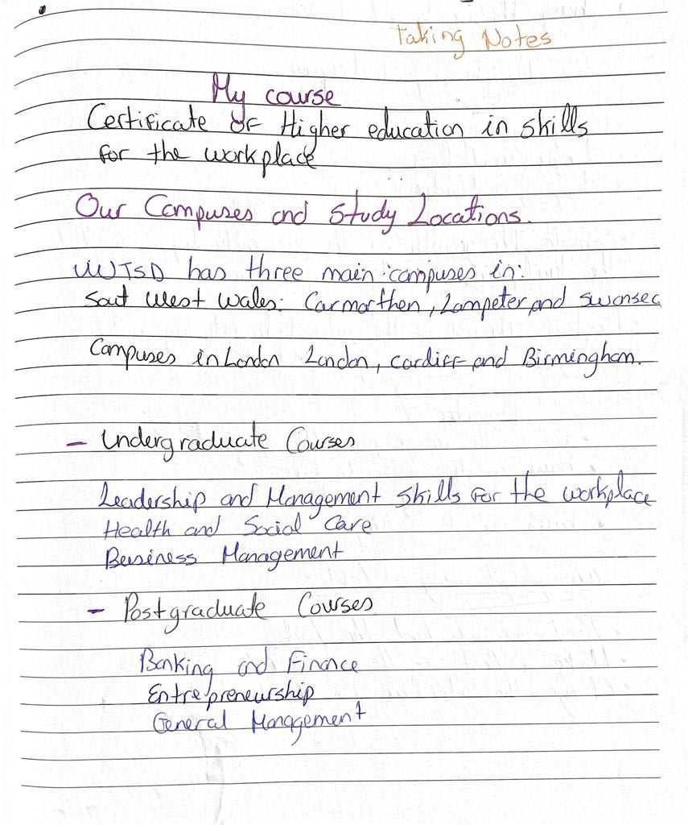
Example of how to take notes .(I did it myself)

Paraphrasing
Paraphrasing is writing the ideas of another person in your own words.
To rehash something composed or talked utilizing distinctive words in shape less difficult and shorter that makes the first meaning clearer,(Cambridge University Press,2021)
For a better explanation and to be able to practice how to paraphrase and have some tips .This topic was given in the week four . We had to search five synonyms each . We also had to paraphrase , we thought it would make it more complicated but it was easier for me .
Before the lecturer started giving the class on this topic , I was a bit happy because it was a topic that I had heard in the past , but I could never understand about it . I realized that in this topic there was a lot to learn , to be able to handle this in all the assignments. Some people in the class participated by sharing the synonyms that they found on the website and also paraphrasing by sharing their ideas .I felt satisfied after having this explanation , I could understand perfectly .
The things that were good and worked very well was that each person produced good quality . Moreover , I expected that half of the class would share with us what they did about paraphrasing , but very few showed their work . The things that clearly didn’t work was that not everyone collaborated and that is really important because we can check together what kind of mistake we have .
I think the reason that our individual participation of each part of the work went well was because each person was focus on what the lecturer explained and the examples that he showed us helped a lot . I have experienced practicing paraphrasing but unfortunately I didn’t get what my teacher in the past explained . I think that when you are really interested in the classes , you get the results you want to have .
I learned from all these tasks that we should look for the synonyms to paraphrase in an easy way and also practice all the time at home .
Next time I will watch for different videos that it will give me a bit more ideas and tips to use it in the future .
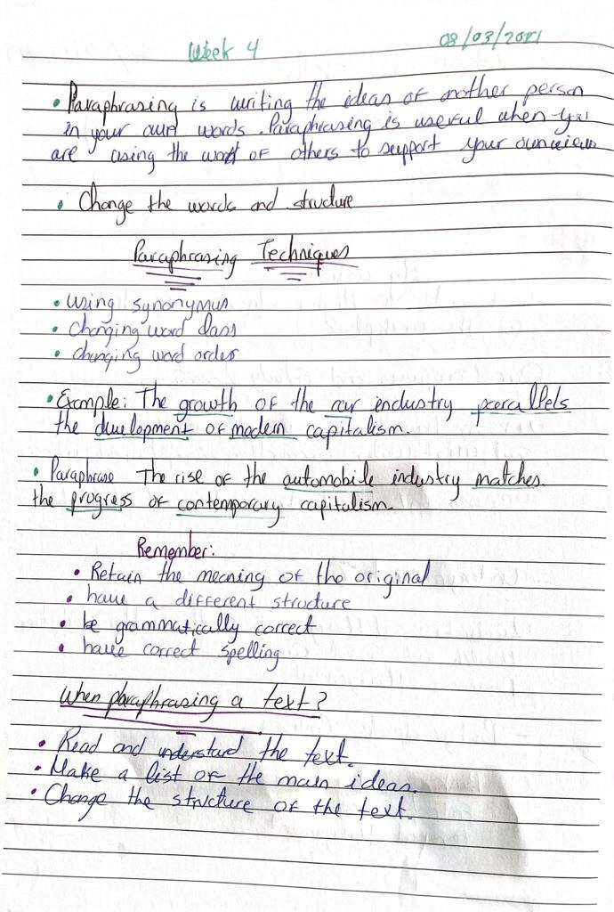
- This picture contains :
-The concept of what is paraphrasing.
-Paraphrasing Techniques .
- One example that show clearly how to paraphrase
-Some tips to use in the future
-When we should paraphrase a text .
Real Text:
There have never been so many opportunities to work in the environmental field. In Canada, more than half a million people are employed in green jobs, and over one hundred thousand organizations have at least one environmental employee.
Paraphrased text:
There have never been so numerous openings to work within the natural field. In Canada, more than half a million individuals are utilized in green employments, and over one hundred thousand organizations have at slightest one natural worker.
Conclusion
Having done this kind of report I’ve discovered what skills I have and what skills I need to improve .
I need to improve few skills such as : self-confidence , cause I need to believe in my abilities , actions and decisions . When you have confidence in yourself, you might be more likely to pursue ambitious goals and try new things and believe you can succeed .Even I learned how I could improve my skills and how to organize myself with my chores . Moreover , identify what strengths , weaknesses, opportunities and threats I have .I learned various concepts such as : academic writing , when to use it and that it is also very important on a daily basis . Something very important that I learned is when you read a text how to paraphrase .

References
Administrator, 2018. My assignment services. [Online]
Available at: https://www.myassignmentservices.com/blog/how-to-write-gibbs-reflective-cycle#:~:text=Gibbs%20Reflective%20Cycle%20is%20a%20theoretic%20model%20that,to%20improve%20upon%20by%20giving%20it%20more%20attention. [Accessed 18 03 2021].
Dictionary.com, 2021. Dictionary.com. [Online]
Available at: https://www.dictionary.com/browse/to-do-list [Accessed 25 03 2021].
Grant, M., 2021. investopedia. [Online]
Available at: https://www.investopedia.com/terms/s/swot.asp [Accessed 05 04 2021].
M.Hellsten, L.-A., 2012. What Do We Know About Time Management? A Review of the Literature and a Psychometric Critique of Instruments Assessing Time Management. https://www.intechopen.com/books/time-management ed. s.l.:Todor Stoilov.
Press, C. U., 2021. Cambridge Dictionary. [Online]
Available at: https://dictionary.cambridge.org/dictionary/english/paraphrase [Accessed 28 03 2021].
Stanley, J. .., 2017. Skill. Volume 51 (4), pp. 713-726.
Administrator, 2018. My assignment services. [Online]
Available at: https://www.myassignmentservices.com/blog/how-to-write-gibbs-reflective-cycle#:~:text=Gibbs%20Reflective%20Cycle%20is%20a%20theoretic%20model%20that,to%20improve%20upon%20by%20giving%20it%20more%20attention.
[Accessed 18 03 2021].
Dictionary.com, 2021. Dictionary.com. [Online]
Available at: https://www.dictionary.com/browse/to-do-list [Accessed 25 03 2021].
M.Hellsten, L.-A., 2012. What Do We Know About Time Management? A Review of the Literature and a Psychometric Critique of Instruments Assessing Time Management. https://www.intechopen.com/books/time-management ed. s.l.:Todor Stoilov.
Stanley, J. .., 2017. Skill. Volume 51 (4), pp. 713-726.
UKEssays. (November 2018). Definition Of Personal And Professional Development Commerce Essay. Retrieved from https://www.ukessays.com/essays/commerce/definition-of-personal-and-professional-development-commerce-essay.php?vref= (Accessed 25 03 2021 )
BMJ, 2019-09-09,How do I improve my time mangement skills Vol.366, p.l5322-l5322

