BMSW4003
Digital Skills and Research Methods
REPORT
WRITTEN ASSINGMENT

Student Name: Iliyana Ilieva
Student ID: 2120454
Lecturer: Suneth Fernando

Table of Contents
Introduction 3
Rationale 3
Objectives of Research 4
Literature Review 4
Research Methodology 5
Primary Data Analysis 5
Secondary Data Analysis 12
Impacts of Virtual Learning Environment 12
Conclusion 13
References 14
Appendices 15

Introduction
Covid 19 has changed the whole world drastically. People were forced to stay at home and avoid any kind of social gatherings to prevent the covid 19 infection. It impacted many sectors such as education, business, medical etc. Due to the lockdown, students could not attend the classes physically. However, education was not halted by this. Modern technologies allow communication from home and the same technology allowed the students and teachers to get connected virtually, which is called the virtual learning system. There are different tools used by the different institutions to ensure the academic activities are being carried out. Similar to the other institutions, the University of Wales Trinity Saint David London Campus has also provided the facilities of virtual learning using the Virtual Learning Environment (VLE) - Moodle. This report has gone through different data to find out the impact of this new learning system.

Rationale
The technologies have evolved so quickly in the last couple of years. It brought many opportunities and made changes to the lifestyle of the people. Usually, the students in any institution were used to the traditional physical classes. Although the technologies of online learning were available before the pandemic, most of the institutions and their stakeholders focused on the traditional approach (Ariyo and Reams-Johnson, 2022). However, the pandemic has forced the institutions to be halted. Therefore, a shift of mass students from the physical learning environment to the virtual learning environment has been a topic to be discussed. There are different tools available even before the pandemic that is allowing virtual learning such as Zoom, Moodle, Coursera, Google classroom, EDx, Microsoft Teams etc. and the pandemic has forced the students and teachers to adopt those technologies (Bedrik et al., 2021).
The shift of a large number of people has helped to realise different issues of virtual learning as well as the hidden benefits. The experience is very different and it is expected that the behavioural study of virtual learning will provide new insights that will eventually help to develop the education system further. Adopting this learning method was not smooth and the overall experience was affected by different factors. The role of different factors on virtual learning shall be studied to gain a better understanding of this can help find out better solutions.

Objectives of Research
Although virtual learning is available for many years now, the institutions were urged to find a solution to carrying out academic activities only during the pandemic. This paper’s objective is to find out how the students’ experiences were regarding the virtual learning environment using the Moodle that has been used by the University of Wales Trinity Saint David London Campus. The objective of the paper also includes a deep understanding of different factors’ impact on this new learning system.
However, this paper primarily collected data from the University of Wales Trinity Saint David London Campus’s students. Therefore, it aims to build insights based on the students of this campus. Therefore, the relationship between effective and efficient learning with these platforms will be drawn. Eventually, these will help the academians to advance these platforms and do further research.

Literature Review
A virtual environment based on the web platform that allows the students and the teachers to connect in a class, and arrange the digital course materials in the educational institutions is called the Virtual Learning Environment (VLE) (Childs and Withnail, 2019). Although different institutions use different platforms for the virtual learning environment, the fundamental of these platforms is using the internet and connecting the multiple ends at a place where the materials shared or classes, exams, viva, presentations etc. are conducted (Cuthell, 2017). These platforms provide different tools that help the students and the teachers to carry out their respective activities. The deadline can be more flexible and as these platforms are mostly cloud-based, the students can have more flexibility in their academic study.
In most cases, virtual learning has been positively accepted as it comes with some handy features that were suitable to continue academic activities during the pandemic. The virtual learning platforms are robust, convenient for the teachers and the students and integrated with different parts of the academic help track performance and improve the quality of the study (Fisher et al., 2021).

Research Methodology
The objective of this paper has already mentioned that the students of the University of Wales Trinity Saint David London Campus will be subject to this research. Their experiences, behaviours, environmental factors, and quality of the study will be considered for this study. A random 100 students have been chosen from the campus to collect the primary data for this study. A questionnaire was prepared for these students that consisted of 10 questions. The answers of the students were gathered using tools such as Google Forms, excel etc. Therefore, an analysis of these data was carried out.
The research aims to find out the effectiveness of the virtual learning environment of the University of Wales Trinity Saint David London campus. Therefore, 50 students from the university’s campus have been chosen randomly for primary data collection. A total of 10 questions were asked to the students to prepare the data of the research. The questionnaire included various sets of questions. Therefore, those responses were brought back to analyse and used to provide the conclusion of the research. The research has collected data from the participants with taking their consent and kept their identities hidden. The information was collected anonymously. The secondary data has been collected from different relevant sources such as books, newspapers, journals, articles etc. Any study intends to get to a conclusion that has not been biased by anything (Information Resources Management Association, 2012). This study also maintained avoidance of any kind of business to ensure the finding is appropriate.

Primary Data Analysis
A questionnaire with 10 questions was provided to the randomly chosen students of the University of Wales Trinity Saint David London Campus through Google forms and their responses were analysed.
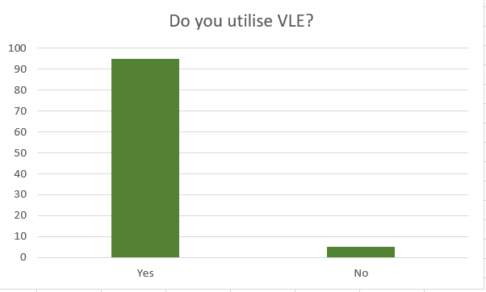
The first question was about whether the students had utilised the VLE in the pandemic. The responses show that among 100 students, 95 students have responded positively by saying that they utilise the VLE. Only 5 students have responded negatively.
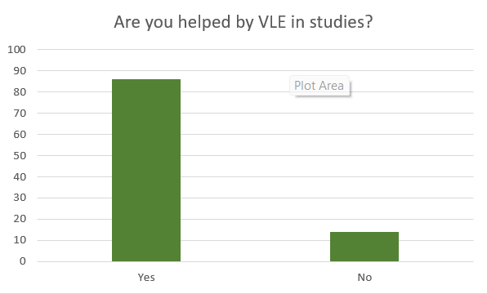
The second question that was asked to the students was, whether the VLE helped them in their studies or not. As expected, 86 students have replied yes and the other 14 students replied the VLE did not help in their studies. It implies that the majority of students felt the VLE is helping with their studies which is an objective of the platform.
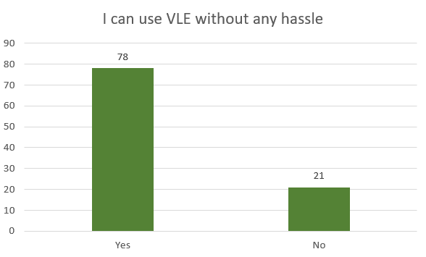
This question has been asked to know if the students faced any hassle while using the VLE for their academic activities. The responses show that 78 students have not faced any hassle while using the platform. On the other hand, 21 students have faced some sorts of issues while using the VLE. Only one student has decided not to respond to this question. It implies that most of the students could easily use the VLE and it is user friendly.
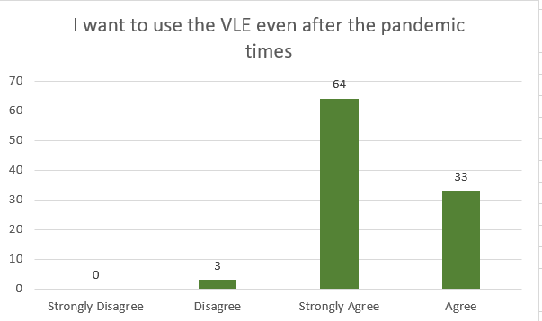
In this question, 64 students have responded that they strongly agree with the statement that they will use the VLE even after the pandemic. 33 students agree with the statement. On the other hand, 3 students have responded that they disagree with the statement and no student has strongly disagreed with it.

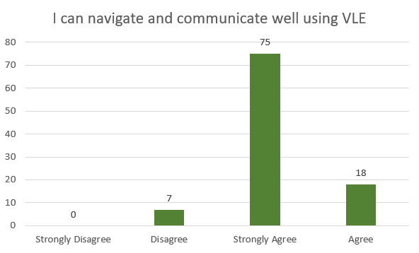
In this part of the questionnaire, a statement saying that the students can navigate and communicate well using the VLE has been provided and the students’ responses have been recorded. Here, 75 students shared that they strongly agree with the statement mentioned in the questionnaire. 18 students have shared that they agree with the statement whereas, only 7 students have disagreed with the statement and no students strongly disagreed with the statement.
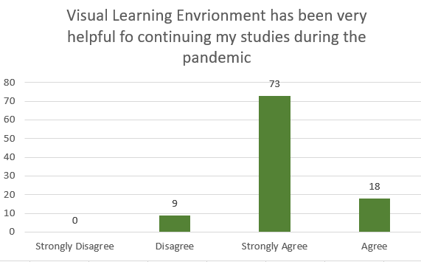
This statement indicates whether the VLE helped continue the studies of the students during the pandemic. 73 students strongly agreed with this statement, 18 students agreed, 9 students disagreed with the statement and no student strongly disagreed with the statement.

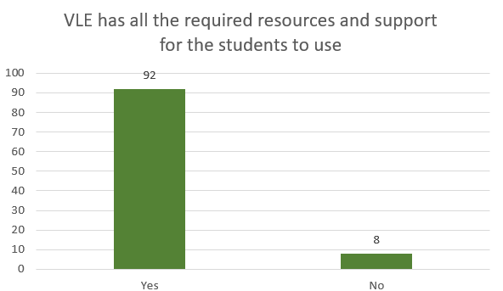Students were asked if the VLE platform had all the resources they need and whether the students got the support from it. The responses were very positive in this case. 92 students have responded positively and only 8 students have responded negatively.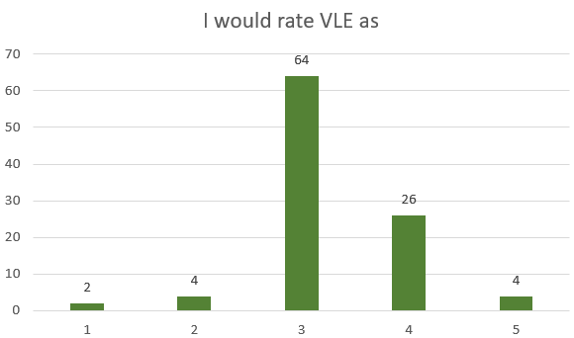
The 8th question is about what ratings the students give after using the VLE. Most of the students rated it a 3, followed by a 4 rating. 64 students have rated the VLE 3, and 26 students have rated it 26. and 5 ratings have been given by only 4 students. 2 and 1 rating has been given by 4 and 2 students respectively.
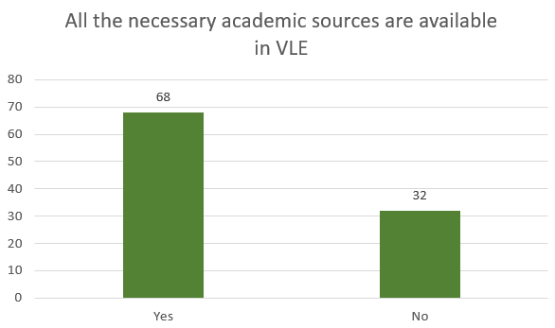
The 9th question was about whether the students agreed with the students that the VLE had all necessary academic sources for them. 68 students have responded positively and 32 students have felt there is a scarcity of enough resources required for them.
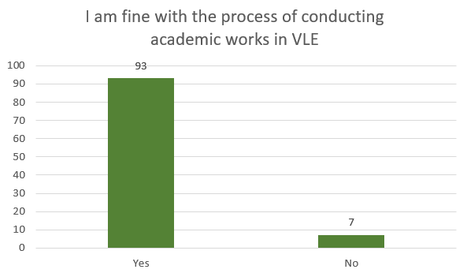
Finally, a statement was shared with the students which intend to find whether the students are fine with the process of conducting the academic work in VLE. Here, 93 students have responded positively and 7 students out of 100 have responded negatively.

Secondary Data Analysis
The secondary data is the data that has already been collected from the primary sources and recorded in a material such as a book, research paper etc (Horner et al., 2015). For this study, secondary data was also collected from relevant sources such as books on virtual learning, research paper, articles, videos etc. During the pandemic, different tools or platforms used for virtual learning saw high growth. It implies that the finding that was found earlier in this study that the usage of such platforms increased is justified. The scenario is similar not only in the institutions of the UK but also all over the world as the whole world faced lockdown due to the pandemic (Lacasa, 2013).
Virtual learning has helped many countries to continue their education system during the pandemic. However, many countries could not properly utilise the benefits due to the lack of infrastructural development (Iniguez and Lorange, 2021). It implies that different factors have a sheer impact on these learning methods. The environment of the home is not always perfect for attending the classes. The lack of physical group discussion has hampered the effectiveness. The students used less paper and the energy consumption rate has decreased (Peters and Besley, 2020). However, most of the students preferred the virtual learning environment to be mixed with the traditional learning method even after the pandemic.

Impacts of Virtual Learning Environment
The adaption of the virtual learning environment was very quick as the technologies were already available and the institutions wanted to get rid of the disruption as quickly as possible (Scott, 2017). The students and teachers struggled initially, but eventually, they became familiar with the virtual learning environment. The impact of this system made changes that are going to last even after the pandemic. Whereas these technologies were not used before, now these are being integrated with the traditional system. Teachers are taking more classes using VLE. The students and teachers became more flexible with academic activities and the overall efficiency increased.
Although the virtual learning environment will not substitute the traditional physical learning environment at any time sooner, the VLE will always be preferred where the traditional learning will not be possible (World Bank, 2020). Many institutions are allowing some of the courses to be taken virtually allowing students from distance to attend. The chance of missing any lecture for any problems is reduced now.

Conclusion
The pandemic has changed the lives of people in different ways. The changes it brought to virtual learning will not perish any time sooner. The impact is long term and impacted by many factors that are required to be addressed to improve the virtual learning environment for the individuals. The analysis of the primary and secondary data shows that the responses from the students were positive regarding the virtual learning environment. This paper also showed that students and teachers were able to capitalise on the benefits of the platforms in a very short time. Finally, this whole system of virtual learning will be practised more than before and the integration of this system with physical learning will open more opportunities in the coming years.

References
Ariyo, O. and Reams-Johnson, A. (eds.) (2022) Education Reform in the aftermath of the COVID-19 pandemic. Hershey, PA: Business Science Reference.
Bedrik, A. et al. (2021) Universities and the pandemic: educational practices, assessments and expectations of students. Southern Federal University.
Childs, M. and Withnail, G. (2019) Experiential learning in virtual worlds. Edited by M. Childs and G. Withnail. Brill. doi: 10.1163/9789004372153.
Cuthell, J. P. (2017) Virtual Learning. London, England: Routledge.
Fisher, M. E. et al. (2021) Lessons from the transition to pandemic education in the US: Analyses of parent, student, and educator experiences. New York: Routledge.
Horner, W. et al. (eds.) (2015) The education systems of Europe. 2nd ed. Cham, Switzerland: Springer International Publishing.
Information Resources Management Association (ed.) (2012) Virtual learning environments: Concepts, methodologies, tools and applications. Hershey, PA: Idea Group.
Iniguez, S. and Lorange, P. (eds.) (2021) Executive education after the pandemic: A vision for the future. 1st ed. Cham, Switzerland: Springer Nature.
Lacasa, P. (2013) Learning in real and virtual worlds: Commercial video games as educational tools. 2013th ed. Basingstoke, England: Palgrave Macmillan.
Peters, M. A. and Besley, T. (2020) Pandemic education and viral politics. London, England: Routledge.
Scott, D. (2017) Education systems and learners: Knowledge and knowing. 1st ed. Basingstoke, England: Palgrave Macmillan UK.
World Bank (2020) Remote learning, distance education and online learning during the COVID19 pandemic. World Bank, Washington, DC.

Appendices
Research Questionnaire


