

SHABANA KAUSER
2332882
MODULE CODE : BMHP5015
COMPONENT 1: PORTFOLIO
LECTURER: PARESE AHMED

Task 1 – Personal Brand
Personal branding is important because it can influence how other people see your skills, qualities, and experience. A strong personal brand can help you stand out from other applicants and show employers what you can offer (Indeed, 2025).
My personal brand is based on being reliable, hardworking, compassionate, organised, good communication skills, and respectful towards others. I believe these qualities are important for my future career in nursing because nurses need to communicate effectively, work as part of a team, and provide compassionate care. The NHS values include compassion, respect and dignity, working together for patients, and ensuring everyone counts (NHS England, 2024).
Although I do not have a lot of work experience in health and social care yet, I am developing my knowledge and skills through my studies. I am a reliable, hardworking, and organised person, and I am willing to learn from new experiences. I understand that building a personal brand is not only about previous experiences but also about showing employers your strengths, attitude and potential. I belive my positive attitude, commitment and willingness to learn are important strengths that i can bring to my future career.
To develop my brand further, i would gain more experience in health and social care, for example through care work or volunteering. This would allow to develop my confidence when supporting people and improve my understanding of person centred care. I would also continue developing my communication, teamwork and leadership skills through my studies and future work experience.
I want my personal brand to show that i am dependable, caring and committed to learning. By developing these qualities and gaining relevant experience, i can strengthen my CV and prepare myself for applying for a nursing degree and eventually working as a nurse.

Task 2 - Network Map and Rationale

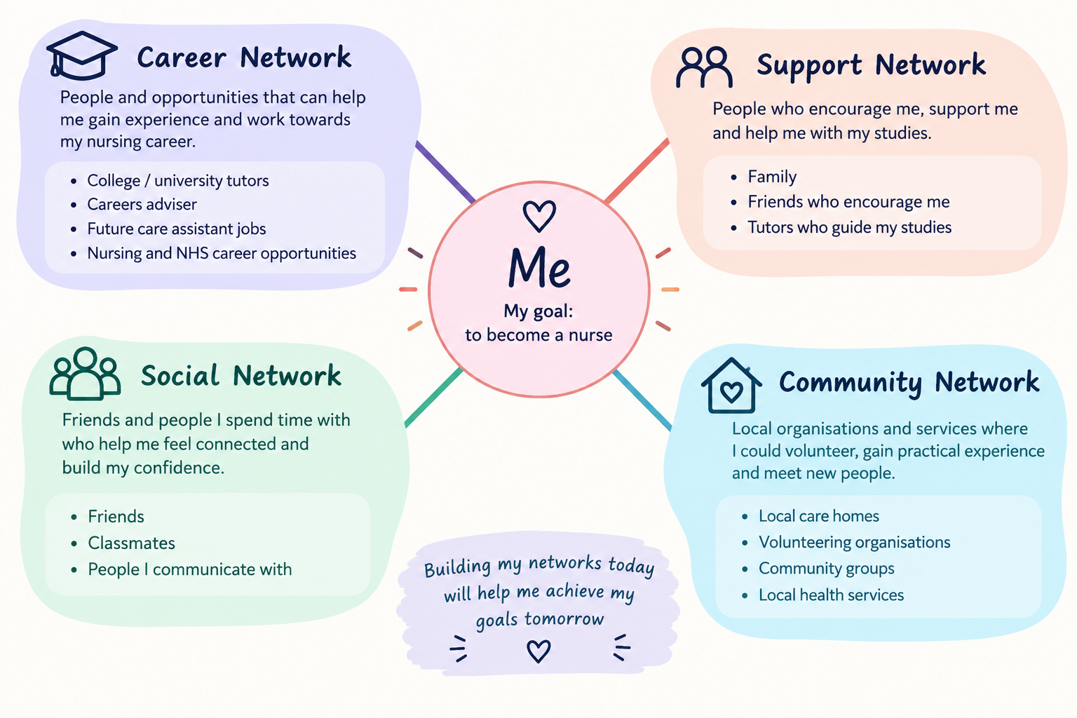
My personal network includes people and organisations that can support me with my education, career development, and personal life. My career network includes my tutors, careers advisors and potential employers. As i do not currently have much experience in health and social care, these contacts can help me find suitable volunteering or care work opportunities and develop my understanding of the sector. Networking can help people find work opportunities, gain advice and find work experience (National Career Service, 2026).
My support network includes my family, friends, and tutors. They can provide encouragement and advice when i face challenges with my studies or future career plans. My social network friends and people from my course, which gives me opportunities to communicate with others, share experiences and build my confidence.
My community network could include local community organisations, volunteering opportunities, care homes, and health services. Getting involved in volunteering could help me develop new skills and gain experience that supports my career goals. The National Career Service explains that volunteering can help people learn new skills and support their career development (NHS, nd).
Overall, my network has useful strengths because I have people who can provide emotional, educational, and career support. However, I currently have limited professional contact within health and social care. I could improve my network by volunteering, gaining care experience, attending careers events and developing professional relationship's. This could increase my confidence and help me work towards my future goal of becoming a nurse.

Task 3- Blog
PARKINSON'S IN YOUNG ADULTS

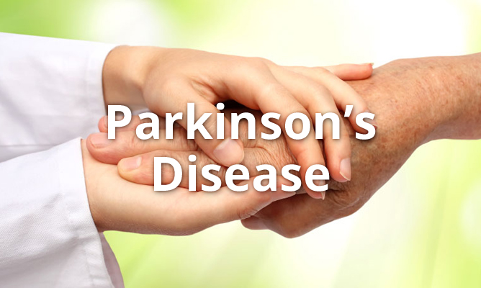

PARKINSONS DISEASE IN YOUNG ADULTS: IT CAN AFFECT ANYONE
A health and social care blog for young adults, families, and carers

More than an older person's condition
When people hear about Parkinsons disease, they may think it only affects older people. However, Parkinsons can affect younger adults too, sometimes when they are building careers, raising children, or planning their future. This is an important issue because younger people may face challenges that are different from those experienced by older adults.
According to Parkinsons UK (2025), around166,000 people in the UK have a Parkinsons diagnosis, and one in 16 people diagnosed were under the age of 50. These statistics show why greater awareness and support are needed (Parkinsons UK).

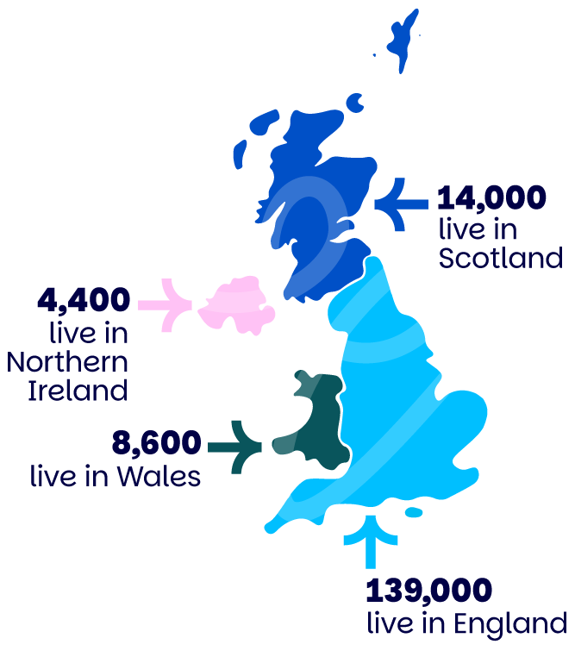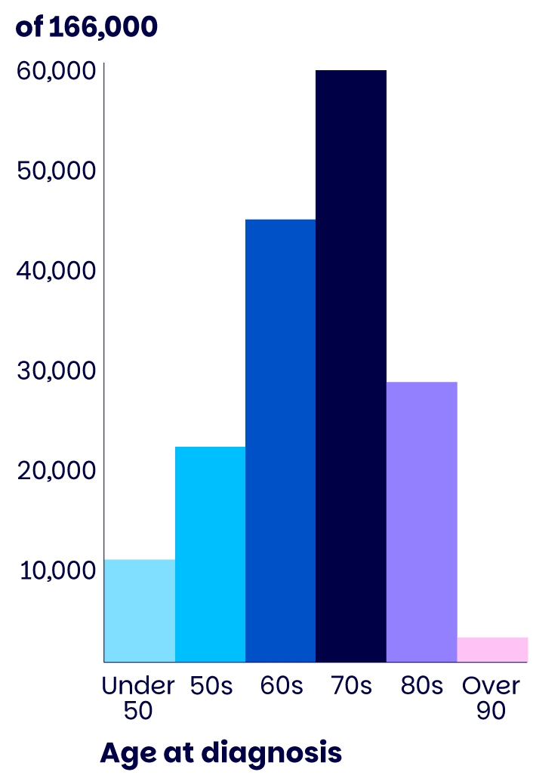

What is Parkinson's disease?
Parkinsons disease is a progressive neurological condition that affects the brain. It develops when nerve cells that produce dopamine are lost. Dopamine helps control movement, so people may experience shaking, stiffness, slowness of movement and balance problems. Some people also experience sleep difficulties, anxiety, depression, and tiredness (NHS,2022).
The challenges of being diagnosed young
Research and information from Parkinsons UK show that a diagnosis at a younger age can affect different areas of life, including work, relationships and family responsibilities. Young adults may worry about keeping their job, managing money, raising children and how their condition could affect their future. They may also feel isolated if friends or colleagues do not understand what they are experiencing.
This issue is personally important to me because my brother was diagnosed with Parkinson's at the age of 35. His diagnosis has helped me understand why awareness, understanding, and support for younger people matter.
What support is available?
Although there is currently no cure, treatment and support can help people manage symptoms and maintain their quality of life. The NHS explains that support may include medication, physiotherapy, occupational therapy, and an individual care plan.
Families, employers, and health and social care professionals can also make a difference by listening, providing emotional support and helping people remain as independent as possible. Parkinson's UK offers information, a helpline and support groups, including groups for younger people.
Let's raise awareness
Young adults living with Parkinson's should not feel alone or believe their future opportunities have disappeared. Better awareness can reduce stigma and encourage people to seek help. By understanding the challenges and providing appropriate support, we can help younger people living with Parkinson's feel valued, included and supported.

Task 4- NHS Equality, Diversity and Inclusion Quiz
- What is the primary goal of the NHS Equality, Diversity, and Inclusion Improvement Plan?
The main goal is to improve equality, diversity and inclusion across the NHS workforce, so that staff feel valued, respected and that they belong, while reducing discrimination and unfair treatment (NHS England,2023).

- How does the NHS EDI Improvement Plan propose to tackle the gender pay gap?
It proposes analysing pay gap data, implementing the Mend the Gap recommendations, and promoting flexible working. NHS organisations should monitor progress and work towards reducing gender, race and disibility pay gaps.

- What is meant by the term ‘intersectionality’ as used in the NHS EDI Improvement Plan?
Intersectionality means recognising that people can have several identities or characteristics, such as race, sex and disability, which can combine to create different or greater experiences of inequality or disadvantage.

- Why is it important for the NHS to create a psychologically safe work environment?
It helps staff able to speak up, ask questions, raise concerns and admit mistakes without fear. This supports staff wellbeing, teamwork and safer patient care.

- How does the NHS EDI Improvement Plan suggest improving the experience of internationally recruited staff?
It recommends comprehensive onboarding, culturally aware teams, psychological safety and ensuring internationally recruited staff have equal access to training, development and career progression.

- What role does leadership play in advancing EDI objectives according to the NHS Improvement Plan?
Leaders are expected to set the culture and lead by example. Chief executives, chairs and board members must have specific EDI objectives and be accountable for improving inclusion.

- Identify one way the NHS EDI Improvement Plan aims to reduce health inequalities within the workforce.
One way is to reduce bullying and harassment and increase civility, helping improve staff health, wellbeing and inclusion, particularly for groups experiencing greater disadvantages.

- Why does the NHS EDI Improvement Plan emphasise the importance of collecting and analysing data on protected characteristics?

Reliable data helps the NHS identify inequalities, understand where problems exist, and monitor whether EDI actions are improving staff experiences and outcomes.

- Explain how flexible working policies can contribute to equality and inclusion in the NHS workforce.

Flexible working can support work life balance, caring responsibilities, health, and wellbeing, and continued professional development, therefore making NHS employment more accessible to different groups of staff.

- What is one strategy mentioned in the NHS EDI Improvement Plan to combat bullying and harassment in the workplace?
The plan recommends reviewing data on bullying and harassment by protected characteristics, setting reduction targets, and providing psychological support for staff who experience bullying, harassment or discrimination.

Task 5- A Letter to Yourself

Dear younger me,
I want you to know that you are stronger than you realise. In 2019, when your 19-year-old son suffered a traumatic brain injury, your world felt as though it had stopped. It was a frightening and emotional time, and hearing the worst possible news about your son was something no parent is prepared for. You were worried, scared, and uncertain about what the future would hold. You had to face emotions that were difficult to understand while trying to stay strong for your other children.
Looking back, I realise how important emotional intelligence would have been during that time. Emotional intelligence means recognising and understanding your own feelings and being able to manage them. Although you could not control what was happening, understanding your emotions could have helped you to cope with fear and uncertainty. It would also have helped you recognise when you needed support instead of feeling that you had to be strong all the time. Talking to family, friends, or healthcare professionals could have helped you feel less alone.

Resilience was equally important. Resilience means being able to cope with difficult experiences and gradually finding ways to move forward. During those frightening days, you had to keep going even when you felt overwhelmed. You did not know what the outcome would be, but you continued to face each day. Thankfully, your son pulled through and recovered well. This experience showed you how unpredictable life can be and how important it is to appreciate the people you love.
I want you to remember that being resilient does not mean hiding your feelings or never crying. It means allowing yourself to feel emotions, accepting help, and finding the strength to continue. Developing emotional intelligence and resilience could have helped you manage stress, communicate your feelings, and look after your own wellbeing during this difficult period.

Be kind to yourself. You did the best you could do in a situation that was frightening and beyond your control. Never be afraid to ask for help or admit you are struggling. You are stronger than you think, and this experience has helped shape the person you are today.

With love, your older self

Task 6- GANTT Chart

Tasks  My progression to becoming a nurse | Sep  2024 | Sep  2025 | Jan  2026 | Jan  2027 | Jan  2028 | Sep  2029 | Sep  2030 | Sep  2031
Task 1:
BSc Health and Social Care (Level 4)
Task 2:
BSc Health and Social Care (Level 5&6)
Task 3:
Master's in nursing (2 Years)
Task 4:
Work experience
Task 5:
Cover letter & CV
Task 6:
Applying for jobs

Task 7- Making Changes- Report

Report: Introducing Regular Person-Centred Care Plans Reviews

Introduction
As a care home manager, I would introduce monthly reviews of residents care plans and update them whenever their needs or preferences change. This would help ensure care respects residents dignity, choices, and independence. Research by Hodge et al. (2024) highlights the importance of understanding older people experiences of personalised care in care homes, including considering their individual needs and preferences. Therefore, regular care plans reviews would help staff provide care that is suitable for each resident.
I will be using Lewin's Change Model to introduce care plan reviews in a planned way. Lewin's model has three stages: unfreeze, change and unfreeze. Hussain et al. (2018) explains how the model can help organisations manage change and highlight the importance of leadership and staff involvement. I would use this model to introduce regular care plan reviews by explaining the reason for change, supporting staff during implementation and making reviews part of everyday practice.

Unfreeze
First, I would explain to staff why regular reviews are important and how they can improve residents care. I would hold a team meeting, listen to concerns and explain the benefits. Some staff may worry about extra work or limited time, so I would reassure them that support would be provided. NICE (2018) highlights the importance of considering peoples individual needs and preferences when planning care and support.

Change
I would introduce monthly care plan reviews involving residents and, with their permission, their families. Staff would discuss changes in residents health, personal care, nutrition, emotional wellbeing, and prefernces. Any agreed changes would be recorded and shared with relevant staff to ensure consistant care. I would provide staff with guidance and support to help them complete reviews correctly. Good communication, leadership and organisational skills would help me intoduce the change sucessfully.

Refreeze
I would make monthly care plan reviews a regular part of the care home routine. I would check records to ensure reviews are completed on time and care plans are kept up to date. Staff would recieve regular feedback and support to mantain good practice. This would help make the change permanent and ensure residents continue to recieve person-centred-care.

Barriers and solutions
Possible barriers include staff shortages, limited time and resistance to change. I would plan reviews in advance, share responsibilities fairly and explain why this change matters. I would also provide guidance and encourage staff to raise difficulties.

Conclusion
Overall, Lewin's model would help me introduce care plan reviews in a structured way. This change could improve communication, respect residents choices and help ensure care continues to meet their individual needs.

Reference List

Hodge, G., Lang, I., Byng, R. and Pearce, S. (2023). Older peoples” lived experiences of personalised care in care homes: A meta‐ethnography. International Journal of Older People Nursing, 19(1). doi:10.1111/opn.12585. [online] https://onlinelibrary.wiley.com/doi/10.1111/opn.12585 [Accessed 21/10/2026]

Hussain, S.T., Lei, S., Akram, T., Haider, M.J., Hussain, S.H. and Ali, M. (2018). Kurt Lewin’s change model: A critical review of the role of leadership and employee involvement in organizational change. Journal of Innovation & Knowledge, 3(3), pp.123–127.[online]
https://www.sciencedirect.com/science/article/pii/S2444569X16300087 [Accessed 23/10/2026].

Indeed Career Guide (2025) Personal brand building : Definition, importance and examples. [online] Available at: https://uk.indeed.com/career-advice/career-development/personal-brand-building [Accessed 20/09/2026].

National Careers.Service.gov.uk. (n.d.). Networking | careers advice | national careers service. [online] Available at: https://nationalcareers.service.gov.uk/careers-advice/networking [Accessed 15/10/2026].

NICE (2018). Recommendations | people’s experience in adult social care services: Improving the experience of care and support for people using adult social care services | guidance | NICE. [online] Nice.org.uk. Available at: https://www.nice.org.uk/guidance/ng86/chapter/Recommendations#care-and-support-needs-assessment-and-care-planning [Accessed 25/10/2026].

NHS (2024). Values of the NHS constitution. [online] Health Careers. Available at: https://www.healthcareers.nhs.uk/working-health/working-nhs/nhs-constitution [Accessed 20/09/2026].

NHS England (2023). NHS equality, diversity, and inclusion improvement plan. [online] NHS England. Available at: https://www.england.nhs.uk/long-read/nhs-equality-diversity-and-inclusion-improvement-plan/#foreword [Accessed 07/10/2026].

NHS (nd). NHS England volunteering. [online] Available at: https://www.england.nhs.uk/get-involved/get-involved/volunteering/ [Accessed 15/10/2026].

NHS (2022) Overview Parkinsons disease [online] Available at: https://www.nhs.uk/conditions/parkinsons-disease/ [Accessed 15/10/2026].

Parkinson's UK (2025) Parkinsons statistics our latest data on the number of people living with Parkinson's in the UK. [online] Available at: https://www.parkinsons.org.uk/information/about-parkinsons/statistics [Accessed 18/10/2026].

