
YAA ADUTWUMWAA
(2017652)

HE CERT HEALTH AND SOCIAL CARE LEVEL 4 (C5) GROUP 3
UWTSD BIRMINGHAM

PROFESSIONAL CAREER DEVELOPMENT
(BMSW4005_BIRM)

LECTURER: FARAH ISLAM

CV

Mobile: 02111100000
Email: 2017652
Coventry

Profile
A hardworking, reliable, and adaptable individual who maintains a professional manner in the workplace. Able to work under pressure in an orderly and responsible way. Works well as part of a team or alone unsupervised using own initiative. Very driven, highly motivated, enthusiastic, organised, and able to communicate effectively both verbally and written.
Key Skills and Achievements

- Keyboard skills and using Information Technology (Word, Excel, and PowerPoint)
- Relating to people from a wide range of backgrounds
- Following written and verbal instructions
- Good level of physical fitness
- Good at motivating and organising to get the job completed
- Good time management skills

Employment History

2020 - 2021 YOUNG FOUNDATIONS
Residential Support Worker
Duties: assisting and supporting young people with autism and mental health disorders to live and manage their day to day lives.

2015-2020 - KINGSWAY SUPERB SHINE
Cleaning Supervisor

2013 – 2020 THE CARE BUREAU
-Care Assistant
Duties:
- Assisting elderly people to manage their lives day to day
- Maintaining good levels of hygiene
- Ensuring that the residents maintained a healthy diet
- Reporting any injuries, bruises, or skin tears to nursing staff
- Taking care of general well- being and planning activities
- Moving and handling residents
- Following Health and Safety procedures

2008-2012 – House of Empowerment (Voluntary) –General Assistant
Duties:
- Typing and record keeping
- Organising paperwork
- Organising and coordinating activities for children
- Writing minutes and agendas for meetings

Education and Training
Jan 2021 Level 4 in Health and Social Care
Jan 2021 - Level 2 in IT (IT user skills)
Nov 2020 - Level 2 in Customer Service
May 2020 - Level 2 of Functional Skills Mathematics, achieving higher distinction
April 2020- Level 2 of Functional skills English, achieving higher distinction
August 2019 Level 3 in Admin and Secretarial skills achieving higher distinction.
November 2016 Level 3 in Health and Social Care (health and safety, safeguarding children, mental health awareness, safeguarding adults, fluids and nutrition, dementia and cognitive issues, infection prevention and control, learning disabilities awareness, duty of care, information handling, privacy and dignity, communication, basic life support, equality, and diversity, working in person centred way etc.
YWCA Secretarial School (Accra-Ghana)- Typewriting, audio typing, computer literacy and Information Technology – 1996-1998

Certificates available for confirmation

Interests & Hobbies

I enjoy socialising with family and friends, reading, listening to music, watching tv

References available upon request

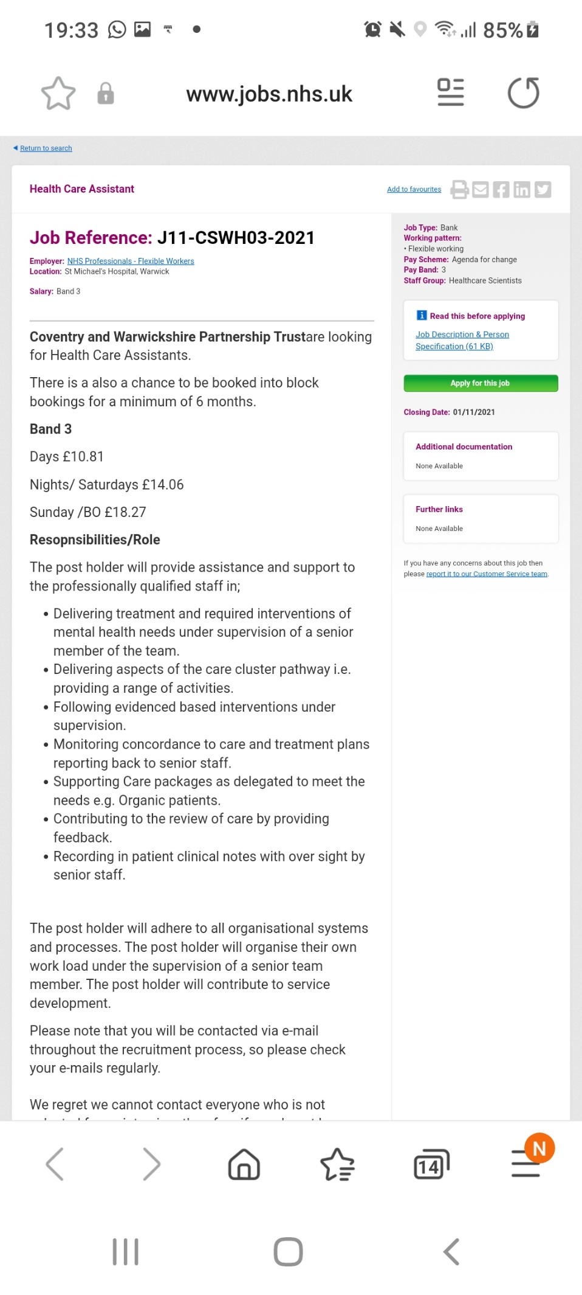

APPLICATION LETTER

October 20, 2021
Coventry and Warwickshire Partnership Trust
Wayside House, Wilsons Lane
CV66NY
Coventry
UK

Job reference: J11-CSWH03-2021

Dear Sir/ Madam,

I am writing to apply for the Health Care Assistant position advertised in your website. A long-time Health Care Assistant with over ten years’ experience, I would love to help Coventry and Warwickshire Partner Trust to achieve its mission of rendering the best service to its service users.

A brief review of my CV will highlight the strong match between my qualifications as well as experience and your position. I believe strongly that my qualifications and past job experiences has prepared me for the challenges this position offers.

I am available for interview at your earliest convenience.

Thank you for your consideration.

Yours sincerely,

…………………………….

Yaa Adutwumwaa

COVER LETTER

Yaa Adutwumwaa
01222220000
yaagoo@gmail.com

20 October 2021

Dear Vect Frant,

I am excited to be applying for the position of Health Care Assistant in Coventry and Warwickshire Partnership Trust.

I have been a health care assistant since 2012 and have experience in assisting both the elderly with dementia and young people with autism and learning difficulties.
- Assisting them to manage their daily living
- Maintaining good levels of hygiene
- Ensuring that the residents maintained a healthy diet
- Reporting any injuries, bruises, or skin tears to nursing staff
- Taking care of general well- being and planning activities
- Moving and handling residents
- Supporting and encouraging them to follow Health and Safety procedures
- Organising keywork sessions to help service users to address their concerns.

With my experience and qualification in Health and Social Care Level 4 in digital and employability skills, professional development and psychology, level 3 in administration and secretarial, I am confidence I will be valuable to your great team.

Thank you for your time. I look forward to hearing from you soon.

Yaa Adutwumwaa

REFERENCES

S. Cameron (2013)
The Business student handbook: skills for study and employment
Financial Times
Harlow, England

S. Cottrell (2015)
Skill for success: personal development and employment 3rd edit
Basingstoke, England
Palgrave Macmillan

- Duckworth (2016)
Grit: The Power of Passion and Perseverance
New York, USA
Simon and Schuster

Q Kelly (2019) Business and Professional Communication: keys for workplace excellence
Total pages
4th Edition, Vol 1
SAGE Publication
Los Angeles

D. Wethey, (2013) Decided: better way of making decisions
London: Kogan page.

