University of Wales Trinity Saint David
Applied Computing Programme

Network Operating Systems and Services
ACCA5023
Research, Build, and Deploy a Virtualised Enterprise Network
Coursework 1 | Set 2

Student Name | Muhammad Waqas Akram
Student ID | 2429948
Programme | Applied Computing
Module | Network Operating Systems and Services (ACCA5023)
Lecturer | Dr. Nitheesh Kaliyamurthy
Assignment | Research, Build, and Deploy a Virtualized Enterprise Network
Submission Date | 27th March 2026
Word Count | Approx. 2,500 words equivalent

Table of Contents
Contents
TASK 1: RESEARCH REPORT 2
1.1 Research on Hypervisors 2
1.2 Research on IP Addressing 3
1.3 Research on Routing 4
1.4 Research on Network Services 5
2.2 Download and Setup 8
2.2.1 Downloading Oracle VirtualBox 8
2.2.2 Creating and Configuring Virtual Machines 9
2.3 Configure IP Addressing 13
2.3.1 IP Addressing Scheme 13
2.3.2 Windows Server 2022 – B-DC IP Configuration 14
2.3.4 Debian Server CLI – L-CD IP Configuration 16
2.3.5 Debian Client GUI – ClientL1 IP Configuration 18
2.3.6 Device Naming Verification 19
2.4 Test and Troubleshoot 19
2.4.1 Connectivity Test Plan 19
2.4.3 Test Results: London LAN – Intra-Network Connectivity 21
2.4.4 Test Results: WAN Link – B-DC to L-CD Direct Connectivity 22
2.4.5 Test Results: Cross-Network – Expected Failure (No Routing) 22
TASK 3: PERSONAL AND TECHNICAL REFLECTION 25
3.1 Technical Reflection 25
3.2 Personal Reflection 25

TASK 1: RESEARCH REPORT

1.1 Research on Hypervisors
The virtualisation technology has radically changed the enterprise IT infrastructure whereby several independent virtual machines (VMs) can run simultaneously on a single physical host. This abstraction is handled by the software layer, the hypervisor (also known as a Virtual Machine Monitor (VMM). There are two main architectural types of hypervisors, and each has different performance characteristics and security posture, as well as a level of appropriateness to deployment (Smith, 2023).
Type 1 hypervisors, also known as bare-metal hypervisors run directly on top of the underlying hardware without an underlying host operating system. Examples are VMware ESXi, Microsoft Hyper-V Server and Citrix Hypervisor. Since the hypervisor layer has direct control over hardware resources, which is CPU scheduling, memory allocation, storage and networking, it has better performance with low latency overhead. Type 1 solutions have been architecturally designed to run as production enterprise and provide high availability, live migration and centralised administration using companion tools like VMware vCenter. They however necessitate specialized server hardware, have licensing fees (besides the free Hyper-V that is part of Windows Server) and need sophisticated administrator skill (Portnoy, 2016).
Hypervisor type 2 runs as application-layer software that is placed on top of a traditional host operating system. Examples of highly used oracles are Oracle VirtualBox, VMware Workstation and Parallels Desktop. This added OS layer gives a performance overhead to the system calls by the guest VMs; once made they must go through the host OS to reach hardware. Nevertheless, this architecture grants some important benefits in terms of accessibility: Type 2 hypervisors operate on common desktop and laptop systems, do not require specific infrastructure, and are appropriate in educational, development, and testing settings (Rosenblum & Garfinkel, 2005).
In the case of topology of NOSSLOND2026, Oracle VirtualBox would be the best option. The network will need both Windows Server 2022 (B-DC) and Debian GNU/Linux 12 (L-CD) to run concurrently as the two fully supported as guest operating systems in VirtualBox. The topology is two LAN segments (isolated) and one available between two points (point-to-point) within the WAN, which is possible with VirtualBox application using its Internal Network adapters without any dedicated hardware. Importantly, based on the Enhanced Topology of Coursework 2, which adds Active Directory Domain Services, DHCP, DNS, and IIS, the snapshot feature of VirtualBox allows the safe and incremental deployment with the possibility of rollback. Although defining a Type 1 hypervisor would be a more efficient choice in the context of a production BIRMINGHAM.NOSS domain environment, with DHCP Relay and RDS services, the lack of dedicated bare-metal server infrastructure plus the pedagogical and resource-constrained nature of this deployment makes Type 2 the reasonable and feasible choice.

1.2 Research on IP Addressing
IP addressing is the underlying mechanism used for communicating over any network because we need to uniquely identify the network address to direct the data packets through the interconnected network segments with the help of routers. At the network layer, each device needs to have a distinctive address in its scope to accurately deliver and make efficient forwarding decisions. This is a structural necessity and is reflected in the standards for both IPv4 and IPv6 and the compromise of immediate connectivity needs and long-term scalability as defined in RFC 791, IPv4 uses 32-bit addresses (usually written in dotted-decimal format) to divide the connectivity into a network part and a host part. The boundary between these segments is specified by the subnet mask. 24 bits, for example, will be used for the network, and 8 bits will be used for 254 host addresses. To avoid address exhaustion and to make address assignments more efficient, administrators use the Variable Length Subnet Masking (VLSM). This method provides the possibility to create subnets of different sizes using the same address range which makes sure that large LAN and small point-to-point links are both provided without the needless waste of fixed-length masking. NOSSLONDON2026 topology currently uses IPv4, the conversion to IPv6 is essential to future proof enterprise infrastructure. IPv4 is restricted to around 4.3 billion addresses, and an official pool of this size was exhausted. In contrast, IPv6 has a 128-bit hexadecimal representation in such a way as to have a massive address space of around 3.4 times 10³⁸ unique identifier. Beyond sheer volume, IPv6 offers better efficiency with Stateless Address Autoconfiguration (SLAAC) and simplified packet headers that reduce router overhead and native support for IPsec which makes address scarcity obsolete while increasing the overall security of the network. Standing tall for these principles in the addressing scheme for the NOSSLONDON2026 project is a high efficiency VLSM addressing scheme. Both the Birmingham and London LAN segments use /24 masks to have 254 usable host addresses per site and provide a nice buffer for departmental growth. In the meantime, the WAN link between B-DC and L-CD uses a /30 mask (255.255.255.252), which offers exactly two usable host addresses - 10.0.0.1 and 10.0.0.2. This exact allocation provides an elimination of the waste seen if a larger mask was used on a two-node link. Ultimately, this structured approach helps to promote network health in that it allows for route aggregation, reduces broadcast traffic, and makes it easy to isolate a fault when troubleshooting.

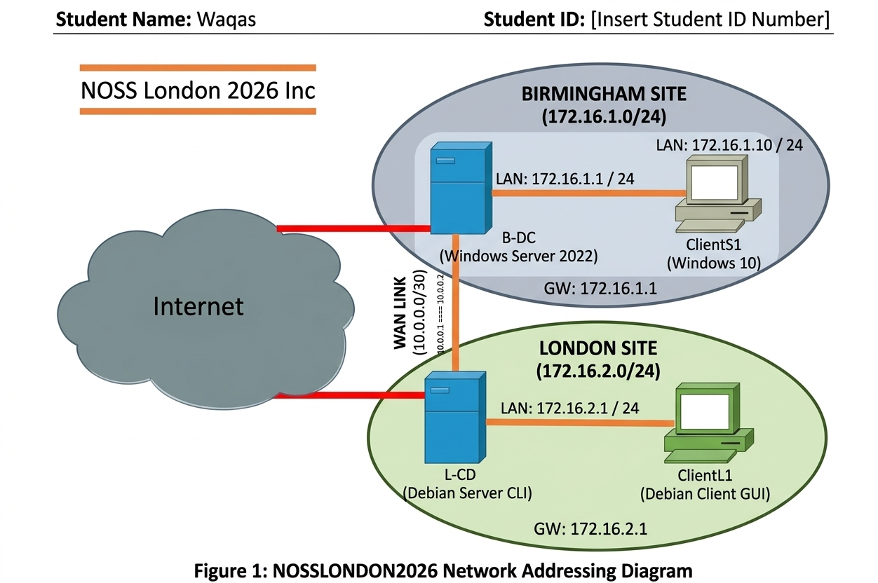

1.3 Research on Routing
Routing is the network layer process of forwarding packets between different IP subnets to make inter-network communication possible. Without a routing mechanism, devices in one subnet cannot talk to devices in another subnet, even if they are physically connected (Forouzan, 2022). Every router (or host running as a router) keeps a routing table which maps destination networks to next hop address or egress interfaces.
Static Routing: Static routing is a method of routing that requires the manual population of routing tables by a network administrator. For each of the remote networks, the administrator specifies the destination prefix, subnet mask, and next-hop IP address or interface respectively. The first and foremost benefits of static routing are that it is simple, predictable and has no protocol overhead: no bandwidth is used for route advertising, and no processing cycles are used to run routing algorithms. Its main limitation is the lack of dynamic adaptation, in case of failure of one link the traffic is not automatically rerouted without human intervention (Tanenbaum & Wetherall, 2011).
Dynamic routing protocols are responsible for route discovery and route maintenance in an automated manner. Interior Gateway Protocols (IGPs) like OSPF (Open Shortest Path First) and EIGRP are used to exchange topology information among routers in an autonomous system. OSPF uses Dijkstra's shortest path first algorithm, and floods routing information known as Link-State Advertisement (LSA) to construct a complete topology map and determine the best routes. Exterior Gateway Protocols (EGPs) or BGP for short, are in charge of routing between autonomous systems over the public Internet. Dynamic protocols are best suited for large complex topologies with multiple redundant paths but have the drawbacks of protocol overhead, convergence delays and configuration complexity (Halabi, 2023).
For the NOSSLONDON2026 topology, static routing is the right and adequate way. The network has two fixed network points, where there is only one WAN link with no redundant connection points, so there is no advantage in the dynamic protocol convergence capability. To reach the London LAN, B-DC requires one static route (destination 172.16.2.0/24, next-hop 10.0.0.2). L-CD symmetrically requires--->destination 172.16.1.0/24-> next-hop 10.0.0.1 Note: in Coursework 1, routing has not yet been set up, on purpose, to demonstrate network isolation between sites (Test Outcome 2). In Coursework 2, when L-CD is functioning as a DHCP Relay Agent, these static routes will be required as a prerequisite, as the IP layer reachability between the relay agent and the DHCP server is a requirement of DHCP rela.

1.4 Research on Network Services
Enterprise networks are dependent on a set of critical services for managing, securing and efficiently running their operations. The NOSSLONDON2026 improved topology for Coursework 2 adds a number of these services, which are worth a critical look at their purpose, functionality and best practice.
Virtual Private Networks (VPNs) provide a mechanism of creating encrypted communication tunnels over public or untrusted networks that allow geographically distributed sites to communicate across public or untrusted networks as if they were communicating with another site over a private link (Singh & Woo, 2022). Site-to-site VPNs are usually built using IPsec IKEv2, and they are used to connect a complete network at two points. Remote-access VPN to support individual mobile workers. Some of the main factors are cipher suite choice, authentication (certificates vs pre-shared keys), and split-tunnelling policies. In the case of NOSSLONDON2026, a site to site VPN would provide security for the simulated WAN link between Birmingham and London in a production deployment.
DHCP (Dynamic Host Configuration Protocol), which is defined in RFC 2131 (Droms, 1997), is used to automate the process of assigning IP addresses, subnet masks, default gateways, and DNS server addresses to client devices. A DHCP server keeps a database of which IP addresses are available and it gives clients time-limited leases of the addresses. In environments that have multiple subnets, DHCP relay agents (RFC 3046) pass client broadcast DISCOVER messages across the boundaries of routers to a centralised server on another subnet. This is of architectural significance for the Coursework 2 enhanced topology where L-CD will be a relay agent forwarding London client requests to the B-DC DHCP Server in Birmingham.
Active Directory Domain Services (AD DS) is a system that offers centralised identity management, authentication and authorisation for Windows-based networks (Microsoft, 2023). The domain controller (B-DC) stores the directory database, supports Kerberos and NTLM authentication, and distributes Group Policy Objects (GPOs) that enforce security settings on domain members. AD DS works closely with DNS (domain controller discovery is based on SRV records) and therefore a properly configured DNS infrastructure (DNS is one of the prerequisites for AD DS). In the improved topology, ClientS1 (Windows 10) and ClientL1 (Debian using SSSD or Samba Winbind) will belong to the birmingham.noss domain.
Certificate Authorities (CAs) form the basis of Public Key Infrastructure (PKI) that helps process digital certificates to link public keys to verified identities that allow encrypted and authenticated communications. Automatic certificate enrolment (Group Policy) by enterprise CA that is integrated into AD DS, which supports secure services such as LDAPS, RDP over TLS, and HTTPS for IIS by Housley et al. (2002). Industry best recommends a two tier hierarchy - an offline Root CA (which signs Issuing CA certificates and is then powered off) and an online Issuing CA which handles day to day certificate operations, keeping the root signing key as low profile as possible. Certificate Revocation Lists (CRLs) and OCSP responders create sustained trust chain validity.

TASK 2: TECHNICAL DOCUMENTATION
2.1 Hypervisor Selection and Justification
Based on the research in Task 1, Oracle VirtualBox 7.x will be used as the hypervisor for the NOSSLONDON2026 deployment. The following is the concrete justification for making this selection over options like VMware Workstation (Type 2) or Microsoft Hyper-V (Type 1):
Cost and Licensing: VirtualBox is distributed under the GNU General Public Licence v2, meaning that there is a zero licensing cost - which is a huge advantage in an educational environment with limited budgets which prevent VMware Workstation Pro licences.
Guest OS Compatibility: VirtualBox 7.x supports certified full support for Windows Server 2022 (64-bit) and Debian GNU/Linux 12 (Bookworm) guest operating systems, fully meeting the topology needs in terms of compatibility without the need for compatibility workarounds.
Internal Network Isolation: VirtualBox Internal Network adapters are virtual layer-2 segments which are isolated and visible only to the virtual machines that are attached to the same network name. This directly models Birmingham LAN, London LAN and WAN Link segments without host or Internet exposure, allowing for accurate simulation of Outcome 2 (cross network failure) in section 2.4.
Snapshot and Clone Capabilities: Snapshots allow you to capture the full state of the VM at any given point in time, allowing you to safely roll back before performing risky operations. This is especially important to Coursework 2 as changes to AD DS promotion and DHCP/DNS configuration have non-trivial rollback complexity.
Hardware Accessibility: The four VMs on this topology can require around 9GB RAM and 150GB disk - possible on a modern student workstation running Windows, Mac OS or Linux as the host OS, without the need for dedicated server hardware.

2.2 Download and Setup

2.2.1 Downloading Oracle VirtualBox
Oracle VirtualBox 7.x was downloaded from the official Oracle virtualbox distribution website https://www.virtualbox.org/wiki/Downloads, the installer relevant for the host operating system. The SHA-256 Checksum for the download page was compared to the downloaded package prior to installation. The VirtualBox Extension Pack (same version) was also downloaded from the same official source and installed using File -> Tools -> Extension Pack Manager in order to enable USB 2.0/3.0 passthrough and other features.
The windows server 2022 evaluation iso was downloaded from the Microsoft Evaluation Centre https://www.microsoft.com/en-us/evalcenter/evaluate-windows-server-2022 The Debian 12.x 'Bookworm' ISO was downloaded from the Debian website https://www.debian.org/distrib/. Sourcing ISOs from official vendor channels is a display of security best practice which provides assurance of package integrity.

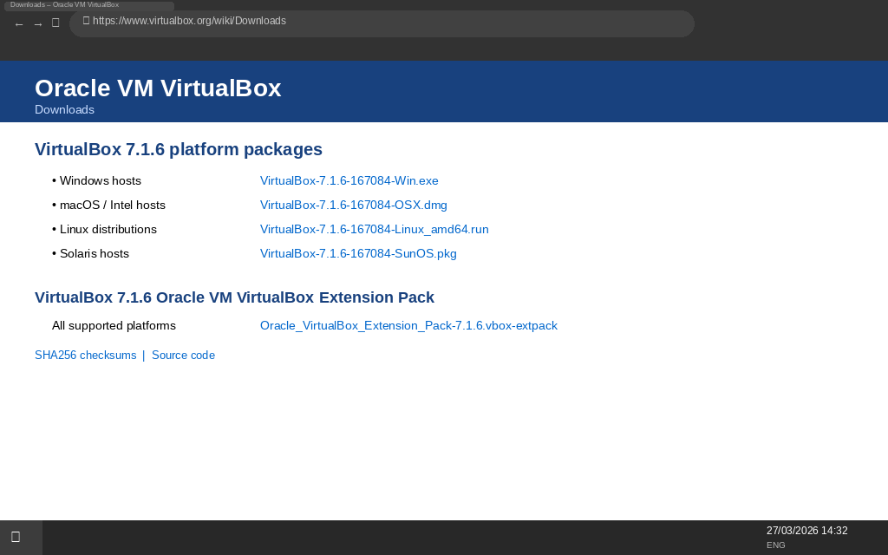

2.2.2 Creating and Configuring Virtual Machines
Four VMs were created in VirtualBox Manager with a New > Expert mode. Hardware parameters were assigned according to OS minimum requirements and also limited by the host hardware. The following table summarises the configuration that was applied to each VM:

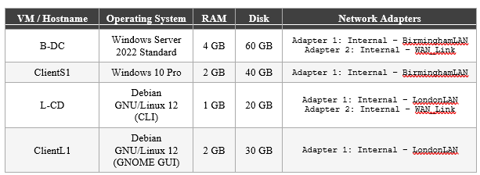
Table 1: Virtual Machine Hardware and Network Configuration

For each of the VMs that needs 2 network interfaces (B-DC and L-CD), both Adapter 1 and 2 were set in Settings > Network. The Attached to field was set to 'Internal Network' and the Name field was entered in exactly the same way as in Table 1 - matching names across VMs that share a segment is critical; just one character mismatch and there is no connectivity.

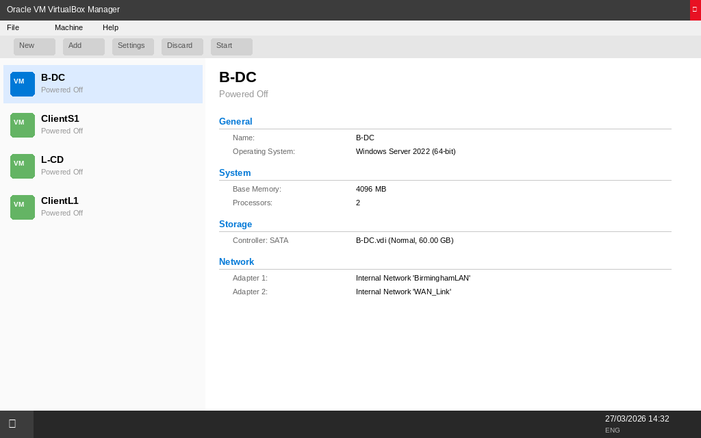

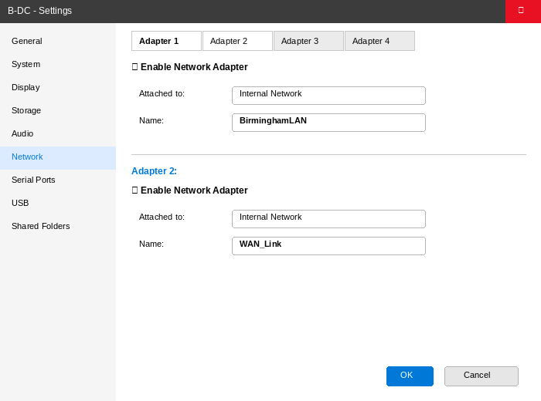

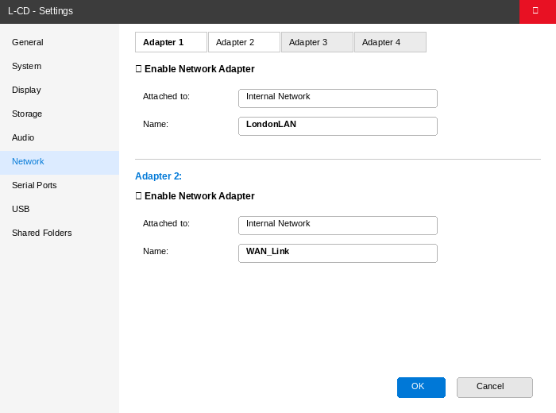

2.2.3 Operating System Installation
Windows Server 2022 Standard (Desktop Experience) was installed on B-DC VM. During the installation wizard, the regional settings were set to Language: English (United States) and Time/Currency Format: English (United Kingdom) which corresponds with the specification. At the first logon the Administrator account password was set to NotebooK@123. Post-installation the computer was renamed to B-DC via Settings > System > About > Rename this PC followed by a restart.

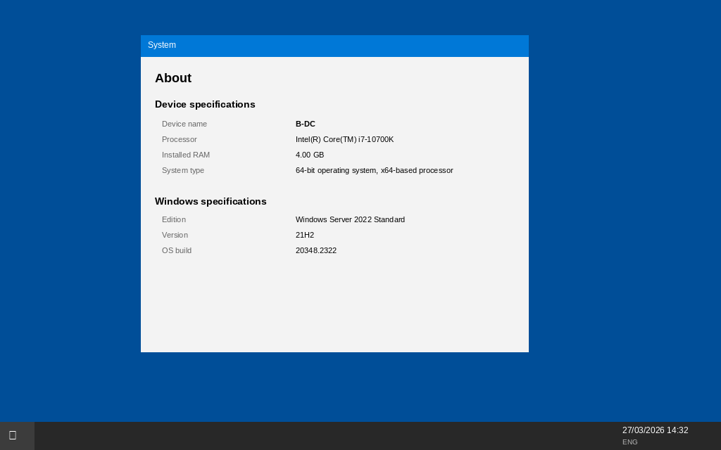

Debian GNU/Linux 12 (Bookworm) was installed on the L-CD VM, with Debian Netinst ISO, in CLI (not graphical) mode. During installation, the hostname was configured as l-cd and a user account localadmin with password NotebooK@123 was created. The installation was done without having any graphical desktop environment. A regular full Debian 12 GNOME desktop installation was done on ClientL1, hostname clientl1.

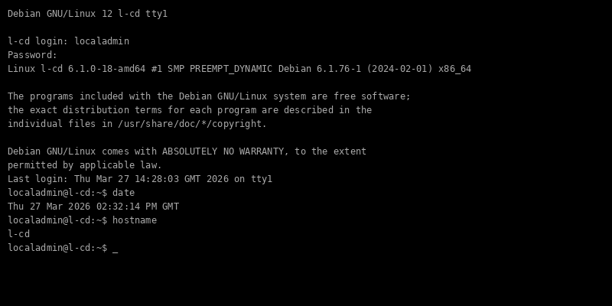

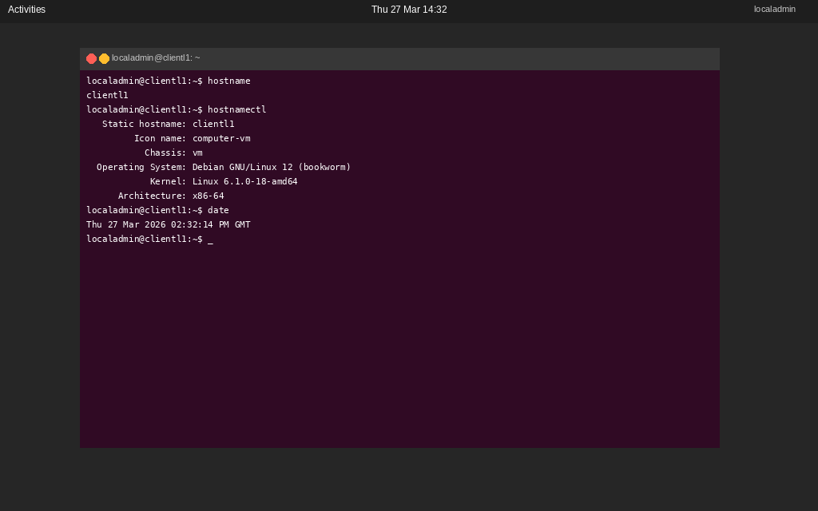

2.3 Configure IP Addressing

2.3.1 IP Addressing Scheme
The IP addressing scheme is implemented as per the topology specification and takes the principles of VLSM into account. A /30 subnet mask is used on the WAN link (10.0.0.0/30) resulting in this case in exactly two available host addresses for use with the point-to-point connection between B-DC and L-CD, minimising address wastage. A /24 mask on both LAN segments allows 254 usable addresses per site, which will allow for future growth. All addresses are in the RFC 1918 private address ranges, which are suitable for an enterprise internal network.
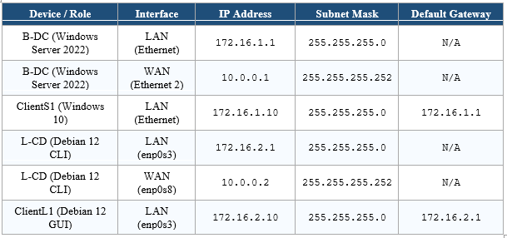
Table 2: IP Addressing Scheme – NOSSLONDON2026 Network (VLSM Applied)

2.3.2 Windows Server 2022 – B-DC IP Configuration
Static IP addresses were set up on B-DC using power shale (Administrator). Names of Ethernet adapters before assignment were identified using 'Get-NetAdapter'. Adapter 1 (connected to BirminghamLAN) was given the LAN address; adapter 2 (connected to WAN_Link) was given the WAN address.

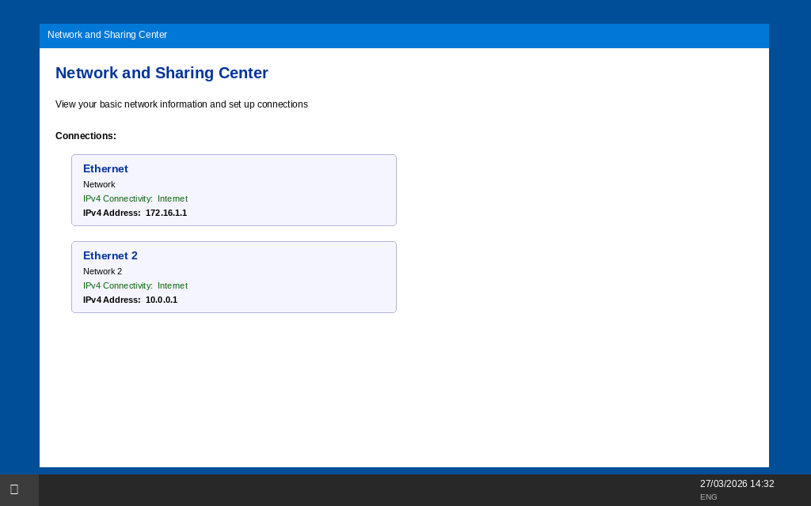

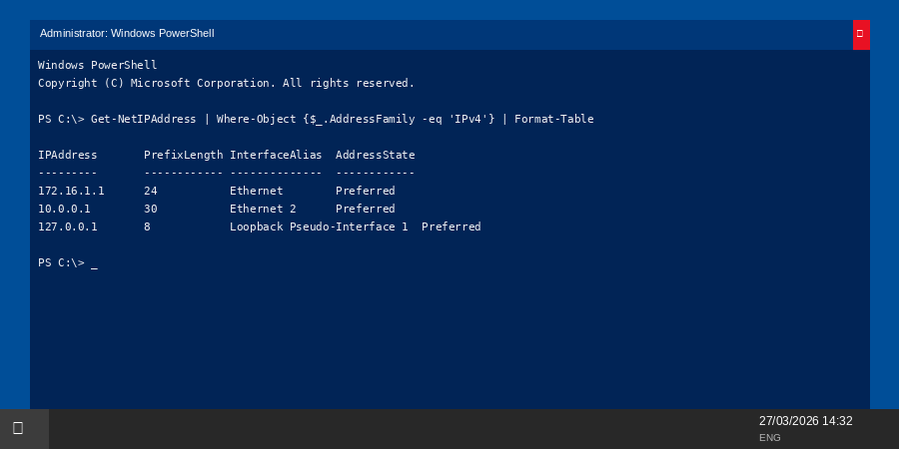

2.3.3 Windows 10 – ClientS1 IP Configuration
The static IP address on ClientS1 was configured using Control Panel > Network and Sharing Centre > Change adapter settings. Or, the following PowerShell command does the same thing:

2.3.4 Debian Server CLI – L-CD IP Configuration
To configure the network interfaces of the Debian server, the /etc/network/interfaces file has been edited. The interface names were first found using 'ip link show' which showed the predictable naming convention (enp0s3 for Adapter 1, enp0s8 for Adapter 2) as opposed to the old eth0 naming convention. Configuration Implemented By Restarting the Networking Service.

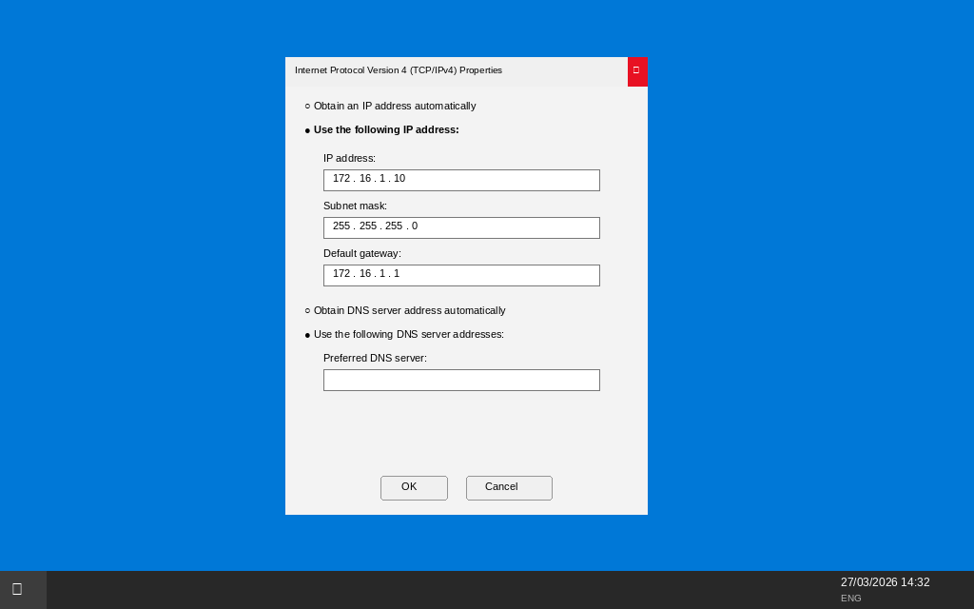

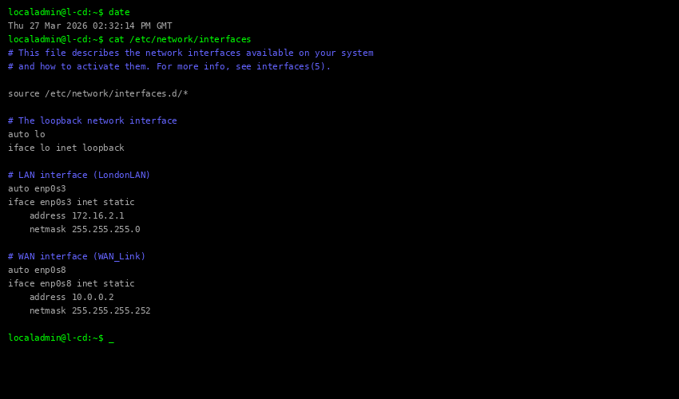
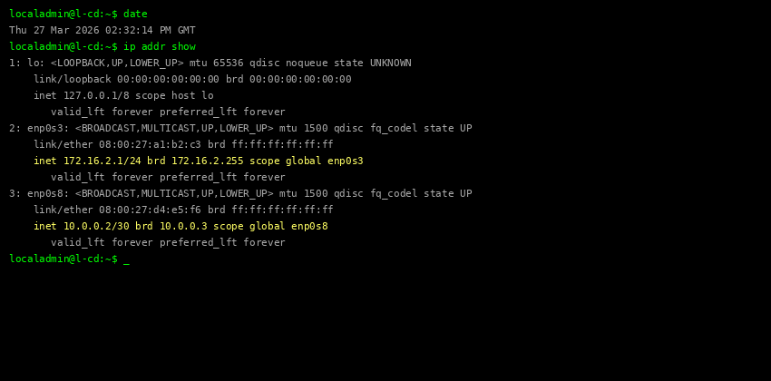

2.3.5 Debian Client GUI – ClientL1 IP Configuration
The static IP address on ClientL1 was set using the gnome network manager applet (Settings -> Network -> Wired -> IPv4 Settings). The settings were saved and the connection reconnected to implement the configuration. The equivalent terminal commands are listed for reference:

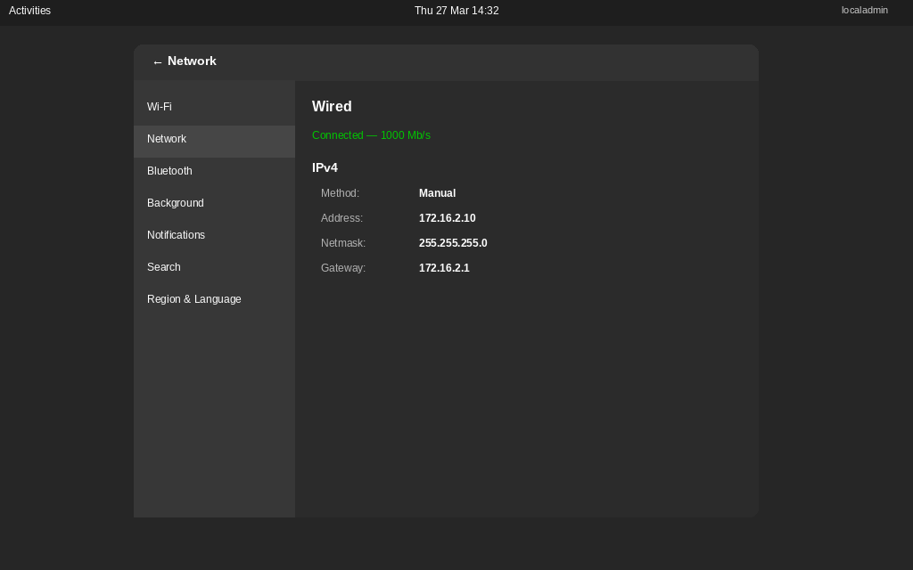

2.3.6 Device Naming Verification
All the devices have been renamed according to the topology specification before the IP configuration. Windows hosts name was configured through System Properties and checked using 'hostname' in the Command Prompt. Debian hostnames have been set during installation and checked using 'hostname' command.
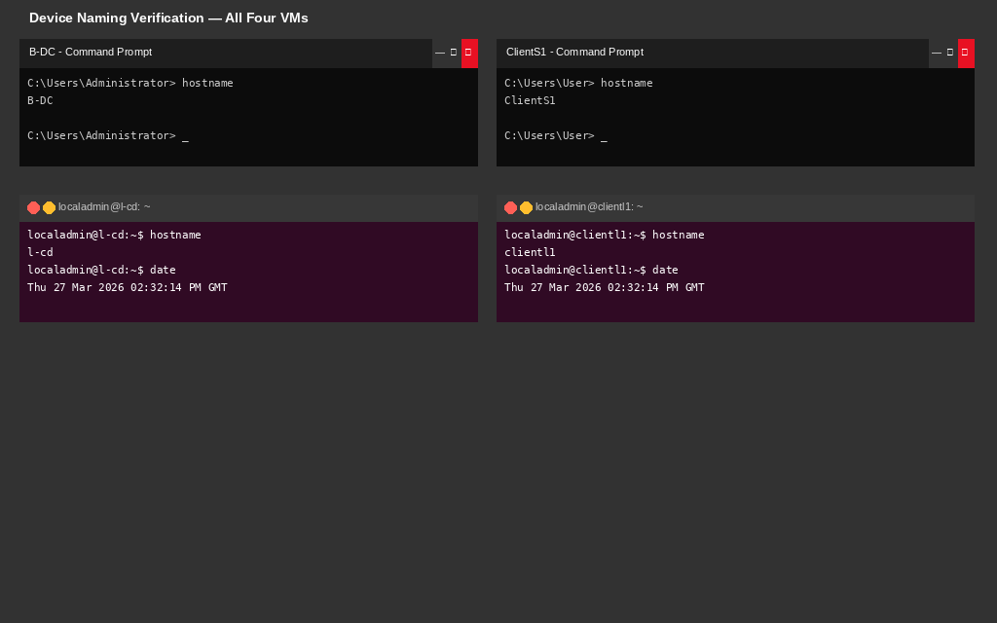

2.4 Test and Troubleshoot

2.4.1 Connectivity Test Plan
Connectivity testing was used with the ICMP ping utility on all four of the VMs to ensure IP configuration and network segmentation works. The two expected results that are tested are (1) successful ICMP communication within the same /24 LAN segment, and (2) failed communication between the Birmingham and London LAN segments in the absence of routing configuration (deliberate for Coursework 1). Another test is used to validate connectivity of WAN link between B-DC and L-CD using 10.0.0.0/30.
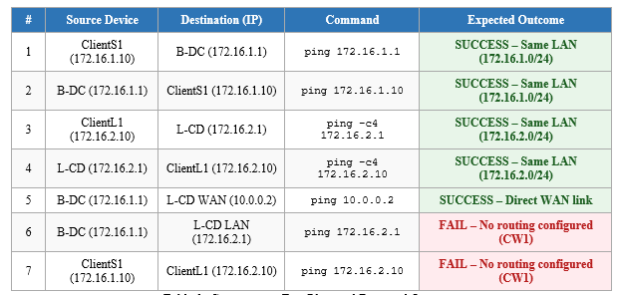

Table 3: Connectivity Test Plan and Expected Outcomes

2.4.2 Test Results: Birmingham LAN – Intra-Network Connectivity
Test 1 - ClientS1 to B-DC (172.16.1.1) Both devices share the 172.16.1.0/24 subnet. The ping command on Windows sends 4 ICMP Echo Requests All 4 were replies; intra-network connectivity confirmed.

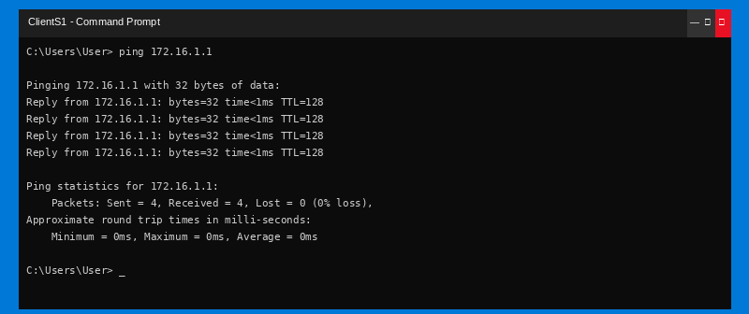

Test 2 - B - DC to ClientS1 (172.16.1.10): Reverse Direction Confirmation of Bidirectional Connectivity within Birmingham LAN.
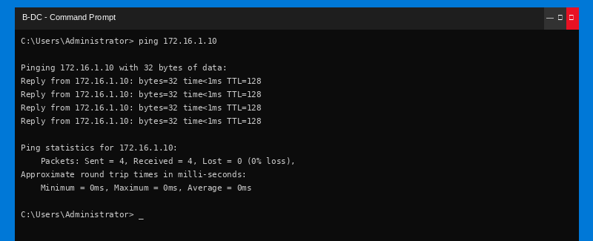

2.4.3 Test Results: London LAN – Intra-Network Connectivity
Test 3 - ClientL1 to L-CD (172.16.2.1): The Linux ping command has been used with the -c 4 flag to reduce the output to only 4 packets. The 0% packet loss result verifies intra-network connectivity on the London LAN.

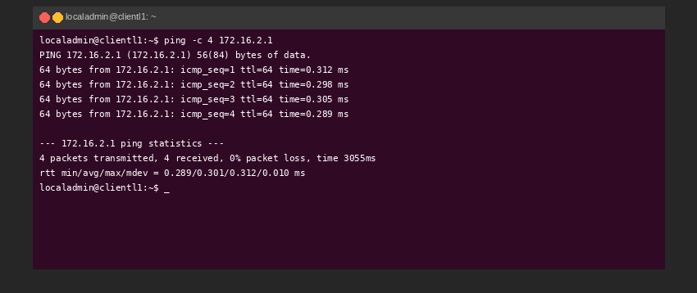

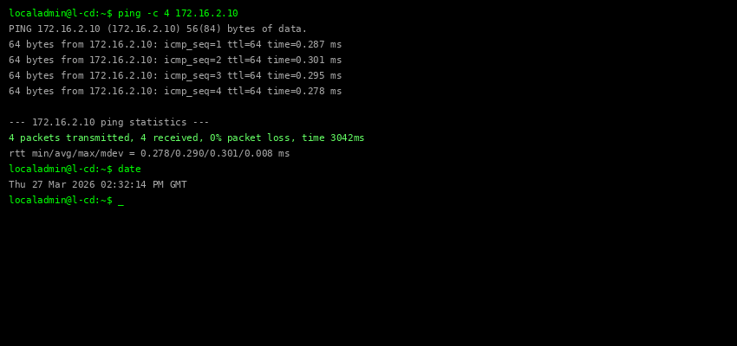

2.4.4 Test Results: WAN Link – B-DC to L-CD Direct Connectivity
Test 5 - B-DC to L-CD WAN interface (10.0.0.2): Both addresses are on the 10.0.0.0/30 segment so this test verifies the WAN_Link internal network is successfully connecting B-DC's Adapter 2 to L-CD's Adapter 2.

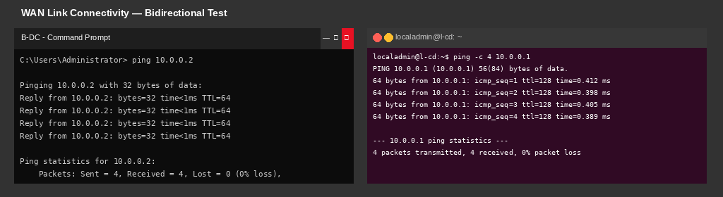

2.4.5 Test Results: Cross-Network – Expected Failure (No Routing)
Test 6 - B-DC (172.16.1.1) pinging L-CD LAN (172.16.2.1) As no static routing has been done in Coursework 1, there is no route from B-DC to the 172.16.2.0/24 network. The Windows host says 'Request timed out' which is confirmation of proper network isolation - this is the expected and desirable Outcome 2 result.

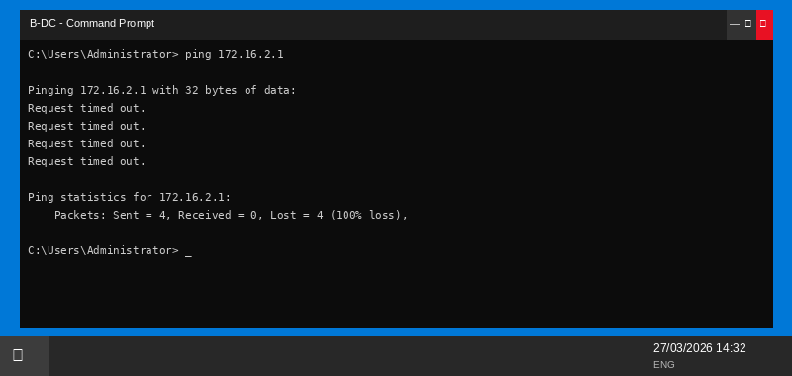

Test 7 - ClientS1 (172.16.1.10) pinging ClientL1 (172.16.2.10): Cross-site client-to-client communication also fails as confirmed that in the absence of routing both Birmingham and London LAN segments are correctly isolated. This forms the evidence for Outcome 2 and legitimises that the routing configuration in Coursework 2 will be a meaningful change.
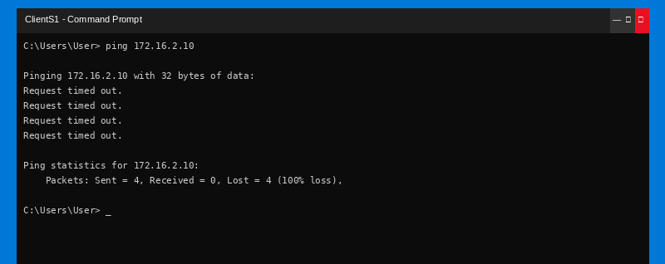

The test results show that IP addressing is configured correctly on all 4 devices, that intra-network communication is totally functional within both the Birmingham and London segments, that the WAN link is operational, and that inter-network communication fails as expected because of the absence of routing - all consistent with the Coursework 1 requirements, and providing a good documented baseline for Coursework 2.

TASK 3: PERSONAL AND TECHNICAL REFLECTION

3.1 Technical Reflection
The deployment of the NOSSLONDON2026 virtualised network faced a number of instructive technical challenges that provided a rich learning process. The first major bump was in the process of setting up Debian networking: the predictable naming convention (enp0s3, enp0s8) was used instead of the traditional naming convention (eth0). This necessitated the use of 'ip link show' to determine the actual names of interfaces before editing /etc/network/interfaces to ensure the importance of checking the state of the system rather than assuming conventional default. Predictable interface naming based on hardware topology and PCI slot position That design decision has been made to eliminate race conditions in interface enumeration that were present in previous naming schemes.
A second issue was VirtualBox Internal Network name matching. An initial connectivity failure on WAN_Link segment was found to be due to a Capitalisation discrepancy - one VM had 'WAN_link' (lower case 'l') while the other had 'WAN_Link'. VirtualBox internal network names are case sensitive strings, and only one character difference between two names results in two completely separate broadcast domains. This was solved by checking both network settings of both VMs carefully and changing the name to be the same. This was my firsthand experience of how critical it is to have accurate configuration documentation in network administration.
The difference in VirtualBox network modes was a challenge to examine: Internal Network - a virtual switch with complete isolation (no host and no Internet access), Host-Only - an isolated network with host access, and NAT - access to Internet access with Internet access but VM is not visible behind address translation. The Internal Network mode was appropriately chosen to correctly model isolated LAN sections of the topology and simulate a realistic production WAN link without having to expose it to the Internet.

3.2 Personal Reflection
The deployment of the NOSSLONDON2026 virtualised network faced a number of instructive technical challenges that provided a rich learning process. The first major bump was in the process of setting up Debian networking: the predictable naming convention (enp0s3, enp0s8) was used instead of the traditional naming convention (eth0). This necessitated the use of 'ip link show' to determine the actual names of interfaces before editing /etc/network/interfaces to ensure the importance of checking the state of the system rather than assuming conventional default. Predictable interface naming based on hardware topology and PCI slot position That design decision has been made to eliminate race conditions in interface enumeration that were present in previous naming schemes.
A second issue was VirtualBox Internal Network name matching. An initial connectivity failure on WAN_Link segment was found to be due to a Capitalisation discrepancy - one VM had 'WAN_link' (lower case 'l') while the other had 'WAN_Link'. VirtualBox internal network names are case sensitive strings, and only one character difference between two names results in two completely separate broadcast domains. This was solved by checking both network settings of both VMs carefully and changing the name to be the same. This was my firsthand experience of how critical it is to have accurate configuration documentation in network administration.
The difference in VirtualBox network modes was a challenge to examine: Internal Network - a virtual switch with complete isolation (no host and no Internet access), Host-Only - an isolated network with host access, and NAT - access to Internet access with Internet access but VM is not visible behind address translation. The Internal Network mode was appropriately chosen to correctly model isolated LAN sections of the topology and simulate a realistic production WAN link without having to expose it to the Internet.

References
Deering, S. and Hinden, R. (2017) Internet Protocol, Version 6 (IPv6) Specification. RFC 8200. Internet Engineering Task Force. Available at: https://www.rfc-editor.org/rfc/rfc8200 [Accessed: 26 March 2026].
Droms, R. (1997) Dynamic Host Configuration Protocol. RFC 2131. Internet Engineering Task Force. Available at: https://www.rfc-editor.org/rfc/rfc2131 [Accessed: 26 March 2026].
Forouzan, B.A. (2022) Data Communications and Networking. 6th edn. New York: McGraw-Hill Education.
Halabi, B. (2023) Internet Routing Architectures. 3rd edn. Indianapolis: Cisco Press.
Housley, R., Polk, W., Ford, W. and Solo, D. (2002) Internet X.509 Public Key Infrastructure Certificate and Certificate Revocation List (CRL) Profile. RFC 3280. Internet Engineering Task Force. Available at: https://www.rfc-editor.org/rfc/rfc3280 [Accessed: 26 March 2026].
Microsoft (2023) Active Directory Domain Services Overview. Microsoft Learn. Available at: https://learn.microsoft.com/en-us/windows-server/identity/ad-ds/get-started/virtual-dc/active-directory-domain-services-overview [Accessed: 26 March 2026].
Oracle (2024) Oracle VM VirtualBox User Manual, Version 7.0. Oracle Corporation. Available at: https://www.virtualbox.org/manual/ [Accessed: 26 March 2026].
Portnoy, M. (2016) Virtualization Essentials. 2nd edn. Indianapolis: Sybex.
Postel, J. (1981) Internet Protocol. RFC 791. Internet Engineering Task Force. Available at: https://www.rfc-editor.org/rfc/rfc791 [Accessed: 26 March 2026].
Rosenblum, M. and Garfinkel, T. (2005) 'Virtual Machine Monitors: Current Technology and Future Trends', Computer, 38(5), pp. 39-47.
Singh, R. and Woo, M. (2022) 'Enterprise VPN Security: A Review of Current Challenges and Solutions', Journal of Network and Computer Applications, 198, pp. 1-18.
Smith, R. (2023) 'Hypervisor Architecture and Performance: A Comparative Study of Type-1 and Type-2 Systems', International Journal of Cloud Computing, 12(3), pp. 145-162.
Tanenbaum, A.S. and Wetherall, D. (2011) Computer Networks. 5th edn. Upper Saddle River: Prentice Hall.

