Documentary Portfolio for
Desert Padre a short documentary about Gareth Hughes (Brother David)
Wales’ first silent Hollywood film star

Documentary Portfolio

The key modes I would like to consider for my documentary are performative and participatory, with an element of reflexive to compliment these.
Nichols, (2017) explains that:

‘Participatory mode: emphasises the interaction between filmmaker and subject. Filming takes place by means of interviews or other forms of even more direct involvement, such as conversations or provocations. This mode is often coupled with archival footage to examine historical issues’.

In the case of my documentary, historical events that took place during the late 1900’s to the late 1950’s, regarding the actor and latter missionary Gareth Hughes (Brother David), will be looked at.
Nichols, (2017) goes on to say that:

‘Performative mode: emphasises the subject or expressive aspects of the filmmaker's own involvement with the subject; it rejects notions of objectivity in favour of evocation and affect. The films in this mode also share qualities with experimental and personal films’.

My will be both performative and participatory, because it is a personal account or point of view of the chosen subject Gareth Hughes. This documentary is as much about my journey, as it is about the main subject.
I would like to include all of the photographs and footage I have collected via Internet sources, such as eBay Inc. and other specialist sites, and artefacts that have been donated to me by various family members. These items will help to not only tell Gareth’s story, but my own as well.

I was first told about Gareth Hughes by my grand-mother and her recollection of her ‘famous’ cousin, and how proud she was of him and that he never forgot his family in Wales. She would often talk about how he would send jellies and sweets over from America to my great grand-mother, and letters to keep in contact with the family (see Figures 1 (a) and (b)).
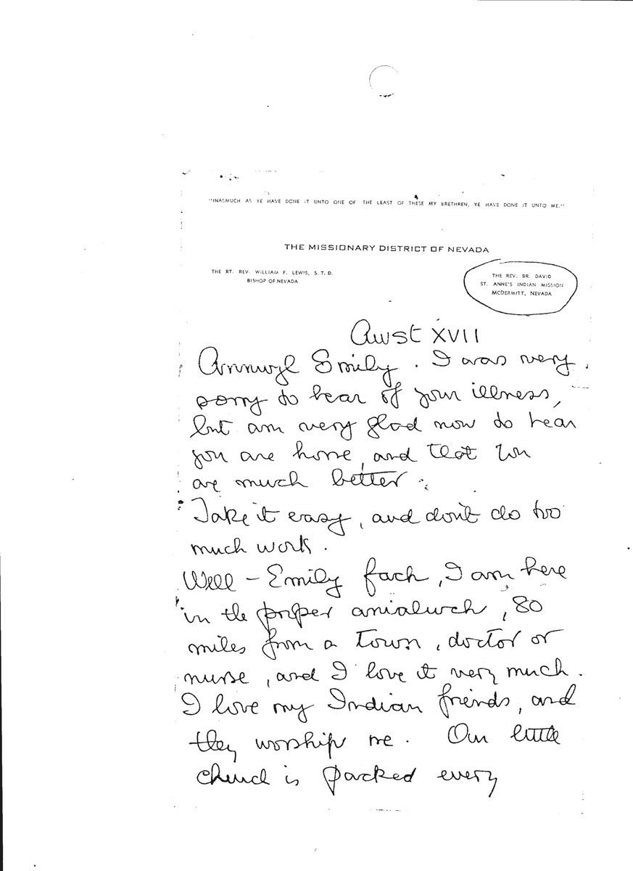

Figure 1 (a). Letter from Gareth to my great grand-mother (Guy, 2019)

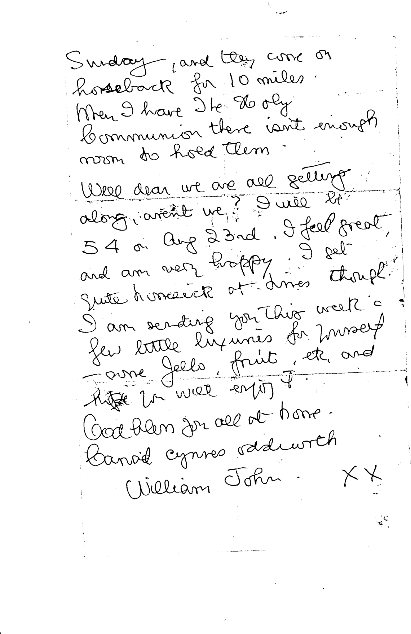
Figure 1 (b). Letter from Gareth to my great grand-mother (Guy, 2019)

As well as recounting his life as a silent film star, I would also like to explore Gareth the man and missionary and how he changed my life. Once I started to research and look more into his life I started a journey of discovery into Gareth’s life and possibly my own. It gave me the opportunity to travel, firstly to California and then Nevada.
Through detailed research I was able to find a article kept at The National Archives at the National Library of Wales in Aberystwyth.
Figure 2 (see below) was sourced at the National Archives by an online search, it was found by chance.

Figure 2. Magazine article ‘Desert Padre’ from An Ocean Apart. Wartime Memories of a Mountain Ash Childhood, sourced from the National Archive, Roberta Powell (1988)
Through reading the article ‘Desert Padre’, I was able to find out that Gareth visited Fallon, a small town in Nevada, on a regular basis. Again, with some research I found out that there was a museum in Fallon called the Churchill County Museum (see Figure 3).

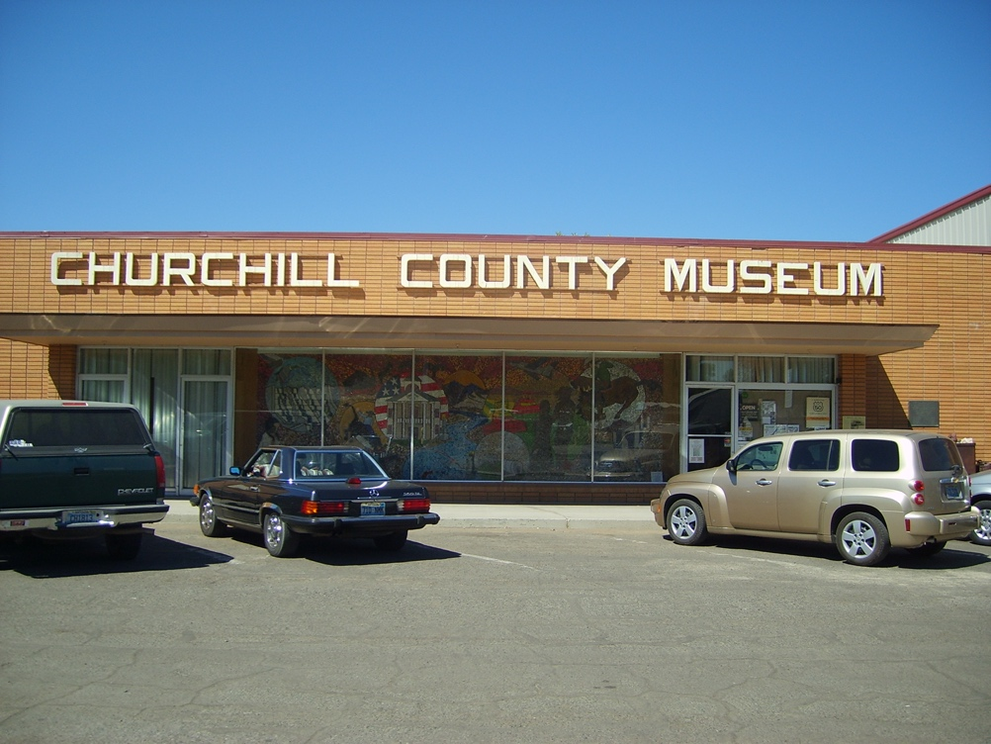
Figure 3. Churchill County Museum (Guy, 2006)

I spoke to a lady called Bunny Corkill who knew who Gareth was, not only that, but her grand-father was Welsh. This was just the start. Through Bunny I was introduced to the vice chair of the Paiute tribal council; I have no doubt that even though Gareth had been dead over fifty years his name still held a lot of respect in this region. Being a relative of Gareth’s helped me to gain access to their archive and also get permission to film on the Paiute reservation. This was an honour, as the Paiute people are very selective who they allow to film on the reservation. This is just one account of many how Gareth’s name helped open many doors for me that could have been slammed shut in my face.
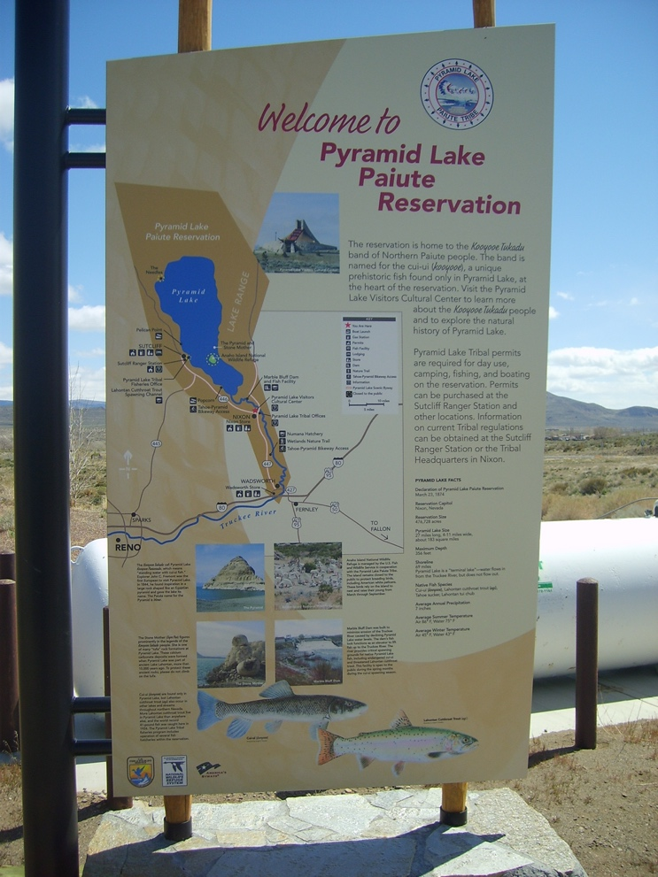
Figure 4. ‘Welcome to’ sign. (Guy, 2008)

The interaction with The National Archives, Churchill County Museum and the Paiute tribal archive address both performative and participatory modes of documentary making.

In my documentary I would like to look at the many ways Gareth has helped me and the many lives he touched during his time with the Paiutes.
By using interviews filmed during my first and second visits to the reservation, and interviews with relatives in America, the documentary will take a very brief glimpse into the life of this unassuming man - who decided to leave the life of a Hollywood film star far behind and serve in a more meaningful way.
As stated earlier, I will be using footage filmed during my visits to the Paiute reservation along with interviews of people that were children during Gareth’s time on the reservation. I will also be using photographs and footage from the Special Collection Department of Nevada University, Reno. Who have been very helpful in allowing to access some of the rarely seen footage of Gareth on the Paiute reservation.
Here are some examples of photographs taken during and after interviews with people that knew Gareth. I will be using clips from these interviews in the documentary.

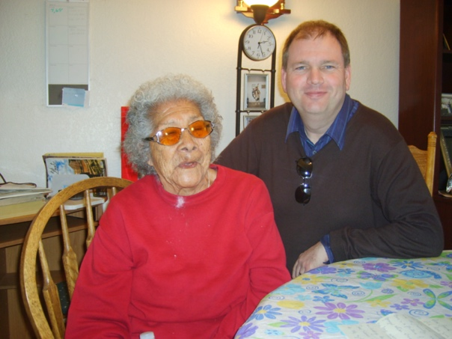
Figure 5. Benita Winnemucca (Guy, 2008)

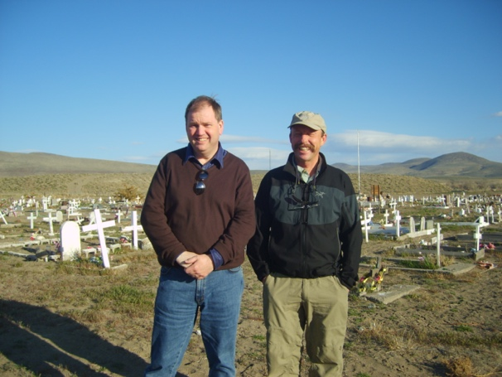
Figure 6. Lance Wyeth (Guy, 2008)

I will also be using family cine film and photographs, along with some new footage.
What do I hope achieve by making this short documentary? I would like anyone who watches this to want to know more about this amazing man, asking the questions: Who was Wales’ very first silent film star and why did he give it all up to lead a life of service?

From the module handbook, ‘The ethical and theoretical debates surrounding the production of contemporary documentaries within this tradition’ must be addressed. There could be some ethical issues when filming, especially on an indigenous peoples’ reservation. I could have manipulated and subsequently misrepresented the Paiute people in a similar way to that of Robert Flaherty, when he documented the Inuit’s in Nanook of the North (1922). I believe that this distorted the reality of this community in-line with a westernised perception of the Inuit people. Yes, there could have been many pit falls, because I had what I thought was an idea of what Native Americans should look like and sound like. But, it could not have been further from the truth. Initially the Paiutes were a bit unsure of my intentions, but after spending time with them they grew to trust me, and I think that is the answer - trust. Unlike Flaherty, I was not there to make them ‘act out’, but to film them giving a true account of their time with Gareth Hughes and their lives on the reservation.
I was honoured with an invitation to a pow wow and for an outsider to be invited was very rare. So I felt I had to repay them for allowing me into their family, by representing them and Gareth’s time with them with respect and truthfulness.
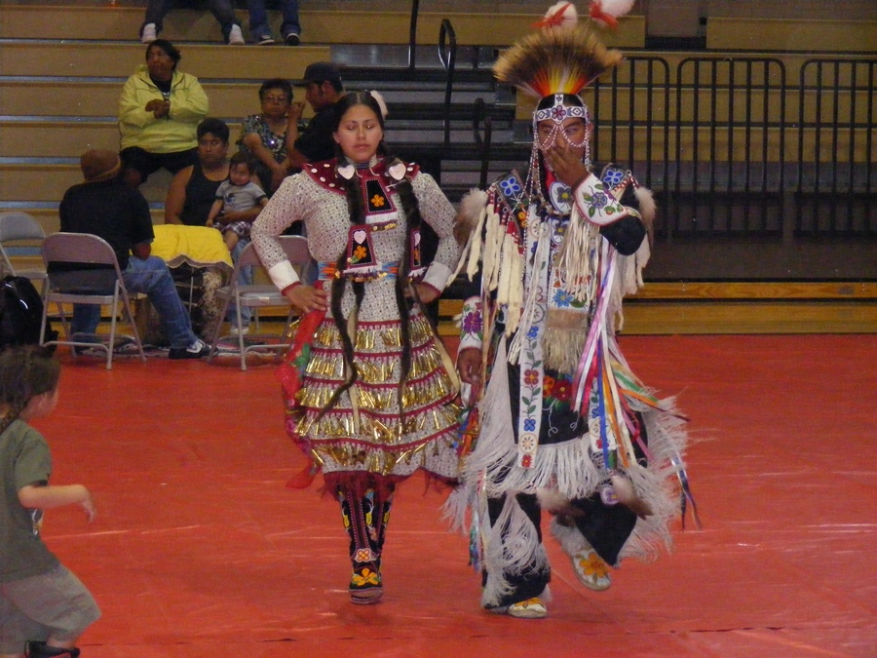
Figure 7. Image from the pow wow in Pyramid Lake High School, Nixon, Nevada (Guy, 2008)

My intention in my short documentary is to not only represent the Paiute people and Gareth Hughes with respect, but also the accounts of the many people I have meet that knew him and shared their stories with me. Because these accounts are preciouses to everyone who came into contact with Gareth. I see myself as a custodian of their stories and accounts of their time with Gareth.

I find similarity with my own journey with that of the musician, filmmaker and author Gruff Rhys in his American Interior (2014) project.

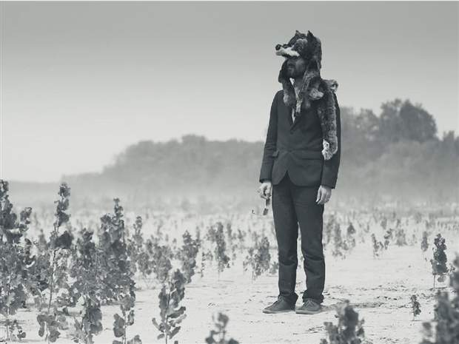
Figure 8. Gruff Rhys American Interior (2014). (cuff.docs / calgary herald 2014)

Rhys in an interview with Volmers, (2014) says that ‘...I don’t think there’s such a thing as a normal family, but if there is, I think my family is normal. But in every family there is always one or two characters that don’t fit in. I’m interested in verifying whether those stories are true or are family myths that have been constructed.’
This is why I think the mode and style of my documentary fits in so well with American Interior (Goch, Rhys 2014) because it is about getting to the bottom of things. Looking beyond the myth.
I have heard so many myths and have been told so many stories about Gareth over the years I just want to get to the truth for myself. One example of a myth about Gareth was that he walked to London, when in fact the family payed for a train ticket to get him there.
That is just one example of a story told by different family members over the years, which you believe it to be true. Until you get the opportunity to research for yourself.
Gareth Hughes or William John Hughes, which was his birth name, like John Evans did not fit in, he (Gareth) always had a longing to perform from a very young age. He used to charge his school friends a button to see him perform in his father’s old pigsty at the bottom of the garden. So acting was in his blood from a very young age. He wanted to see the world, visit the bright lights of the city, he longed to get away from Llanelli.
Rhys in his documentary was also on a quest, a journey of discovery to not only try and get to the truth about his relative John Evans, but to also try and get to know the man behind the myth. The more Rhys got to know John Evans and the hardships he faced the more Rhys was starting to discover more about himself.
Again in the interview with Volmers, (2014), Rhys states, ‘The songs I wrote before the tour were quite playful and upbeat. The songs I wrote after having made the journey and learned his history were much more solemn and downbeat.’
So I think Rhys had far more respect for John Evans after he had retraced his steps. Rhys’ documentary was a voyage of discovery which is how I see mine, because my documentary like Rhys’s is not just about Gareth Hughes but myself.
Since I started researching this somewhat forgotten silent film star Gareth Hughes, who became known as Brother David to the Paiute. My life has changed I’m doing things now I never thought I would be, running a film festival and in my final year as a film undergraduate. I hope my documentary will be a tribute to Gareth and encourage people to find out more about him.
But unlike Gruff Rhys I won’t be singing.

Reference List:

ie ie Productions. (2019) Two Men. Two Quest. Two Centuries Apart. American Interior, Four ways to experience the search for a lost tribe. Available at: http://american-interior.com/ (Accessed: 7 November 2019)

Nichols, B. (2017) Introduction to Documentary. Bloomington: Indiana University Press.

Volmers, E. (2014) Welsh songwriter Gruff Rhys follows ancestor's 18th Century trek to America for documentary. Available at: http://www.calgaryherald.com/entertainment/welsh+songwriter+gruff+rhys+follows+ancestor+18th+century+trek+america+documentary/10399852/story.html
(Accessed: 7 November 2019)

Filmography:

American Interior (2014) Directed by Dylan Goch and Gruff Rhys, UK, Soda Pictures, Sianel 4 Cymru (S4C).

In Search of Gareth Hughes (2009) Directed by Kelvin Guy, UK, Pyramid Lake Productions.

Bibliography:
Hampe, B (2007) Making Documentary and Videos. New York: Henry Holt and Company, LLC

History of Documentary. (2017) Participatory Documentary. Available at: http://joshbernhardfilmmaker.com/uncategorized/participatory-documentary/ (Accessed: 8 October 2019)

ie ie Productions. (2019) Two Men. Two Quest. Two Centuries Apart. American Interior, Four ways to experience the search for a lost tribe. Available at: http://american-interior.com/ (Accessed: 7 November 2019)

Nichols, B. (2017) Introduction to Documentary. Bloomington: Indiana University Press.

Volmers, E. (2014) Welsh songwriter Gruff Rhys follows ancestor's 18th Century trek to America for documentary. Available at: http://www.calgaryherald.com/entertainment/welsh+songwriter+gruff+rhys+follows+ancestor+18th+century+trek+america+documentary/10399852/story.html
(Accessed: 7 November 2019)

Ward, P. (2005) Documentary the Margins of Reality. London: Wallflower Press.

Wemmy's Media Studies Blog. (2009) Performative Documentary Characteristics. Available at: https://wemz29.wordpress.com/2009/09/08/performative-documentary-characteristics/ (Accessed: 8 October 2019)

Filmography:

American Interior (2014) Directed by Dylan Goch and Gruff Rhys, UK, Soda Pictures, Sianel 4 Cymru (S4C).

In Search of Gareth Hughes (2009) Directed by Kelvin Guy, UK, Pyramid Lake Productions.

Performative Documentary: Immortal (Holmzy Films 2018) Available at:
https://youtu.be/QftwXNAVPfA (Accessed 15 October 2019)

