Assignment 2:housekeeping development plan

Training development program for all new employees as Hotel Trinity
  - Tutor: Laurence Blake Name: Jasmin Khatun Due Date: 18th Nov

Introduction:
Hello and welcome to our family at Hotel Trinity. On behalf of Hotel Trinity, we would like to welcome you to our housekeeping department. All of us here are excited to get to know you and work with you on upcoming projects. We are very happy to have you onboard our team and working alongside us for our journey towards growth and improvement. For all new employees at Hotel Trinity, we wish to provide a safe, healthy and stable working environment in which you can learn the values and ethos our company hold. We as a company like to prioritise anyone who is eligible to join and be a part of our family, therefore, hope that your new position here at Hotel Trinity will be a nice and comfortable fit. The positions within the housekeeping department consist of
- Director of Housekeeping
- Director of Maintenance
- Director of Operations
- Executive Housekeeper
- Housekeeper
- Housekeeping Aide
- Housekeeping Supervisor
- Lead Housekeeper
- Maid
- Maintenance Supervisor
- Maintenance Worker
As per regulations, in our introduction we will go through requirements and expectations which must be met and upheld for any member of our housekeeping department. When joining our establishment, you are expected to be wearing a name badge at all times when on the premises so you can be identified along with aiding in precautionary and security measures. In terms of appearance, you are expected to hold a professional view and meet all necessary requirements. You are expected to have well looked after nails and hair which will not encumber you in this role. Your hair must be worn in a way in which It won’t interfere with your job along with taking preventative measures if you shed a lot. Our establishments offer headpieces which will prevent hair being left throughout the rooms in our establishment. Your nails must also be looked after and not too long avoiding any unnecessary damages to linens or equipment. Also, avoiding long nails will aid in preventing the transfer of collected dirt and bacteria which may collect under one’s fingernails, this will help avoid sickness in both guests and colleagues.
Characteristics which we look for in members of our team varies widely and consists of sophistication and professionalism. At a surface level all members of the team must showcase tact, diplomacy and discretion. Segmenting this leads to the many different characterises we search for including:
- Efficiency
- Clear and Effective Communication
- Willingness of service
- Pleasing Personality
- Honesty and Dedication
- Politeness and Civility
- Attention to Detail
Also, regarding jewellery and cosmetics employees are permitted to only wear a band or wedding ring as other forms of jewellery could result in safety hazards. Light makeup is also permitted to uphold a neat and tidy appearance. Perfume must be light avoiding any strong-smelling scents which may linger in guest rooms. Lastly, a uniform is required to represent the professionalism and branding of Hotel Trinity. A uniform is required for many a reason one of the many being it makes you easily identifiable to guests and colleagues along with avoiding any damages or stains on your personal clothing. Also although not likely, if required it can protect you from any chemicals that you may work with.
One of our most important requirements is cleanliness, this encompasses the deadly sins of cleanliness which are:
- Hair
- Stains on bedding, seating or carpet
- Evidence of a previous guest
- Dust
- Flies: dead or alive
- Residue
- Smudges
These must be avoided and prevented at all costs when working as part of our housekeeping team here at Trinity Hotel.

A summary of a daily routine at Hotel Trinity would be arriving to the premise with uniform on along with a name badge, this would then lead to clocking in and receiving your morning brief. Also, you would be expected to prioritise your board of rooms along with preparing the housekeeping cart and collecting your keys. This would then lead onto your cleaning shift in which you would prepare a guest room and bathroom for cleaning, clean said facilities, replace the amenities then finish off with a final check and inspection of the room. The end of the shift would consist of cleaning and returning equipment, returning your completed housekeeping allocation board, logging and storing any lost or stolen property into the lost and found, return to sign back in your housekeeping keys which then leads onto signing off for the day.
This Smoothly transitions us into the 8-week induction programme which all new members will undertake when joining our establishment.
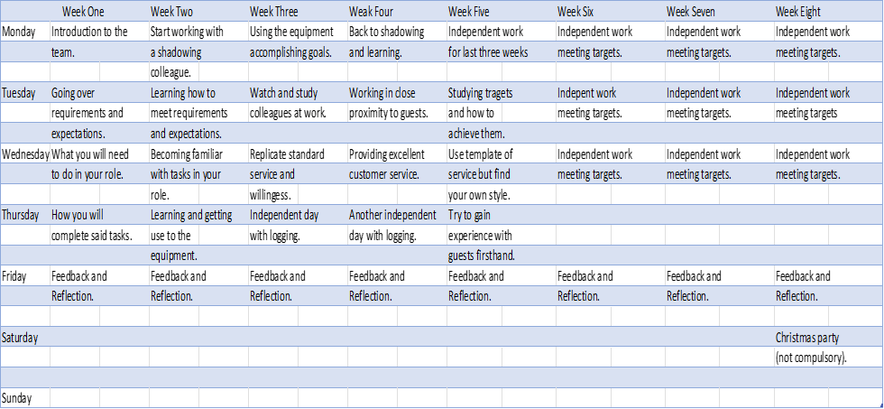
This is the induction/training programme which you will ensue when joining our family. This consists of a variety of activities in which you will become familiarised with your role and position within the establishment.
Firstly, you will become acquainted with your future team along with studying and learning what will be expected of you. Also, you will go over the previously listed expectations and requirements and will be inspected upon arrival on the premise to ensure you are following all the rules and regulations required to work for our housekeeping department. Then you will learn the activities you will need to accomplish in said role this will be a lengthy and in depth part of the training activities and guarantees to make sure you will be clued into everything you must be able to do in your respective role. This then leads to ending the week off with a feedback and reflection with your higher up going through any questions you may have along with setting targets to accomplish. In addition, incentives will commonly be set in these meetings. Hotel Trinity wishes to rightly reward and recognise the hard work and dedication that employees may put forth.
The second week will consist of mostly the same, but you will be working in a practical setting in which you will be shadowing and learning from a fellow colleague. This will help you see first-hand what is expected of you here at Hotel Trinity. You will be expected to help out where necessary and will be guided by said colleague on the equipment used at the establishment and how to correctly apply it in the intended way. The end of the week will have a repeated feedback and reflection in which you may voice any concerns along with checking whether you are on the correct path to meeting your targets. Incentives may also be Discussed.
The start of week three will consist of getting use to and using the hotel equipment for its intended use and updating your progress towards your targets. This week will also consist of shadowing your colleague and replicating the willingness and service that they showcase. This process will allow you to become acclimated to the professional environment in which you will be working. You will end the week off with an independent day in which you will test what you have learned along with the repeated feedback and reflection on Friday.
Week 4 will be where you will go back to shadowing to further what you have already learned, you will also be working in close proximity to hotel guests now and will gain practical experience. You will then work towards providing excellent service moving onto and independent day in which you will log the things you learn, the rooms you attend and the things you accomplish. This will then lead onto the repeated sequence of feedback and reflection on Friday in which you will be prepared for working independently.
Week five will be the week where you find yourself within the establishment finding your own style of service and work. This will be where you will slot into the team smoothly bringing your characteristics and skills to use. You will study your targets and how to accomplish them along with gaining practical experience in the establishment. The week will end off with the repeated feedback and reflection meeting. Questions and answers can be discussed along with progress and incentives.
The last three weeks will consist of independent work within Hotel Trinity allowing you to find yourself and meet targets set prior. You must log all your days and progress towards achieving all your goals. The last day of each week will consist of the repeated feedback and reflection meeting which will provide clarification and incentives.
After the eight weeks have been completed in relation to the present season we will be hosting a Christmas party which all hotel staff will be invited to this is not a compulsory part of the training but who doesn’t enjoy parties?
Safety Training:
This is a compulsory part of becoming a member of our team here at Hotel Trinity, this will consist of a variety of safety measures which must be considered second nature to all employees in case of emergencies. Another segment of this is security measures and this mainly consists of
- Guest theft
- Lost and Found
- Employee Theft
- Suspicious Activity
In our hotel, these must be studied, and able employees must be able to recognise each respective factor. This will be accomplished in the eight-week training programme.
Fire safety training is also practised within our facility and all employees will receive the necessary training in which they will be educated on what to do in situation of a fire. COSHH (Control of Substances Hazardous to Health) training will also be compulsory which ensues:
- COSHH Risk Assessment.
- Precautions.
- Prevent or control exposure.
- Maintenance of control measures.
- Monitor exposure.
- Health surveillance.
- Plans & procedures for accidents and emergencies.
- Training for employees.
Also, common health and safety training will be compulsory in which you will learn countermeasures to any health and safety risks which may be present in the Hotel.
Branding and Logo:
Here at Hotel Trinity, we pride ourselves on the branding logo and image that the company has gained throughout its strenuous years. As stated earlier wearing our uniforms which provide a professional and sophisticated look are required when working at our establishment. This aids the branding of the company and allows the company to gain exposure. We have created our brand image for potential guests to see and recognise the sophisticated and luxurious experience they will partake in during their stay at Hotel Trinity. As a future part of the company, you are expected to meet and uphold these standards at all possible times. Our logo was created considering the image and representation we wish to put forth.

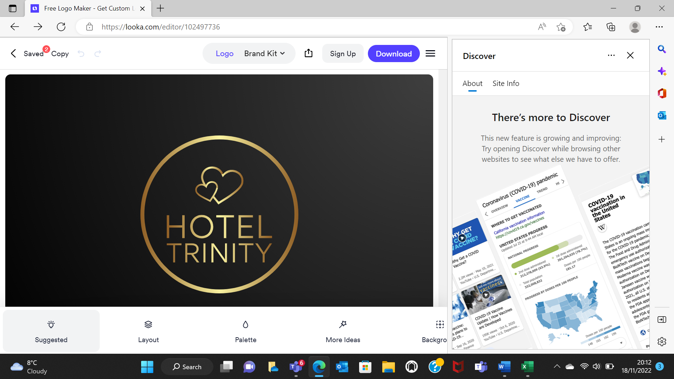

References:
Raghubalan, G. and Raghubalan, S. (2016) Hotel Housekeeping - Operations And Management. 3rd ed. India: Oxford University Press.
Casado, M. (2012) Housekeeping Management. London: Wiley.
Jones, T. (2010) Professional Management of Housekeeping Operations. London: Wiley.
Wood, R. (2013) Key Concepts in Hospitality Management. London: Sage.
Tesone, D. (2010) Principles Of Management For The Hospitality Industry. 1st ed. London: Routledge.

