Machine Learning Model
Artificial Intelligence and Machine Learning (ACCA6011)
Jonathan Wilcox (2206641)
Abstract

This study applies supervised and unsupervised machine learning techniques to predict player engagement and discover behavioural patterns using the Predict Online Gaming Behaviour dataset, which includes demographic and behavioural features for 40,034 players. Two supervised models were used, Decision Tree and Support Vector Machine (SVM) to group players into High, Medium, and Low engagement levels, with a focus on identifying Low-engagement players at risk of leaving. After hyperparameter and threshold tuning, the SVM achieved the best performance, correctly predicting 90% of Low-engagement players. Unsupervised methods were then tested, including K-Means and Agglomerative Clustering. These revealed three behavioural groups which focused around session duration, purchasing activity and age demographics. These insights provide a more in-depth understanding of player behaviour, which complements the predictive supervised models. Overall, combining supervised prediction with unsupervised behavioural clustering offers a useful business process for identifying players at risk of leaving to aid in targeted retention strategies and future game design designs.

Table of Contents

List of Figures 3
Abbreviations 4
1. Introduction 5
2. Literature Review 6
3. Problem Statement 8
4. Methodology 9
4.1 Data Preprocessing 9
4.2 Supervised Machine Learning Models 10
4.2.1 Support Vector Machine (SVM) 10
4.2.2 Decision Trees 10
4.3 Evaluation Metrics 11
4.4 Hyperparameter Tuning 12
4.5 Unsupervised Learning 13
5. Results and Discussion 15
5.1 Data Investigation 15
5.2 Supervised Model Performance 16
5.3 Unsupervised Clustering Results 20
5.4 Supervised vs Unsupervised Learning 23
6. Business Recommendations 24
7. Conclusion 25
Link to Youtube Demo 26
References 27

List of Figures
Figure 1. Split Data into train and test 9
Figure 2. SVM Model, with train and test outputs 10
Figure 3. Decision Tree model, with train and test outputs 11
Figure 4. Function to display confusion matrix and classification report 12
Figure 5. Hyperparameter Tuning on SVG model 13
Figure 6. Elbow plot to identify suitable number of clusters for algorithm 14
Figure 7. Correlation Analysis Between Numerical Features 15
Figure 8. SVM Classification Report and Confusion Matrix 16
Figure 9. ROC Curve for the Tuned SVM Model 17
Figure 10. SVM Model Test Results After Threshold Tuning 17
Figure 11. Decision Tree Train Data Results 18
Figure 12. Decision Tree Classification Report and Confusion Matrix 19
Figure 13. ROC Curve for the Tuned Decision Tree Model 19
Figure 14. Elbow Method Showing 3 Clusters are Optimal 20
Figure 15. Silhouette Score Confirming 3 Clusters are Optimal 21
Figure 16. Grouped Bar Chart of Cluster Behaviours (K-Means) 21
Figure 17. Grouped Bar Chart of Cluster Behaviours (Agglomerative Clustering) 22

Abbreviations
Abbreviation | Full Term
ML | Machine Learning
SVM | Support Vector Machine
K-Means | K-Means Clustering
AHC | Agglomerative Hierarchical Clustering
RBF | Radial Basis Function
AUC-ROC | Area Under the Receiver Operating Characteristic Curve

1. Introduction
Player engagement is a vital factor in the success of online games, directly impacting retention and long-term profits. This study uses the Predict Online Gaming Behaviour dataset, which contains demographic and player behaviour metrics with an engagement label for each player. The data is used to predict player engagement and for behavioural analysis.
The aim of this project is to apply both supervised and unsupervised machine learning methods to help understand the player base and player engagement. Two supervised models are used, Decision Trees and Support Vector Machines (SVMs). These models are designed to categorise players into High, Medium, and Low engagement levels, with a focus on identifying Low-engagement players who may be at risk of leaving. Hyperparameter tuning and evaluation metrics are used to assess and improve model performance.
Unsupervised methods, including K-Means and Agglomerative Clustering, are then applied to find behavioural groups/clusters within the player base. These clusters provide insight into different player types and can inform targeted retention techniques, marketing strategies, and adjustments to game design.
By comparing the results of both supervised and unsupervised approaches, the study gives recommendations that help the business improve engagement.

2. Literature Review
Machine learning refers to the development of algorithms capable of recognising patterns and making predictions within data-driven environments [1]. In the context of game analytics, machine learning has become increasingly important for understanding player behaviour, supporting business decisions, and improving long-term retention. Recent research by Melhart et al. has demonstrated that machine learning can enhance “game companies” ability to model and respond to player experiences, improving engagement and revenue outcomes [2].
Supervised learning is a widely used type of machine learning in which models learn from labelled data to map input features to known outcomes [3]. This approach is beneficial for tasks such as player engagement prediction, where the target classes are already defined. Common supervised learning methods include Decision Trees, Support Vector Machines (SVMs), and Linear Models. Decision Trees split data into branches based on simple rules, making them easy to interpret and useful for identifying important behavioural features [4]. SVMs work by finding optimal boundaries between classes and are effective for modelling complex or non-linear relationships [5]. In gaming applications, supervised learning has proven highly effective. Runge et al. found that SVMs outperformed logistic regression and decision trees when predicting churn for high-value mobile game players [6], while Pedersen et al. showed that Decision Trees could successfully model player preferences in platform games using behavioural inputs such as movement, completion time, and interaction style [7].
Unsupervised learning, unlike supervised methods, uses unlabelled data to discover hidden structures, patterns, or groups within the dataset [8]. This makes it particularly useful in game analytics, where behavioural data is rich, varied, and often unlabeled. One of the most widely used methods is K-Means clustering, which groups players based on similarity by minimising the distance to cluster centroids [9]. Drachen et al. demonstrated the importance of this method by successfully identifying behavioural classes, such as "Completionists" and "Speed runners" among 70,000 players, discovering insights that traditional analysis could not reveal [10]. Another common approach is Agglomerative Hierarchical Clustering (AHC), which iteratively merges players based on similarity to form a hierarchy of clusters [11]. AHC is particularly effective for exploring how behaviours relate at different levels of granularity.
Both supervised and unsupervised learning offer distinct but complementary advantages. Supervised learning enables the accurate prediction of outcomes, such as engagement levels, providing direct support for retention strategies. Unsupervised learning uncovers natural behavioural segments that can inform personalised game design, marketing strategies, and player retention initiatives.
To evaluate these methods effectively, metrics such as accuracy, precision, recall, and F1-score are commonly used for supervised models [12], with recall being especially important for identifying at-risk, low-engagement players. Clustering quality is assessed using metrics such as silhouette score and inertia, ensuring behavioural groups are meaningful and well-separated.
The literature demonstrates that combining both supervised and unsupervised approaches provides a proven, robust analytical framework, helping both prediction and exploration.

3. Problem Statement
Understanding and predicting player engagement is essential for a gaming company, as activity levels directly affect retention and profit. Engagement in this dataset is labelled as High, Medium, or Low, making this a multiclass classification problem. Identifying Low-engagement players is important because they are most likely to become inactive, leading to financial loss.
The dataset contains demographic and behavioural variables such as playtime, session frequency, achievements, and purchases, all of which help predict engagement. The key challenge is achieving high recall for the Low-engagement group so that at-risk players can be identified early.
In addition to prediction, the project also aims to uncover behavioural patterns within the player base. Previous research has shown that clustering is effective for identifying player types and supporting personalised retention strategies [14]. Overall, this project aims to apply supervised and unsupervised learning to predict engagement levels and explore patterns that can help improve player retention.

4. Methodology
This section outlines the methodology used in the study.

4.1 Data Preprocessing
Machine learning models require a clean and well-prepared dataset to work efficiently. The original dataset contained multiple feature types, including numerical and categorical variables and a target variable (EngagementLevel).
The PlayerID feature is a unique identifier and does not help machine learning algorithms, so it was removed. An initial exploratory analysis was conducted to understand the dataset's structure and identify any potential issues that could impact model performance. This included examining feature distributions, checking for outliers, and confirming that all variables were in the correct formats. No missing values were identified, and no errors were found within the dataset. A correlation analysis was also conducted to explore relationships between numerical features; however, no strong correlations were identified.
Categorical variables were encoded into numerical features to ensure compatibility with machine learning algorithms, which require numerical inputs. Numerical variables were standardised using z-score scaling to ensure that all features contributed equally to the algorithms; this is particularly important for algorithms such as K-Means and SVMs that are sensitive to feature size [15].
Following the data preparation steps, the dataset was split into training and testing sets to help with model evaluation. A 70%-30% split was used, allocating 70% of the data for training and 30% for testing, a commonly used split with machine learning algorithms [16].
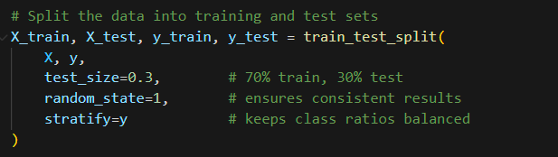
Figure 1. Split data into train and test

4.2 Supervised Machine Learning Models
Two supervised models were implemented: a Decision Tree and a Support Vector Machine (SVM).

4.2.1 Support Vector Machine (SVM)
A Support Vector Machine (SVM) is a supervised learning model used for classification by finding the best boundary that separates different classes [17]. An SVM model with three kernels: linear, polynomial, and Radial Basis Function (RBF) was initially tested to determine which configuration worked best with the dataset. Kernel selection is a crucial step because different kernels capture distinct types of relationships within the data. The linear kernel is effective when the data can be separated with a straight line; the polynomial kernel can detect more curved relationships. The RBF kernel is well-suited for complex datasets and can model a wide range of non-linear patterns
[17]. After testing all three, the RBF kernel showed the best performance and was selected for further tuning to optimise the results.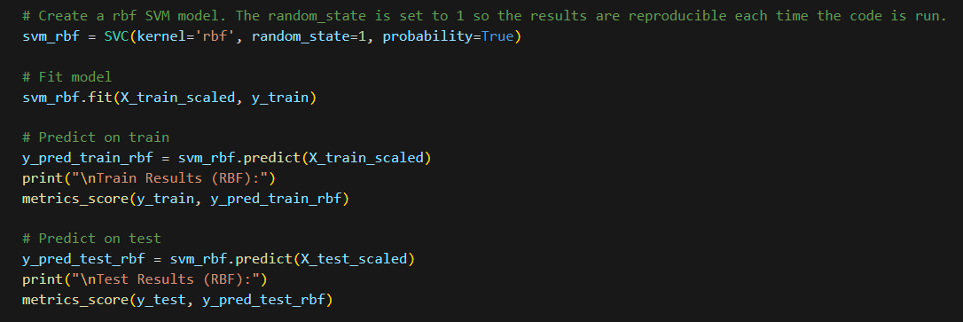
Figure 2. SVM Model, with train and test outputs

4.2.2 Decision Trees
A Decision Tree is a supervised learning model that makes predictions by asking a series of simple yes/no questions based on the input features. Decision Trees work by splitting the data into smaller groups based on the most valuable features, forming a tree-like structure where each final branch represents a prediction [18]. One advantage is interpretability, as the tree provides a clear picture of how the model makes decisions. However, Decision Trees can easily overfit, especially if the tree becomes too deep or the data is noisy [19]. To avoid overfitting, the Decision Tree was tuned to reduce this issue and provide a good comparison model to the SVM.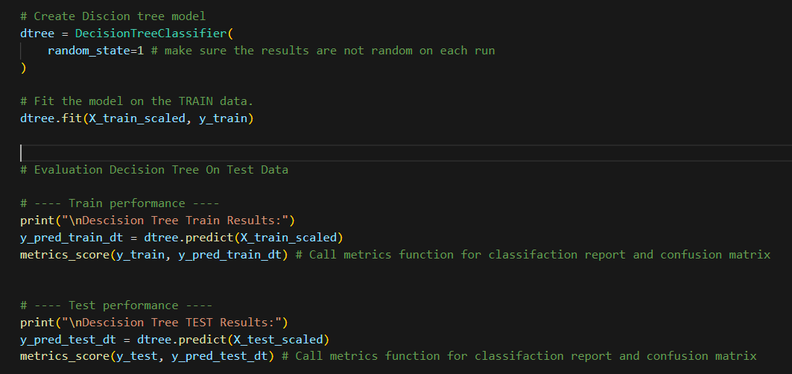
Figure 3. Decision Tree model, with train and test outputs

4.3 Evaluation Metrics
Model performance was assessed using standard classification metrics, including accuracy, precision, recall, F1-score, and AUC-ROC. Accuracy measures the overall proportion of correct predictions, while precision indicates how many predicted positives are correct. Recall measures how many actual positives the model successfully identifies and was prioritised in this study because detecting Low-engagement players is a important business objective. The F1-score combines precision and recall into a measure. AUC-ROC evaluates how well the model separates Low from Not-Low players across different thresholds [12]. A confusion matrix and ROC curve were also used to visualise classification performance.
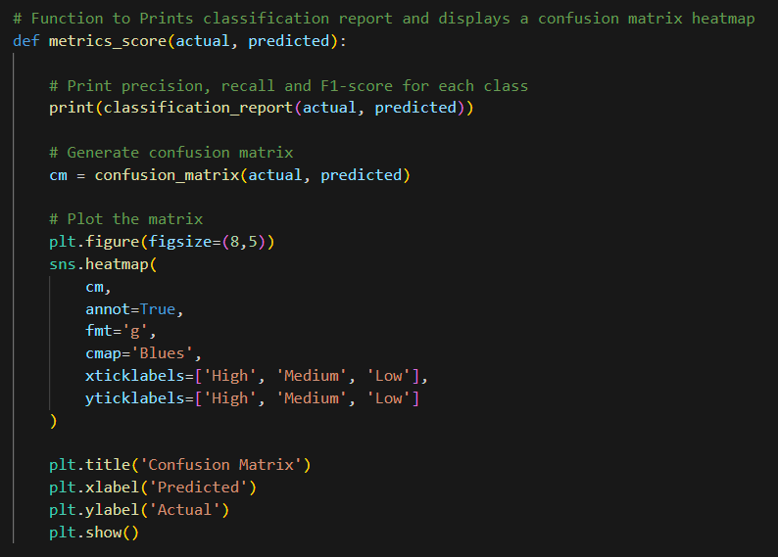
Figure 4. Function to display confusion matrix and classification report

4.4 Hyperparameter Tuning
Hyperparameter tuning was performed to improve model performance by finding the best parameter settings. This was done using Grid Search, which attempts multiple combinations of hyperparameters and selects the configuration that produces the best results [20]. For the SVM, parameters such as C and gamma were tested across multiple combinations. For the Decision Tree, parameters for example max depth were altered to reduce overfitting and improve performance. Overall, tuning helped both models produce better predictions, especially in terms of recall.
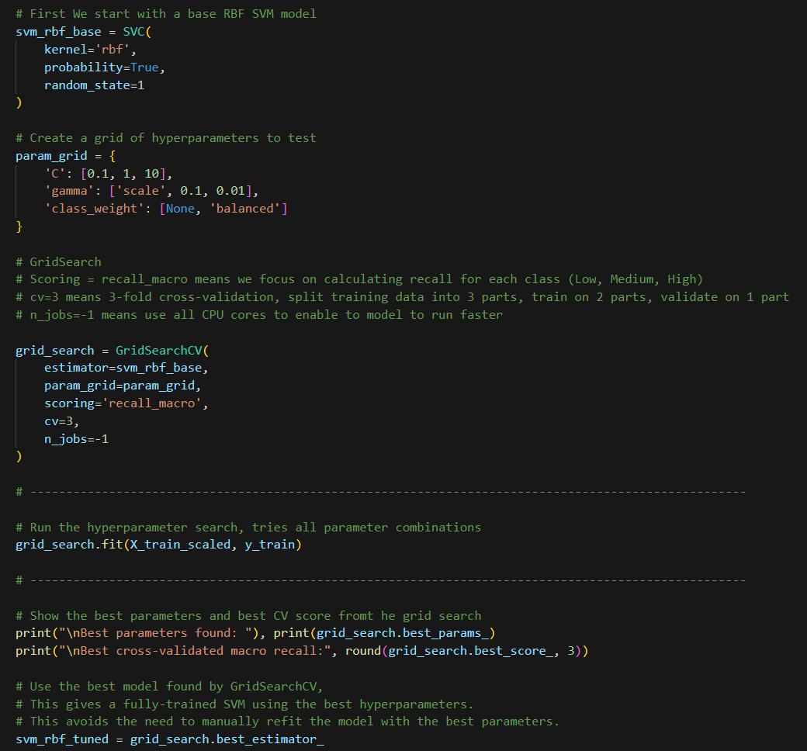
Figure 5. Hyperparameter Tuning on SVG model

4.5 Unsupervised Learning
Unsupervised learning was used to explore behavioural patterns within the data. Two methods were applied: K-Means and Agglomerative Clustering. K-Means groups players based on similarity, using distances to cluster centroids. Only behavioural numerical features were used because these reflect how players interact with the game and provide meaningful patterns for clustering.

The elbow method and silhouette scores were used to indicate the number of suitable clusters. Agglomerative Clustering was also used for comparison. It starts by treating each player as their own group and then joins the closest groups step by step. These unsupervised methods provided a more in-depth understanding of how players interact with the game, complementing the supervised models by revealing patterns within the player base.
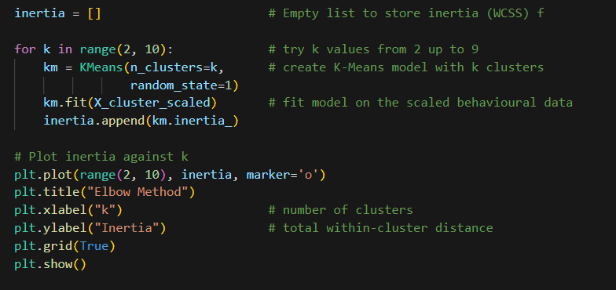
Figure 6. Elbow plot to identify suitable number of clusters for algorithm

5. Results and Discussion
This section presents the results of the models and their importance to business decisions.

5.1 Data Investigation
Initial data investigation revealed that the dataset was whole, with no missing values across the 40,034 records. Numerical and categorical features were clearly defined, and irrelevant fields such as player number were removed before analysis. Behavioural features such as session duration, weekly activity, and player progression showed clear differences between engagement groups, while demographic features for example gender, location and difficulty had minimal influence on engagement.
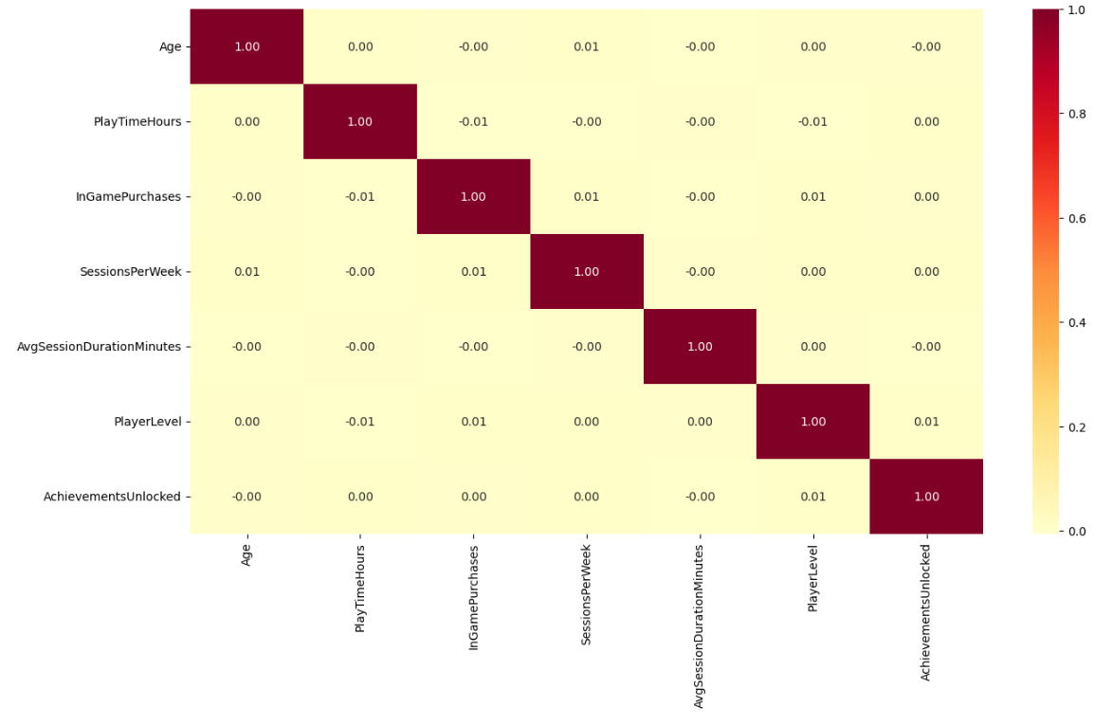
Figure 7. Correlation analysis between numerical features
Correlation analysis also showed no strong relationships between numerical features, suggesting that engagement is mainly influence by behaviour features. These findings helped identify which features were most important for the modelling.

5.2 Supervised Model Performance
Both supervised models, SVM and Decision Tree were evaluated using Accuracy, Precision, Recall, F1-score, and AUC-ROC. Each model produced strong results, the SVM model was slightly better than the Decision Tree, particularly when predicting the Low-engagement class.

The SVM showed higher Recall for Low-engagement players, which is the most important metric for this project. Recall is more important because missing a Low-engagement player is worse than incorrectly predicting someone as Low. The untuned SVM achieved a Recall of 0.85 for the Low-engagement class, meaning it correctly identified 85% of at-risk players. After hyperparameter tuning, this improved to 0.89, indicating that the tuned model correctly detected 89% of actual Low-engagement players.
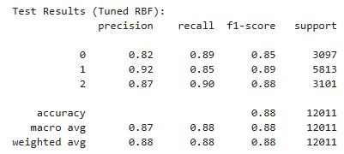

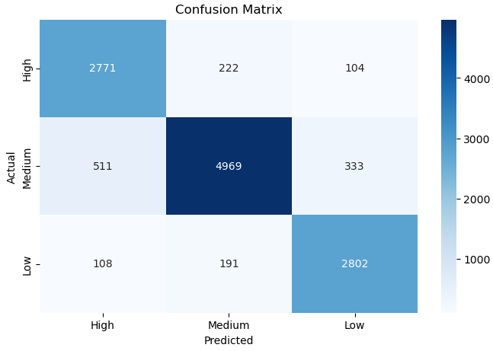
Figure 8. SVM Classification Report and Confusion Matrix

Although overall Accuracy decreased slightly after tuning, the model still achieved a strong test Accuracy of 0.88, showing good generalisation to unseen data. Training and test performance were also similar, confirming that the model is not overfitting. The tuned SVM achieved an AUC-ROC score of 0.94, showing a strong ability to distinguish between Low and Not-Low engagement players.

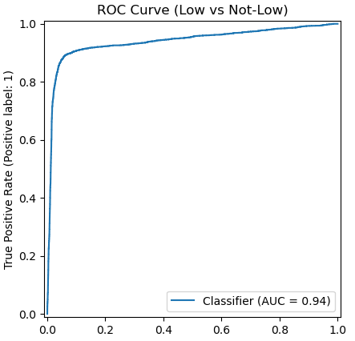

Figure 9. ROC curve for the tuned SVM model

In addition to hyperparameter tuning, adjusting the decision threshold further improved the SVM’s performance further when predicting Low from Not Low engaged players. After threshold tuning, the model accomplished a Low-class Recall of 0.90 on the test data, meaning it successfully identified 90% of players at risk of disengaging.

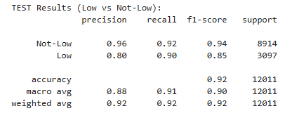
Figure 10. SVM model test results after threshold tuning
The Not-Low class also remained highly accurate, and overall test Accuracy and recall increased to 0.92. These improvements demonstrate that threshold tuning played an important role in improving the model’s ability to detect low-engagement players.

In comparison, the untuned Decision Tree initially showed clear overfitting, achieving 100% accuracy on training data but only 0.83 on the test set.

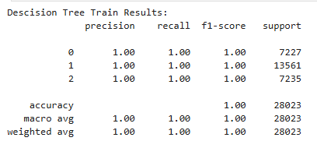
Figure 11. Decision Tree train data results

After tuning max_depth and minimum samples, overfitting was reduced and test accuracy improved to 0.91 and recall for Low engagement increased to 0.89. The AUC-ROC score of 0.93 shows good class separation, but overall the model remained less consistent than the SVM, particularly in distinguishing Medium and High classes.

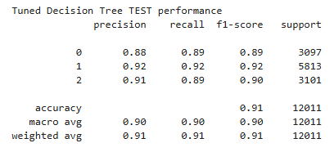

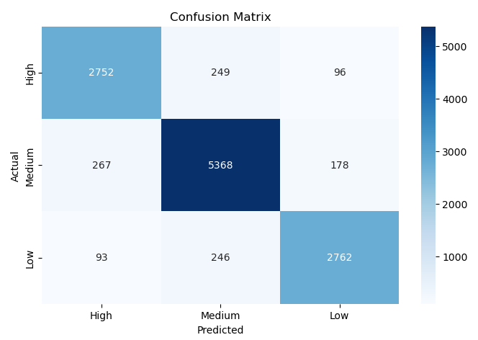
Figure 12. Decision Tree Classification Report and Confusion Matrix

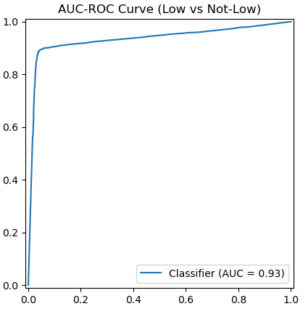

Figure 13. ROC Curve for the Tuned Decision Tree Model

Hyperparameter tuning played an important role for both models, and the use of grid search / Threshold tuning helped improve generalisation, increase recall for the Low-engagement class, and improved accuracy on the test data compared to base models.
Although the tuned Decision Tree achieved better Accuracy and trained faster than the SVM, the SVM proved to be slightly more reliable model. Its higher recall for Low-engagement players, stronger generalisation to unseen data, and slightly better AUC-ROC score makes it the best choice for identifying at-risk players in this project and for helping business decision-making.

5.3 Unsupervised Clustering Results
The unsupervised analysis provided additional insight into player behaviour outside the labelled engagement classes. K-Means clustering was used to discover natural behavioural patterns within the player base. Before fitting the model, the elbow method and silhouette score were applied to determine an appropriate number of clusters.
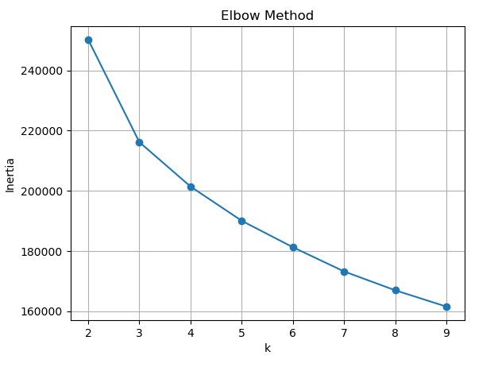
Figure 14. Elbow Method Showing 3 Clusters are Optimal
The elbow plot showed a clear point at k = 3, where the reduction in inertia began to level off, indicating that additional clusters would not significantly improve separation.
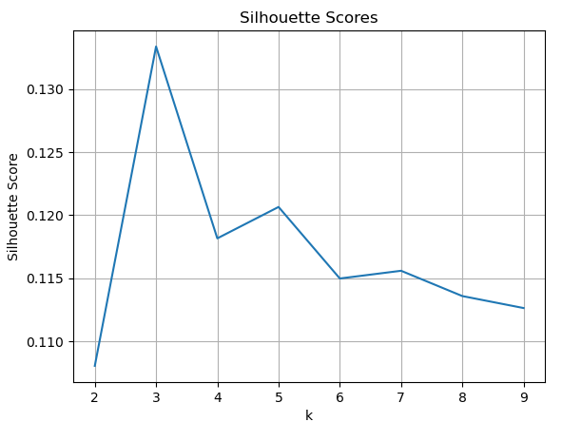
Figure 15. Silhouette Score Confirming 3 Clusters are Optimal
The silhouette score also reached its strongest value at k = 3, indicating that the data naturally forms three defined groups.
Once the final model was fitted, the results were analysed using a horizontal grouped bar chart that compared average behavioural features across the three clusters.
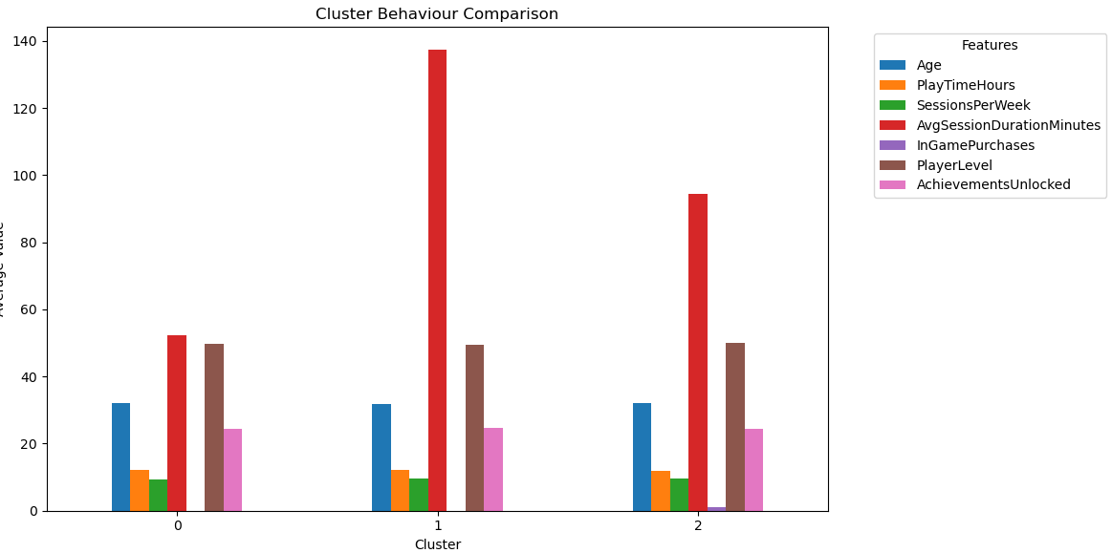
Figure 16. Grouped Bar Chart of Cluster Behaviours (K-Means)
The chart shows that most features Age, SessionsPerWeek, PlayerLevel, AchievementsUnlocked, and PlayTimeHours are very similar across all clusters. This indicates that these variables do not strongly influence how the model separates players. Only two features show noticeable variation: Average Session Duration and InGamePurchases. Based on this analysis, the cluster can be defined as:
Cluster 0 – Short Session Casual Players: These players have the shortest session times and make no in-game purchases. Their behaviour is low-intensity, indicating casual play.
Cluster 1 – Long Session Immersive Players: Players in this group have longer sessions than the other clusters. Their extended play suggests deeper engagement, although they do not make purchases.
Cluster 2 – Medium Session Players with Purchases: This group has moderate session lengths and is the only cluster that makes in-game purchases, contributing additional revenue despite average activity levels.
Overall, the clusters highlight three distinct behavioural patterns mainly influenced by session duration and purchasing behaviour. These findings offer the business a useful information for tailoring content, promotions, or retention strategies for different types of player clusters.
To validate the findings from K-Means, Agglomerative Clustering was tested using the same number of clusters. The model produced three groups with similar behavioural patterns to K-Means, supporting the earlier conclusion that session duration and purchase activity are the main factors separating player clusters.
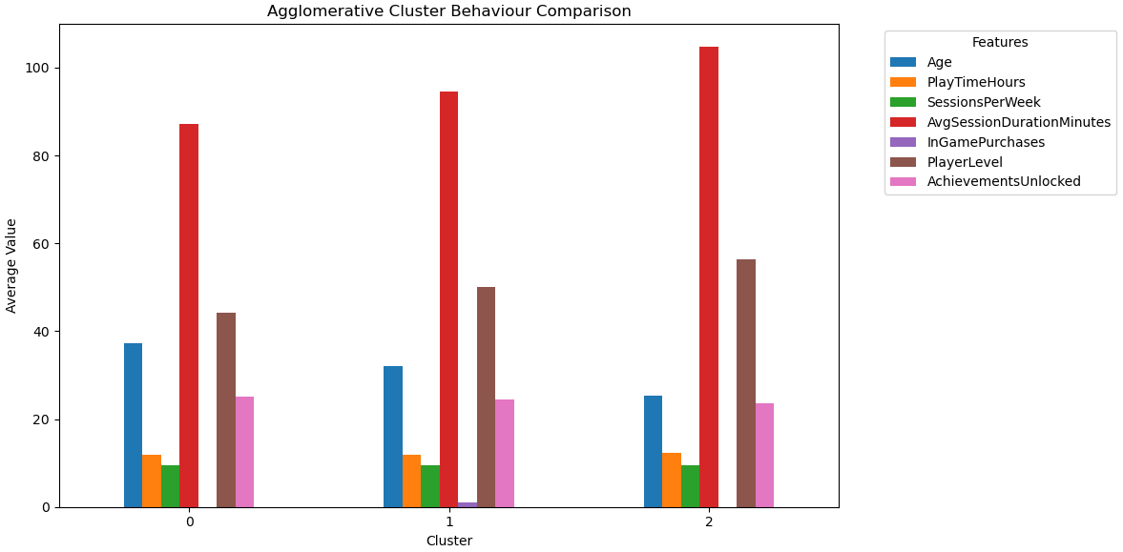
Figure 17. Grouped Bar Chart of Cluster Behaviours (Agglomerative Clustering)
However, unlike K-Means, this model also showed Age as another factor. Cluster 0 showed noticeably older players on average, while cluster 2 consisted of younger players. Other than this small difference, both clustering methods identified very similar behavioural groups.

5.4 Supervised vs Unsupervised Learning
Supervised and unsupervised learning each offer different advantages and limitations when analysing player engagement and behavioral patterns. Using both approaches together provides a more complete view of how players behave and how likely they are to stop playing.

Supervised learning, as identified by the SVM and Decision Tree models, is very effective for predicting player engagement levels when labelled data is available. Its main strength is the ability to identify at-risk players, with the SVM model performing exceptionally well. This makes supervised models helpful in determining where early intervention is needed to help with retention strategies. However, supervised learning is limited by its reliance on labelled data, meaning prediction quality depends on how accurately engagement levels are defined.

Unsupervised learning does not require labelled data and instead reveals behavioral patterns within the players. K-Means and Agglomerative Clustering both identified meaningful clusters, primarily around session duration, purchase activity, and age, providing insight into different user types, such as casual players, long-session players, and purchasers. This is useful for marketing, game content design, and personalised retention strategies. However, unsupervised learning has limitations; it cannot predict engagement level or the risk of players leaving. Additionally, cluster interpretation can be highly subjective, particularly when feature differences are minimal.

For player engagement, supervised learning is best for this prediction and will enable the business to identify which players may be at risk of leaving. Unsupervised learning is best for identifying segmentation, helping the company understand how behaviors vary across the player base. When combined, the two approaches complement each other, helping the business with decision-making.

6. Business Recommendations
By combining predictive modelling with behavioural segmentation, the business can make more informed decisions, improve retention, and personalise the player experience.
The SVM model should be used to identify players at risk of low engagement so that targeted interventions such as item promotions, difficulty adjustments, or personalised events can be used to reduce churn. The model can also highlight highly engaged users who may be good for premium content or upselling.
Unsupervised methods like K-Means and Agglomerative Clustering should be used to segment the players into meaningful groups. These clusters help explain how different players prefer to interact with the game. Casual short-session players may benefit from simpler gameplay and early rewards, while long-session players may respond better to enhanced content. Players who make purchases could be targeted with personalised store offers or loyalty incentives.
Using both supervised and unsupervised insights together allows the business to target each group more effectively. For example, a high-spending player identified as at risk may require more personalised retention efforts.
Future work could examine how behaviour changes over time and explore additional models to improve prediction accuracy and identify more detailed player segments.

7. Conclusion
This study showed that combining supervised and unsupervised machine learning techniques can enhance the understanding of an online gaming player base and help inform business decision-making.
The SVM and Decision Tree models both performed well at predicting engagement levels, with the tuned SVM providing the most reliable results for identifying Low-engagement players. Its high recall and high AUC-ROC score make it well-suited for detecting at-risk players who may require intervention.
Unsupervised clustering added an additional insight by revealing three main behavioural groups based on session duration and purchase activity. Short-session casual players, long-session immersive players, and medium-session purchasers. These clusters can help the business tailor game content, promotions, and retention strategies. This will be even more useful when combined with supervised learning predictions.
Overall, combining predictive modelling with behavioural clustering offers a useful tool for reducing player churn, improving retention, and implementing targeted marketing and game design decisions. Future work could expand on this project by analysing trends over time and testing additional models to improve accuracy and identify further player clusters.

Link to YouTube Demo
https://youtu.be/HRKTXJ1Nnx8

References
[1] W. Koehrsen, “What is Machine Learning? How I Explain the Concept to a Newcomer,” Medium [Online]. Available: https://medium.com/data-science/what-is-machine-learning-how-i-explain-the-concept-to-a-newcomer-d96f35a5c4f3. [Accessed: 20/11//2025].
[2] Melhart, D., Liapis, A., & Yannakakis, G. N. (2021). Towards General Models of Player Experience: A Study Within Genres. IEEE Conference on Computational Intelligence and Games, 01–08. https://doi.org/10.1109/CoG52621.2021.9618902
[3] IBM, “Supervised Learning,” IBM Think [Online]. Available: https://www.ibm.com/think/topics/supervised-learning. [Accessed: 20/11//2025].
[4] 1 Scikit-learn, “Supervised Learning Algorithms” scikit-learn [Online]. Available: https://scikit-learn.org/stable/supervised_learning.html[Accessed: 20/11//2025].
[5] Moez R, “Supervised Machine Learning” Data Camp [Online]. Available: https://www.datacamp.com/blog/supervised-machine-learning [Accessed: 22/11//2025].
[6] J. Runge, P. Gao, F. Garcin, and B. Faltings, “Churn prediction for high-value players in casual social games,” in Proc. IEEE Conf. Computational Intelligence and Games (CIG), Dortmund, Germany, 2014, pp. 1–8, doi: 10.1109/CIG.2014.6932875.
[7] C. Pedersen, J. Togelius and G. N. Yannakakis, "Modeling player experience in Super Mario Bros," 2009 IEEE Symposium on Computational Intelligence and Games, Milan, Italy, 2009, pp. 132-139, doi: 10.1109/CIG.2009.5286482.
[8] Géron, A. (2023). Hands-on machine learning with Scikit-Learn, Keras and TensorFlow : concepts, tools, and techniques to build intelligent systems (Third edition.). O’Reilly Media, Inc.
[9] Windland V, “What is k-means clustering?”,, IBM [Online]. Available: https://www.ibm.com/think/topics/k-means-clustering [Accessed: 23/11//2025].
[10] Drachen, A., Sifa, R., Bauckhage, C., & Thurau, C. (2012). Guns, swords and data: Clustering of player behavior in computer games in the wild. 2012 IEEE Conference on Computational Intelligence and Games (CIG), 163–170. https://doi.org/10.1109/CIG.2012.6374152
[11] babu p, “Agglomerative Hierarchical Clustering (AHC)”,, Medium [Online]. Available: https://medium.com/@prasanth32888/agglomerative-hierarchical-clustering-ahc-e9e7a48cb042 [Accessed: 23/11//2025].
[12] kashyap p, “Understanding Precision, Recall, and F1 Score Metrics”,, Medium [Online]. Available: https://medium.com/@piyushkashyap045/understanding-precision-recall-and-f1-score-metrics-ea219b908093 [Accessed: 23/11//2025].
[13] Óskarsdóttir, M., Gísladóttir, K. E., Stefánsson, R., Aleman, D., & Sarraute, C. (2022). Social networks for enhanced player churn prediction in mobile free-to-play games. Applied Network Science, 7(1), Article 82. https://doi.org/10.1007/s41109-022-00524-5
[14] M. H. Schiller, M. Schedl, A. Flexer, and S. G. Schulz, “Inside the Group: Investigating Social Structures in Player Groups and Their Influence on Activity,”IEEE Transactions on Games, vol. 11, no. 4, pp. 416 - 425, Dec. 2019, doi: 10.1109/TG.2018.2858024.
[15] Bobbitt Z, “Z-Score Normalization: Definition & Examples”, Statology [Online]. Available: https://www.statology.org/z-score-normalization/ [Accessed: 19/11//2025].
[16] Raschka, S. (2018). Model Evaluation, Model Selection, and Algorithm Selection in Machine Learning. https://doi.org/10.48550/arxiv.1811.12808
[17] “Support Vector Machine (SVM) Algorithm”, Geeks for geeks. [Online]. Available: https://www.geeksforgeeks.org/machine-learning/support-vector-machine-algorithm/ [Accessed: 25/11//2025].
[18] Kavlakokoglu, E, “What is a decision tree?”, IBM [Online]. Available: https://www.ibm.com/think/topics/decision-trees [Accessed: 28/11//2025].
[19] Bhaskar, N, “Overfitting in Decision Tree Models: Understanding and Overcoming the Pitfalls”, Medium [Online]. Available: https://www.ibm.com/think/topics/decision-trees [Accessed: 29/11//2025].

[20] Gianluca, M, “Hyperparameter tuning. Grid search and random search”, Medium [Online]. Available: https://www.yourdatateacher.com/2021/05/19/hyperparameter-tuning-grid-search-and-random-search/ [Accessed: 30/11//2025].

