Engineering Science Assignment
Written by: Will Gabriel
Dated: 6th December 2024
Contents
Introduction 1
Experimental Procedure 2
Results 3
Analysis 4
Conclusion 7
Evaluation 8
Further Work 9
References 10

Introduction
This assignment will cover a run of tensile strength tests applied to various materials, from metal to plastic. Through these tests, we can gain a better appreciation of how each material handles stretching – truly seeing their strengths and weaknesses as the load increases, as they progress from stretching/elasticity through to snapping.
We will be able to observe the elasticity of each material as it stretches under loads applied, along with the yield point of each material and thus where the materials no longer obey Hooke’s Law (Hooke, 1678) which of course means the point of no return; the material is permanently stretched.

Experimental Procedure
This experiment was conducted via the use of a tensile-testing machine. There was a thread, with laterally protruding handles, the operator uses to twist and either increase or decrease the separation distance of the mounts the specimen is attached to. By increasing the separation, we increase the load upon the mounted specimen; we increase the tensile force applied.
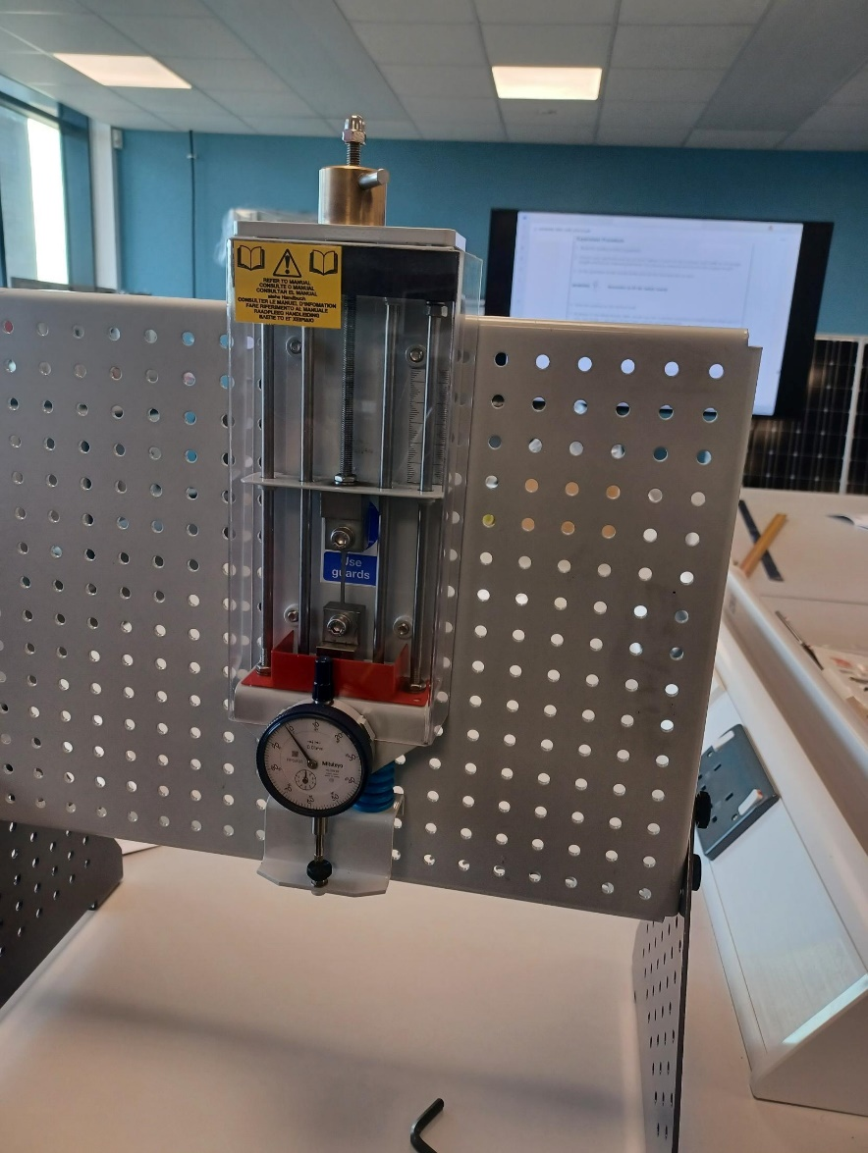
The device photographed to the left (ACHA4002, 2024) applies the tensile load upon the material in the middle. There is equal force acting upon each end, pulling away from the middle, so the point where these forces collide is the middle.

To show this understanding more clearly, photographed below is our PVC specimen (ACHA4002, 2024). We see the two square mounting points, joined by the central “arm”. Equal separation forces will meet in the middle.
These material strips had the load increased progressively, measuring their extension precisely and tracking how much load was applied. We measured the load using the number of rotations of the top thread/handle.
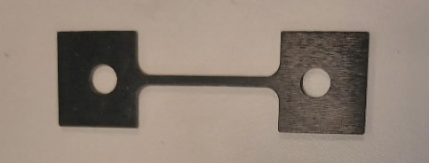

Results
For each material, the measurement (in mm) is that of the stretching read from the dial-gauge on the front of the device.
Load Nut | Steel | Aluminum | Duralumin | PVC
Movement
(mm) | (mm) | (mm) | (mm) | (mm)
0 | 0 | 0 | 0
0.2 | 0.08 | 0.17 | 0.17 | 0.06
0.4 | 0.25 | 0.24 | 0.35 | 0.13
0.6 | 0.45 | 0.52 | 0.54 | 0.19
0.8 | 0.63 | 0.7 | 0.73 | 0.23
1 | 0.81 | 0.87 | 0.9 | 0.25
1.2 | 1 | 1 | 1.1 | 0.2
1.4 | 1.7 | 1.24 | 1.28 | 0.18
1.6 | 1.38 | 1.41 | 1.45 | 0.15
1.8 | 1.56 | 1.58 | 1.65 | 0.13
2 | 1.75 | 1.75 | 1.83 | 0.13
2.2 | 1.93 | 1.89 | 2.02 | 0.15
2.4 | 2.12 | 2 | 2.2 | 0.14
2.6 | 2.31 | 2.09 | 2.39 | 0.14
2.8 | 2.49 | 2.2 | 2.57 | 0.14
3 | 2.66 | 2.26 | 2.74 | 0.14
3.2 | 2.84 | 2.38 | 2.92 | 0.15
3.4 | 3 | 2.43 | 3.1 | 0.14
3.6 | 3.14 | 2.51 | 3.28 | 0.14
3.8 | 3.25 | 2.58 | 3.46 | 0.15
4 | 3.37 | 2.61 | 3.64 | 0.14
4.2 | 3.5 | 2.67 | 3.82 | 0.14
4.4 | 3.62 | 2.7 | 4 | 0.14
4.6 | 3.74 | 2.7 | 4.16 | 0.14
4.8 | 3.85 | 2.76 | 4.32 | 0.13
5 | 3.96 | >snapped< | 4.46 | 0.13
6 | 4.43 |  | 4.75 | 0.12
7 | 4.77 |  | 4.92 | 0.11
8 | 5 |  | >snapped< | 0.12
9 | 5.24 |  |  | 0.14
10 | 5.3 |  |  | 0.11
20 | >snapped< |  |  | 0.11
30 |  |  |  | 0.08
40 |  |  |  | >snapped<

Analysis
In the graph below, the top line (Load Nut) measures the distance the top chuck/mount is pulled upwards by the operator. The X-axis aligns 1:1 with this line, as they are both displaying the top-chucks movement. The Y-axis is the movement measured by our front gauge/spring deflection.
Looking at the data in the form of a line graph, we can track the elasticity of the specimens more easily. Looking at the graph below, from 0mm of Load Nut movement up to 4.8mm of Load Nut movement, we can see the metals track in a consistent predictable manner – whilst the PVC quickly starts stretching. Where the machine puts on a load, the plastic does not hold that load/tension and stretches out – reducing the deflection of the springs below. The specimen “absorbs” the tension. So, at 3mm of load-nut movement, if the springs below read 2.5mm that means the specimen has stretched 0.5mm.
So, we see PVC is the weakest and Duralumin is the stiffest. By that I am commenting on their ability to withstand stretching forces acting upon their respective specimens. PVC should be ashamed of itself.
Below we can compare the

We can observe deformation across their entire respective load applied, for each specimen, using the following graphs which track the stress (measured in MPa) relative to the strain:

An anomaly can be observed within the data for steel, at 1.4mm of load-nut movement we measured a major jump in stretching. This is most likely due to a misread by the operator of the device, as the rest of the data follows a line/path you’d expect the data to follow. We can see the yield point occurring at 0.014179104 strain for our steel specimen, as it transitions into the plastic region before snapping after 0.07 strain.

Very typical data for our aluminum specimen here, no sudden elasticity nor abrupt shifts. It appears the yield point for plastic deformation occurred at an early point, under 0.00238806 strain.

The graph for duralumin here bears a path of data suggesting it did not experience plastic deformation. Just consistent tensile strength under load until eventually snapping. The entire experience for it appears to have taken place in the elastic region, with no yield point nor plastic region. Just elastic until the eventual snap.

This graph for our PVC specimen shows how garbage PVC is under stress/stretching forces. Once the stress reaches 12.5 MPa it leaves the elastic region, hits its yield point, and enters the plastic region. The specimen is eager to stretch beyond this point, making precise extension measurements tricky. We see that represented in this graph with data that jumps and dips as we move across.

Conclusion
Comparing our results to data we can find online; we see a difference in the curve.
Below we can see the tensile test results of a 6061 aluminum sheet following a tensile strength test (Safdarian, 2018). Their data shows a sharp spike followed by a smooth curve, leading to a sharp drop. Compared to our data, we see a smooth curve leading to the specimen snapping. This will in part be due to the composition of the aluminum used by the testers, being 6061 Aluminium (alloy), whereas ours was a pure aluminum specimen. This will also be due to the different scaling of our X-axes on the graphs, for I don’t know how to match my Y-axis data to specific X-axis increments.
Nonetheless, we can observe one constant. Under very small strain, we see the specimen reach the yield point. For R. Safdarian it occurs before 0.02 strain, early on his graph (Safdarian, 2018). For us, the same deal. It occurs early on our graph. As we know, beyond the yield point the materials no longer obey Hooke’s Law and enter the plastic deformation phase (Hooke, 1678). This point is referred to as the “Yield Stress”. The amount of stress required to make the material yield. With a constant and even increase in strain beyond this point, the increase of stress in relation to the strain actually decreases smoothly – resulting in a smooth curve on both of our graphs.
Given the small stretching tolerance of this material, we can denote aluminum as brittle.

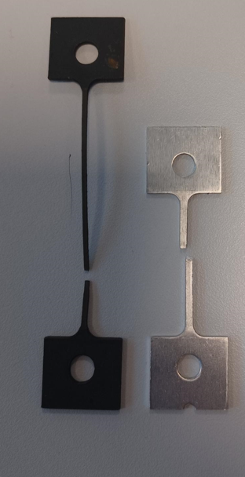
If we compare our PVC specimen to our Aluminum specimen, we can see very clearly the difference between a brittle material and a ductile material. PVC being the ductile one.
(ACHA4002, 2024)

Evaluation
Through the testing conducted on all specimens we made sure to be extremely precise with our adjustment of the top load-nut handle, this was to ensure we were applying an exact load to the chucks. Precise handling of the chucks ensures the data to be as accurate as can be.
The data was immediately noted down to ensure data was not forgotten or misremembered. We had 2 people operating the device and 1 person assigned to taking account of the readings using his laptop.
Granted, we appear to have one error from our testing. Errors can come from the simplest things, such as mis-reading the dial gauge. Perhaps, next time, it would be better to have someone double check the readings – though time is a concern.

Further Work
With more time and resources, we could improve this test by conducting it more than once per specimen/material. The usage of multiple specimens per material would allow the operators to observe if the same material reaches the yield point as the same/very similar points across multiple tests. This would provide evidence of consistency and repeatable data.
Conducting this test with specimens of various thicknesses/dimensions would provide a more rounded data set, allowing one to observe if Youngs Modulus (Young, 1801) is consistent across different shapes/sizes of the same material under load.
A certain way to ensure higher accuracy would be a video recorder recording the dial gauge, as we encountered an issue with the PVC stretching quickly once we let go of the adjustment handle on top to give the reader time to read the dial. With a camera, we could reduce (if not eliminate) the time needed to pause and interpret the dial readings.
With spare funding, attaching a party blower to activate upon snapping of the material would certainly give the operator a more satisfying end to the test.

References

ACHA4002, G. 3. (2024, November 13). Tensile Testing Lab Session. Swansea, UK.
Hooke, R. (1678). Lectures de potentia restitutiva.
Safdarian, R. (2018). Forming limit diagram prediction of 6061 aluminum by GTN. Behbahan: Mechanics & Industry.
Young, T. (1801). II. The Bakerian Lecture. On the theory of light and colours.

