
Computational methods
ACMA 6012
James Minton
2204900
10/04/2026

Word count: 3526

Contents
1 Introduction 4
2 Abstract 4
3 Governing Equation 4
4 Finite Difference Method 6
4.1 Introduction to finite Difference Approximations 6
4.2 Taylor Series Expansion 6
4.3 Finite Difference Approximation of First Derivatives 6
4.4 Finite Approximation of Second Derivatives 7
4.5 Truncation Error and Numerical Accuracy 7
4.6 Discretisation of the Spatial and Temporal Domains 7
4.7 Explicit Finite Method (EFDM) 9
4.8 Fourier Number and Stability Criterion 10
5 Initial Condition, Boundary Conditions and Analytical Solution 11
6 Code 12
7 Validation of the Model 22
8 Sensitivity Analysis of Key Numerical Parameters 26
9 Limitations of Numerical Model 29
9.1 Limitations linked to the numerical method EDFM 29
9.2 Coding implementation 31
10 Suggested Improvements and Future Developments 31
10.1 IFDM and ADI 31
10.2 Alternative Numerical Methods 31
10.3 Improved Thermal Equilibrium 31
10.4 Future development 32
11 Conclusion 32
12 References 32
13 Appendix 33

Introduction
This study will focus on the numerical solutions of the two-dimensional transient heat equation for a solid aluminium plate using the Explicit Finite Difference Method (EFDM). The aim of this report is to develop, validate, and critically assess a numerical model for transient heat conduction, while identifying the limitations of the EFDM approach and the implications of numerical parameter selection on solution accuracy and physical interpretation.

Abstract
The study shows the numerical solution of a two-dimensional transient heat conduction equation using Explicit Finite Difference Method (EDFM). The model simulates heat diffusion within a rectangular aluminium plate that is subject to Dirichlet boundary condition with a fixed temperature along the north boundary.
Validation of the numerical model was performed by comparing the EFDM solution with a truncated analytical Fourier series, evaluated using up to 50,000 terms. The results demonstrated strong correlation between the low root mean square error (RMSE) and maximum absolute error, confirming the accuracy of the implementation. However, localised discrepancies were observed near boundary corners, due to discretisation error amplifying in regions of high temperature gradients.
A sensitivity analysis was also conducted to study the effects of grid spacing, time step, and convergence tolerance on solution stability and accuracy. The results showed monotonic behaviour with grid refinement, consistent with second-order spatial accuracy, while the time-step variation exhibited non-monotonic behaviour due to the competing factor of temporal truncation error and round-off error. It was also shown that the convergence criterion defines a purely numerical condition, showing that the predicted equilibrium time does not represent a physically meaningful result.
The study also includes key limitations of the EFDM approach, including discretisation errors, geometric restrictions imposed by the five-point stencil, and sensitivity to boundary conditions.

Governing Equation
Heat transfer via conduction is the physical process of analysing the transport of thermal energy within a solid material. Applications such as heat exchangers, electronic cooling systems and structural components, assessing the temperature distribution within a solid material is essential for having thermal integrity, efficiency and safety. The behaviour of heat transfer through solid material is mathematically described by the heat equation that is derived from theprinciple of energy conservation and Fourier’s law of heat conduction. (Özisik, 1993; Holman, 2010).
The heat equation provides a link between the variation in temperature and the distribution within the material; these are known as temporal variation of temperature and spatial distribution of material. In this study the heat equation is applied to model the transient heat conduction through a two-dimensional aluminium plate, with constant and isotropic material properties, and no heat source to be considered.

For a two-dimensional solid domain with no internal heat generation, the heat equation is expressed as:

$$\frac{∂T}{∂t}=α∙\left(\frac{∂^{2}T}{{∂x}^{2}}+\frac{∂^{2}T}{{∂y}^{2}}\right)$$
(Equation 2.1, Holman, 2010)
This equation shows the balance between the rate of change of the thermal energy within the material and the conductive heat flux in the spatial directions. (Croft & Lilley, 1977)
Where:
$T(x,y,t)$is the temperature (K or °C)
$t$ is time (s)
$x$ and $y$ are the spatial coordinates in the two-dimensional plane (m)
$α=\frac{k}{ρ_{Cp}}$ thermal diffusivity ()

$k$ is the thermal conductivity of the material (W·m⁻¹·K⁻¹)
$ρ$ is the density of the material (kg·m⁻³)
$c_{p}$ is the specific heat capacity at constant pressure (J·kg⁻¹·K⁻¹)
The ratio $\frac{k}{ρ_{Cp}}$ is known as the thermal diffusivity this ratio quantifies the rate of which the heat diffuses through a solid material, meaning materials with a higher thermal diffusivity respond more rapidly to change in thermal boundary conditions, making this ratio critical in heat transfer analysis. (Özisik, 1993)

Finite Difference Method

Introduction to finite Difference Approximations
One of the most widely used numerical techniques for solving partial differential equations is the Finite Difference Method (FDM). FDM is based on approximating the derivatives in the differential equation using the Taylor series expansions. By approximating the derivatives with simple algebraic difference expressions, the heat equation can be transformed into one or a set of linear equations that can be solved. (Smith, 1985; Versteeg and Malalasekera, 2007).

Taylor Series Expansion
A Taylor series expansion is expressed in terms of its value and derivatives at a reference point. For example, the function $T\left(x_{0} +h\right)$ the Taylor series expansion about the point $x_{0}$ is given as:
$T\left(x_{0}+h\right)=T\left(x_{0}\right)+h\frac{∂T}{∂x}+\frac{h^{2}}{2}\frac{∂^{2}T}{{∂x}^{2}}+\frac{h^{3}}{6}$ $\frac{∂^{3}T}{{∂x}^{3}}+O\left(h^{4}\right)$
(Equation 3.1 Chapra and Canale, 2015)

Where $h$ is the spatial step size and $O\left(h^{n}\right)$ is the higher order terms that are neglected in the approximation of $T\left(x_{0}+h\right)$. (Holman, 2010; Chapra and Canale, 2015).”

Finite Difference Approximation of First Derivatives
Applying the Taylor series expansions, the first derivative with respect to $x$ can be approximated using the forward difference approximation:

$$\frac{∂T\left(x_{0}\right)}{∂x}=\frac{T\left(x_{0}+h\right)-T\left(x_{0}\right)}{h}+O\left(h\right)$$
(Equation 3.2 Chapra and Canale, 2015))
The approximation has a truncation error of order $O\left(h\right)$ this mean that the error decreases linearly as the grid spacing is reduced. (Smith, 1985; Chapra and Canale, 2015).

Finite Approximation of Second Derivatives
The second derivative that appears in the heat equation is approximated using a central difference formula:
$$\frac{∂^{2}T}{{∂x}^{2}}=\frac{T(x_{0}+h)-2T(x_{0})+T(x_{0}-h)}{h^{2}}+O(h^{2})$$
(Equation 3.3 Ferziger and Perić, 2002)
This approximation has a truncation error of order $O\left(h^{2}\right)$ this means that the error decreases quadratically as the grid spacing is reduced. (Smith, 1985; Ferziger and Perić, 2002).

Truncation Error and Numerical Accuracy
Truncation error is the difference between the exact derivative and the finite difference approximation due to the neglected higher order terms in the Taylor series. Therefore, decreasing the spatial step $h$ decreases the truncation error. While a small h is ideal for an improved accuracy, from a numerical perspective, a small h increases the computational cost due to the higher number of grid points that this implies. A balance must therefore be found between numerical accuracy and computational efficiency.
The truncation errors introduced in the discretisation process are used for later analysis of how the grid spacing and time step impact the solution stability, convergence and overall accuracy (Chapra and Canale, 2015; Ferziger and Perić, 2002). These are particularly important for transient heat conduction problems that use explicit time-marching, as stability constraints add additional limitation on the numbers of time steps.

Discretisation of the Spatial and Temporal Domains
To have a numerical solution for the transient heat equation the spatial and temporal domains must be discretised as we cannot compute the heat transfer for an infinite amount. This changes the temporal and spatial continuous domains to domains with a finite set of points that the temperature field is approximated in, forming the start of the explicit finite difference method. (Smith, 1985; Versteeg and Malalasekera, 2007).
Spatial Discretisation:
The physical domain that is considered is an aluminium plate; this plate is dived into $Lx$ and $Ly$ directions creating a uniform grid with a constant grid spacing $h$ in both the X and Y directions.

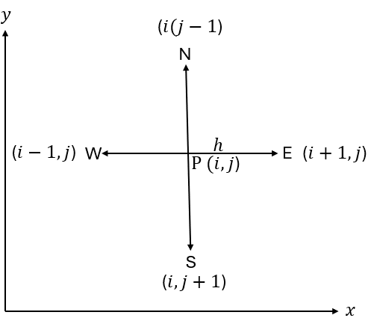
Figure 3.1 the five-point stencil
To amount of grid points in both direction is calculated as:
$$N_{c}=\frac{Lx}{h}+1{ N}_{r}=\frac{Ly}{h}+1$$
(Equation 3.4)

Where $Nc$ is total number grid point in the Y direction and $Nr$ is the total number of grid points in the Y direction.
The temperature at each point is the grid stored in temperature matrices T1 and T2 where:
$$T_{i,j}^{n}≡T1\left(i,j\right) at time level n$$
$$T_{i,j}^{n+1}≡T2\left(i,j\right) at time level n+1$$
represents the temperature at the spatial locations $x_{j}$ and$y_{i}$ at the current and next time levels.
Temporal Discretisation:
The temporal domain is discretised into equal time steps $∆t$ that is chosen by the user. The time advancement is used explicitly; this means that the temperature at the next time level (n+1) is dependent on the values from the previous time level (n).
A single time level is defined by $n$ where:
$$t^{n}=nΔt$$

Explicit Finite Method (EFDM)
To create the EFDM the derivatives are approximated as follows:
- Temporal forward derivative approximation, at the grid points ($ⅈ,j$) and time level $n$, with the truncation error $O(Δt)$
$$\frac{∂T}{∂t}=\frac{T_{i,j}^{n+1}-T_{i,j}^{n}}{∆t}+O(Δt)$$

(Equation 3.5)

- Spatial central second derivative approximation.
x and y directions both have spatial approximations with truncation error $O\left(h^{2}\right)$ where $h=∆x=∆y$:
$$\frac{∂^{2}T}{∂x^{2}}=\frac{T_{i+1,j}^{n}-2T_{i,j}^{n}+T_{i-1,j}^{n}}{h^{2}}+O\left(h^{2}\right)$$

$$\frac{∂^{2}T}{∂y^{2}}=\frac{T_{i+1,j}^{n}-2T_{i,j}^{n}+T_{i,j-1}^{n}}{h^{2}}+O\left(h^{2}\right)$$
(Equation 3.6)

This can then be substituted into the heat equation 2.1:
$$\frac{T_{i,j}^{n+1}-T_{i,j}^{n}}{∆t}=α\left(\frac{T_{i+1,j}^{n}-2T_{i,j}^{n}+T_{i-1,j}^{n}}{h^{2}}+\frac{T_{i+1,j}^{n}-2T_{i,j}^{n}+T_{i,j-1}^{n}}{h^{2}}\right)$$
(Equation 3.7)

This equation can then be rearranged for the unknown temperature $T_{i,j}^{n+1}$ to get the EFDM formula:
$T_{i,j}^{n+1}=T_{i,j}^{n}+α∆t\left(\frac{T_{i+1,j}^{n}-2T_{i,j}^{n}+T_{i-1,j}^{n}+T_{i+1,j}^{n}-2T_{i,j}^{n}+T_{i,j-1}^{n}}{h^{2}}\right)$ (Equation 3.8)

Fourier Number and Stability Criterion
Fourier number:
Fourier number is ratio of diffusive transport rate over thermal energy storage rate. This ratio controls the balance between temporal discretisation and spatial discretisation, physically speaking it measure how far the heat can diffuse during a single time increment relative to the spacing of the grid. Rearranging the equation for the Fourier number gives:
$$T_{i,j}^{n+1}=T_{i,j}^{n}+Fo\left(T_{i+1,j}^{n}+T_{i-1,j}^{n}+T_{i,j+1,}^{n}+T_{i,j-1}^{n}+4T_{i,j}^{n}\right)$$
(Equation 3.9)

Fourier number equation:
$$Fo=\frac{α∆t}{h^{2}}$$
(Equation 3.10 Versteeg and Malalasekera, 2007)

$Δt$= time step (s)
$h$= spatial grid spacing (m)

As the time step increase so does the Fourier number, while increasing the grid number also increases the Fourier number, a refinement of spatial resolution needs a proportional reduction in time step to maintain the numerical stability. The relationship between time and space discretisation is a defining feature of explicit methods. (Ferziger and Perić, 2002; Versteeg and Malalasekera, 2007).

Stability of Explicit Finite Difference Method:
The stability of the EFDM is controlled by the magnitude of the Fourier number as the EFDM is conditionally stable.
According to von Neumann stability analysis, that evaluates the growth of the Fourier errors analysing the truncation error within the scheme, the stability criterion of a two-dimensional heat equation is (Smith, 1985; Morton and Mayers, 2005.):
$$Fo≤\frac{1}{4}$$

The criterion guarantees that the numerical errors add by each time step do not increase exponentially, however if:
$$Fo>\frac{1}{4}$$
The output becomes unstable adding oscillatory behaviour and divergence of the temperature field.
The stability criterion can be rearranged to allow for the maximum time as:
$$∆t≤\frac{h^{2}}{4α}$$
(Equation 3.11)

This equation ensures that the numerical solution stays stable and physically meaningful.

Initial Condition, Boundary Conditions and Analytical Solution
The initial and boundary conditions considered are:
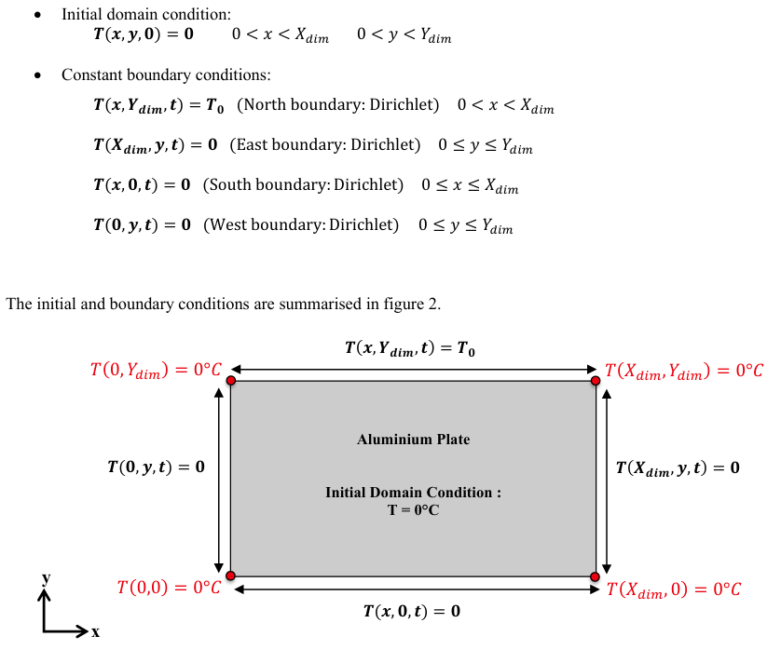
Figure 4.1 Boundary conditions
These conditions have been chosen because they provide an analytical solution against which the code will be tested.
The analytical solution is the following Fourier series:
$$T\left(x,y\right)=\frac{4∙T_{0}}{π}×\sum_{n=0}^{∞}{\left[\frac{1}{k}∙\sin\left(\frac{kπx}{X_{dim}}\right)∙exp\frac{\left(\frac{kπ(y-Y_{dim}}{X_{dim}}\right)-exp\left(\frac{-kπ(y+Y_{dim⁡)}}{X_{dim}}\right)}{1-exp\left(\frac{-2kπY_{dim}}{X_{dim}}\right)}\right]}$$
$$k=2n+1$$
(Equation 4.1 Özisik, 1993; Carslaw and Jaeger, 1959)

The solution cannot be evaluated using an infinite number of terms and must therefore be truncated to a finite number of terms. This introduces a truncation error, as the higher-order terms in the series are ignored. However, the contribution of these higher-order terms decreases due to the exponential behaviour of the hyperbolic sine functions. Meaning a larger number of terms can provide a more accurate approximation.
The temperature predicted by the Fourier series along the north boundary ($y=Y_{dim}$) was compared against the imposed boundary condition $T=T_{0}$, because the solution must meet these conditions the deviation between the computed and prescribed values are a direct measurement of the truncation error.
It was observed that as the number of terms increases, the solution converges toward the exact boundary condition with the error decreasing. Although beyond a certain number of terms the increase in the terms produces negligible changes in the temperature distribution.

Code
This chapter present the MATLAB code created to solve the two-dimensional transient heat equation using EFDM, each section of the code demonstrates the mathematical solution shown in figures (fill in later) and how it was implemented.
Section 1 workspace management- This section sets the MATLAB environment before running the code.
Section 2 material properties- This section defines the properties of the material
The thermal diffusivity calculated as:
α$=\frac{k}{ρ_{Cp}}$
the thermal diffusivity controls the rate at which the heat moves through a given material and appears at the start of the heat equation.
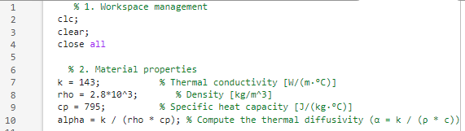
where:
- $k$= thermal conductivity
- $ρ$= density
- $c_{p}$= specific heat capacity

Section 3a plate dimensions- This code prompts for the user-defined inputs for the domain size and spatial resolution, the grid point spacing h determines the discretisation accuracy as previously discussed in chapter 3 decreasing the h value increases the accuracy but cost more computation resources and restricts the allowable time steps due to stability limits
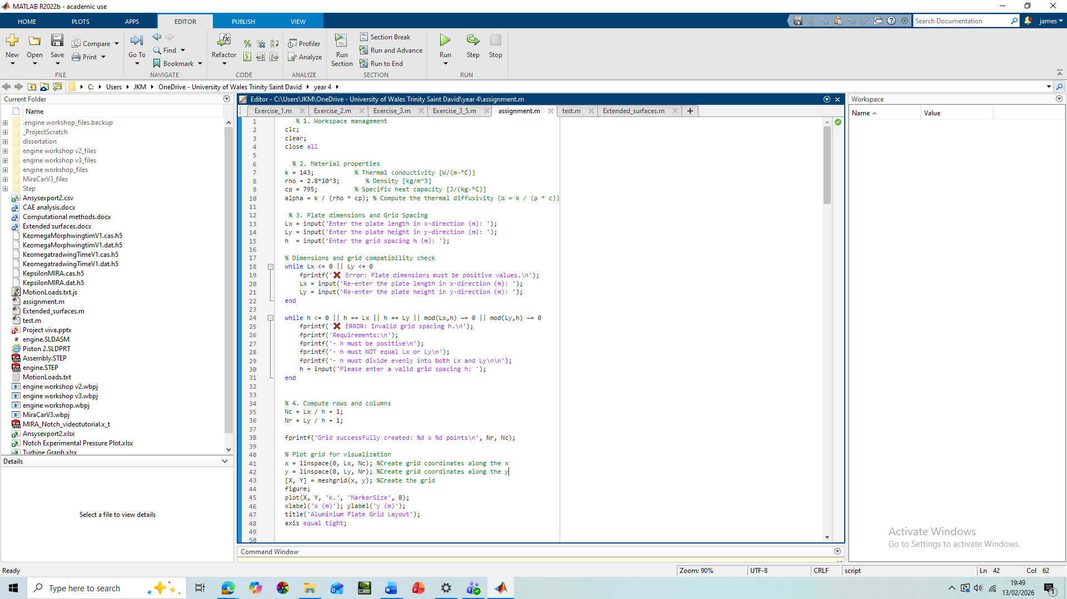
Section 3b Grid compatibility- This validation loop stops the geometry of the plate from becoming a negative value while a second validation loop checks the grid’s compatibility preventing fractional grid nodes appearing ensuring the grid stays consistent, this is because a grid that has negative values or is zero is physically impossible.
Section 4a grid generation- This section generates the columns and row the +1 accounts for the boundary nodes.
The line-space code generates evenly spaced coordinates for the plate, while mesh-grid code creates a 2D computational domain.

Section 4b grid visualisation- The grid visualisation confirms that the grid is generated correctly and has equal spatial discretisation.
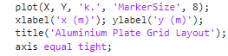
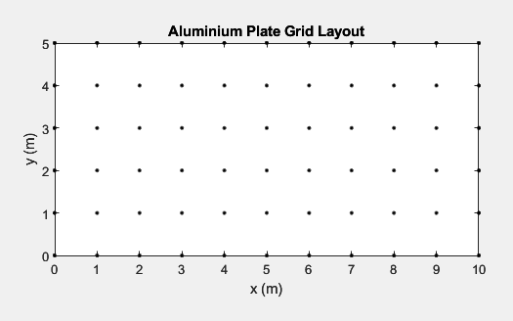
The axis equal function saves the geometric properties while the tight function removes any unneeded white space.

Section 5a temperature matrix- this code initialises the temperature matrix T1 this allows the temperature values to be stored at each grid node.
Nr = number of rows (y direction)
Nc = number of columns (x direction)
The matrix is filled with zeros this is the initial temperature condition before the boundary heat source is applied: T (x, y, 0) = 0
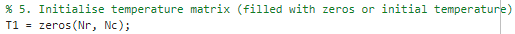

Section 5b Boundary conditions- this code allows the user to apply a fixed temperature to the north boundary.
With the following matrix indexing:
- 1 is the first row of the matrix
- 2: end-1 excludes the corner nodes
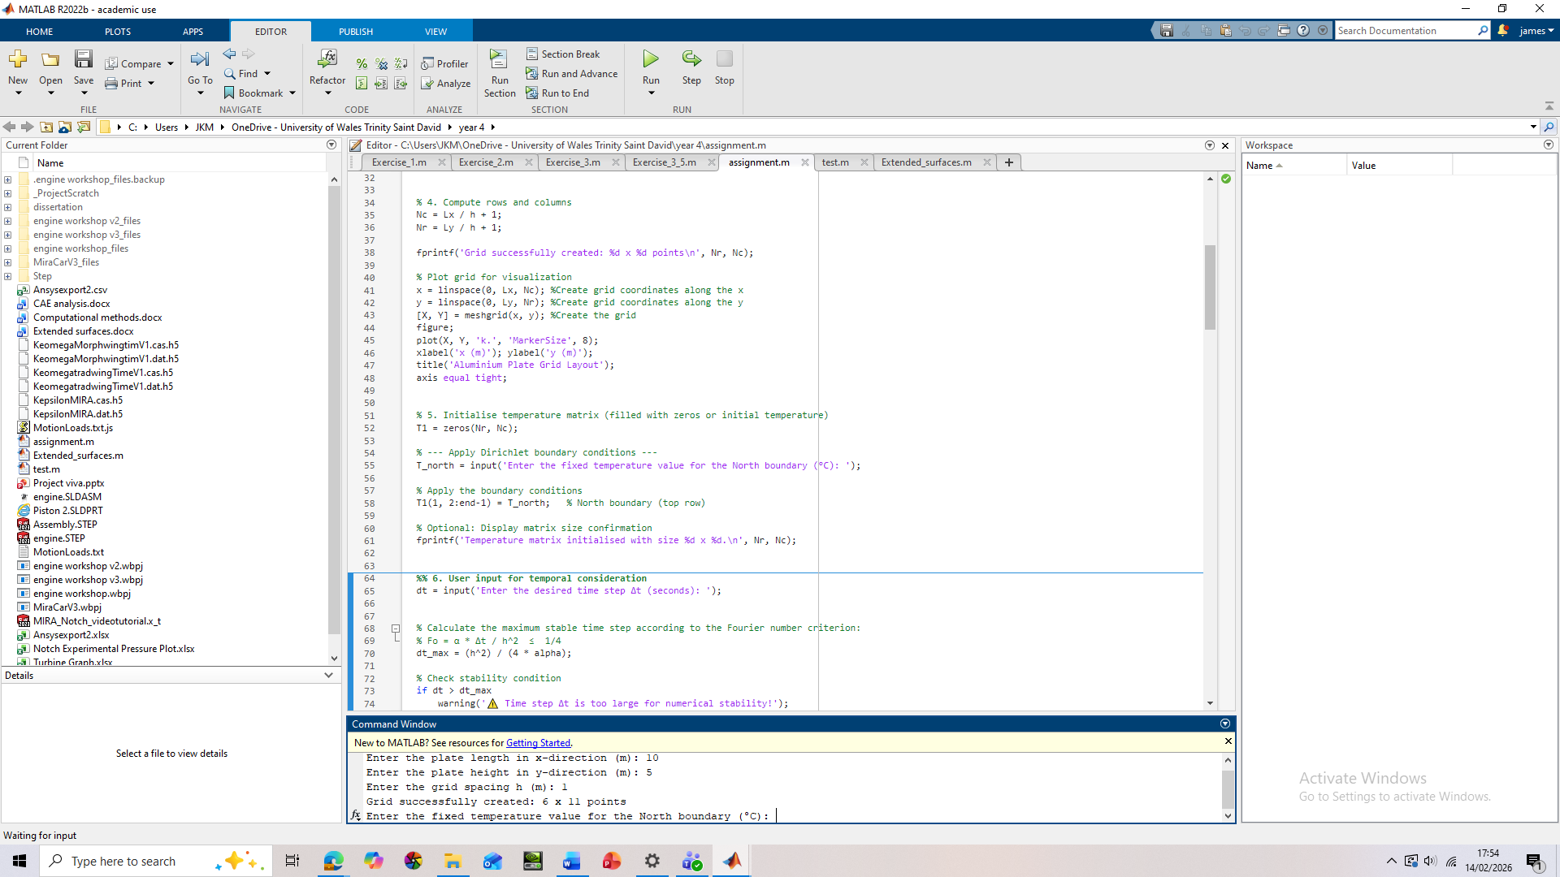

Section 5c matrix confirmation size- This confirms if the grid has been correctly generated and that the temperature matrix dimensions match that of the computation domain.

Section 6a Time step selection and Fourier number- this section the user selects the number of s time steps, however in explicit schemes not every time steps are numerically stable. The Fourier number represented as dt_max is the maximum number of time steps that can be achieved before stability issues occur.
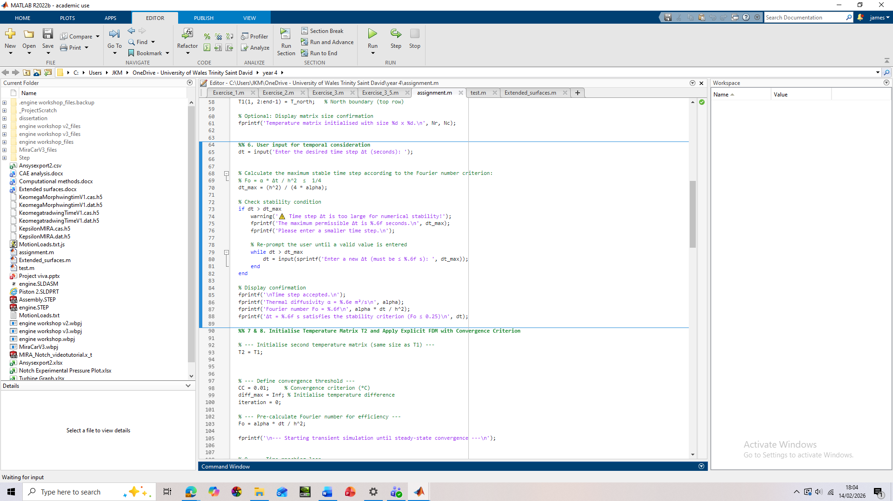

Section 6b stability checks- if the user selects a time step value that is larger than the allowable time step the code will not move forward. This is because a time step that is above the maximum threshold with introduce numerical stability.
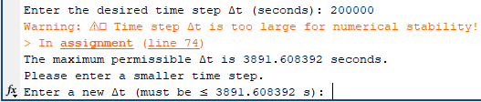

Section 6c confirmation output- prints the Fourier number used so the user can verify $F_{0}=\frac{αΔt}{h^{2}}$

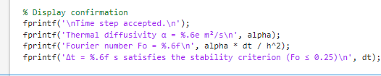
And that it is with accordance of $F_{0}≤0.25$
Section 7 second temperature matrix and convergence- This create a second matrix T2 that is the same size as the matrix T1, doing so preserves the mathematical form of the discretised heat equation.
CC = stopping tolerance
diff_max = largest temperature change between iterations
iteration = time-step counter

Convergence is when the transient solution has reached a steady state $\frac{∂T}{∂t}=0$
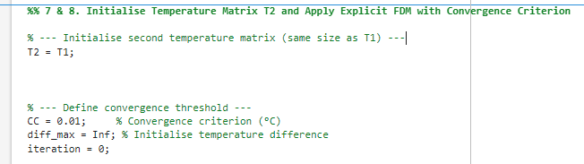
Section 8 Fourier number- controls how the temperature diffuses at each time step while satisfying $Fo≤0.25$
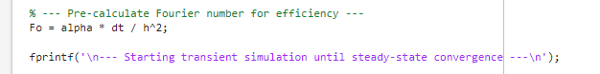
Section 9a time marching loop- Each pass through this loop increases the solution by one time step +1
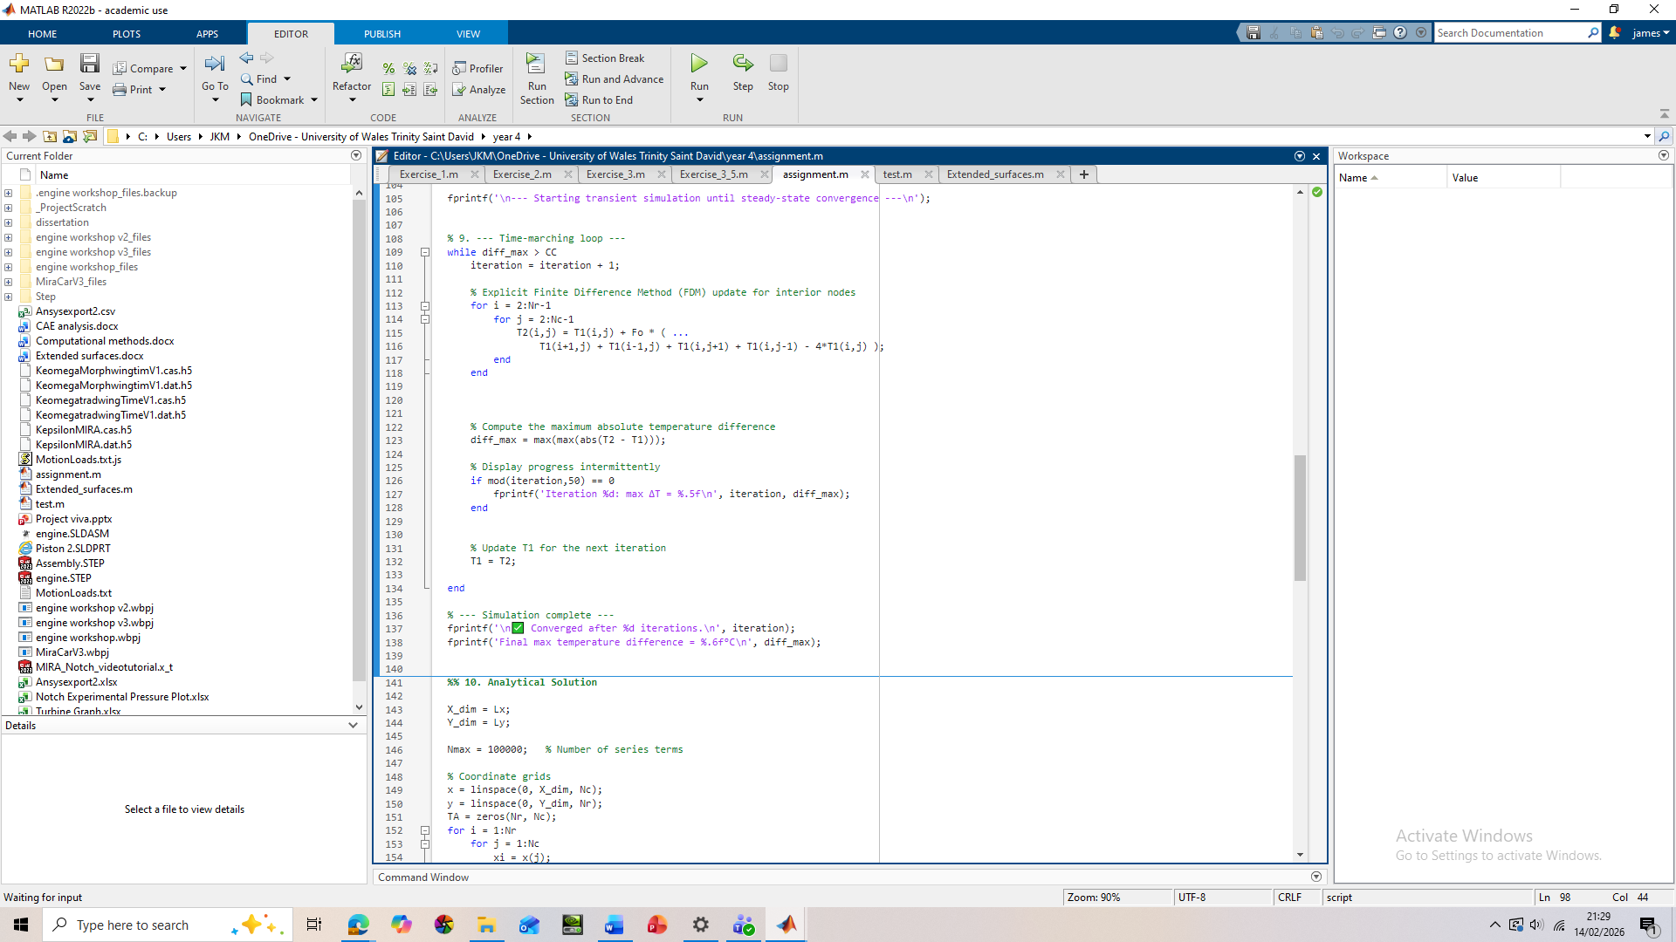
Section 9b EFDM for interior nodes- the reason it starts at 2 and ends at Nr-1 is because the boundaries are fixed (Dirichlet condition) and only the interior nodes are updated.
This model the discretised equation (3.4) based on the five-point stencil described in section 3.6.

Section 9c temperature difference- this code measures the absolute maximum temperature difference allowing the user to find out how far they are from steady state.
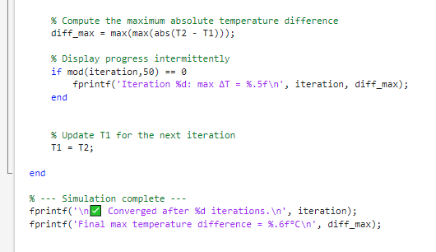
It then displays the results for every 50 integration this helps analysis the convergence rate, numerical behaviour and if there is any instability.
After computing $T^{n+1}$it will become the new $T^{n}$ for the next iteration, repeating the process.
When $diffmax<CC$ the loop will stop, creating an end condition meaning the transient solution has converged to the steady state. It is important to note here that this mathematical definition of steady state might not be a true definition of thermal equilibrium from a physical standpoint. This will be illustrated in the sensitivity analysis.
Section 10a domain sizes, series term and grid coordinates- the start of this section code assigns physical plate dimensions. A analytical solution is then provided as an infinite Fourier series, since it is impossible to compute an infinite sum. A sufficiently large number of terms is chosen to improve accuracy as explained in chapter 4. This does however imply additional computational time. A grid is then created to initialise the temperature from the matrix TA.
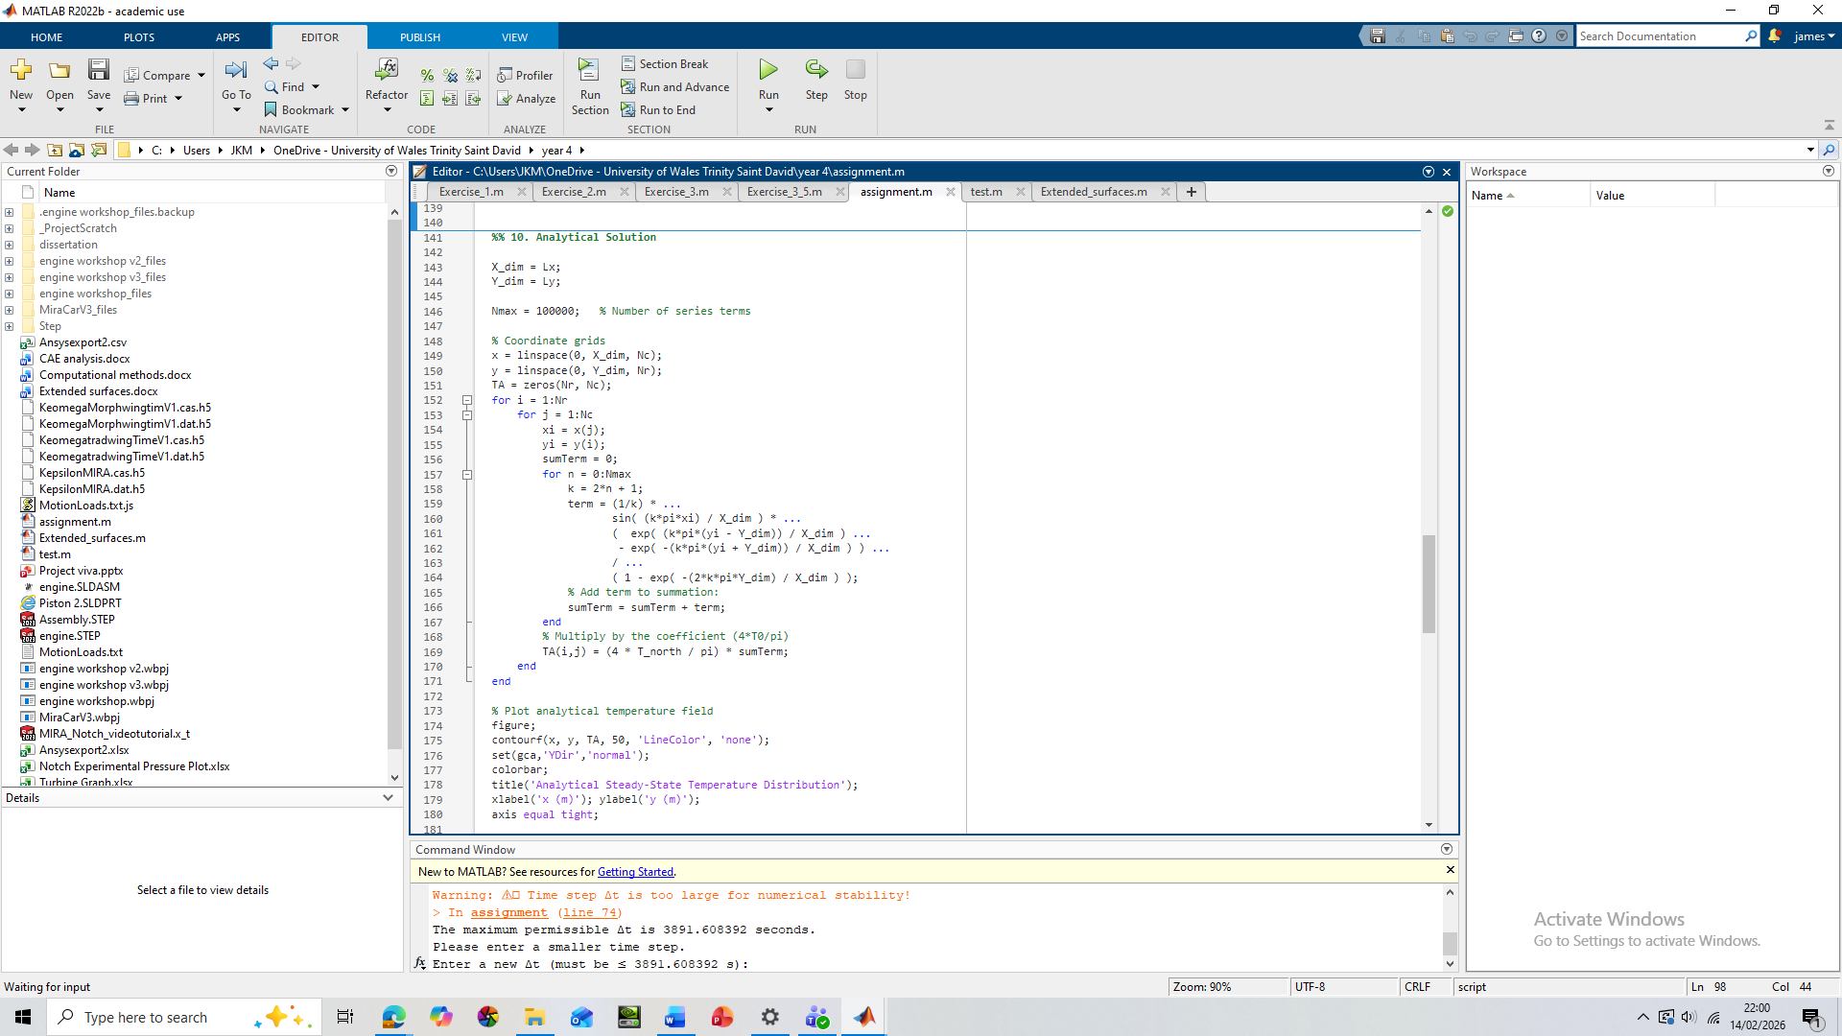
Section 10b analytical term- Firstly the analytical term is computed at every grid point, then the Fourier series in expanded creating odd harmonics k=1,3,5, 7..., this occurs because the boundary conditions correspond to a half-range sine series.
The core analytical equation is then applied implements the steady state plate solution, once this is done the code builds the Fourier series term by term. The full analytical solution is then applied making TA contain the steady sate solution.
Finally, a plot is generated this produces a contour plot, displays the temperature distribution, adds 50 contour levels and ensures the correct axis orientation
Section 11a validation – The first part of the code flips analytical solution orientation so that it matches the numerical solution so both can be compared, then the code calculates the absolute pointwise error field, it then uses the rmse() and max() functions to calculate the root mean square error across the plate and the worst error anywhere in the domain. These are then displayed in the command window.
It should be considered that the RSME calculation only considers the interior domain and excludes the boundary points. This is because the boundary conditions are explicitly enforced in the numerical and analytical solutions.
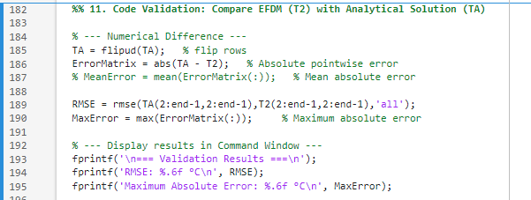
Section 11b validation plots- 3 plots of then displayed in order of numerical plot (EDFM), analytical plot and the error distribution plot. These plots can then be cross analysed with one another
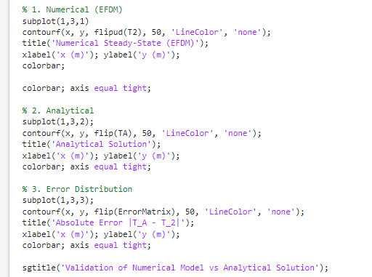

Section 12 time to thermal equilibrium- This code turns numerical iterations into a physical time that can be more easily understood, rather than displaying just seconds the code converts the time into separate margins:
Seconds (< 1 min)
Minutes (< 1 hour)
Hours (< 1 day)
Days (≥ 1 day)

The code shows convergence tolerance (cc), the total number of iterations, the time step size and the total physical time, with a final display showing the final steady-state numerical temperature field T2 and the exact steady-state solution TA allowing a full inspection of the deviations, spatial error structure and pointwise accuracy.
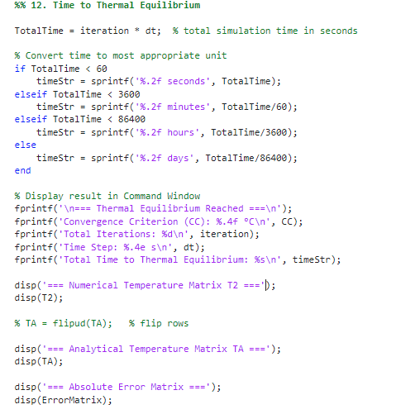

Validation of the Model
The analytical solution was evaluated using 1,000, 10,000 and 50,000 Fourier terms to assess the impact of series truncation. To quantify the truncation error, the temperature along the north boundary (where $T0={100}^{∘}C$).
Number of terms: 1000
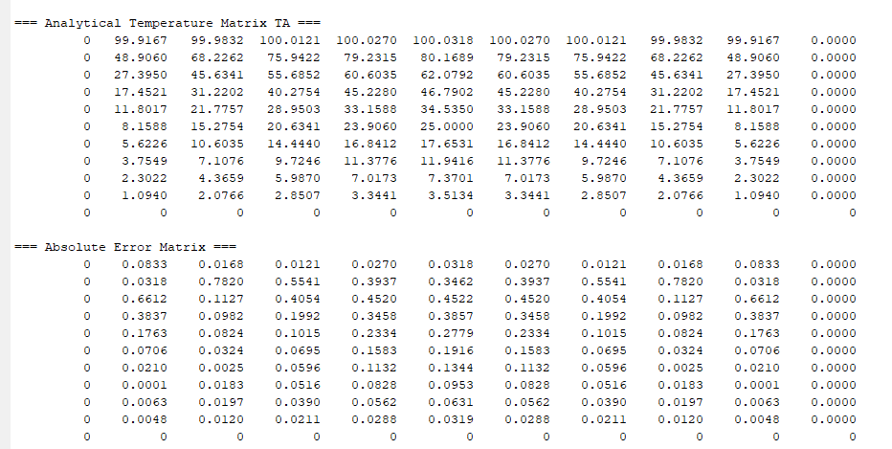
Number of terms: 10,000
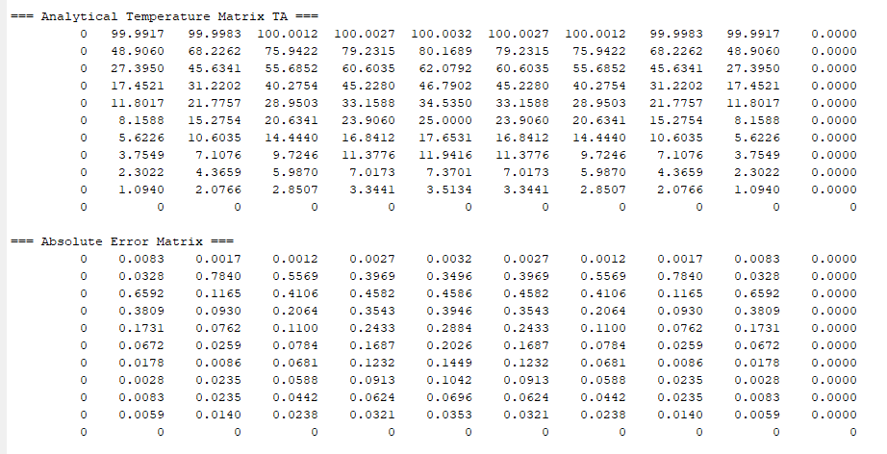

Number of terms: 50,000
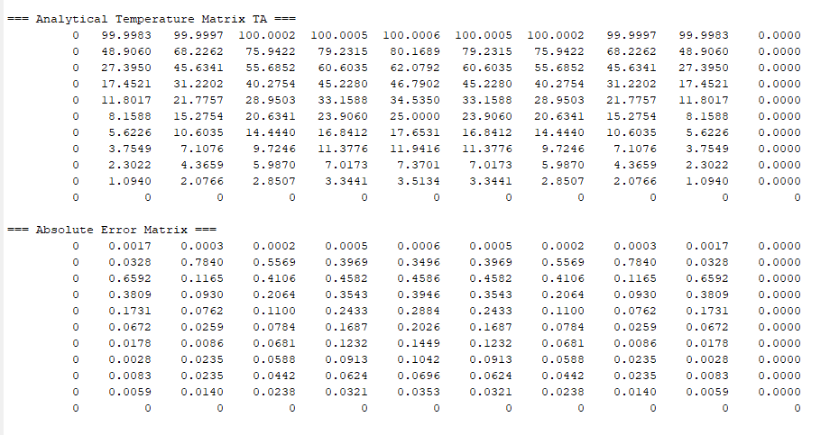
For 1,000 terms, noticeable deviations were present near the north boundary, particularly close to the corners, indicating insufficient convergence of the series. Increasing to 10,000 terms significantly reduced the error, while at 50,000 terms the maximum truncation error along the north boundary became negligible, confirming convergence of the Fourier series.
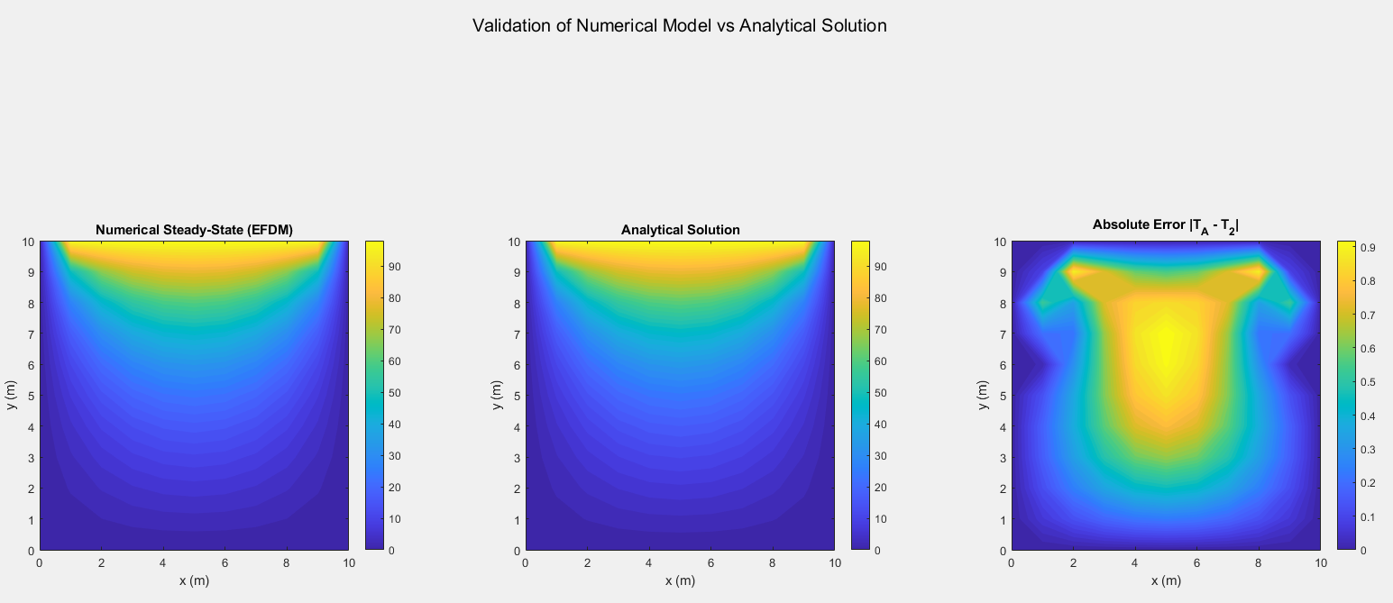
Enter the plate length in x-direction (m): 10
Enter the plate height in y-direction (m): 10
Enter the grid spacing h (m): 1
temperature value for the North boundary (°C): 100
step Δt (seconds): 900
=== Validation Results ===
RMSE: 0.537464 °C
Maximum Absolute Error: 0.936697 °C
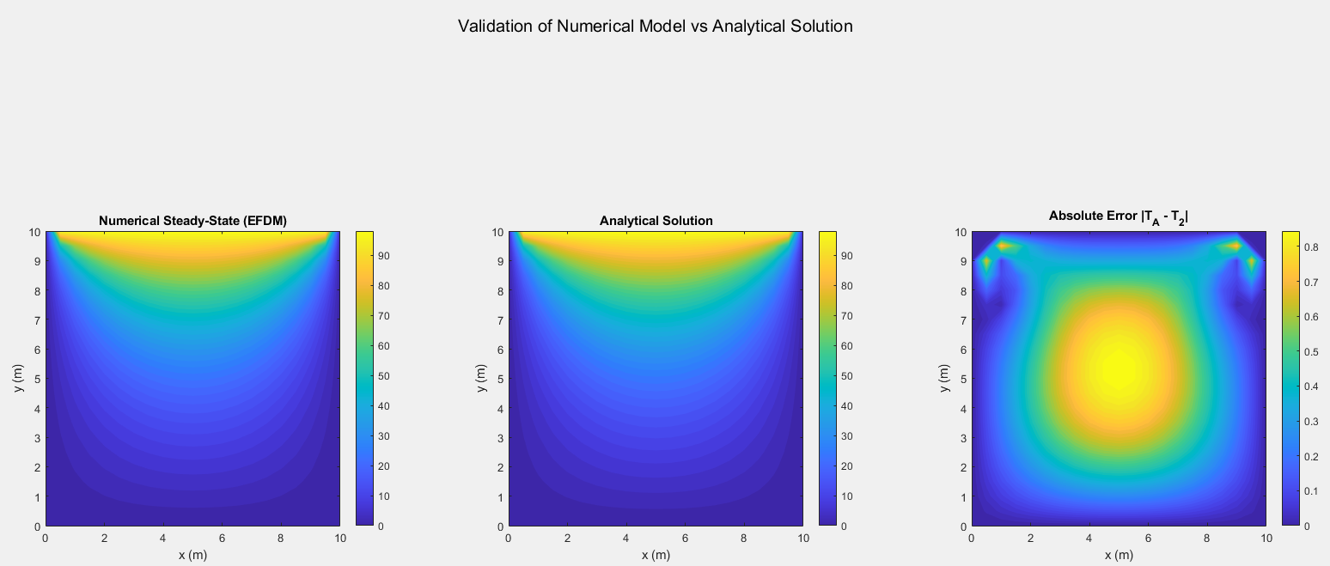
Enter the plate length in x-direction (m): 10
Enter the plate height in y-direction (m): 10
Enter the grid spacing h (m): 0.50
temperature value for the North boundary (°C): 100
time step Δt (seconds): 900
=== Validation Results ===
RMSE: 0.466227 °C
Maximum Absolute Error: 0.861087 °C

The absolute error distribution shows that the largest discrepancy happens near the top corners, while the interior regions show a very small error. The spatial distribution of error shows a clear concentration near the top corners of the domain. This behaviour arises from three numerical effects:
- Boundary gradient effects:
The north boundary imposes a temperature discontinuity relative to adjacent boundaries, creating steep temperature gradients. Discretisation errors increase in areas of high gradients because derivative approximations become less accurate when the solution varies rapidly over a small spatial distance. (Roache, 1998; Ferziger and Perić, 2002).
- Grid discretisation error:
The scheme implements a second-order central approximation, creating an error proportional to $O(h^{2})$. While this error is small inside the domain where the solution is smooth, it increases near the boundaries where gradients are the largest and the grid resolution may be insufficient to fully capture the change.
- Second-order truncation error:
The central difference approximation introduces a truncation error proportional to the second spatial derivatives of temperature. Near the corners, where curvature of the temperature field is highest, this truncation error locally increases.
The combined effect of these mechanisms explains why the maximum absolute error is localised near the top corners, while the interior domain exhibits very low error.
The root mean square error (RSME) is relatively small to the maximum temperature indicating a strong relationship between the solutions.
Where $N$ is the amount of grid points
$$RMSE= \sqrt{\frac{1}{N}\sum_{i=1}^{N}{(T_{A}-T_{EFDM})^{2}}}$$
Key observations- The temperature distribution are visually the same, the maximum error is small, the RSME confirms low deviation, and the error pattern is consistent with second order behaviour.
The validation shows that the EFDM implementation is reliable, correct and reasonably accurate for steady-state heat conduction problems.

Sensitivity Analysis of Key Numerical Parameters
The objective in this chapter is to assess how variations in grid spacing, time step and thermal equilibrium tolerances influence the predicted temperature distribution. By changing each parameter, the reliability of the model can be tested, and appropriate parameter ranges can be identified. All combinations of grid spacing $h$, time step $Δt$, and convergence tolerance (CC) used in this sensitivity study were selected such that the stability condition for the two-dimensional explicit finite difference method was satisfied:
$$Fo=\frac{αΔt}{h^{2}}≤0.25$$
This ensures that the numerical scheme remains conditionally stable throughout all simulations.
Grid spacing:
The results show that for a fine grid mesh $h=0.75$ the thermal equilibrium times start to stabilise until any further mesh refinement produces negligible effects in the time equilibrium that indicates grid convergence.
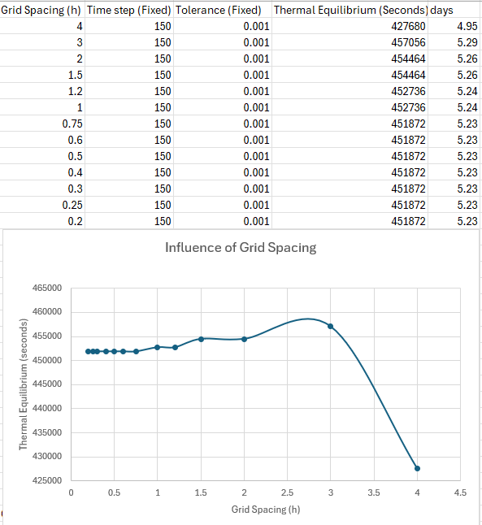
This is consistent with the spatial discretisation error theory that the second order central scheme used for spatial discretisation creates an error proportional to $O\left(h^{2}\right)$. As $h$ increases the truncation error increases reducing the accuracy of gradient representation (Smith, 1985; Hoffman, 2001)
The results show monotonic behaviour as the grid spacing is altered creating oscillations in the graph, as $h=0.75$ the solution begins to converge showing that the spatial discretisation error has become negligible and a clear convergence is reached.
Time step:
The results show non-monotonic behaviour that does not converge, the reason for this is the change in the time steps. For small time steps the temporal discretisation creates low truncation errors this does mean however it needs many iterations to ready steady state, the large number of iterations increases the round-off errors caused by limited numerical precision.
Larger time steps reduce the total number of iterations in turn decreasing the round-off error but at the expense of increasing the truncation error.
Both errors reduce the accuracy of the solution it is therefore suggested to select a middle ground where both errors are weighted equally.
A more rounded explanation is that varying $Δt$ changes the truncation error compared to spatial discretisation error $O(h^{2})$. For small $Δt$, spatial errors dominate, for larger $Δt$, temporal errors become more significant. This balance between $O(Δt)$and $O(h^{2})$errors is well established in numerical analysis (Smith, 1985; Chapra and Canale, 2015, Ferziger and Perić, 2002).
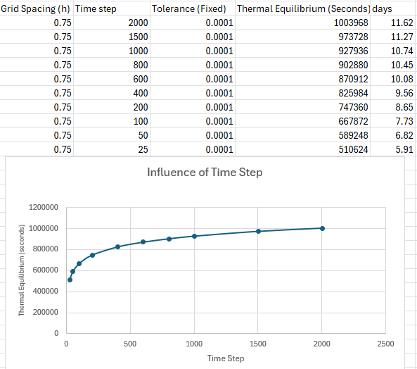
Tolerance (CC):
The tolerance is used to determine when thermal equilibrium has been reached, this is based on the maximum allowable difference between the successive temperature fields.
A larger CC value will increase the risk of a premature convergence to occur, whereby the simulation acknowledges a convergence before a true steady-state solution is found, leading to reduced solution accuracy and under-developed temperature fields.
A small value CC enforces a stricter convergence tolerance requiring a higher level of mathematical precision as it minimises the difference between the successive iterations.
While this provides a practical measure of numerical convergence, it does not correspond to the physical definition of thermal equilibrium. (Roache, 1998; Ferziger and Perić, 2002).
A critical implication of this is that the equilibrium time reported by the model is not a physically meaningful quantity, but rather a numerical solution on the chosen tolerance. Therefore, the predicted time to thermal equilibrium should be interpreted cautiously, as it reflects the convergence behaviour of the numerical scheme rather than the true physical evolution of the heat transfer. This distinction is fundamental in transient heat transfer modelling and highlights a limitation of using purely numerical stopping criteria (Roache, 1998; Ferziger and Perić, 2002).

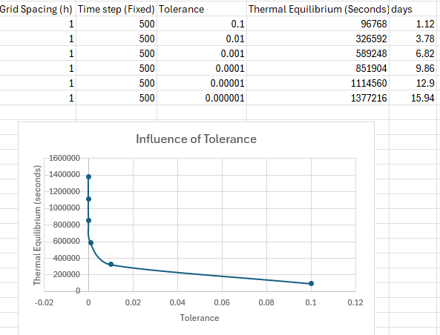
Summary:
The modelling of thermal equilibrium using this mathematical framework shows a key limitation between the numerical convergence and the true physical equilibrium. This is what the sensitivity test demonstrates, reinforcing the fact that this numerical scheme is not ideal and must be amended or a different model used.

Limitations of Numerical Model

Limitations linked to the numerical method EDFM
- Truncation errors and round-off errors: The sensitivity analysis demonstrated that spatial and temporal discretisation errors directly influence the accuracy and behaviour of the solution. For grid spacing, a clear monotonic convergence trend was observed, where decreasing $h$ led to improved accuracy and stabilisation of the thermal equilibrium time.
EDFM is subjected to numerical errors, these are truncation errors and round-off errors, both influence the accuracy of the solution. As seen in the sensitivity analysis decreasing the time step ($Δt$) decreases the truncation error but increases the round of round-off error due to the finite precision. While increasing the time step ($Δt$) decreases the iterations needed to converge by decreasing the round-error but this will increase the truncation error. This demonstrates that the EFDM solution is sensitive to the balance between these error sources, rather than improving monotonically with parameter refinement.
- Stability: A limitation identified in Chapter 7 is that the convergence (CC) defines a purely numerical stopping result, rather than a physically meaningful condition. Therefore, the numerical results cannot be interpreted as an accurate representation of physical thermal behaviour without additional physical validation being done. The model defines thermal equilibrium as the point at which the maximum change between successive iterations falls below a prescribed tolerance. However, this does not guarantee that the system has reached a true steady state in a physical sense.
- Geometry: The EFDM scheme is based on a structured grid and a five-point stencil seen in Figure 3.1, which imposes restrictions on the types of geometries that can be accurately represented. The stencil assumes equal spacing and grid alignment, making it unsuitable for complex or irregular geometries. This limits the model to simple rectangular domains as more complex geometries would require alternative methods such as finite volume or finite element formulations.
- Boundary Corners: Chapter 6 showed that the maximum error occurs near the top corners of the domain, despite low overall RMSE values. This behaviour highlights a limitation of the numerical scheme in regions of strong boundary gradients. The second-order finite difference approximation becomes less accurate in these regions, leading to localised errors.
- Assumptions: The current model assumes:
- Uniform material properties.
- Pure heat conduction.
- A rectangular domain.
- Dirichlet boundary conditions.
These are not limitations of the EFDM itself, but simplifications introduced to make the problem analytically viable and suitable for validation. However, they do still restrict the model to idealised scenarios and less complex problems.
- Summary of limitations:
- Discretisation errors that require balancing of $h$ and $Δt$.
- Non-physical definition of thermal equilibrium due to convergence criteria.
- Geometric restrictions due to the five-point stencil.
- Local errors amplifying near boundary corners.
- Simplifying modelling assumptions limiting real-world applications.

Coding implementation
The thermal equilibrium in the code corresponds to state where the temperature change between iterations is negligible meaning the model has reached converged. However, this is purely numerical and does not account for the true physical steady-state of thermal equilibrium. Careful selection of convergence criteria and numerical parameters also need to be taken in to account to ensure that the results remain physically meaningful and reliable.

Suggested Improvements and Future Developments

IFDM and ADI
One improvement for this model would be to use Implicit Finite Difference method (IFDM) implicit models are unconditionally stable meaning larger time steps can be used without exposing stability constraints. (Chapra and Canale, 2015)
An alternative method to IFDM would be Altering Direction Implicit method (ADI) this method deconstructs the multidimensional implicit problem into one-dimensional solutions. ADI schemes remain unconditionally stable while decreasing the computational cost when compared to fully implicit solutions.

Alternative Numerical Methods
- Finite Element Method (FEM) has more capable of handling non-linear geometries, non-uniform meshes and complex boundary conditions. By discretising the domain into elements rather than a pointed grid system allowing local mesh refinement in region with steep gradient.
- Finite Volume Method (FVM) offers strict conservation of energy over the control volume making it ideal for heat transfer and fluid problems the conservative formula would increase the physical reality of the solution.
- Boundary Element Method (BEM) decreases the dimensions of the problem by discretising the boundaries only, reducing the overall computational cost.

Improved Thermal Equilibrium
The thermal equilibrium in this model is defined by the tolerance and comparing each successive temperature field this does not enforce the physical steady-state condition.
Better recommended approaches include:
- Analysing the global residual norm of the discretised governing equation.
- Analysing the rate of change of total thermal energy inside the domain.
- Defining the equilibrium when the maximum time derivative on all nodes goes below a physically meaningful limit
- Solving the steady-state Laplace equation separately and comparing it to the transient evolution.
All these approaches would reduce dependence on the numerical parameters and provide more physically appropriate definition of equilibrium.

Future development
The current model should focus on three key implementations:
- Improving the stability and efficiency by applying Implicit or ADI schemes.
- Improving the geometric flexibility though FVM or FEM.
- Improving the physical rigour in equilibrium detection.

Conclusion
To conclude the EFDM provides an effective and computationally efficient method for modelling transient heat conduction. However, the study demonstrates that careful consideration of discretisation error, stability constraints, and convergence criteria is essential to ensure both numerical accuracy and meaningful physical interpretation of the results.

References
Carslaw, H.S. and Jaeger, J.C., 1959. Conduction of Heat in Solids. 2nd ed. Oxford: Oxford University Press.
Chapra, S.C. and Canale, R.P., 2015. Numerical Methods for Engineers. 7th ed. New York: McGraw-Hill.
Ferziger, J.H. and Perić, M., 2002. Computational Methods for Fluid Dynamics. 3rd ed. Berlin: Springer.
Hoffman, J.D., 2001. Numerical Methods for Engineers and Scientists. 2nd ed. New York: Marcel Dekker.
Holman, J.P., 2010. Heat Transfer. 10th ed. New York: McGraw-Hill.
Morton, K.W. and Mayers, D.F., 2005. Numerical Solution of Partial Differential Equations. 2nd ed. Cambridge: Cambridge University Press.
Özisik, M.N., 1993. Heat Conduction. 2nd ed. New York: John Wiley & Sons.
Patankar, S.V., 1980. Numerical Heat Transfer and Fluid Flow. New York: Hemisphere Publishing Corporation.
Roache, P.J., 1998. Verification and Validation in Computational Science and Engineering. Albuquerque: Hermosa Publishers.
Smith, G.D., 1985. Numerical Solution of Partial Differential Equations: Finite Difference Methods. 3rd ed. Oxford: Oxford University Press.
Versteeg, H.K. and Malalasekera, W., 2007. An Introduction to Computational Fluid Dynamics: The Finite Volume Method. 2nd ed. Harlow: Pearson Education.
Zienkiewicz, O.C., Taylor, R.L. and Zhu, J.Z., 2013. The Finite Element Method: Its Basis and Fundamentals. 7th ed. Oxford: Elsevier.
Brebbia, C.A. and Dominguez, J., 1992. Boundary Elements: An Introductory Course. 2nd ed. Southampton: Computational Mechanics Publications.
Peaceman, D.W. and Rachford, H.H., 1955. The numerical solution of parabolic and elliptic differential equations. Journal of the Society for Industrial and Applied Mathematics, 3(1), pp.28–41.

Appendix
% 1. Workspace management
clc;
clear;
close all

% 2. Material properties
k = 143; % Thermal conductivity [W/(m·°C)]
rho = 2.8*10^3; % Density [kg/m^3]
cp = 795; % Specific heat capacity [J/(kg·°C)]
alpha = k / (rho * cp); % Compute the thermal diffusivity (α = k / (ρ * c))

% 3. Plate dimensions and Grid Spacing
Lx = input('Enter the plate length in x-direction (m): ');
Ly = input('Enter the plate height in y-direction (m): ');
h = input('Enter the grid spacing h (m): ');

% Dimensions and grid compatibility check
while Lx <= 0 || Ly <= 0
fprintf('❌ Error: Plate dimensions must be positive values.\n');
Lx = input('Re-enter the plate length in x-direction (m): ');
Ly = input('Re-enter the plate height in y-direction (m): ');
end

while h <= 0 || h == Lx || h == Ly || mod(Lx,h) ~= 0 || mod(Ly,h) ~= 0
fprintf('❌ ERROR: Invalid grid spacing h.\n');
fprintf('Requirements:\n');
fprintf('- h must be positive\n');
fprintf('- h must NOT equal Lx or Ly\n');
fprintf('- h must divide evenly into both Lx and Ly\n\n');
h = input('Please enter a valid grid spacing h: ');
end

% 4. Compute rows and columns
Nc = Lx / h + 1;
Nr = Ly / h + 1;

fprintf('Grid successfully created: %d x %d points\n', Nr, Nc);

% Plot grid for visualization
x = linspace(0, Lx, Nc); %Create grid coordinates along the x
y = linspace(0, Ly, Nr); %Create grid coordinates along the y
[X, Y] = meshgrid(x, y); %Create the grid
figure;
plot(X, Y, 'k.', 'MarkerSize', 8);
xlabel('x (m)'); ylabel('y (m)');
title('Aluminium Plate Grid Layout');
axis equal tight;

% 5. Initialise temperature matrix (filled with zeros or initial temperature)
T1 = zeros(Nr, Nc);

% --- Apply Dirichlet boundary conditions ---
T_north = input('Enter the fixed temperature value for the North boundary (°C): ');

% Apply the boundary conditions
T1(1, 2:end-1) = T_north; % North boundary (top row)

% Optional: Display matrix size confirmation
fprintf('Temperature matrix initialised with size %d x %d.\n', Nr, Nc);

%% 6. User input for temporal consideration
dt = input('Enter the desired time step Δt (seconds): ');

% Calculate the maximum stable time step according to the Fourier number criterion:
% Fo = α * Δt / h^2 ≤ 1/4
dt_max = (h^2) / (4 * alpha);

% Check stability condition
if dt > dt_max
warning('⚠️ Time step Δt is too large for numerical stability!');
fprintf('The maximum permissible Δt is %.6f seconds.\n', dt_max);
fprintf('Please enter a smaller time step.\n');

% Re-prompt the user until a valid value is entered
while dt > dt_max
dt = input(sprintf('Enter a new Δt (must be ≤ %.6f s): ', dt_max));
end
end

% Display confirmation
fprintf('\nTime step accepted.\n');
fprintf('Thermal diffusivity α = %.6e m²/s\n', alpha);
fprintf('Fourier number Fo = %.6f\n', alpha * dt / h^2);
fprintf('Δt = %.6f s satisfies the stability criterion (Fo ≤ 0.25)\n', dt);

%% 7 & 8. Initialise Temperature Matrix T2 and Apply Explicit FDM with Convergence Criterion

% --- Initialise second temperature matrix (same size as T1) ---
T2 = T1;

% --- Define convergence threshold ---
CC = 0.01; % Convergence criterion (°C)
diff_max = Inf; % Initialise temperature difference
iteration = 0;

% --- Pre-calculate Fourier number for efficiency ---
Fo = alpha * dt / h^2;

fprintf('\n--- Starting transient simulation until steady-state convergence ---\n');

% 9. --- Time-marching loop ---
while diff_max > CC
iteration = iteration + 1;

% Explicit Finite Difference Method (FDM) update for interior nodes
for i = 2:Nr-1
for j = 2:Nc-1
T2(i,j) = T1(i,j) + Fo * ( ...
T1(i+1,j) + T1(i-1,j) + T1(i,j+1) + T1(i,j-1) - 4*T1(i,j) );
end
end

% Compute the maximum absolute temperature difference
diff_max = max(max(abs(T2 - T1)));

% Display progress intermittently
if mod(iteration,50) == 0
fprintf('Iteration %d: max ΔT = %.5f\n', iteration, diff_max);
end

% Update T1 for the next iteration
T1 = T2;

end

% --- Simulation complete ---
fprintf('\n✅ Converged after %d iterations.\n', iteration);
fprintf('Final max temperature difference = %.6f°C\n', diff_max);

%% 10. Analytical Solution

X_dim = Lx;
Y_dim = Ly;

Nmax = 50000; % Number of series terms

% Coordinate grids
x = linspace(0, X_dim, Nc);
y = linspace(0, Y_dim, Nr);
TA = zeros(Nr, Nc);
for i = 1:Nr
for j = 1:Nc
xi = x(j);
yi = y(i);
sumTerm = 0;
for n = 0:Nmax
k = 2*n + 1;
term = (1/k) * ...
sin( (k*pi*xi) / X_dim ) * ...
( exp( (k*pi*(yi - Y_dim)) / X_dim ) ...
- exp( -(k*pi*(yi + Y_dim)) / X_dim ) ) ...
/ ...
( 1 - exp( -(2*k*pi*Y_dim) / X_dim ) );
% Add term to summation:
sumTerm = sumTerm + term;
end
% Multiply by the coefficient (4*T0/pi)
TA(i,j) = (4 * T_north / pi) * sumTerm;
end
end

% Plot analytical temperature field
figure;
contourf(x, y, TA, 50, 'LineColor', 'none');
set(gca,'YDir','normal');
colorbar;
title('Analytical Steady-State Temperature Distribution');
xlabel('x (m)'); ylabel('y (m)');
axis equal tight;

%% 11. Code Validation: Compare EFDM (T2) with Analytical Solution (TA)

% --- Numerical Difference ---
TA = flipud(TA); % flip rows
ErrorMatrix = abs(TA - T2); % Absolute pointwise error
% MeanError = mean(ErrorMatrix(:)); % Mean absolute error

RMSE = rmse(TA(2:end-1,2:end-1),T2(2:end-1,2:end-1),'all');
MaxError = max(ErrorMatrix(:)); % Maximum absolute error

% --- Display results in Command Window ---
fprintf('\n=== Validation Results ===\n');
fprintf('RMSE: %.6f °C\n', RMSE);
fprintf('Maximum Absolute Error: %.6f °C\n', MaxError);

% --- Graphical Comparison ---
figure;

% 1. Numerical (EFDM)
subplot(1,3,1)
contourf(x, y, flipud(T2), 50, 'LineColor', 'none');
title('Numerical Steady-State (EFDM)');
xlabel('x (m)'); ylabel('y (m)');
colorbar;

colorbar; axis equal tight;

% 2. Analytical
subplot(1,3,2);
contourf(x, y, flip(TA), 50, 'LineColor', 'none');
title('Analytical Solution');
xlabel('x (m)'); ylabel('y (m)');
colorbar; axis equal tight;

% 3. Error Distribution
subplot(1,3,3);
contourf(x, y, flip(ErrorMatrix), 50, 'LineColor', 'none');
title('Absolute Error |T_A - T_2|');
xlabel('x (m)'); ylabel('y (m)');
colorbar; axis equal tight;

sgtitle('Validation of Numerical Model vs Analytical Solution');

%% 12. Time to Thermal Equilibrium

TotalTime = iteration * dt; % total simulation time in seconds

% Convert time to most appropriate unit
if TotalTime < 60
timeStr = sprintf('%.2f seconds', TotalTime);
elseif TotalTime < 3600
timeStr = sprintf('%.2f minutes', TotalTime/60);
elseif TotalTime < 86400
timeStr = sprintf('%.2f hours', TotalTime/3600);
else
timeStr = sprintf('%.2f days', TotalTime/86400);
end

% Display result in Command Window
fprintf('\n=== Thermal Equilibrium Reached ===\n');
fprintf('Convergence Criterion (CC): %.4f °C\n', CC);
fprintf('Total Iterations: %d\n', iteration);
fprintf('Time Step: %.4e s\n', dt);
fprintf('Total Time to Thermal Equilibrium: %s\n', timeStr);

disp('=== Numerical Temperature Matrix T2 ===');
disp(T2);

% TA = flipud(TA); % flip rows

disp('=== Analytical Temperature Matrix TA ===');
disp(TA);

disp('=== Absolute Error Matrix ===');
disp(ErrorMatrix);

