

An investigation into the use of software systems to improve the enrolment process in educational institutes

By Joshua Hanbury

Supervisor: Jeanette Adams
Second Marker: John Williams

Project submitted as part of the requirements for the award of BSc(Hons) Applied Computing

January 2020

Abstract
The main aim of the project is to give reason why the current enrolment process used by NPTC Group is outdated and in need for an update to fit modern times and students. I will accompany the research with a system I will develop myself to be a solution to the problem that I will identify. The system will be planned and created alongside my research to ensure that the features and functionality of the system is based off the negatives that I have found from my research. I will be performing an in-depth literature review using research methodologies and look into existing systems during this.
I will then research other enrolment systems used by colleges and educational institutes, and the solutions provided by organisations for commercial use. I will be retrieving staff feedback on the current system to help discover the advantages and disadvantages of the current system and all the features that staff like about the current system and what would be desired in a new system.
I will finally aim to design, develop and implement a solution for NPTC Group based on research findings. The final stage of this object will be having a working system and research documentation that can be used to prove that the problem has been solved using research to identify what is needed for NPTC Group and the system as proof of what is required and how it will be used to solve the problem.

There will be a few different research methods used within the project proposed to ensure that the project will provide the best, most accurate and useful results. Different layers of the research onion will be discussed as it forms my approach to the research methods. In short, phenomenology, induction approach, case studies, cross-sectional studies, primary and secondary data will all be used to form the layers of the research onion for this project.
Findings show that the most popular FE institute in the UK still uses a physical enrolment system which potentially shows that the traditional physical enrolment process is still effective and is not going to become obsolete any time soon.
Findings show that not many British FE institutes provide digital enrolment solutions, with distance learning providers leading the way in digital enrolment due to their online educational methods compared to traditional physical institutes. Organisations such as Tribal Dynamic LTD offer solutions for FE institutes relating to students through their Student Lifecycle management software which includes enrolment features and capabilities which would be one solution for improving the current system at NPTC Group.
I concluded that the majority of further education institutes enlisted a physical enrolment process requiring applicants to personally attend enrolment days as it is a system which works as proved by Manchester College, the largest further education provider in the UK, who still use a physical enrolment process with no versatility via digital enrolment solutions to those who may require or prefer them.
It was also drawn that distance education providers, such as The Open University, provide mainly digital enrolment systems to their pupils which could be located anywhere nationwide. It could be seen that the digital enrolment solutions used by these distance learning providers has not caught on with other, more traditional educational institutes, due to the low numbers of distance learning providers disregarding how many pupils they may have during semesters.
I came to recommend the use of the solution provided to allow for digital enrolment for users in the comfort of their own home or environment due to the use of the application being a web-based system.
Furthermore, other bespoke systems could be used for the institute depending on their requirements or budget for the software. Existing CRM’s could be adapted to the institute which would allow for proven and tested systems to be implemented rather than taking a risk on a new system with no history.
Contents
0
Abstract 1
Chapter 1 – Introduction 5
Chapter 2 – Research & Review of literature 6
2.1 Introduction 6
2.2 What is enrolment and why is it important to NPTCG? 6
2.3 Funding 6
2.4 Competition 8
2.4.1 Sixth Forms in Schools 8
2.4.2 Further Education Colleges 8
2.5 Methods of Enrolment 9
2.5.1 Physical Enrolment 9
2.5.2 Digital Enrolment 10
2.6 Current digital tools 11
2.6.1 Open University 11
2.6.2 Student Enrolment System (SES) 12
2.6.3 Customer Relationship Management Systems 12
2.7 Neath Port Talbot College’s enrolment obstacles 12
2.7.1 NPTC Enrolment Staff costs 13
2.7.2 NPTC Staff efficiency due to enrolment 13
2.7.3 NPTC Staff’s view on Digital Enrolment 13
2.8 Conclusion 14
Chapter 3 – Research And/or Development Methodology 15
3.1 Research methodology 15
3.1.1 Philosophies 15
3.1.2 Approaches 15
3.1.3 Strategies 15
3.1.4 Time Horizon 16
3.1.5 Data Collection Method 16
3.1.6 Evaluation criteria 16
3.1.7 Methods of Testing 17
3.2 Development methodology 17
1.2.1 Development Method 17
3.2.2 Software 17
3.2.3 Hardware 18
3.2.4 Materials and Tools 18
Chapter 4 – Design 19
4.1 design 19
4.1.1 Project requirements 19
4.1.2 System models 19
4.1.3 System interfaces 21
4.2 Implementation 25
4.2.1 Problems and successes 25
4.2.2 Tools and Techniques 25
4.2.3 Code snippets 26
4.2.4 Software testing 28
4.2.5 The finished product 29
Chapter 5 – Evaluation 33
5.1 Evaluation Criteria 35
Chapter 6 – Conclusions and Recommendations 37
6.1 Conclusions 37
6.2 recommendations 38
6.3 Suggestions for further work 38
Chapter 7 – Reflection 40
Chapter 8 – References 42
Chapter 9 – Bibliography 44
Demonstration file 45
Appendices 46
Testing 46
Interview with a member of NPTC’s IT Department. 59

Chapter 1 – Introduction
The project undertaken is regarding the enrolment systems currently used by further education institutes. Through research and investigation, the project will find out the current situation on what enrolment systems are used in further education institutes and why they are used. The effectiveness and overall usage of digital enrolment systems will be researched, compared and contrasted to traditional physical enrolment processes.
I aim to gather data on the systems currently in use and how a digital enrolment system could improve the overall enrolment processes within further education institutes. This will be achieved through research on the systems that are used by all further education providers including online distance learning institutes such as the Open University.
Through research and development of an application that could be used by further education institutes for digital enrolment purposes I aim to reach a conclusion on how effective the current systems are in regard to the performance of the created system.
Within the project there will be multiple chapters outlining many of the different topics relevant to the project. The following chapter will be the research and review of literature which will form the main body of research regarding the project. Chapter 3 will show the research methodology used within the project, including why and what has been used for which purposes. Chapter 4 will talk about the design and implementation of the project deliverable. This chapter will be followed by an evaluation of the project to outline what has been found out and how the objectives have fared during the project. Chapter 6 is the conclusions and recommendations of the project which will be derived from the data received from completing the project and what could be done alternatively or in the future. Chapter 8 includes a reflection on the project which will mention what was learned during the project. Chapter 8 & 9 will contain data on the references and bibliography to show where data came from and how relevant or reliable it is.

Chapter 2 – Research & Review of literature

2.1 Introduction

NPTC Group is a group of colleges that was formed in 2013 due to a merger between Neath Port Talbot College and Coleg Powys. There are 9 separate facilities that belong to the college group that all provide learning to students [3].
According to NPTC Group’s website [3] the college “is one of the largest Further Education providers in Wales covering 30 percent of the country’s landmass with a total of nine campuses stretching from south to north Wales. This shows how large the group is.
With the everyday advancements in technology there is a large amount of formal processes that are done via digital systems to improve attributes such as accuracy, time saved, costs saved and potential number of applications.
The process to be investigated is enrolment, which is one of the most important activities in all Further Education providers, including NPTC Group of Colleges.

2.2 What is enrolment and why is it important to NPTCG?

The official definition as explained by the Collins dictionary is “enrolment is the act of enrolling at an institution or on a course” which is what will be application in the project regarding educational institutes [1].

While enrolment is the term for the action, the process can be entirely different depending on where it is done and what purpose it is done for. The enrolment process, ideally, should be welcoming for new students while being fast and easy so that more students are willing to attend, boosting the number of students that will participate and ultimately complete their respective courses.

2.3 Funding

Further education providers, such as NPTC Group, will gain funding per student that completes an academic year of learning with the institute. The funding the institute receives comes directly from the government and is calculated using a formula that takes in many elements to produce a final funding cost per student. The Gov.uk website lists the following attributes as the elements which are used in the funding formula: “student numbers, split into bands by size of programme, national funding rate per student, retention factor, programme cost weighting, disadvantage funding, large programme uplift, area cost allowance.”.

The official Government website has a visible table displaying all the funding bands that are applicable to further education providers throughout the UK. The table itself is shown below.
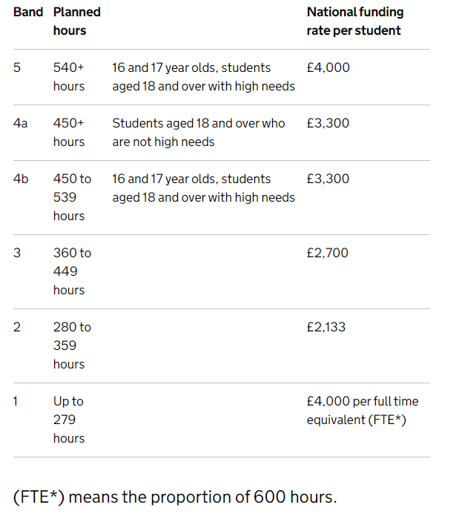
Figure 1 National Further Education Funding Bands [5]
If we consider further education providers, such as NPTC Group, as businesses then it is clearly shown by the funding bands that profit per student is very good, and important to the upkeep of the institute. Furthermore, they would aim to make as much profit as possible through students completing an academic year under the college. The more students, the more profit and this all starts with the first stage of a student joining the college; enrolment.
Every student who wishes to participate in a course must be enrolled as the process will put the student in the college system and register them official as a number to be processed for government funding.
Enrolment in NPTC is a long and tedious process which requires students visits multiple people in the process to complete the relevant paperwork before the payment and ID photos are taken. The enrolment process, ideally, should be welcoming for new students while being fast and easy so that more students are willing to attend, boosting the number of students that will participate and ultimately complete their respective courses. This profit variable alone should be enough of an incentive for NPTC Group to update their enrolment process to revolve around student’s availability to attend physically or complete online enrolment. As any regular business, there is also competition between colleges to retain and encourage new students. For NPTC Group there is a variety of campuses throughout wales with the Neath Campus being the largest.
In a review published by the Financial Times regarding the Augar Review published in June 2017 shows a graph on the funding for further education institutes over the last decade. The graph displays the funding for FE institutions from 2007 to 2017. Overall funding for 2007/08 was above £7.1Bn which then rises to a peak income of £7.6Bn in 2009/10. This overall funding amount slowly drops to its lowest point in 2017/18 at £5.9Bn [12]. This is a clear display of how the funding has dropped over the years for FE institutes which could be an issue for many institutes.
As most of the FE funding is received for students who complete the academic year then it should be crucial that the number of students who enrol should increase, which could be done using updated enrolling systems [13].

2.4 Competition

As any regular business, there is also competition between colleges to retain and encourage new students. Regarding further education, there may be competition between colleges and sixth forms whom both provide qualification teaching such as A Levels or BTEC courses.

2.4.1 Sixth Forms in Schools
A sixth form in school, or “Year 12 / 13” would be continued learning in a school environment where students would typically follow the same principles as they had previously done so In the school regarding rules, uniform and policies. This is a good option for students who feel comfortable and settled into the environment. The range of subjects available for further learning may be limited in a sixth form, but still may provide the courses that individual students wish to learn. UCAS describes Sixth Form Schools with “If you’re already at a school with a sixth form, you could stay on – you already know the place, the teachers, and your friends (who might stay on too).” [19].

2.4.2 Further Education Colleges
Further Education Colleges are establishments which provide further education teaching to students. Many FE colleges also provide GCSE Level courses such as English or Maths for those who require it. Some also may provide higher education learning through HND’s or BSc’s.
FE colleges may provide more freedom to students that Sixth Form Schools as it is considered an adult learning environment where students hold more responsibility for themselves. UCAS provides the following statement on FE Colleges, “College is an adult environment where you take more responsibility for yourself and your learning – there's support and guidance available, but it‘s also a chance for you to prepare for work and life post-education.” [19]
. A popular college also located on the south coast of Wales is Gower College. According to the official Government website for Swansea the population of the city stands at 246,500 as of mid-2018. Out of 246,500 only 5.9% of the demographic are aged between 15 – 19, as an amount of 14,700 [6]. This is many potential students which would choose between Gower or Neath college if they chose to stay local. According to the organisation Family Lives, “Nearly 80% of young people stay in learning after Year 11 and this is likely to rise as young people find ways to cope with the recession” which would roughly equal 11760 potential students in the Swansea area [9]. Google Maps direct roughly 12.3 miles as a minimum between Gower college and Neath college, meaning that the distance isn’t very much and makes for definite competition between school leavers from the Swansea and Neath area [7]. The Gower college website explains “The Gorseinon Campus accommodates more than 2000 full time students, who have access to nearly 40 A Level subjects and a wide range of vocational courses.” [9], which is another competitor campus to Neath College as it lays only 14 miles away. Gorseinon campus is considerably smaller than Neath college but would still gain many funding. Gower college boasts on their website that “Students at Gower College Swansea are celebrating an overall A Level pass rate of 99%, with 1205 separate exam entries.”, which would accumulate to 1193 passing students. Even at the lowest funding band provided by the government Gower would have earned atleast £2544669 from A Level students alone [10]. If NPTC Group updated their enrolment system, then there is potential to add to their funding fortune by potentially attracting school leavers from all neighbouring areas to Neath.
One of the important features of enrolling in-person at NPTC Group is that bus passes that are paid for on the day are instantly given to the students. If a digital solution is implemented, then people may feel insecure about paying for a bus pass that they wouldn’t get for a few days in the post or by picking it up at the college themselves. This should not be an issue as the bus pass will arrive on time if the enrolment is complete and processed before the ending date. The college website shows the beginning of the 2019/2020 term as the 3rd September. The enrolment period lasted from the 22nd of September through to the 30th, allowing for 4 days before the start of term. If the digital enrolments are processed by the 31st of August, then the relevant ID’s and Bus passes could be sent 1st class and received by the 2nd of September [11].

2.5 Methods of Enrolment

2.5.1 Physical Enrolment
One of the types of enrolment process that may be in use is physical enrolment. This process is done manually by the participant on paper or physical forms where details would have to be written formally and given to the relevant person for processing. As described by Borders College, “You will sit with a member of administration staff while they enrol you onto your course” which shows that enrolment process involved the students speaking with an administrator to manually enter data. This could be a problem as set days would be in place for people to visit the institute to enrol making it difficult or even impossible for some people if they are unavailable on the set days [2].

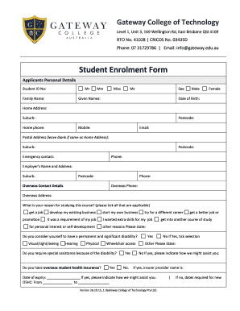
According to their website, Manchester College is the “The largest further education college in the uk”. The process undertaken by Manchester College uses a physical enrolment method. If the college with this acclaim still uses the physical enrolment process, then it only leaves for imagination of how much they could improve from a digital system themselves [14][31].

An image of a generic college enrolment form can be seen.

An advantage of this method is that the entire process can be sorted in one day with all the necessary documentation being given on the day to the enrolee. Items such as ID cards, Bus passes and welcome packs can all be received rather than waiting for them via the post.
A disadvantage, however, would be that this method of enrolment is very considerate of those who cannot attend enrolment dates or have disabilities disallowing them to go to crowded public gatherings to complete the process.

Figure 2 Generic Physical Enrolment Form [20]

2.5.2 Digital Enrolment

Digitally enrolling would be the process of enrolling onto the course that the individual wants to do via online forms, emails or communication with the institute rather than the physical approach of having all aspects of enrolment complete face-to-face at a set date within the institute.

An enforced and established digital enrolment system used by a college is quite a unique quality that is mainly preserved by online or “distance” learning institutes. The Digital College is a recognised institute that provides online teaching facilities to students like those of the Open University. With coursework and no exams, the digital college is a good alternative for education for those who do cannot attend a physical college. It can be argued that a digital enrolment system is used for The Digital College and the Open University as they require less information than a physical institute where people attend. However, if a digital college can award the same certification and qualifications as a physical college is there really need for so much data to be held that a physical enrolment is required? A digital solution could be implemented which includes all the relevant questions to be more suitable and flexible for students enrolling [15].
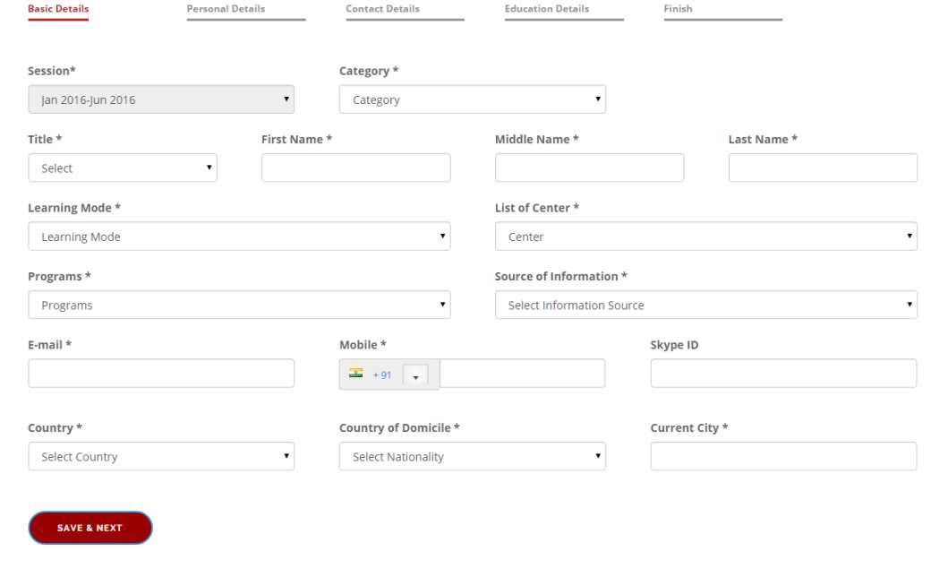
Shown alongside, is an image of an online enrolment form.

An advantage of an online enrolling process would be that it is very practical for people who wish to enrol in their own time and can avoid human contact.
A disadvantage however, could be that people may not trust that their enrolling fees and data is being provided to an online form rather than face-to-face with someone that they can ensure is not a scam or phisher.
Figure 3 Generic online enrolment form [21]

2.6 Current digital tools
Some of the tools are used will be mentioned in this section.

2.6.1 Open University
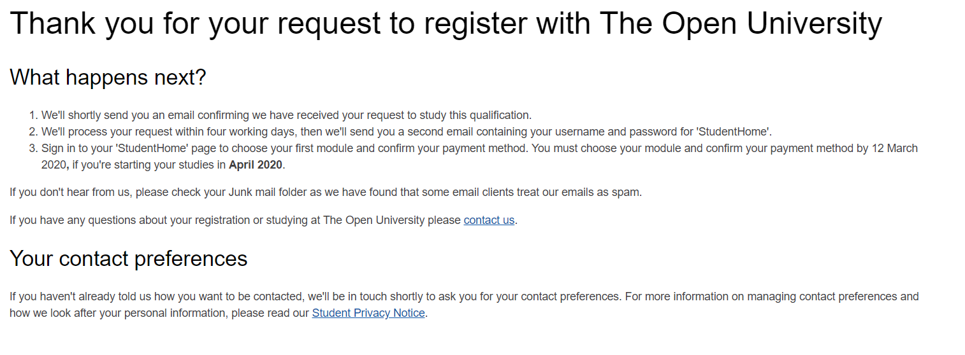
Open University describes themselves as “We are the leading university for flexible, innovative teaching and world-leading research in the United Kingdom”. Open University uses their own custom enrolment system which can be accessed through registration once a user has selected a course they wish to study. The process is in two parts; firstly, an application is sent for the course selected. The second part is payment and further personal data to finish to enrolment if the first stage is complete and accepted. This is a good system that allows for easy applying and simple form filling. A disadvantage however, is that applicants may have selected the incorrect course to what they originally planned and may go through the entire process without realising and therefore having to restart the entire process when they realise the mistake that they have made.
The open university has the options of enrolling digitally, through internet forms and applications or physically through printed out applications that are to be sent off for review. Alternatively, people in prisons can apply to do a course with the Open University and can complete their enrolment physically or digitally through forms being printed and sent off or filled out and then emailed to the Open University representative [4][29][30]

2.6.2 Student Enrolment System (SES)
The Student Enrolment System is a formerly used system by the university of Oxford. It was used as a web-based tool with multiple features and functionality that allowed students to view relevant information for graduate training, course information and the ability to enrol onto courses. It was provided the advantage of having all the data required by students available in one single software that could display course data to students while allowing them to apply and enrol for courses they hold data on. A disadvantage, however, was that students were only limited to applying and enrolling to course data held by SES. This was replaced with a new tool by oxford known as Researcher Training Tool [23].

2.6.3 Customer Relationship Management Systems
CRM’s are used in many different businesses and sectors to unite customer actions with a business purpose for analysis or overseeing purposes. They can be seen as a method to reroute processes to a paperless system. While existing CRM’s such as HubSpot CRM may not specifically provide Enrolment services, they do have admission and evaluation tools which could be modified to provide enrolment features to students as similar tools are already existing. An advantage of this is that the system is already full of useful tools that could be incorporated into an FE institute for use. A disadvantage would be that a CRM system would need rework for it to be suitable for enrolment which could be costly and eventually lead to faults or problems as it is not solely a enrolment system but a modified analysis system. An example of this would be Tribal Dynamic’s student lifecycle management software which includes an enrolment feature.

2.7 Neath Port Talbot College’s enrolment obstacles
There is bound to be some issues which are set with the enrolment system currently in use at NPTC. An interview took place with a member of the IT Department at NPTC.
It is clear that NPTC has no current system for digital enrolment and has no current development on the topic. The closest relative to a digital enrolment system within NPTC is the application page where students can apply for courses and will only receive back relevant information. This system allows for efficient applications but has no data collection or use for direct enrolment into the system. There have been suggestions of a digital enrolment system between NPTC staff but yet nothing has been implemented.

2.7.1 NPTC Enrolment Staff costs
NPTC cannot, with the current staff whose duties include data entry, deal with the volume of students who attend enrolment days when they occur. There is multiple data entry staff who are stationed with the purpose of getting student details from their enrolment forms onto the NPTC system for the enrolment to occur. However, due to the sheer number of students, the staff are overwhelmed and resort to dragging staff from their departments to play a role within the enrolment stages. The option to drag staff from their positions is NPTCs way of saving costs through using existing staff instead of hiring temporary staff for data entry purposes.
Staff, such as from the IT Department completing their work as Web Application Developers, do not have the duty to perform data entry for enrolment days as they have their own jobs which require completion. When they are being taken from their posts to engage within the enrolment process then they are being taken from their jobs and losing efficiency and time. This is all done to ensure no extra costs are paid to temporary staff when money can be saved via the borrowing of staff from other departments.
Temporary data entry clerks can earn anything ranging between £8 and £11, and when grouped this can accumulate to a fairly large amount over the course of the enrolment period. This is why the college will opt to use staff already accounted for to complete these jobs to ensure that costs are not spent on hiring temporary staff.
[28]

2.7.2 NPTC Staff efficiency due to enrolment
While the costs are one variable to consider, it is also important that staff efficiency is accounted for during the enrolment period. As mentioned, staff from IT departments are brought into the enrolment process when they are not contracted nor obliged to.
In the efforts of saving costs, it could lead to losses in terms of efficiency and productivity among the staff who have been brought into the enrolment process as they will not be engaging with their primary duties for a period of time which could affect the entire department or application of NPTC.
With members of staff removed, the department they come from may run into problems in their absence which will then be the responsibility of the remaining members of the department which can further lead to a decrease in productivity. This also ascends the danger risks of the software and systems which are being maintained as they could run into issues or have security risks.
Efficiency will definitely drop amongst the staff as they would have jobs and purposes they must fulfil which will then be delayed or dropped due to the enrolment period requiring their aid, and when they return it may be too late to finish their job, they may have lost motivation or potentially make mistakes due to being out of the field for a period of time.
[28]

2.7.3 NPTC Staff’s view on Digital Enrolment
The staff member who was communicated with identified that they would like to attempt a digital enrolment system with the college and stated it would not be risky if the development was done with careful consideration and validity included. Efficiency, costs and time will all be saved through the use of a digital enrolment solution as there would be potentially less students enrolling physically, making it so less data entry staff are needed, and the IT department can maintain their staff. Costs and efficiency would be saved as staff would remain where they are meant to be, and temporary staff would not need to be hired. Time would also be saved as less enrolees would require less data entry staff altogether, allowing them to get on with other tasks or jobs which were meant to be complete at later stages.
One drawback however is that a department or individual would have to monitor the digital enrolment requests consistently to approve, decline and contact enrolees. This would not become a major hassle as it could be a shared duty and would require constant attention as enrolment requests would be scattered across days and times, unlike a physical enrolment system which occurs on set days at set times.
[28]

2.8 Conclusion
In conclusion I have found that the overall income of institutes comes from the number of students who complete the academic year with the institute. This emphasises the cruciality of getting students on each course to build the overall number of students for the year, which all begins with the enrolment stage. I researched the different methods of enrolment, including physical and digital methods and found that most institutes operate using the physical process of enrolment, especially the University of Manchester whom could be seen as a role model to smaller institutes due to their accolades. I then analysed three digital tools and found that there is not many options for bespoke digital enrolment systems, leading to institutes having to create their own product that could be used, potentially being a large factor to why physical enrolment is the most viable option used.

From my research I believe that a custom digital enrolment system should be created for NPTC group to provide more flexibility and ease of access for enrolling students, especially those who cannot attend physical enrolment dates or have reasons they cannot attend, such as mental illnesses, physical disabilities or simply have no ability to reach the enrolment institute on the date.

My proposed system would be a fully digitalised enrolment process which would capture the personal details of students that are required as well as allowing for uploading images for student ID’s and taking payment for the enrolment and bus passes if necessary.

Chapter 3 – Research And/or Development Methodology
There will be a few different research methods used within the project proposed to ensure that the project will provide the best, most accurate and useful results. Different layers of the research onion will be discussed as it forms my approach to the research methods.

3.1 Research methodology

3.1.1 Philosophies
The philosophy that will be used for research is phenomenology. This is because, “A phenomenological study explores what people experienced and focuses on their experience of a phenomena” [16]. This philosophy has been chosen due to the focus on personal experience which is what would be the research purpose for the project. Feedback of staff and student experiences with the enrolment process used at NPTC Group would be successful feedback for the project. The main advantage of this method is that feedback would be provided by experienced personnel that know what they are talking about and can provide valuable insight. A disadvantage however could be that the amount of people to gather phenomenological data from is low. This will be dealt with via efficient time management to devise and set up meetings to gather enough data from the people who are available with enough slack within the timeframe to gather data from external personnel if required.

3.1.2 Approaches
The induction approach will be taken for the project as “this is the process by which we draw a general conclusion from individual instances or observations.” [17]. This approach is used as an initial conclusion is gathered from observation for the project which should be improved upon through completion of the project. Through the use of information gathered from users that have experience within the topic area a general conclusion can be formed on the current state of the enrolment process and how it is received by staff. This can then lead to further data being gathered to form a solution or to evaluate the initial conclusion from the studied individuals against results from other companies, institutes or studies. A disadvantage is that data that goes unnoticed or is not found cannot contribute to the conclusion which is formed, leaving a gap or forming an incorrect conclusion as data could be unnoticed. [25]

3.1.3 Strategies
Many strategies may be looked at but for the project a case study will be the important strategy. A case study would be good for this project as it would look at specifically enrolment within the business using real life evidence and scenarios. A positive of this method is that a case study would provide information gathered from people’s personal experiences and knowledge of the topic area, making it easy to compare with this project. Important or useful aspects of the case study can be used for assistance in the project. A disadvantage may be that such a specific or precise case study may be hard to find. If this is the case, then the project will aim to look at broader cast studies regarding enrolment in different educational institutes or different countries which would still provide information on enrolment processes and features. [24]

3.1.4 Time Horizon
The project will be using a cross-sectional study for its time horizon. This has been chosen as the project will be looking at different variables of enrolment systems and relevant surrounding aspects of the enrolment process such as people’s emotions and business aspects of enrolment [18]. An advantage of using a cross-sectional study for the project’s time horizon is that there are many different variable that must be tended to during the project to ensure a successful outcome, and cross-sectional provides the means to focus on many different aspects of the project rather than a single specific factor which could lead to lacking of quality in areas. However, there is the disadvantage that some of the aspects may not be given enough time and will consequently be lacking compared to the other variables. [26]

3.1.5 Data Collection Method
The use of both Primary and secondary data will occur within the project. This will allow for new data through interviews and observations analysis to be used in the project alongside existing data through document analysis and research. This will give a large understanding on how people feel towards existing systems and what they wish and desire a new system to include and be used. Through interviews and observations there can be first-hand data retrieved from users, staff and relevant figures that could be crucial to the progress of the project. There are two methods used as it would provide more, and different variations of data compared to relying on a single method. Secondary data will be retrieved through document analysis, software reviews and online research to discover information relevant to the project and any useful sources that could influence the outcome of the project. An interview took place to ensure primary, first hand data was collected for the research which provided valuable data from an individual in a position of high relevancy to the project.

3.1.6 Evaluation criteria
The evaluation criteria will vary between multiple factors such as relevance, effectiveness and what impact the solution has on the area it has been deployed in. The solution will have to be relevant to the project in terms of its features and how it can be used by both users and admins alike. Effectiveness is a key criteria which will be closely evaluated as the project itself is aiming to increase effectiveness with the project being the instrument to do so. The impact will be an evaluation criteria based on what impact the solution will have, relating to effectiveness. The solution will aim to have a positive impact which increases productivity and ease for students and could impact the institute by the numbers of students who enrol that year in total. Below is a bullet pointed list of all of the evaluation criteria I will be using later in the documentation. The evaluation criteria is as follows:
- Relevance – Is the solution relevant to the research?
- Effectiveness – does the solution provide features which allow the problem to be solved?
- Impact – How will the solution change the enrolment results?
- Access – Is the solution accessible by users?
- Efficiency – How will the solution improve efficiency to students and staff?

3.1.7 Methods of Testing
The solution will be tested using variable methods to ensure the solution works, is effective and will provide an outcome of what is expected. This will be assured through software testing later in the document using unit, system, usability and acceptance testing. Unit Testing will ensure the separate units of the solution work correctly and as planned, allowing for them to be used in the full system. Any issues with the units can be fixed during testing to ensure a working final system provided all the units function correctly. The system testing is the overall testing of the system and its features to ensure it works as a full package with no faults or errors.

3.2 Development methodology
As the project solution requires development, this section will outline the requirements of the development.

Development Method
The development methodology being used is the waterfall development method. Due to the project requiring stages which fall into the next section, waterfall is the most suitable method and will allow for the research and design to lead into the development phases. A disadvantage of this method is that once a stage has been passed and the next begun / complete, it is very difficult to go back and make changes. In preparation for this, I will ensure that all stages are completed entirely and checked before progressing onto the next. Through effective time management and research, I will ensure all stages are 100% complete before I consider beginning the next stage.
I will be ensuring time-management through the use of timeboxing. Time boxing will allow for me to allot slots for what I plan to do on specific dates and times. Using this method, I will be able to specifically plan all of the segments which will take place during the project, from start to finish. This is a useful scheduling technique which I aim to follow precisely to ensure I do not go off track and stick to my own management deadlines set. I know if I follow my timeboxing correctly, I will complete the project on time with all of the sections concluded and have had enough time spent on them for the outcome to be what is required and expected.

3.2.2 Software
I will be using the IDE Brackets to code the solution as it provides an efficient development interface. The solution will be run using Xampp software to allow the use of Apache and MySQL for web hosting purposes. Web browsers will then be used to access the application.

3.2.3 Hardware
No specific hardware will be required for the solution to be used upon. Below is a table containing data on the hardware used to develop the solution.

3.2.4 Materials and Tools
I am using HTML, CSS, JavaScript, PHP and SQL to develop the solution as they are all the tools that are required to make an effective web application that will store and retrieve enrolment requests which can be used as a new enrolment system.

Chapter 4 – Design

4.1 design
This section will talk about the design of the solution and what factors were implemented for what reasons.

4.1.1 Project requirements
The following headers are requirements of the project to ensure efficiency, usability and relevancy.

Access through web
One of the requirements is that users should be able to access the enrolment system via web and web browsers from their own homes. This is a key requirement as the system aims to tackle issues of users not being able to physically attend enrolment days. It also allows for users to complete the enrolment process in their own time. This was discovered during my literature review to ensure that people could access the enrolment system wherever they are with internet and a capable device.

Admin Sign in
There should be a suitable method in which administrators and staff can sign into the application. This should be in the form of a log in form that will appear when the appropriate sign in button or heading has been pressed allowing for easy signing in by relevant people. This requirement was made due to research where I found that it would be essential for staff to have a sign in portal on the enrolment system to ensure requests can be dealt with appropriately.

Enrolment Form to be filled in
An enrolment form should be able to be filled in by students on the web page which is then held in a database. This sign in form should include all of the necessary data required by the institute to enrol a student onto the system. Further information would be required but would not be held on this form. This was found as a requirement and key need of the system as it is what will be filled in to allow for enrolment to take place.

Upload image of student
An image of the student should be uploaded with each enrolment form to ensure people are who they say they are and can have an image associated with their application which will then be used for an identification card. This was found during research to ensure security and student validity; students will upload an image of themselves firstly and then corresponding ID in a later stage of enrolment to ensure they are who they say they are.

Only show courses applicable to students based on their grades
To avoid students applying for courses they are not eligible for, the form should filter what courses can be applied for based on what grades the students enter. This will ensure students do not apply for courses they cannot join, while also ensuring that time students are not wasting time submitting another application due to applying for a course out of their reach. This was found during research to ensure efficiency through students only being able to apply for courses they are eligible for.

4.1.2 System models
This section will display some of the DFDs and task analysis of the solution.

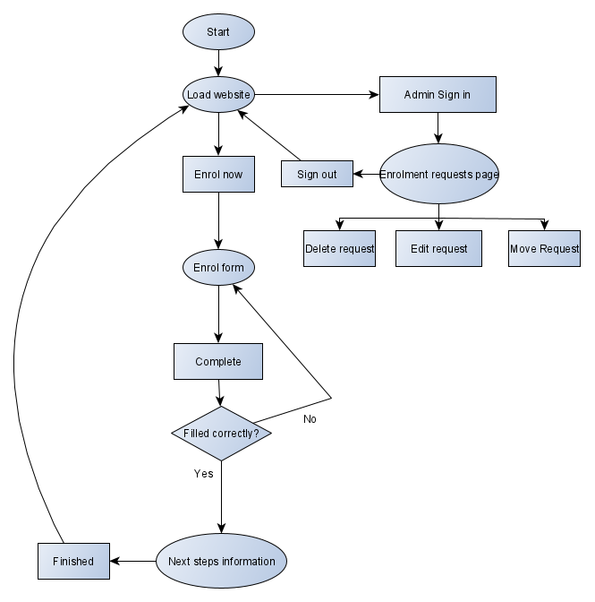
4.1.2.1 Data Flow Diagram
The first model is a data flow diagram. The data flow diagram aims to show what occurs when the solution is used, from the site first being loaded until the user finishes an enrolment form. The DFD shows how simple the solution will be and how it can be used by admins to control the enrolment requests.

4.1.2.2 Task Analysis
The task analysis aims to break down each part of the project and how it is used by users. This is to show the features of the application and what stages occur.
The following task analysis diagram shows the path which users planning to enrol will take.
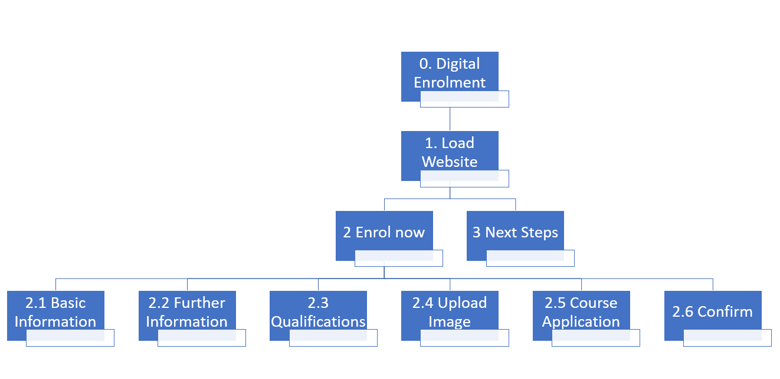
The following task analysis is the path in which staff and admins would take when using the solution and how they may use the application.
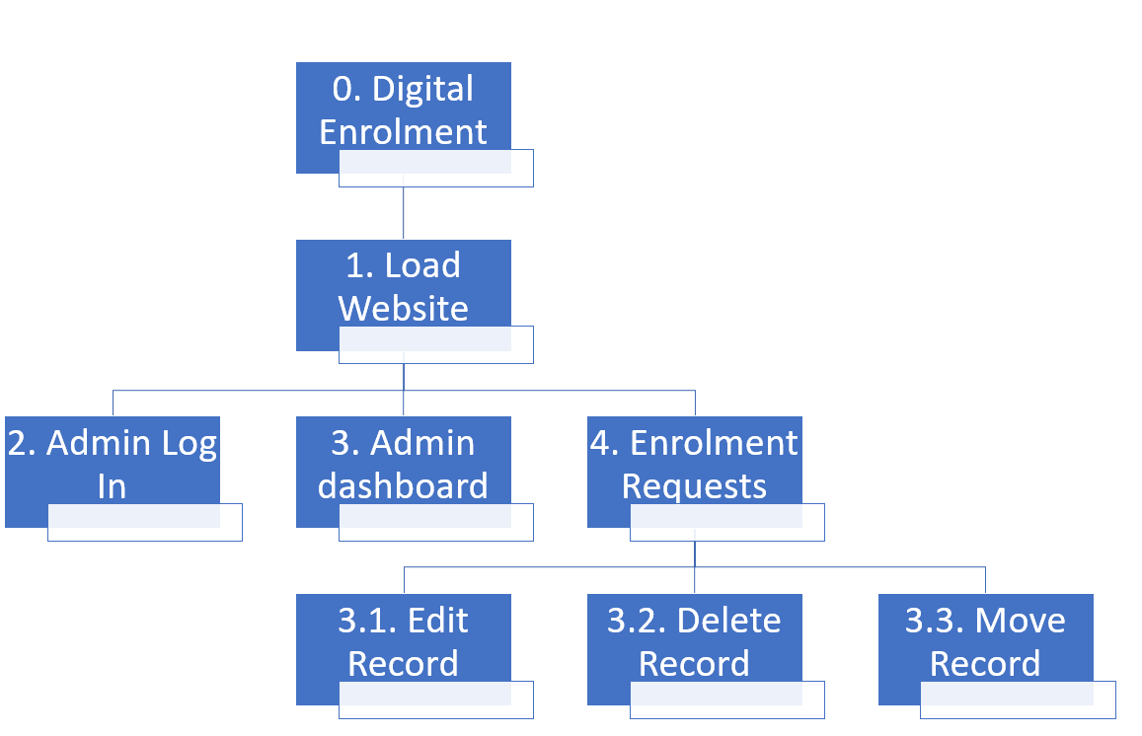

4.1.3 System interfaces
This section will show wireframes and prototypes of the solution to show how the page is designed to look. The designs have been made to ensure clarity for users through no unnecessary data or features being displayed. A central text motto with supporting text will be in the centre of the web page to support the college and convince potential students to go further with their enrolment. The header will contain all of the necessary links to NPTC for further reading by users if they desire, while also having contact information such as the email address and contact number. The item with most emphasis on the page will be the enrolment button which will be of a larger size and different colour to the rest of the items. With a dark background, the Enrol Now button will be a bright green to gain the users attention.

4.1.3.1 Wireframes
The wireframes were the first designs created to show how the pages of the application should appear.
Home

Sign In
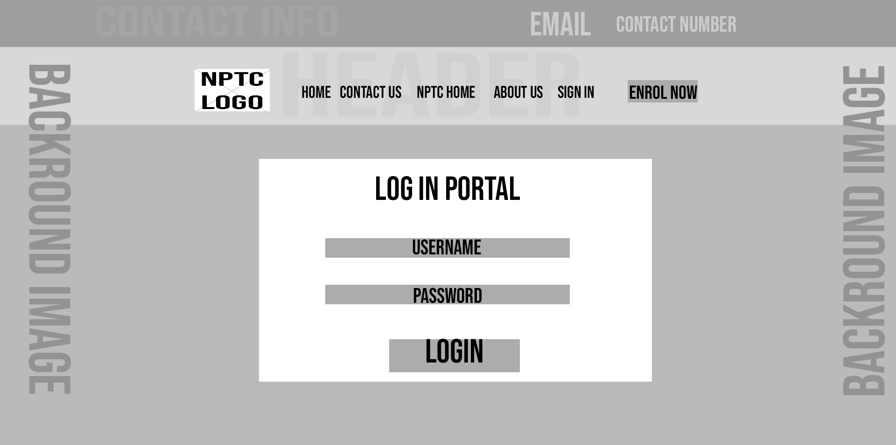
Enrolment Form


Admin Dashboard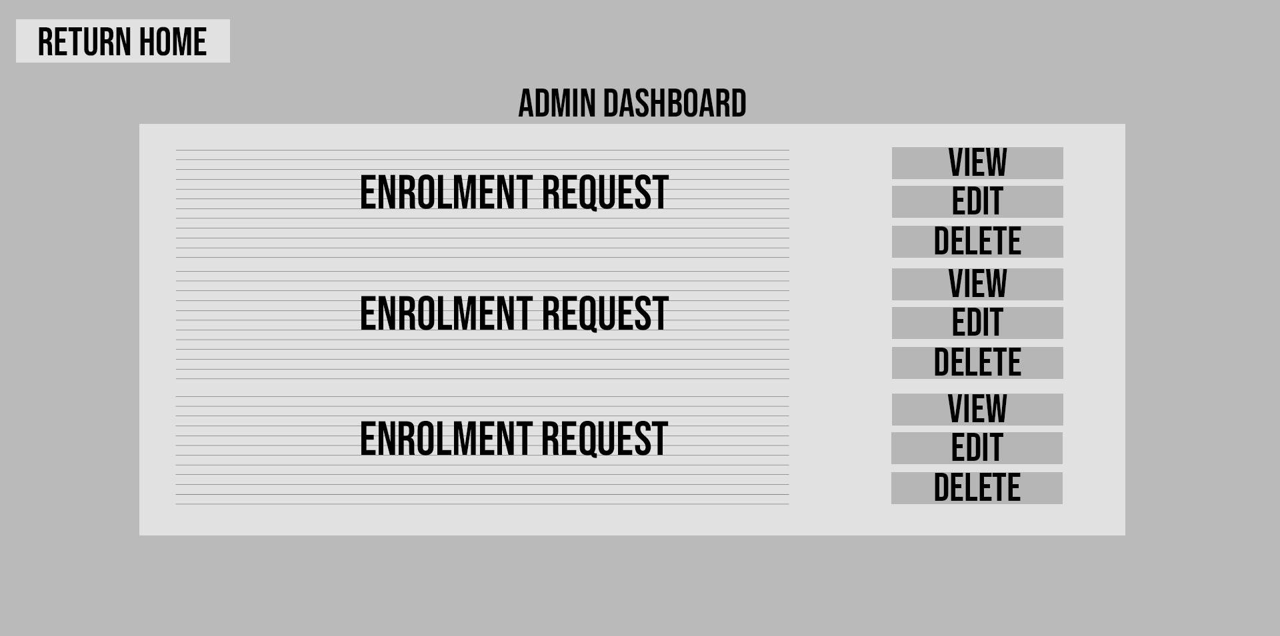

4.1.3.2 Prototypes
The prototypes were designed pages that would be improved prior to deployment.
Home

Sign In
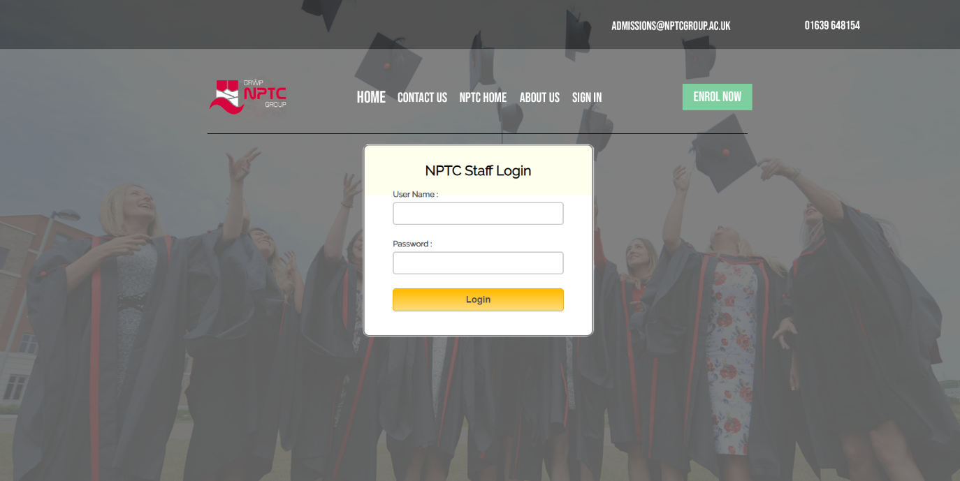

4.2 Implementation
This section outlines the implementation of the application. Firstly, images of the final solution will be included below for viewing purposes.

4.2.1 Problems and successes
This section will outline the problems and successes that were encountered during the development and Implementation of the solution.
The first problem encountered was my incompetency in programming and developing web applications. This was a large issue due to the project requiring skills within web application development for the solution to be created. Through the use of frameworks and technologies such as CakePHP I was able to structure and create an effective application while learning alongside development. CakePHP became one of the success of the project as it allowed for the enrolment requests to be easily viewed, edited and deleted by admins through a simple table display controller that can be accessed by admins after signing in.
Another problem which was encountered was how the web application would be accessed during the development period. This was an issue as it would be difficult to view the website as it was created. This was overcome by using XAMPP to create a virtual Localhost server to view the website on when required to see the application progress. XAMPP allowed for the web application to be accessed through web browsers on the set address using Apache, one of the technologies available through XAMPP. The database of the application came through MySQL using XAMPP to store data and set a reliable connection between site and database.
A security issue which was faced was the log in system which the application would require. A potential solution to this was to include a ‘users’ table to the database which could be used to provide log ins to staff. This would not be able for implementation currently due to time restrictions and has been added as a function to be implemented in the long term running of the solution. In the meantime, a solution to this issue has been a login system running entirely through JavaScript to ensure only correct log in names and passwords combinations are used and that only logged in users can access the admin dashboard.
One of the main success of the project is the process of capturing data and having it input to the MySQL database in the backend through PHP. The enrolment form which gathers all of the required data has validation to ensure all of the required fields have been entered. Once the user clicks submit then all of the data, provided it is entered correctly, will be saved and stored in a new record within the database and the user will be redirected to a processing, then, home page.

4.2.2 Tools and Techniques
The design was split into many different parts to ensure that everything could be complete to a high standard and most importantly, on time. For the design I mainly used photoshop to ensure I could visualise an accurate design to the size and position of elements. Through groups and layers, I could create the designs based on how I was going to code them. This was a technique I was happy to use as I could design sections, such as the header, main content and features to how I was going to code them. For example, I designed the header group. During the development I then went back and focused only on the header design group and followed it to ensure the solution’s header followed how the design header looked. I did this in sections for each part of the design so that the solution matched it. For other parts of the designs I opted to use visual charts and diagrams to allow for the creation of task analysis and data flow diagrams. For coding, I used Brackets which is an IDE for multiple languages. I found that useful for the programming as it allowed for me to view the file structure and files with a vertical split to increase my productivity.
Other small design techniques used were gradients on buttons to give the application a colourful look. Hover design techniques were used for usability purposes to ensure people know when they are about to click on a heading or button, or simply hovering over them.

4.2.3 Code snippets
This section is showing some of the key code snippets used within the project. These are snippets I found useful for the project.
Connecting the enrolment form to the database:
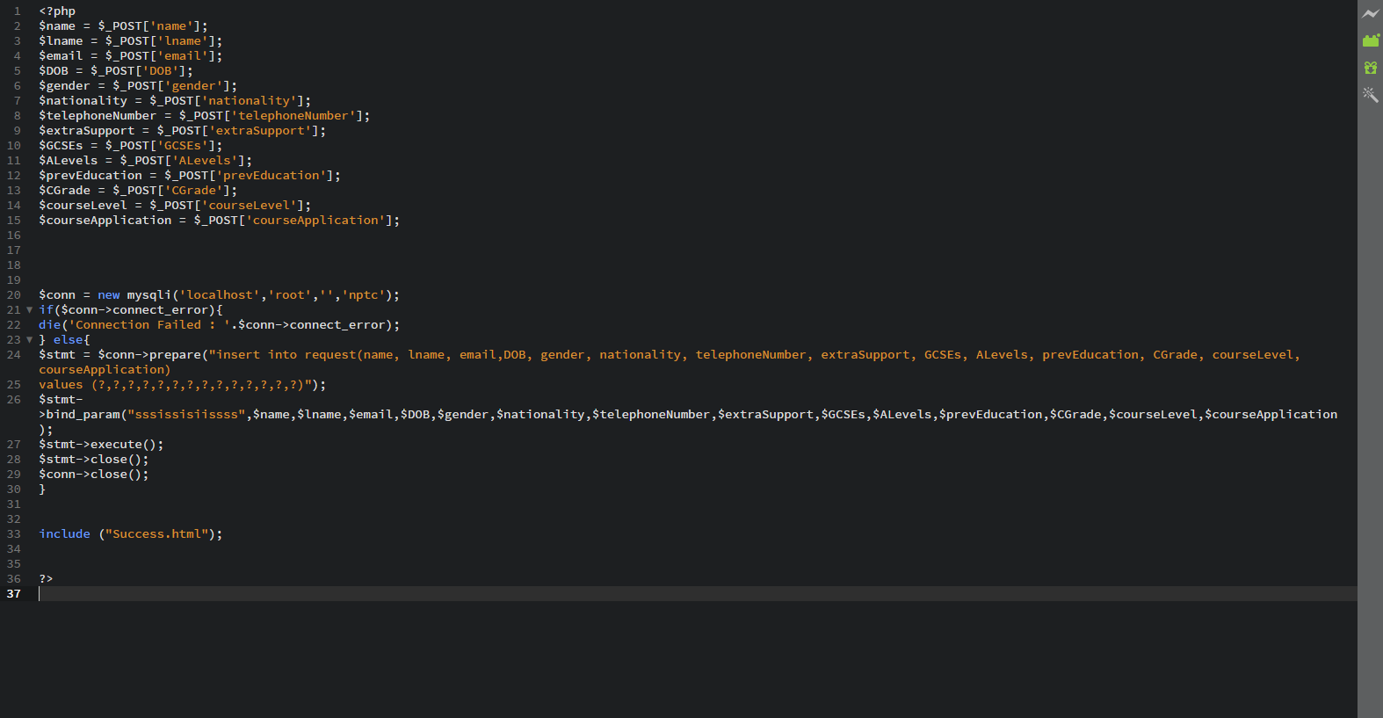

Request table controller:
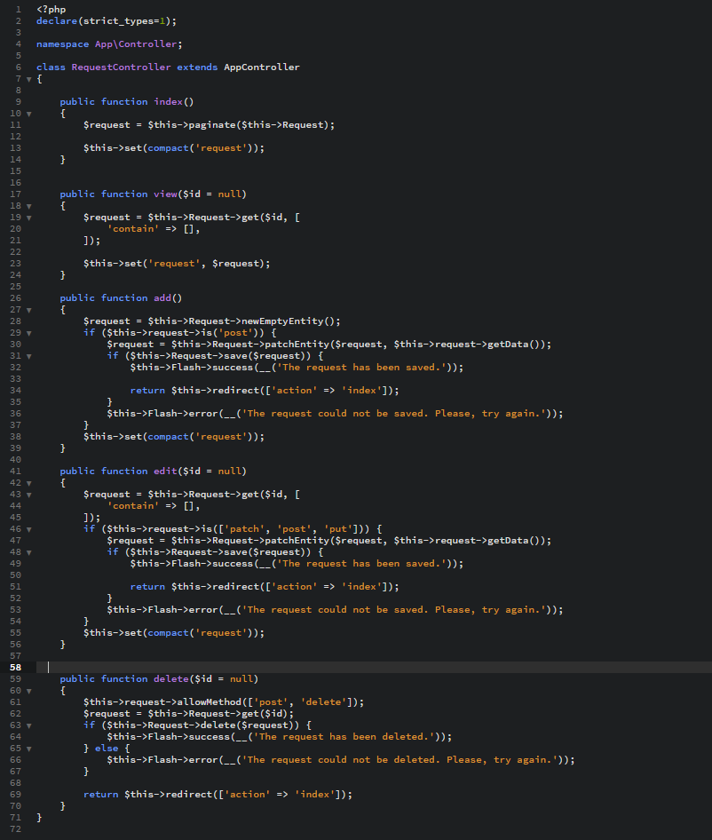
Setting up the MySQL Database:
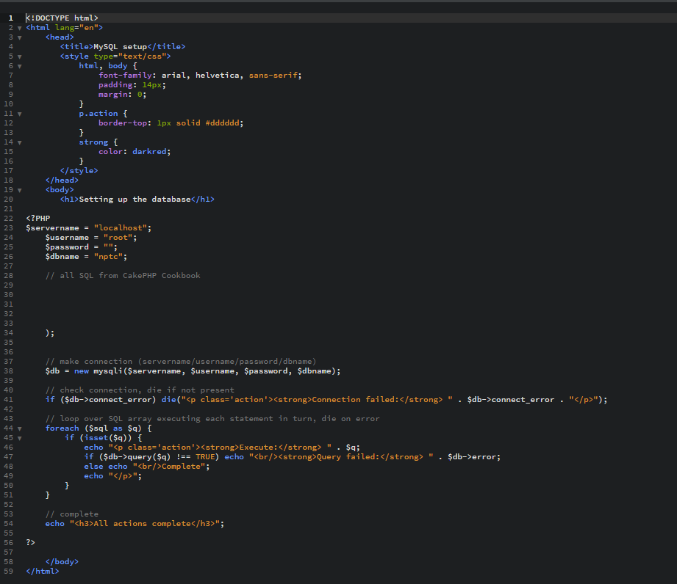

4.2.4 Software testing
This section is all about the testing methods used to ensure the software is operating as planned. Detailed testing specifications can be found in the appendices.

4.2.4.1 Unit testing
Unit testing is the testing method which gathers smaller segments or sections of an application to check if they are working as planned. Below will be documentation of different segments which will be tested to ensure they work correctly. The unit testing taken place tested all the individual sets of the application to ensure they work individually before system testing is considered. Detailed testing specifications can be found in the appendices.

4.2.4.2 System testing
This is the testing of the overall system to ensure it works correctly as a whole and can be implemented. The system will be tested through every single page to ensure it works as a whole and does what is required, and developed.

4.2.4.3 Usability testing
The usability testing aims to test the usability features of the application. This regards buttons, links, text and font. All of the features that relate to usability which have been included on the application have been tested to ensure usability is at a high standard to assist users when operating the application.

4.2.4.4 Acceptance testing
Acceptance testing ensures that the application acts how it is expected to by the user. This is features such as inputs or links where the user has a predictable knowledge of what the function of the item is. The acceptance testing went through various methods in which the application suggests something to a user and how it reacts to the users input. Remarkable acceptance is required, where all of the functions work as shown and can be used by both staff and potential enrolees.

4.2.5 The finished product
Home

Enrol Now
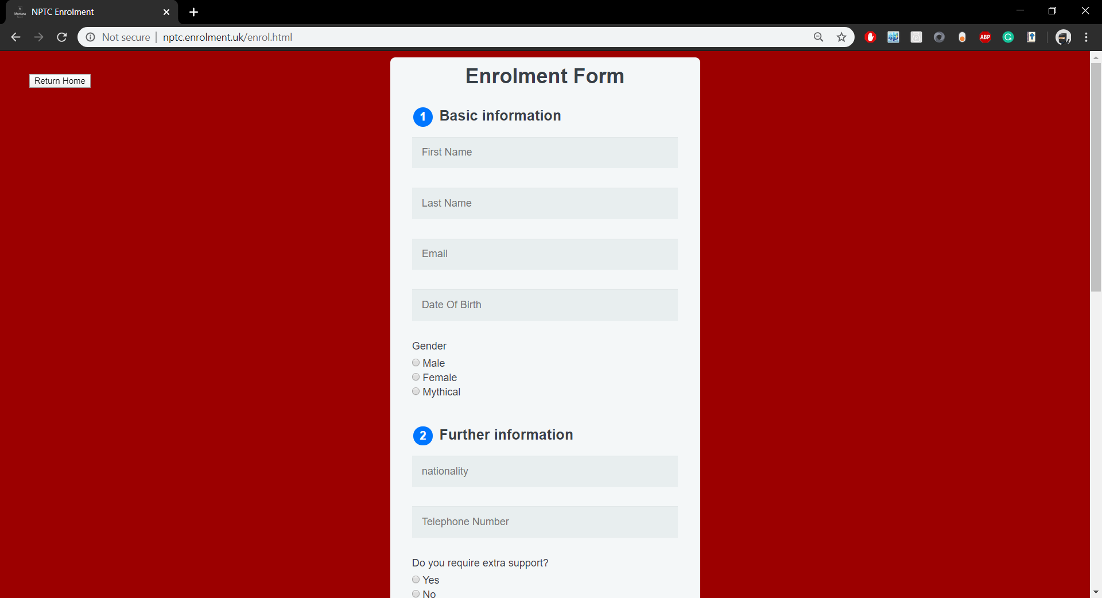
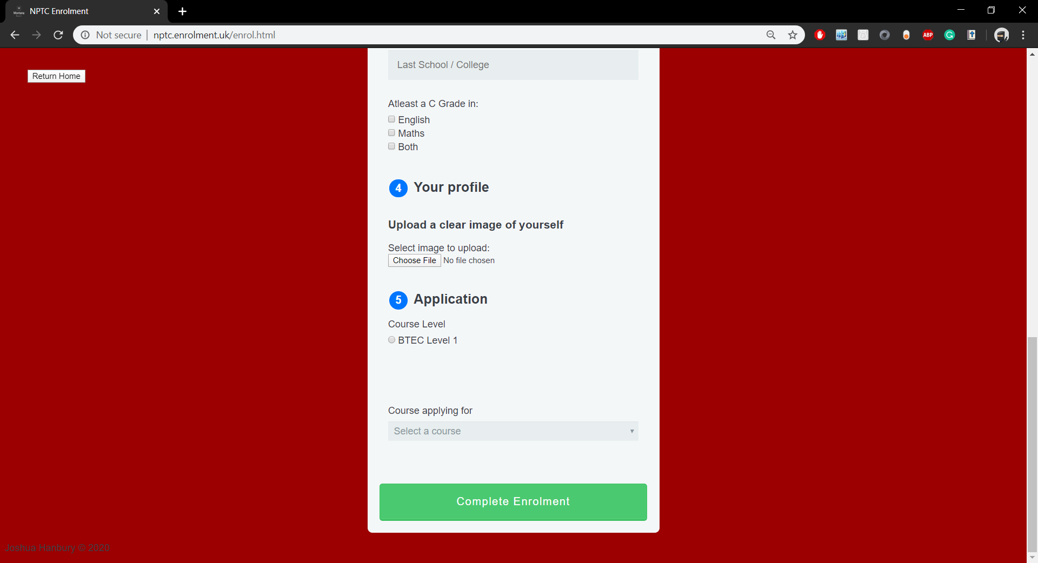

Enrol Processing
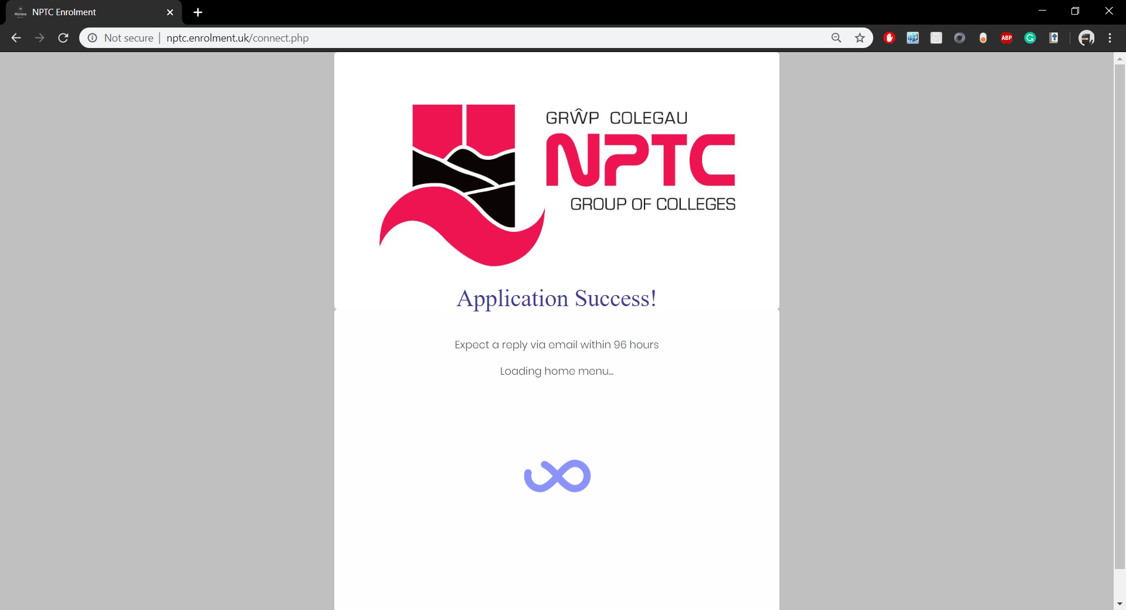Sign In
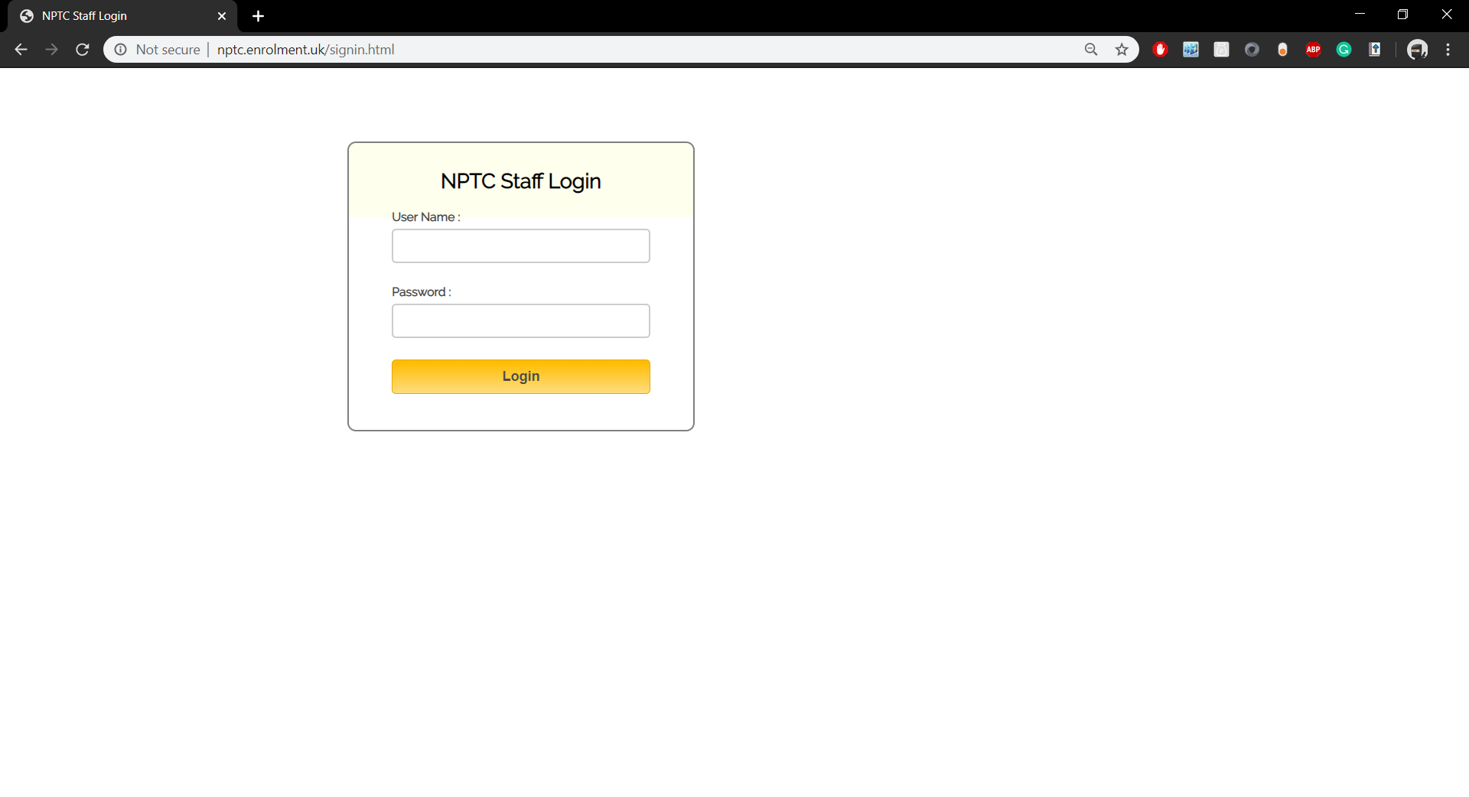
Admin Dashboard
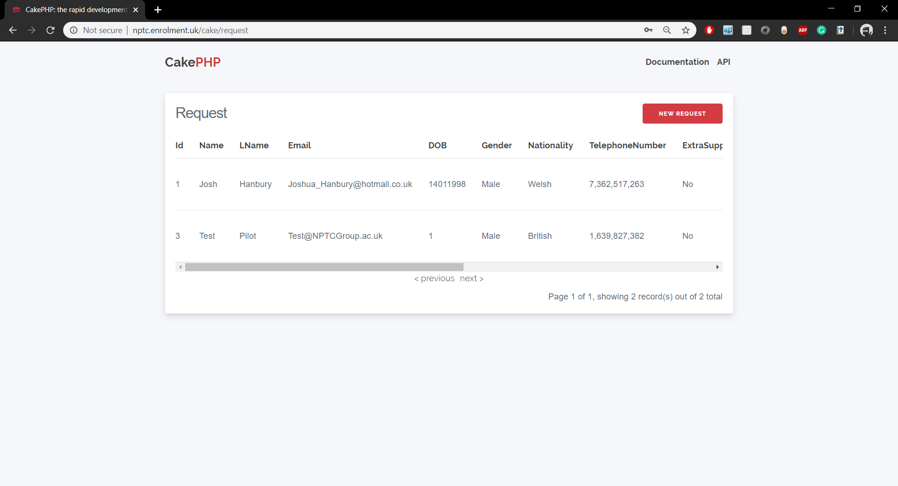
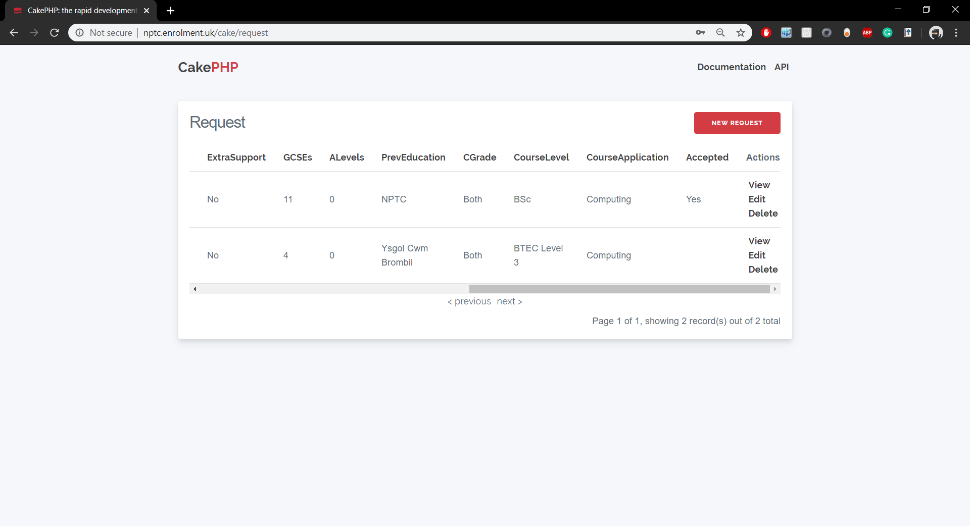

Chapter 5 – Evaluation
An evaluation of the project will be undertaken during this chapter.
Firstly, I concluded from my data that a large majority of educational institutions use a physical enrolment system. Institutes such as Manchester College, the largest further education provider in the UK, down to Neath Port Talbot college in Wales, use physical enrolment systems where students are required to make a personal attendance on set days to participate within the enrolment process. This was the first conclusion which was drawn, giving the initial spark which lead to more questions on why digital methods were sparse and neglected by the institutes.
Furthermore, I drew the conclusion that there are instruments for digital enrolment available to those whom seek it. These instruments come in the form of online enrolment applications provided through Customer Relationship Management software (CRM). CRM software can be purchased commercially via companies such as Swansea based Tribal Dynamics. Institutes such as The Open University have their own enrolment tools, requiring users to fill out online forms and undergo processing prior to any payments or classes begin. If these digital solutions and proven methods exist, why are they being disregarded, ignored or overlooked as much as they are?
An underlying issue of a digital enrolment system would be the validation of applicants. Whereas physical enrolment requires applicants to personally attend with valid identification, when online, anyone can impersonate or act upon someone’s behalf. During the research I found that most, if not all, of the digital enrolment processes required users to submit identification such as a Passport, Drivers Licence or any valid Photo ID to the institute. While this could be seen as a drawback to digital enrolment, with user trust and effective security by the institute this should not been seen as a negative to the idea of digital enrolment. During the development of the solution I was able to implement a photo submission point for users which was stored in the database for verification purposes. While I found that this could be a potential security risk, it should not be an element which discourages users, as effective security could ensure that all submitted data and images are held safely by the company. In situations where the integrity of provided identification is disputable then there may be the requirement of users sending the physical evidence to be verified by the institute themselves. This should not be an issue provided the identification is sent safely through recorded delivery during transition both ways. Individuals may see this as a risk to their identification, but it can also act as a deterrent to applicants with false or forged identification.
In my research I mention how institutes could provide digital enrolment methods to users through their own developed software or CRMs. With the solution I proved that it could be a viable option to create a bespoke system that could be used with ease. It would not be a difficult operation to obtain a digital enrolment system, especially if one is purchased or optimised for use within the specific institute.
As a project, the aim was to give reason on why the current physical enrolment process was outdated and could be improved to thrive in modern times. In a business sense it would be more appropriate to provide a method suitable to more people, making digital solutions a good contender to improve the business needs of the college through enrolments. It is also crucial that methods are set to provide for those who may not be able to attend physical enrolment days for various reasons including crowd anxiety, disability or general unavailability for the set enrolment days.
Funding was found out to be one of the key reasons of enrolment. Enrolment is a key stage for educational institutes as it is the first process students will undertake and could potentially sway a pupil’s decision of whether they would like to join that institute or not. It also gathers the official numbers of students which calculate the funding the institute gets.
Through research and findings, it became clear how important enrolment could be for the business aspects of the institutes, especially for competition between close institutes where there is a need to sway potentially students away from other institutes through advertisements, benefits or rewards. The more students enrolled, the more money would be earned by the institute, so it would be ideal to ‘steal’ as many pupils from other institutes as possible to boost the numbers. Digital enrolment would be a potential method for convincing students to join the institute as they have an easy enrolment process and skip any unwanted crowd events such as a physical enrolment day which could end up taking a few hours to be complete.
The project held many objectives which were all described during the proposal. The aim was met and assisted through completion of the objectives.
Firstly, I set the objective of completing an in-depth literature review using research methodologies. I firmly believe that this objective was met and complete to a high standard which assisted a great deal in regard to the final solution. There were issues during the development of the literature review regarding sources and data regarding enrolment, which was overcome through the use of academic websites and information harvested directly from educational institutes websites and resources.
Researching other enrolment systems in use by local colleges and sixth forms was another objective which the project was to cover. During the literature review I was able to cover this section through competition and more importantly, gather a scope on the enrolment systems used by the most popular institutes within the United Kingdom. While this objective was met, I feel as it was brushed aside slightly due to my desire to pull data together about popular institutes as they would potentially be seen as role models to smaller institutes due to their size differences. If a college, such as Manchester college, has so many pupils then they must be doing something right, and how? This is what I quickly determined myself to find out during the literature review.
I set out to design and implement a solution for NPTC group based on the findings of the project which would be evaluated. The solution was designed and implemented in the previous chapter with efficient testing complete. The solution was designed then developed according to the designs which were accurate to the wireframes and prototypes. This objective was met as the solution was implemented successfully and is usable to provide enrolment requests to a database which can then be viewed by staff through the admin dashboard.
The final objective which was set required the project to result in a working system with research documentation which proves the problem identified and can be used to solve it. The system was built, and it completes it purpose of providing a digital method of enrolment through a web application, while having the supporting research within the literature review to show why a solution was necessary.

Regarding the evaluation criteria, I believe that it was met through the solution created. The solution met all of its requirements in terms of wide access for users via the application being a web application. The application is used to gather information on enrolling students which can then be reviewed by staff on the web application. This allows the solution to be effective which is one of the key criteria mentioned for evaluation. The other criteria was relevancy and how the solution relates to its purpose. The solution had the upmost relevancy regarding the purpose to why it was made, with it containing all the required tasks to improve the efficiency of enrolment for NPTC Group. With the evaluation criteria met, the project could be evaluated effectively through the purpose of the solution being met and providing a use to the overall project.
Overall, the outcome of the project is what I have expected. The research carried out fell inline with my initial hunch of physical enrolment having dominance over digital enrolment due to institutes favouring a physical approach. I was expecting for a digital enrolment solution to be necessary for the project, as it was, and the research led me into creating a solution as expected.
The overall outcome is what was expected. Research was conducted and an application was built upon data gathered from the research. The solution was built and will assist the institute in areas of efficiency during enrolment.
I feel as a whole the project was a success. If I were to conduct the same, or similar project again I would make some changes to how things were done. One of the first things I would have done differently was the research methods. I feel as though research was done to a good standard, but was lacking any primary first hand data from staff themselves. If I were to do it differently I would prepare questionnaires or surveys for administration staff to undergo to find information on what staff would desire the solution to contain or ignore. I may also consider the technologies used for creating the solution to ensure that I am using languages and software that I am more competent in using compared to using new technologies while learning them during the development of the solution. This could ensure more time is allocated for development as learning would not be required. Technologies could include using HTML and PHP rather than using CakePHP which I have not touched previously.
I do not think major changes would be made as the project is seen as a success in my eyes, and not much went wrong. If there were more difficulties, failures or issues with the project I would consider more changes.

5.1 Evaluation Criteria
This section will be commenting on how the solution met the evaluation criteria previously set in the document.
- Relevance – Is the solution relevant to the research?
The solution was planned closely with the results of the research to ensure relevancy was kept. The solution aims to deal with any issues that was found via the research and for these reasons it maintains

- Effectiveness – does the solution provide features which allow the problem to be solved?
The solution was built with all of the problems and requirements firmly considered, with all of the necessary features implemented to ensure effectiveness during the enrolment stages. Provided that the requirements and problems have been found from research, the implementation of features to support these requirements and problems will ensure effectiveness.

- Impact – How will the solution change the enrolment results?
If used, the system will allow for students to enrol online via the web application which could see an improvement in enrolment numbers. As the system will be implemented alongside a physical enrolment system, there is no risk of students unwilling to complete the online enrolment as the physical enrolment system is still in place. It is unlikely to lead to less enrolments as it is not in place of any existing method, but instead an optional feature that students could use rather than attending a physical enrolment day.

- Access – Is the solution accessible by users?
The solution is a web based application. Users with internet can use the application on their devices such as computers, laptops and phone to ensure that as many people as possible can access it.

- Efficiency – How will the solution improve efficiency to students and staff?
The solution will save time for both staff and students. Students will be able to avoid confusing and time consuming physical enrolment days and can simply follow onscreen instructions for the digital enrolment. Staff, will also have less students to deal with during the physical enrolment and instead, will be able to keep regular updates on the digital enrolment requests which can be directly injected into databases rather than typing everything up during physical enrolment sessions. This will be efficient for both staff and students as time will be saved.

Overall, I believe the evaluation criteria has been met, with the solution hitting the criteria proving that it has been evaluate fairly upon what is required of it.

Chapter 6 – Conclusions and Recommendations
This chapter will describe the conclusions made of the project and the recommendations provided after completion of the project.

6.1 Conclusions
Here, the conclusions drawn during the project will be broadcasted.
The first conclusion drawn was that the largest further education institute within the UK, Manchester College, still adopts a physical enrolment system with no trace of digital enrolment possible. This could be reasoning to why other colleges and sixth forms do not have any digital enrolment systems in place currently, as they see Manchester College as a role model due to its high number and accomplishment as the largest further education institute within the UK. If Manchester College took a digital approach or adaption to enrolment then the other, smaller, colleges may follow suite in a domino effect.
The second conclusion followed on from the first. The majority of FE Institutes, including NPTC Group, across the UK, still use a physical enrolment system where students are required to attend a location to complete necessary paperwork and processing to become official students of their desired institute. These physical systems vary, but NPTC use a hybrid system requiring systems to fill out paper forms which then get converted to the college’s computerised system via admin staff. This is all unnecessary contact and procedures as the time and effort could be cut via switching to digital forms and processing.
Another conclusion which was drawn is that distance learning providers such as The Open University primarily use digital enrolment methods. This was expected and can be justified due to the institutes’ online presence, very rarely requiring students to attend physical lessons, seminars or sessions unless chosen by the student. The Open University has stated that they are the largest provider of higher education for disabled users with a total of 24,709 students with disabilities studying at the Open University in the 2017/18 academic year. The reasoning to why this may be, is that the users are provided with a digital enrolment process where they do not require to attend physical enrolment sessions where they could feel uncomfortable, vulnerable or generally unavailable to attend.
Digital solutions are available. This is a conclusion that came about due to inquiring why digital solutions were so sparse. FE Institutes could create their own bespoke software if required, which could do all of the functions necessary while maintaining a physical enrolment system. The Open University proved that bespoke software for enrolment was possible due to their own built enrolment process with allowed 174,739 students during the 2015/16 academic year. This is not the only method for obtaining a digital solution as the company Tribal Dynamics were identified as one of the providers of Customer Relationship Management Software (CRM) which can be used as an enrolment system when optimised for an institute. This is a viable option for software which is proven, tested and reliable.
During the research I identified and concluded that funding and competition should be two key factors in enrolment. An institute will gain its money through government funding based off student numbers. Student numbers are all generated from enrolment, which should emphasis the need for more enrolment methods to gain more funding. This led onto competition. Local colleges and sixth forms will compete with one another to gather as many students as possible from the area to secure more funding. These are very important factors, which could be improved via the use of a digital enrolment system to ensure that as many people can enrol as possible.
The research methodology concluded what actions were taken during the literature review to ensure data was gathered effectively and in ways that proved useful and effective to the overall findings of the review. The entire methodology was split into layers in accordance with the ‘Research Onion’ to ensure that tested and proven research methods were undertaken to improve the accuracy of research and the overall quality of the literature review.
Designs and prototypes were initially created to give an insight on how the solution would look, making it easier to develop. The designs helped to create an effective and usable application due to the clarity of the wireframes and prototypes.
In conclusion for the evaluation, the project, in my eyes, is a success and has reached its targets of identifying the problem and completing all of the necessary steps into solving the problem. Many different aspects of the project have been discussed in the evaluation to a good standard. I have described what expectations were and if they had been met while giving insight on any changes that could take place if the project were to be completed again.
The final conclusion drawn was that a solution has been created which works effectively and could be used by NPTC Group to increase enrolment numbers through a web-based digital enrolment solution. The web-based solution would accommodate those who can not attend enrolment ceremonies or may have mental issues such as anxiety which will prevent them from attending a gathering such as enrolment days. With the solution implemented, physical enrolment can still undergo normal proceedings, but there is still the digital option for those who require or desire it.

6.2 recommendations
Within this section I will be describing any recommendations I have regarding the project and further actions which could be taken, or alternative routes.
Firstly, I would recommend the use of the solution created for the project as it provides all the features necessary for NPTC within a digital enrolment application. Users can enrol for courses in the comfort of their own home or within their own time to ensure they have the chance to join courses that they may not have been potentially able to if they could not attend the physical enrolment days. As the solution is a custom system made specifically for NPTC Group, I would also recommend that other institutes venture into the creation of their own bespoke software for digital enrolment purposes to ensure that all potential students are catered for. For NPTC Group, the solution will complete all of the necessary actions required in the enrolment process for both users and administrators.
Another recommendation is that institutes could look into the use of CRMs and how they could be optimised to work specifically for digital enrolment by the institute, or to include unique features that could benefit the enrolment process. CRMs are available and could be implemented quickly compared to bespoke software, making it easier for institutes to choose and implement a CRM they desire. Using a CRM would bypass the risks that come with bespoke software, such as, security issues, usability and reliability issues or any flaws that could be taken advantage of by users.

6.3 Suggestions for further work
Further research could be conducted into the budgets of the institutes to display the costs they have permitted for web upkeep, which could be a reason to why digital solutions are put off. If the budget states a low amount for web applications, servers or security then institutes may be declining avenues into digital enrolment systems as they cannot afford it or would have security issues due to low budget restrictions.
If time was not an issue and resources were available, further work could also include the testing of effectiveness of a digital enrolment system. This would be a desirable test which could provide rich results that I would suggest for further work. Any participating institute, NPTC desirably, could implement a digital enrolment system alongside their physical enrolment system as a beta test one academic year. Through this, data could be gathered on how effective the solution is and if it has brought any positives to the college, such as improved student numbers. It could also be a benefit for the institute as they may potentially gain more pupils and would have a solution they could keep or develop further if required.

Chapter 7 – Reflection
This chapter is a self reflection of the project.
A large segment of the project was the research which was unique and unlike any other project or task I have undertaken before. Prior to the project I felt uneasy when considering research tasks and learning of new field. Looking back from where I am sitting now, to where I was when I first started this project I would definitely, with pride, say how much I believe I have developed as a researcher due to the project. With all of the variables such as relevency, intergrity and reliability of data, I started the project quite naïve and closed minded. As the project progressed I developed a better sense of the paths I should take, with new routes of research opening up the further I got into the research. I learned that the research methodology played a large part in the quality of data received, and that the data retrieved will vary regarding what methodology is used.
Regarding the solution, I definitely learned largely about the considerations that have to be put in place prior to the development of a project to ensure easier development. The considerations, such as aims, objectives, types of users and functionality were all known by myself prior to development which I had gained through the research. If I had been set the project to create the solution in the mindset of when I first started the project then I would undoubtedly have failed my task of creating a solution or would have an unusable, unfunctional piece of software which I would not be proud of, or wish to submit.
Tech-wise, I learned lots about languages and frameworks during the development of the solution. These skills learned are definitely skills I am glad to have learned as they add a new caliber of knowledge to my skillset which can be used in the future. It was very fascinating to learn about the languages, frameworks and techniques during the development and I will benefit in future projects thanks to it. Particularly, HTML, JavaScript and PHP were all languages which I used heavily in development which I had a lack of knowledge in before. Due to constant usage and learning of these languages I have a much higher knowledge of them now and feel as if I have matured as a computing student thanks to this.
I feel as though the most important skill / technique I have learned during the entire process is how to act maturely and professionally during a project, which is definitely a skill I did not posses before, mainly due to my lack of experience of participating in large projects. Rather being a single skill I learned, I think this as a set of skills I have acquired and developed over the course of the project’s completion. Time management, researching, self-leadership and motivation were all skills I am confident have been greatly improved due to the stress, deadlines and importance of the project. These are all skills I believe I had beginning the project, but have been greatly learned and improved over the last few months as a result of the project.
I feel as though the time management for the project as an overall, went well. I feel this because the project and each of the stages were complete on time and to a standard I was personally happy with. I also feel the same way about the deliverable which concluded with all the needs and requirements hit, while being lightweight and easy to use by staff and users.
I could have done the literature review better. This is an issue I raised within the previous chapter. The literature review was absed off document analysis and was entirely gathered using secondary data. None of the data acquired was primary or from somebody directly, but instead from recources available by colleges, universities and reputable sources. I could have improved the literature review through questionnaires or surveys aimed at staff and students to gather data on the enrolment process from those who are directly involved.
I was proud of my efforts put into the project and how I disciplined myself throughout the entire project regarding time management and completing segments of the project by the deadlines I had personally set. I am proud of this as I had no overseer or verifier to ensure I was doing the right thing or on the right track. The project was entirely managed by myself, making me realise how much of a difference it could be to set milestones and targets to reach rather than going head-first into the work not knowing which directions to take. Prior to the project I did not know if I’d have the self believe and motivation to complete the project on time while providing a useful deliveryable, but post-project, I am very pleased and proud of my efforts and it has definitely changed me as a person.
I believe that the project has changed me as a person in many different ways. Mainly, I believe that I have matured as a researcher and developer alike. The way I see and plan future projects has definitely been changed due to this experience and will most likely lead to me being more proficient in the next project I am involved in, as a leader or team member. My perspective and planning of projects will definitely be different for the next, compared to what it was prior to this project. I believe that I have academically matured and have been opened up to the differences that can be made depending on the research gathered on the project.
There will definitely be some long-term implications developed from this experience which will ultimately benefit me and lead to the growth of more skills over time. For one, I believe my view on planning and methodologies will be different for my next project as I now know the seriousness and importance of the choices that are made early on in the project, which was something I did not posses nor consider when starting this project.

Chapter 8 – References
- Enrolment definition and meaning | Collins English Dictionary [Internet]. Collinsdictionary.com. 2019 [cited 11 November 2019]. Available from: https://www.collinsdictionary.com/dictionary/english/enrolment
- What is Enrolment Day all about? [Internet]. Borderscollege.ac.uk. 2019 [cited 11 November 2019]. Available from: http://www.borderscollege.ac.uk/future-students/what-is-enrolment-day-all-about/
- About Us - NPTC Group of Colleges - Find the Right Course for You [Internet]. NPTC Group of Colleges. 2019 [cited 11 November 2019]. Available from: https://www.nptcgroup.ac.uk/about-us/
- Enrolment/Registration Process | Supporting Students in Secure Environments [Internet]. Open.ac.uk. 2019 [cited 11 November 2019]. Available from: http://www.open.ac.uk/secure-environments/students-prison/enrolmentregistration-process
- 16 to 19 funding: how it works [Internet]. GOV.UK. 2019 [cited 12 November 2019]. Available from: https://www.gov.uk/guidance/16-to-19-funding-how-it-works
- Gower College Swansea to NPTC Group of Colleges - Neath College [Internet]. Gower College Swansea to NPTC Group of Colleges - Neath College. 2019 [cited 12 November 2019]. Available from: https://www.google.com/maps/dir/Gower+College+Swansea,+Tycoch+Road,+Sketty/NPTC+Group+of+Colleges+-+Neath+College,+Dwr-Y-Felin+Rd,+Neath+SA10+7RF/@51.651143,-3.9745194,12z/data=!3m1!4b1!4m14!4m13!1m5!1m1!1s0x486ef4c94d640bbf:0x192e1f3252c9b763!2m2!1d-3.984366!2d51.6218851!1m5!1m1!1s0x486e5e46e799b1b7:0x44478182e1f97eb!2m2!1d-3.814153!2d51.666613!3e0
- Swansea - Population [Internet]. Swansea.gov.uk. 2019 [cited 12 November 2019]. Available from: https://www.swansea.gov.uk/population
- Gorseinon | Gower College Swansea [Internet]. Gcs.ac.uk. 2019 [cited 12 November 2019]. Available from: https://www.gcs.ac.uk/Gorseinon
- What's next after exams? - Family Lives [Internet]. Familylives.org.uk. 2019 [cited 12 November 2019]. Available from: https://www.familylives.org.uk/advice/secondary/learning-school/what-s-next-after-exams/
- Gower College Swansea exam results 2019 | Gower College Swansea [Internet]. Gcs.ac.uk. 2019 [cited 12 November 2019]. Available from: https://www.gcs.ac.uk/news/gower-college-swansea-exam-results-2019
- Term Dates - NPTC Group of Colleges [Internet]. NPTC Group of Colleges. 2019 [cited 12 November 2019]. Available from: https://www.nptcgroup.ac.uk/term-dates/
- [Internet]. Ft.com. 2019 [cited 19 November 2019]. Available from: https://www.ft.com/__origami/service/image/v2/images/raw/http%3A%2F%2Fcom.ft.imagepublish.upp-prod-eu.s3.amazonaws.com%2F47404128-97ff-11e9-8cfb-30c211dcd229?fit=scale-down&quality=highest&source=next&width=700
- Further education colleges struggle to cope with UK funding squeeze | Financial Times [Internet]. Ft.com. 2019 [cited 19 November 2019]. Available from: https://www.ft.com/content/1932d904-8845-11e9-a028-86cea8523dc2
- How And When To Enrol 19+ [Internet]. The Manchester College. 2019 [cited 20 November 2019]. Available from: https://www.tmc.ac.uk/study-with-us/how-when-enrol/19
- College T. About | Digital College [Internet]. Thedigitalcollege.co.uk. 2019 [cited 20 November 2019]. Available from: https://www.thedigitalcollege.co.uk/about
- LibGuides: Qualitative Research Methods: Phenomenology [Internet]. Guides.library.duq.edu. 2019 [cited 21 November 2019]. Available from: https://guides.library.duq.edu/c.php?g=836228&p=5972144
- inductive or deductive approaches [Internet]. Warwick.ac.uk. 2019 [cited 21 November 2019]. Available from: https://warwick.ac.uk/fac/soc/ces/research/current/socialtheory/maps/when/
- Cross-sectional vs. longitudinal studies [Internet]. Iwh.on.ca. 2019 [cited 21 November 2019]. Available from: https://www.iwh.on.ca/what-researchers-mean-by/cross-sectional-vs-longitudinal-studies
- Choosing where to study or train [Internet]. UCAS. 2019 [cited 25 November 2019]. Available from: https://www.ucas.com/further-education/post-16-qualifications/choosing-where-study-or-train
- Fillable Online gateway edu Student Enrolment Form - Gateway College of Technology - gateway edu Fax Email Print - PDFfiller [Internet]. Pdffiller.com. 2019 [cited 25 November 2019]. Available from: https://www.pdffiller.com/371218331-Student-Enrolment-Form_Oct_2015pdf-Student-Enrolment-Form-Gateway-College-of-Technology-gateway-edu-
- Online Enrolment page [Internet]. 2019 [cited 25 November 2019]. Available from: https://management.ind.in/img/n/Online-Application-Form-Of-Amity-University-Noida-4.jpg
- About The Open University [Internet]. About The Open University. 2019 [cited 25 November 2019]. Available from: http://www.open.ac.uk/about/main/
- Student Enrolment System | WebLearn Blog [Internet]. Blogs.it.ox.ac.uk. 2019 [cited 26 November 2019]. Available from: https://blogs.it.ox.ac.uk/adamweblearn/2011/09/student-enrolment-system/
- Rowley J. Using case studies in research. Management Research News. 2002 Jan;25(1):16–27.
- Hox JJ, Boeije HR. Data collection, primary versus secondary.
- Thomas DR. A General Inductive Approach for Analyzing Qualitative Evaluation Data. American Journal of Evaluation [Internet]. 2006 Jun [cited 2020 Mar 20];27(2):237–46. Available from: https://journals.sagepub.com/doi/10.1177/1098214005283748
- Cross-sectional vs. longitudinal studies [Internet]. Iwh.on.ca. 2017 [cited 2020 Mar 20]. Available from: https://www.iwh.on.ca/what-researchers-mean-by/cross-sectional-vs-longitudinal-studies
- Anonymous. Interview: Enrolment within NPTC Group. 2020.
- Sutton College - Enrol Online - it’s fast, secure & easy! [Internet]. Sutton College - Sutton College of Learning for Adults - Education and Training in South London. 2019 [cited 2020 Mar 22]. Available from: https://www.suttoncollege.ac.uk/enrol/enrol-online/
- How to Apply & Enrol at South West College [Internet]. Swc.ac.uk. 2020 [cited 2020 Mar 22]. Available from: https://www.swc.ac.uk/learn/how-to-apply-enrol
- How & When to Enrol [Internet]. The Manchester College. 2016 [cited 2020 Mar 22]. Available from: https://www.tmc.ac.uk/study-with-us/how-when-enrol

‌

Chapter 9 – Bibliography

Demonstration file
The demonstration file has been uploaded to youtube and can be find via the link below.
https://youtu.be/SaoZxnw9qBw

Appendices

Testing
Test No | Unit | Expected Result | Actual Result | Comment | Evidence
1 | Nav Bar | All of the nav bar links should work correctly. | All of the links in the nav bar took the user to the correct locations. | When the nav bar link was clicked the user was taken to the link which was set for each navigation item |   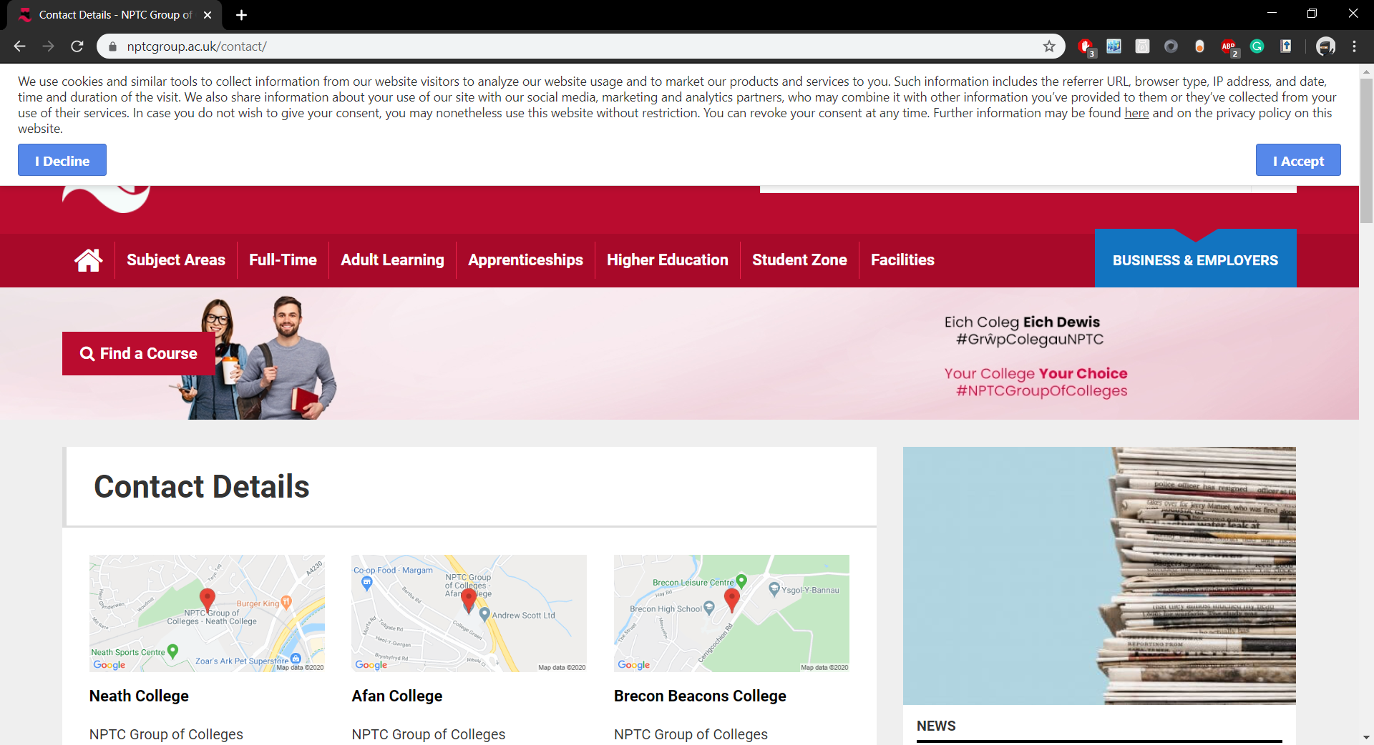
2 | Sign in button | The sign in button should take the user to the sign in portal | The user was taken to the sign in portal | When clicked, the sign in button loaded the sign in page. | 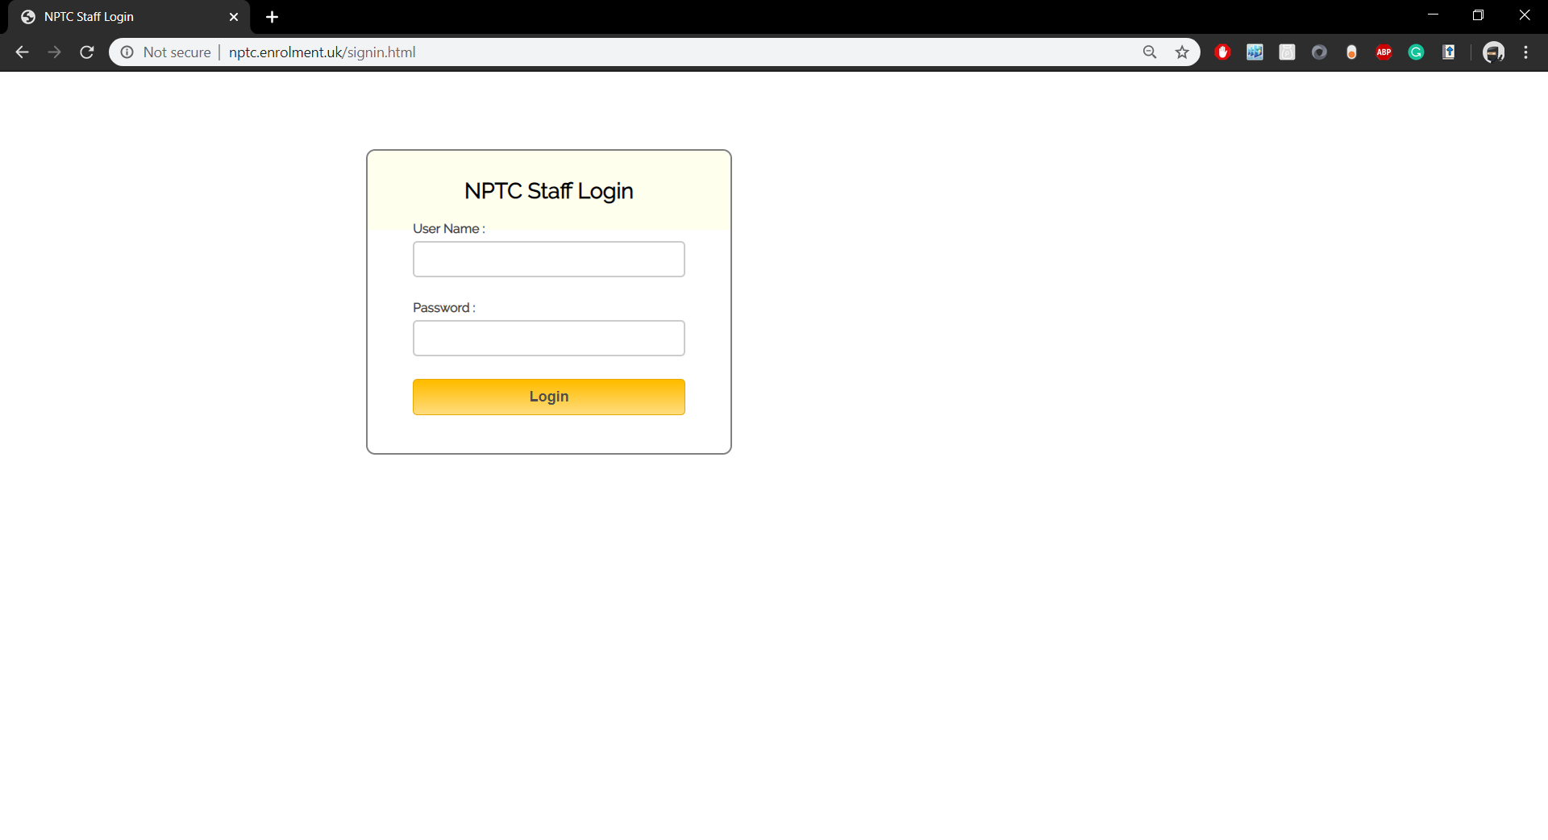
3 | Incorrect log in | An incorrect login should show an error message and how many attempts are left | An error message was shown and the user was informed of how many attempts were left | The user was given a portal to sign in and given an incorrect combination provoked the portal to give an error message and how many more attempts were allowed | 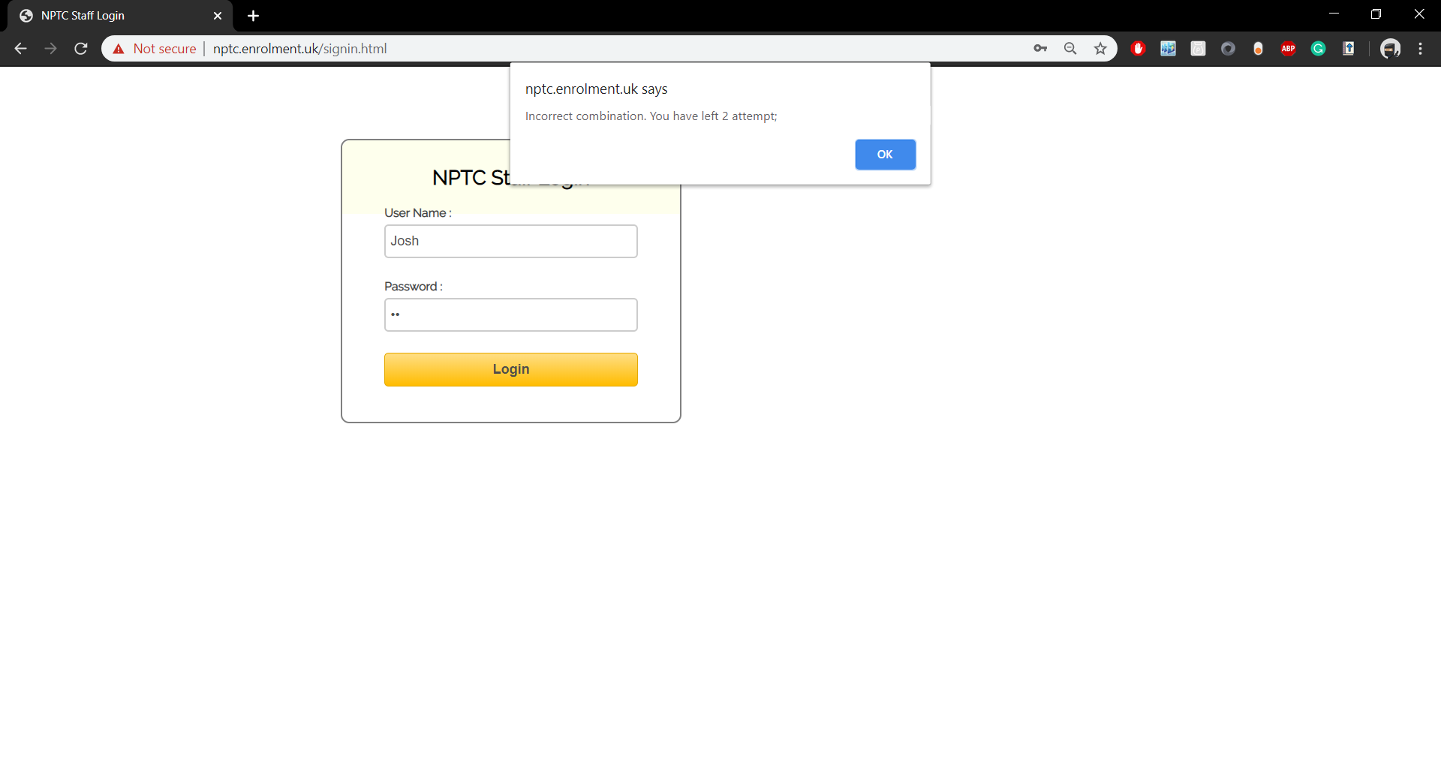  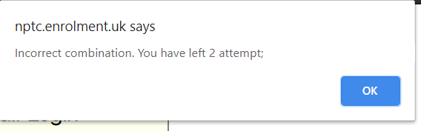
4 | Form validation | Incorrect input values should return a validation error. | An incorrect email format was entered which resulted in a validation message | The enrolment form has different input types which the database requires specific formats for. Each input has a validation attached to it to ensure the correct data is being sent to the database. Wrong formats will be declined, making the user fill in the form correctly to continue. | 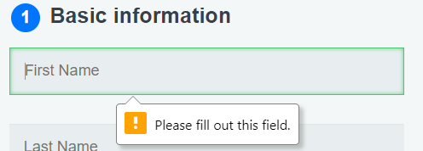  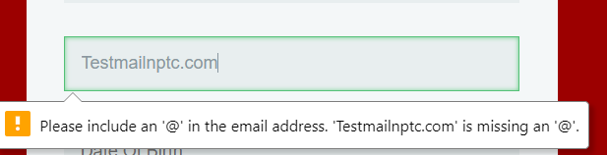
5 | Form Submit | The form should be submitted correctly leading to the processing page | The form was submitted, and the processing page loaded | Upon submitting a correctly filled out form the user should be redirected to the processing page | 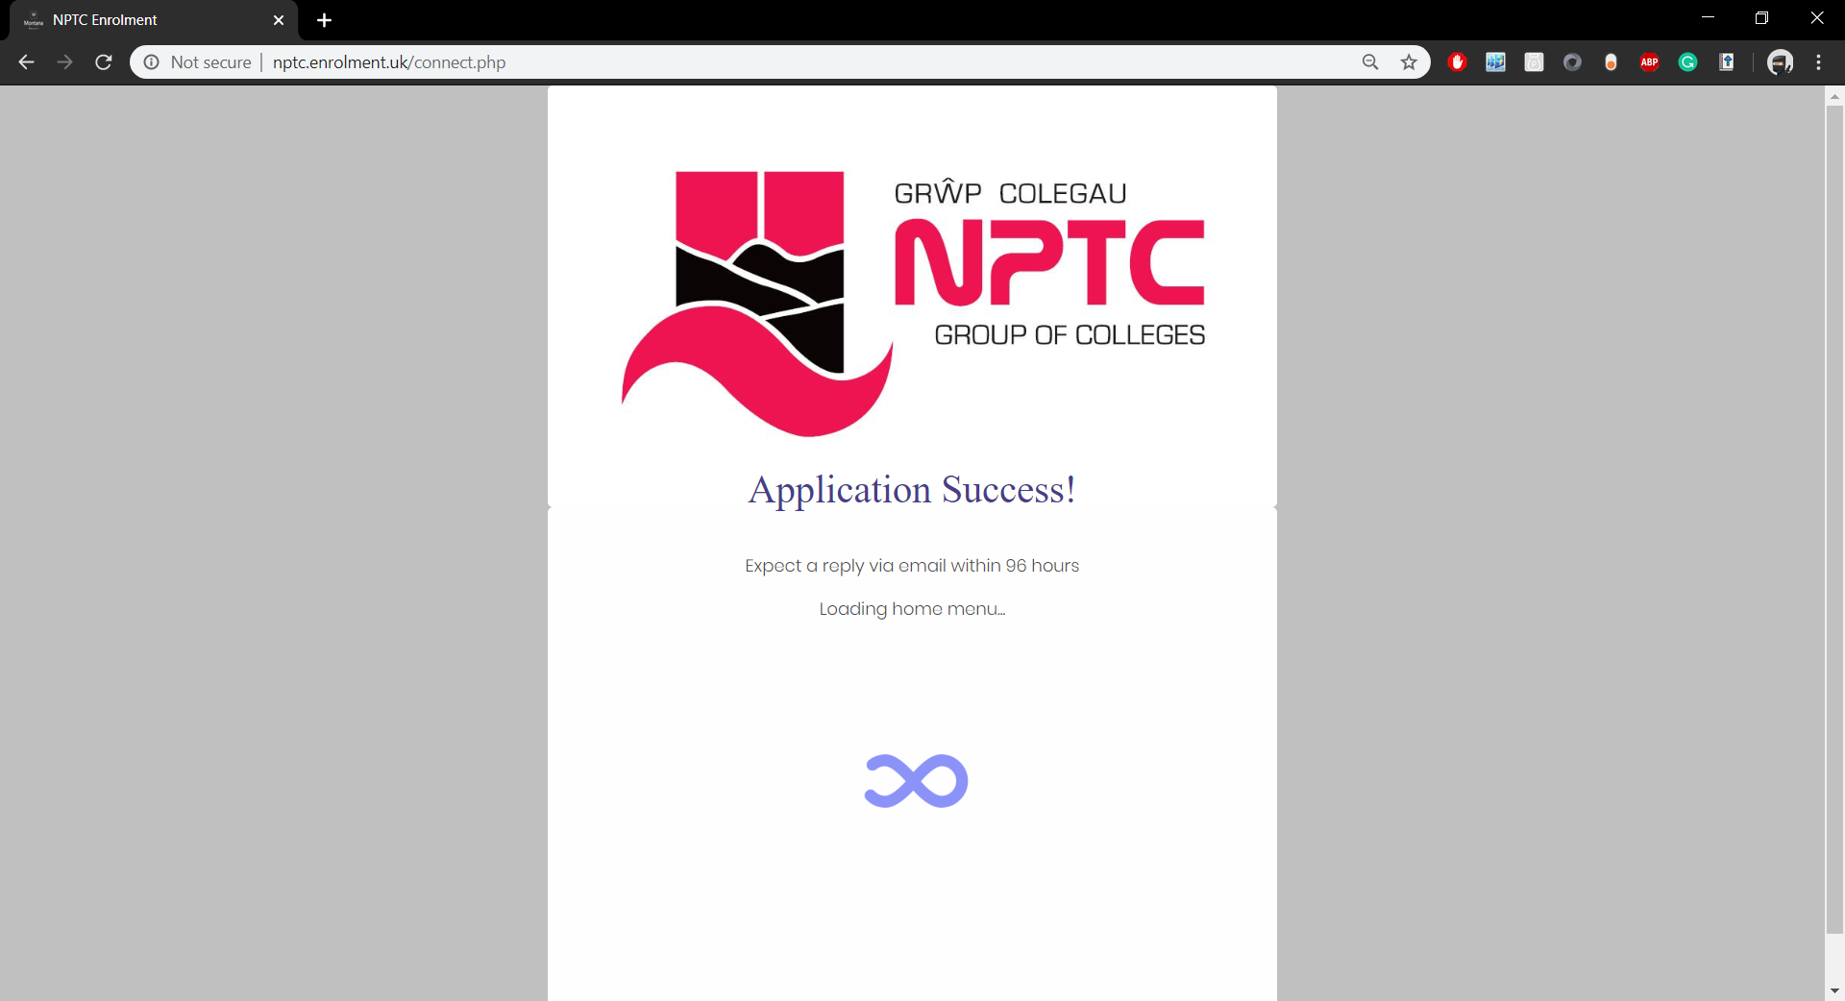
6 | Processing Redirect | The processing page should redirect after 15 seconds. | The processing page redirected to the home page | The processing page will appear for 15 seconds, giving users enough time to read the information on screen before returning to the home screen | N/A
7 | Locked sign in | After 3 incorrect sign in attempts users should be locked from attempting to sign in again | The user was blocked from signing in again until opening a new window |  | 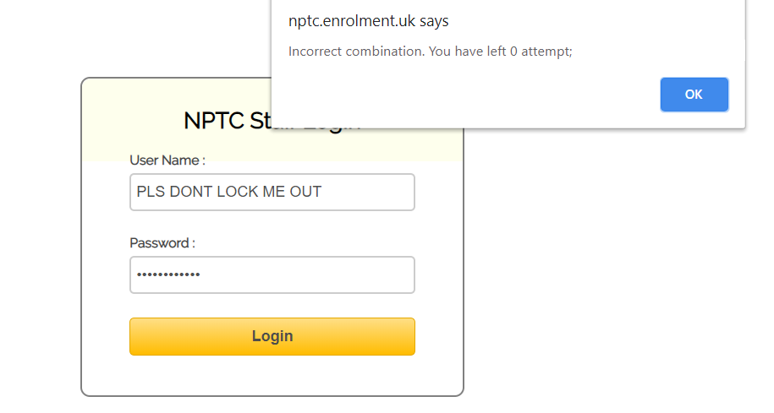  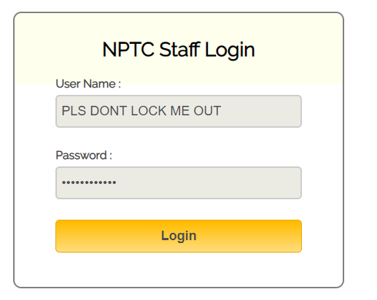
8 | Admin Dashboard | On a successful log in attempt the user should arrive at the admin dashboard | The user was brought to the admin dashboard | When signed in successfully users will be taken to the admin dashboard where enrolment requests can be accepted, viewed, edited or deleted. | 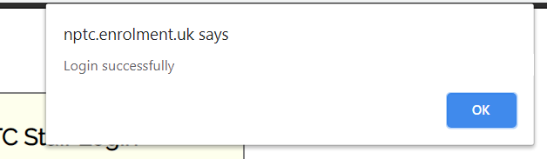  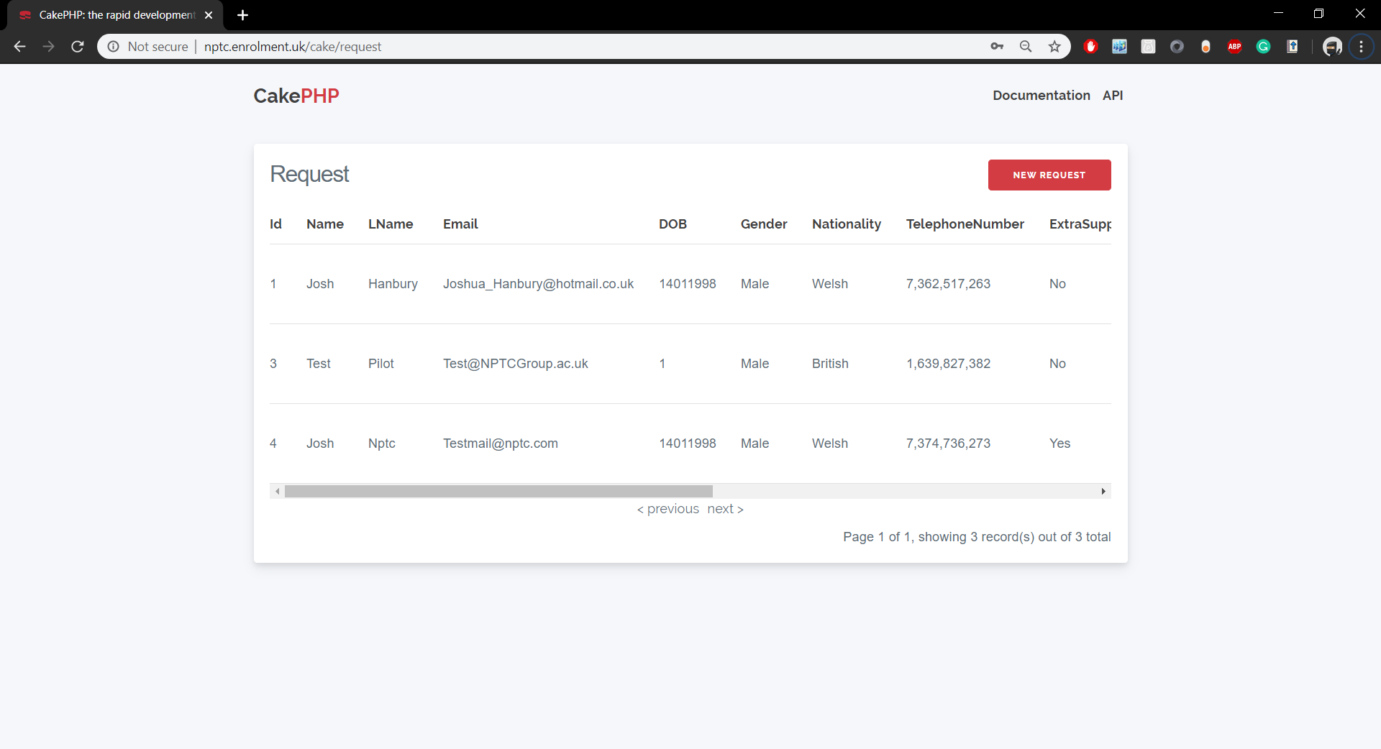
9 | View record | The record should be individually viewed | The record was loaded alone for viewing |  | 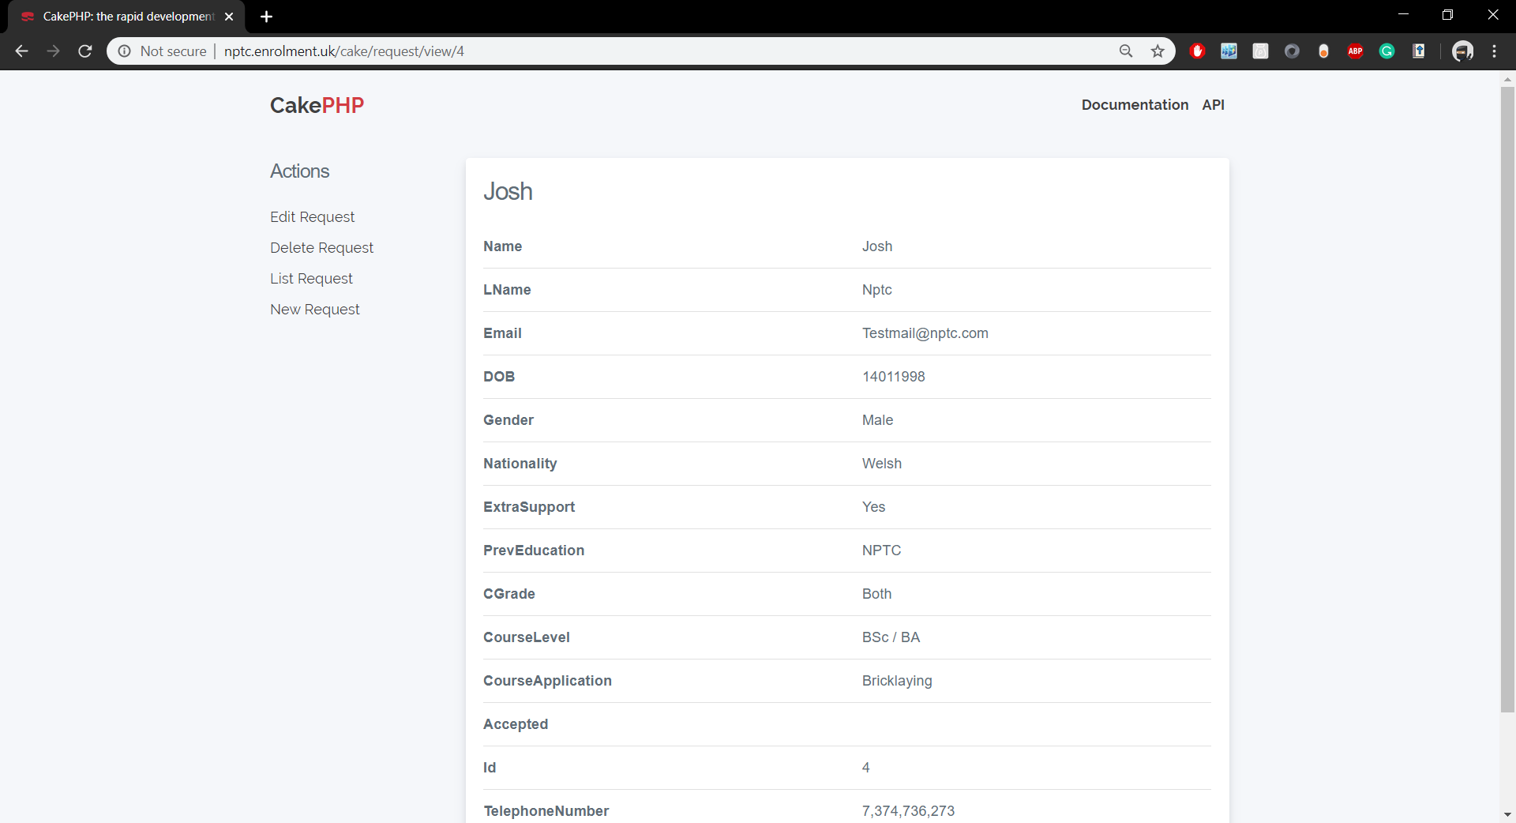
10 | Edit Record | The record should allow editing and then save the change | The record allowed editing and the changes were saved |  | 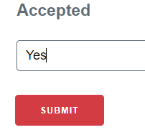  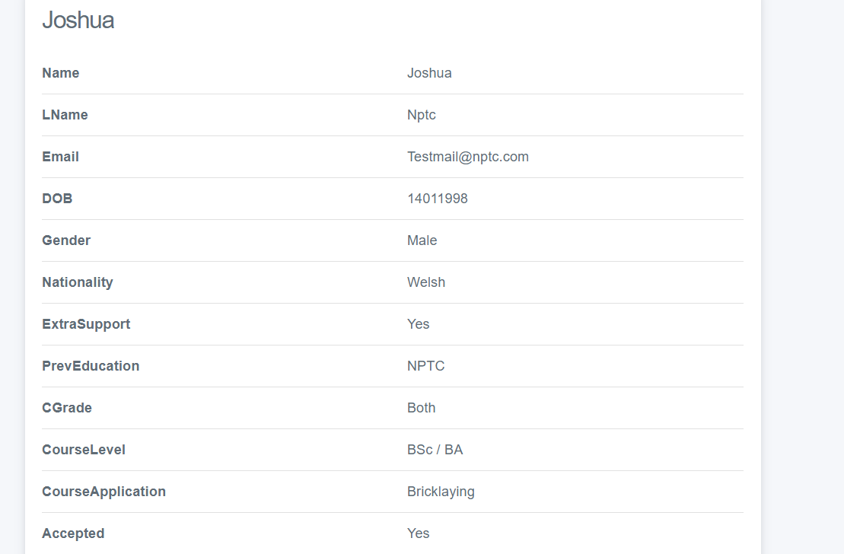
11 | Delete Record | The record should be deleted | The record was deleted |  | 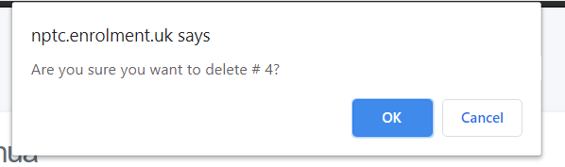  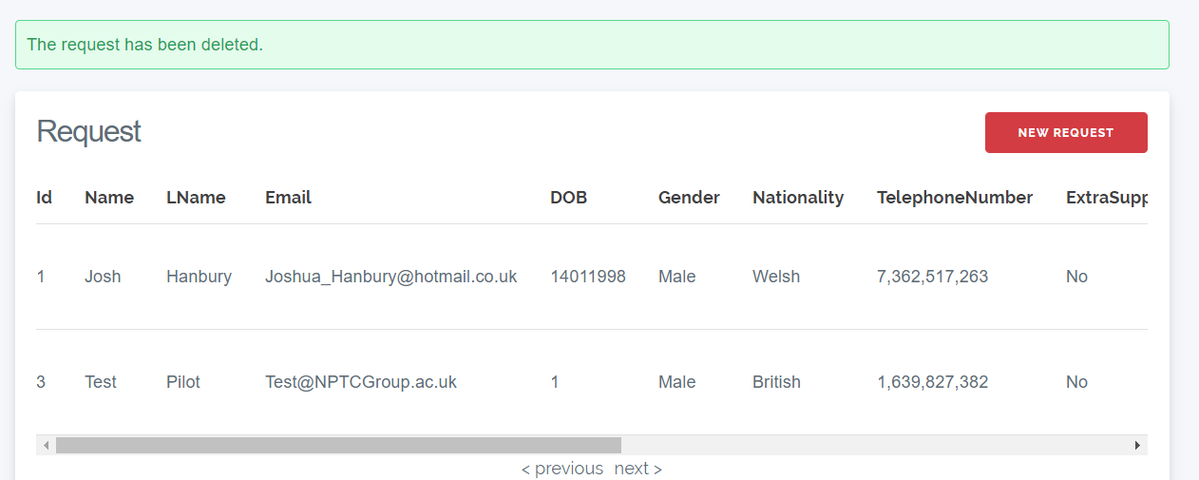
12 | Add record | A record should be added | A record was added |  | 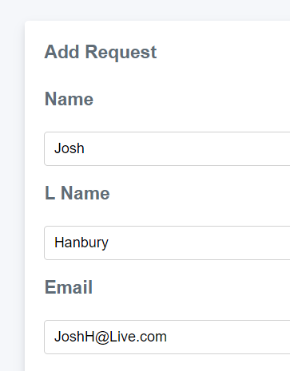  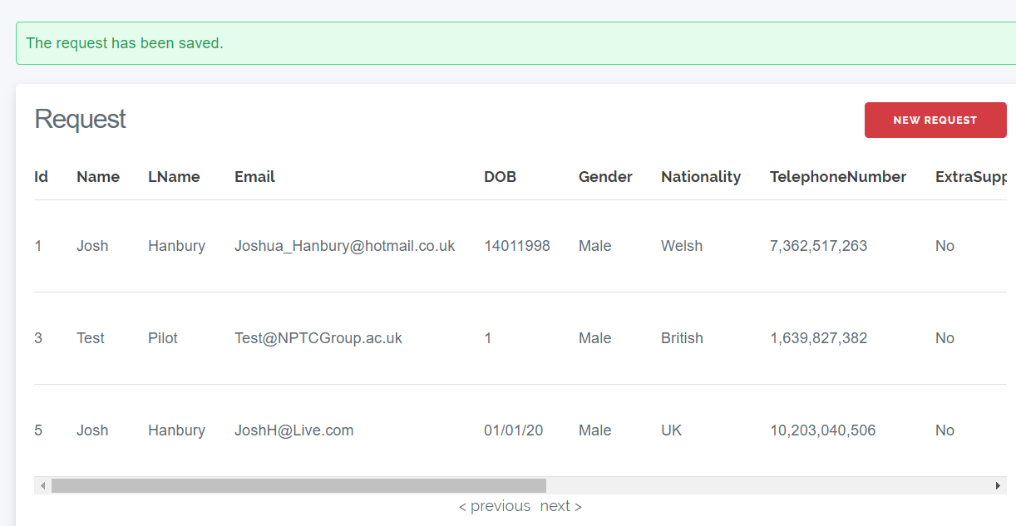
12 | Return Home | Upon clicking the logo in the top left corner, the user should be returned to the home page | The user was returned to the home page |  | 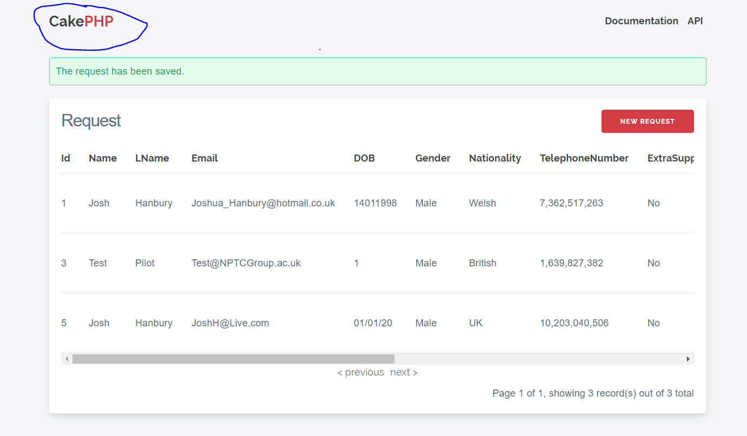  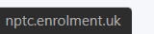

4.2.3.2 System testing
This is the testing of the overall system to ensure it works correctly as a whole and can be implemented.
TestNo | Test name | Expected result | Actual result | Comment | Evidence
1 | Loading the application | The web application will load | The web application loaded | When the URL is entered correctly the web application should load | 
2 | Loading the enrolment application | The enrolment form page will load | The enrolment form | The enrolment form page will load when the ENROL NOW button is pressed
3 | Returning to home page | The application should load the home page | The application returned home | When the user presses the RETURN HOME button, they should be redirected to the home page of the web application
4 | Form Submit | The form should be submitted correctly leading to the processing page | The form was submitted, and the processing page loaded | Upon submitting a correctly filled out form the user should be redirected to the processing page
5 | Viewing the submitted request | The form which was just submitted should appear in the database with a blank “Accepted” row | The form was found in the database with an empty “accepted” value | Once a successful form has been submitted, it should appear in the database with the other records while maintaining an empty “accepted” value as it hasn’t been reviewed yet.
6 | View record | The record should be individually viewed | The record was loaded alone for viewing
7 | Edit Record | The record should allow editing and then save the change | The record allowed editing and the changes were saved |  | 8
8 | Delete Record | The record should be deleted | The record was deleted
9 | Add record | A record should be added | A record was added

4.2.3.3 Usability testing
The usability testing aims to test the usability features of the application. This regards buttons, links, text and font.
TestNo | Test name | Expected result | Actual result | Evidence
1 | Hover colours | Home page nav bar links should change colour when hovered over | The links changed colour to show they are being hovered over |   
2 | Background image rotation | The background should rotate between two images every few second | The background changed images every few seconds or manually using the slide arrows on the side of the browser |   
3 | Form box highlight | When selecting a box on the forum which is being filled out, it should be highlighted to show the user where they are. | The box in use was highlighted | 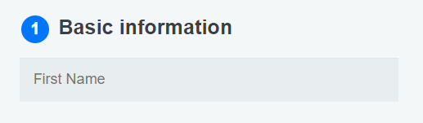  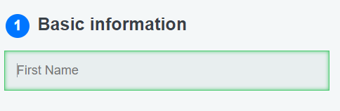
4 | Drop Box selection | When the drop box is selected, it should show a list of selectable items | The drop box was displayed and allowed for an item to be selected | 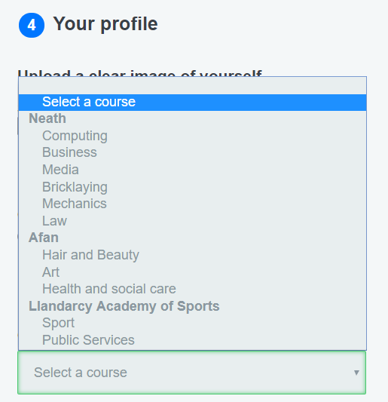
5 | Button Hover | The submit button should change its font size and provide a shadow when it is hovered over | The submit button changed font size and had a shadow when hovered over |   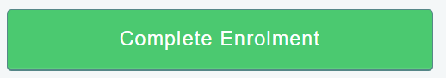
6 | Processing Icon | The processing icon should show on the processing page and move as it is a GIF image | The image was shown and animated appropriately
7 | Navigation using Keyboard | The form should allow navigation for keyboard-only users. | The form could be used by tabbing to the next item to be filled in. ENTER and SPACE allowed for options to be chosen and selected. | N/A
8 | Locked sign in after 3 attempts | After 3 failed attempts the user shouldn’t have any more attempts of signing in | The user was blocked from typing a username and password while the submit button has lost all functionality, not allowing a submission. | 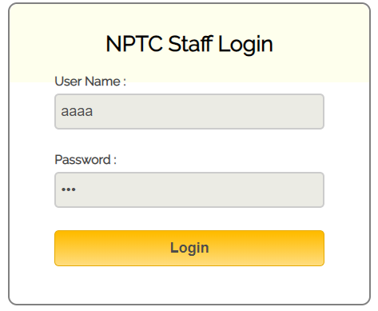
9 | Sign in page messages | The user should have a browser message telling them the status of their log in request | A status was provided for each log in attempt. Giving details on failed and successful attempts. | 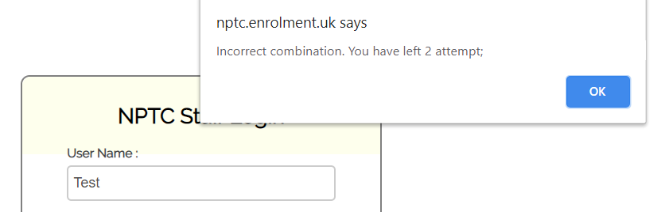  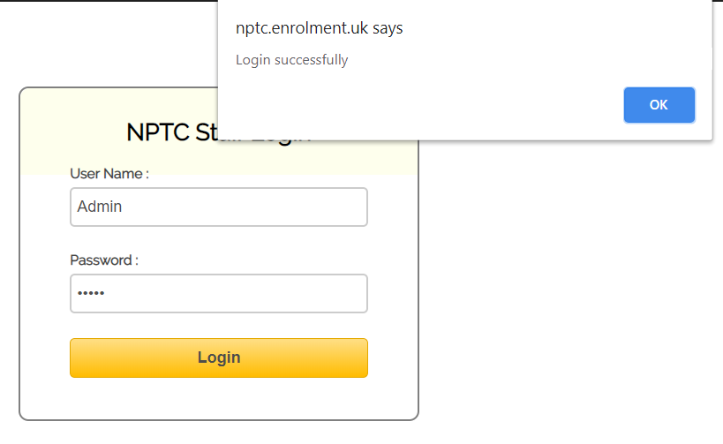
10 | Sign in button Hover | When hovering over the “Login” button the background colour should flip gradients to identify it is being hovered over | The colour gradient of the button changed when hovered over. |   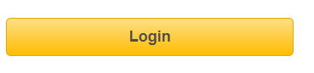
11 | Dashboard buttons hover | When the admin dashboard buttons are hovered over, they should change colour | The buttons and headers changed colours when hovered over | Orginal       | Hovering  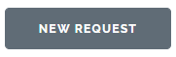    

4.2.3.4 Acceptance testing
Acceptance testing ensures that the application acts how it is expected to by the user. This is features such as inputs or links where the user has a predictable knowledge of what the function of the item is.
TestNo | Test name | Expected result | Actual result | Evidence
1 | Heading links and directions | The headings should take the user to the link relating to the heading | The user was taken to the link relating to the heading option |   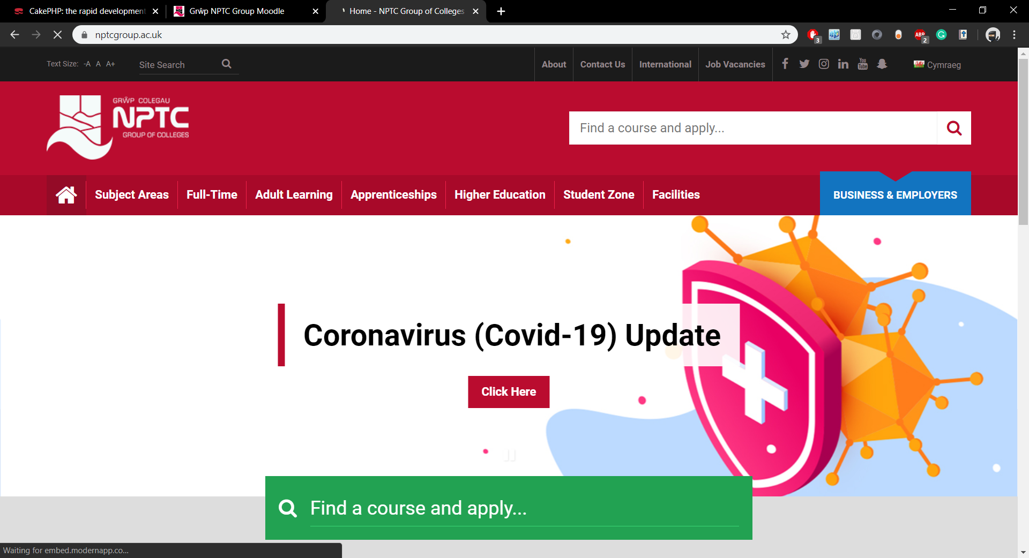
2 | Return Home button | The return home button on the enrolment form should return the user to the home page | The user was returned to the home page |   
3 | Radio Buttons | When a radio button is selected it should become active on the selected item | The radio button selected was highlighted | 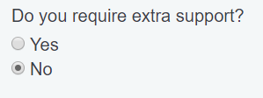
4 | Drop Down box | The drop-down box will display many different choices to the user. The chosen choice should become active in the drop-down list | The item chosen became the main item of the drop-down box | 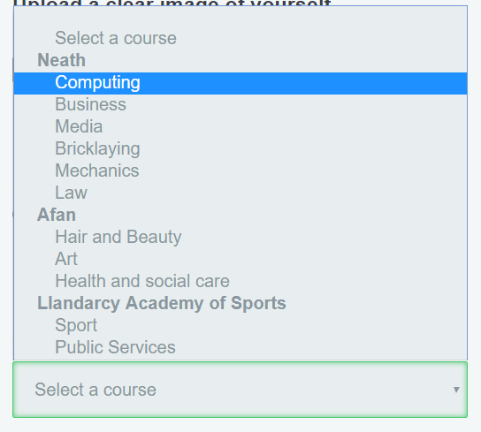  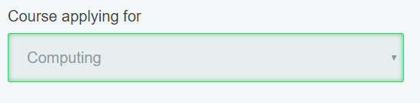
5 | Submit | The submit button should end the form process and let the user know the form has been successfully submitted | The user submitted the form and was taken to the processing page | 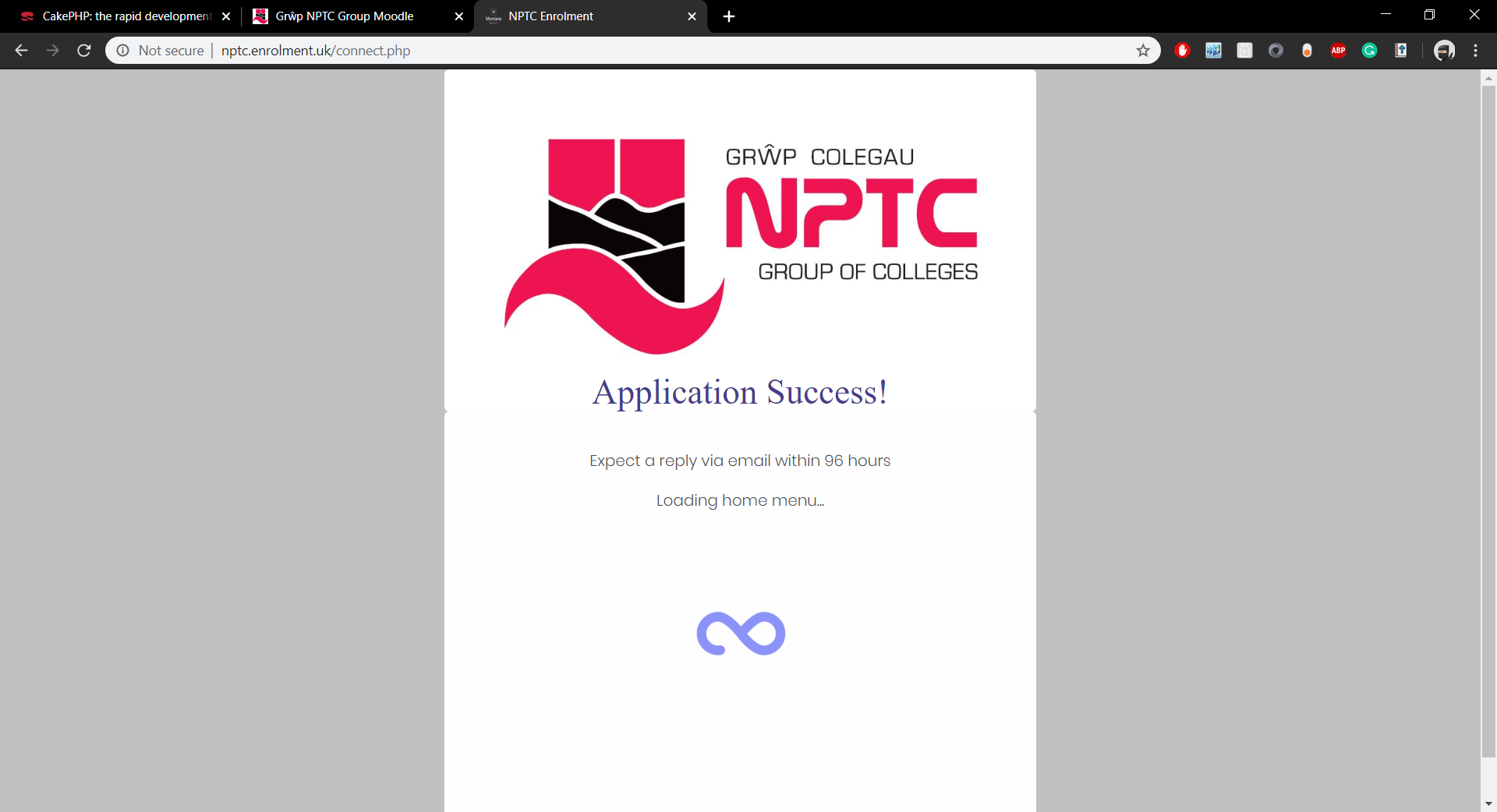
6 | Processing redirect | The processing page says the user will be taken back to the home page | The user was taken back to the home page after a short waiting period of ~ 10 seconds | N/A
7 | Correct admin functions | The admin functions should act as described. View, Edit and Delete. | The admin functions all worked as described. | N/A

Interview with a member of NPTC’s IT Department.
Job Role: Web Application Developer
Identity anonymous

- What is your job within NPTC?
My job role is a web application developer, alongside a few others we maintain the systems provided by NPTC and occasionally work on new or existing ones. We work predominantly back end and only deal with the systems.

- Do you know of any enrolment software within the college?
There is no enrolment software currently in use or being developed by the college, but there is application software which allows users to send applications directly to us where we can then get back to applicants to let them know enrolment days, if they have the correct qualifications to get on their requested course and so forth.

- Has there been any talk of enrolment software being implemented into the college?
There have been suggestions of it, but nothing has materialised. Maybe it is a future development and will be considered more over the next few months or years.

- Would you welcome the idea of a digital enrolment system?
I would be happy to give it a shot. Provided it is developed correctly then it shouldn’t cause any harm and may help improving numbers and assisting staff who are busy during enrolment days

- Who deals with enrolments during the enrolment period?
Usually there is a data entry team that are responsible for dealing with enrolments and inputting student details onto the system, but this team a lot of the time contains staff whose duties do not include enrolment data entry to save money.

- Are you involved in the enrolment process?
My job is not to do data entry and enrolment days, but often, if not always, I am included as the data entry team as the college wants to save money and not hire temps for enrolment days.

- Does this affect you?
It can affect me and the other web application developers as we may have jobs or issues which need tending to, but then instead are told we have to do data entry which is not what we should technically be doing.

- Would a digital enrolment system assist you in this aspect?
I think if a digital system or software was implemented then it could potentially cut short the number of students who attend enrolment days, making it so less staff are required for data entry and hopefully us. This would allow us to get on with our planned tasks and would save the college from wasting our time, and their money on hiring temps or using us

- Do you think a digital enrolment system would have any implications or difficulties?
I think initially it would as staff would need to get used to it. There is still the risk of applicants being clumsy and putting wrong information in, but with the correctly validation and development that can be minimised. Maintaining enrolments would also be a mundane and time consuming task but it would benefit us as it would mean less people would be required to do data entry on enrolment days. Some staff could be set duties to maintain the digital enrolment requests and it could work as the requests would be spread out, unlike a few days of constant rushing students trying to enrol.

