Knowledge and Information Management Skills for The Workplace
(Company- Marks & Spencer)

Module Code- BMSW5106
Student Name- Md Humaun Kabir
Student ID-1712646

Table of Contents
1, Introduction 2
2, Evaluation of the concept and importance of knowledge management in the context of Marks & Spencer 3
3, Relationship between data, information, and knowledge of Marks & Spencer 3
4, Transformation process of the data and information: 4
5, Relationship between individual knowledge and organisational knowledge in context of Marks & Spencer 4
6, Analysis and modelling techniques to identify knowledge assets of Marks & Spencer 6
7, Evaluation of the actual and potential knowledge assets of Marks & Spencer 7
8, Understanding of important knowledge management processes in the context of Marks & Spencer’s development 9
9, Requirements for creating, storing, applying and integrating knowledge of Marks & Spencer 9
10, Importance of intellectual property rights at Marks & Spencer 10
11, Framework for establishing a knowledge management culture at Marks & Spencer 12
12, The contribution knowledge assets have on Marks & Spencer 12
13, Evaluation of the knowledge requirements for the Marks & Spencer 13
14, Evaluation of the framework of the knowledge sharing for the Marks & Spencer 14
15, Recommendation for improvements to the current framework 15
Conclusion 16
References 17

Introduction
The business environment is evolving from time to time according to the needs and requirement of the target customers or users. The customers wish to pay for the value they get and the organisations want to innovate and produce more value adding features to the products and services. Such cyclical process requires continuous improvement and development which can be acquired through the knowledge management process in the organisation. In this assignment, different aspects of the knowledge management process have been delineated from the perspective of Marks & Spencer, which is a UK-based multinational organisation, headquartered in London. The main products of Marks & Spencer include clothes, home appliance and food products.

Evaluation of the concept and importance of knowledge management in the context of Marks & Spencer
The idea of data, information and knowledge are very significant in relation to the value creation from the perspective of the business organisation (Barry, 2019). Different aspects of the knowledge, data, information are delineated below from the view point of Marks & Spencer.

Relationship between data, information, and knowledge of Marks & Spencer
The data can be defined as the raw unit of the large collective information without any process or dissemination (Blackstone and Christian, 2020). The data could be either quantitative or qualitative from the perspective of its contents. The data which contains the numerical characteristics is regarded as quantitative data and the data that contains the statement type of information is called the qualitative data.
The concept of information is very closely related to the data and information is the collection of data which is the analysed, evaluated, disseminated and processed in order to make a valuable meaning for the users. For making different business decisions, the processed information is very helpful to get the insight into different aspects (Bodnar and Hopwood, 2014).
The knowledge is the expanded concept of the data, information along with other facts, figures, experience, expertise, skills etc. which are gathered to be benefited from that accumulated resources (Cheema, 2020).

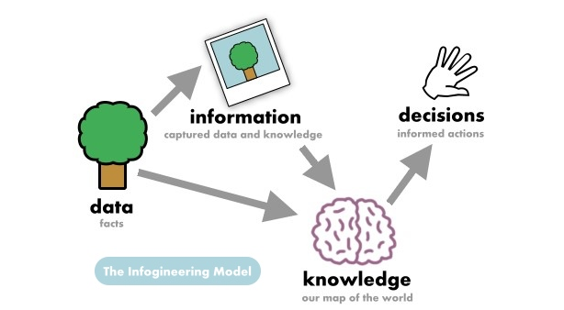
Figure: Relationship between data, information, and knowledge
Source: (Cheema, 2020)
However, there is close relationship between these three terms as they are complementary to one another. For making the effective business decision, it is essential to use all these three effectively and simultaneously. Because, only the information may not make sense due to absence of the knowledge because the decision maker may not know what to do with this information and how they could be useful. Again, without raw data and appropriate processing of them, the information cannot be created or developed.

Transformation process of the data and information:
The raw data is firstly transferred into the information or insight, then some pieces of information turn into the knowledge. The transformation process is integrated within the data, information and knowledge. From the perspective of Marks & Spencer, the wish or demand for a particular style of clothes in a summer season of an individual customer can be obtained as raw data. From hundred or thousand of customers’ data can be analysed and processed to prepare the useful information of the potential customers for a particular clothes demand. There could be many other sets of information available for different styles and for different years. However, the knowledge is the gathered experience and expertise of the management of Marks & Spencer to make appropriate decision accordingly based on the collected information and comparing the results with the previous information in order to determine the trends ongoing.

Relationship between individual knowledge and organisational knowledge in context of Marks & Spencer
The knowledge can be individual or organisational from the view point of place or storage. However, the knowledge acquired through education, studying, learning, training, expertise, and experience by the individual person can be defined as the personal knowledge (Galliers and Currie, 2019). For the personal development in the career, it is very essential for the person to acquire the knowledge continuously from different sources. The knowledge acquired, gathered, processed, disseminated, analysed, evaluated, created, and implemented by the organisation or any other institution in order to benefit different stakeholders of the business organisation (Galati, 2016). The success of the business organisation largely depends on the knowledge resources of that organisation.

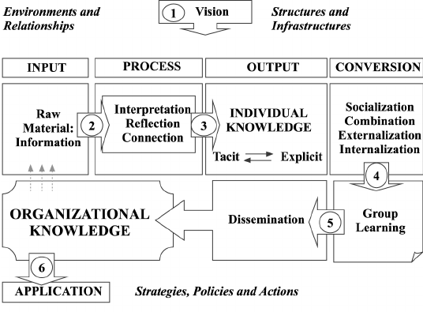
Figure: Relationship between individual knowledge and organisational knowledge
Source: (Laudon and Laudon, 2017)
From the above figure, it is observed that, the knowledge of the person is collected, analysed and disseminated in order to create the organisational knowledge and reversely the persons are benefited from the knowledge and expertise gathered in the organisation. From the perspective of Marks & Spencer, the knowledge management between the person and organisation play very crucial role as the organisation is customer focused and needs to be more innovative continuously. For instance, a person who is a newly recruited employee of Marks & Spencer may have the expertise and experience on working in a similar type of organisation or business and he / she may have greater insight regarding any particular subject matter. Thus, that individual may share his / her idea and knowledge in order to help the decision-making authority to make better business decision. Such insights of different persons develop the organisational knowledge. On the other hand, the other individual persons can learn that skills and expertise from the organisational training and learning process and thus they can make themselves better competent for the new situation to be faced in the giant organisation like Marks & Spencer.

Analysis and modelling techniques to identify knowledge assets of Marks & Spencer
The knowledge assets can be defined as the valuable knowledge which is created through the comprehensive organisational practices (Barry, 2019). The knowledge assets can be developed through the process of sharing, learning and developing the experience, skills, expertise, group discussion, success story of the person, reason for failure, brain storming etc. The knowledge gathered in the organisation can be undocumented or documented. Different modelling technique can be used for identifying the potential knowledge of the organisation.

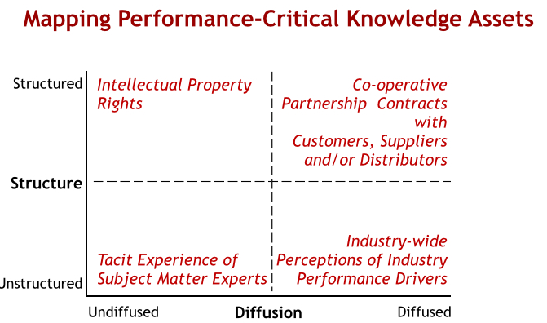
Figure: Modelling techniques to identify knowledge assets
Source: (Debowski, 2020)
According to the above-mentioned technique, the knowledge assets can be identified in four different segments which are as follows-
Intellectual property rights: The business organisation may have some intellectual property rights which are properly licensed and registered. These are regarded as the potential sources of knowledge assets. It is regarded as structured process of knowledge management. The huge organisation like Marks & Spencer should take and maintain proper measures for protecting such intellectual properties as the knowledge assets (Frappaolo, 2016).
Tacit experience: It involves the creation and management of the knowledge in the unstructured format, which is gathered and distributed through the experience, knowledge, expertise and competency of the persons from one to another in order to create the value for the organisation. At Marks & Spencer, this process is regarded as the natural and common process of knowledge management.
Industry-wide knowledge: The knowledge can be gathered and generated both from internal sources and external sources. The respective industry is a great source of potential knowledge assets (Cheema, 2020). For instance, the industry information helps the management of Marks & Spencer to generate new knowledge and understanding regarding the industry trend and movement. Thus, the new shared knowledge can be developed in the organisation.
Co-operative partnership: The business organisation may form the partnership arrangement in order to share and create knowledge assets which is regarded as the strong source of creating and developing the knowledge assets in the business organisation. From the viewpoint of Marks & Spencer, the potential knowledge and insight can be developed from different parties including the customers, distributor, suppliers, employees and managers.

Evaluation of the actual and potential knowledge assets of Marks & Spencer
As the business environment is changing day by day and the competition among the organisations have been increasing rapidly, the business organisations focus on the incessant improvement of their capacity and values for the customers. As one of the largest luxury retailers of the UK, Marks & Spencer focuses on the creativity and uniqueness. For this reason, the organisation needs to develop the knowledge assets on the continuous basis.
The knowledge assets can be categorised into different types. For instance, explicit knowledge, implicit knowledge and tacit knowledge.
Explicit Knowledge: The explicit knowledge can be defined as the knowledge resources which can be easily articulated, understood, written down and shared with the other parties. From the perspective of Marks & Spencer, the explicit knowledge would be the license or patents.
Implicit Knowledge: The implicit knowledge can be defined as the knowledge resources which application or implication of the explicit knowledge (Debowski, 2020). For instance, knowledge of designing the clothes can be regarded as the explicit assets but when the design is done, it can be defined as the implicit knowledge. Again, such explicit knowledge when it is used to do another work, can be regarded as the implicit knowledge.
Tacit Knowledge: It is the knowledge obtained from the personal experience and understanding which is complex to express can be regarded as the tacit knowledge. For example, operating a complex machine at Marks & Spencer can be categorised as the tacit knowledge.
The actual and potential knowledge assets of the giant organisation like Marks & Spencer are both structured and unstructured. The structured knowledge assets include the patents or intellectual property rights and formal partnership with different parties. For instance, the copyrights, patents designs, license etc. are the actual knowledge assets that the organisation have. Any values or knowledge to be created through these could be regarded as the potential knowledge assets as well. Again, the strategic partnership with different suppliers, distributors and other external parties are regarded as the knowledge assets as well (Longley, 2015). Through their mutual and joint effort, research and development the potential knowledge assets can be created. For instance, new way of producing or distributing the products, cost minimisation technologies to be developed etc.

Understanding of important knowledge management processes in the context of Marks & Spencer’s development
The knowledge assets have been very crucial factor for the development of the business organisation in the concurrent business world and for this reason, the business organisation must ensure the proper management of the knowledge assets.

Requirements for creating, storing, applying and integrating knowledge of Marks & Spencer
The knowledge management is the combined process of creating, storing, applying and integrating the acquired knowledge in the organisation. To facilitate this comprehensive process, different measures are taken by the business organisation as follows-
Creating Knowledge: To create the knowledge assets in the organisation, it is required to take different actions by the organisation like Marks & Spencer. Sharing the knowledge among the employees by themselves is regarded as one of the major sources of creating the new knowledge. The employees can share their previous work knowledge and industry experience in order to increase the effectiveness and efficiencies of the other employees. The research and development department can act jointly with the employees to create and develop new knowledge assets in the organisation (Simkin, Rose and Norman, 2013). For the sustainable development of the business organisation, the role of research and development organisation in creating and adding values to the organisation is very huge. The knowledge can be created through the process of brainstorming among the knowledge management and development team. By digging down the existing knowledge and incorporating the new information with the historical information, the knowledge can be created very easily and effectively.
Storing Knowledge: The created knowledge should be preserved and stored in appropriate manner in order to be benefited from the. However, the process of the knowledge storing at Marks & Spencer depends on the nature and significance of the knowledge assets. If the knowledge assets are related to the core business operations and organisational competencies, various defensive measures must be taken. For instance, the patents, license and trade mark of Marks & Spencer should be registered and monitored properly with the help of sufficient legal procedures. Moreover, the physical security of such knowledge is also necessary so that the rivals cannot copy the knowledge assets. The cyber security is a very essential area where necessary attention needs to be taken (Bodnar and Hopwood, 2014).
Applying Knowledge: The knowledge which is created and stored needs to be implemented wherever applicable. The knowledge assets help the organisation like Marks & Spencer to design and develop new products and services for the customers. Since, Marks & Spencer focuses on the creativity and uniqueness, it is imperative that the developed knowledge assets are implemented in different stages and operational areas of the organisation. For implementing the new knowledge assets, the respective project managers or employees must be very careful regarding the potential consequences of the actions to be taken. However, the systematic procedure should be followed in step by step, to implement the knowledge assets of the organisation.
Integrating Knowledge: The knowledge management of the business organisation is regarded as the continuous process which is one of the core managerial activities of the modern competitive business organisation like Marks & Spencer (Tiwana, 2016). In order to sustain in the market for the long-run, it is required for the business organisation to increase creation, development, preservation and implementation of the knowledge more and more so that the organisation can create more values for the stakeholders. Therefore, for integrating the knowledge assets with all other aspect of the business organisation, the management should include this issue with the strategic objective of the organisation.

Importance of intellectual property rights at Marks & Spencer
The nature of the business operations has been changing in the recent years and the core competencies of the business organisation has been changing from time to time (Galati, 2016). In the current context of the business world, the intellectual property rights play a vital role for the large business organisations.
Differentiation of business: In the competitive business world, it is very crucial for the organisation to present itself different from the others in front of the customers in order to attract them and make them to spend more money for the products. Because of the nature of the business of Marks & Spencer, the intellectual property right play very important role here to serve the customers with unique products and services.
Marketing strategy: The branding of the intellectual property has been regarded as the effective marketing tools for the organisation like Marks & Spencer. The organisation can have the competitive advantages in the marketing strategies with the help of the intellectual property rights which creates a positive vibe in the mind of the customers and thus the customers are attracted to the particular brands or products (Galliers and Currie, 2019).
Financing opportunity: The existence of the tangible assets and intangible assets are very crucial for the organisation in enhancing the external financing capabilities of the organisation. Different intangible assets like intellectual properties can be used as the collateral to the financial institution in order to obtain loans and other financing when required by the organisation.
Continue revenue stream: For the sustainability of the organisation in the long run with the current products and development of the products, it is required to have enough cashflows to the organisation. However, of the larger organisation like Marks & Spencer, the cashflow requirement for the operation is also huge. The competitive advantages created through the development of the intellectual property rights helps the organisation to increase the sales revenue and attract the new customers.

Framework for establishing a knowledge management culture at Marks & Spencer
Knowledge management is regarded as the integrated and continuous development process for the organisation like Marks & Spencer. For establishing the knowledge management culture at the business organisation, it is essential to have a proper framework and systematic process.

The contribution knowledge assets have on Marks & Spencer
The knowledge assets contribute from different aspects of the business organisation. The contribution of the knowledge assets is discussed below from the perspective of Marks & Spencer.
Decision making: The first and foremost contribution of the knowledge assets in the business organisation is that, it facilitates the prudent business decision making by the authority. The knowledge management is the integral process which increase the decision-making capabilities of the managers. Moreover, the existence of the knowledge assets helps the authority of the business organisation to make different business decisions because it enables them to have multiple options in front of them (Oz, 2019).
Business environment: The existence of the knowledge assets in the organisation is the indicative of the knowledge management throughout the business organisation. With the help of the proper knowledge management, the cooperation and coordination are increased in the organisation. The employees become more efficient and effective in their performance and feel more motivated and engaged towards their organisation. Therefore, the knowledge assets increase the performance of the employees and create a better business environment.
Financial performance: The financial performance is regarded as the key indicator of the business organisation regarding its activities, value creation, appeal to the customers and investors (Simkin, Rose and Norman, 2013). With the help of the different knowledge assets, the business organisation like Marks & Spencer is able to make more sales and profit through the business operations. The knowledge assets help the organisation to earn other revenue from the other organisations by selling or letting them use of the knowledge assets.
Creativity and innovation: The knowledge assets of the business organisation facilitate its product and service development team to be more creative and innovative in their activities. Different knowledge assets provide them the options to implement them in order to develop the new products and services or efficient operational procedures (Galliers and Currie, 2019).

Evaluation of the knowledge requirements for the Marks & Spencer
Different types of knowledges are required for the day to day business operations. For the giant organisation like Marks & Spencer with many different business wings and operations, the knowledge required is also huge and diversified. Some of them are as follows-
Core operational knowledge: It involves the core business operational knowledge required by the employees and management of the organisation. From the perspective of Marks & Spencer, since the business operations are diversified and most of the products are outsourced and produced by the contract manufacturer, it is essential for the organisation to have proper knowledge of dealing with the manufacturers (Barry, 2019). The product designing and development knowledge are regarded as another very important thing which is required by the respective team members.
Intangible and intellectual property: These are the knowledge assets which provides the organisation with the better competitiveness over the organisations. The proper knowledge regarded these are must to ensure the sustainability of the business organisation (Blackstone and Christian, 2020). Lack of such knowledge will decrease the competitiveness of the business organisation. The business organisation like Marks & Spencer which focuses on the uniqueness and creativity should ensure the management of the such knowledge in order to develop them continuously.
Finance and accounts: These are regarded as the basic business knowledge which are required by all the modern business organisation. The performance of the business organisation largely depends on different crucial financial and accounting decisions, including the sources of financing, investment and risk management decisions.
Sales, marketing and promotion: These are regarded as the strategic management decisions which affect the performance of the business organisation as well. Therefore, these requires substantial knowledge, experience and expertise by the management of the organisation like Marks & Spencer. The leadership and management quality help the organisation to make better strategic decisions like marketing, promotion, distribution and expansion of the organisation.
Technologic knowledge: As the implementation of the technologies are increasing day by day in each and every segment of the business operations, the proper knowledge regarding the concurrent development of the technologies is must have for any organisation (Cheema, 2020). Marks & Spencer should adopt all the applicable latest technologies in order to sustain in the market for long run.

Evaluation of the framework of the knowledge sharing for the Marks & Spencer
The organisational knowledge management process follows different customised frameworks by different business organisation. The structured and systematic procedures are followed by the business organisations in sharing the knowledge. However, the knowledge sharing process at Marks & Spencer can be performed by implementing the following framework of knowledge management.
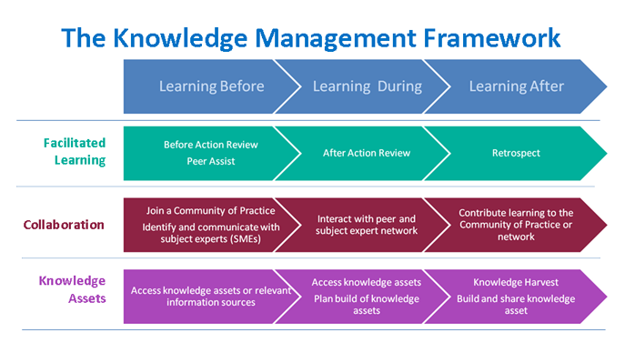
Figure Knowledge Management Framework
Source: (Frappaolo, 2016)
The organisation needs to develop and maintain a proper guideline for the knowledge learning procedure and then the learning activities need to be selected as per the requirements. The learning policies should be designed in such a way that the employees can acquire the knowledge from open sources. The employees should have an open platform to share their previously acquired knowledge with the others. The moderators should be appointed for managing the discussion of the knowledge sharing. The shared knowledge should be reviewed and evaluated critically by the moderators and other decision maker experts by considering the organisational vision, values, and strategic objectives (Galliers and Currie, 2019). The knowledge which is qualified for preservation should be stored with appropriate measure. The newly created knowledge and previous knowledge should be developed and shared with all the related employees of the organisation through proper means. For example, a training and development program can be arranged by Marks & Spencer to share the newly developed knowledge and information with the respective personnel in order to ensure the effectiveness and efficiencies of the employees.

Recommendation for improvements to the current framework
Marks & Spencer has the knowledge management framework which is analysed in the previous section. The systematic knowledge management procedure and framework are developed considering the organisational shared objective and strategies. Like the other organisation, Marks & Spencer should follow the proper procedure of knowledge management framework which will maximise the values creation of the stakeholders.
The huge business organisation like Marks & Spencer has a huge base of the employees throughout the world. These employees would be the main source of the organisational knowledge. Marks & Spencer should develop and implement such a framework which facilitate the easiest way of knowledge sharing. The employees should be encouraged for sharing their respective knowledge, experiences, success stories, learning from failures, self-developed knowledge with the other employees in the organisation. Marks & Spencer should take necessary steps for offering sufficient financial and non-financial motivation for encouraging the knowledge management though knowledge sharing.
The knowledge gathered through sharing and collecting should be evaluated, analysed and disseminated properly so that access to that knowledge for the respective person become easier. The knowledge should be utilised in order to develop and create new knowledge and competencies in different operational levels of Marks & Spencer.
The proper procedure for implementing the knowledge gathered should be followed. To do so, the existing organisational procedure should be followed to avoid any potential risks or complexities to be arisen (Tiwana, 2016). Therefore, the overall strategy regarding the knowledge sharing framework should be the open source platform in which the knowledge sharing and development are highly encouraged.

Conclusion
The knowledge management procedures have been a fundamental part of the modern business organisations. The systematic process of the knowledge management should be implemented and maintained by the business organisations. As Marks & Spencer is one of the largest luxuries brand with large market share, it is imperative for this organisation to continue the value creation activities in order to produce the differentiated and unique offerings and attract the customers.

References
# Barry, C., 2019. Information Systems Development. Guildford: Springer London.
# Blackstone, W. and Christian, E., 2020. Commentaries On The Laws Of England. [Place of publication not identified]: [Nabu Press].
# Bodnar, G. and Hopwood, W., 2014. Accounting Information Systems. Harlow, Essex: Pearson Education Limited.
# Cheema, D., 2020. Knowledge Management. New Delhi: Abhishek Publications.
# Debowski, S., 2020. Knowledge Management. New Delhi: Willey India.
# Frappaolo, C., 2016. Knowledge Management. Oxford: Capstone.
# Galati, S., 2016. Geographic Information Systems Demystified. Boston: Artech House.
# Galliers, R. and Currie, W., 2019. The Oxford Handbook Of Management Information Systems. Oxford: Oxford University Press.
# Laudon, K. and Laudon, J., 2017. Essentials Of Management Information Systems. Upper Saddle River, N.J.: Prentice Hall.
# Longley, P., 2015. Geographical Information Systems. Hoboken, N.J.: John Wiley & Sons.
# O'Brien, J. and Marakas, G., 2019. Management Information Systems. New York: McGraw-Hill Higher Education.
# Oz, E., 2019. Management Information Systems. Boston, Mass.: Thomson/Course Technology.
# Simkin, M., Rose, J. and Norman, C., 2013. Accounting Information Systems. Singapore: Wiley.
# Tiwana, A., 2016. The Knowledge Management Toolkit. Upper Saddle River, N.J.: Prentice Hall PTR.

