

Programme Name: Master of Business Administration
Module Name: Financial Management
Module Code: LCMB7002
Assignment Title: Component 1- Marketing Environment Analysis
Lecturer’s Name: Shengfeng Mei & Patrick Yeboah
Student Name: Arkeshbhai Rajubhai Pansuriya
Student ID: 2529488
Word Count : 5000

Executive summary
The report analyses the financial performance and the strategic position of Hyundai Motor Company in the five-year period. The report reveals that its revenue growth and liquidity were high, and there was resiliency and sound financial management in the short run. In recent years, however, profitability has fallen because of the increasing costs, and efficiency has been deteriorating, indicated by a longer cash conversion cycle. Growing financial risks are indicated in increasing leverage and negative operating cash flows. In order to overcome these problems, it is proposed to carry out a working capital reform and to restructure the financial strategy. The results of investment appraisal show that the number of viable projects is low, and Project C is proving to be fairly better. On the whole, the company is not in bad financial condition, yet it needs to enhance efficiency and capital management in order to promote long-term development.
Table of Contents
1. Introduction 4
2. Financial Health Check 4
2.1 Financial Data from Annual Reports 4
2.2 Ratio Analysis 8
2.3 Trends, strengths and threats 9
3. Working Capital Management 11
3.1 Cash operating cycle 11
3.2 Improving Liquidity through Working Capital Reforms 12
3.3 Short-Term vs Long-Term Financing Options 13
4. Strategic Financial Restructuring Plan 14
4.1 Capital Structure and Shareholder Value Analysis 14
4.2 Need for Restructuring 15
4.3 Strategic Options 16
4.4 Impact Analysis 17
4.5 International & Ethical Considerations 18
5. Investment Appraisal & Capital Budgeting 19
5.1 Analysis 19
5.2 Project Selection Decision 21
5.3 Consideration of Non-Financial Risks 21
5.4 Capital Rationing Decision 22
6. Conclusion 22
7. References 24
8. Appendix 26

1. Introduction
Hyundai Motor Company is a large global automotive company and one that has a diversified portfolio comprising internal combustion engine vehicles, and has recently expanded its electric vehicle (EV) branch. The report has evaluated the financial performance and the management of the firm within the past five years in terms of profitability, liquidity, efficiency, and capital structure. It also looks at the working capital management, describes the key fiscal problems, and suggests the key possible ways of the strategic reorganization directed to the long-term development. Furthermore, it is possible to estimate future projects using the future investment appraisal methods, which will help in decision-making. The report will attempt to provide a detailed financial discussion towards ensuring Hyundai is competitive and sustainable in a competitive automobile industry worldwide.

2. Financial Health Check

2.1 Financial Data from Annual Reports
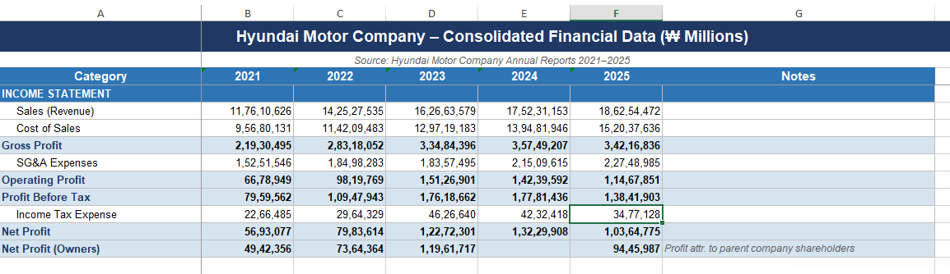
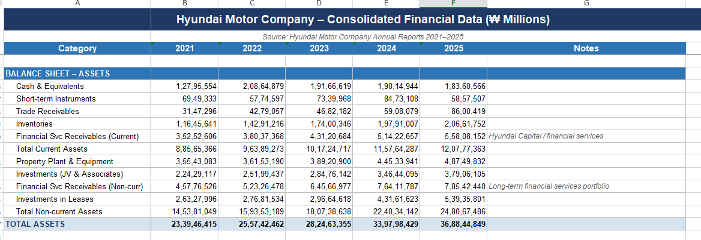
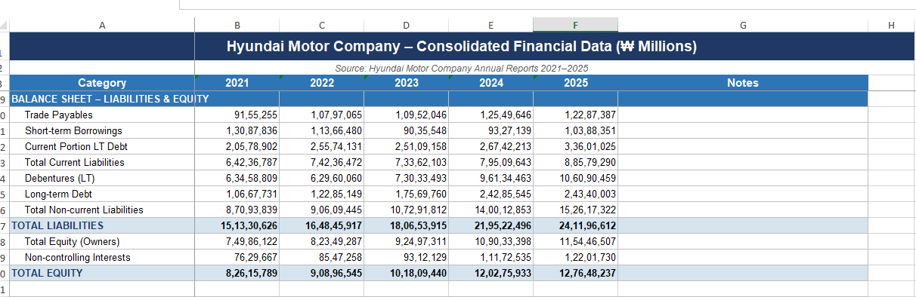
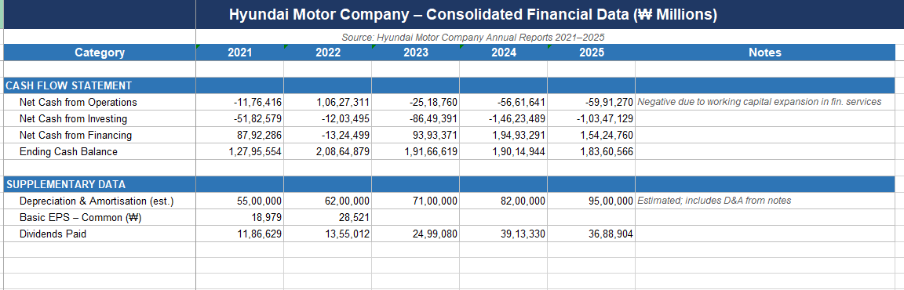
Figure 1: Financial Data from Annual Reports
Hyundai Motor Company is characterized by high revenue growth and rising profitability over the five years, wherein sales will continue to increase, with profitability growing the most in 2023 before levelling off in 2025. The profitability ratios (gross, operating, and net margins) show a growth in operational efficiency, followed by a small pressure due to increased costs. Liquidity is also maintained at a steady level, with current and quick ratios reported to be above 1, which is a showing of sufficient working liquidity. Efficiency trends indicate a decreasing inventory turnover with an increasing trend in receivable days, which points to slower cycling of working capital (hyundai.com, 2026). There has been a progressive rise in leverage, a growing debt ratio and a falling interest coverage, which signifies the increased financial risk. The cash flow performance is not stable, with negative operating cash flows in the past few years, because of the expansion of working capital. Generally, Hyundai has a high growth potential and robustness, but it is experiencing new threats to its liquidity and ability to maintain debt.
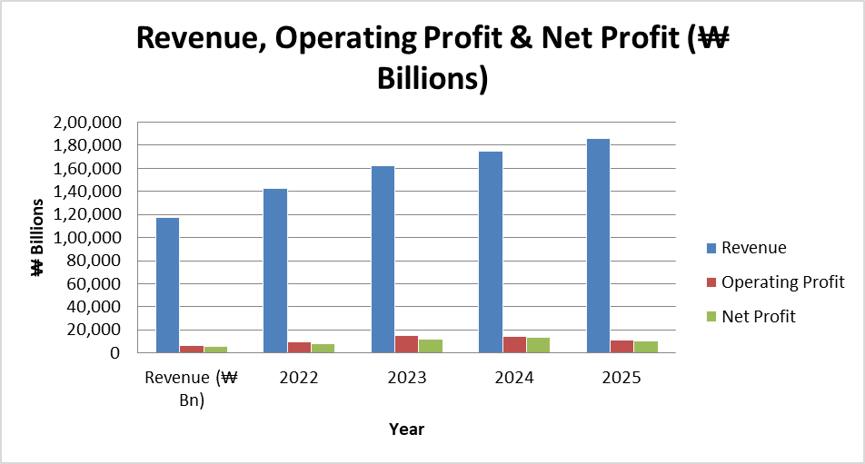
Figure 2: Hyundai Motor Company: Revenue and Profitability Trends (2021–2025)
The trend in the Hyundai Motor Company chart shows that revenue experienced a positive, steady trend between the years 2021 and 2025, and this implies that it will experience a positive increase in sales and a positive increase in market growth. The operating profit and the net profit also increase significantly up to the year 2023, as the operational performance and cost management improve. However, the profits decline slightly in 2024 and 2025 despite the fact that there is an increase in revenue which serves as an indication of pressure on the margins and higher expenditure (Potharla, 2025). Overall, Hyundai is a well-developed company regarding its growth and profitability but the recent decline in profitability highlights some new cost issues that may impact its future financial performance and require appropriate cost control.
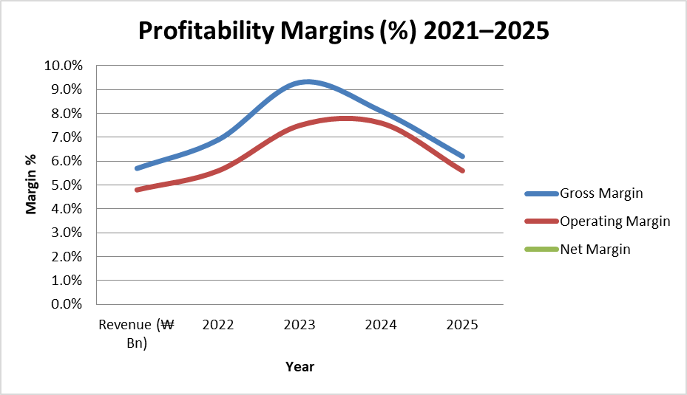
Figure 3: Profitability Margin Trends (2021–2025)
The trend of the profitability margin of the Hyundai Motor Company since 2021 up to 2023 has been on an increasing curve, as represented by the chart above, with the gross, operating, and net margin reaching their highest point in 2023. This implies that it is cost-efficient and this pricing power is high at the moment. However, the margins declined in 2024 and more in 2025, which signals the rising cost of production and pressure of operation, although revenues always grow. The negative trend indicates the new problems of profitability in the future, and need to enhance cost control and efficiency to sustain the financial performance in the long run.

2.2 Ratio Analysis
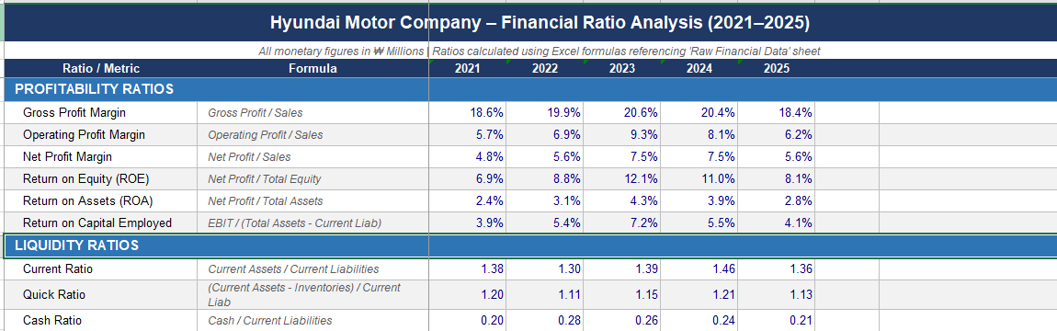
Figure 4: Profitability and Liquidity Ratio Trends (2021–2025)
Over the period 2021-2023, Hyundai Motor Company has been registering growth in profits in terms of gross, operating, and net margins, and in returns on assets and equity. This means that there will be more efficiency and appropriate control of expenses. However, the yearly 2024 to 2025 pegs all decline of profitability, which is an indicator of an escalation of costs and margin strains. The current and quick ratios are also above 1, which implies that there is enough liquidity to cover in the short term. The relatively low cash ratio shows that there is a limited amount of cash within the short-term, although the financial position of the business is identified and its expansion continues.
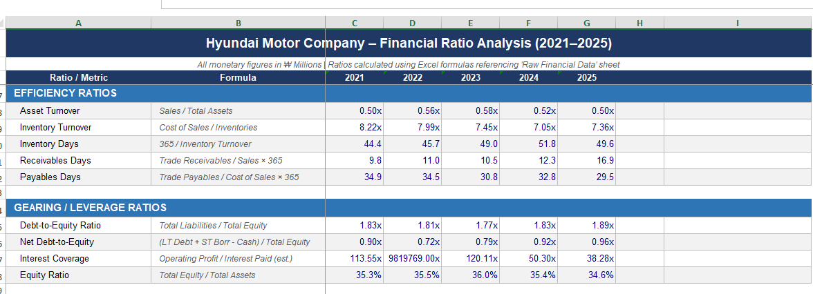
Figure 5: Efficiency and Leverage Ratio Trends (2021–2025)
Between 2021 and 2025, the Hyundai Motor Company is experiencing decreasing operational efficiency as assets turnover is projected to decline (0.58x (2023) to 0.50x (2025)), as well as inventory turnover (8.22x (2021) to 7.36x (2025)). Inventory days also grow to 49.6 days (up to 44.4), whereas receivables days grow considerably (9.8 to 16.9), which means slower collections. Payables days vary and are decreasing. The leverage is increasing, as debt-to-equity and interest coverage ratios increase to 1.83x and 1.89x, respectively, indicating an increase in financial risk and loss of capacity to service debt.
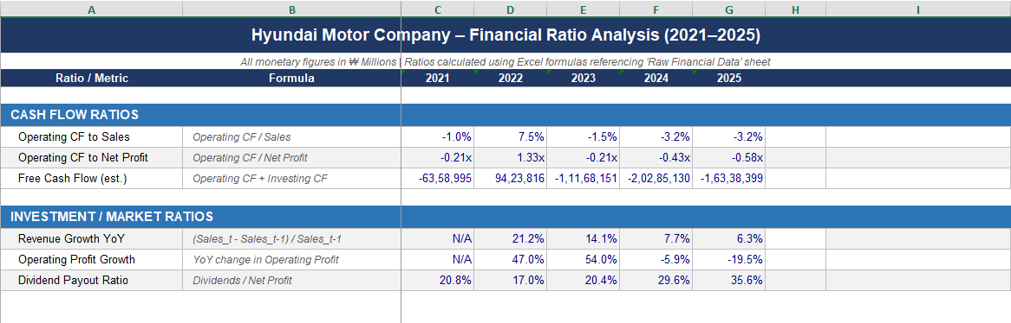
Figure 6: Cash Flow and Investment Ratio Trends (2021–2025)
The performance of Hyundai Motor Company has shown a fluctuating result of cash flow performance, with operating cash flow turning negative, excluding 2022, which impedes the company because of the expansion of working capital. Free cash flow is largely negative, which means that they are hugely invested and are incurring great capital spending. This year (2022 (21.2%) will experience high revenue growth that, however, matures to grow by 6.3% in 2025. The operating profits grow at a higher rate in 2023 and subsequently the growth decreases sharply (Yingnan and Shuang, 2024). In the meantime, the dividend payout ratio increases with a progressive trend, referring to the strength of the dividend paid to the shareholders, which is greater, but the cash flow weakens.

2.3 Trends, strengths and threats
The five-year financial trends demonstrate the financial health of HMC in profitability, liquidity, efficiency, leverage, and cash flows. Higher revenue and profitability were documented in 2023 compared to 2021, and the highest level of margins and returns witnessed indicates good management of costs and performance of the operations. However, 2024-2025 are marked by a drop in profitability, higher costs of inputs, inflationary pressures and potentially price caps.
Liquidity is also a strength because current and quick ratios are also maintained at a level that is more than 1, which means that the company can be in a position to pay off its short-term obligations. Moreover, the growth of revenues and increasing equity shows a steady increase in financial stability and health (Fathoni et al. 2025). Despite these strengths, there exist several threats. The efficiency is negative as it deteriorates in the sense that there is an asset and inventory turnover and receivables days that are decreasing, indicating slow functioning and bad working capital control. The cash conversion cycle of holding cash in operation has greatly increased.
The leverage is also escalating, and debt to equity is escalating with a fall in the interest coverage, indicating that there is an escalation of the financial risk and a diminution in the capacity to service debt. Moreover, there have been negative operating and free cash flows over the years that impose liquidity pressure, even though it records accounting gains. Overall, Hyundai is recording good growth and stability, but in cases where threats of declining efficiency are increasing, rising debt and worsening cash flow, that, unless well managed, may hamper long-term financial sustainability.

3. Working Capital Management

3.1 Cash operating cycle
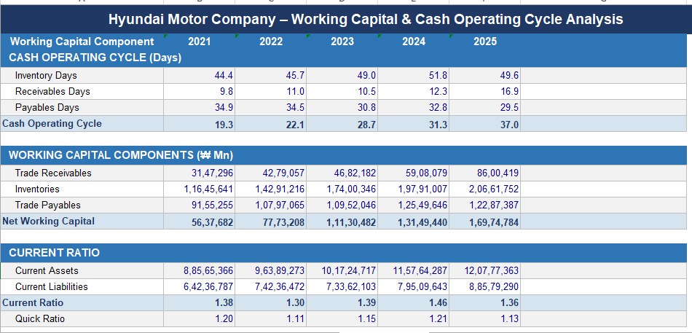
Figure 7: Working Capital Components and Liquidity Trends (2021–2025)
The working capital analysis reveals that the net working capital is steadily rising between 2021 and 2025, with the majority of the increase being attributed to increasing inventories and trade receivables. This shows that they have more cash that is tied to the operations and this may lessen the liquidity efficiency. Both current and quick ratios are above 1 during the period, indicating sufficient short-term solvency, but the slight decrease in 2025 indicates some potential pressure. The widening divergence between current assets and liabilities not only points to a tight liquidity position but also indicates asset utilisation efficiencies (Özdemir and Kırhasanoğlu, 2025). In order to enhance liquidity, Hyundai ought to maximise its inventory, faster collection of receivables by using more stringent credit policies, and better negotiation with suppliers to lengthen the payables where possible. These reforms would free trapped cash and enhance the liquidity of operations.
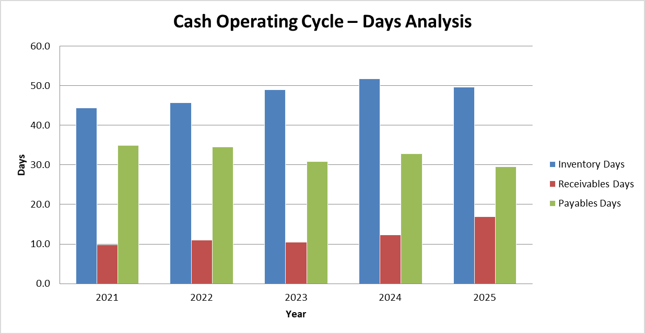
Figure 8: Cash Operating Cycle Analysis (2021–2025)
The operating cycle of cash flow is greatly declining between 19.3 days in 2021 and 37.0 days in 2025, which means that the working capital efficiency is not good anymore. The main factor of this increase is growing inventory days and drastically changing to high receivable days, although the number of payables days is decreasing, which removes supplier financing advantages. The longer cash cycle means that the company has a greater tied-up cash in operations, which contributes to the negative operating cash flows that have been experienced in the past few years. In order to handle this, Hyundai ought to implement just-in-time inventory, reinforce credit control protocols and reevaluate the supplier terms to lengthen the payment term (Ja’afar and Zulkifli, 2025). On financing, long-term financing is offered to address the lack of temporary working capital, whereas short-term financing is provided by trade credit and overdrafts.

3.2 Improving Liquidity through Working Capital Reforms
In the analysis, the working capital efficiency is evidently worsening as the cash operating cycle has risen by 19.3 days to 37.0 days within the five-year period. This is a trend that shows that more cash is acquired in inventories and receivables, and this decreases cash liquidity even though current and quick ratios are stable. Inventory days have increased, showing slow movement of stock, whereas receivables days have increased, largely indicating a delay in the collection of money. Simultaneously, the payables days have dropped; that is, the company is paying suppliers more quickly and forfeits the profit of trade credit. All these elements lead to the liquidity pressure as well as negative operating cash flows over recent times.
Some working capital reforms need to be introduced to enhance liquidity. First, there should be optimal inventory management through embracing the just-in-time (JIT) systems and advanced demand forecasting methods. This would lower the stock levels, decrease holding costs, and enhance turnover efficiency. Second, tighter credit control measures should be enhanced, including reducing credit periods, assessing customer credit more strictly and offering early payment discounts. Such measures would speed up cash receipts and enhance the receivables cycle (Yin et al. 2024). Third, one should strategically manage the payables by renegotiating with the supplier on terms to increase their payment periods without harming the relationship with the supplier. This would enable the company to keep cash longer and enhance liquidity.
Moreover, operational efficiency can be improved, and delays can be minimised with the help of digitalisation of working capital processes, such as automated invoicing and real-time inventory tracking. Days Sales Outstanding (DSO) and Days Inventory Outstanding (DIO) are also key performance indicators that the company should pay more attention to, to guarantee the process of constant improvement. All in all, the objectives of these reforms are to reduce cash conversion cycle, free up trapped cash and increase short-term financial flexibility.

3.3 Short-Term vs Long-Term Financing Options
The firm should strike a balance between the short-term and the long-term funding sources to support working capital needs. Financing with short-term duration encompasses: bank overdraft, trade credit, commercial papers and short-term loans. These are typically more flexible and easier to reach and hence are suitable for managing temporary liquidity shortages and seasonal variations in working capital. Trade credit would be one such example, enabling the company to pay the suppliers when they need to finance their operations without paying them all at once. Nonetheless, short-term funding is associated with greater refinancing risk and may turn out to be expensive in case of an increase in the interest rates or when a firm overrelies on short-term rolling over borrowing.
On the other hand, long-term financing sources involve bonds, long-term bank loans, and equity financing. These are more stable and fit better in financing structural working capital requirements, particularly in a capital-intensive business. Long-term debt helps ease the burden of regular refinancing and provides certain repayment schedules that may help in strategic planning. Equity funding is also costly in terms of dilution of ownership, but enhances the capital structure, and financial risk by reducing leverage.
It is advisable to take a balanced approach. Operational flexibility and day-to-day liquidity management should be financed in the short term, and sustained working capital investments should be financed in the long term, with the purpose of minimising the risk of refinancing (Surendra and Mahesh, 2025). Due to the increasing leverage and decrease in interest coverage observed, overdependence on debt, especially the short-term debt, should be avoided. Rather, the liquidity will be increased using a mix of re-established internal cash through optimal working capital reforms and sound financing decisions, as well as facilitating long-term financial stability.

4. Strategic Financial Restructuring Plan

4.1 Capital Structure and Shareholder Value Analysis
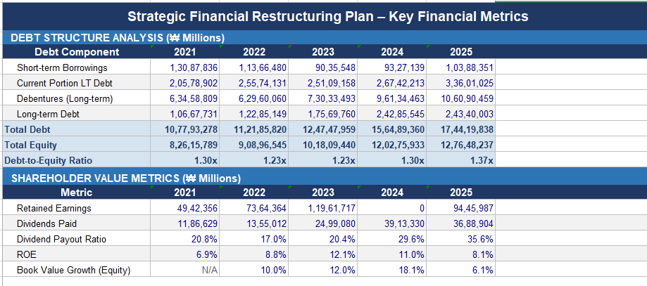
Figure 9: Strategic Financial Restructuring Plan
The figures show that the overall trend is towards a gradual increase in the total debt over the period 2021-2025; however, with an average increase in equity, which translates into both upward and downward equity-to-debt ratios. The shareholder value indicators are fluctuating, of which in 2024 there are negative decreased retained earnings but in 2025, there are gains. In general, Hyundai has revealed that its leverage is managed and that it does not vary with the investment pressures it undergoes.
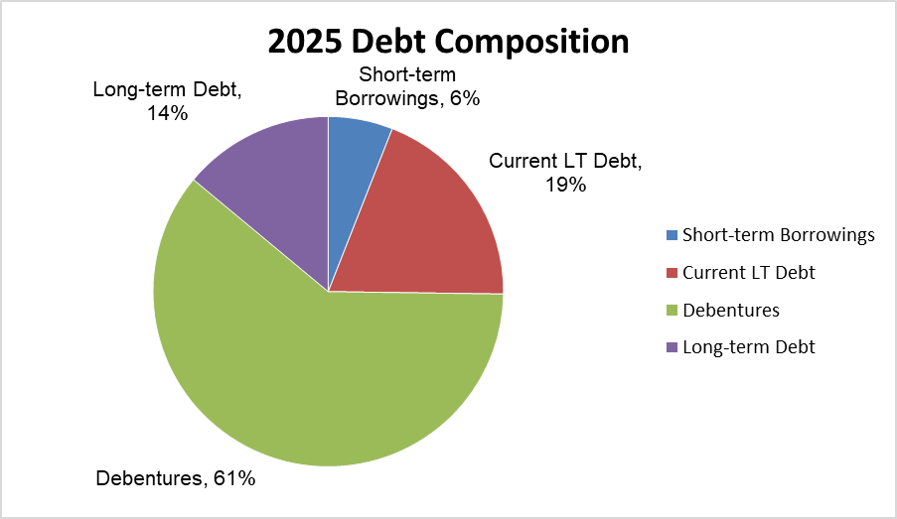
Figure 10: Debt Composition of Hyundai Motor Company (2025)
The percentage of debt incurred in the form of debts is a significant part of the total debt amounting to 61%, indicating the reliance on long-term financing instruments. There is a prevailing long-term debt of 19% and short-term borrowings of just 6%. This comes as a result of a strategic focus on stable funding in the long run that would aid funding of capital-intensive investments in EV.

4.2 Need for Restructuring
The financial stress that the Hyundai Motor Company experiences in its attempt to reorganize to withstand the requirements of the global market dynamics is continuously increasing due to the capital-intensive nature of the change into electric vehicles (EVs) and the changing global market dynamics. Hyundai reported good financial performance as per the annual report, and in FY 2024-25, the motor company reported a revenue of 23,392 million and a profit after tax of 56,402 million (hyundai.com, 2026). This expansion, however, is accompanied by more investment needs, particularly in EV development, infrastructure, and localisation. The company will launch 26 new models, 6 of them will be EVs, and its future capital commitment is the way forward. Furthermore, Hyundai is expanding to an annual capacity of 1 million, which will require immense capital outlay (Potes et al. 2025). These high-level projects, alongside increased competition and technological revolution, strain the budgets. Therefore, it must restructure its financial resources so that it can be in a position to use the earnings profitably and expand sustainably in the rapidly evolving EV market.

4.3 Strategic Options
Option 1: Divestiture
Divestiture is the process of selling the core or non-performing assets in a bid to invest in the strategic asset. This can be in the form of exposure to less appealing internal combustion engine (ICE) or non-strategic subsidiaries in the case of Hyundai. The reorganization of its capital base towards the classical business can increase the efficiency of finance since the company will transform further to EVs and even more sophisticated mobility solutions (Muller, 2025). The sale will assist Hyundai in streamlining its portfolio, reducing the complexity of operations and focusing on high-growth areas such as EV technology, battery development, and digital mobility services. It also enhances the liquidity without increasing the degree of debt. More careful consideration, however, should be given to the long-run implications, as the early sale of the lucrative ICEs may lead to a reduction in short-term cash flows currently being used to invest in EVs.
Option 2: Strategic Alliances/Mergers
Mergers and strategic alliances allow Hyundai to share risks and expenses associated with EV development. A collaboration with the technology companies, battery makers, or even any other car manufacturer can hasten the innovation process and reduce the capital burden. Battery manufacturing or development of charging infrastructure alliances are some of the examples whereby the cost of investments can be significantly lowered, and competitiveness in the market may be augmented (Lundgren and Viganò, 2024). It also opens new markets and technologies through alliances, which is advantageous to Hyundai and its desire to promote the worldwide distribution of EVs. In addition, the joint ventures can increase economies of scale and efficiency. These kinds of collaboration, though, must be regulated with prudence so as to avoid conflict of interest and to ensure that the partners are aligned with the overall strategic goals of Hyundai.
Option 3: Equity Financing
Equity financing is also the raising of capital through the issuance of new shares, as was witnessed in the issuance of new shares by Hyundai that made the company more financially stable to the tune of 3.3 billion dollars. It is an affordable means of covering such a big investment in EVs since it does not contribute to increased debt. Equity financing enhances financial flexibility and eliminates financial risk, compared to debt financing. It also facilitates investments in the long run, such as EV infrastructure, research and development, and capacity expansion (Raval and Thakrar, 2025). However, new issues of shares are known to dilute shareholders in terms of ownership and earnings per share. In this matter, Hyundais are advised to balance the benefits of increased capital and any potential shareholder interests and ensure that any capital is efficiently put into use to generate a longer-term value.

4.4 Impact Analysis
Impact on Shareholder Value
Strategic restructuring is a direct result of shareholder value. Divestiture can be used to increase profitability because the assets that are generating low returns can be eliminated, thereby increasing profitability. Alliances offer a competitive edge and innovation, which can translate into a better market value. A better source of capital to finance the growth is equity financing because Hyundai can invest in high-paying EV projects that can bring long-term shareholder profit. However, short-term equity issuance may reduce earnings per share (Chap and Liu, 2024). Overall, restructuring strategies, when done appropriately, can strengthen the market positions of Hyundai and create a stronger long-term shareholder value.
Impact on Debt Structure
The restructuring strategies have extensive implications for the capital structure of Hyundai. Divestiture reduces the external funding as it would generate internal funds, thus reducing the debt levels. Costs can be shared through strategic alliances since it does not involve additional borrowing. Equity funding boosts the debt-to-equity ratio because it leads to equity more qualified to stabilize the financial stance. This is even more essential given that EV investments are very capital-intensive (Fernández Serrano, 2025). The capital structure is balanced, reducing the financial risk and improving creditworthiness. However, excessive equity may result in an increase in the cost of capital, so financial planning plays a crucial role in ensuring optimum returns of debt and equity are implemented.
Impact on Operational Flexibility
Good restructuring enhances the flexibility of operations. Divestiture streamlines the organisation, and the management focuses on the core aspects of its plans. The strategic alliances provide access to outside skills and technology and increase adaptability in a swiftly evolving industry. The equity funding allows investment in innovation and has made Hyundai quick to respond to market needs. The EV industry requires more flexibility, as technology and customer needs are rapidly evolving (Dincă and Akomeah, 2026). Alliances, however, lead to coordination problems, and divestiture may reduce diversification. In such a manner, Hyundai must create a balance between pliability and steadiness because the actions of the company are sustainable.

4.5 International & Ethical Considerations
The global and moral factors should be considered in the restructuring plan of Hyundai. The currency risk is critical due to its global operations, in which any exchange rate changes might impact revenues and expenditures. Inflation also influences production costs, particularly in the supply chain and raw materials, and will affect overall profitability. Tax laws in different countries can also affect the investment decision made, and effective financial planning should be made to maximise the efficiency of the taxes. Hyundai, being an ethical company, should focus on environment, social, and governance (ESG). The company has already taken an interest in sustainability, 88% of the electric power they consume is also a renewable energy source (hyundai.com, 2026). As the manufacturing of EVs increases, the materials need to be sourced in a responsible manner and the carbon emissions diminished. Moreover, the restructuring of ethics should be based on the welfare of the employees and the immediate surrounding environment. There should be a restructuring of strategic decision-making, which should be in harmony with the corporate social responsibility and long-term sustainable development goals.

5. Investment Appraisal & Capital Budgeting

5.1 Analysis
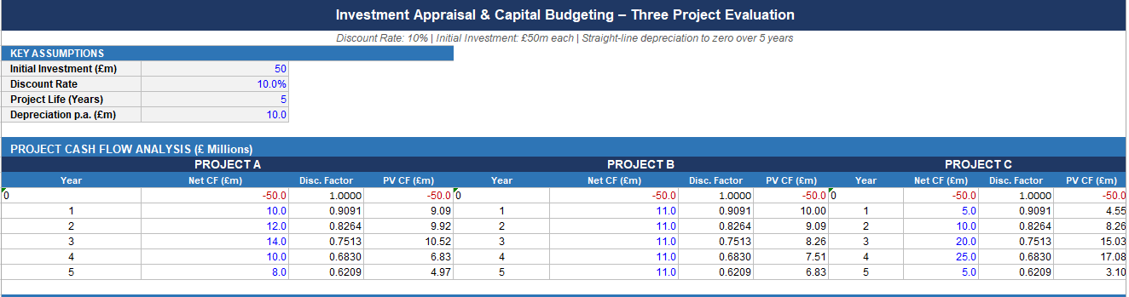
Figure 11: Project Cash Flow and Discounted Cash Flow Analysis
The cash flow analysis reveals that positive inflows of all three projects over a period of five years are realized but at very different times. Project A is characterised by moderate cash flows that are not evenly distributed, whereas Project B has stable and consistent cash flows every year. Conversely, Project C is back-loaded, with more cash inflows in the later years. The present values of the future cash flows in all projects decrease when discounted by 10, suggesting the value of time. Inflows in project C have a higher discount later, thereby diminishing its present value, although the nominal returns are higher. This is an indication of the significance of the timing of cash flows to investment decisions, especially in the capital-intensive environment.
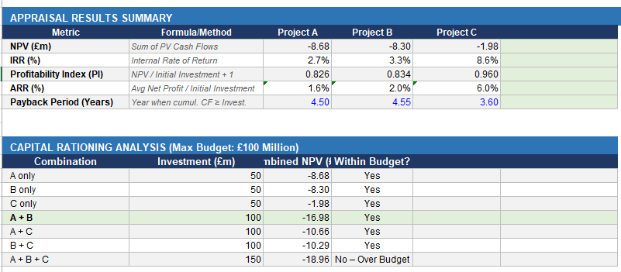
Figure 12: Investment Appraisal Results and Capital Rationing Analysis
The results of the appraisal show that the three projects have negative NPVs, which indicates that they fail to comply with the required 10% level of return. Project C is a better showing in terms of the least negative NPV and the highest IRR (8.6%) than Project B and Project A. Payback analysis depicts that Project C is liquidated fastest (3.6 years). Nevertheless, the values of ARR are low on all the projects, indicating low accounting returns. Project A + B is chosen as the least negative NPV combination under capital rationing under the constraint of £100 million from London, though it still fails to generate value (Chiradeja et al. 2025). This implies that there are limited viable investment options as per current assumptions.
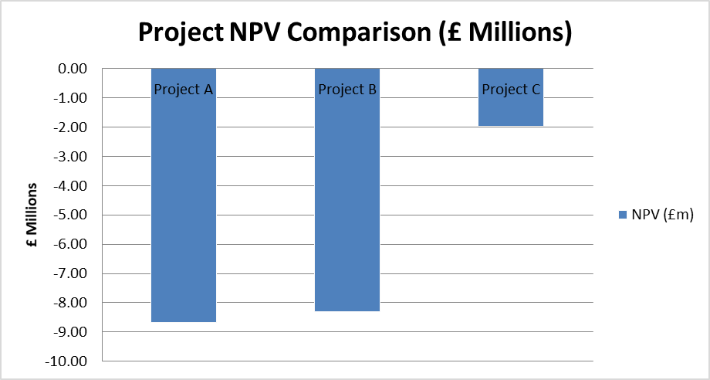
Figure 13: Net Present Value (NPV) Comparison of Projects
In the NPV comparison chart, it is evident that all three projects will have negative value, showing none of them to be financially viable at a discount rate of 10%. Project C demonstrates maximum (least negative) NPV, which means that it is going to perform better than Projects A and B. Project A represents the minimum NPV, which is the least preferable choice. Although Project B may have a flow of cash, its NPV is negative as a result of inadequate returns as compared to the discount rate. Altogether, the chart shows that Project C is relatively more favourable, yet there are no projects that comply with the value creation criteria, which is why the project is to be re-evaluated, or alternative investment opportunities are to be proposed.

5.2 Project Selection Decision
According to the outcomes of the investment appraisal, none of the three projects satisfies the 10% discount rate, with all of the projects generating negative Net Present Values (NPV). Nevertheless, out of the possibilities, Project C can be regarded as the most appropriate choice. It has the highest IRR (8.6%), minimum negative NPV (-£1.98m) and the longest payback period (3.6 years). These indicators indicate that Project C will yield relatively higher returns and payback in a shorter time than Projects A and B. However, even though it falls short of the required return, it realises the minimum destruction of value and is rooted in a superior performance in terms of finances when compared to the alternative choices.
Financially, this recommendation is in line with the current performance trend of the company. The peak of profitability was observed in 2023, and it has been declining, which suggests the growing pressures of costs and compressing margins (Gutierrez and Taco, 2024). Further, cash flow analysis indicates operating cash flows that are negative over the last couple of years as a result of the working capital expansion. A project that recovers its cash in the shortest time, such as Project C, is better in such an environment because it enhances liquidity and lessens the strain on the internal cash reserves. Although Project B has some stable cash flows, the returns thereof are not enough, and Project A demonstrates worse results in general.

5.3 Consideration of Non-Financial Risks
Other non-financial factors also justify the choice of Project C. The automotive market is a very sensitive segment as it is prone to changes in technology, as well as changes in regulations and consumer demands, especially when it comes to a shift towards electric vehicles (EVs). Project C and its enhanced returns thereafter in the later years might be more appropriate to be long-term strategy investments like EV development, digitalisation, or new manufacturing technologies. These divisions normally take time before they can generate large returns, but have high growth potential.
Nonetheless, Project C is a bit risky because of its back-loaded cash flows. The uncertainty of future returns is greater and vulnerable to political risks, including alterations in government policies, environmental policies and global trade policies (Neto et al. 2024). Otherwise, projected cash inflows can be influenced by market risks, such as shifting customer preferences and heightened rivalry. Nevertheless, the strong brand reputation of the company and increased customer loyalty offer this strength, the company some form of resilience, which can help in long-term investment decisions.

5.4 Capital Rationing Decision
The company will use a capital constraint of £100 million to choose the best combination of projects in order to maximise value. Only two projects can be implemented since only two projects need 50 million pounds. The analysis indicates that none of the possible combinations will lead to positive NPVs, but the aim is to reduce the loss of value. Out of the potential combinations, Project A + Project B has the lowest potential negative combined NPV (-£16.98m), so it would be the best one to select in the case of capital rationing. Project C is the best of the choices when it comes to the individual level, but when it is combined with another project, we have a greater loss than in A + B. Hence, based on its financial aspect, a combination of projects B and A will be the most reasonable choice under the specified budget constraint (Bonifácio, 2025). Project C should be suggested as an optimal independent investment because it exhibits better relative performance in IRR, NPV and payback period. It fits with the situation that the company requires better liquidity and long-term strategic growth despite its nature risks. Nonetheless, when capital rationing takes place, Projects A and B are preferred to combine since it lowers the overall loss of value within the budget constraint of £100 million. This shows how a trade-off between financial metrics and strategic considerations can be very factual in making strategic investment decisions in a dynamic and capital-intensive industry.

6. Conclusion
Hyundai Motor Company show strong growth and financial stability in the period of five years, which is evidenced by increasing revenues and liquidity. Nevertheless, a reduction in profitability, augmented leverage, and deteriorating cash flows underscore impending financial strains. Liquidity is further strained by working capital inefficiencies and an increasing cash cycle. Performance must be maintained by strategic restructuring and better management of working capital. Although with the current state of affairs, investment opportunities are still scarce, project selection into careful financing choices will be essential to retain value and competitiveness in the rapidly changing EV market.

7. References
Bonifácio, G.D.P.N.T., 2025. A strategic operational, and financial review of evomotion's performance in the business in practice simulation and corresponding personal reflections.
Chap, S. and Liu, J., 2024. Debt Risk Analysis of Automotive Enterprises. Economics & Management Information, pp.1-15.
Chiradeja, P., Yoomak, S., Sottiyaphai, C., Ngaopitakkul, A., Klomjit, J. and Ananwattanaporn, S., 2025. Analysis of Investment Feasibility for EV Charging Stations in Residential Buildings. Applied Sciences, 15(17), p.9716.
Dincă, M.S. and Akomeah, F., 2026. Firm Profitability Drivers in the Automotive Sector: Evidence from ROA-Based Analysis.
Fathoni, R.F., Indradewa, R., Iskandar, M.D. and Negoro, D.A., 2025. Strategic Financial Planning of Ev-Station Voltwave Network: A Case Study from Indonesia's Ev Infrastructure Sector. Journal of Syntax Literate, 10(10).
Fernández Serrano, C., 2025. Financial and strategic impact of mergers and acquisitions in the automotive industry: a multi-case study.
Gutierrez, M. and Taco, D., 2024, September. Risk Analysis for Electric Vehicle Investments: Beta Trends and Monte Carlo Insights. In Conference on Sustainable Mobility. SAE Technical Paper.
hyundai.com, 2026. Towards new horizons. Available from: https://www.hyundai.com/in/en/investor-relations/financial-information/reports/annual-report-digital-summary Accessed on: [23/4/2026]
Ja’afar, N.F.M. and Zulkifli, N.A., 2025. Budgeting and Forecasting Challenges for EV Startups in a Capital-Intensive Market. International Journal of Research and Innovation in Social Science (IJRISS), 9(10).
Lundgren, L.S.V. and Viganò, V., 2024. Interplay between Sustainability and Financial Performance: A Mixed-Methods Analysis in the Automotive Industry.
Muller, B.A., 2025. Sectoral financial analysis of the automotive industry: insights into financial and operational dynamics.
Neto, R.A.O., Souza, C.G.P., Brito, L.R.B. and Guimarães, G.L.N., 2024, December. Challenges in cost reduction for automotive parts: A comprehensive analysis. In SAE Brasil 2024 Congress. SAE Technical Paper.
Özdemir, M. and Kırhasanoğlu, Ş., 2025. Electric Vehicle Production Costs and Financial Impacts. Değişen ve Dönüşen İş Dünyasında Muhasebe Bilimi Araştırmaları, p.21.
Potes, T.M.C.M.D.C., 2025. Financing the future: how electrification shapes capital structure decisions in the automotive industry.
Potharla, S., 2025. Financial and strategic analysis of Tata Motors: Insights from corporate finance perspectives. Available at SSRN 5294575.
Raval, D.S. and Thakrar, P., 2025. A Study On Financial Solvency Of Selected Automobile Companies In India Using Altman Z-Score Model.
Surendra, Y. and Mahesh, G., 2025. A STUDY ON FINANCIAL RATIO ANALYSIS WITH REFERENCE TO TVS MOTORS PVT. LTD, NELLORE.
Yin, S., Liu, A., Zhang, Y., Wang, Y. and Wang, J., 2024. A fuzzy model using entropy weight for financial risk measurement and analysis to enhance energy performance: A case study of new energy vehicle in China. Journal of Innovative Research in Mathematical and Computational Sciences, 3(1), pp.22-48.
Yingnan, S. and Shuang, L., 2024. Research on financial risk evaluation of new energy automobile manufacturing enterprises. Дискуссия, (1 (122)), pp.54-62.

8. Appendix


