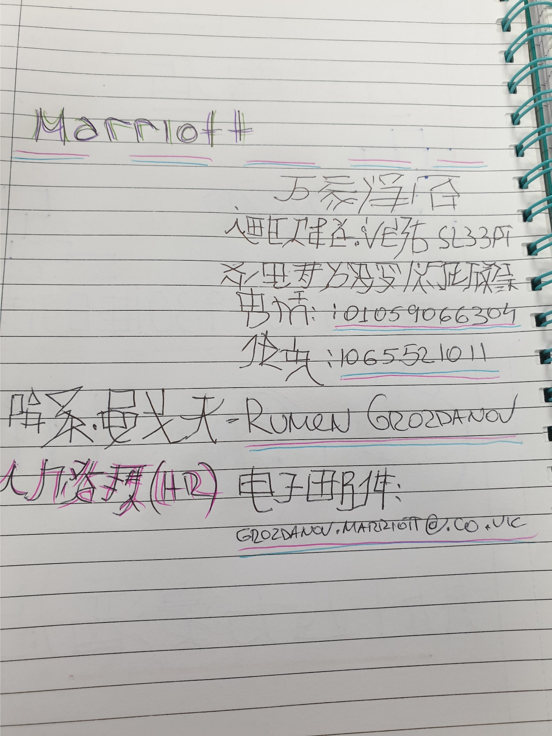
Rumen Grozdanov 1815102
This is my home work Number 5 for Module Foreign languages and Cultural Awareness Rumen Grozdanov 1815102 UWTSD LONDON

