Professiona
Corey Jones (1812188)
[Email address]
BMSK4005
A Reflective Review
of My Journey
Professional Career Development

PROFESSIONAL CAREER DEVELOPMENT
BMS
COREY JONES
CONTENTS

- Introduction/Summary
- Steven Covey-7 Habits
- Smart Goal Objectives
- Swot Analysis
- Kolbs Learning Cycle
- GO MAD
- VARK Learning Styles
- Honey and Mumford Leaning styles
- PDP
- Conclusion
- References

Introduction

This essay will examine my personal self-development in relation to self-awareness. Demonstrating an understanding of the skills and knowledge which will contribute towards me working effectively, also showing my readiness for employment, understanding my Personal strengths and areas I have for further development as well establishing my goals, developing an action/Development plan.

Reflective review of my Journey

My name is Corey Jones, starting a Course at Swansea University, Skills for the Workplace, in which I will be attending every Monday and Wednesday for the next 12months to learn new skills, build on my confidence to develop myself., to identify my development I will Conduct a SWOT analysis on myself, highlighting my strengths, weaknesses and threats and how I can turn them into opportunities looking at the appropriate conversion strategies.
Applying the GO MAD framework on myself learning the 7 Principle steps which needs to be addressed to reach my result aiming to complete 12months in university finishing 2020 and setting a goal for 5 years’ time in 2025 which would be managing my own dog grooming service putting it together using the SMART Strategy. Also using Kolb's Learning Cycle which is a well-known theory which argues we learn from our experiences of life, even on an everyday basis. It also treats reflection as an integral part of such learning. According to Kolb (1984), using The VARK questionnaire will find out my preferred learning style also be using Honey & Mumford learning style questionnaire created by Peter Honey and Alan Mumford its an internationally proven tool designed to pin point your learning preferences so that in a better position to select a learning experiences that better suit your style having a greater understanding.

Firstly, at the beginning of our module: Professional Career Development, We Discussed An American born Author, motivator and speaker Stephen Covey, Who Wrote the book “The Seven Habits Of Highly Effective People”

The 7 Habits being:
- Proactive
- Begin with the end in mind
- Put things first
- Think win win
- Seek first to understand then to be understood
- Synergise
- Sharpen the saw (Moves, n.d.)
(Hussain, n.d.)
The First 3 Habits focus on Self Control and moving from Dependence to Independence, Habits 4, 5, 6 are focused on developing teamwork, Cooperating and Communication Skills.7 Is to continuously grow, develop, improve/realise all the other habits.

The book focuses on perpetual proposition of fairness, Integrity, honesty and human dignity. It Contains life changing information which I believe can make you suddenly get up and realise that there are so many simple things that can help to navigate your life correctly.
Overall Covey shows how a principle centred, character-based life helps you build the healthy relationships that are key to an effective life.
This really motivated me on my Reflective review of my journey It helped me design my SMART OBJECTIVES.

.

SMART OBJECTIVES

SMART goals are goals which are specific, measurable, achievable, relevant, and time-bound. It is easily remembered by using the acronym S-M-A-R-T.
SMART goals can be used to improve both your personal and professional life. Smart goal setting gives a structure to your plan of achieving your goal. To attain your goals or objectives, you need to focus on many things and overcome all the hindrances that comes in between. I like most about SMART goal setting, it gives a clear transparency to the whole process.
(Briantracy.com, n.d.)

Specific
I am going to gain new employability and communication skills and build on my confidence whilst attending a full-time course at Swansea university twice a week on Mondays and Wednesdays studying Skills for the work place level 4.i want to pass the course in 12 months finishing in 2020 and further my education onto level 5 looking to Open a dog grooming salon in the future.

Measurable
Attending Swansea University course Skills for the workplace for 12 months, I will be Punctual and will attend every Monday and Wednesday. Completing all assignments on time, My goals will be met when I have gained new skills and Knowledge which will give me the confidence to apply for new jobs gaining employment or opening new opportunities.

Achievable
After having the opportunity and being enrolled into university, studying a course relevant to me to improve my employability skills building on my communication and confidence skills. I need to make sure my assignments are handed in on time and to gain a certificate at the end of the year turning up to every lecture class for the result, the final assignment.

Relevant
Meeting this goal will help me make a career change to a job that will help me gain a healthy work and life balance, learning new skills and knowledge building on myself esteem. Opening new opportunities.

Timebound
To achieve a certificate in Skills for the workplace in 12 months’ time attending university full time course Mondays and Wednesdays 10am-2pm

SWOT ANALYSIS
SWOT analysis is an analytical tool used to evaluate strengths, weaknesses, opportunities and threats. Identifying these helps make decisions that align with goals. Identification of SWOTs is important because they can inform later steps in planning to achieve the objective. First, decision-makers should consider whether the objective is attainable, given the SWOTs. If the objective is not attainable, you must select a different objective and repeat the process. (Reference, n.d.)
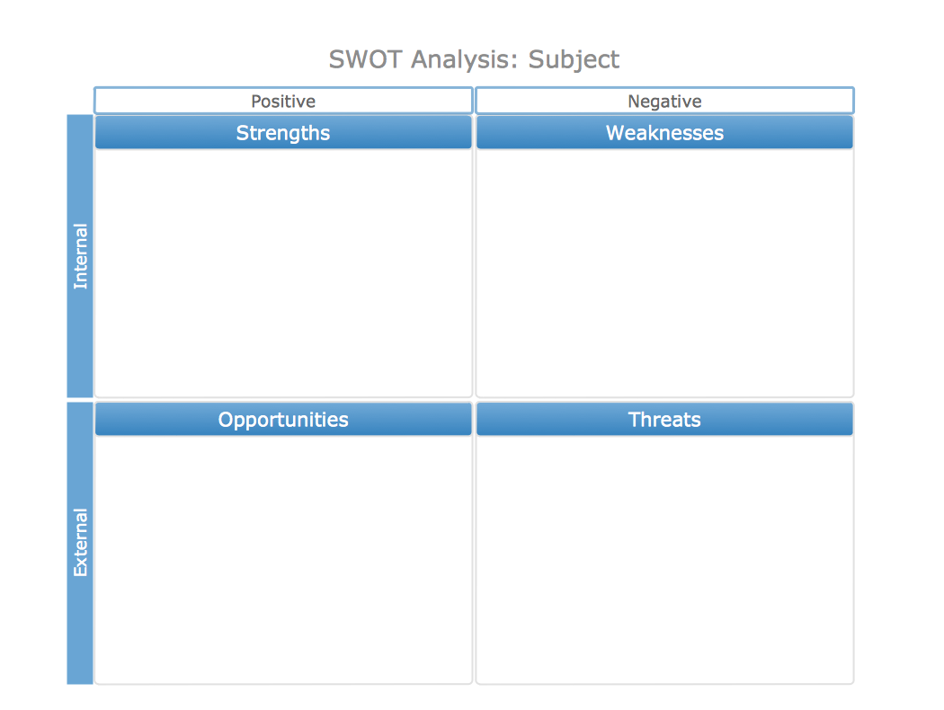
S W O T A N A L Y S I S

- Do not Drive
- Negative attitude
- Speaking In front of people
- Communication skills
- Too cautious don’t take enough risks
- Undecisive

- Technology Skills
- Punctual
- Work good as a team
- Able to work on my own initiative
- Can follow instruction
- Listening skills
- Learning from my mistakes
- Dog grooming Skills
- Would have a regular customer base from just friends/Family

- Childcare
- Eczema
- Have not passed my driving test
- Not Completing University
- Other award-winning dog groomers in the same area making Competition
- Finding a suitable premise for dog grooming shop

- Husband helping
- with childcare
- Catching a train to university
- Started university
- Learning new skills
- To gain a certificate in Higher education in 12months
- Social communication
- Build on my Confidence
- Visit dog shelters/local dog Charites
- increase in dogs
- Increasing use of Social media
- Designing a eye catching Logo

TURNING MY STRENGHTS INTO OPPORTUNITIES
- Using my IT skills in university for assignments
- Attending university will open opportunities gaining a certificate
- For me to sustain a regular customer base I could use a loyalty card service or for recommending a friend Percentage off grooms
- Welcome dog shelters to work together
- Advertise on social media and posters
- Attending university will help me gain knowledge and employability skills
- Confidence and skills to open my own dog grooming business
CONVERTING MY WEAKNESS IN TO STRENGTHS
- Attending university participating in class presentations will build my confidence and communication skills
- Turning negative attitude into positive instead of saying I cannot do this I CAN do this
- Making sure I balance my time to complete assignments to achieve a certificate
- Having driving lessons for me to pass my driving test widening more opportunities
- Take more risks and not be so cautious
NEUTRALISING MY THREATS
- Taking Antiestamine to control eczema for desired job
- Advertising door to door flyers for people with no internet access
- Work with the competitors if they are full can recommend vis versa
- Pass driving test to open opportunities
- Organising childcare for me to attend the course

KOLBS LEARNING CYCLE
Kolb, 1984, p.38)
Kolb's experiential learning theory was given by David A. Kolb, who published his model in 1984 which is a four-stage theory of learning, Kolb’s experiential learning theory is a holistic perspective that combines experience, perception, cognition, and behaviour. Making a reflective look on Your journey and learning from it. The learning cycle is divided into two aspects:
- Knowing
- Understanding or "Transforming" Knowledge

EXPERIENCE
- Applied for a place at university to study Skills for the workplace

PLANNING THE NEXT STEPS
- To ensure I get all my assignments handed in completed on time
- To Ask for help if needed
- Take advantage of study skills
- Motivate myself
- Research
- Talk to family/Friends

OBSERVATION
Had an interview at Swansea university, I felt so nervous and that my nerves got the better of me through lack of confidence I felt I had failed the interview.

KOLBS LEARNING CYCLE

CONCLUSION
Managed to get a place on the course Skills for the workplace. Even though I felt I struggled with my confidence and my negative thoughts of not getting a place, it has made me more determined to achieve a career and new skills leading to the career I would enjoy doing opening a dog groomer in 5years with the help of this course improving my confidence, Knowledge and skills

THE GO MAD FRAMEWORK Gilbert, A

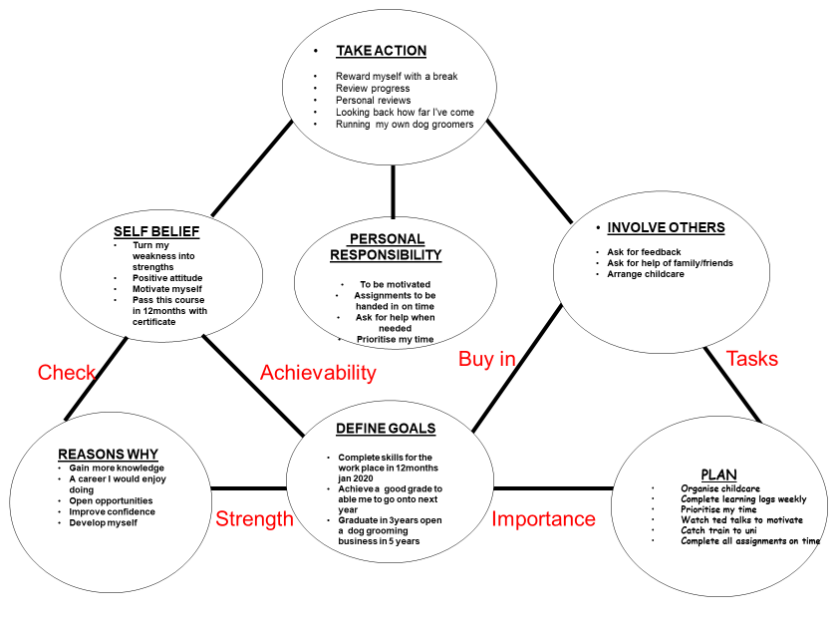

(Gilbert, n.d.)
Go MAD is a results Framework & Thinking System. It was developed by Andy Gilbert in 1997 used worldwide by major corporations and hundreds of thousands of people in over 40 countries
with over 20 years’ experience in studying peak performance and how people think in a solution focused way when they "Go Make A Difference" in achieving goals and accelerate results but a worthwhile contribution to complement other personal development studies and techniques such as Covey's habits.

VARK QUESTIONAIRE

VARK stands for : VISUAL AUDITORY READ/WRITE KINESTHETIC
sensory modalities that are used for learning information. Fleming and Mills (1992) suggested four modalities that seemed to reflect the experiences of the students and teachers. (Vark-learn.com, n.d.)

.

If you are a Visual learner, you learn by reading or seeing pictures.
if you are an Auditory learner, you learn by hearing and listening.
If you are a Read/write Learner, you learn best by reading and writing.
If you are a Kinaesthetic Learner, you would learn through physical motion..
scores give an indication of my preference for some of the different ways of learning
Total number of V’s = | 4
Total number of A’s = | 7
Total number of R’s = | 1
Total number of K’s = | 1
After doing the VARK test, the test indicated I learn best Auditory, Visual being second and low for the Read/write Kinaesthetic style learning
(Vark-learn.com, n.d.) (Bing.com, n.d.)

Describing myself as a Auditory learner would be right, as I feel I can relate to the research of that type of learning style I prefer to discuss work, and work in groups I prefer to listen I understand oral instruction rather than written I learn best speaking out loud making more sense of it as I say it .I also think I am a visual learner too as I like to observe take notice to eye detail and I tend to memorise it better visually. Having these learning styles is good for the type of career I would like to do. Being a dog groomer a good skill to have would be the visual learning skill, eye for detail auditory listening to the customers preferences.

HONEY AND MUMFORD LEARNING STYLE
Honey and Mumford learning styles developed by Peter Honey and Alan Mumford, based upon the work of Kolb, they identified four distinct learning styles or preferences:
. These are the learning approaches that individuals naturally prefer, and they recommend that to maximise one's own personal learning each learner ought to understand their learning style

(Www2.le.ac.uk, n.d.) (2011-2019, n.d.)
Honey, P. & Mumford, A. (1982) Manual of Learning Styles London: P Honey

The 4 types of learning styles are:

Activists are "do-ers" and "go-getters." They take action, get involved and fully immerse themselves in a learning situation.

Theorists tend to think carefully and logically about situations, tend to question everything they think problems through in a step to step logical way.

Reflectors like to take a step back from a situation and learn by observation rather than jumping into action and making instant decisions

Pragmatists prefer to apply knowledge and theories in a practical and literal sense.
To understand your learning style Honey and Mumford have developed a Learning Style Questionnaire in which I took part in.

ACTIVISTS  15 | THEORIST  13 | REFLECTOR  18 | PRAGMATIST  15

As you can see from the table above my highest score was a REFLECTOR after taking part in the learning style questionnaire I strongly agree with my results after reading the 4 styles I felt I could relate more as being a reflector learner I like to stand back from events prefer to listen and observe, Good listening to others and comprehending information reviewing what has happened and what I have learnt, being a reflector I like to get to the bottom of things, very careful, thoughtful never jumping to conclusions and can reach a decision in my own time without pressure and deadlines. The Weaknesses I encounter being a reflector are, I tend to hold back from direct participation, slow deciding, don’t take enough risks and not very assertive not very forth coming and find it hard to small talk. Looking at my results it links to my confidence issue in which I am currently working towards gaining during my university course.

. (Help.open.ac.uk, n.d.)
Personal development planning or PDP is a structured framework you can use to:
- Become aware of skills you have
- identifying and developing the skills you need
- Working out what you want to achieve and how to achieve it
- focus on potential study, career and personal development options and goals
- develop a source of information
  - for CVs, job applications and interviews
  - to support appraisals at work
  - to demonstrate your readiness for promotion or for development opportunities

CONCLUSION

After doing a reflective view of my journey it has made me realise how forward I am moving towards my ambitions, .Starting off my journey listening to TEDtalks and listening to Andy Gilbert talk about the 7 habits helped motivate me and made me think I want to achieve to better myself and learn new skills that would benefit me for my future and for employability.by using SMART its helped give me structure to plan to achieve and attain my goals or objectives to focus and overcome hindrances giving me a clear perception of the process. Using the SWOT helped me to identify my Strengths and weaknesses Neutralising my threats turning my weaknesses into opportunities. Also using the Kolb learning cycle it’s made me aware of what I need to work on to progress myself.
As well as using GO MAD framework will help me efficiently identify key issues, recognise and overcome obstacles and define my goals and outcomes. It has taught me how to think about something I want to achieve and my reason why to move forward with this and build on my confidence levels to believe in myself that I can do it.
Exploring my possibilities and creating myself Personal responsibilities,
Prioritising my possibilities Self-belief, deciding what I will do first, by when and who will I involve helping me towards achieving my goal. Making sure I reward myself by taking action
Setting myself goals to achieve before reaching the top of the cycle I must work towards prioritising things in order, what I need to do to get to the next stage and who will help me to achieve, asking family/friends for help extra lessons in university if I feel I am struggling. Whilst studying and taking part in a learning style questionnaire identifying myself as a Reflector and an Auditory learning really suited my character as I would say I am better at listening to people and would learn better listening also being a reflector as I reflect on everything and tend to hold back from direct participation I would say it is down to the lack of confidence I have and self -belief this is why I applied for skills in the workplace to build on my confidence communication skills and to be able to perform activities instead of holding back. gaining new employability and communication skills.

References
2011-2019, (. (n.d.). Learning Styles | SkillsYouNeed. [online] Skillsyouneed.com. Available at: https://www.skillsyouneed.com/learn/learning-styles.html [Accessed 6 Mar. 2019].
Bing.com. (n.d.). Vark Learning Styles - Bing. [online] Available at: https://www.bing.com/images/search?view=detailV2&id=0B13E462BD0A99814C75CFDE5F7C36BF3D4121DA&thid=OIP.M3qgre-VdO5iKqgENMkwSQHaEn&mediaurl=http%3A%2F%2Fmedia-cache-ak0.pinimg.com%2F736x%2F6f%2Fff%2F1c%2F6fff1ceaf872688bfe9eec8348e8b0e5.jpg&exph=394&expw=633&q=Vark+Learning+Styles&selectedindex=5&ajaxhist=0&vt=0&eim=1,6 [Accessed 4 Mar. 2019].
Briantracy.com. (n.d.). SMART Goals 101: Get Examples, Templates & A FREE Worksheet. [online] Available at: https://www.briantracy.com/blog/personal-success/smart-goals/ [Accessed 28 Feb. 2019].
Gilbert, A. (n.d.). [online] Available at: https://uk.linkedin.com/in/andygomad [Accessed 28 Feb. 2019].
Hussain, A. (n.d.). 7 Habits of Highly Effective People [Book Summary]. [online] Blog.hubspot.com. Available at: https://blog.hubspot.com/sales/habits-of-highly-effective-people-summary [Accessed 29 Feb. 2019].
Moves, T. (n.d.). The 7 Habits of Highly Effective People: Best Summary & PDF. [online] The Power Moves. Available at: https://thepowermoves.com/the-7-habits-of-highly-effective-people/ [Accessed 28 Feb. 2019].
Reference. (n.d.). What Is the Purpose of a SWOT Analysis?. [online] Available at: https://www.reference.com/education/purpose-swot-analysis-2064f70f995b8d11?aq=swot+analysis+definition [Accessed 28 Feb. 2019].
Skillsforlearning.leedsbeckett.ac.uk. (2019). Example 1 - Kolb's Learning Cycle | Models for structuring reflection | Skills for Learning Preview. [online] Available at: https://skillsforlearning.leedsbeckett.ac.uk/preview/content/models/02.shtml [Accessed 28 Feb. 2019].
Skillsforlearning.leedsbeckett.ac.uk. (n.d.). Example 1 - Kolb's Learning Cycle | Models for structuring reflection | Skills for Learning Preview. [online] Available at: https://skillsforlearning.leedsbeckett.ac.uk/preview/content/models/02.shtml [Accessed 28 Feb. 2019].
Vark-learn.com. (n.d.). The VARK Modalities | VARK. [online] Available at: http://vark-learn.com/introduction-to-vark/the-vark-modalities/ [Accessed 28 Feb. 2019].
Www2.le.ac.uk. (n.d.). Honey and Mumford — University of Leicester. [online] Available at: https://www2.le.ac.uk/departments/doctoralcollege/training/eresources/teaching/theories/honey-mumford [Accessed 6 Mar. 2019].
Help.open.ac.uk. (n.d.). Develop your career: Personal development plan (PDP) - Help Centre - Open University. [online] Available at: https://help.open.ac.uk/pdp [Accessed 3 Mar. 2019].

