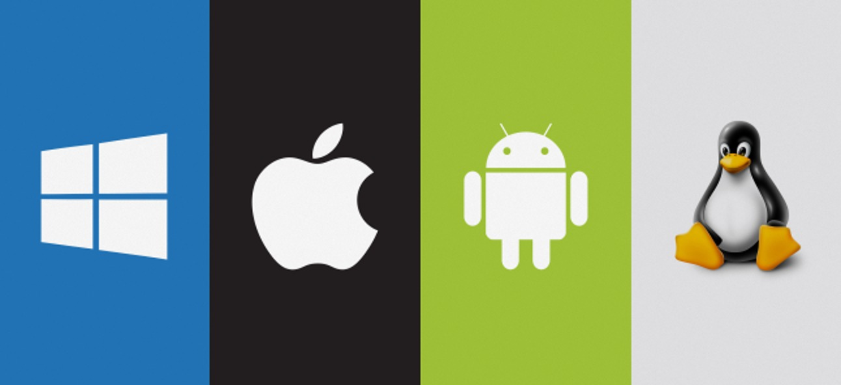

[Operating Systems]
[2211832]
[Computer Architecture and Operating systems]
[Gareth Jones/James Williams]
[April 7th, 2023]

Table of Contents

Introduction

Key Functions of General Operating Systems.

Use of Windows OS CLI Commands.

Use of Linux OS CLI Commands.

Use of Windows OS scripts.

Use of Linux OS scripts.

Conclusion

References





Introduction

A report on computer operating systems is presented here. An operating system (OS) is a computer software that, after being first installed by a boot programme, governs all other application programmes on a computer. The application programmes ask the operating system for services using a specific application programme interface (API). Throughout this report there will be an explanation of what an operating system for a computer is, as well as what its purposes are and how it goes about fulfilling them. In this report, clear details on the differences between Linux and Windows OS CLI commands and OS scripts, what each accomplishes, and what each of them fails to do. A quick comparison of Windows and Linux operating systems will be made in this paper. All current computers utilize some sort of operating system; thus, it is an important application that will be found in many computers. This is something that needs to be kept in mind.

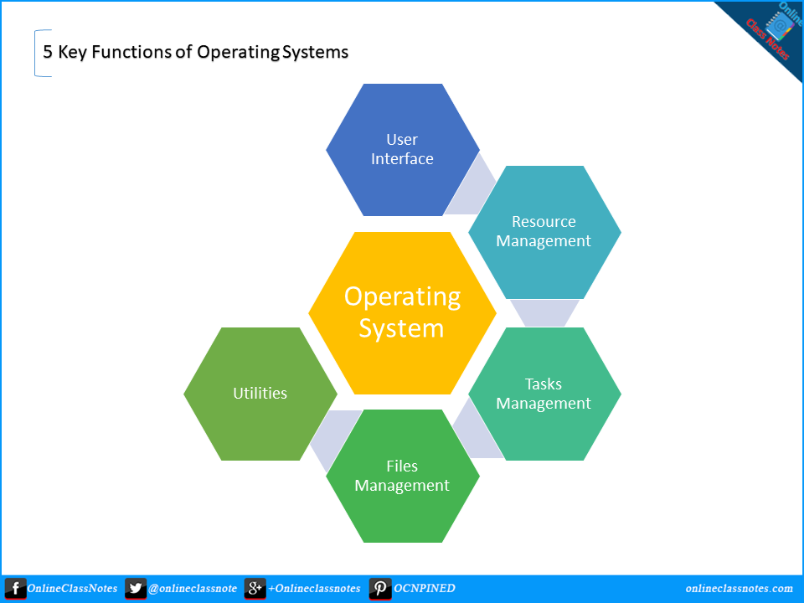

Key functions of general Operating systems

First off, an operating system is a piece of software that manages and directs the hardware components of a computer while also running other programmes and apps. In a sense, system software serves as the framework for application software. Users can also directly communicate with the operating system by utilising a user interface, such as a command-line interface (CLI) or a graphical user interface (UI) (GUI). The resources that the operating systems allot enable the process to communicate. The resources of other processes are protected, and processes are synchronized. The OS regularly moves running processes between memory and storage (hard disc or SSD) to accommodate the allocation process, always maintaining the status of each memory location's allocation. The operating system controls auxiliary input and output devices, including cameras, keyboards, monitors, printers, and scanners. It controls the sending and receiving of data. To do this, the operating system employs a programme known as a device driver. Device drivers include instructions for controlling the device. An operating system (OS) is a programme that, after being first installed into the system by a boot programme, governs all other application programmes in a computer. The application programmes ask the operating system for services using a specific application programme interface (API). In the future, the operating system will provide techniques for user authentication that guarantee the authenticity of user access. The operating system provides antivirus protection against malicious attacks and has a built-in firewall that acts as a filter to identify the type of incoming traffic to the system. Management of system performance, to maximize performance, the operating system keeps an eye on the system's general health.To get a full picture of the system's health, keep note of the times between service requests and system responses. By providing crucial information for correcting issues, this can enhance performance. Users and other software working together, Moreover, operating systems organize and distribute other software to computer users, such as compilers, assemblers, and interpreters. Aids for detecting errors, The OS constantly examines the hardware to check for problems and prevent a computer system from malfunctioning. The operating system is in charge of managing memory, namely the main memory, also known as the primary memory. A massive number of bytes or words make up the main memory. Furthermore, Changing the file system, where data or files should be saved, such as on a floppy disc, hard disc, or pen drive, is up to the operating system (OS). How data is processed and saved is decided by the operating system.

Use of Windows OS CLI commands

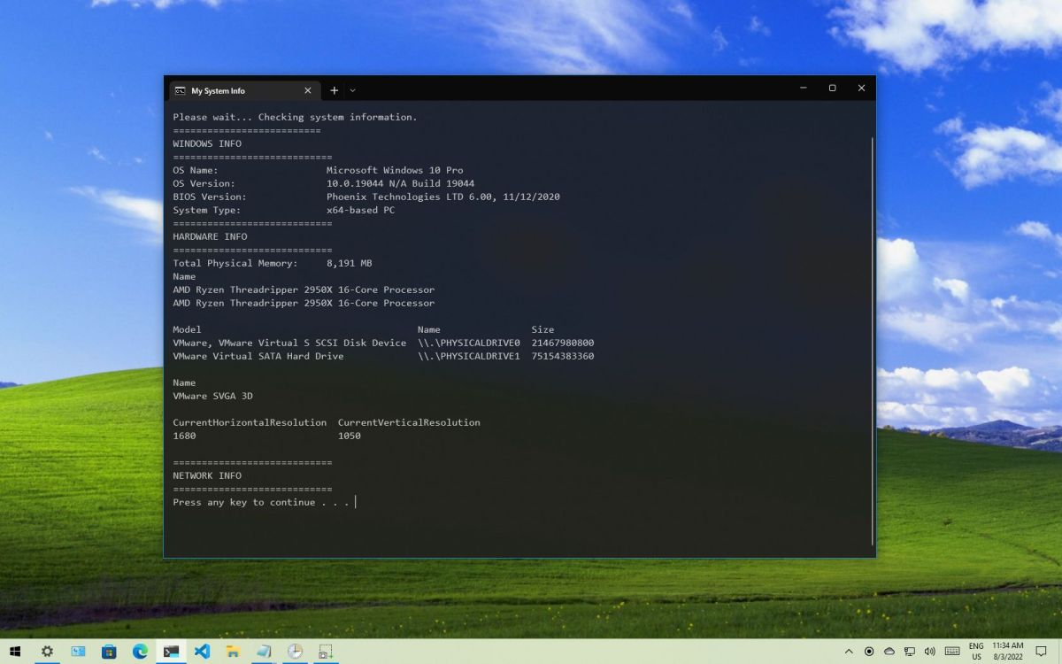

The graphical operating system known as Microsoft Windows was developed and published by Microsoft. It provides a way to store files, run programmes, play games, watch videos, and connect to the Internet. To communicate with computers and run programmes, one uses a command-line interface (CLI), a text-based user interface (UI). Other names for command-line interfaces include character user interfaces, console user interfaces, and command-line user interfaces. The command prompt allows you to interact with the System directly and do many tasks that the graphical user interface does not offer (GUI). Some batch instructions for a Windows 10 command prompt are displayed above. A batch file is a script file that contains instructions to be carried out serially. It assists in automating repetitive processes devoid of user input or intervention. Moving on, the most recent version of Microsoft language is present in CMD files, but the previous version is present in BAT files. While BAT is incompatible with earlier versions, CMD is. The majority of command.com scripts use CMD, whereas BAT by itself won't execute unless specifically instructed to do so. Another important advantage of CLI is that it may complete configuration much more quickly than a GUI after some practise. Using a few text commands, a user can configure interfaces, routing protocols, and access lists.

Use of Linux OS CLI commands

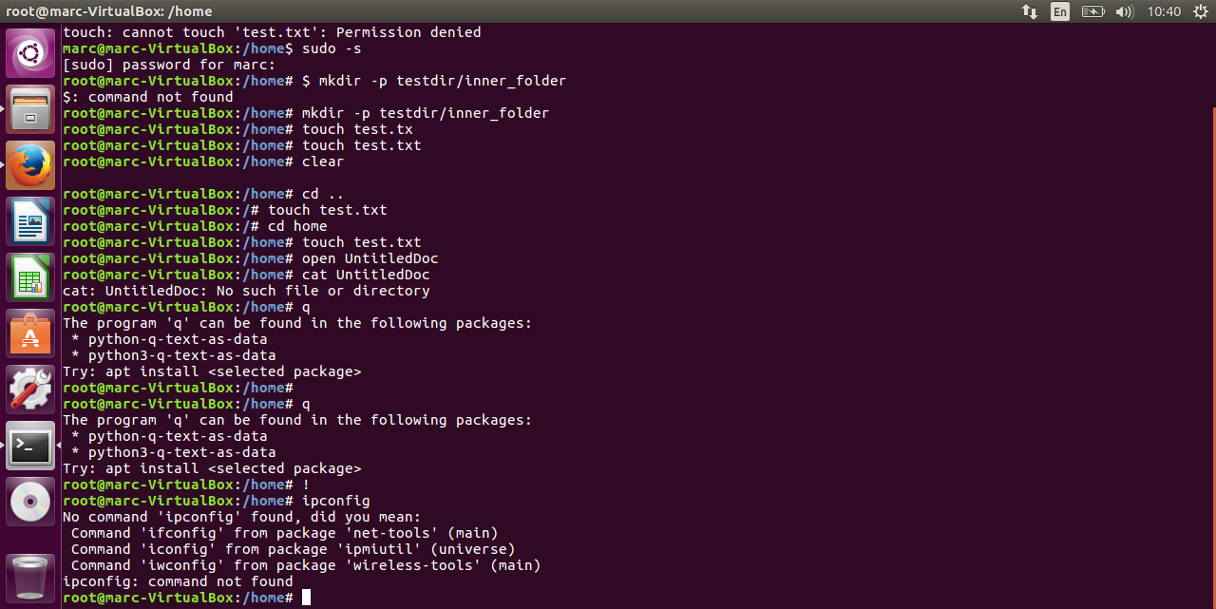

The 'ls' command can be used to list files and directories. The contents of your current working directory, which is simply the directory that your terminal is presently in, will be listed if you execute the "ls" command without any other options. The Linux cd command can be used in a number of different ways to navigate and change the working directory in the terminal window. You may navigate to parent or root directories, switch between directories using relative or absolute paths, and find directories with obscure names thanks to this feature. To create one or more directories, use the mkdir command and the Directory parameter. To delete files you no longer require, use the rm command. With the mv command, you can move files and directories across directories or rename a directory or file. The cp command is used to copy files from one place to another. In addition, this operation can copy directories (folders). The usual output of the pwd command displays the complete path name of your current directory (from the root directory).The touch command updates the access and modification times for each file provided in the File argument of each directory listed in the Directory parameter. The pager less command in a Linux terminal shows a file's contents one screen at a time. Working with large text files requires little time to load since it accesses the file page by page rather than loading the entire thing at once. The "more" command displays the text file after reading files. After every screen, the command pauses and prints the word "More" at the bottom of the display.

Use of Windows OS scripts

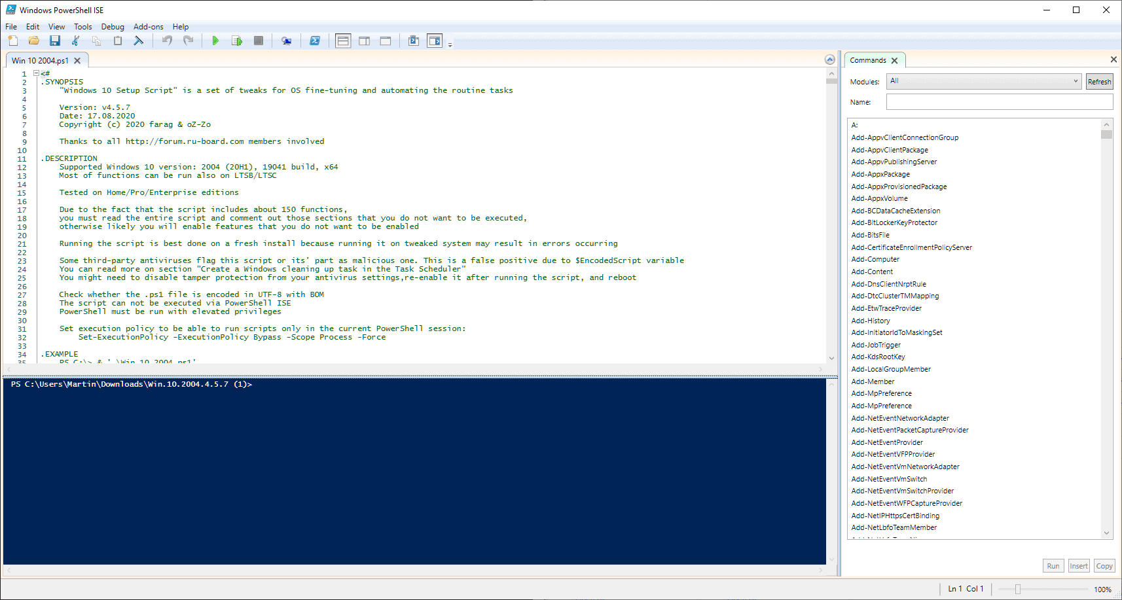Program loading, concurrently running numerous processes, or sequentially performing repetitive activities on the system are some typical uses for batch files. To automate system management, PowerShell is commonly used as a scripting language. It is often used to develop, test, and deploy solutions in CI/CD setups. .NET objects are used for all inputs and outputs in PowerShell (CLR), which is based on the.NET Common Language Runtime. To extract information, parsing text output is not necessary. The PowerShell scripting language has the following features: use of modules, scripts, functions, and classes. Flexible formatting technique for straightforward output. Dynamic types can be created using an extensible type of system. support for popular data formats including CSV, JSON, and XML is already built in. Another scripting language supported by Windows OS is batch. The advantages of batch production include the chance for companies to produce fewer goods to offer a wider variety of products. As equipment has the capacity to support a wide range of manufacturing processes, it is frequently used efficiently. Because products can be verified and tested at every stage of the manufacturing process, potential flaws and issues are easier to manage. Batch processing is characterized by little to no manual processing and little to no human involvement. But it wasn't always this way, this is a big part of what makes it so effective. Punch cards were used to initiate batch processing, and the results were tabulated into instructions for computers. The batch processing system completes all jobs in a shorter amount of time. With a batch operating system, all tasks are automatically repeated without the user's knowledge. Systems for batch processing can help small businesses finish quick jobs. Because it is shareable, the Batch operating system can be used by several users. It is appropriate for big jobs. Large jobs can be efficiently managed by it with ease.

Use of Linux OS scripts

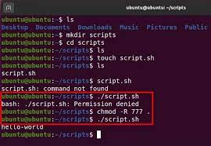

It is free to use Linux. So long as they do so in compliance with the same licence, which is also publicly available, anyone in the world is free to change, analyse, redistribute, or sell copies of improved software. Linux has been integrated into embedded products such as supercomputer servers, electronic devices, and watches. Linux installation needs between 4GB and 8GB of disc space, but it consumes less overall. Linux by default has a command-line interface, but it can be changed to use a graphical user interface similar to Windows. The primary approach is to install packages. To access a GUI in a Linux environment, most people log in to the Ubuntu server. Then install its desktop environment; in the image above, Ubuntu is used above to demonstrate this. End-to-end encryption is supported by Linux, and public keys are stored on the server. Each piece of data is password-protected and allows users to log in. Moreover, it provides file permissions, a secure shell, and numerous other security features. The Shell command-line interpreter on Linux acts as a conduit between the user and the kernel, which in turn runs what are known as commands. Linux enables simultaneous usage of numerous users and multiple applications, as well as simultaneous access to system resources. User files are organized in a clear directory structure in Linux, which has a well-defined file system.The Linux operating system provides a wide range of easily available software updates that may be configured and used as needed. Linux is extensively used since it is available in all languages. As a result, language can be changed to fit preferences and needs using the keyboard.Linux is independent of the hardware's quality and can operate in any setting. It can be used at any time by a large number of users on a variety of devices. Any form of hardware can support its operation.



Conclusion

In this article, Linux and Windows are contrasted along with their differences and similarities. We can still say that the two operating systems are fundamentally different from one another even though none is very different from the other and they are both vital for computer users. Both of these are operating systems, which are among the most important computer programmes since they regulate how data is stored, how people interact with computers, and how the device as a whole operates. For these reasons, your computer has to have an operating system. There is no best operating system. But both are unique and make an effort to satisfy customer and market demands. Each OSs have unique marketing goals. Linux provides excellent speed and security, whereas Windows provides excellent usability so that even non-techies may function on home computers simply. Many corporate firms use Linux as their server and operating system for security reasons, while Windows is mostly utilised by business users and gamers.

References

https://byjus.com/gate/functions-of-operating-system-notes/#what-are-the-functions-of-operating-systems

https://www.codingninjas.com/codestudio/library/introduction-to-process-management#:~:text=The%20operating%20systems%20allocate%20resources,like%20scheduling%20and%20resource%20allocation.

https://www.investopedia.com/terms/b/batch-processing.asp#:~:text=A%20defining%20characteristic%20of%20batch,tabulated%20into%20instructions%20for%20computers.

https://www.techtarget.com/whatis/definition/operating-system-OS#:~:text=An%20operating%20system%20(OS)%20is,application%20program%20interface%20(API).

https://www.bbc.co.uk/bitesize/guides/zr9kw6f/revision/1#:~:text=The%20operating%20system%20manages%20peripheral,how%20to%20control%20a%20device.

https://www.techtarget.com/searchwindowsserver/definition/batch-file#:~:text=A%20batch%20file%20is%20a,a%20sequence%20in%20the%20system.

https://builtin.com/data-science/bash-commands

https://www.scaler.com/topics/features-of-linux-operating-system/

https://www.ibm.com/docs/en/aix/7.2?topic=m-more-command

