

Emerging Network Technology

WC February 10, 2014

Faculty of Applied Design and Engineering
School of Applied Computing
Mount Pleasant Campus
Swansea
SA1 6ED

- Introduction and OBJECTIVES OF THE Exercises
OPNET Modeler uses a project-and-scenario approach to model networks. Project is a collection of network-related scenarios, each of which explores a particular aspect of the network design. All projects contain at least 1 scenario. Scenario is a single instance of a network. Typically, a scenario presents a unique configuration for the network. The term "configuration" can refer to different aspects such as topology, protocols, applications, traffic, and simulation settings
Roman
This tutorial focuses on the use of Opnet’s Project Editor
- The Project Editor will allow you to quickly create, simulate, and analyse the performance of a computer network
By the end of this tutorial, you should be able to:
- Build a network quickly
- Collect statistics about the network’s performance
Analyse these statistics
In this tutorial
- You will build a small network
- Choose statistics to collect
- Run a simulation
- Analyse the results

Projects and Scenarios
When creating a new network model, you must first create a new project and scenario.
Project:
A project is a group of related scenarios that each explores a different aspect of the network design. Projects can contain multiple scenarios.
Once you have created a new project, you can use the Start-up Wizard to set up a new scenario

Creating a project
- Log on to the computer.
- Open the Opnet program by clicking on the respective icon. or go to start -> all program -> OPNET Modeler 17.5
- Go to File and select New.
- Select Project and click Ok

- Give the project a meaningful name other than the default (project1) and also a scenario name other than the default (scenario1). Select Use start-up Wizard when creating new scenario

- Select Create empty scenario and click Next.

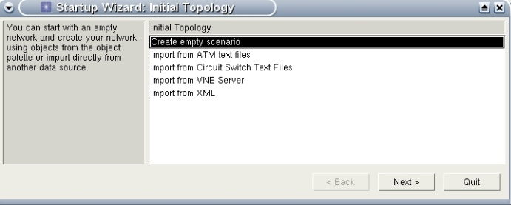

- Select Office as Network Scale and select Use metric units.

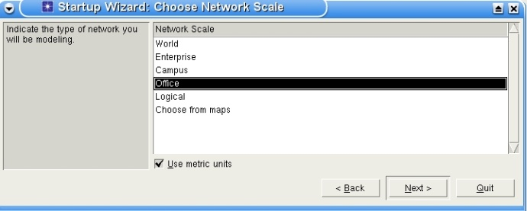

- Specify the units as follows and click Next.
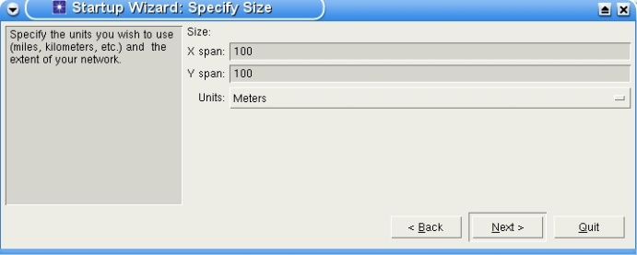

- Scroll down to the bottom and select the technology wireless_lan_adv (or a network of your choice) by clicking on the corresponding field in the Include? column, and click Next.
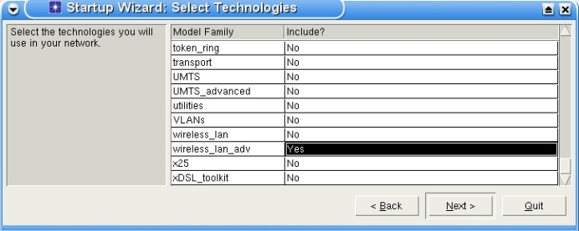

- Click Finish.
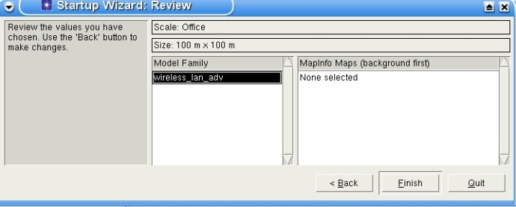

- Dragging and dropping objects from an Object Palette into the Project Editor workspace
- In this step, setup the network model in the project/network editor of the OPNET simulator as shown in the figure below.
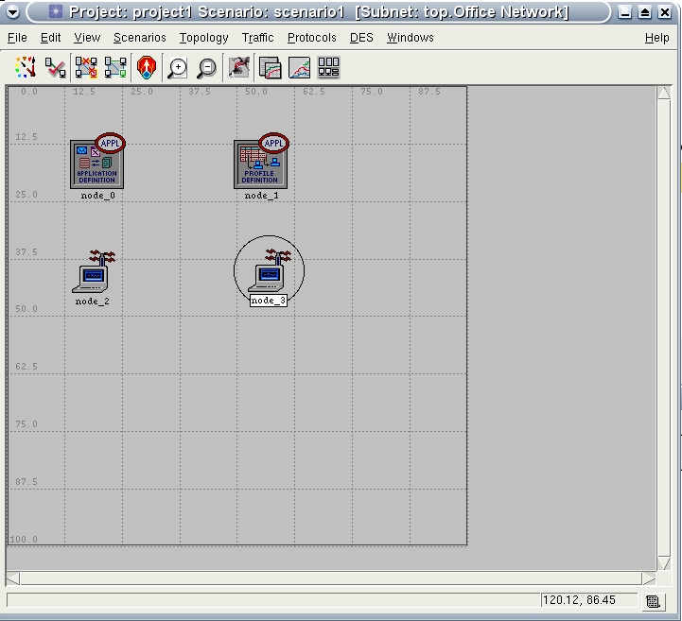

(a) From Node Models under the item wireless_lan_adv in the the object palette, drag the Application Config object into the opnet workplace with pressing the left button of the mouse on and then press out the left button and press the right button to drop that in the workplace.
(b) In the same way, drag and drop the Profile Config object.
(c) Add one wireless LAN fixed workstation which is labelled wlan_wkstn_adv, Fixed Node and one wireless LAN mobile workstation which is labelled wlan_wkstn_adv, Mobile Node into the workplace.
- Save your project by clicking Save As... and give the name of your file a meaningful name.

- Configuring applications for the model
(a) Use the Application Config and Profile Config nodes from the object palette.
(b) Configure the Video Conferencing application like as follows using the application configuration:
o Click the right button over the application config object, and then click on
Advanced Edit Attributes to open a window with different attributes and corresponding values.
o Click on the Application Definition attribute. Add a row and name as vdo_app. Set the Video Conferencing item to High Resolution Video.

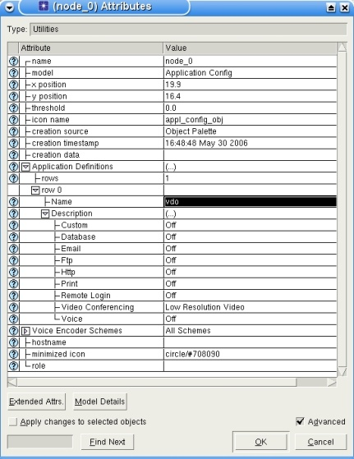

• Deploy the application you have generated using the profile configuration and name it
vdo_pro.
o Under Profile Configurations in the applications list add a row and select the
name vdo_app from the drop-down menu.
o Select Start Time Offset as No Offset.
o Select Start Time of the simulation as constant (0) and keep the other items as
default.
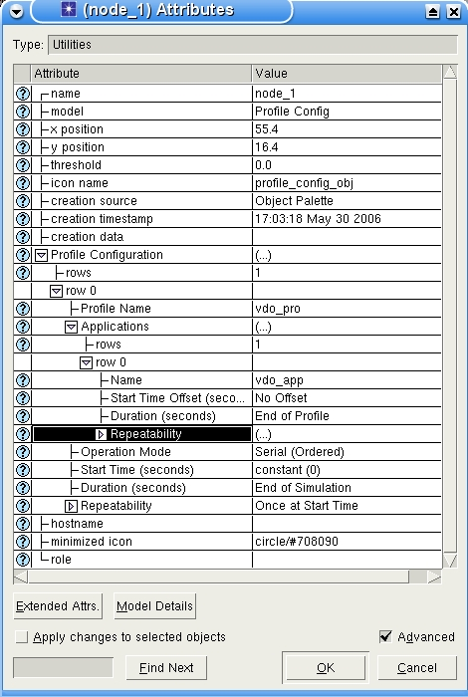

- Configuring some basic attributes of the workstations
(a) Click onto the fixed station with the right mouse button and select Advanced Edit
Attributes.
(b) Set the following values.
■ name: source
■ x position: 13
■ y position: 10
■ ...
(c) Click onto the mobile station with the right mouse button and set the attributes as follows.
■ name: destination
■ x position: 10
■ y position: 10
■ trajectory: NONE (to make it stationary)
- Deploying the profiles in the workstations and configuring
(a) Go to the attributes of source
■ Set Application: Destination Preference and Supported Profiles as follows.

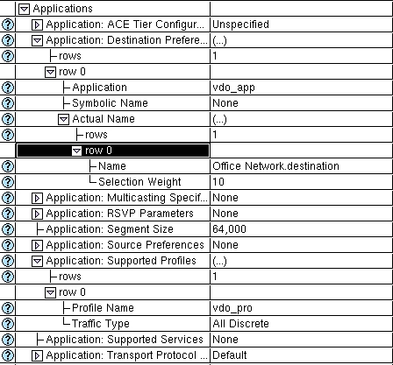

■ Set the following wireless LAN parameters like in the figure below:
● Physical Characteristics,
● Data rate (bps),
● Transmit power (W),
● Packet Reception-Power Threshold (dBm).
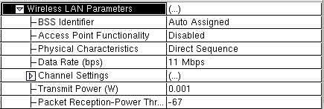

(b) Go to the attributes of the node destination.
■ Set Application: Supported Services

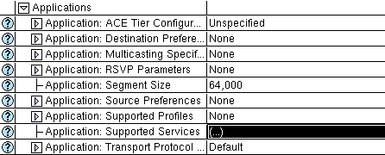

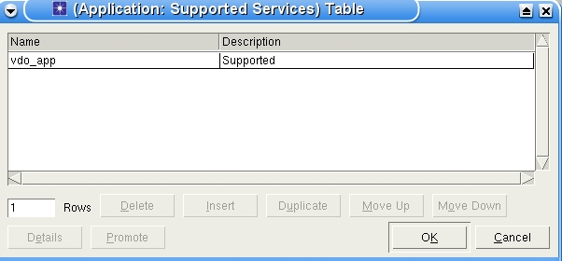

■ Set the following three Wireless LAN parameters like in the figure below
● Physical Characteristics
● Data rate (bps)
● Transmit power (W)
● Packet Reception-Power Threshold (dBm)
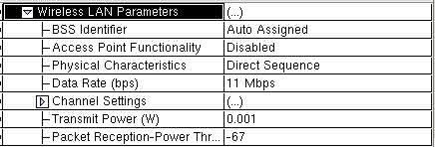

- Choose the statistics for the workstations
(a) Go to DES in the menu bar and click on Choose Individual Statistics
(b) Click Node Statistics, then Wireless LAN. Check Delay (sec) and Throughput (bits/sec)
as follows.

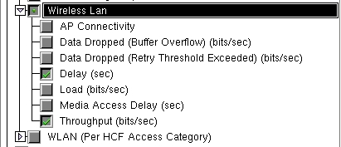

- Run the simulation
(a) Go to DES in the menu bar and click on Configure/Run Discrete Event Simulation.
(b) set the items Duration, Seed etc. as shown in figure below and run

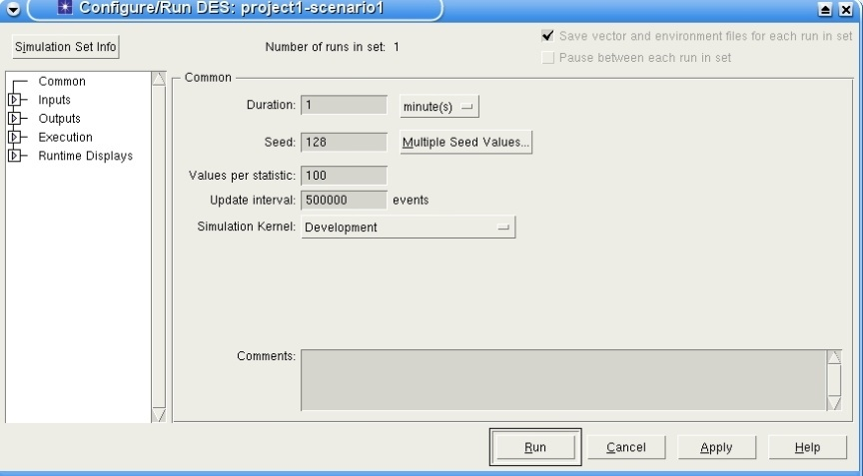

- Collect the results:
(a) Keep the mouse pointer over project editor and click the right button of the mouse.
Choose View Results in the pop-up menu.
(b) To get the average value for the delay and the throughput, select average in the drop down
menu which is set to As Is by default.

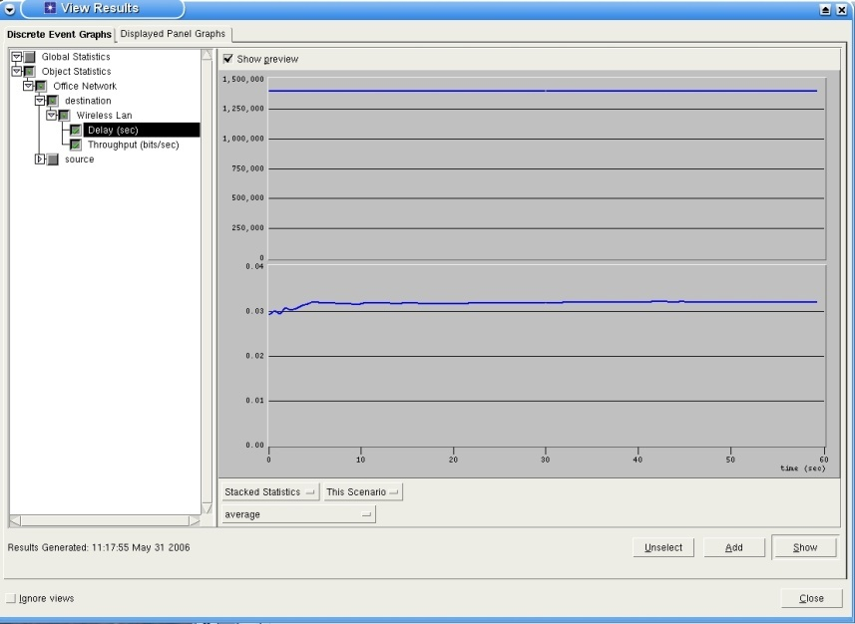

(c) Click on the show button and you will get following window.
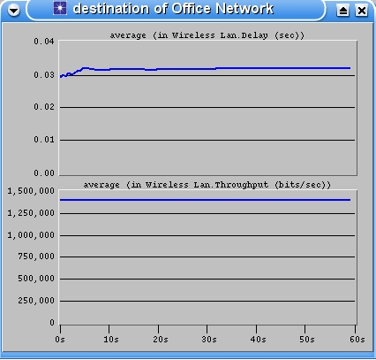

(d) Keep the mouse pointer over the window but outside the area into which the graph is plot
and click the right button of the mouse. Choose Show Statistic Data in the list and the
following window will appear.
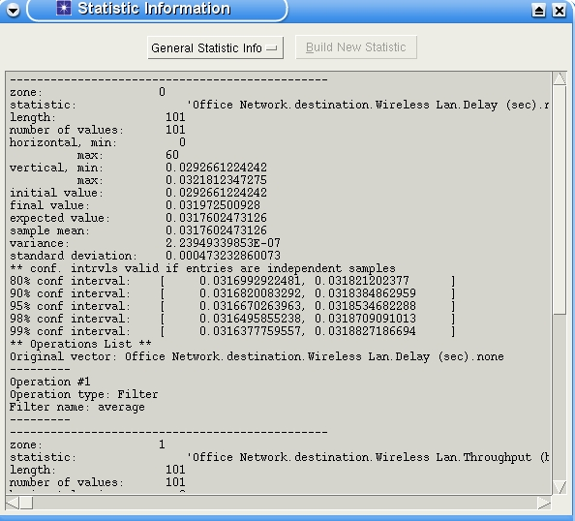

(e) Write down the sample mean and the standard deviation for the delay and the throughput.
You can copy and paste the numeric values from the window by marking them with the
left mouse button and pasting them into a text editor by pressing the middle mouse button.
- Make the destination node mobile. For adding mobility to the destination, a trajectory has to
be created in the following way:
■ Go to Topology in the menu bar and then select Define Trajectory.
■ Give the Trajectory name as mob.
■ Select Trajectory type as Fixed interval.

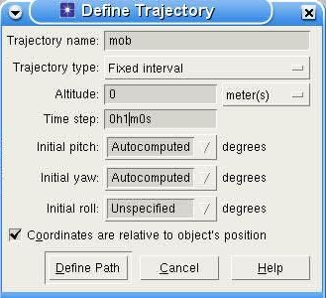

■ Set Time step to 1 m.
■ Check the box Coordinates are relative to object's position.

■ Then click on Define Path and the following window will appear.
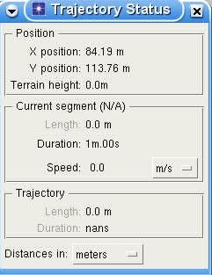

■ For Speed select m/s from the drop-down menu.
■ Click with the left button on any place in the work place to point to the start of the
trajectory, then move the mouse to another place and click the left button to point to
the end.
■ Click the right button and select Edit trajectory definition.
■ A window appears which must be filled out as shown below and confirmed by
clicking OK.
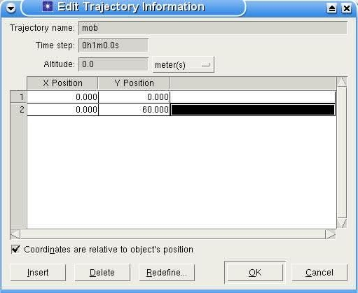

- Now, select the destination and go to Advanced Edit Attributes. Select mob for trajectory.

- Re-run the simulation as before with simulation duration 1 minute.

- View the results of delay and throughput for destination node. Click on the show button and
you will get the window with the result graphs.

(OPTIONAL)
Another way of creating a quick, common network topologies:

1a Go to File and select New.
2a Select Project and click Ok
3a Give the project a meaningful name other than the default (project1) and also a scenario name other than the default (scenario1).
4a Un-tick Use Start-up Wizard when creating new scenario

5a Using the Topology --> Rapid Configuration... command from the
Menu Bar to quickly deploy common network topologies

6b Available configurations: Bus, Mesh (Full or Randomized), Ring, Star, Tree, and Unconnected Networks

7b Example

(OPTIONAL)
Another way of Building wireless networks:

1b Go to File and select New.
2b Select Project and click Ok
3b Give the project a meaningful name other than the default (project1) and also a scenario name other than the default (scenario1).
4b Un-tick Use Start-up Wizard when creating new scenario
5b Using the Topology --> Deploy Wireless Network... Command from the Menu Bar to specify and build a wireless network

To Know about OPNET

The standard model library consists of the following types of objects:
- Subnetworks
- Nodes (aka devices)
- Links
- LANs and clouds
- Utility objects
Roman

Subnetworks
Subnetworks are essentially containers that abstract the network components specified within them into one object A subnetwork can also contain other subnetworks. A special subnetwork called the top level or global subnetwork is the highest level subnetwork in the network hierarchy

Nodes
A node represents a network device with a wide range of possible capabilities (router, switch, hub, workstation, server, firewall, etc.) The actual function and behavior of a node is determined by its node model

Links
Links represent the physical media and properties (line rate in bits per second, delay, likelihood of data corruption, etc.). Links are represented as line segments or a series of line segments with arrowheads.

LANs
A LAN object abstracts the LAN infrastructure into one object LAN objects dramatically reduce the amount of configuration required to do to represent an internetwork of LANs, and the amount of memory needed to run the simulation.

Clouds
A cloud object abstracts the WAN infrastructure into one object Cloud objects provide high-level characteristics (packet latency and discard ratio) used to simulate the behavior of ATM, Frame Relay, and IP WANs

Utility objects
Utility objects do not correspond to the actual physical infrastructure Instead; they perform logical functions in the network (configuration of network resources, scheduling special events, etc.)

Applications and Traffic

The first step is to drag and drop Application Config and Profile Config objects from the Object Palette to the Project Editor workspace.

Application Config specifies standard and custom applications used in the simulation, including traffic and QoS parameters. Standard applications (Light/Heavy): Database, Email, FTP, HTTP, Print, Remote Login, Video Conferencing, Voice

Profile Config specifies the activity patterns of a user or groups of users in terms of the applications used over a period of time. You can have several different profiles running on a given workstation or a LAN
These profiles can represent different user groups and behavior patterns

Example:

Choosing Statistics

Choose statistics to collect
- Menu Bar--> DES--> Choose Individual Statistics...
- Or Right-click in the Project Editor-->) Choose Individual DES
- Statistics
- List of statistics appears

Types of statistics
- Global: collected on the total network (e.g., application response time)
- Node: collected on individual nodes (e.g., delay, delay variation)
- Link: collected on individual links (e.g., utilization, throughput, queuing delay)

Choose Results dialog box

Running Simulations

- Menu Bar--> DES--> Configure/Run Discrete Event Simulation...
- Set simulation options and click Run

View Results

- Menu Bar-->DES-->Results-->View Results...
- Or Right-click in the Project Editor--> View Results

Other Tutorial sessions will base on how to create:

- Node Model
  - Node models are created using the Node Model Editor which allows you to define the behavior of each network object. Behavior is defined using different modules, each of which models some internal aspect of node behavior such as data creation, data storage, etc. Modules are connected through packet streams (or statistic wires). A network object is typically made up of multiple modules that define its behavior.

- Process Model
  - Process models are created using the Process Model Editor. The Process Editor lets you create process models which control the underlying functionality of the node models created in the Node Editor. Process models are represented by finite state machines (FSMs), and are created with icons that represent states and lines that represent transitions between states. Operations performed in a state or on a transition are described in embedded C or C++ code blocks. Each state contains two code blocks: the Enter Executive block that is executed as the state is entered and the Exit Executive block which is executed when the state is left.

