Joseph Liles-Smith

Richard Morgan

January 16, 2020

Manufacturing Process and Material Selection.

Materials and Introduction to Manufacturing

Introduction
Improving customer satisfaction and allowing for mass customization is the easiest way of increasing the quality of a product. Although it is a more expensive way of creating a product due to the costing of the printing machine itself and also the cost of the materials used to create the molding higher than the cost of conventional methods of creating items.

The vast quantity of manufacturing processes are cannot be improved by adding 3D manufacturing to the process of production as the products do not need mass customization and such as items that fit body parts as every persons ergonomics.

Therefor creating products for the fit of a person will be beneficially cost affective as every single product is different and people will also pay more for better quality products.

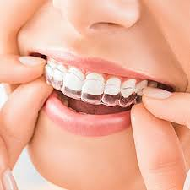
As any person with braces or has previously had braces will know, one of the most uncomfortable situations throughout the process is being stuck in your orthodontists chair with a large molding piece positioned tightly between both sets of teeth causing you to choke and trigger your gag reflex.

Having retainers is the most important part of teeth alignment as without the them the teeth will go back to the natural way they were before the process started. This means the retainer aligners must be a strong material (polypropylene) to hold the teeth in the correct position for the rest of your life. They are worn after block and wire braces generally to sleep to stop movement but for clear aligner braces they are worn for around 22 hours a day usually only take off for eating and oral hygiene routines.

This mould which is made from alginate powder compound made from seaweed or kelp that is added to water to make something that looks like silly putty. It usually only takes about 60 seconds to harden (orthadontic associates, 2018) will then be filled with polysiloxane will give the orthodontist a model of your teeth which they can fit retainers onto.

The process involves filling the mould with polysiloxane leaving it to set before adding a vacuum molded polypropylene plastic sheet over the mould to set so they can fit teeth with close to perfection not allowing the gums to change positions of the teeth after the braces being removed.

There is another use for the vacuum molded retainers which can bypass the use of the braces. With teeth sets that only need minor adjustments, retainers can be used to move the gums sockets slightly. This can be done by visually adjusting the mould before it is set and vacuum coated. This is not accurate and can cause more damage than what the retainers are set to do if these adjustments are not to perfection.

Main body
X-rays create images of the teeth with only the teeth showing. From these images we can see where the gums are holding the teeth in an abnormal position. Generally these images are used just to check the teeth position but they could be used to create a 3D model.

From these x rays we can also program software to create a 3D image of the teeth by adding the x-rays from both sides of the mouth together and create an image of the full set of teeth. From this we can use a 3D printer to create a model of the teeth which is perfectly accurate due to the precise printing of the 3D printer rather than filling a mould made by alginate which could leave air gaps or could have foreign objects in the mould causing miss-shaping of the teeth mould which is coated with the polypropylene plastic sheet by the method of vacuum molding to create the retainers.

The material which would be best for printing the mould of the teeth would be PLA this is due to it being a cheaper alternative to using metals such as copper or brass printing and PLA has a high stiffness and ultimate strength as shown below. PLA also has a higher melting point which is around 205 degrees which is higher than the polypropylene plastic sheets which are melted when vacuum coated which is melted at 166 degrees. Therefor the teeth mould will not be affected when the heated film is added over it. This would cause major problems and would possible affect the mould causing misalignment.

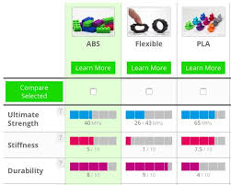

(3DERS, 2016)

As stated previously an important factor to justify changing from the traditional manufacturing process to the additive manufacturing process is the precision of the adjustments through the retainers when using the new teeth adjustment method without using traditional wired braces.
Through researching a new and upcoming alignment method I have found that the leading company is this process is Invisalign by top doctors. This company sends sets of retainers to your door weekly which will change the position of your teeth through moulding the gums slightly by every change in retainers. In the video below this explains the process of how affective the retainers system works, how the retainers are produced and also an explanation of what happens to the patients teeth. It also shows a good comparison to ordinary braces made by the NHS and the companies product.

https://www.youtube.com/watch?v=6kXOuBt7hNo&feature=youtu.be

(uk, 2018)

This process can be dramatically changed and improved for the patient by adding my process of additive manufacturing to it. It will not only make it an easier process and very much less painful but also make the whole process or alignment of teeth more accurate and therefor make is a shorter process.
This is beneficial as each set of retainers cost variable amounts of money each week as it costs to produce the plastic retainers.
By 3D printing the sets of teeth you can reprint the models every week rather than adjusting the models by hand eye coordination. As stated in the short video by the orthodontist the retainers will move the teeth sockets quarter of a millimetre a week and then after the 7 days of use of the retainers you will change to another retainer set. This means you can set the retainers for the full course of the alignment treatment in one session by printing all the moulds in one go again saving time for the 3D printer being used and then vacuum mould all the alignment retainers in one go. This will not only decrease the price of the treatment but also increase satisfaction as once the session with the orthodontist is complete you will not have to return for more treatment or check ups with this as you have the correct products to finish the treatment.

For the traditional form of braces this is also a huge benefit as you can 3D print the teeth after the blocks and wire have been removed and print form the retainers to keep the gums in the correct place for the time you wear the retainers. An important benefit of the speed creation for retainers for post wire and block treatment is the distance the teeth will move after they are taken off so it is essential that the retainers are used immediately to avoid movement, pain and more than anything the waste of wearing block and wire braces.

The final benefit of using 3D printing to create the moulds for the retainers is the use of the software to create a tooth that may have been lost in previous experiences which will cause problems with the standard cast moulding for the retainers. This can be overcome buy adding a tooth in the shape of the tooth that should have been in that position. As shown below.
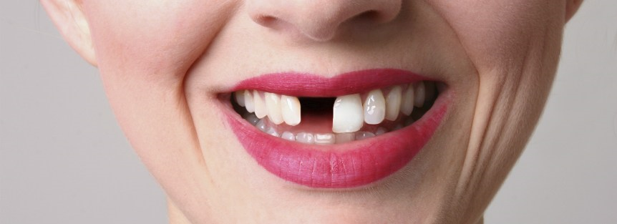 (care, 2020)
This photograph shows the how missing a tooth can make a change to someone’s appearance dramatically. Therefor adding retainers in with a 3D printed tooth in them until the tooth can be replaced correctly can make a tremendous addition to someone’s confidence.
Having a 3D printer on hand in an orthodontist can make a series difference to someone’s life for this unfortunate period of time.

Here is an example of a set of retainers with 3D printed missing teeth in, this photo shows how they can be used to benefit patients and how they will fit into the retainers.
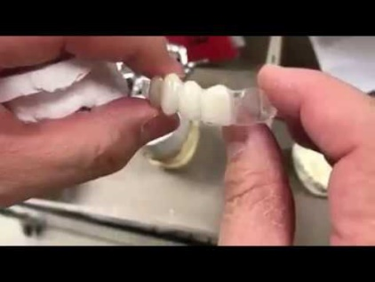

Conclusion

To conclude this report on how the additive manufacturing method of creating 3D printed sets of teeth to produce retainers is far superior to the traditional method of moulding through cast moulding of teeth used in common orthodontists.

The cost of the machine and maintenance for the 3D printer would be covered within a short period of time due to the increased cost of the product as the satisfaction of the customers will increase and they will have an increase in charge therefor it will be cost effective which is what all businesses strive for to decrease their outgoings to therefor make a profit and grow.

In my opinion due to my previous experience with orthodontist procedures it seems it is much simpler to use the 3D printing method of creating the moulds in the first place and I would also prefer the new method of gum alignment as it is a lot less uncomfortable, can be produces on the same day as the orthodontist visit and more cost effective for the orthodontist so the service will also be better. This method will also allow replacement retainers to be attained at a faster pace.

Retainers are extremely important in teeth alignment and I believe this way of creating them is a step in the right direction and should be made a common practice across the world for brace users.

